Molbank 2010, M676; doi:10.3390/M676
OPEN ACCESS
molbank
ISSN 1422-8599
www.mdpi.com/journal/molbank
Short Note

(E)-2-((4R,5R)-5-((Benzyloxy)methyl)-2,2-dimethyl-1,3-dioxolan-4-yl)but-2-ene-1,4-diol

Carlos R. Carreras ¹, Celina E. García ², Víctor S. Martín ², Carlos E. Tonn ¹, David Díaz Díaz ^{3,4,}* and Juan Pedro Ceñal ^{1,}*

¹ INTEQUI-CONICET-Facultad de Química, Bioquímica y Farmacia, Universidad Nacional de San Luis, Chacabuco y Pedernera, 5700 San Luis, Argentina
² Instituto Universitario de Bio-Orgánica “Antonio González”, Universidad de La Laguna, Avda. Astrofísico Francisco Sánchez, 2, 38206 La Laguna, Tenerife, Spain
³ Institut für Organische Chemie, Universität Regensburg, Universitätsstr. 31, 93040 Regensburg, Germany
⁴ ICMA, CSIC-Universidad de Zaragoza, Pedro Cerbuna 12, 50009 Zaragoza, Spain

* Authors to whom correspondence should be addressed; E-Mails: jcenal@unsl.edu.ar (J.P.C.); David.Diaz@chemie.uni-regensburg.de (D.D.D.).

Supporting Information

 (E)-2-((4R,5R)-5-((benzyloxy)methyl)-2,2-dimethyl-1,3-dioxolan-4-yl)but-2-ene-1,4-diol (3)

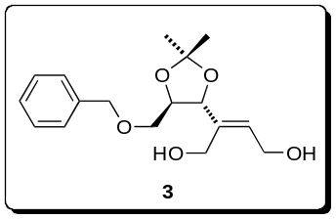
¹H NMR (CDCl₃)

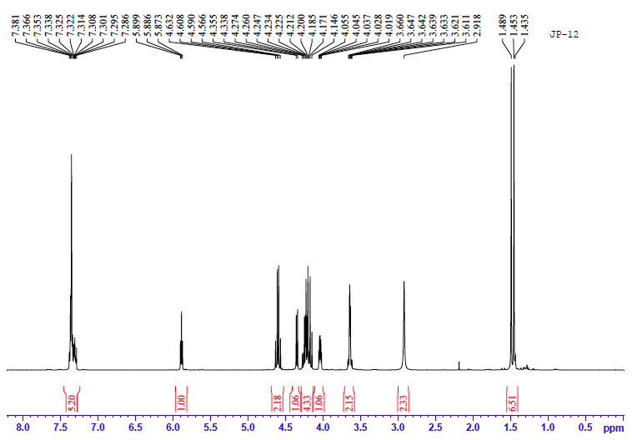

¹³C NMR (CDCl₃)

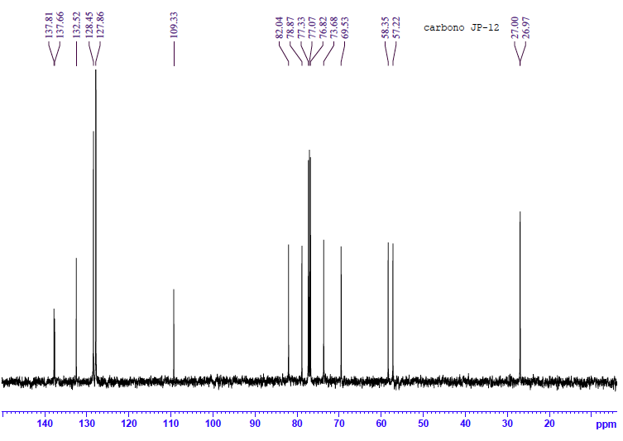

nOe (CDCl₃)

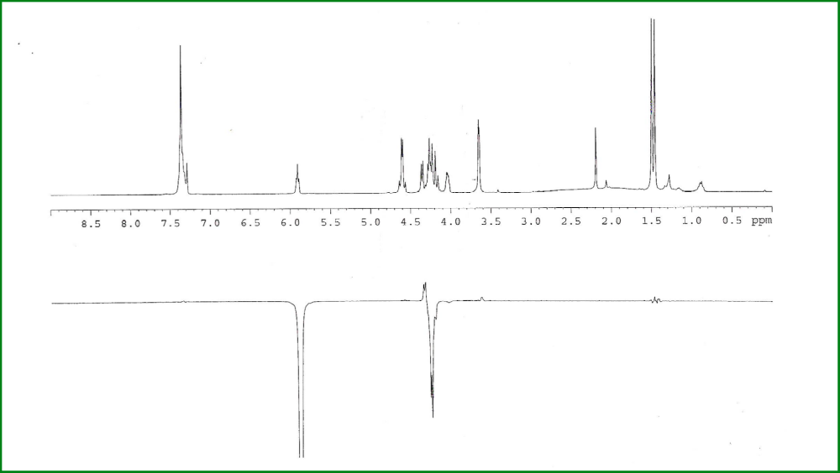

COSY (CDCl₃)

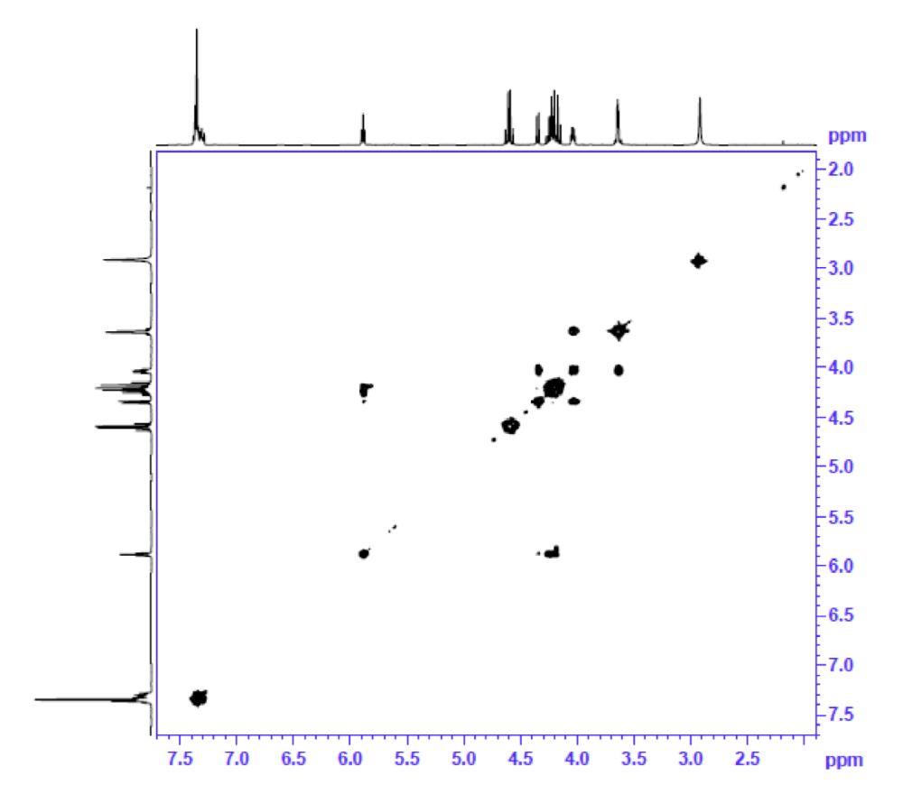

HSQC (CDCl₃)

