Molbank 2010, M680; doi:10.3390/M680
OPEN ACCESS
molbank
ISSN 1422-8599
www.mdpi.com/journal/molbank
Supporting Information

(−)-5-[(4R,5R)-5-(benzyloxymethyl)-2,2-dimethyl-1,3-dioxolan-4-yl]-2,2-dimethyl-4,7-dihydro-1,3-dioxepine

Carlos R. Carreras¹, Celina E. García², Víctor S. Martín², Carlos E. Tonn¹, David Díaz-Díaz^{3,4*} and Juan P. Ceñal^{1*}

¹ INTEQUI-CONICET-Facultad de Química, Bioquímica y Farmacia, Universidad Nacional de San Luis, Chacabuco y Pedernera, 5700 San Luis, Argentina
² Instituto Universitario de Bio-Orgánica “Antonio González”, Universidad de La Laguna, Avda. Astrofísico Francisco Sánchez, 2, 38206 La Laguna, Tenerife, Spain
³ Institut für Organische Chemie, Universität Regensburg, Universitätsstr. 31, 93040 Regensburg, Germany
⁴ ICMA, CSIC-Universidad de Zaragoza, Pedro Cerbuna 12, 50009 Zaragoza, Spain

* Author to whom correspondence should be addressed; E-mail: jcenal@unsl.edu.ar, David.Diaz@chemie.uni-regensburg.de

 (−)-5-[(4R,5R)-5-(benzyloxymethyl)-2,2-dimethyl-1,3-dioxolan-4-yl]-2,2-dimethyl-4,7-dihydro-1,3-dioxepine (2):

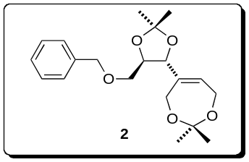

¹H NMR (CDCl₃)

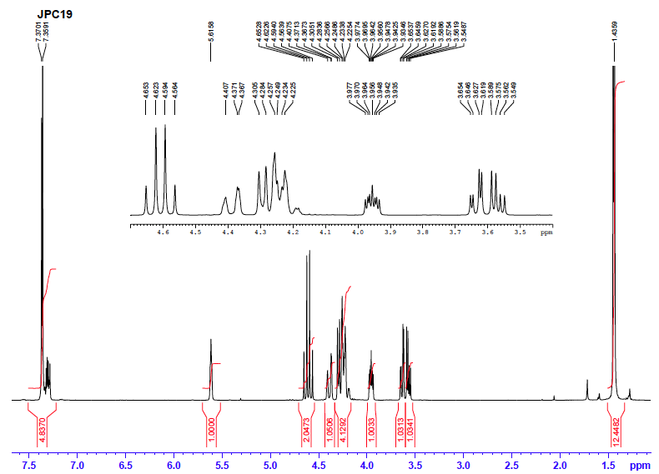

¹³C NMR (CDCl₃)

