Molbank 2010, M705; doi:10.3390/M705
§
OPEN ACCESS
molbank
ISSN 1422-8599
www.mdpi.com/journal/molbank
Supplementary Files

N,N'-(1,2-phenylene)-bis[4-(chloromethyl)benzamide]

Jürgen Bachl ¹ and David D. Díaz ^{1,2,}*
¹ Institut für Organische Chemie, Universität Regensburg, Universitätsstr. 31, 93040 Regensburg, Germany
² ICMA, CSIC-Universidad de Zaragoza, Pedro Cerbuna 12, 50009 Zaragoza, Spain
* Author to whom correspondence should be addressed;
E-Mail: David.Diaz@chemie.uni-regensburg.de.
1. ¹H and ¹³C NMR spectra of product 3
 N,N'-(1,2-Phenylene)-bis[4-(chloromethyl)benzamide] (3)
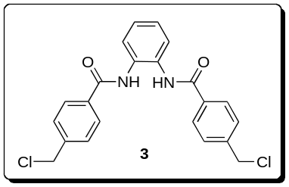
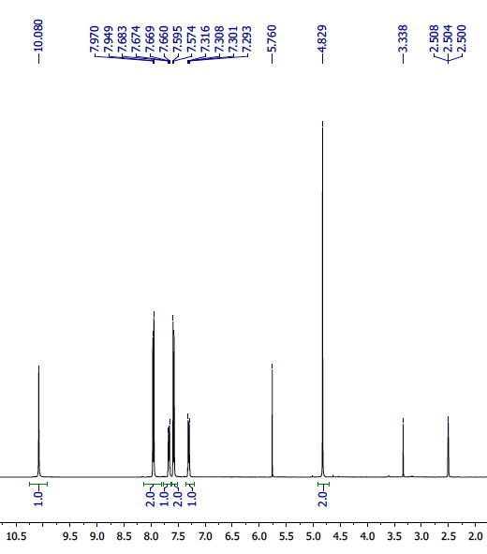
Figure S1. ¹H NMR spectrum of 3 (400 MHz, DMSO-d₆). Identification of additional signals: 2.50 ((CH₃)₂SO from DMSO-d₆), 3.34 (H₂O from DMSO-d₆), 5.76 (CH₂Cl₂ occluded after recrystallization of 3 from CH₂Cl₂/pentane).
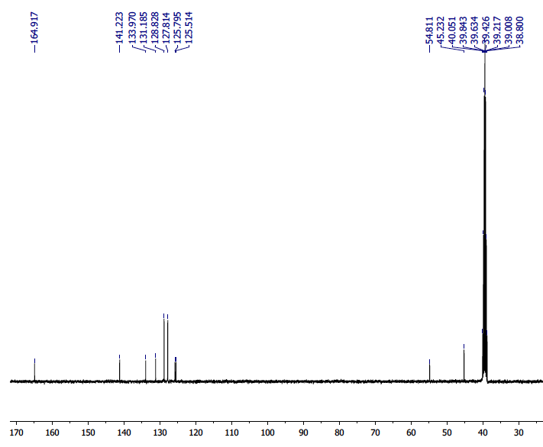
Figure S2. ¹³C NMR spectrum of 3 (75 MHz, DMSO-d₆).

