**Supplementary information**

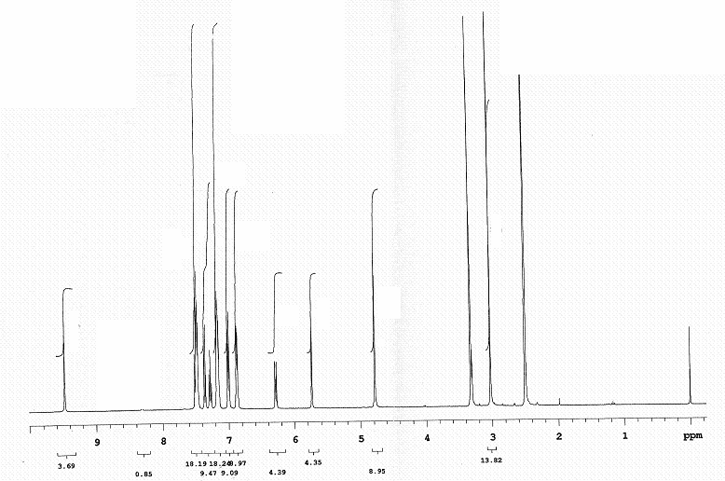

Mass spectrum of*N*-(4-methylsulfonamido-3-phenoxyphenyl)-9, 10-dihydro-9, 10-

ethanoanthracene-11, 12-dicarboximide.

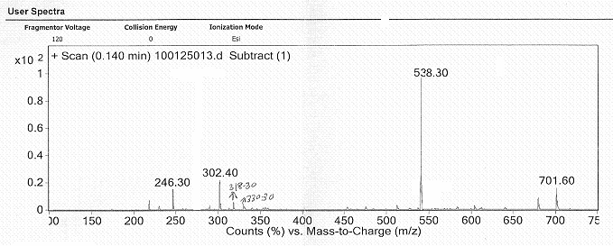

IR spectrum of *N*-(4-methylsulfonamido-3-phenoxyphenyl)-9, 10-dihydro-9, 10-

ethanoanthracene-11, 12-dicarboximide.

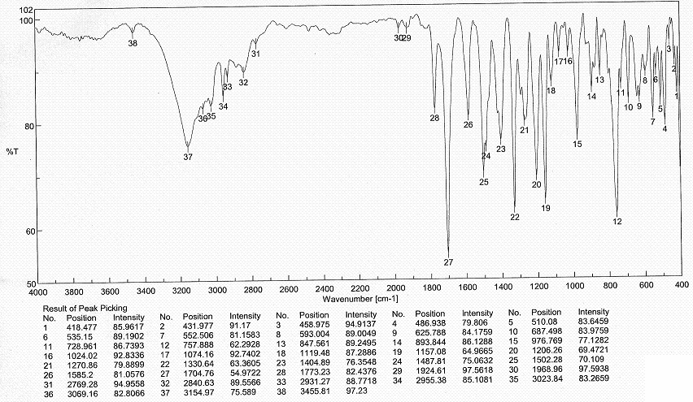

13CNMR *N*-(4-methylsulfonamido-3-phenoxyphenyl)-9, 10-dihydro-9, 10-ethanoanthracene-11,

12-dicarboximide

