MADE BY @thecubejsablover ON TIKTOK
TRANSPHOBES IS DUMB!!!!!!!!!!!!!!
Make sure to check out other debunking video in my profile too! (Fav -> Collection)

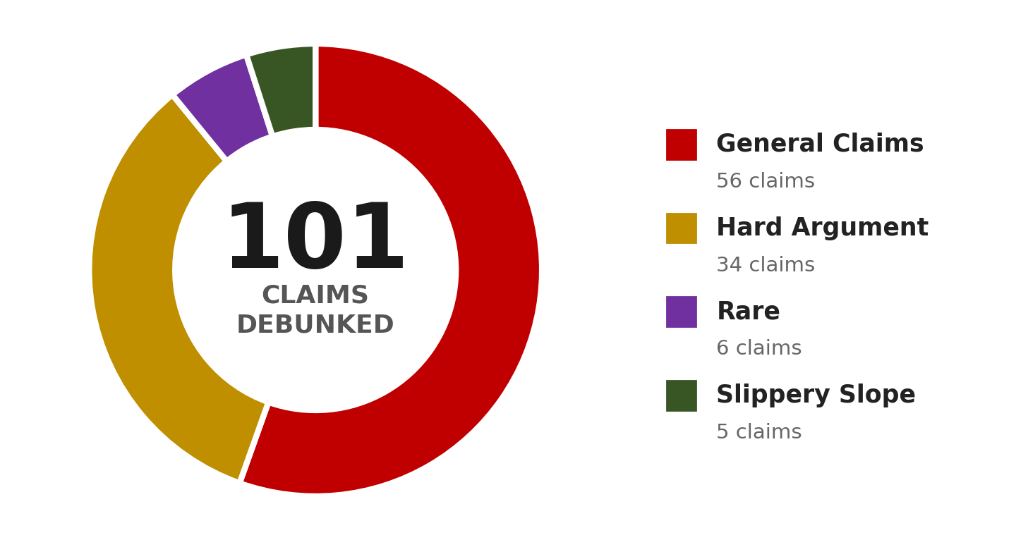
📋 CLAIM / ARGUMENT LIST 📋

1. There are only two genders, based on basic biology.
2. Transgender, non-binary, and gender-diverse people are denying biological reality.
3. Biological sex is immutable and fixed by chromosomes, reproductive anatomy, and genetics.
4. If 'woman' or 'man' is not defined by biological sex, then no objective definition remains.
5. Changing language, pronouns, and labels does not change underlying biological reality.
6. Agender is impossible because humans biologically cannot have no gender.
7. You cannot identify as something you are not.
8. Non-binary, genderfluid, and genderflux identities are not real and are completely made up.
9. You cannot be genderfluid because you cannot change your gender every day.
10. Demigender and bigender people are just confused cisgender people seeking attention.
11. Xenogenders and neopronouns are mental illnesses or mockeries of 'real' transgender people.
12. Being transgender or non-binary is a social contagion driven by peer groups and online communities.
13. Most young people will grow out of being transgender or non-binary (a concept called desistance).
14. Minors are incapable of understanding the long-term consequences of medical transition (hormones and surgery).
15. Some people later detransition, which proves we should not affirm transgender identities.
16. Gender dysphoria is a mental illness, and non-binary identities are also psychiatric conditions.
17. People adopt non-binary identities just to feel special, avoid misogyny, or escape sexism.
18. Young people are too young to know their gender; it is just a phase.
19. You must look androgynous or medically transition to be considered genuinely non-binary.
20. You must experience constant gender dysphoria to be genuinely transgender or non-binary.
21. Transitioning based on feeling masculine or feminine reinforces harmful gender stereotypes.
22. Transgender women retain physical advantages from male puberty, making women's sports unfair.
23. Transgender and non-binary people have higher percentages to be minor-attracted persons, pedophiles, murderers, shooters, or other violent criminals.
24. If self-identification determines gender, there is no principle stopping someone from identifying as anything else, such as a different age or species.
25. Transgender rights are a direct threat to cisgender women's rights and feminism.
26. Non-binary identities erode the definition of 'woman'/’men’ and harm cisgender women/men.
27. Society cannot accommodate infinite genders and pronouns; it is too complicated.
28. Using a transgender person's preferred pronouns is 'forced speech' and confuses children.
29. Teaching children about non-binary or genderfluid identities is grooming and indoctrination.
30. Transgender and non-binary people are a threat to women and children.
31. Non-binary people have it easier and should not speak over 'real' binary transgender people (or vice versa)
32. You are not really transgender unless you transition strictly between male and female.
33. If pronouns do not equal gender, then changing your pronouns is just performative.
34. Gender-specific diseases (like prostate cancer in transgender women) prove you are still your birth sex.
35. Transgender women are not real women because they were not raised as women.
36. Transgender men are just confused women who hate themselves.
37. You can always tell if someone is transgender just by looking at them.
38. 'Cisgender' is a made-up slur; I refuse to accept or use it.
39. Transgender people are just homosexual or lesbian individuals who are confused about their sexuality.
40. Transgender activists are conspiring to 'trans' children.
41. The high suicide rates among transgender people prove they are mentally unstable, rather than proving they need support.
42. Transgender people have higher percentages to have mental illnesses (other than gender dysphoria).
43. No external verification is possible. A clinician cannot confirm or deny a person's gender identity through any objective test. They must simply accept the patient's word as truth. In every other area of medicine, self-report is a starting point for investigation, not the final conclusion. We do not diagnose depression, cancer, or diabetes based purely on how a patient feels. We use objective tests to confirm or disconfirm their subjective experience. By removing objective verification from gender diagnosis, we have created a double standard that is unique in all of medicine.
44. Being assigned female at birth and identifying as a demigirl just makes you a cisgender girl invading trans spaces.
45. Non-binary people are just 'man-lite' (if assigned male at birth) or 'woman-lite' (if assigned female at birth) rather than a valid third option.
46. You must be dysphoric all the time; if your genderflux identity's dysphoria fluctuates, it is not real.
47. Being transgender or non-binary is a choice or a lifestyle, not an innate identity.
48. Transgender women are like men in 'womanface,' actively mocking womanhood.
49. There is an inherent conflict between transgender rights and the rights of everyone else.
50. Society has used binary language and gender roles for millennia; it is unreasonable and burdensome to force everyone to change their language, pronouns, and thinking overnight just to accommodate a tiny minority.
51. Transgender rights activists are demanding 'special rights' that go beyond basic equality, and they are moving too fast, alienating the general public and making it harder for society to accept them.
52. The 41% suicide attempt rate among transgender people proves that being transgender is inherently pathological and that gender transition does not actually resolve underlying mental health issues.
53. Allowing transgender women into women's bathrooms, locker rooms, and prisons will increase sexual assaults, because transgender women are statistically more likely to be sexual predators.
54. Transgender people have higher rates of criminality and violence compared to the general population, so they should not be given unrestricted access to vulnerable spaces.
55. Society should prioritize the comfort and safety of the vast majority (cisgender people) over the feelings of a very small minority, because democracy means serving the greatest number of people.
56. A masculine trans girl is not valid, and vice versa. It is mocking transgender people and gender dysphoria.

⚡ HARD ARGUMENT CATEGORY ⚡
57. Gender identity is an entirely subjective, internal feeling that is unverifiable by anyone else. Since science relies on observable, objective phenomena, how can society build legal frameworks and medical policies on something so purely subjective?
58. Womanhood, historically and sociologically, has been defined by a shared material reality, including reproductive capacity, systemic oppression, and specific biological vulnerabilities. A person assigned male at birth cannot retroactively acquire that specific historical and social experience.
59. Anti-discrimination laws are built on protected classes like biological sex. If 'sex' becomes entirely fluid and self-defined, the legal mechanism used to measure and prosecute sex-based wage gaps, pregnancy discrimination, or workplace harassment becomes functionally useless.
60. Requiring zero psychological evaluation for gender-affirming medical treatment removes the standard gatekeeping that exists for every other major irreversible medical procedure, undermining evidence-based practice and informed consent protocols.
61. Some individuals report gender euphoria after transitioning, but euphoria might simply be relief from external social pressures or internalized shame. How do we distinguish an innate, immutable identity from a trauma response or a coping mechanism for unresolved distress?
62. Several long-term longitudinal studies suggest that mental health improvements post-transition are not universal and sometimes diminish over time. Does this not suggest that medical transition is an oversimplified solution to complex psychiatric comorbidities?
63. By defining 'woman' as 'anyone who identifies as a woman,' we erase the biological and sociopolitical specificities that uniquely affect cisgender women, such as abortion rights, maternal mortality, and reproductive health, diluting their advocacy power.
64. If gender is purely a social construct that we should ultimately abolish, why are transgender activists reinforcing the gender binary by transitioning to conform to traditional masculine or feminine stereotypes?
65. If a cisgender man claims he 'identifies as a woman' solely to gain access to women-only scholarships, leadership programs, or shelters, under pure self-identification laws there is no legal basis to deny him. This exposes a genuine vulnerability in equality law.
66. Refusing to use someone's requested pronouns is often framed as an act of violence. However, isn't it simply a disagreement about the nature of language and reality, rather than a hate crime? Compelled speech conflicts with classical liberal values of free thought.
67. The transgender movement relies heavily on the concept of 'gender identity,' but this concept lacks a universally agreed-upon operational definition in psychology or biology, making it more of a political assertion than a scientific fact.
68. Puberty blockers were originally designed for central precocious puberty in young children, not for healthy adolescents with gender dysphoria. Using them off-label for extended periods lacks robust long-term safety data regarding bone density and brain development.
69. If we accept genderfluidity, where a person's gender can change daily, then how can this fluctuating state serve as a stable, reliable basis for permanent legal documentation, medical treatment plans, or prison classification?
70. Radical feminist theory historically aimed to dismantle gender roles entirely. Transitioning to the opposite sex to alleviate dysphoria inadvertently reinforces the regressive idea that specific behaviors, clothing, and appearances must belong to a specific biological sex.
71. Legally recognizing non-binary genders requires massive overhauls of passports, healthcare databases, prison systems, and sports categories. The administrative cost and societal burden on the whole population outweigh the benefit to a statistical minority.
72. The documented phenomenon of rapid-onset gender dysphoria, observed in friendship clusters of adolescents, suggests that social influence and peer dynamics play a significantly larger role in identity formation than previously acknowledged.
73. Many detransitioners report that their gender dysphoria was actually caused by unresolved childhood trauma, sexual abuse, or internalized homophobia. By affirming transition immediately, we risk bypassing crucial trauma therapy and permanently altering healthy bodies.
74. A transgender woman retains male-typical bone density, cardiovascular risk profiles, and lung capacity. Medical protocols designed for female bodies are clinically inappropriate for her, proving that biological sex remains pervasively relevant in healthcare.
75. Non-binary or transgender people break bathroom, sports, and prison laws.
76. If the category 'woman' now includes anyone who identifies as one, the term becomes so broad that it loses all descriptive power. A category that describes everyone describes no one, and cannot be used for meaningful political advocacy.
77. Activists frequently claim that transgender children will commit suicide without immediate affirmation. This coercive framing silences medical professionals who have legitimate, evidence-based safety concerns about early medicalization and prevents open scientific debate.
78. Gender dysphoria is a distress signal, but treating it solely with hormonal and surgical transition is a one-dimensional physical approach. We treat body dysmorphic disorders such as anorexia with therapy and cognitive interventions, not surgical affirmation. Why the double standard?
79. Enforcing pronoun usage via legal penalties, workplace mandates, or academic policies is a form of compelled speech that violates foundational classical liberal principles of free expression and intellectual freedom.
80. If the only requirement to be legally recognized as a woman is self-identification, then a male-bodied person could claim womanhood to avoid male-only military drafts, selective service registration, or gender-specific legal responsibilities, creating legal inequalities.
81. The existence of intersex conditions is often used to argue that sex is a spectrum. However, intersex makes up roughly 1.7% of births (including late-onset forms) and is medically distinct from transgenderism, making that comparison scientifically flawed and rhetorically deceptive.
82. Medical transition does not change a person's chromosomal karyotype (XX or XY). Since chromosomes influence cellular biology throughout the entire body, biological sex is pervasive and immutable at a microscopic level, not limited to external genitalia.
83. If gender identity is internal and fluid, future medical research might eventually develop therapies that alleviate dysphoria without requiring physical transition. By dogmatically focusing only on affirmation today, we might be halting scientific inquiry into alternative solutions.
84. Historical cultures had third-gender roles, but those were rigid social positions tied to specific religious or cultural functions, not modern concepts of internal identity. Extending modern transgender theory backward to ancient civilizations is an anachronistic misappropriation.
85. The transgender community frequently silences detransitioners and ex-trans individuals, labeling them as 'grifters' or 'traitors.' Suppressing these minority voices creates a dangerous echo chamber that hides the full spectrum of outcomes and complications.
86. Society has a duty to protect vulnerable minors from irreversible harm. Until there is absolute, consensus-based, long-term evidence for the safety and efficacy of pediatric gender transition, the precautionary principle demands that we default to therapeutic watchful waiting rather than immediate medicalization.
87. The Race and Money Argument. If race is socially constructed, we do not allow individuals to change their race based on internal feelings. If money is socially constructed, a one-dollar bill cannot become a hundred-dollar bill simply by identifying as one. We do not invent new races daily, nor do we legally recognize a person claiming a new race every morning. Therefore, simply because gender is socially constructed does not logically mean it should be subject to unlimited personal redefinition based purely on subjective self-identification. There must be an objective anchor, and biological sex is that anchor.
88. The Biological Verification Argument. If gender identity is biologically rooted in the brain, then why do we not use objective neurological scans, such as functional MRIs or brain structure analysis, to diagnose gender identity and confirm eligibility for medical transition? Every other biological condition with a neurological basis is diagnosed through objective medical testing, not through patient self-report. Relying purely on subjective verbal affirmation for a condition that supposedly has a physical basis contradicts every other standard of evidence-based medicine and opens the door to false positives.
89. The Detransition Data Paradox. Transgender allies frequently cite low regret rates for transition, typically around 1% to 2%. However, these studies often exclude detransitioners who do not return to their original clinics, who are too ashamed to report their regret, or who are actively silenced by community pressure. Furthermore, a significant percentage of detransitioners cite social pressure, inability to pass, or unresolved mental health comorbidities as reasons for stopping. Since detransition itself is highly stigmatized and often leads to loss of community support, the true regret rate is almost certainly underreported. Without a mandatory, unbiased, globally tracked longitudinal registry of every transition outcome, we cannot scientifically claim the regret rate is negligible enough to justify broad, easily accessible pediatric interventions.
90. The Homosexuality versus Gender Dysphoria Overlap. A substantial portion of transgender youth report experiencing same-sex attractions prior to transitioning. Historically, a significant percentage of children who experienced gender dysphoria grew up to be gay or lesbian adults rather than transgender adults. Given this overlap, how can a clinician definitively distinguish between a child who is gay and a child who is transgender, especially when both may experience distress about their bodies or social roles? Affirming a gay child's distress by encouraging them to transition to the opposite sex runs a disturbing parallel to conversion therapy, just reversed. How do we screen for internalized homophobia without being accused of transphobia, and what safeguards exist to prevent misdiagnosing homosexuality as transgenderism?

🔍 RARE CATEGORY 🔍
91. The Historical Anachronism Argument. The modern framework of transgender identity relies on a 20th-century Western concept of the autonomous, self-defining individual. However, most historical cultures that recognized gender variance, such as the Hijra in South Asia, the Two-Spirit people in Indigenous North American cultures, or the Fa'afafine in Samoa, did not conceptualize these roles through the lens of internal identity. They were rigid social, religious, or occupational positions tied to specific cultural functions. By retroactively applying modern transgender theory to these ancient cultures, we are engaging in a form of historical misappropriation that erases the cultural specificity of these roles. Proponents of transgender identity often claim historical continuity, but this is a selective reading of history that flattens complex cultural phenomena into a single, ahistorical narrative of transgender existence. If the modern concept of gender identity is a Western invention, then claiming it is universal across all cultures and all time periods is not historically honest.
92. The Linguistic Determinism Problem. Language shapes thought. By introducing an ever-expanding array of gender identities, pronouns, and labels, we are fundamentally altering the cognitive frameworks through which people understand human relationships, attraction, and social organization. This linguistic restructuring is not politically neutral; it is a form of engineered social change that imposes a specific worldview on the entire population, including those who do not consent to it. Unlike scientific discoveries, which describe pre-existing realities, the proliferation of new gender categories is actively constructing new social realities. Demanding that the public adopt these new linguistic frameworks, often under threat of social or professional penalty, is a form of coercive linguistic engineering that bypasses democratic deliberation and organic cultural evolution.
93. The Evolutionary Biology Baseline. Human beings, like all sexually reproducing species, have evolved under the selective pressures of binary reproductive roles. Every aspect of human anatomy, physiology, and even behavior is shaped by millions of years of evolution that assumed two distinct reproductive functions. While human culture is more complex than simple reproductive roles, the evolutionary baseline cannot be ignored. For a species that evolved entirely around binary sexual reproduction, claiming that gender is entirely divorced from biology and exists on a limitless spectrum flies in the face of evolutionary logic. Even if a small percentage of individuals experience gender variance, this does not negate the fact that human biology, at its most fundamental level, is organized around reproductive dimorphism. Evolutionary frameworks do not disprove transgender existence, but they do demand that claims about gender being entirely socially constructed account for the overwhelming biological reality of binary reproduction and its influence on human development.
94. The Global Human Rights Inconsistency. Transgender rights advocates in wealthy Western nations often demand that developing countries adopt progressive gender policies. However, many of these nations are struggling with basic human rights crises, including poverty, lack of clean water, child mortality, and widespread infectious diseases. In the global hierarchy of human rights priorities, gender self-identification ranks far below access to food, water, and basic healthcare. By focusing Western political capital and aid funding on LGBTQ+ rights in developing nations, Western activists are imposing a set of priorities that do not reflect the lived realities of people in those countries. This is a form of cultural imperialism that prioritizes a relatively niche issue over fundamental survival needs. Additionally, many of these nations have cultural norms around gender that are organic to their own historical development, and Western pressure to adopt foreign gender frameworks disregards their cultural autonomy.
95. The Bodily Autonomy Conflict. Bodily autonomy is a foundational principle of liberalism. However, the transgender rights movement demands not only that individuals have autonomy over their own bodies, but that society must affirm and validate every choice they make regarding their bodies. This creates a conflict: if a person has full bodily autonomy to transition, do others have full bodily autonomy to refuse to participate in or affirm that transition? For example, should a female athlete be forced to compete against someone with male physiological advantages in the name of transgender inclusion? Should a rape survivor be forced to share a locker room with someone assigned male at birth? Should a religious healthcare worker be forced to participate in gender-affirming surgeries? The transgender movement often demands that other individuals sacrifice their own bodily autonomy, safety, or religious freedom to accommodate its goals. True liberalism would recognize that one person's bodily autonomy ends where another person's begins, and the current framework often fails to balance these competing rights.
96. The Medicalization of Normal Human Variation. Human beings have always exhibited a wide range of gender expression, from feminine men and masculine women to individuals who lived outside traditional gender roles entirely. Historically, this was accepted as part of the diversity of human personality and preference. However, modern transgender theory has medicalized these variations by framing them as a condition requiring medical intervention. In the past, a feminine boy might have been accepted as simply a feminine boy, or a masculine girl as simply a masculine girl. Today, both are immediately flagged for potential transgender identity and medical transition. This pathologization of natural human diversity has resulted in a society where individuals who would have previously lived ordinary lives as gender-nonconforming cisgender people are now being funneled into medical systems. We have replaced social tolerance with surgical intervention, and that is a deeply regressive step, not a progressive one.

⚠️ SLIPPERY SLOPE ABUSE ARGUMENTS ⚠️
97. My religion says it is a sin to not attack or criticize transgender people, so it is not my fault if I do that.
98. The framework is unfalsifiable. A claim that cannot be falsified is not a scientific claim; it is a belief. If a person says they are a woman, and no external evidence can contradict that claim, then the claim is unfalsifiable. Unfalsifiable claims belong in the realm of religion, philosophy, or personal spirituality, not in the realm of evidence-based medicine, law, or public policy. We are being asked to treat an unfalsifiable belief as if it were objective fact, and that is epistemologically indefensible.
99. It creates a hierarchy of subjectivity. If subjective self-identification is the ultimate authority, then a person who claims to be a woman cannot be questioned, even if they have a full beard, a deep voice, XY chromosomes, and no desire to transition. However, a cisgender woman who claims she is a woman is also making a subjective claim, but hers is never questioned. This creates a double standard where the cisgender woman's subjective identity is treated as automatically valid without needing to declare it, while the transgender woman's subjective identity is only valid if she declares it and society accepts it. The framework is internally inconsistent.
100. It collapses the distinction between identity and reality. Identity is a cognitive construct; reality is an external state of affairs. In every other area of human life, we distinguish between how someone identifies and what they actually are. We do not allow a person to identify as a different age, a different race, a different species, or a different historical period. We recognize that identity is a psychological phenomenon, but reality is independent of psychology. By insisting that gender identity is the only area where subjective identity overrides objective reality, transgender theory has created an epistemological exception with no logical grounding.
101. It prevents scientific inquiry into the nature of gender. If a researcher asks, "What is a woman?" and the answer is "anyone who identifies as one," the researcher cannot investigate the biological, psychological, or sociological factors that contribute to gender. The definition is circular, and circular definitions end inquiry rather than advancing it. By defining womanhood as a tautology, we have shut down the very scientific investigation that could help us understand gender dysphoria, gender expression, and human identity.
102. It demands social and legal enforcement of a belief system. We are not simply being asked to tolerate or respect transgender individuals. We are being asked to actively affirm and enforce a specific epistemological position: that subjective identity overrides objective biology. This goes beyond tolerance and becomes a demand for intellectual conformity. Those who disagree with this epistemological position are labeled bigots, regardless of their reasons. This is not a neutral policy; it is an ideological imposition that requires everyone to adopt a specific philosophical framework about truth, identity, and reality.

For my part
0.I : Definition of transgenderism, gender, non-binary, gender-fluid, agender and biological sex
- A transgender (often shortened to trans) person has a gender identity different from that typically associated with the sex they were assigned at birth
(wikipedia)
- Gender is attitudes, feelings, and behaviors that a given culture associates with a person's biological sex
(APA)
- Non-binary : Non-binary (also written as nonbinary) or genderqueer gender identities are those that are outside the male/female gender binary.
(Wikipedia)
- Gender-fluid : Gender fluidity (commonly referred to as genderfluid) is a non-fixed gender identity that shifts over time or depending on the situation. These fluctuations can occur at the level of gender identity or gender expression
(Wikipedia)
- Agender : Agender, also known as genderless and sometimes abbreviated to “AG”, is an identity to describe someone that entirely lacks a gender or with complete genderlessness. They may identify most strongly as just an individual, rather than as any given gender.
(lgbtqia.wiki)
- Genderflux : Refers to a person whose experience with their gender identity changes in intensity. A genderflux person's connection to gender may weaken or strengthen at random
(lgbtqia.fandom)
- Bigender : Bigender is a gender identity in which a person has or experiences two or more genders at once. The genders may be any combination of two genders, and those genders can be binary ("man" or "woman") or non-binary.
(lgbtqia.fandom)
- Biological sex : A person’s biological status
(APA)
Key Indicators:
It is primarily associated with physical attributes such as:
- Sex chromosomes
- Hormone prevalence
- Internal and external reproductive anatomy and genitalia
(APA)

- Gender is different from biological sex

0.II : Proving gender is a social construct
Different cultures have different gender categories. If gender were purely biological, every culture would have the exact same understanding of it. But they don't. In South Asia, the hijra community has been recognized as a third gender for centuries, playing religious roles at weddings and births. The Bugis people of Indonesia recognize five distinct genders, including calalai, calabai, and bissu. These aren't modern inventions. They have existed for generations, showing that gender categories are shaped by culture, not just biology.
Gender is performed, not innate. Sociologists West and Zimmerman argued back in 1987 that gender is an ongoing performance we do in social interactions, not a fixed trait we are born with. Think about how you dress, talk, move, or style your hair. Those aren't biological instincts. They are choices influenced by what society expects from men and women. If gender were just biology, those expectations wouldn't change so much depending on where you live or what decade you are in.
Gender roles change dramatically over time. What society considers masculine or feminine today would have looked very different a hundred years ago, and will probably look different a hundred years from now. The WHO notes that as a social construct, gender varies from society to society and can change over time. Pink used to be considered a strong masculine color for boys. High heels were originally worn by men. These shifts prove that gender norms are not fixed biological facts but cultural agreements that evolve.
Sex and gender are not the same thing. The WHO makes a clear distinction between sex, which refers to biological and physiological characteristics like chromosomes and hormones, and gender, which refers to socially constructed roles and behaviors. If gender were simply biology, this distinction wouldn't exist. But it does, because gender is about how society expects people to act, not just about their bodies. This is also why the American Psychological Association and other major health organizations recognize that gender identity is a deeply felt internal experience that may not align with sex assigned at birth.
In short, gender isn't something we are handed at birth and never question. It is something we learn, perform, and recreate every single day through our interactions with each other. And the fact that it looks so different across cultures and throughout history is the strongest proof that it is a social construct.
Quick clarification before you keep reading, because I use “gender” a lot in this section and “gender identity” later on, and I don’t want that to look like I’m flip flopping. Everything above is about gender roles and expression, the clothes, jobs, and behavior a culture attaches to being a man or woman. That part is 100% shaped by culture and changes constantly. Gender identity is a different layer: it’s your own internal sense of being a man, woman, both, neither, etc, and there’s actual evidence later on (twin studies, brain imaging) that this layer has a biological component too. Both things are true at once. The roles are constructed, the identity underneath them isn’t just made up on the spot.
@thecubejsablover (Tiktok)

0.III : Some popular misunderstanding
Pre.0.
Being transgender is a mental illness
This is probably the biggest one. The World Health Organization stopped classifying being transgender as a mental disorder in January 2022, moving it out of the mental illness chapter and into one on sexual health. The American Psychiatric Association also removed "gender identity disorder" back in 2012 and replaced it with "gender dysphoria," which specifically refers to the distress some trans people feel, not the identity itself. Gender dysphoria is a condition some transgender people experience, but it is not the same thing as being trans. As the American Psychiatric Association notes, trying to force someone not to be trans is harmful and results in poor mental health outcomes. The distress trans people face is largely fueled by stigma and discrimination, not by their identity itself.
1. "Trans people change their sex, not their gender"
This one gets it backwards. Being transgender is about gender identity, not sex. Gender identity is who you are inside. Sex refers to biological traits like chromosomes, hormones, and anatomy. Many trans people do choose to medically transition to align their physical body with their gender identity, but that is not what makes them trans. What makes them trans is the internal sense of self not matching the sex they were assigned at birth. Medical transition is just a tool some use to feel more comfortable in their bodies.
2. "Transition means getting surgery"
A lot of people think all trans people get surgery, but that is just not true. Not every trans person wants or can access surgery. Transition can mean different things for different people. Some change their name and pronouns. Some take hormone therapy. Some get various surgeries. Some do none of these. Every trans persons journey looks different, and all of them are valid.
3. "Trans people are just confused about their bodies"
This misunderstanding reduces a deep internal experience to simple confusion. Research shows that gender identity is a deeply felt internal sense of self. A study found that transgender children's gender identities are as strong as cisgender children's. They are not confused. They know who they are!!!
4. "Trans women are just men pretending to be women"
This is harmful and completely false. Trans women are women. Their gender identity is female, even if they were assigned male at birth. The American Psychological Association affirms that gender identity is a person's internal sense of being male, female, or something else, and that being transgender is not a mental disorder. Trans women are not pretending. They are living authentically.
5. "Nonbinary means someone is just indecisive"
Nonbinary is not indecision. It is a legitimate gender identity for people who feel their gender doesn't fit neatly into just male or female. Some nonbinary people might feel like both, neither, or somewhere in between. The Mayo Clinic explicitly notes that not all trans people identify as male or female, and for some, gender might exist outside of those terms. It is a real identity, not confusion.
6. "Trans people are trying to trick others"
This is a dangerous stereotype with no basis in reality. Trans people are not trying to deceive anyone. They are just trying to live as their authentic selves. Most trans people just want to live their lives in peace, get a job, love their families, and be treated with the same basic respect as anyone else. The idea that they are hiding something or tricking others is used to justify discrimination and violence.
7. "Kids are being rushed into transition"
The reality is the opposite. Medical transition for minors follows strict guidelines and usually requires years of evaluation, therapy, and parental consent. Most care for trans youth involves social transition, like using a different name or pronouns, not medical intervention. Hormone blockers are reversible and simply delay puberty, giving kids more time to figure things out. Surgeries are almost never performed on minors. The process is careful, not rushed.
@thecubejsablover
0.IV : For further information :
- About gender dysphoria :
https://www.mayoclinic.org/diseases-conditions/gender-dysphoria/symptoms-causes/syc-20475255
https://www.ummhealth.org/health-library/gender-dysphoria-0
https://www.psychologytoday.com/us/conditions/gender-dysphoria
https://en.wikipedia.org/wiki/Gender_dysphoria
https://en.wikipedia.org/wiki/Gender_dysphoria_in_children
- The struggle of trans people :
https://www.ohchr.org/en/special-procedures/ie-sexual-orientation-and-gender-identity/struggle-trans-and-gender-diverse-persons
https://en.wikipedia.org/wiki/Transphobia
http://theconversation.com/from-misgendering-to-missed-diagnoses-the-barriers-that-can-keep-trans-people-from-safe-healthcare-269427
https://reports.hrc.org/an-epidemic-of-violence-2024
https://www.hrc.org/resources/fatal-violence-against-the-transgender-and-gender-expansive-community-in-2024

🔥 NOW THE DEBUNKING PART 🔥
1. There are only two genders, based on basic biology.
2. Transgender, non-binary, and gender-diverse people are denying biological reality.
3. Biological sex is immutable and fixed by chromosomes, reproductive anatomy, and genetics.
4. If 'woman' or 'man' is not defined by biological sex, then no objective definition remains.
5. Changing language, pronouns, and labels does not change underlying biological reality.
1. First, the claim would be right if it’s “biological sex”, but we’re talking about gender here, and I’ve already proven that biological sex is different from gender and gender is a social construct.
2. Just like before, gender is different from biological sex, and it is a social construct, so they’re not denying basic biology
3 & 5. Yes I agree on that (keep in mind biological sex is different from gender!)
4. Woman and man are not just biological terms. They are also social and legal categories. The World Health Organization defines gender as socially constructed and notes it varies from society to society and can change over time. This means we can objectively study the different roles, behaviors, and expectations that define woman and man in a given culture. The definition isn't arbitrary. It is based on observable social facts.
Many people also define these terms through a persons internal sense of self. The American Psychological Association defines gender identity as a persons deeply felt inherent sense of their gender. While internal, this sense of self is a real objective psychological phenomenon that can be studied. Major health organizations recognize this as a valid and important part of a persons identity.
There is also growing evidence suggesting that gender identity has a biological basis, influenced by genetics and other innate factors. This indicates that a persons gender identity isn't just a made up social construct but is a real biological trait.
So setting aside biological sex as the sole definition does not eliminate objectivity. It simply shifts the focus to other equally valid and definable aspects of human identity, such as social roles and psychological sense of self.
- The Cambridge Dictionary still lists the primary definition of "woman" as "an adult female human being," but it now also includes a second definition: "an adult who lives and identifies as female though they may have been said to have a different sex at birth". The same applies to "man," with a second definition being "an adult who lives and identifies as male though they may have been said to have a different sex at birth"
@thecubejsablover

6. Agender is impossible because humans biologically cannot have no gender.
7. You cannot identify as something you are not.
8. Non-binary, genderfluid, and genderflux identities are not real and are completely made up.
9. You cannot be genderfluid because you cannot change your gender every day.
10. Demigender and bigender people are just confused cisgender people seeking attention.

6. Agender is not impossible. The American Psychological Association defines agender as a person who identifies as not having a gender or being without a gender. The idea that humans biologically cannot have no gender confuses biological sex with gender identity. Biological sex refers to physical traits like chromosomes and hormones. Gender identity is a persons internal sense of self. These are different things. A person can absolutely have a gender identity that is neither man nor woman, or no gender at all. The Psychological Association of the Philippines explicitly states that experiencing gender as fluid or nonexistent is a normal part of human diversity.
7. You can identify as something you are not. This statement assumes that identity is fixed and externally determined. But identity, including gender identity, is a deeply felt internal experience. If a person’s internal sense of self does not align with the sex they were assigned at birth, then identifying as their true gender is not identifying as something they are not. It is identifying as who they actually are. The World Health Organization defines gender identity as a person’s individual experience of gender, which may or may not align with the sex they were assigned at birth. The American Psychological Association similarly defines gender identity as a person’s psychological sense of their gender. So the claim that you cannot identify as something you are not misunderstands what identity means.
8. Nonbinary, genderfluid, and genderflux are real. These are not made up. They are recognized terms used by psychologists and medical professionals. The American Psychological Association defines nonbinary as people who experience their gender identity as neither exclusively male nor female. Genderfluid refers to a person who is able to incorporate all genders into their identity and to flow easily between them. A 2025 study found that people with a fluid gender identity demonstrated better well being indicators compared to those rigidly identifying as men or women. Nonbinary is also an umbrella term that includes agender, genderfluid, bigender, demigirl, demiboy, and others. The WHO has also recognized that it is important to be sensitive to identities that do not necessarily fit into binary male or female categories
9. You can be genderfluid. The idea that you cannot change your gender every day misunderstands what genderfluid means. It does not mean arbitrarily changing identity for attention. It means that for some people, their internal sense of gender is not fixed. It can shift over time, sometimes day to day, depending on context. A 2026 study based on interviews with transgender and nonbinary people found that their gender identities or displays shifted day by day and audience by audience. This is not a choice. It is a lived experience. Genderfluidity is a relational experience, informed by interactions in community, not just an individual choice.
10. Demigender and bigender people are not confused or seeking attention. These are legitimate identities recognized in psychological literature. Bigender refers to a person who identifies as having two genders. Demigender refers to a person who feels a partial connection to a gender. The American Psychological Association has explicitly listed bigender as a valid gender identity alongside agender, man, woman, and Two Spirit. Calling these identities confusion or attention seeking dismisses the real experiences of people who have spent time understanding themselves. A 2024 study noted that nonbinary youth face significant minority stressors and mental health concerns precisely because their identities are often invalidated. The stress comes from discrimination, not from the identity itself.
@thecubejsablover
11. Xenogenders and neopronouns are mental illnesses or mockeries of 'real' transgender people.
12. Being transgender or non-binary is a social contagion driven by peer groups and online communities.
13. Most young people will grow out of being transgender or non-binary (a concept called desistance).
14. Minors are incapable of understanding the long-term consequences of medical transition (hormones and surgery).
15. Some people later detransition, which proves we should not affirm transgender identities.

11.
Neither xenogenders nor neopronouns are mental illnesses, and they are not mockeries. The APA defines neopronouns as pronouns that aren’t officially recognized and are typically intended to be gender neutral, such as ze/hir/hirs, ey/em/eir, and ne/nim/nis. Pronouns are distinct from gender identity, and not all nonbinary people use gender neutral pronouns, while some men and women may use they/them or neopronouns. Xenogenders are gender identities that go beyond the typical human understanding of gender, often described through metaphors, concepts, or connections to things like nature, animals, or aesthetics. They are not mental illnesses. They are simply ways for people to describe their internal experience when existing language feels insufficient. The idea that they mock real trans people is also false. Xenogender and neopronoun users are often part of the trans and nonbinary community themselves. They are not mocking anyone. They are just trying to find language that fits their own experience. Misgendering someone, including refusing to use their pronouns, is known to have negative impacts on mental health and wellbeing. Using the correct pronouns helps people feel seen, valued, and validated!!
12.
This claim has been directly debunked by research. A study published in the journal Pediatrics looked at data from the CDC's Youth Risk Behavior Survey from 2017 and 2019. The researchers found that in 2017, 2.4% of surveyed adolescents self identified as trans. In 2019, that number actually dropped to 1.6%. The researchers said this decrease was incongruent with the claim that social contagion is persuading more youth to embrace trans identity, since trans representation in the media actually improved during those years. They also pointed to the higher rates of bullying experienced by trans youth, noting that such bullying would act as a deterrent rather than a motivator for coming out as trans. The study's senior author explicitly stated that the hypothesis does not hold up to scrutiny and should not be used to argue against gender affirming care. In short, if social contagion were real, the numbers would have gone up, not down.
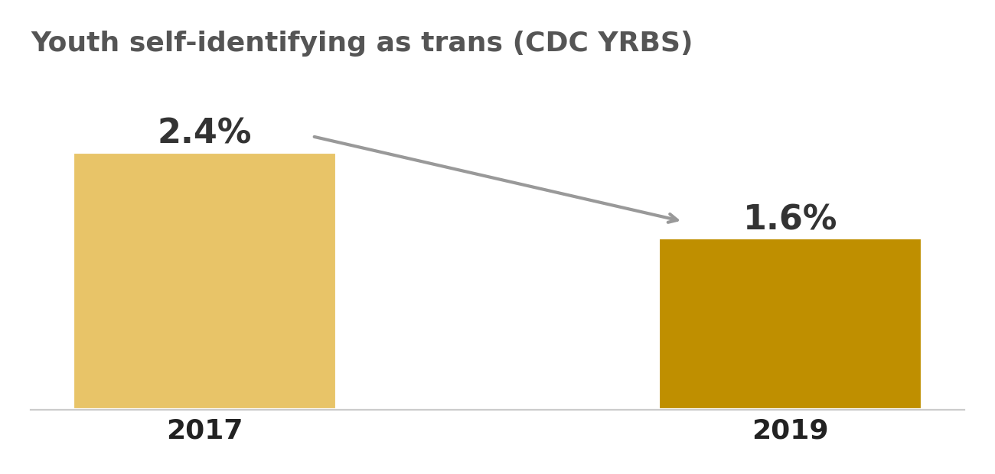
13.
This is a myth that has been thoroughly debunked. The claim that 60% to 90% of trans youth desist comes from a 2016 blog post that cited outdated studies conducted before 1990 on very small sample sizes. A 2026 study from Virginia Commonwealth University analyzed 11 studies from that blog post and five more recent studies. The researchers found that desistance could be estimated as low as 0% to as high as 100% depending on how the data was interpreted, which shows how unreliable those earlier conclusions were. A 2026 Canadian multicenter study followed 445 adolescents referred to gender clinics and found that 94.6% continued with their presenting gender identity or reidentified as nonbinary. Only 5.4% changed back to a gender identity aligned with their birth sex. Among those who started gender affirming hormones, only 1.1% discontinued them. The researchers concluded that the majority, 97.1%, continued to identify with a gender not typically aligned with their birth sex. The idea that most kids grow out of it is simply not supported by the data.
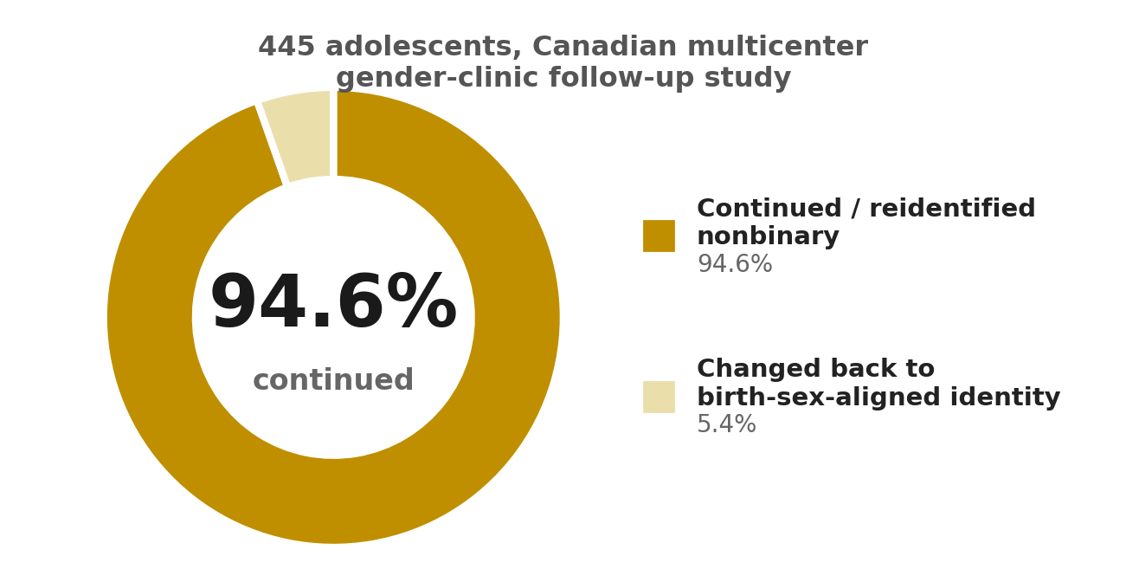
14.
This is where I agree with you partly. I do think that minors, especially younger ones, should not make irreversible medical decisions without careful consideration. But for trans youth who are 13 and older, they absolutely can understand the long term consequences with proper support and education. A 2024 scoping review published in BMC Medical Ethics examined the available data on adolescent capacity to consent to gender affirming medical treatments. The review found that age was correlated with capacity in most studies, meaning older adolescents tend to have the decision making capacity needed. The review also noted that cognitive measures like IQ, literacy, and numeracy can impact aspects of capacity like understanding and reasoning. For clinicians caring for trans youth, tools like the MacArthur Competence Assessment Tool can be useful in conjunction with consideration of youth developmental abilities and shared decision making practices. The process is not rushed. It involves multiple evaluations, therapy, and informed consent from both the youth and their parents. A 13 year old who has been consistent, insistent, and persistent about their gender identity for years is absolutely capable of understanding what hormones will do to their body, especially when guided by medical professionals.
15.
Detransition does happen, but it is extremely rare and the reasons behind it are often misunderstood. A 2026 Canadian study found that among 445 adolescents, only 2.9% reverted to a gender identity aligned with their birth sex. Another study found that more than 90% of detransition cases were driven by external pressures such as family rejection and job insecurity, not because the person realized they were wrong about their identity. People detransition because the world makes it too hard to be trans, not because being trans is fake. Using detransition as a reason to deny affirming care to everyone is like using the fact that some people regret knee surgery to argue that no one should ever have knee surgery. It ignores the overwhelming majority who benefit from it and the specific reasons why a small minority regret it. The existence of detransitioners does not invalidate transgender identities. It just shows that some people need more support, and that society needs to be less hostile so people don't feel forced to detransition due to external pressure.
“ People detransition because the world makes it too hard to be trans, not because being trans is fake. ”
@thecubejsablover

16. Gender dysphoria is a mental illness, and non-binary identities are also psychiatric conditions.
17. People adopt non-binary identities just to feel special, avoid misogyny, or escape sexism.
18. Young people are too young to know their gender; it is just a phase.
19. You must look androgynous or medically transition to be considered genuinely non-binary.
20. You must experience constant gender dysphoria to be genuinely transgender or non-binary.

16. The APA explicitly resolved that neither transgender nor gender nonbinary identities constitute evidence of a mental disorder. The WHO moved gender incongruence out of the mental disorders chapter in ICD-11, stating these identities are "not conditions of mental ill-health". Gender dysphoria is the distress some experience, not the identity itself, and the WHO clarified that for ICD-11 gender incongruence, "neither distress nor dysfunction is a required feature".
17. Research shows nonbinary people face significant discrimination, harassment, and are often misgendered or overlooked. They also experience pressure from communities where being nonbinary is not accepted. Nonbinary people also face unique challenges accessing gender affirming care because medical frameworks often don't accommodate them. All of this contradicts the idea that people adopt these identities for attention or to avoid opression, since it actually exposes them to more.
18. Children develop a sense of their gender identity early. Around age two, they become conscious of physical differences, and by age four, most have a stable sense of their gender identity. Research suggests that children who assert a gender diverse identity know their gender as clearly and consistently as their developmentally matched peers. It is not a phase, it is a deeply felt sense of self that emerges early.
19. Nonbinary identity does not require androgynous gender expression, and not all people who present androgynously identify as nonbinary. Transition is a personal and individualized process that can include internal reflection, community support, or therapy. Nonbinary identity journeys are often nonlinear and don't have a single destination. Many nonbinary people do not seek medical transition at all, and that does not make them any less valid.
20. The Merck Manual explicitly states that "those who identify as transgender may, or may not, have a current diagnosis of gender dysphoria". Gender dysphoria refers to the distress that can occur when there is a mismatch, but not every trans or nonbinary person experiences that distress constantly, or at all. Many trans and nonbinary people live well adjusted and fulfilling lives. You don't need to suffer to be who you are.
@thecubejsablover

21. Transitioning based on feeling masculine or feminine reinforces harmful gender stereotypes.
22. Transgender women retain physical advantages from male puberty, making women's sports unfair.
23. Transgender and non-binary people have higher percentages to be minor-attracted persons, pedophiles, murderers, shooters, or other violent criminals.
24. If self-identification determines gender, there is no principle stopping someone from identifying as anything else, such as a different age or species.
25. Transgender rights are a direct threat to cisgender women's rights and feminism.

21. This assumes trans people transition solely to conform to stereotypes, which misrepresents why people transition. Gender identity is a persons internal sense of self, not a performance of stereotypes. Transitioning is about aligning one's life with that internal identity, not about fitting into a box of masculine or feminine traits. Framing it as reinforcing stereotypes also ignores that many trans people actively challenge traditional gender roles, and many do not transition at all or do so in ways that don't conform to stereotypical presentations. The idea that trans people are simply "playing a role" dismisses the deep, personal nature of gender identity.
22. This one’s worth an actual answer instead of a plug. Sports federations don’t just take self ID, most (IOC, World Athletics, etc.) require months to years of hormone suppression before someone can compete in the female category, and research on athletes post suppression shows a lot of the advantage narrows over time, strength and hemoglobin especially, though not every metric closes all the way, height and bone structure obviously don’t change. It’s a genuinely contested area in sports science, not the open and shut case either side likes to pretend it is, and elite-level rules are way stricter than what your local rec league needs to worry about.
23. This is a false and harmful stereotype with no basis in fact. Research consistently shows that transgender people are far more likely to be victims of violence than perpetrators. In 2023 alone, 35 homicides of transgender people were recorded in the US, and globally 320 trans and gender-diverse people were reported murdered. Transgender individuals are also victimized by violent crimes at rates four times higher than their cisgender peers. Criminologists have stated that "no reliable data supports the argument that transgender people commit violent crimes at higher rates", and that trans people are more likely to be victims than perpetrators. The idea that they are more likely to be pedophiles or mass shooters is a recycled moral panic similar to those used against gay men and other marginalized groups in the past.
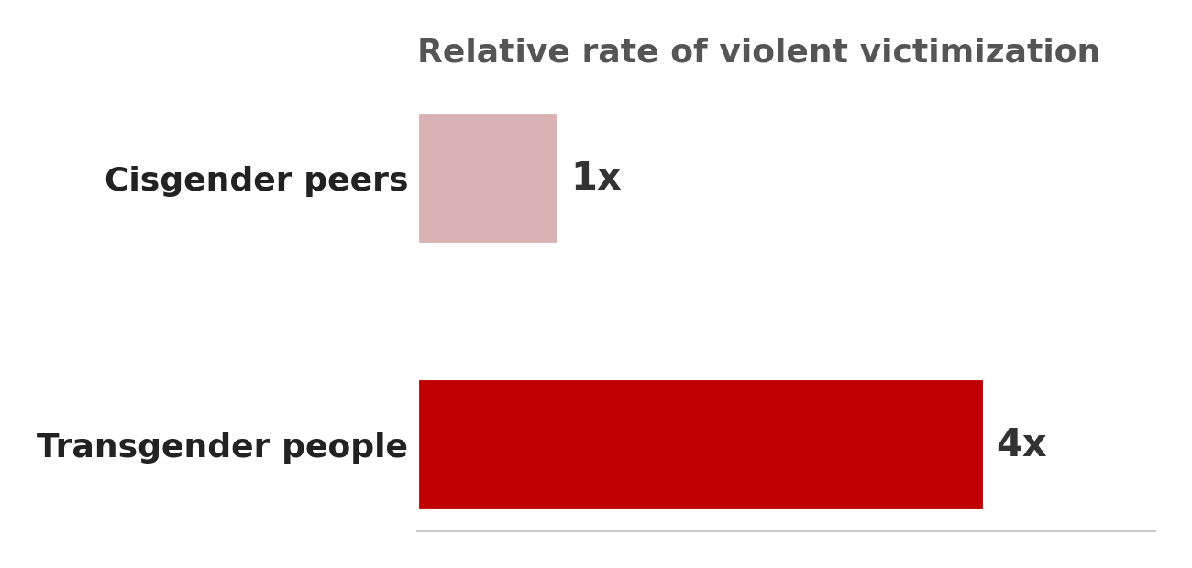
24. This is a classic slippery slope fallacy. The argument falsely assumes that because one form of self-identification (gender) is recognized, there is no principle to stop any other form (age, species). However, gender identity is a well-documented aspect of human psychology, recognized by major medical and psychological organizations. Identifying as a different age or species does not have the same basis in internal identity, nor is it supported by scientific or medical consensus. The argument tries to equate different categories to create a fear of chaos, but it ignores the specific, evidence-based understanding of gender identity that exists. It is not a free-for-all; it is about recognizing a real aspect of human experience. And there's a cleaner way to put the actual difference: age and species are settled by something outside you, a birth certificate, a biological fact you can check. Gender identity is a recognized internal psychological trait, the kind of thing we already assess through self-report and clinical judgment for lots of conditions. The slope isn't slippery because those categories aren't running on the same tracks to begin with.
25. This is a false framing that pits two marginalized groups against each other. There is no evidence that transgender rights threaten cisgender women's rights. In fact, many feminists argue that trans-exclusionary positions reinforce the same rigid gender norms that have historically been used to oppress all women. Arguments used to exclude trans women from women's spaces have also been used against cisgender women who do not conform to traditional femininity. The majority of feminists support transgender rights, and framing trans rights as a threat to feminism is a tactic used to create division and roll back rights for all. Feminism is about liberation for all genders, not just those assigned female at birth.
@thecubejsablover

26. Non-binary identities erode the definition of 'woman'/’men’ and harm cisgender women/men.
27. Society cannot accommodate infinite genders and pronouns; it is too complicated.
28. Using a transgender person's preferred pronouns is 'forced speech' and confuses children.
29. Teaching children about non-binary or genderfluid identities is grooming and indoctrination.
30. Transgender and non-binary people are a threat to women and children.

26. The concern that non-binary identities somehow erode the definition of woman or man misunderstands how language and identity work. Gender is not a zero-sum game where acknowledging one group diminishes another. In fact, research shows that moving away from rigid binary categories can be beneficial for many people, including cisgender and heterosexual individuals. The legal recognition of non-binary identities simply reflects that some people do not fit neatly into the existing two boxes. Rather than harming anyone, this recognition allows people to live more authentically. The definition of woman and man remains intact for those who identify with those terms; it just no longer serves as a cage for everyone else.
27. Languages around the world already handle complex pronoun systems with ease. Turkish and Finnish, for example, have no gendered pronouns at all, while Hebrew requires gender marking even in first and second person speech. English sits in the middle, and adding a neutral option like they/them is hardly the logistical nightmare some make it out to be. The Linguistic Society of America has pointed out that pronouns express all kinds of social qualities like formality, politeness, status, and age, not just gender. Children readily learn languages with dozens of pronouns that shift dynamically. What feels complicated is usually just unfamiliar, not genuinely difficult.
28. Referring to someone by their correct pronouns is not forced speech any more than using someone's chosen name is. The Linguistic Society of America has explicitly debunked the claim that using preferred pronouns confuses children, noting that pronouns do not make an objective truth claim about biology. In fact, the brief pointed out that it would be far more confusing for children to ignore a transgender woman's visible social characteristics and refer to her as Mr.. Pronouns are social tools, not biological statements. Using them correctly is about basic respect, not compelled ideology. And as for confusing children, they adapt to new language far more easily than adults give them credit for.
29. Teaching children that some families have two moms or that some people use they/them pronouns is no more grooming than teaching them that some families have divorced parents or that some people are left handed. The term grooming has a specific meaning, it refers to manipulating a child for sexual abuse. Simply acknowledging that LGBTQ+ people exist does not fit that definition. In fact, excluding LGBTQ+ identities from education can make young people more vulnerable to actual grooming and exploitation because it denies them the language and support they need. Schools already teach children about all kinds of family structures and human diversity. Including gender diversity is simply an honest reflection of the world they already live in.
30. The data PAINTS the opposite picture. Transgender and nonbinary people are far more likely to be victims of violence than perpetrators. A major study from Penn State found that children of transgender and nonbinary parents show typical emotional and behavioral development, indistinguishable from children in the general population. The study also found that despite facing higher levels of depressive symptoms from discrimination, these parents appear to protect their children from that stress through distinctive parenting practices. The real threat to women and children comes from the hostility and discrimination these families face, not from their existence. Framing an already vulnerable group as a danger is a tactic that has been used against many marginalized communities throughout history, and it is not supported by evidence.
@thecubejsablover

31. Non-binary people have it easier and should not speak over 'real' binary transgender people (or vice versa)
32. You are not really transgender unless you transition strictly between male and female.
33. If pronouns do not equal gender, then changing your pronouns is just performative.
34. Gender-specific diseases (like prostate cancer in transgender women) prove you are still your birth sex.
35. Transgender women are not real women because they were not raised as women.

31. Framing this as a competition over who has it harder misses the reality that both groups face serious discrimination. Research across 30 European countries found that trans people consistently report more discrimination than cisgender LGB people. Nonbinary individuals actually reported higher rates of violence than trans men, while trans women and trans men both reported more discrimination than nonbinary people. A separate study found nonbinary individuals had higher odds of physical or sexual assault and partner conflict compared to binary transgender adults. Different struggles, but both are real and both deserve to be heard.
32. This is a common misconception but medically inaccurate. Transition is deeply personal and not always linear. The clinical definition of transgender simply means a gender identity different from the sex assigned at birth, and that includes binary identities like trans men and trans women as well as nonbinary, fluid, or genderqueer identities. Medical guidelines now explicitly address hormonal treatment strategies for both binary and nonbinary transgender people. You don't need to transition strictly between male and female to be valid.
(Also intersex female exist!)
33. Pronouns and gender are related but not the same thing. Someone can use she/her and not be a woman, and someone can identify as a woman but use they/them pronouns. Changing pronouns isn't performative, it's about finding language that feels comfortable and authentic. Pronouns are social tools that help people navigate the world, not rigid biological statements.
34. Having a prostate simply means you have a prostate, it doesn't define your gender. The Cleveland Clinic explicitly states that anyone with a prostate, including transgender women and nonbinary people assigned male at birth, can get prostate cancer. In fact, transgender women on estrogen have PSA levels 50fold lower than cisgender men, and research shows they actually have lower risk of prostate cancer compared to cisgender men. Medical risks are about anatomy, not identity.
35. Womanhood is not a single universal experience. Every woman's experience is different shaped by race, class, culture, and countless other factors. A trans woman's experience of womanhood will differ from a cis woman's, just as a wealthy woman's experience differs from a workingclass woman's. Difference does not mean illegitimacy. Trans women are women because their internal sense of self is female, not because they were raised a certain way.
@thecubejsablover

36. Transgender men are just confused women who hate themselves.
37. You can always tell if someone is transgender just by looking at them.
38. 'Cisgender' is a made-up slur; I refuse to accept or use it.
39. Transgender people are just homosexual or lesbian individuals who are confused about their sexuality.
40. Transgender activists are conspiring to 'trans' children.

36. Research shows that trans men are not motivated by self hatred but by a desire to live authentically. One study found that pre transition trans men experience distress not because they hate themselves, but because their internal sense of identity was suppressed by external pressure to conform to gender binary norms. Through transition, these individuals achieved alignment with their true selves. Another study on trans men's body image actually found themes of feeling good, comfortable, and at home in their bodies after transition.
37. No, you really cannot always tell. Many trans people are what is called cis passing, meaning their gender history is not evident just by looking at them. In fact, the pressure to pass is so intense because not passing can lead to anxiety, depression, and even violence. The whole concept of passing proves that plenty of trans people move through the world without anyone ever knowing their trans status.
38. Cisgender is not a slur, it is a neutral descriptor. The Merriam Webster dictionary defines it as a term for someone whose internal sense of gender corresponds with the sex they were assigned at birth. The prefix cis comes from Latin meaning on this side of, which is the direct opposite of trans, meaning across from. The researcher who coined the term in 1994 used it for precise descriptive language, not as an insult. Merriam Webster explicitly states that current evidence shows cisgender and its variants are overwhelmingly used neutrally.
39. Gender identity and sexual orientation are two completely different things. Sexual orientation is about who you are attracted to, while gender identity is about who you are. Being transgender is about a persons internal sense of self not matching their sex assigned at birth, while being gay or lesbian is about attraction to the same gender. A trans person can be straight, gay, bisexual, or anything else. These are separate categories.
40. This is a conspiracy theory with no basis in reality. Research shows that children who are supported in their transgender identities tend to show developmental patterns that mirror their cisgender peers. The idea that trans activists are brainwashing kids has been described as fear mongering that does not reflect reality. In fact, the process of gender affirming care for minors involves extensive evaluation and is not rushed.
@thecubejsablover

41. The high suicide rates among transgender people prove they are mentally unstable, rather than proving they need support.
42. Transgender people have higher percentages to have mental illnesses (other than gender dysphoria).
43. No external verification is possible. A clinician cannot confirm or deny a person's gender identity through any objective test. They must simply accept the patient's word as truth. In every other area of medicine, self-report is a starting point for investigation, not the final conclusion. We do not diagnose depression, cancer, or diabetes based purely on how a patient feels. We use objective tests to confirm or disconfirm their subjective experience. By removing objective verification from gender diagnosis, we have created a double standard that is unique in all of medicine.
44. Being assigned female at birth and identifying as a demigirl just makes you a cisgender girl invading trans spaces.
45. Non-binary people are just 'man-lite' (if assigned male at birth) or 'woman-lite' (if assigned female at birth) rather than a valid third option.

41. High suicide rates do not prove someone is mentally unstable. They only show that a group is experiencing significant distress. Research consistently finds that factors like discrimination, family rejection, bullying, and lack of access to healthcare contribute heavily to poor mental health outcomes among transgender people. If being transgender itself were the cause, acceptance and treatment would not improve outcomes, yet studies such as Turban et al. (2020, Pediatrics) found lower suicidality among transgender people who received gender-affirming care.
42. Transgender people do have higher rates of conditions like depression and anxiety, but that does not prove their identity is invalid. The key question is why those rates are higher. The Minority Stress Model (Ilan Meyer) and studies such as Hendricks & Testa (2012) suggest that stigma, discrimination, and social rejection play a major role. A group having higher rates of mental illness does not mean the group's defining characteristic is itself a mental illness.
43. This is not unique to gender identity. Many medical and psychological conditions, including depression, anxiety, PTSD, chronic pain, and migraines, have no objective laboratory test. Doctors rely on interviews, symptom patterns, history, and clinical judgment. Gender dysphoria is diagnosed through the same kind of assessment. Clinicians do not simply accept any claim without evaluation; they follow established diagnostic criteria and professional guidelines. That said, this doesn’t mean the door is closed forever, further down I get into twin studies and brain imaging research that’s starting to map a biological side to gender identity too, we just don’t have a single lab test yet, same as with depression.
44. This argument assumes every demigirl experiences gender exactly like a cisgender girl. A demigirl is generally someone who identifies partly, but not fully, as a girl. Whether they belong in a particular trans or nonbinary space depends on that community's rules, but simply being assigned female at birth does not automatically make their experience identical to that of a cisgender woman.
45. Calling nonbinary people "man-lite" or "woman-lite" is mostly a label, not an argument. Many nonbinary people describe themselves as neither male nor female, both, somewhere in between, or outside that framework entirely. Human cultures have recognized gender categories beyond male and female for centuries, including the Hijra in South Asia and Fa'afafine in Samoa. Disagreeing with nonbinary identities is one thing, but reducing them to "man-lite" or "woman-lite" does not address how nonbinary people actually describe their experiences.
@thecubejsablover

46. You must be dysphoric all the time; if your genderflux identity's dysphoria fluctuates, it is not real.
47. Being transgender or non-binary is a choice or a lifestyle, not an innate identity.
48. Transgender women are like men in 'womanface,' actively mocking womanhood.
49. There is an inherent conflict between transgender rights and the rights of everyone else.
50. Society has used binary language and gender roles for millennia; it is unreasonable and burdensome to force everyone to change their language, pronouns, and thinking overnight just to accommodate a tiny minority.

46. The idea that you must be dysphoric all the time for your identity to be real is just not how gender works for everyone. A study of transgender adolescents found that 15 to 18 percent of them actually reported gender fluidity, meaning their internal sense of gender was not fixed and could change. The same study found that the nonbinary group reported significantly higher levels of fluidity compared to the binary group. The gender experience is simply not binary and fixed for all trans people. If your dysphoria fluctuates, that is a normal part of being human and not proof that your identity is fake.
47. This is another one that just does not hold up to scrutiny. Gender identity is not a choice. The APA recognizes gender identity as "a person's deep felt, inherent sense" of their gender. Forensic psychiatrists have also explained that feelings of gender identity are not chosen but are discovered and experienced in the mind. It is not a lifestyle you pick out of a catalog. It is a core part of who someone is.
48. This "womanface" trope is just a deliberate piece of fearmongering. GLAAD has identified it as a common anti-trans trope used to push false narratives about trans people. It disingenuously equates trans women's identities with blackface, implying that trans women are not real women and that their identities are inherently offensive. But trans women are not mocking womanhood. They are living it. The argument falls apart the moment you actually listen to trans women instead of projecting bad intentions onto them.
49. This idea that trans rights conflict with everyone elses rights is a zero sum way of looking at the world that does not reflect reality. Human rights are not a limited resource. The UN has repeatedly warned that violence and discrimination against LGBTIQ+ people are widespread, with particularly severe impacts on trans, nonbinary, and intersex people. Protecting the rights of a marginalized group does not take rights away from anyone else. It just means more people get to live with dignity.
50. This framing that society is being forced to change overnight is just inaccurate. The idea that gender has always been a strict binary is historically false. Trans experiences have been documented since the dawn of civilization, with concepts like being "neither a man nor a woman" integrated into belief systems across six continents and five millennia. Nonbinary gender has been recorded as far back as 400 B.C. to 200 A.D. in ancient Hindu texts. What is actually unreasonable is pretending that diversity hasnt always been there just because you are only now being asked to acknowledge it.
@thecubejsablover
51. Transgender rights activists are demanding 'special rights' that go beyond basic equality, and they are moving too fast, alienating the general public and making it harder for society to accept them.
52. The 41% suicide attempt rate among transgender people proves that being transgender is inherently pathological and that gender transition does not actually resolve underlying mental health issues.
53. Allowing transgender women into women's bathrooms, locker rooms, and prisons will increase sexual assaults, because transgender women are statistically more likely to be sexual predators.
54. Transgender people have higher rates of criminality and violence compared to the general population, so they should not be given unrestricted access to vulnerable spaces.
51. The framing that these are "special rights" or that things are moving "too fast" ignores that what is asked for is basic protection from discrimination. A 2024 survey of over 22,000 American adults found around four in ten opposing laws that force IDs to show birth sex rather than gender identity. Change can feel uncomfortable, but waiting for everyone to be ready has never been how civil rights work.
52. The 41% suicide attempt statistic is often used to paint being trans as pathological, but this misreads the data. The same studies identify the root causes as external factors like lack of family support, discrimination, abuse, and violence. A 2024 review in JAMA Psychiatry found trans people have higher odds of suicidal ideation, but also pointed out gaps in understanding the causes. A 2025 umbrella review noted that social supports are key protective factors. It's the rejection, not the identity, that is the problem.
“ It's the rejection, not the identity, that is the problem. ”
53. The idea that trans women in bathrooms, locker rooms, or prisons will lead to more sexual assaults is not backed by criminological data. When laws allow trans people to use matching facilities, crime rates do not increase. In fact, trans-exclusionary policies increase victimization for trans people without protecting cisgender women. Trans people are far more likely to be victims of violence in these spaces. One federal study found more than one-third of transgender prisoners reported being sexually assaulted within the previous year.
54. The claim that trans people have higher rates of criminality is not supported by evidence. The transgender homicide rate is actually below that of the general population. Less than 0.1% of mass shootings in the US from 2013 to 2025 were carried out by trans individuals. Statistics showing higher incarceration rates, like 21% of trans women having spent time in prison compared to 5% of all US adults, are not a sign of inherent criminality but a result of systemic issues like discrimination, poverty, and over-policing. Trans people are not a threat to vulnerable spaces; they are some of the most vulnerable people in those spaces.
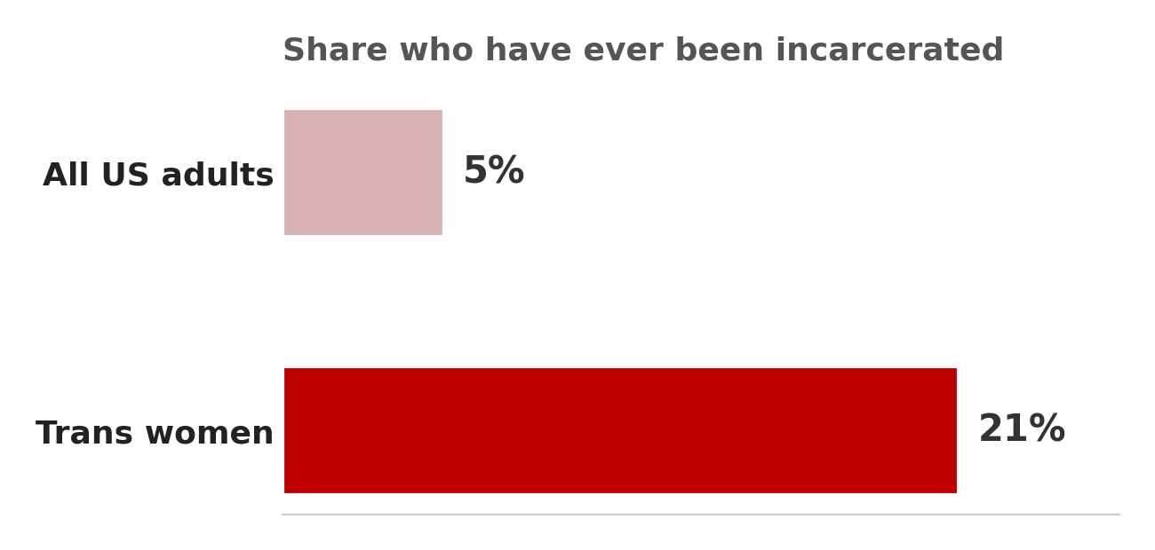
@thecubejsablover

55. Society should prioritize the comfort and safety of the vast majority (cisgender people) over the feelings of a very small minority, because democracy means serving the greatest number of people.
56. A masculine trans girl is not valid, and vice versa. It is mocking transgender people and gender dysphoria.

55. Democracy is not just about serving the numerical majority, it is about protecting the rights of everyone. UN expert Graeme Reid has stated that "States must ensure that the human rights of all people are equally upheld". Courts also play a key role in protecting minorities when legislatures bow to majority pressure. The comfort of the majority does not justify discrimination against a minority, and research shows that transgender people face significant barriers to basic participation, like voting, due to restrictive identification procedures.
56. Gender identity and gender expression are two different things. Gender expression refers to how a person publicly presents their gender through behavior and appearance. A trans woman can have a masculine style and still be a woman, just as a cis woman can be a tomboy. This idea that there is a "right" way to be trans is harmful. Trans activist Eli Erlick shared how she initially felt pressured to dress extra feminine to affirm her gender, but later realized her "trans womanhood is valid no matter how I dress". This pressure is a form of conformity, not a measure of validity. Ultimately, every gender identity and gender expression is valid.
@thecubejsablover

⚡ HARD ARGUMENT CATEGORY ⚡
(those are VERY VERY VERY long so I’ll use smaller size!)
57. Gender identity is an entirely subjective, internal feeling that is unverifiable by anyone else. Since science relies on observable, objective phenomena, how can society build legal frameworks and medical policies on something so purely subjective?
58. Womanhood, historically and sociologically, has been defined by a shared material reality, including reproductive capacity, systemic oppression, and specific biological vulnerabilities. A person assigned male at birth cannot retroactively acquire that specific historical and social experience.
59. Anti-discrimination laws are built on protected classes like biological sex. If 'sex' becomes entirely fluid and self-defined, the legal mechanism used to measure and prosecute sex-based wage gaps, pregnancy discrimination, or workplace harassment becomes functionally useless.
60. Requiring zero psychological evaluation for gender-affirming medical treatment removes the standard gatekeeping that exists for every other major irreversible medical procedure, undermining evidence-based practice and informed consent protocols.

57. The idea that gender identity is entirely unverifiable misses the growing body of neuroscientific evidence supporting its biological basis. A 2015 review in “Endocrine Practice” concluded there is "strong support in the literature for a biologic basis of gender identity," drawing on data from differences of sex development and neuroanatomical studies. A 2025 review similarly found that gender identity is a "multifactorial trait with a heritable component". While we can't yet predict identity from brain scans, the idea that it's purely "subjective" or unverifiable is not supported by the evidence. Legal and medical frameworks already deal with subjective experiences all the time, like pain or consent, and they manage fine. We don't need to perfectly measure something to respect it.
58. This argument defines womanhood through a single narrow lens that excludes many cisgender women, like those who are infertile, have had hysterectomies, or are past menopause. If womanhood is defined by reproductive capacity, then millions of cisgender women would be excluded from their own category. The WHO defines gender as "socially constructed," encompassing norms and roles that vary across societies and change over time. A trans woman who transitions as an adult may not share every experience, but neither do two cisgender women from different cultures or generations. Womanhood is not a single monolithic experience, it is a diverse and evolving social identity, and reducing it to reproductive biology is a choice, not an objective truth.
59. Anti-discrimination laws are not as fragile as this argument suggests. Many jurisdictions already include "gender identity" as a protected class alongside biological sex. Pregnancy discrimination protections exist regardless of gender identity and apply to pregnant people of all genders. The legal system already handles overlapping protected characteristics like race, disability, and religion without collapsing. Adding gender identity does not make sex-based protections useless; it expands them to cover more people. The idea that recognizing trans identities would somehow erase the ability to fight workplace discrimination is a false choice. We can protect cisgender women from pregnancy discrimination and trans people from identity-based discrimination at the same time.
60. This claim misrepresents how gender-affirming care actually works. The WPATH Standards of Care Version 8 require adolescents to demonstrate "emotional and cognitive maturity" for informed consent, with mental health concerns addressed before any treatment. Criteria include "well-documented gender dysphoria/gender incongruence" and capacity to consent. A 2024 review actually found that mandatory mental health assessments can create barriers to care and "ultimately carry little benefit for patients," while primary clinicians are often capable of assessing patients without additional input. The process is not "zero evaluation", it is just shifting away from redundant gatekeeping toward informed consent models used in other medical fields. Requiring psychological evaluation for every major procedure is not the universal standard this argument pretends it is.
@thecubejsablover
61. Some individuals report gender euphoria after transitioning, but euphoria might simply be relief from external social pressures or internalized shame. How do we distinguish an innate, immutable identity from a trauma response or a coping mechanism for unresolved distress?
62. Several long-term longitudinal studies suggest that mental health improvements post-transition are not universal and sometimes diminish over time. Does this not suggest that medical transition is an oversimplified solution to complex psychiatric comorbidities?
63. By defining 'woman' as 'anyone who identifies as a woman,' we erase the biological and sociopolitical specificities that uniquely affect cisgender women, such as abortion rights, maternal mortality, and reproductive health, diluting their advocacy power.
64. If gender is purely a social construct that we should ultimately abolish, why are transgender activists reinforcing the gender binary by transitioning to conform to traditional masculine or feminine stereotypes?
65. If a cisgender man claims he 'identifies as a woman' solely to gain access to women-only scholarships, leadership programs, or shelters, under pure self-identification laws there is no legal basis to deny him. This exposes a genuine vulnerability in equality law.

61. Look, this idea that euphoria is just relief from social pressure misses the point. The clinical concept of euphoria isn't presented as some simple escape hatch. Research actually shows that gender identity has a heritable component, with twin studies estimating it anywhere from 10 to 81 percent. That points to something pretty deeply rooted, not just a trauma response. Could there be overlap? Sure. But reducing a potentially biological identity to just a coping mechanism is a massive oversimplification that the evidence doesn't support.
62. Nobody is claiming transition is a magic fix for everything. The medical community doesn't treat it like a cure-all. The reality is that while some people still deal with depression after transition, the overwhelming majority show major improvements. We are talking about reduced suicide risk and clinically significant drops in depression for most people. The fact that some still struggle just means we need better ongoing mental health support alongside medical care, not that the medical care itself is a mistake.
63. This is a zero sum way of thinking that just isn't necessary. Reproductive rights are about bodies with uteruses. That is a biological reality that does not change just because we also acknowledge that womanhood can be a social identity. Trans women existing does not erase the fight for abortion access or maternal health. It is not a competition. We can advocate for reproductive justice and trans rights at the same time without either one losing ground.
64. This one gets things backwards. The goal of gender abolition is not to erase personal identity. It is to tear down the rigid systems and stereotypes that box everyone in. A trans person transitioning is not reinforcing those systems. They are aligning their external life with their internal sense of self. That is a personal act, not a political statement about what gender should mean for everyone else. Criticizing a trans person for their presentation while also saying we should abolish gender completely just does not make sense.
65. This is a hypothetical that does not reflect how these laws actually work. Germany passed a self ID law and they have not seen this supposed flood of men abusing the system. The whole idea that someone would pretend to be a woman just to get a scholarship or access a shelter is not a real pattern backed by any data. Could someone try? Maybe. But we already have laws against fraud and predatory behavior. We do not deny entire groups their basic rights just because someone might abuse the system.
@thecubejsablover

66. Refusing to use someone's requested pronouns is often framed as an act of violence. However, isn't it simply a disagreement about the nature of language and reality, rather than a hate crime? Compelled speech conflicts with classical liberal values of free thought.
67. The transgender movement relies heavily on the concept of 'gender identity,' but this concept lacks a universally agreed-upon operational definition in psychology or biology, making it more of a political assertion than a scientific fact.
68. Puberty blockers were originally designed for central precocious puberty in young children, not for healthy adolescents with gender dysphoria. Using them off-label for extended periods lacks robust long-term safety data regarding bone density and brain development.
69. If we accept genderfluidity, where a person's gender can change daily, then how can this fluctuating state serve as a stable, reliable basis for permanent legal documentation, medical treatment plans, or prison classification?
70. Radical feminist theory historically aimed to dismantle gender roles entirely. Transitioning to the opposite sex to alleviate dysphoria inadvertently reinforces the regressive idea that specific behaviors, clothing, and appearances must belong to a specific biological sex.

66. Refusing to use someone's pronouns ain’t just "disagreeing about language" any more than refusing to call someone by their chosen name is "disagreeing about names". It's targeted disrespect that contributes to a hostile environment!!! Courts and human rights bodies have consistently recognized that misgendering in workplaces, schools, and public institutions can constitute discrimination or harassment. There's a difference between private belief and public action that harms others. Classical liberalism supports restricting speech that causes demonstrable harm.
67. This is just false! The APA defines gender identity clearly as "how one understands and experiences one's own gender," including "a persons psychological sense of being male, female, or neither". There's an entire field of psychology dedicated to studying this with established measures and diagnostic criteria. Intelligence, personality, and consciousness all lack perfect universal definitions too, but nobody argues they don't exist. Gender identity is operationalized in countless peer-reviewed studies with validated scales used across multiple countries and cultures.
68. Yes, the Cass Review did recommend a pause on prescribing them for minors due to insufficient long-term evidence. Multiple studies have flagged potential risks to bone mineral density, brain development, and fertility. However, the existence of risks doesn't mean they should never be used, it means they should be used carefully with proper monitoring. Many medications are used off-label when potential benefits outweigh risks. Puberty blockers are fully reversible if stopped early, and for many trans adolescents, they prevent irreversible physical changes that would cause severe distress. The UK is running a clinical trial right now to gather the very evidence critics say is missing. The responsible approach is more research and careful oversight, not blanket bans.
69. This misunderstands how systems actually work. Nobody is arguing that someone should change their legal documents daily based on a fluctuating identity. Genderfluid individuals typically have stable enough patterns to make practical decisions. Legal documentation is about consistent identity markers, and for genderfluid people, that usually means choosing a marker that best represents them overall or using non-binary options where available. Medical treatment plans are based on ongoing assessment by healthcare professionals, not daily whims. Prison classification is handled through established policies that consider individual circumstances, safety, and medical needs, not moment-to-moment identity shifts. Policies are designed to be workable.
70. Gender dysphoria is a deeply bodily experience, not just discomfort with social roles. Trans people aren't transitioning because they like dresses or sports, they're transitioning because their internal sense of self doesn't match their physical body. Many trans people actively reject gender stereotypes and live in ways that challenge traditional gender norms. Transfeminism actually builds on radical feminist theory, not opposes it. The idea that trans people are somehow reinforcing the system that oppresses them is a surface-level reading that doesn't engage with what trans people actually say about their own experiences.
@thecubejsablover

71. Legally recognizing non-binary genders requires massive overhauls of passports, healthcare databases, prison systems, and sports categories. The administrative cost and societal burden on the whole population outweigh the benefit to a statistical minority.
72. The documented phenomenon of rapid-onset gender dysphoria, observed in friendship clusters of adolescents, suggests that social influence and peer dynamics play a significantly larger role in identity formation than previously acknowledged.
73. Many detransitioners report that their gender dysphoria was actually caused by unresolved childhood trauma, sexual abuse, or internalized homophobia. By affirming transition immediately, we risk bypassing crucial trauma therapy and permanently altering healthy bodies.
74. A transgender woman retains male-typical bone density, cardiovascular risk profiles, and lung capacity. Medical protocols designed for female bodies are clinically inappropriate for her, proving that biological sex remains pervasively relevant in healthcare.
75. Non-binary or transgender people break bathroom, sports, and prison laws.

71. This frames the issue as a massive expense for a tiny group, but the actual costs are often minimal. Updating records can rack up out-of-pocket expenses, for example, Georgia charges $10 to change the gender on a driver's license. The UK reduced the fee for a Gender Recognition Certificate from £140 to £5 in 2021. The real burden actually falls on the individual, not society. Nonbinary people face extra steps negotiating healthcare and insurance coverage. The cost of updating systems is negligible compared to the harm caused by forcing people into binary categories that don't fit them. And the "statistical minority" argument is weak, about 1.2 million people in the US identify as nonbinary. Denying them basic recognition because it's inconvenient is just discrimination dressed up as fiscal responsibility.
72. The "rapid-onset gender dysphoria" (ROGD) concept was introduced by Lisa Littman in a 2018 study based entirely on parental reports, not on clinical interviews with the adolescents themselves. It describes a subset of youth, primarily natal females, with no childhood indicators of gender dysphoria but a sudden emergence of symptoms during or after puberty. The theory assumes that identifying as transgender serves as a maladaptive coping mechanism for underlying mental health issues and is linked to social influences from peer groups and social media. However, the ROGD hypothesis has been heavily criticized for its methodological flaws, reliance on parent reports from websites with anti-trans biases, and lack of clinical validation. A 2024 review article analyzing the theory against the existing evidence base found that while the hypothesis has generated attention, it lacks robust empirical support. Social influences exist in all identity formation, that's not unique to gender. The existence of peer groups doesn't invalidate the identities of those within them.
73. A survey of 100 detransitioners found that 38% came to view their gender dysphoria as caused by trauma, abuse, or a mental health condition. Homophobia or difficulty accepting themselves as LGB was expressed by 23% as a reason for transition and subsequent detransition. However, the same study found that 60% detransitioned because they became more comfortable identifying as their natal sex, and 49% had concerns about medical complications. Detransition rates are low. One UK study found 6.9% of a clinic cohort met the case definition for detransitioning. The existence of detransitioners doesn't justify denying care to the vast majority who benefit. The claim that "immediate affirmation" bypasses trauma therapy is a strawman. WPATH standards of care require thorough mental health assessments before any medical intervention. The majority (55%) of detransitioners in the Littman survey felt they did not receive an adequate evaluation before starting transition, which is an argument for better care, not for banning care.
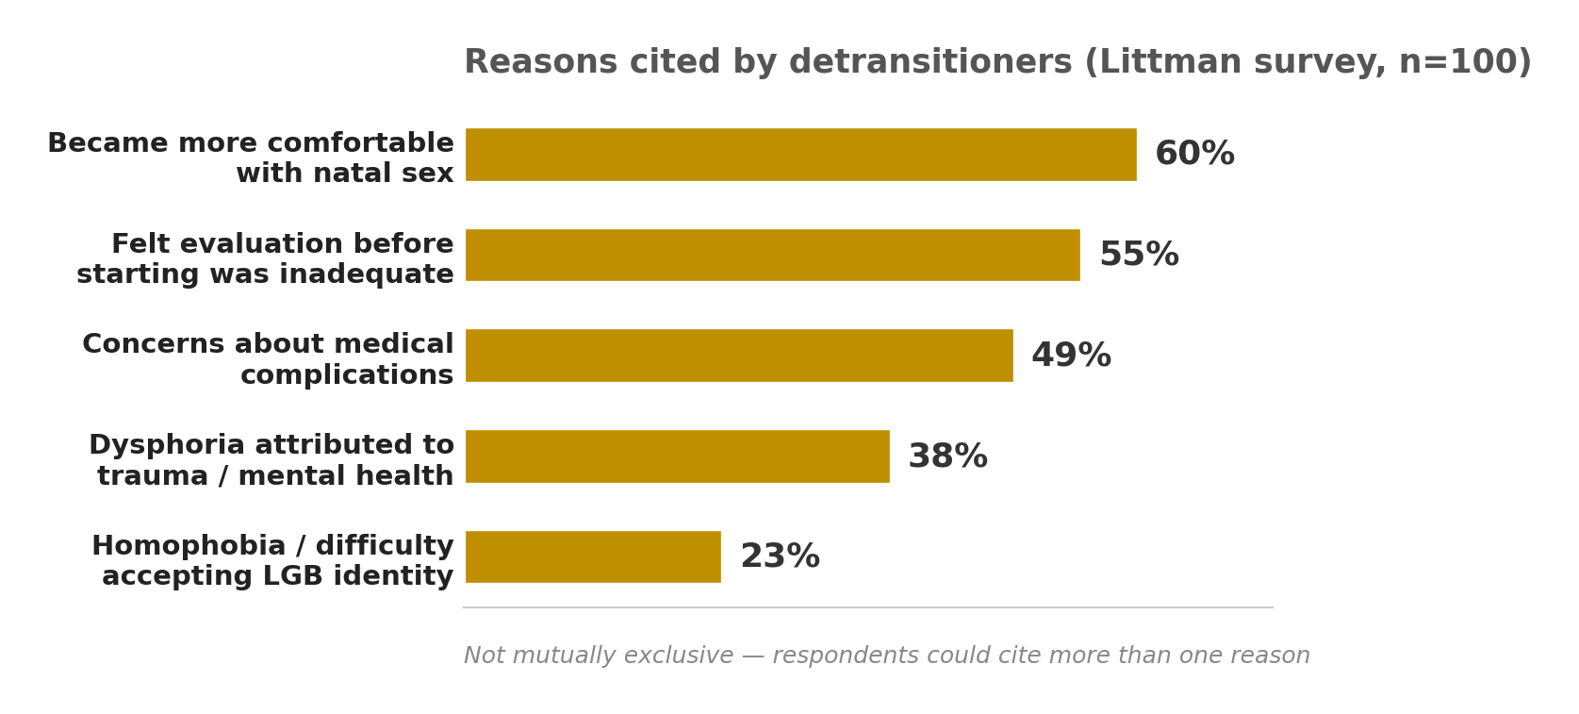
74. This is a half-truth that ignores the effects of hormone therapy. Feminizing gender-affirming hormone therapy (GAHT) significantly alters many physiological parameters. Bone health, cardiovascular risk, and other factors change with hormone levels. Healthcare professionals assess and manage cardiovascular risk and bone health in transgender individuals, considering length and dose of hormone use, current age, and the age at which hormone therapy was started. A trans woman on estrogen for years does not have the same risk profile as a cisgender man. Modern medical protocols are not "designed for female bodies" in a one-size-fits-all way, they are individualized based on current hormone levels, medical history, and other factors. The claim that biological sex remains "pervasively relevant" is true in the sense that sex assigned at birth matters for some things, but it is not the only relevant factor. Medical care for trans people is an evolving field with established guidelines that account for both birth sex and current hormonal status.
75. No, they don't. Laws are not being "broken," policies are being updated to include them. The UK recently issued guidance clarifying when transgender people can be excluded from single-sex spaces, noting that restrictions must be "a proportionate means" of protecting privacy. This is not about "breaking laws," it's about navigating complex legal frameworks. In the US, a wave of laws targeting transgender people ranges from prohibitions on participation in sport to regulating bathroom access. These are not about trans people breaking laws, they are about lawmakers creating new restrictions. The framing of trans people as "lawbreakers" is misleading. They are simply existing in a world that is still figuring out how to accommodate them. Policies are being developed and challenged in courts, that's how legal systems work, not evidence of criminality.
@thecubejsablover

76. If the category 'woman' now includes anyone who identifies as one, the term becomes so broad that it loses all descriptive power. A category that describes everyone describes no one, and cannot be used for meaningful political advocacy.
77. Activists frequently claim that transgender children will commit suicide without immediate affirmation. This coercive framing silences medical professionals who have legitimate, evidence-based safety concerns about early medicalization and prevents open scientific debate.
78. Gender dysphoria is a distress signal, but treating it solely with hormonal and surgical transition is a one-dimensional physical approach. We treat body dysmorphic disorders such as anorexia with therapy and cognitive interventions, not surgical affirmation. Why the double standard?
79. Enforcing pronoun usage via legal penalties, workplace mandates, or academic policies is a form of compelled speech that violates foundational classical liberal principles of free expression and intellectual freedom.
80. If the only requirement to be legally recognized as a woman is self-identification, then a male-bodied person could claim womanhood to avoid male-only military drafts, selective service registration, or gender-specific legal responsibilities, creating legal inequalities.

76. The argument that expanding the category "woman" makes it meaningless is a category error. "Woman" has always been a complex category encompassing biological, social, and legal dimensions. Adding self-identification as one criterion doesn't erase all others. The category still has immense descriptive and political power precisely because it continues to describe a group that faces systemic discrimination and inequality.
77. The claim that activists use suicide risk to "coerce" medical professionals misrepresents how medical ethics actually works. Gender-affirming care is recommended by major medical associations including the American Psychiatric Association, the Endocrine Society, and WPATH based on systematic evidence reviews. The Cass Review, often cited to support this claim, does not endorse banning gender-affirming care. Multiple studies demonstrate reductions in suicidal ideation and improved mental health outcomes with gender-affirming care. Discussing suicide risk is standard medical practice for any condition with elevated mortality rates.
78. Gender dysphoria and body dysmorphic disorder are fundamentally different conditions. Body dysmorphic disorder involves obsessive preoccupation with perceived flaws, and treating the flaw through surgery typically doesn't resolve the distress because the obsession shifts elsewhere. Gender dysphoria is a persistent incongruence between internal sense of self and physical body, and hormonal and surgical interventions consistently reduce this distress by aligning the body with identity. The treatments differ because the conditions differ. Gender-affirming care also includes thorough mental health assessment.
79. The free speech argument against pronoun mandates is one side of a legitimate legal debate, not a settled principle. Courts have consistently held that harassment and discrimination are not protected speech. Refusing to use someone's pronouns isn't just "disagreeing," it's targeted disrespect that can contribute to a pattern of harassment. Many pronoun policies apply to government employees or public institutions where the government has legitimate interest in maintaining respectful, non-discriminatory environments. The balance between free expression and anti-discrimination is complex, but framing pronoun use as pure "compelled speech" ignores the harm that deliberate misgendering causes.
80. This is a strawman fallacy that ignores how Selective Service actually works. The Selective Service bases registration on sex assigned at birth, not gender identity. Transgender women must register and transgender men cannot register. The male-only draft itself has been ruled unconstitutional by a federal judge. The real legal inequality is that only men are required to register at all. The fix is to make registration gender-neutral, not to restrict who can be recognized as their gender.
@thecubejsablover

81. The existence of intersex conditions is often used to argue that sex is a spectrum. However, intersex makes up roughly 1.7% of births (including late-onset forms) and is medically distinct from transgenderism, making that comparison scientifically flawed and rhetorically deceptive.
82. Medical transition does not change a person's chromosomal karyotype (XX or XY). Since chromosomes influence cellular biology throughout the entire body, biological sex is pervasive and immutable at a microscopic level, not limited to external genitalia.
83. If gender identity is internal and fluid, future medical research might eventually develop therapies that alleviate dysphoria without requiring physical transition. By dogmatically focusing only on affirmation today, we might be halting scientific inquiry into alternative solutions.
84. Historical cultures had third-gender roles, but those were rigid social positions tied to specific religious or cultural functions, not modern concepts of internal identity. Extending modern transgender theory backward to ancient civilizations is an anachronistic misappropriation.
85. The transgender community frequently silences detransitioners and ex-trans individuals, labeling them as 'grifters' or 'traitors.' Suppressing these minority voices creates a dangerous echo chamber that hides the full spectrum of outcomes and complications.

81. First, gender and sex are not the same thing (I’ve already proven this) . Sex refers to biological traits like chromosomes, hormones, and reproductive anatomy. Gender identity is a person's internal sense of self, how they feel inside about being male, female, both, neither, or somewhere in between.
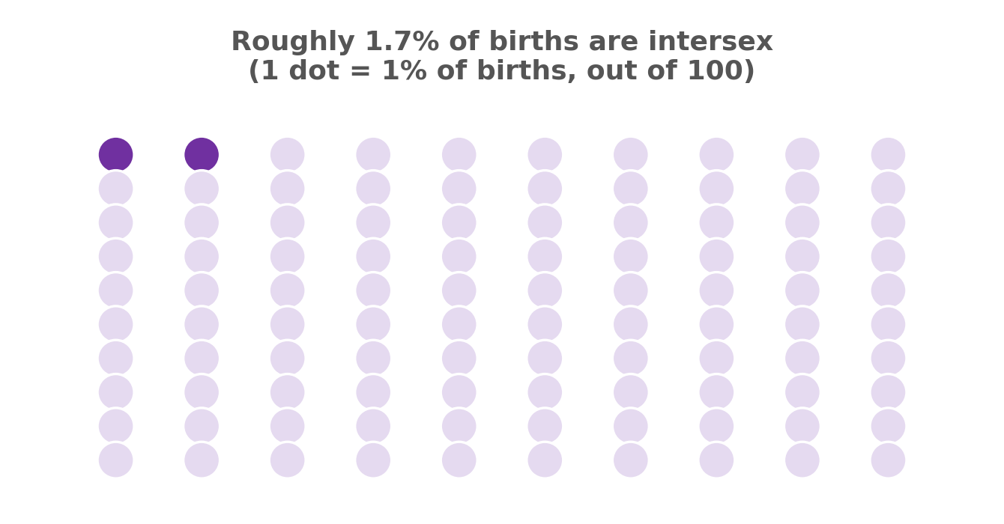
Now, let’s prove why gender is a spectrum. Biologically speaking, sex itself is not a simple binary. More and more research shows that the male/female framework is outdated because it ignores the massive amount of evidence that biological sex is not binary. Human sex characteristics form across four different levels: chromosomes, gonads, hormones, and anatomy, and each of these levels has a wide range of natural variation. Even looking just at chromosomes, there are conditions like Klinefelter syndrome, Turner syndrome, and cases of XX males and XY females caused by SRY gene translocation, all of which show that chromosomal sex itself is a spectrum rather than two separate boxes. The developmental biologist Agustín Fuentes has written that the male/female binary is inaccurate biologically and socially, and that there are many different ways to be female, male, or both. He explicitly says that thinking about sex and gender in binary terms is not only misleading but actually harmful. Sociologically, cross-cultural and cross-national perspectives have consistently shown that the binary model fails to capture the full diversity of human experience. Different cultures have different understandings of gender, from the hijra community in South Asia to Two Spirit people among North American Indigenous tribes, all showing that gender is not fixed to just two forms. Psychologically, gender identity is a multidimensional concept. One study of over 10,000 adolescents aged 12 to 13 found that when gender was measured on a continuum rather than a binary, the diversity of gender identities was far greater than expected. Among those assigned female at birth, 25.9% described themselves as having masculine qualities. Among those assigned male at birth, 9.9% described themselves as having feminine qualities. Another study found that more than 3% of adolescents chose a different gender identity within two years. Research also shows that about one in twenty young people changes their gender identity at least once. A growing body of evidence supports that the broad spectrum of gender identity is a multifactorial trait with a heritable component. Neurologically, the brains of people with different gender identities show high variability in both masculinization and feminization, with considerable overlap between groups. Researchers have also noted that the continuous distribution of gender identity may simply be another expression of diversity that comes with sexual reproduction. Gender is a spectrum, not because someone made it up, but because it is an observable fact across biology, sociology, and psychology.
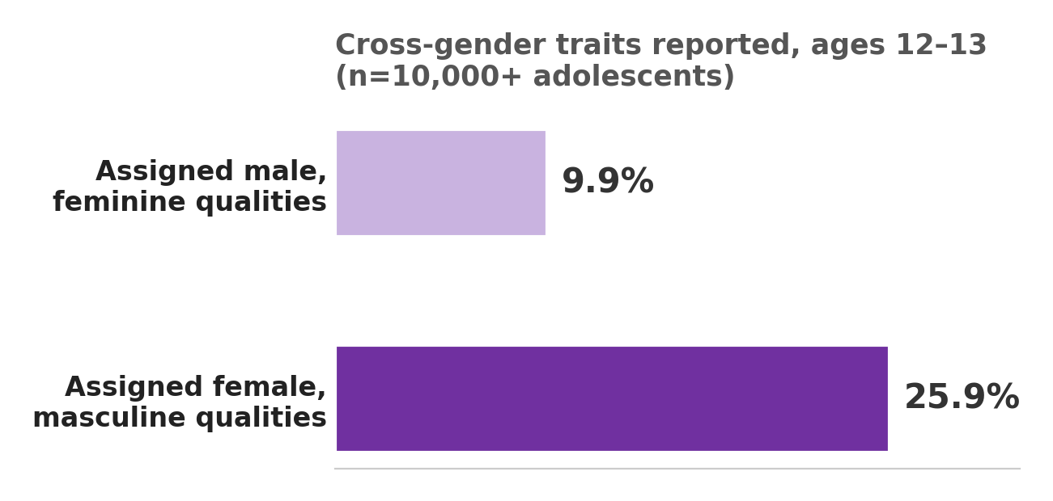
82. The argument that chromosomes cannot change, so sex is fixed, confuses different layers of biological sex. Chromosomes are just one part of it. Biological sex also includes hormones, gonads, genitals, and secondary sex characteristics, and hormone therapy significantly changes many of these. It alters endocrine systems, body fat distribution, muscle mass, and voice. Chromosomes do not change, but the rest of the body does, and that matters just as much. A person with XY chromosomes and CAIS who is assigned female at birth and lives as a woman is not male in any meaningful sense.
83. The idea that focusing on gender affirming care is halting research into other treatments is a false choice. Gender affirming care is the established best practice because the evidence shows it works. Exploring other ways to help people with gender dysphoria and providing effective, life saving treatment now are not mutually exclusive. Medicine is always evolving, but we should not deny people care that is proven to work just because there might be a different approach someday. That would be ethically indefensible.
84. Dismissing historical third gender roles as completely separate from modern transgender identities is a narrow view of history. Yes, the term gender identity is recent, but that does not mean the human experience it describes is new. Cultures across time and place have recognized gender diversity. The hijra community in South Asia, Two Spirit people in North American Indigenous tribes, and the galli priests of ancient Rome all existed long before modern terminology. Reducing them to purely religious or social functions ignores the real continuity of human experience across centuries. The rigid Western binary is not a universal historical constant.
85. The claim that detransitioners are silenced is a narrative often used to discredit transgender rights, but it does not match the reality. Detransitioners are acknowledged and their stories are part of the larger conversation. What matters is the actual numbers. Studies from multiple countries consistently show that detransition is extremely rare. In Sweden, fewer than 1% of those who legally changed their gender reverted. In Canada, over 97% of adolescents continued identifying as trans or nonbinary after several years, and among those who started hormones, less than 1% stopped due to changing identity. More than 90% of detransition cases are driven by external pressure like family rejection or job insecurity, not by regret about identity. Using a tiny minority to invalidate the experiences of the vast majority is not honest.
@thecubejsablover

86. Society has a duty to protect vulnerable minors from irreversible harm. Until there is absolute, consensus-based, long-term evidence for the safety and efficacy of pediatric gender transition, the precautionary principle demands that we default to therapeutic watchful waiting rather than immediate medicalization.
87. The Race and Money Argument. If race is socially constructed, we do not allow individuals to change their race based on internal feelings. If money is socially constructed, a one-dollar bill cannot become a hundred-dollar bill simply by identifying as one. We do not invent new races daily, nor do we legally recognize a person claiming a new race every morning. Therefore, simply because gender is socially constructed does not logically mean it should be subject to unlimited personal redefinition based purely on subjective self-identification. There must be an objective anchor, and biological sex is that anchor.
88. The Biological Verification Argument. If gender identity is biologically rooted in the brain, then why do we not use objective neurological scans, such as functional MRIs or brain structure analysis, to diagnose gender identity and confirm eligibility for medical transition? Every other biological condition with a neurological basis is diagnosed through objective medical testing, not through patient self-report. Relying purely on subjective verbal affirmation for a condition that supposedly has a physical basis contradicts every other standard of evidence-based medicine and opens the door to false positives.
89. The Detransition Data Paradox. Transgender allies frequently cite low regret rates for transition, typically around 1% to 2%. However, these studies often exclude detransitioners who do not return to their original clinics, who are too ashamed to report their regret, or who are actively silenced by community pressure. Furthermore, a significant percentage of detransitioners cite social pressure, inability to pass, or unresolved mental health comorbidities as reasons for stopping. Since detransition itself is highly stigmatized and often leads to loss of community support, the true regret rate is almost certainly underreported. Without a mandatory, unbiased, globally tracked longitudinal registry of every transition outcome, we cannot scientifically claim the regret rate is negligible enough to justify broad, easily accessible pediatric interventions.
90. The Homosexuality versus Gender Dysphoria Overlap. A substantial portion of transgender youth report experiencing same-sex attractions prior to transitioning. Historically, a significant percentage of children who experienced gender dysphoria grew up to be gay or lesbian adults rather than transgender adults. Given this overlap, how can a clinician definitively distinguish between a child who is gay and a child who is transgender, especially when both may experience distress about their bodies or social roles? Affirming a gay child's distress by encouraging them to transition to the opposite sex runs a disturbing parallel to conversion therapy, just reversed. How do we screen for internalized homophobia without being accused of transphobia, and what safeguards exist to prevent misdiagnosing homosexuality as transgenderism?

86. The demand for absolute, consensus-based long-term evidence sounds reasonable on the surface, but no medical intervention actually meets that standard. The WPATH Standards of Care version 8, published in 2022, was developed through five years of rigorous work involving 120 international experts using a Delphi consensus process. The Endocrine Society has cited more than 260 studies in its Clinical Practice Guideline, with over 2,000 scientific studies examining aspects of gender-affirming care since 1975. Research shows that adolescents receiving gender-affirming medical interventions experience improvements in their overall well-being, with mean depression scores and suicidal ideation decreasing over time while quality of life scores improve. The American Psychological Association adopted a landmark policy in 2024 affirming evidence-based care for transgender and gender diverse youth, noting that legislative attempts to obstruct access put them at risk of depression, anxiety, and other negative mental health outcomes. What critics call "watchful waiting" is not neutral. It is itself an intervention that forces adolescents to undergo unnecessary and potentially traumatic puberty. Demanding absolute evidence before providing care that is already supported by a substantial body of research is ethically indefensible.
87. This analogy sounds clever but it collapses under scrutiny. Gender identity is fundamentally different from race or money. Neuroimaging research has found that brain processing for body self-identification aligns with gender identity rather than birth-assigned sex. A 2020 fMRI study evaluated brain activation patterns during gender face discrimination tasks in transgender and cisgender individuals, showing measurable neural differences. Gender identity has a biological basis that race and money simply do not have. The claim that we do not allow people to change their race ignores that race is a social category imposed externally based on ancestry and physical appearance, whereas gender identity is an internal sense of self. The analogy also fails because money is a symbolic agreement that has no connection to human biology or identity. Social construction does not mean "not real." It means the meaning we assign to something is shaped by culture. That does not erase the biological realities underneath. The argument sets up a false choice between biological sex as the only anchor and complete chaos, but the reality is that gender is a complex interplay of biology, psychology, and social factors that we can understand and respect without reducing it to chromosomes.
88. The argument that we should use brain scans to diagnose gender identity misunderstands both the science and how medicine actually works. While neuroimaging studies show that brain processing aligns with gender identity rather than birth sex, these findings are currently used for research purposes, not as validated clinical diagnostic tools. Functional MRIs are expensive, not universally available, and have not been standardized for diagnostic use in this context. More importantly, we do not require brain scans to diagnose depression, anxiety, or other conditions that have neurological underpinnings. We rely on clinical interviews and patient self-report because that is the ethical and practical standard. The WPATH Standards of Care recommend comprehensive biopsychosocial assessments conducted by multidisciplinary teams, not a single brain scan. Requiring fMRI as a gatekeeper would create unnecessary barriers to care and would be inconsistent with how every other psychiatric condition is diagnosed. The argument also ignores that gender identity is not a disease that needs to be "confirmed" by a machine. It is a fundamental aspect of who a person is. Demanding objective neurological proof before respecting someone's identity is not evidence-based medicine. It is moving the goalposts.
89. The claim that regret rates are underreported due to silenced detransitioners is not supported by evidence. A 2021 systematic review and meta-analysis pooling 27 studies and nearly 8,000 transgender patients found that the pooled prevalence of regret after gender-affirming surgery was 1%, with a confidence interval of less than 1% to 2%. Among patients undergoing transmasculine procedures, the regret rate was less than 1%. A 2022 study published in Pediatrics followed 317 transgender youth for an average of five years after their initial social transition and found that 94% still identified as binary transgender, while only 2.5% identified as cisgender. The study concluded that retransitions are infrequent. The idea that detransitioners are "silenced" is a narrative used to attack transgender rights, not a reflection of reality. When detransition does occur, research shows that more than 90% of cases are driven by external pressures like family rejection, job insecurity, or lack of social support, not by regret about identity itself. Using a tiny minority of cases to invalidate care for the vast majority who benefit is not honest science. It is using rare exceptions to deny care to everyone else.
90. This argument fundamentally confuses gender identity with sexual orientation, which are entirely different things. Gender identity is about who you are. Sexual orientation is about who you are attracted to. The claim that a substantial portion of transgender youth previously experienced same-sex attractions does not mean they were "confused gay kids." It means they were exploring their identity, which is normal for any adolescent. The Royal College of Psychiatrists and other professional bodies explicitly state that gender-affirming care is fundamentally different from conversion therapy, which has been proven ineffective and harmful. Gender-affirming care is based on supporting a person's authentic identity, not changing it. The idea that affirming a gay child's distress by encouraging them to transition runs parallel to conversion therapy is a false equivalence. Conversion therapy tries to change who someone is. Gender-affirming care supports who someone already knows themselves to be. Clinical guidelines include comprehensive psychological assessments designed to distinguish gender dysphoria from internalized homophobia or other concerns. The safeguards already exist. Suggesting that clinicians cannot tell the difference is an insult to the medical professionals who have been doing this work for decades. If a gay teenager is distressed about their body, the appropriate response is to explore that distress, not to assume it means they are trans. And if a trans teenager is distressed, the appropriate response is to support their identity, not to assume they are just gay and confused. These are different things, and pretending they are the same is a rhetorical trick, not a medical argument.
@thecubejsablover

🔍 RARE CATEGORY (extremely long!!!) 🔍
91. The Historical Anachronism Argument. The modern framework of transgender identity relies on a 20th-century Western concept of the autonomous, self-defining individual. However, most historical cultures that recognized gender variance, such as the Hijra in South Asia, the Two-Spirit people in Indigenous North American cultures, or the Fa'afafine in Samoa, did not conceptualize these roles through the lens of internal identity. They were rigid social, religious, or occupational positions tied to specific cultural functions. By retroactively applying modern transgender theory to these ancient cultures, we are engaging in a form of historical misappropriation that erases the cultural specificity of these roles. Proponents of transgender identity often claim historical continuity, but this is a selective reading of history that flattens complex cultural phenomena into a single, ahistorical narrative of transgender existence. If the modern concept of gender identity is a Western invention, then claiming it is universal across all cultures and all time periods is not historically honest.
92. The Linguistic Determinism Problem. Language shapes thought. By introducing an ever-expanding array of gender identities, pronouns, and labels, we are fundamentally altering the cognitive frameworks through which people understand human relationships, attraction, and social organization. This linguistic restructuring is not politically neutral; it is a form of engineered social change that imposes a specific worldview on the entire population, including those who do not consent to it. Unlike scientific discoveries, which describe pre-existing realities, the proliferation of new gender categories is actively constructing new social realities. Demanding that the public adopt these new linguistic frameworks, often under threat of social or professional penalty, is a form of coercive linguistic engineering that bypasses democratic deliberation and organic cultural evolution.
93. The Evolutionary Biology Baseline. Human beings, like all sexually reproducing species, have evolved under the selective pressures of binary reproductive roles. Every aspect of human anatomy, physiology, and even behavior is shaped by millions of years of evolution that assumed two distinct reproductive functions. While human culture is more complex than simple reproductive roles, the evolutionary baseline cannot be ignored. For a species that evolved entirely around binary sexual reproduction, claiming that gender is entirely divorced from biology and exists on a limitless spectrum flies in the face of evolutionary logic. Even if a small percentage of individuals experience gender variance, this does not negate the fact that human biology, at its most fundamental level, is organized around reproductive dimorphism. Evolutionary frameworks do not disprove transgender existence, but they do demand that claims about gender being entirely socially constructed account for the overwhelming biological reality of binary reproduction and its influence on human development.
94. The Global Human Rights Inconsistency. Transgender rights advocates in wealthy Western nations often demand that developing countries adopt progressive gender policies. However, many of these nations are struggling with basic human rights crises, including poverty, lack of clean water, child mortality, and widespread infectious diseases. In the global hierarchy of human rights priorities, gender self-identification ranks far below access to food, water, and basic healthcare. By focusing Western political capital and aid funding on LGBTQ+ rights in developing nations, Western activists are imposing a set of priorities that do not reflect the lived realities of people in those countries. This is a form of cultural imperialism that prioritizes a relatively niche issue over fundamental survival needs. Additionally, many of these nations have cultural norms around gender that are organic to their own historical development, and Western pressure to adopt foreign gender frameworks disregards their cultural autonomy.
95. The Bodily Autonomy Conflict. Bodily autonomy is a foundational principle of liberalism. However, the transgender rights movement demands not only that individuals have autonomy over their own bodies, but that society must affirm and validate every choice they make regarding their bodies. This creates a conflict: if a person has full bodily autonomy to transition, do others have full bodily autonomy to refuse to participate in or affirm that transition? For example, should a female athlete be forced to compete against someone with male physiological advantages in the name of transgender inclusion? Should a rape survivor be forced to share a locker room with someone assigned male at birth? Should a religious healthcare worker be forced to participate in gender-affirming surgeries? The transgender movement often demands that other individuals sacrifice their own bodily autonomy, safety, or religious freedom to accommodate its goals. True liberalism would recognize that one person's bodily autonomy ends where another person's begins, and the current framework often fails to balance these competing rights.
96. The Medicalization of Normal Human Variation. Human beings have always exhibited a wide range of gender expression, from feminine men and masculine women to individuals who lived outside traditional gender roles entirely. Historically, this was accepted as part of the diversity of human personality and preference. However, modern transgender theory has medicalized these variations by framing them as a condition requiring medical intervention. In the past, a feminine boy might have been accepted as simply a feminine boy, or a masculine girl as simply a masculine girl. Today, both are immediately flagged for potential transgender identity and medical transition. This pathologization of natural human diversity has resulted in a society where individuals who would have previously lived ordinary lives as gender-nonconforming cisgender people are now being funneled into medical systems. We have replaced social tolerance with surgical intervention, and that is a deeply regressive step, not a progressive one.

91. The Historical Anachronism Argument assumes that modern transgender identity is a purely Western invention and that applying it to historical cultures is "misappropriation." But that reading is actually the one that flattens history. The APA notes that "substantial evidence also exists for individuals who lived at least part of their lives as a different gender than assigned at birth" across cultures from ancient Greece to Native American tribes. Gender diversity has been documented in societies across six continents for millennia. The Hijra community in South Asia appears in ancient Hindu texts like the Ramayana and Mahabharata. The Fa'afafine of Samoa form a well-established third gender. Two-Spirit people in North American Indigenous cultures were often valued as healers and spiritual leaders. The argument that these were "rigid social positions" and therefore not "real" transgender identity is a distinction that only exists if you assume the modern framework is the only valid one. That is not historical honesty, it is a gatekeeping move. The peaceful flowering of early trans acceptance in different Indigenous civilizations met opposition from European colonizers, not from internal cultural rejection. The modern framework did not invent gender diversity, it just gave it a name.
92. The Linguistic Determinism Problem frames the expansion of gender language as "coercive engineering" that imposes a worldview on people. But this ignores that language has always evolved organically. Gender-neutral pronouns have been debated since at least the 1970s, and the use of singular "they" in English dates back to the 14th century. The idea that new language "constructs" new realities rather than describing existing ones is also backwards. A 2025 framework on gender-neutral pronouns found that their use directly affects the well-being of nonbinary people by reducing social stigmatization and discrimination. Neural evidence from 2026 shows that gender-inclusive language can foster gender-neutral representations despite processing costs. This is not "engineering." It is language catching up to the reality that gender diversity has always existed. The people who complain about being "forced" to use new pronouns are usually just uncomfortable with change, and that discomfort is not a valid reason to deny others basic respect.
93. The Evolutionary Biology Baseline argument says that because humans evolved around binary reproduction, gender must also be binary. But this confuses reproductive roles with identity. Biologist Joan Roughgarden has argued that Darwin's sexual selection was evolutionary biology's first universal theory of gender, and that human evolution can point to ways to see trans people as evidence of biological and evolutionary diversity. A 2026 Cambridge University Press publication states that some genetic variants "may influence gender identity, and mate choice so that transgender and homosexual, may both be seen as simply the edges of normal curves of male and female sexual development". Evolution is not a straight line with two boxes. It is a messy, branching process full of variation. The existence of a small percentage of people who do not fit the binary does not disprove evolution; it proves that evolution produces diversity. If anything, the evolutionary argument actually supports transgender existence as a natural variation.
94. The Global Human Rights Inconsistency argument says that LGBTQ+ rights are a Western priority imposed on developing countries that have bigger problems. This framing ignores that LGBTQ+ people in those countries are the ones asking for rights, not just Western activists. The argument also sets up a false choice between basic survival and human rights. The WHO notes that transgender individuals experience high levels of mental health illness linked to discrimination and stigma. This is not a luxury issue. It is a health issue. The idea that LGBTQ+ rights are "Western" also erases the fact that many of these cultures had gender diversity before colonization. The APA notes that "the peaceful flowering of early trans or bisexual acceptance in different Indigenous civilizations met with opposition from European and Christian colonizers". What was actually imported was homophobia and transphobia, not acceptance. The decriminalization of same-sex conduct in the Global South is driven by transnational advocacy networks, but the goal is to support local actors, not direct them. This is not imperialism. It is solidarity.
95. The Bodily Autonomy Conflict argument says that trans rights force others to sacrifice their own bodily autonomy or religious freedom. But this frames the issue as a zero-sum game where one person's rights end where another's begin, and then assumes trans people are the ones crossing the line. However, a person's right to use a bathroom that matches their gender identity does not violate anyone else's bodily autonomy. A rape survivor is not "forced" to share a locker room with a trans woman; they are sharing a public space with another woman. The idea that trans women are a threat is not supported by data, and research shows that trans-exclusionary policies actually increase victimization for trans people without protecting anyone else. Religious exemptions already exist in many legal frameworks, and they can be accommodated without denying trans people basic dignity. The conflict is not between equal rights. It is between a group asking to exist and a group asking them not to.
96. The Medicalization of Normal Human Variation argument says that society has replaced social tolerance with surgical intervention. But this gets the history backwards. Medical transition exists because trans people were denied social tolerance. The APA notes that transgender people have been documented in many cultures “from antiquity until the present day”. But the pathologization of gender variance came from medical authorities, not from trans people themselves. Western trans medicine as a formal healthcare approach originated in the mid-1800s, and early advocates like Magnus Hirschfeld actually believed each human represented a unique combination of sex, gender, and sexuality characteristics. The argument that “feminine boys” and “masculine girls” were just accepted in the past is a romanticized fantasy. They were often bullied, persecuted, or forced to conform. Medical transition is not a replacement for tolerance; it is a response to the fact that tolerance was never offered in the first place. The existence of gender-affirming care does not pathologize normal variation; it provides a pathway for people who need it. No one is forcing anyone to transition. They are just giving people the option to live authentically.
@thecubejsablover

⚠️ SLIPPERY SLOPE ABUSE ARGUMENTS (long!!) ⚠️
97. My religion says it is a sin to not attack or criticize transgender people, so it is not my fault if I do that.
98. The framework is unfalsifiable. A claim that cannot be falsified is not a scientific claim; it is a belief. If a person says they are a woman, and no external evidence can contradict that claim, then the claim is unfalsifiable. Unfalsifiable claims belong in the realm of religion, philosophy, or personal spirituality, not in the realm of evidence-based medicine, law, or public policy. We are being asked to treat an unfalsifiable belief as if it were objective fact, and that is epistemologically indefensible.
99. It creates a hierarchy of subjectivity. If subjective self-identification is the ultimate authority, then a person who claims to be a woman cannot be questioned, even if they have a full beard, a deep voice, XY chromosomes, and no desire to transition. However, a cisgender woman who claims she is a woman is also making a subjective claim, but hers is never questioned. This creates a double standard where the cisgender woman's subjective identity is treated as automatically valid without needing to declare it, while the transgender woman's subjective identity is only valid if she declares it and society accepts it. The framework is internally inconsistent.

97. That religion claim is just not how any major faith works!!! No scripture says "thou shalt attack trans people," that's a personal choice dressed up as divine command. A 2023 paper in the Journal of Law and Religion actually argued that when gender dysphoria is seen as a medical condition (which the WHO and APA agree it is), then there's no religious basis for discrimination. And get this, a 2025 interfaith statement from multiple denominations explicitly said it's a disgraceful misconception that all people of faith reject gender diversity, because many of us actually affirm it. So using God as an excuse to hurt people is a interpretation issue, not a rule.
98. For the falsifiability thing, this is where people misuse Popper. Yeah falsifiability separates science from non science, but that doesn't mean unfalsifiable things are useless or that gender identity has zero evidence. There's actual biological stuff piling up. A 2025 review in Anales de Pediatría said gender identity has a heritable component, and a twin study from Scientific Reports that same year found identical twins had a relative risk of 21.2 for both being trans, whereas fraternal twins had only 8.7, so genetics clearly plays a role (different metric from the 10–81% heritability range I mentioned earlier, but same direction, more than one study lands here independently). Brain imaging from the ENIGMA consortium also showed neuroanatomical differences tied to transgender identity. So, it's not some random, uncheckable claim; it's complex but grounded. Lots of scientific ideas like consciousness are complex too but we still use them in medicine and law without demanding a single test.
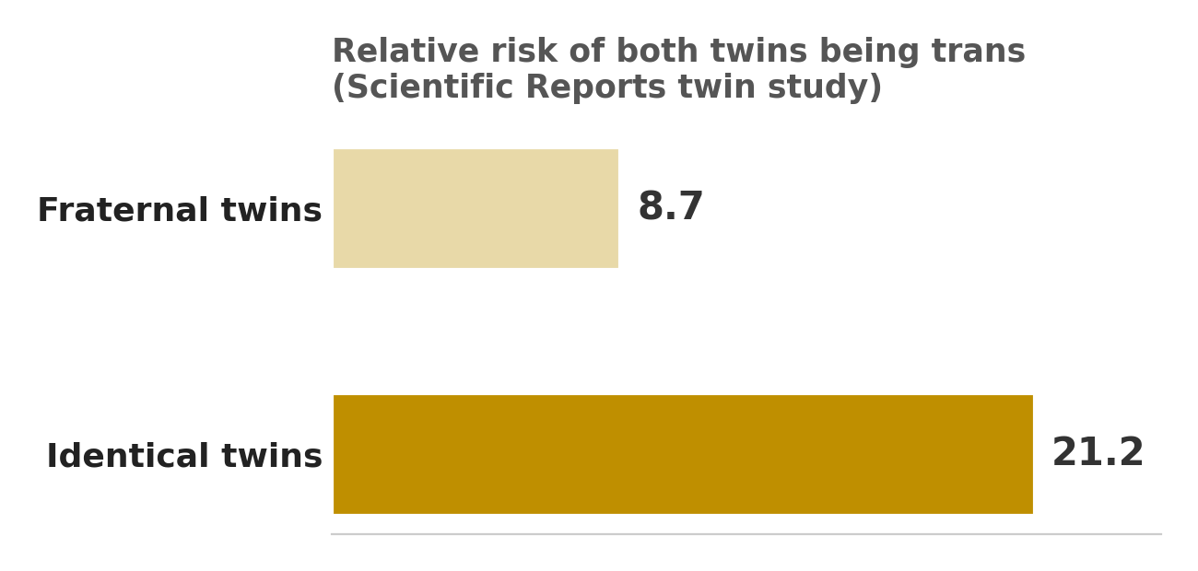
99. Honestly, this flips the logic. The reason cis women's identities aren't questioned is because society already grants them that automatic validity, trans people have to assert theirs because they're constantly doubted. A 2024 paper in Philosophical Studies proposed a subjective fit account which actually fits both trans and cis experiences without implying trans women are less valid. Another 2025 piece in Hypatia said transphobic denials of someone's gender testimony are just false. So the framework isn't inconsistent, it's applying the same principle of self definition, the only difference is that trans people are forced to declare it while cis people never have to prove themselves. That's not a flaw in the framework, that's a flaw in society that the framework tries to fix.
@thecubejsablover

100. It collapses the distinction between identity and reality. Identity is a cognitive construct; reality is an external state of affairs. In every other area of human life, we distinguish between how someone identifies and what they actually are. We do not allow a person to identify as a different age, a different race, a different species, or a different historical period. We recognize that identity is a psychological phenomenon, but reality is independent of psychology. By insisting that gender identity is the only area where subjective identity overrides objective reality, transgender theory has created an epistemological exception with no logical grounding.
101. It prevents scientific inquiry into the nature of gender. If a researcher asks, "What is a woman?" and the answer is "anyone who identifies as one," the researcher cannot investigate the biological, psychological, or sociological factors that contribute to gender. The definition is circular, and circular definitions end inquiry rather than advancing it. By defining womanhood as a tautology, we have shut down the very scientific investigation that could help us understand gender dysphoria, gender expression, and human identity.
102. It demands social and legal enforcement of a belief system. We are not simply being asked to tolerate or respect transgender individuals. We are being asked to actively affirm and enforce a specific epistemological position: that subjective identity overrides objective biology. This goes beyond tolerance and becomes a demand for intellectual conformity. Those who disagree with this epistemological position are labeled bigots, regardless of their reasons. This is not a neutral policy; it is an ideological imposition that requires everyone to adopt a specific philosophical framework about truth, identity, and reality.

100. The distinction between identity and reality is not as clean as this argument makes it out to be. Biological sex is not the same as gender. Sex refers to physical traits like chromosomes and anatomy, while gender identity is a person’s deeply felt internal sense of self. In many areas of life, we already treat subjective identity as a legitimate basis for recognition, names, religious affiliation, and nationality all rely on self-identification to some degree. The comparison to age, race, or species falls apart because those categories are defined by external, immutable facts, whereas gender identity has a demonstrated neurological and psychological basis. This is not about "subjective identity overriding objective reality." It is about recognizing that gender is a complex interplay of biology, psychology, and social factors. The "epistemological exception" is not an exception, it is an acknowledgment that human identity is more nuanced than a simple binary.
101. The claim that defining "woman" as "anyone who identifies as one" prevents scientific inquiry is backwards. Science does not begin with a fixed definition and then stop asking questions. The definition of "woman" as a self-identified category is itself a hypothesis that can be tested, refined, and debated. Researchers continue to investigate the biological, psychological, and sociological factors that contribute to gender identity. The existence of a working definition does not shut down inquiry, it provides a starting point. The "circularity" critique is often overstated. Many philosophers argue that self-identification definitions are not viciously circular but are "response dependent," meaning the concept is defined by the very responses it elicits. This is not a tautology, it is a coherent framework that allows for ongoing investigation into the nature of gender.
102. The framing of transgender recognition as an "ideological imposition" misrepresents what is actually being asked. The demand is not for everyone to adopt a specific philosophical framework, it is for basic respect and non-discrimination. This is the same principle that underlies protections for race, religion, and other characteristics. Labeling those who disagree as bigots is not always accurate, but it is also not the core issue. The core issue is that transgender people face real discrimination, violence, and exclusion. Policies that recognize gender identity are not about enforcing a belief system, they are about ensuring that transgender people can participate fully in society without facing harm. The claim that this is "intellectual conformity" ignores the material reality that trans people are being targeted by laws that remove their rights and erase their existence. Respecting someone's identity is not an ideological imposition, it is a basic human decency.
“ Respecting someone's identity is not an ideological imposition. It is basic human decency. ”

🌈 PRIDE, IN COLOR 🌈
Every identity this document defended has a flag. Here are a few of them.
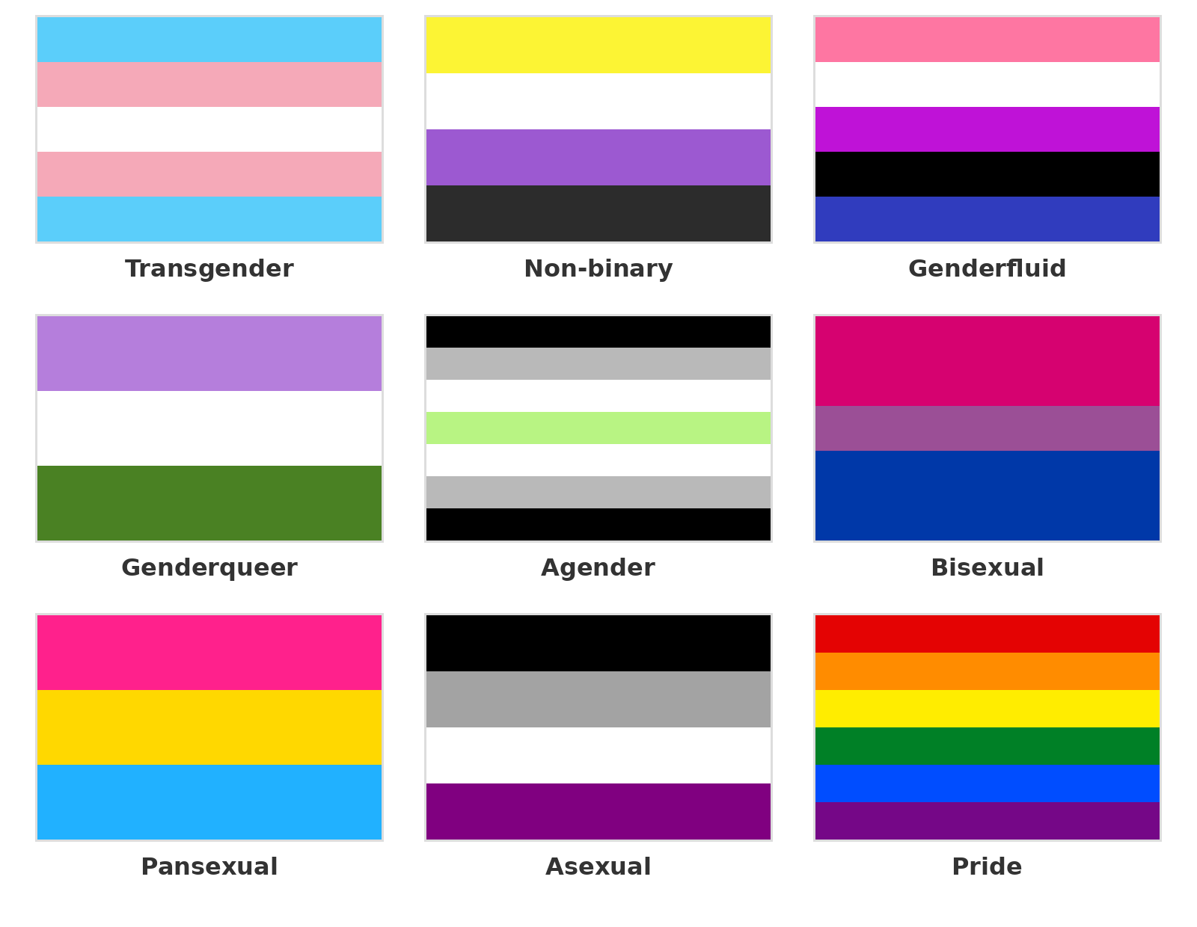
101 claims down. Still here. Still valid.
@thecubejsablover

