Name: Muley, Tushar

Assignment: Week 3 3.2

Date: September 20, 2020

Example 2-1

Based on the results in this chapter, suppose you were asked to summarize what you learned about whether first babies arrive late.

Which summary statistics would you use if you wanted to get a story on the evening news?

Tushar Response-> I would say the one with birthwgt_oz. The headline would read are more Doctors incorrectly measuring new born babies weight?

Which ones would you use if you wanted to reassure an anxious patient?

Tushar Response-> I would say histogram with first born vs. others. To show that first born babies are no earlier or later than any other ordered child born.

Finally, imagine that you are Cecil Adams, author of The Straight Dope, and your job is to answer the question, “Do first babies arrive late?” Write a paragraph that uses the results in this chapter to answer the question clearly, precisely, and honestly.

Do first babies arrive late? Let us explore the nature of that question. Most people use antidotal evidence to indicate whether first born babies arrive late or early. The truth is most pregnancies last about 39 weeks. See histogram of pregnancy length majority of babies regardless of birth order are born at 39 weeks.

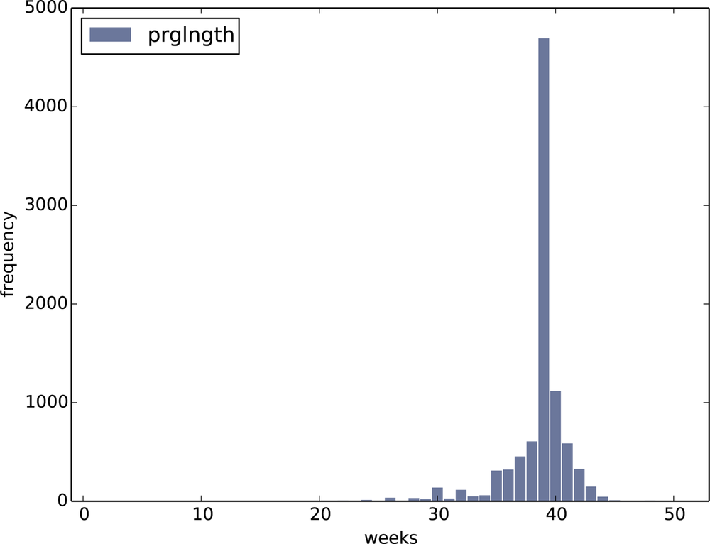

If we took the distribution of first born and all others the below histogram will show that there is a small difference that first born arrive earlier than other orders of babies.

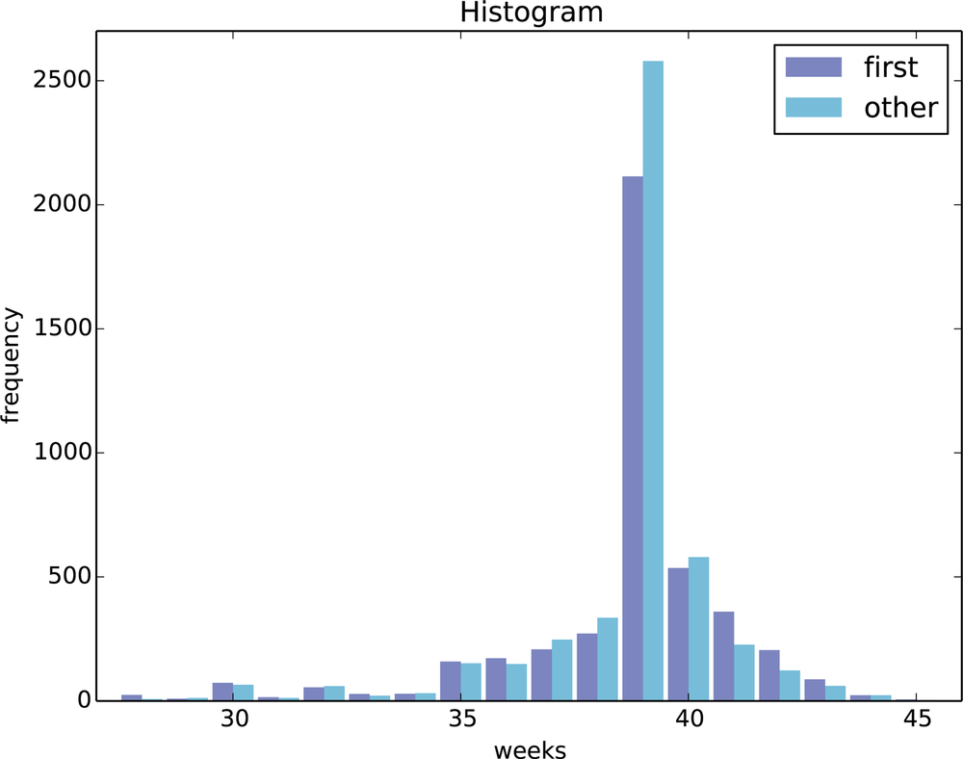

If we went further into the number and looked at effect size which is a summary statistic to describe the difference between two means. If we took the mean of first-born pregnancies which is 38.601 weeks and compared to other birth order means which is 38.523. The difference is 0.078. That works out to 13hours. That is the difference between first born babies and all others. The difference is so small across a large population no one could notice the difference outside of hearsay.