Name: Muley, Tushar

Assignment: Week 1 Assignment 1.2 R Refresh

Date: June 13, 2021

*3. Organize a Data Report*

Generate a summary report. Make sure to include: summary for every variable, structure and type of data elements, discuss four results of your data.

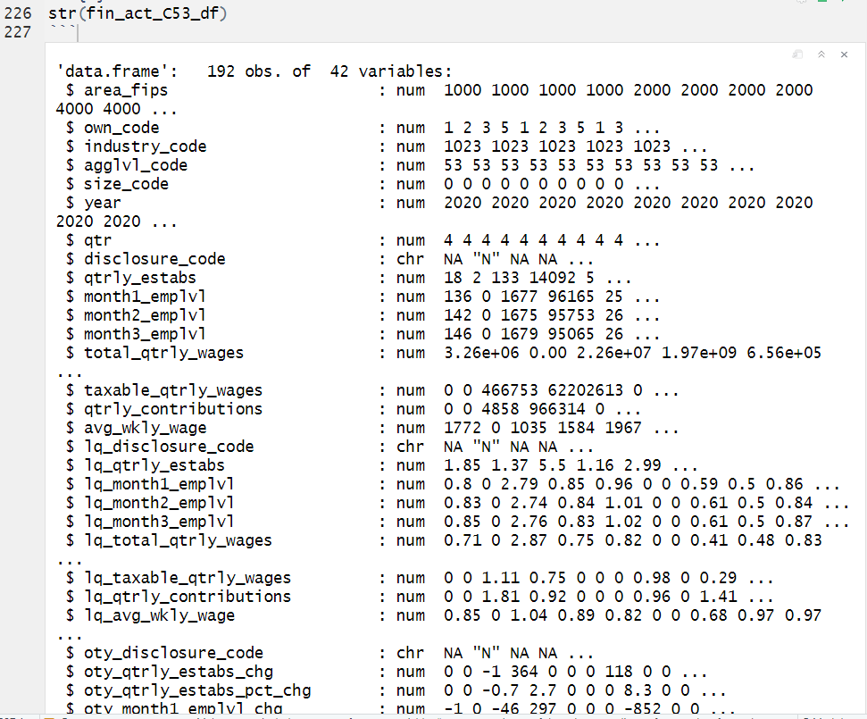

**Figure 1: Summary Report of every variable and structure.**

The above is a screen print showing the summary report for all variable. Below is the complete table.

|  |  |  |
| --- | --- | --- |
| **Column Name** | **Structure** | **Type of Data Element** |
| area_fips | num | discrete |
| own_code | num | discrete |
| industry_code | num | discrete |
| agglvl_code | num | discrete |
| size_code | num | discrete |
| year | num | discrete |
| qtr | num | discrete |
| disclosure_code | chr | discrete |
| qtrly_estabs | num | continuous |
| month1_emplvl | num | continuous |
| month2_emplvl | num | continuous |
| month3_emplvl | num | continuous |
| total_qtrly_wages | num | continuous |
| taxable_qtrly_wages | num | continuous |
| qtrly_contributions | num | continuous |
| avg_wkly_wage | num | continuous |
| lq_disclosure_code | chr | continuous |
| lq_qtrly_estabs | num | continuous |
| lq_month1_emplvl | num | continuous |
| lq_month2_emplvl | num | continuous |
| lq_month3_emplvl | num | continuous |
| lq_total_qtrly_wages | num | continuous |
| lq_taxable_qtrly_wages | num | continuous |
| lq_qtrly_contributions | num | continuous |
| lq_avg_wkly_wage | num | continuous |
| oty_disclosure_code | chr | continuous |
| oty_qtrly_estabs_chg | num | continuous |
| oty_qtrly_estabs_pct_chg | num | continuous |
| oty_month1_emplvl_chg | num | continuous |
| oty_month1_emplvl_pct_chg | num | continuous |
| oty_month2_emplvl_chg | num | continuous |
| oty_month2_emplvl_pct_chg | num | continuous |
| oty_month3_emplvl_chg | num | continuous |
| oty_month3_emplvl_pct_chg | num | continuous |
| oty_total_qtrly_wages_chg | num | continuous |
| oty_total_qtrly_wages_pct_chg | num | continuous |
| oty_taxable_qtrly_wages_chg | num | continuous |
| oty_taxable_qtrly_wages_pct_chg | num | continuous |
| oty_qtrly_contributions_chg | num | continuous |
| oty_qtrly_contributions_pct_chg | num | continuous |
| oty_avg_wkly_wage_chg | num | continuous |
| oty_avg_wkly_wage_pct_chg | num | continuous |

**Figure 2: Complete table of every variable, structure and type of data elements.**

Results of my data:

The data from the Bureau of Labor Statistics (BLS) is pretty interesting. I pulled the data for Financial Industry (industry_code = 1023). I also limited the data to state level aggregation code (agglvl_code = 53).

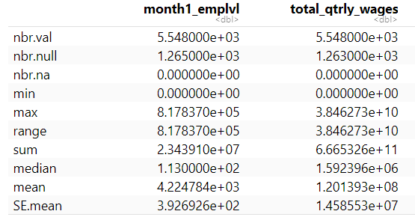

**Figure 3: Summary Statistics of the data.**

Some of the interesting things I found out on the data. Since it contains wage for the fourth quarter of 2020 that they varying degrees. The medium for month level employment is 1.130000e+02 translate to 113 and the mean is 4.224784e+03 translates to 4,224.784. The sum on the same field is 23,439,100. 23 million is the total of all the records. For the mean to just 4,200 is large spread.

Another variable I was interested in was the average weekly wage (avg_wkly_wage) which had a histogram of lot of zero. But was not peaky as I expected. Below is the view of that. As you can see the histogram has a peak around 1,400 to 1,500 per week. Roughly $6,000 average per month. The histogram is positively skewed with a tail going to the right. With a median of $1,536 .

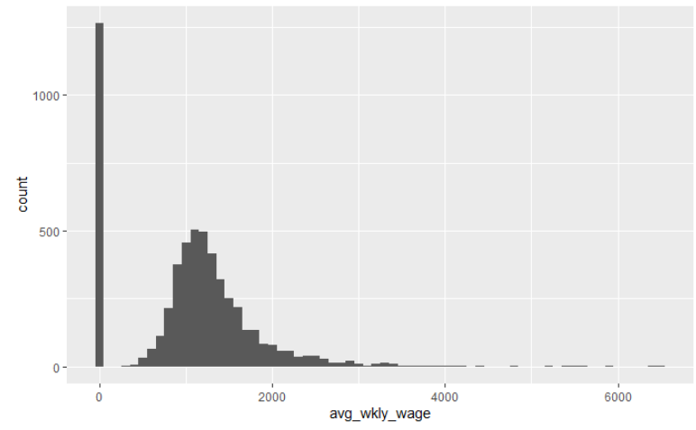

**Figure 4: Histogram of avg_wkly_wage**

Another interesting thing I found is the number of different entities in the financial industry.

|  |  |
| --- | --- |
| **own_code** | **description** |
| 5 | Private |
| 4 | International Government |
| 3 | Local Government |
| 2 | State Government |
| 1 | Federal Government |

**Figure 5: Own code descriptions.**

Own code tells if reporting company is private or international etc…

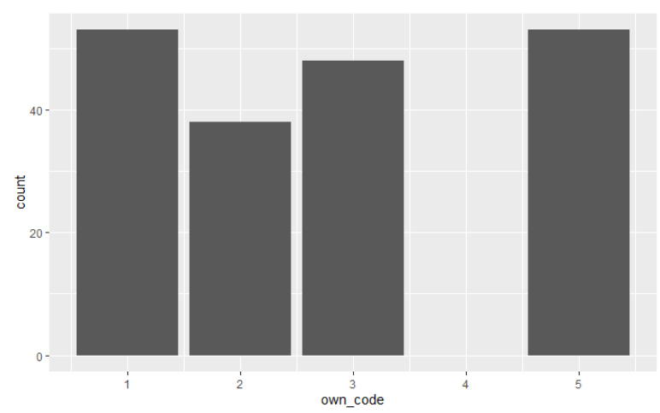

**Figure 6: Bar graph of Own Codes**

This tells that federal government (own_code = 1) has a lot of ownership in the financial sector. Just as much as private does (own_code = 5). The good news is no international governments have any kind of financial ownership in the financial industry.

The data is pretty correlated between wage and taxable wages as you can see from figure 7 and 8 below. This is not too surprising as the wages are taxable income. The more people working the more our communities benefit.

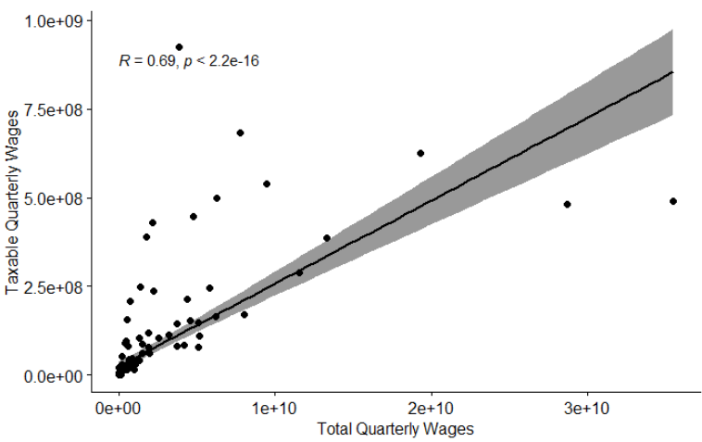

**Figure 7: Correlation between Taxable Quarterly wages and Total Quarterly Wages.**

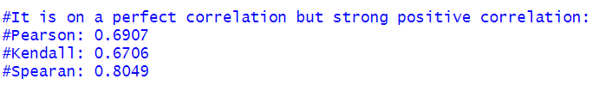

**Figure 8: Comparison of the different correlation coefficient.**