Muley, Tushar Assignment 1-2 Week 1

June 13, 2021

# 1. Import, Plot, Summarize, and Save Data

# Using the Bureau of Labor Statistics data, choose a dataset that interest you.

# Then generate summary statistics for 2 variables, plot some of the features

# (e.g., histograms, box plots, density plots, etc.) of several variables, and save the

# data locally as CSV files.

#Imported Financial_activities_all_states_us.csv #variable to shorting name

fin_act <- read.csv('C:/Users/Tushar/RStudioProjects/DSC630_SUMMER_2021/financial_activities_all_states_us.csv')

#Install pastecs package

install.packages("pastecs",repos = "http://cran.us.r-project.org")

## Installing package into 'C:/Users/Tushar/Documents/R/win-library/3.6'  
## (as 'lib' is unspecified)

## package 'pastecs' successfully unpacked and MD5 sums checked  
##   
## The downloaded binary packages are in  
## C:\Users\Tushar\AppData\Local\Temp\Rtmpg3gQFj\downloaded_packages

library(pastecs,)

#See the column headers  
head(fin_act,)

## area_fips own_code industry_code agglvl_code size_code year qtr  
## 1 1000 1 1023 53 0 2020 4  
## 2 1000 2 1023 53 0 2020 4  
## 3 1000 3 1023 53 0 2020 4  
## 4 1000 5 1023 53 0 2020 4  
## 5 1001 3 1023 73 0 2020 4  
## 6 1001 5 1023 73 0 2020 4  
## disclosure_code qtrly_estabs month1_emplvl month2_emplvl month3_emplvl  
## 1 18 136 142 146  
## 2 N 2 0 0 0  
## 3 133 1677 1675 1679  
## 4 14092 96165 95753 95065  
## 5 N 1 0 0 0  
## 6 120 399 393 401  
## total_qtrly_wages taxable_qtrly_wages qtrly_contributions avg_wkly_wage  
## 1 3255664 0 0 1772  
## 2 0 0 0 0  
## 3 22571083 466753 4858 1035  
## 4 1970245660 62202613 966314 1584  
## 5 0 0 0 0  
## 6 5675563 290647 3720 1098  
## lq_disclosure_code lq_qtrly_estabs lq_month1_emplvl lq_month2_emplvl  
## 1 1.85 0.80 0.83  
## 2 N 1.37 0.00 0.00  
## 3 5.50 2.79 2.74  
## 4 1.16 0.85 0.84  
## 5 N 5.99 0.00 0.00  
## 6 1.43 0.62 0.61  
## lq_month3_emplvl lq_total_qtrly_wages lq_taxable_qtrly_wages  
## 1 0.85 0.71 0.00  
## 2 0.00 0.00 0.00  
## 3 2.76 2.87 1.11  
## 4 0.83 0.75 0.75  
## 5 0.00 0.00 0.00  
## 6 0.63 0.48 0.71  
## lq_qtrly_contributions lq_avg_wkly_wage oty_disclosure_code  
## 1 0.00 0.85   
## 2 0.00 0.00 N  
## 3 1.81 1.04   
## 4 0.92 0.89   
## 5 0.00 0.00 N  
## 6 0.69 0.77   
## oty_qtrly_estabs_chg oty_qtrly_estabs_pct_chg oty_month1_emplvl_chg  
## 1 0 0.0 -1  
## 2 0 0.0 0  
## 3 -1 -0.7 -46  
## 4 364 2.7 297  
## 5 0 0.0 0  
## 6 1 0.8 -5  
## oty_month1_emplvl_pct_chg oty_month2_emplvl_chg oty_month2_emplvl_pct_chg  
## 1 -0.7 2 1.4  
## 2 0.0 0 0.0  
## 3 -2.7 -52 -3.0  
## 4 0.3 -169 -0.2  
## 5 0.0 0 0.0  
## 6 -1.2 -11 -2.7  
## oty_month3_emplvl_chg oty_month3_emplvl_pct_chg oty_total_qtrly_wages_chg  
## 1 11 8.1 41752  
## 2 0 0.0 0  
## 3 -52 -3.0 2554451  
## 4 -958 -1.0 213222335  
## 5 0 0.0 0  
## 6 -3 -0.7 474375  
## oty_total_qtrly_wages_pct_chg oty_taxable_qtrly_wages_chg  
## 1 1.3 0  
## 2 0.0 0  
## 3 12.8 100770  
## 4 12.1 1215500  
## 5 0.0 0  
## 6 9.1 997  
## oty_taxable_qtrly_wages_pct_chg oty_qtrly_contributions_chg  
## 1 0.0 0  
## 2 0.0 0  
## 3 27.5 1064  
## 4 2.0 154025  
## 5 0.0 0  
## 6 0.3 -287  
## oty_qtrly_contributions_pct_chg oty_avg_wkly_wage_chg  
## 1 0.0 -28  
## 2 0.0 0  
## 3 28.0 143  
## 4 19.0 175  
## 5 0.0 0  
## 6 -7.2 108  
## oty_avg_wkly_wage_pct_chg  
## 1 -1.6  
## 2 0.0  
## 3 16.0  
## 4 12.4  
## 5 0.0  
## 6 10.9

#Summary Statistics for 2 variables  
attach(fin_act)  
sum_fin_act<-cbind(month1_emplvl, total_qtrly_wages)  
stat.desc(sum_fin_act)

## month1_emplvl total_qtrly_wages  
## nbr.val 5.548000e+03 5.548000e+03  
## nbr.null 1.265000e+03 1.263000e+03  
## nbr.na 0.000000e+00 0.000000e+00  
## min 0.000000e+00 0.000000e+00  
## max 8.178370e+05 3.846273e+10  
## range 8.178370e+05 3.846273e+10  
## sum 2.343910e+07 6.665326e+11  
## median 1.130000e+02 1.592396e+06  
## mean 4.224784e+03 1.201393e+08  
## SE.mean 3.926926e+02 1.458553e+07  
## CI.mean.0.95 7.698313e+02 2.859335e+07  
## var 8.555429e+08 1.180268e+18  
## std.dev 2.924967e+04 1.086402e+09  
## coef.var 6.923352e+00 9.042852e+00

#Plot some of the features # (e.g., histograms, box plots, density plots, etc.) of several variables

#Move data into a dataframe  
fin_act_df<-data.frame(fin_act)  
  
#Preview the dataframe  
head(fin_act_df)

## area_fips own_code industry_code agglvl_code size_code year qtr  
## 1 1000 1 1023 53 0 2020 4  
## 2 1000 2 1023 53 0 2020 4  
## 3 1000 3 1023 53 0 2020 4  
## 4 1000 5 1023 53 0 2020 4  
## 5 1001 3 1023 73 0 2020 4  
## 6 1001 5 1023 73 0 2020 4  
## disclosure_code qtrly_estabs month1_emplvl month2_emplvl month3_emplvl  
## 1 18 136 142 146  
## 2 N 2 0 0 0  
## 3 133 1677 1675 1679  
## 4 14092 96165 95753 95065  
## 5 N 1 0 0 0  
## 6 120 399 393 401  
## total_qtrly_wages taxable_qtrly_wages qtrly_contributions avg_wkly_wage  
## 1 3255664 0 0 1772  
## 2 0 0 0 0  
## 3 22571083 466753 4858 1035  
## 4 1970245660 62202613 966314 1584  
## 5 0 0 0 0  
## 6 5675563 290647 3720 1098  
## lq_disclosure_code lq_qtrly_estabs lq_month1_emplvl lq_month2_emplvl  
## 1 1.85 0.80 0.83  
## 2 N 1.37 0.00 0.00  
## 3 5.50 2.79 2.74  
## 4 1.16 0.85 0.84  
## 5 N 5.99 0.00 0.00  
## 6 1.43 0.62 0.61  
## lq_month3_emplvl lq_total_qtrly_wages lq_taxable_qtrly_wages  
## 1 0.85 0.71 0.00  
## 2 0.00 0.00 0.00  
## 3 2.76 2.87 1.11  
## 4 0.83 0.75 0.75  
## 5 0.00 0.00 0.00  
## 6 0.63 0.48 0.71  
## lq_qtrly_contributions lq_avg_wkly_wage oty_disclosure_code  
## 1 0.00 0.85   
## 2 0.00 0.00 N  
## 3 1.81 1.04   
## 4 0.92 0.89   
## 5 0.00 0.00 N  
## 6 0.69 0.77   
## oty_qtrly_estabs_chg oty_qtrly_estabs_pct_chg oty_month1_emplvl_chg  
## 1 0 0.0 -1  
## 2 0 0.0 0  
## 3 -1 -0.7 -46  
## 4 364 2.7 297  
## 5 0 0.0 0  
## 6 1 0.8 -5  
## oty_month1_emplvl_pct_chg oty_month2_emplvl_chg oty_month2_emplvl_pct_chg  
## 1 -0.7 2 1.4  
## 2 0.0 0 0.0  
## 3 -2.7 -52 -3.0  
## 4 0.3 -169 -0.2  
## 5 0.0 0 0.0  
## 6 -1.2 -11 -2.7  
## oty_month3_emplvl_chg oty_month3_emplvl_pct_chg oty_total_qtrly_wages_chg  
## 1 11 8.1 41752  
## 2 0 0.0 0  
## 3 -52 -3.0 2554451  
## 4 -958 -1.0 213222335  
## 5 0 0.0 0  
## 6 -3 -0.7 474375  
## oty_total_qtrly_wages_pct_chg oty_taxable_qtrly_wages_chg  
## 1 1.3 0  
## 2 0.0 0  
## 3 12.8 100770  
## 4 12.1 1215500  
## 5 0.0 0  
## 6 9.1 997  
## oty_taxable_qtrly_wages_pct_chg oty_qtrly_contributions_chg  
## 1 0.0 0  
## 2 0.0 0  
## 3 27.5 1064  
## 4 2.0 154025  
## 5 0.0 0  
## 6 0.3 -287  
## oty_qtrly_contributions_pct_chg oty_avg_wkly_wage_chg  
## 1 0.0 -28  
## 2 0.0 0  
## 3 28.0 143  
## 4 19.0 175  
## 5 0.0 0  
## 6 -7.2 108  
## oty_avg_wkly_wage_pct_chg  
## 1 -1.6  
## 2 0.0  
## 3 16.0  
## 4 12.4  
## 5 0.0  
## 6 10.9

library(ggplot2)  
# Basic histogram of average week wages  
ggplot(fin_act_df, aes(x=avg_wkly_wage)) + geom_histogram(binwidth = 100)

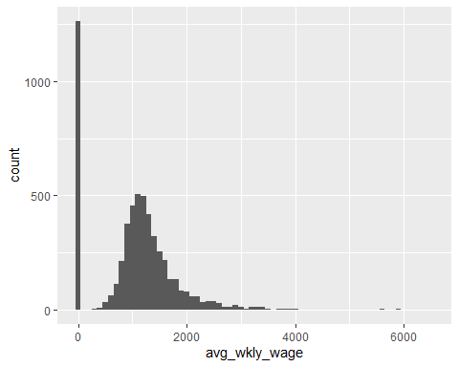

#Denisty Plot of average weekly wages  
ggplot(fin_act_df, aes(x=avg_wkly_wage)) +  
 geom_density(fill="#69b3a2", color="#e9ecef", alpha=0.8)

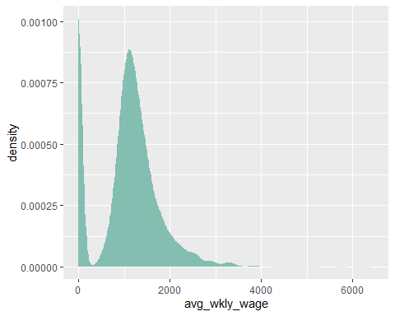

#Historam of average   
ggplot(fin_act_df, aes(x=lq_avg_wkly_wage)) + geom_histogram()

## `stat_bin()` using `bins = 30`. Pick better value with `binwidth`.

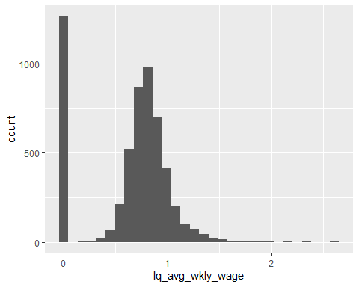

#Historam of quarterly contributions  
ggplot(fin_act_df, aes(x=qtrly_contributions)) + geom_histogram(binwidth = 10000000000)

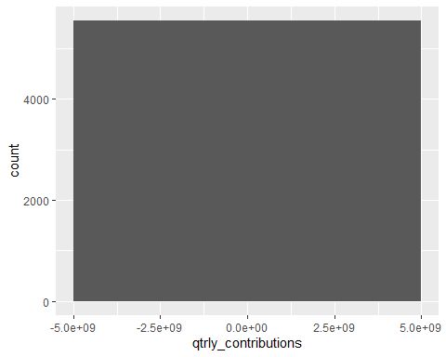

#Denisty Plot of quarterly contributions  
ggplot(fin_act_df, aes(x=qtrly_contributions)) +  
 geom_density(fill="#69b3a2", color="#e9ecef", alpha=0.8)

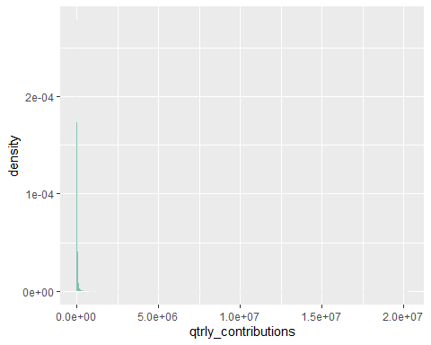

#Denisty Plot of average weekly wages  
ggplot(fin_act_df, aes(x=lq_qtrly_estabs)) +  
 geom_density(fill="#69b3a2", color="#e9ecef", alpha=0.8)

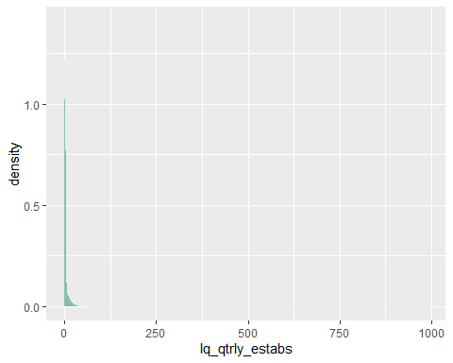

#Need to filter the data by a level code. #Level code 53 Statewide, by Supersector – by ownership sector

head(fin_act_df)

## area_fips own_code industry_code agglvl_code size_code year qtr  
## 1 1000 1 1023 53 0 2020 4  
## 2 1000 2 1023 53 0 2020 4  
## 3 1000 3 1023 53 0 2020 4  
## 4 1000 5 1023 53 0 2020 4  
## 5 1001 3 1023 73 0 2020 4  
## 6 1001 5 1023 73 0 2020 4  
## disclosure_code qtrly_estabs month1_emplvl month2_emplvl month3_emplvl  
## 1 18 136 142 146  
## 2 N 2 0 0 0  
## 3 133 1677 1675 1679  
## 4 14092 96165 95753 95065  
## 5 N 1 0 0 0  
## 6 120 399 393 401  
## total_qtrly_wages taxable_qtrly_wages qtrly_contributions avg_wkly_wage  
## 1 3255664 0 0 1772  
## 2 0 0 0 0  
## 3 22571083 466753 4858 1035  
## 4 1970245660 62202613 966314 1584  
## 5 0 0 0 0  
## 6 5675563 290647 3720 1098  
## lq_disclosure_code lq_qtrly_estabs lq_month1_emplvl lq_month2_emplvl  
## 1 1.85 0.80 0.83  
## 2 N 1.37 0.00 0.00  
## 3 5.50 2.79 2.74  
## 4 1.16 0.85 0.84  
## 5 N 5.99 0.00 0.00  
## 6 1.43 0.62 0.61  
## lq_month3_emplvl lq_total_qtrly_wages lq_taxable_qtrly_wages  
## 1 0.85 0.71 0.00  
## 2 0.00 0.00 0.00  
## 3 2.76 2.87 1.11  
## 4 0.83 0.75 0.75  
## 5 0.00 0.00 0.00  
## 6 0.63 0.48 0.71  
## lq_qtrly_contributions lq_avg_wkly_wage oty_disclosure_code  
## 1 0.00 0.85   
## 2 0.00 0.00 N  
## 3 1.81 1.04   
## 4 0.92 0.89   
## 5 0.00 0.00 N  
## 6 0.69 0.77   
## oty_qtrly_estabs_chg oty_qtrly_estabs_pct_chg oty_month1_emplvl_chg  
## 1 0 0.0 -1  
## 2 0 0.0 0  
## 3 -1 -0.7 -46  
## 4 364 2.7 297  
## 5 0 0.0 0  
## 6 1 0.8 -5  
## oty_month1_emplvl_pct_chg oty_month2_emplvl_chg oty_month2_emplvl_pct_chg  
## 1 -0.7 2 1.4  
## 2 0.0 0 0.0  
## 3 -2.7 -52 -3.0  
## 4 0.3 -169 -0.2  
## 5 0.0 0 0.0  
## 6 -1.2 -11 -2.7  
## oty_month3_emplvl_chg oty_month3_emplvl_pct_chg oty_total_qtrly_wages_chg  
## 1 11 8.1 41752  
## 2 0 0.0 0  
## 3 -52 -3.0 2554451  
## 4 -958 -1.0 213222335  
## 5 0 0.0 0  
## 6 -3 -0.7 474375  
## oty_total_qtrly_wages_pct_chg oty_taxable_qtrly_wages_chg  
## 1 1.3 0  
## 2 0.0 0  
## 3 12.8 100770  
## 4 12.1 1215500  
## 5 0.0 0  
## 6 9.1 997  
## oty_taxable_qtrly_wages_pct_chg oty_qtrly_contributions_chg  
## 1 0.0 0  
## 2 0.0 0  
## 3 27.5 1064  
## 4 2.0 154025  
## 5 0.0 0  
## 6 0.3 -287  
## oty_qtrly_contributions_pct_chg oty_avg_wkly_wage_chg  
## 1 0.0 -28  
## 2 0.0 0  
## 3 28.0 143  
## 4 19.0 175  
## 5 0.0 0  
## 6 -7.2 108  
## oty_avg_wkly_wage_pct_chg  
## 1 -1.6  
## 2 0.0  
## 3 16.0  
## 4 12.4  
## 5 0.0  
## 6 10.9

fin_act_C53_df <- fin_act_df[fin_act_df$agglvl_code == '53',]

head(fin_act_C53_df)

## area_fips own_code industry_code agglvl_code size_code year qtr  
## 1 1000 1 1023 53 0 2020 4  
## 2 1000 2 1023 53 0 2020 4  
## 3 1000 3 1023 53 0 2020 4  
## 4 1000 5 1023 53 0 2020 4  
## 145 2000 1 1023 53 0 2020 4  
## 146 2000 2 1023 53 0 2020 4  
## disclosure_code qtrly_estabs month1_emplvl month2_emplvl month3_emplvl  
## 1 18 136 142 146  
## 2 N 2 0 0 0  
## 3 133 1677 1675 1679  
## 4 14092 96165 95753 95065  
## 145 5 25 26 26  
## 146 N 15 0 0 0  
## total_qtrly_wages taxable_qtrly_wages qtrly_contributions avg_wkly_wage  
## 1 3255664 0 0 1772  
## 2 0 0 0 0  
## 3 22571083 466753 4858 1035  
## 4 1970245660 62202613 966314 1584  
## 145 656187 0 0 1967  
## 146 0 0 0 0  
## lq_disclosure_code lq_qtrly_estabs lq_month1_emplvl lq_month2_emplvl  
## 1 1.85 0.80 0.83  
## 2 N 1.37 0.00 0.00  
## 3 5.50 2.79 2.74  
## 4 1.16 0.85 0.84  
## 145 2.99 0.96 1.01  
## 146 N 59.64 0.00 0.00  
## lq_month3_emplvl lq_total_qtrly_wages lq_taxable_qtrly_wages  
## 1 0.85 0.71 0.00  
## 2 0.00 0.00 0.00  
## 3 2.76 2.87 1.11  
## 4 0.83 0.75 0.75  
## 145 1.02 0.82 0.00  
## 146 0.00 0.00 0.00  
## lq_qtrly_contributions lq_avg_wkly_wage oty_disclosure_code  
## 1 0.00 0.85   
## 2 0.00 0.00 N  
## 3 1.81 1.04   
## 4 0.92 0.89   
## 145 0.00 0.82   
## 146 0.00 0.00 N  
## oty_qtrly_estabs_chg oty_qtrly_estabs_pct_chg oty_month1_emplvl_chg  
## 1 0 0.0 -1  
## 2 0 0.0 0  
## 3 -1 -0.7 -46  
## 4 364 2.7 297  
## 145 0 0.0 0  
## 146 0 0.0 0  
## oty_month1_emplvl_pct_chg oty_month2_emplvl_chg oty_month2_emplvl_pct_chg  
## 1 -0.7 2 1.4  
## 2 0.0 0 0.0  
## 3 -2.7 -52 -3.0  
## 4 0.3 -169 -0.2  
## 145 0.0 1 4.0  
## 146 0.0 0 0.0  
## oty_month3_emplvl_chg oty_month3_emplvl_pct_chg oty_total_qtrly_wages_chg  
## 1 11 8.1 41752  
## 2 0 0.0 0  
## 3 -52 -3.0 2554451  
## 4 -958 -1.0 213222335  
## 145 3 13.0 8021  
## 146 0 0.0 0  
## oty_total_qtrly_wages_pct_chg oty_taxable_qtrly_wages_chg  
## 1 1.3 0  
## 2 0.0 0  
## 3 12.8 100770  
## 4 12.1 1215500  
## 145 1.2 0  
## 146 0.0 0  
## oty_taxable_qtrly_wages_pct_chg oty_qtrly_contributions_chg  
## 1 0.0 0  
## 2 0.0 0  
## 3 27.5 1064  
## 4 2.0 154025  
## 145 0.0 0  
## 146 0.0 0  
## oty_qtrly_contributions_pct_chg oty_avg_wkly_wage_chg  
## 1 0 -28  
## 2 0 0  
## 3 28 143  
## 4 19 175  
## 145 0 -82  
## 146 0 0  
## oty_avg_wkly_wage_pct_chg  
## 1 -1.6  
## 2 0.0  
## 3 16.0  
## 4 12.4  
## 145 -4.0  
## 146 0.0

#Min  
min(fin_act_C53_df$total_qtrly_wages)

## [1] 0

#Max  
max(fin_act_C53_df$total_qtrly_wages)

## [1] 35504756396

#Median  
median(fin_act_C53_df$total_qtrly_wages)

## [1] 5740782

#Mean  
mean(fin_act_C53_df$total_qtrly_wages)

## [1] 1216410953

#Median  
median(fin_act_C53_df$avg_wkly_wage)

## [1] 1536

#Denisty Plot of qtrly_establishment  
ggplot(fin_act_C53_df, aes(x=qtrly_estabs)) +  
 geom_density(fill="#69b3a2", color="#e9ecef", alpha=0.8)

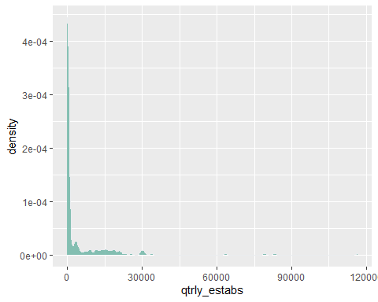

#Histogram of month2_emplvl  
ggplot(fin_act_C53_df, aes(x=month2_emplvl)) + geom_histogram(binwidth = 100000)

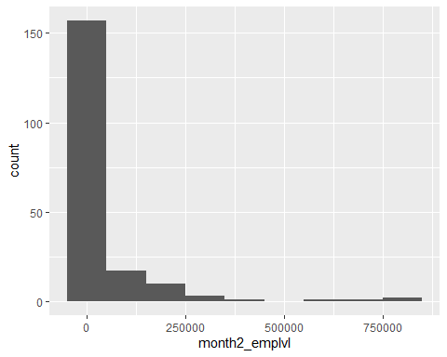

#Density plot of oty_month1_emplvl_chg  
ggplot(fin_act_C53_df, aes(x=oty_month1_emplvl_chg)) +  
 geom_density(fill="#69b3a2", color="#e9ecef", alpha=0.8)

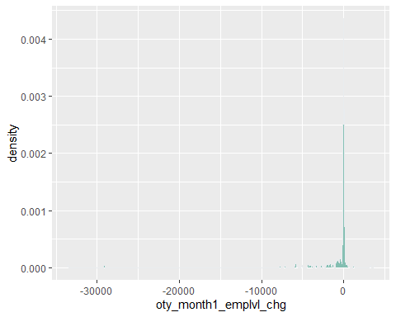

#Boxplot of month 3 Employment and own code  
ggplot(fin_act_C53_df, aes(x=month3_emplvl, y=own_code, group=own_code)) +   
 geom_boxplot() + facet_wrap(~own_code)

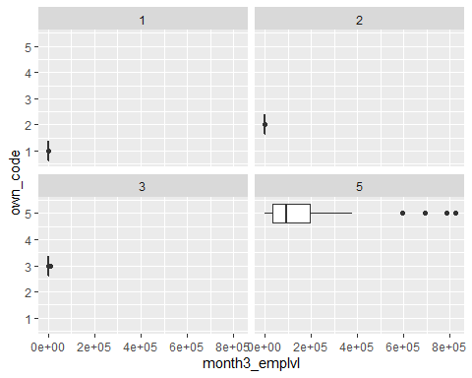

#Bar graph of own codes  
ggplot(fin_act_C53_df) +  
 geom_bar(mapping = aes(x = own_code))

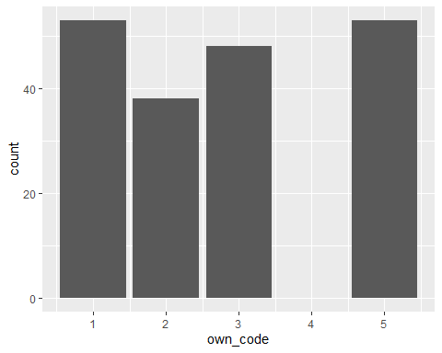

#2. Explore Some Bivariate Relations #Use the same dataset within the same website to explore some bivariate relations #(e.g. bivariate plot, correlation, table cross table etc.)

install.packages("ggpubr", repos = "http://cran.us.r-project.org")

## Installing package into 'C:/Users/Tushar/Documents/R/win-library/3.6'  
## (as 'lib' is unspecified)

## package 'ggpubr' successfully unpacked and MD5 sums checked  
##   
## The downloaded binary packages are in  
## C:\Users\Tushar\AppData\Local\Temp\Rtmpg3gQFj\downloaded_packages

library("ggpubr")

#Checking to see Quarterly wage correlate to Taxable Quarter Wages

ggscatter(fin_act_C53_df, x = "total_qtrly_wages", y = "taxable_qtrly_wages",   
 add = "reg.line", conf.int = TRUE,   
 cor.coef = TRUE, cor.method = "pearson",  
 xlab = "Total Quarterly Wages", ylab = "Taxable Quarterly Wages")

## `geom_smooth()` using formula 'y ~ x'

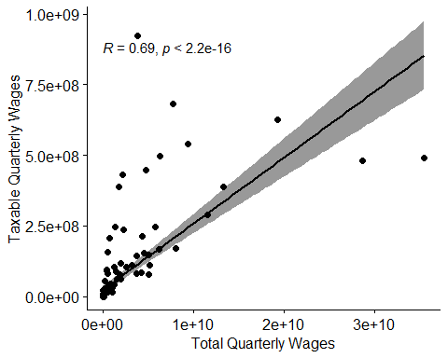

#QQPlot

# total_qtrly_wages  
ggqqplot(fin_act_C53_df$total_qtrly_wages, ylab = "total_qtrly_wages")

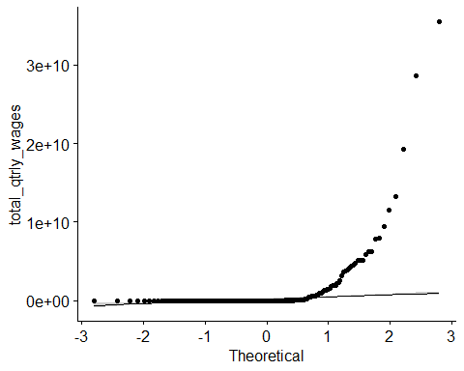

# Taxable Quarterly Wages  
ggqqplot(fin_act_C53_df$taxable_qtrly_wages, ylab = "taxable_qtrly_wages")

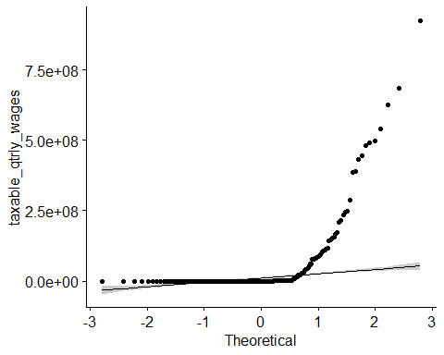

#Pearson Correlation

person_cor <- cor.test(fin_act_C53_df$total_qtrly_wages,   
 fin_act_C53_df$taxable_qtrly_wages, method = "pearson")  
person_cor

##   
## Pearson's product-moment correlation  
##   
## data: fin_act_C53_df$total_qtrly_wages and fin_act_C53_df$taxable_qtrly_wages  
## t = 13.168, df = 190, p-value < 2.2e-16  
## alternative hypothesis: true correlation is not equal to 0  
## 95 percent confidence interval:  
## 0.6087066 0.7582125  
## sample estimates:  
## cor   
## 0.6907718

#Pearson Correlation:

#t is the t-test statistic value (t = 13.168), #df is the degrees of freedom (df= 190), #p-value is p-value = 2.2e^-16}). conf.int is the confidence interval of the correlation coefficient at 95% (conf.int = [0.6087, 0.7582]);

sample estimates is the correlation coefficient (Cor.coeff = 0.6907).

#Kendall Rank Correlation

kendall_cor <- cor.test(fin_act_C53_df$total_qtrly_wages,   
 fin_act_C53_df$taxable_qtrly_wages, method="kendall")  
kendall_cor

##   
## Kendall's rank correlation tau  
##   
## data: fin_act_C53_df$total_qtrly_wages and fin_act_C53_df$taxable_qtrly_wages  
## z = 12.692, p-value < 2.2e-16  
## alternative hypothesis: true tau is not equal to 0  
## sample estimates:  
## tau   
## 0.6706145

#Kendall Correlation: #Correlation coeffient between total quarterly wages and taxable quarterly wages #0.6706 and p-value = 2.2e^-16

#Spearman Correlation

spreaman_cor <-cor.test(fin_act_C53_df$total_qtrly_wages,   
 fin_act_C53_df$taxable_qtrly_wages, method = "spearman")

## Warning in cor.test.default(fin_act_C53_df$total_qtrly_wages,  
## fin_act_C53_df$taxable_qtrly_wages, : Cannot compute exact p-value with ties

spreaman_cor

##   
## Spearman's rank correlation rho  
##   
## data: fin_act_C53_df$total_qtrly_wages and fin_act_C53_df$taxable_qtrly_wages  
## S = 230102, p-value < 2.2e-16  
## alternative hypothesis: true rho is not equal to 0  
## sample estimates:  
## rho   
## 0.8049345

#Spearman Correlation: #Correlation coefficient between quarterly wages and taxable quarterly wages is #0.8049 rho and p-value is 2.2e^-16

#Based on this these correlation I would say we have a positive correlation between #quarterly wages and taxable quarterly wages.

#It is on a perfect correlation but strong positive correlation: #Pearson: 0.6907 #Kendall: 0.6706 #Spearan: 0.8049

#If quarter wages go up so does taxable quarterly wages.

#3. Organize a Data Report #Generate a summary report. Make sure to include: summary for every variable, #structure and type of data elements, discuss four results of your data.

str(fin_act_C53_df)

## 'data.frame': 192 obs. of 42 variables:  
## $ area_fips : Factor w/ 3707 levels "1000","10000",..: 1 1 1 1 659 659 659 659 1967 1967 ...  
## $ own_code : int 1 2 3 5 1 2 3 5 1 3 ...  
## $ industry_code : int 1023 1023 1023 1023 1023 1023 1023 1023 1023 1023 ...  
## $ agglvl_code : int 53 53 53 53 53 53 53 53 53 53 ...  
## $ size_code : int 0 0 0 0 0 0 0 0 0 0 ...  
## $ year : int 2020 2020 2020 2020 2020 2020 2020 2020 2020 2020 ...  
## $ qtr : int 4 4 4 4 4 4 4 4 4 4 ...  
## $ disclosure_code : Factor w/ 3 levels "","-","N": 1 3 1 1 1 3 3 1 1 1 ...  
## $ qtrly_estabs : int 18 2 133 14092 5 15 3 1540 12 18 ...  
## $ month1_emplvl : int 136 0 1677 96165 25 0 0 10395 125 761 ...  
## $ month2_emplvl : int 142 0 1675 95753 26 0 0 10384 126 764 ...  
## $ month3_emplvl : int 146 0 1679 95065 26 0 0 10309 127 784 ...  
## $ total_qtrly_wages : num 3.26e+06 0.00 2.26e+07 1.97e+09 6.56e+05 ...  
## $ taxable_qtrly_wages : int 0 0 466753 62202613 0 0 0 54053368 0 179839 ...  
## $ qtrly_contributions : int 0 0 4858 966314 0 0 0 816004 0 7386 ...  
## $ avg_wkly_wage : int 1772 0 1035 1584 1967 0 0 1392 2220 1070 ...  
## $ lq_disclosure_code : Factor w/ 2 levels "","N": 1 2 1 1 1 2 2 1 1 1 ...  
## $ lq_qtrly_estabs : num 1.85 1.37 5.5 1.16 2.99 ...  
## $ lq_month1_emplvl : num 0.8 0 2.79 0.85 0.96 0 0 0.59 0.5 0.86 ...  
## $ lq_month2_emplvl : num 0.83 0 2.74 0.84 1.01 0 0 0.61 0.5 0.84 ...  
## $ lq_month3_emplvl : num 0.85 0 2.76 0.83 1.02 0 0 0.61 0.5 0.87 ...  
## $ lq_total_qtrly_wages : num 0.71 0 2.87 0.75 0.82 0 0 0.41 0.48 0.83 ...  
## $ lq_taxable_qtrly_wages : num 0 0 1.11 0.75 0 0 0 0.98 0 0.29 ...  
## $ lq_qtrly_contributions : num 0 0 1.81 0.92 0 0 0 0.96 0 1.41 ...  
## $ lq_avg_wkly_wage : num 0.85 0 1.04 0.89 0.82 0 0 0.68 0.97 0.97 ...  
## $ oty_disclosure_code : Factor w/ 2 levels "","N": 1 2 1 1 1 2 2 1 1 2 ...  
## $ oty_qtrly_estabs_chg : int 0 0 -1 364 0 0 0 118 0 0 ...  
## $ oty_qtrly_estabs_pct_chg : num 0 0 -0.7 2.7 0 0 0 8.3 0 0 ...  
## $ oty_month1_emplvl_chg : int -1 0 -46 297 0 0 0 -852 0 0 ...  
## $ oty_month1_emplvl_pct_chg : num -0.7 0 -2.7 0.3 0 0 0 -7.6 0 0 ...  
## $ oty_month2_emplvl_chg : int 2 0 -52 -169 1 0 0 -723 -2 0 ...  
## $ oty_month2_emplvl_pct_chg : num 1.4 0 -3 -0.2 4 0 0 -6.5 -1.6 0 ...  
## $ oty_month3_emplvl_chg : int 11 0 -52 -958 3 0 0 -733 1 0 ...  
## $ oty_month3_emplvl_pct_chg : num 8.1 0 -3 -1 13 0 0 -6.6 0.8 0 ...  
## $ oty_total_qtrly_wages_chg : num 4.18e+04 0.00 2.55e+06 2.13e+08 8.02e+03 ...  
## $ oty_total_qtrly_wages_pct_chg : num 1.3 0 12.8 12.1 1.2 0 0 5.2 1.2 0 ...  
## $ oty_taxable_qtrly_wages_chg : int 0 0 100770 1215500 0 0 0 -1470347 0 0 ...  
## $ oty_taxable_qtrly_wages_pct_chg: num 0 0 27.5 2 0 0 0 -2.6 0 0 ...  
## $ oty_qtrly_contributions_chg : int 0 0 1064 154025 0 0 0 -27202 0 0 ...  
## $ oty_qtrly_contributions_pct_chg: num 0 0 28 19 0 0 0 -3.2 0 0 ...  
## $ oty_avg_wkly_wage_chg : int -28 0 143 175 -82 0 0 161 32 0 ...  
## $ oty_avg_wkly_wage_pct_chg : num -1.6 0 16 12.4 -4 0 0 13.1 1.5 0 ...