Details of Misc/Capillary_Transmission

Documentation  
 Provides the transmission of X-ray through a capillary tube  
 x : Independent variable in the form of a scalar or an array  
 Xh : center of the hole in mm if the capillary is mounted within a hole  
 Dh : width of hole in mm if the capillary is mounted within a hole  
 Xch : Center of the capillary tube w.r.t the hole center  
 Dc : Inner diameter of the capillary tube in mm  
 tc : thickness of glass wall in mm  
 lc : absorption length of capillary tube wall in mm  
 ls : absorption length of sample inside the capillary tube  
 Db : width of the X-ray beam in mm assuming the beam profile to rectangular  
 norm : Normalization factor  
 bkg : background  
 Npt : No. of points to be used for beam profile convolution

The Capillary Transmission function calculates the ratio of the intensities of the transmitted X-rays to the incident X-rays as a function of the position, $x$, of a capillary tube, holding a sample within it, with respect to the direct X-ray beam. The absorption lengths of the capillary tube and the sample are assumed to $l_{c}$ and $l_{s}$, respectively. The capillary tube of inner diameter, $D_{c}$, and thickness, $t_{c}$, is assumed to be placed on a capillary tube holder with a circular window as shown in Figure 1. The hole is assumed to be centered at $X_{h}$ from the direct beam position along the X-direction, and the capillary tube is assumed to be offset by $X_{ch}$ from the hole center.

$$T\left(x\right)=\exp\left(-2\left(\frac{t_{sx}\left(x,D_{c},X_{c},X_{ch}\right)}{l_{s}}+\frac{t_{cx}\left(x,D_{c},X_{ch},t_{c},D_{h}\right)-t_{sx}\left(x,D_{c},X_{c},X_{ch}\right)}{l_{c}}\right)\right)H\left(x,D_{h},X_{h}\right)$$

Where,

$$t_{sx}=\sqrt{\left(\frac{D_{c}^{2}}{4}-{\left({x-X}_{h}+X_{ch}\right)}^{2}\right)} ∀ \left|x-X_{h}+X_{ch}\right|≤\frac{D_{c}}{2}$$ $=0 ∀ \left|x-X_{h}+X_{ch}\right|>\frac{D_{c}}{2}$,

$$t_{cx}\left(x,D_{c},{X_{ch},t_{c}, D}_{h},X_{h}\right)=\sqrt{\left(\frac{{\left(D_{c}+2t_{c}\right)}^{2}}{4}-{\left(x-X_{h}+X_{ch}\right)}^{2}\right)}∀ \left|x-X_{c}+X_{ch}\right|≤\frac{D_{c}+2t_{c}}{2}$$ $=0 ∀ \left|x-X_{c}+X_{ch}\right|>\frac{D_{c}+2t_{c}}{2}$,

and

$$H\left(x,D_{h},X_{h}\right)=0 ∀ \left|x-X_{h}\right|>\frac{D_{h}}{2} \\ =1 ∀ \left|x-X_{h}\right|≤\frac{D_{h}}{2}$$

The above function is only for X-ray beams of point size. For the X-ray beam of finite size the above function needs to be convoluted with the square function, $B\left(x,D_{B}\right),$ where $D_{B}$ is the beam width. Hence, the transmission function, broadened by the beam finite beam width with an arbitrary normalization, $norm$, and background, $bkg$, can provided by:

$$T_{B}\left(x\right)=norm*T\left(x\right)⊗B\left(x,D_{B}\right)+bkg$$

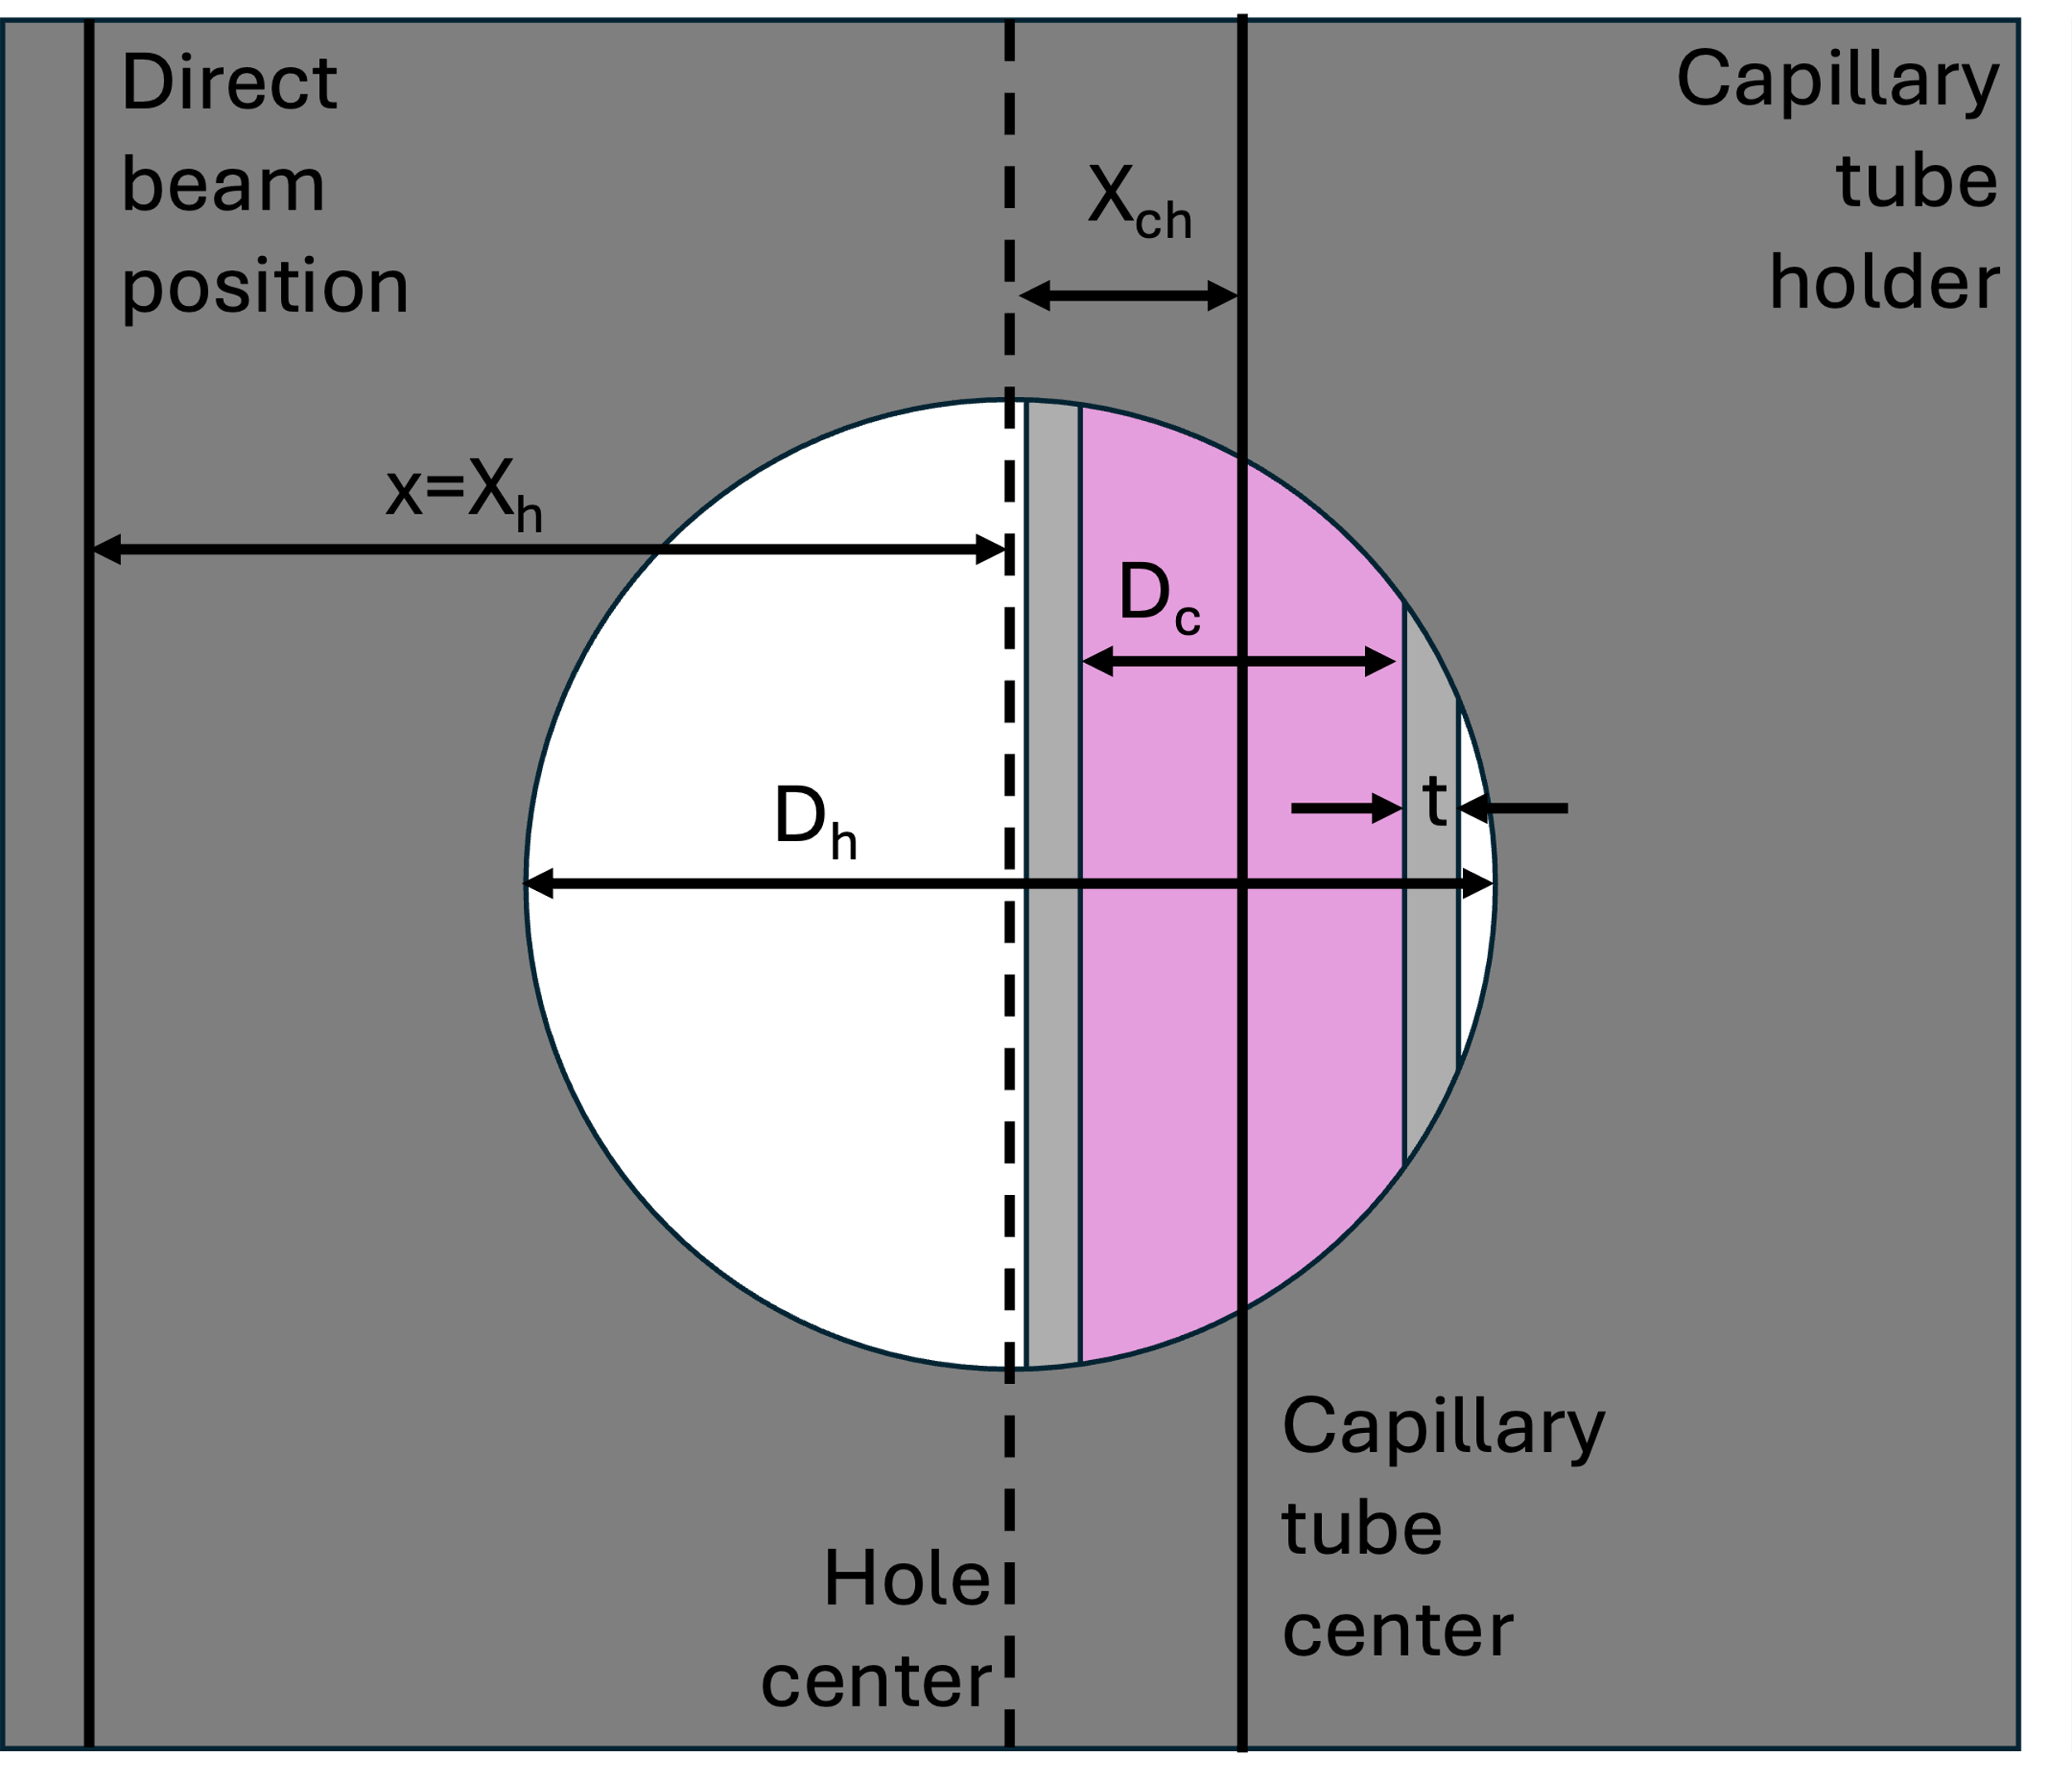

Figure 1 Schematics of the front view of the capillary tube within a capillary tube holder

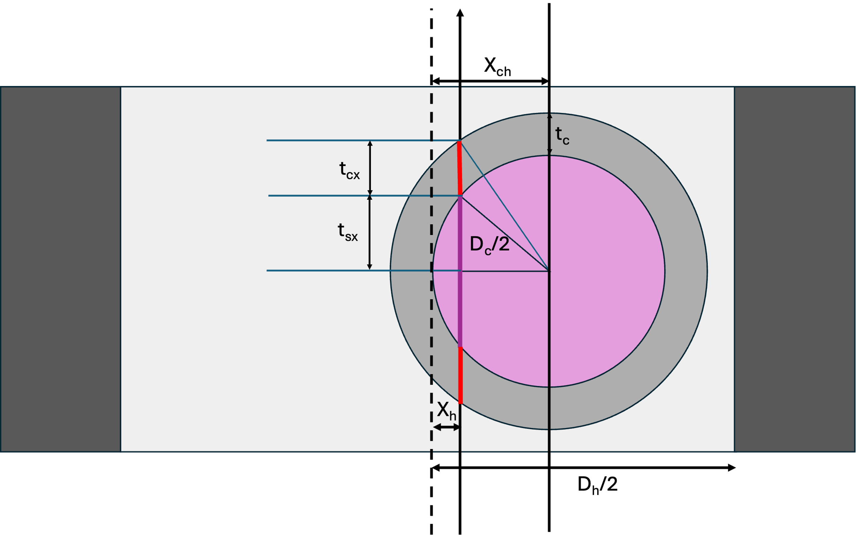

Figure 2: Schematics of the top view of the capillary tube within a capillarty tube holder to show different transmission regions when the direct beam transmits through the capillary tube.

It is noted that while trying to fit the function with experimental transmission data collected from capillary tubes mounted on a capillary tube holder with circular window, the Levenberg-Marquardt algorithm does not fit the hole parameters, $X_{h}$ and $D_{h}$. The global minimization algorithm provided by ‘Differential-Evolution’ can only be used to obtain the optimized $X_{h}$ and $D_{h}$ parameters along with other parameters. The issue with global optimization is it does not provide error-bars on the parameters. Hence, error-bars on other parameters can obtained by again carrying out the fit with the Levenberg-Marquardt algorithm and fixing the hole parameters to the values obtained from global optimization.