Hey Guys!

First of all, I want to thank you for being a part of this project, even though you are not entirely sure what it is. You guys are not just random folks, you are kind of a sounding board, and maybe even a voice of sanity if you like. I want to give you guys early access just for helping me out, for lending your ears and eyes.

<BADASS picture>

Second, there is so much I want to talk about. I want to talk about being poor, about all the cool math going into this project, and my education, (which has to do with control systems and robotics.) Anyway I can’t do that in a single update, so I’m just going to highlight some of my pre-alpha progress, some of the story. For these few first updates I’m just going to tell you what I’m up to every week or two.

Imagine Being a Prisoner

Imagine you woke up in a military facility, one full of not only doctors performing strange experements on you, but in a facility that is patrolled by lanky robots, who drag their claws across the walls wryly, and wisper through the ducts at all hours of the night. Imagine month after month passes, and you slowly lose grips with who you are, and why you are there. I for sure have ton’s of inspiration for this, and here is a good video short if you want to feel what I feel:

(Concept: https://www.youtube.com/watch?feature=player_embedded&v=WfI69DC_jaw)

Then one lucky day commotion erupts; you have a breif moment to escape, as the whole building reverberates with what feels like a bomb. Someone says the rebels are attacking. Despite a persistant weakness in your legs, and all of the crusted sleep in your eyes, you staggar into an aircraft hangar, and pry open in what *appears* to be a simple an escape pod.

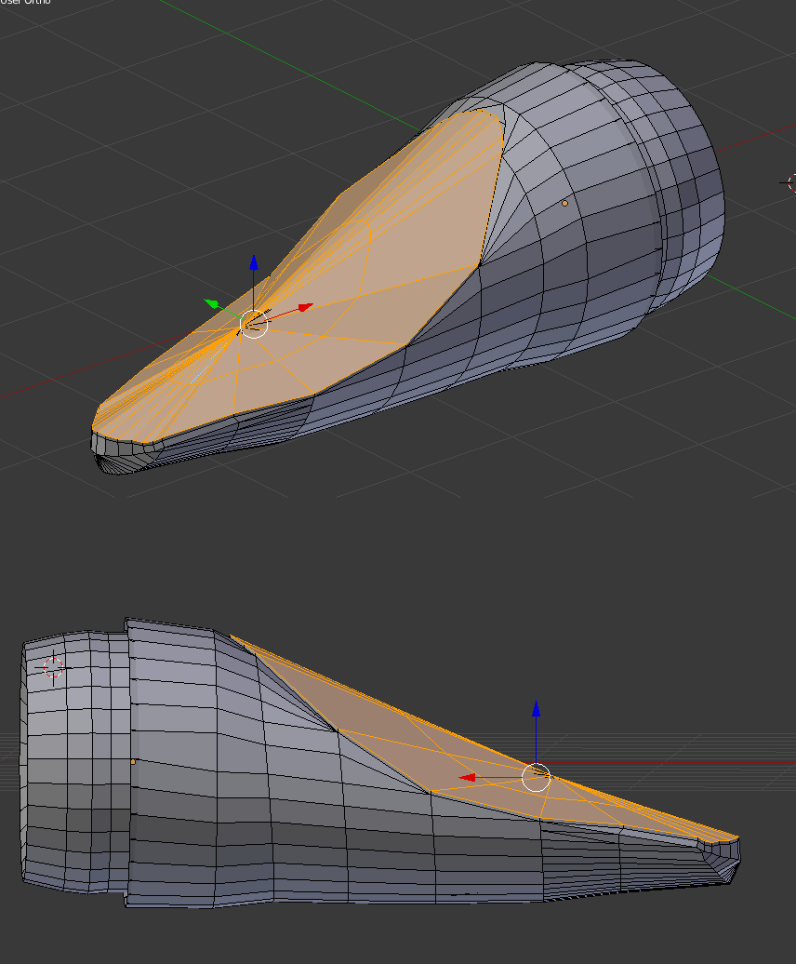

As you slide into the cockpit, none of the buttons are where they are supposed to be. In addition, there are more of them, more gizmos and flashing screens than you have ever seen in any shi[. Just as you reach for a button a female voice speaks up, “You probbably don’t want to touch that.”

The ship introduces herself with a gentile voice: “I’m . . . S.A.M. and I’m ready for testing protocol alpha as instructed. Is it time for a test run?”

You say. “Jesus Christ god please just take off of the planet.”

And with that you are launched into an unknown galaxy. The viewscreen is strange. In fact, you can seemingly toggle from a 2d map view to a 3d view at a moments whim. This is actually, as it turns out, really important, because you launch into an asteroid field, and there is no way that a standard 3d-view would show you all the dangers flying at you from around the ship.

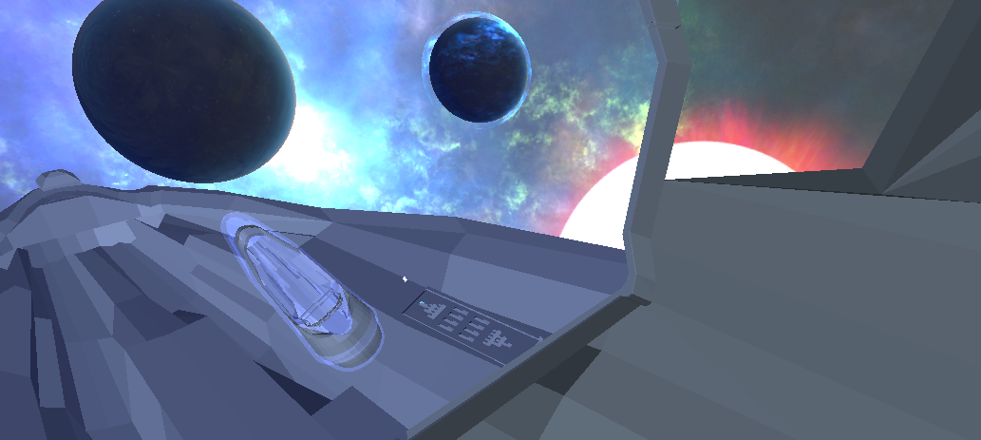

So that’s the game, or the beginning at least. The core feature I’m working on, which is coming along quite well, is this viewscreen. It’s taking what can only be called an extreme amount of effort.

**The effing Viewscreen**

It grants the ability to toggle between a 2d-side scrolling arcade game and 3d-space flight simulator with a button press. Sometimes it’s best (like in an asteroid field) to play in 2d as objects, ships and bullets can fly at the ship from many different angles. Other times, like in a dogfight, or when searching for intresting stars across the galaxy, the 3d view will be superior.

On top of that, the view is capable of plotting paths through the entire galaxy and the current star system. It is able to zoom in and zoom out depending on how much sensor power you are willing to spend. Energy waste aside maximum distance scanning is a terrible idea, because the more you scan a system the more your sensors act as a beacon for the military enemies, reducing your escape potential.

Aside from a screen, there will be at least 7 spacecraft panels in the spacecraft interior, showing readouts that relate to many of the ships sub systems. They are ALL interacive, at least with the mouse, and can be fun to play with in their own right. (My favourite part of games are the functional details, consoles, readouts, things that mean something showing a well thought out functional world.)

Lets take one (almost finished) panel as an example, and gloss over Machine Learning and Spacecraft Control.

Thrusters / Spacecraft Dymanics and Control

This panel shows the status of all of the thrusters on the spaceship. (Currently there 10 external thrusters.)

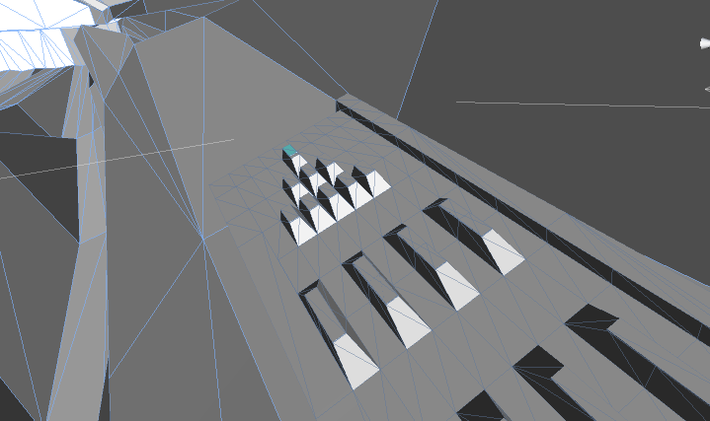

The panel shows the operating ability and current status of each external thruster. From a player standpoint, the ship’s navigation system is controlled with the arrow keys and mouse. (yes, you can press the thruster buttons manually– but there is no point past extremely awesome novelty.)

When the player is using the viewscreen, they can aim where they want with the mouse, and use the keyboard to control movement, like a first person shooter in space, in either 2d or 3d. The 3d plays like Call of Duty, 2d plays like an old game called Abuse.

The thing is, it’s not goddam magic. No no. When you give commands, the ship’s computer figures out (in real time, using machine learning,) which of the thrusters to fire on the outside of the spaceship to both orient the ship and generate the desired speed. Instead of having a fake-ish spaceship thet glides through space like magic, you will be playing a spacecraft that will handle exactly as if it was the real thing (err, if we had the kind of badass thrusters I’m making at least). What’s more, the individual thrusters on the outside can be damaged:

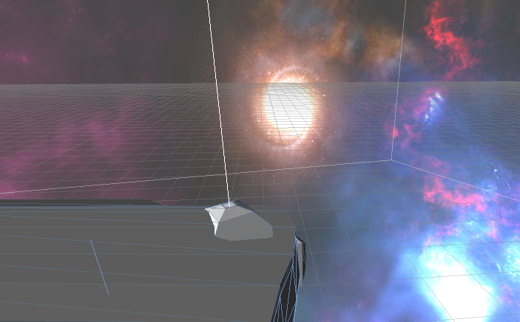

So you have to be careful. Lucky for you, S.A.M. is pretty smart. Even with a few broken sensors, she can usually figure out how to get you moving again, even it if isn’t as smooth as it was.

So I guess that’sa good initial taste. As soon as I have some (passable) videos you can expect to see some awesome spaceship updates. And I’ll be in touch soon. As you may have been able to tell, 3d art is not the point of the game, but really deep functionality and gameplay is. If you are into realistic, stressful, hard like “OMG IM GOING TO LOSE MY LEFT THRUSTER” hard gameplay, then you will love this game.

Thanks again,

Justin