# Update 0.5 – Testing 1,2,3.

Hey Guys!

First of all I want to thank you for being a part of this project even though you are not entirely sure what it is. You guys are not just random folks, you are kind of a sounding board, and maybe even a voice of sanity if you will. At this point, you can all be as much a part as you want, including attending gameplay parties where I’m libel to stuff you full of beer and listen to your awesome criticism. I want to give you early access just for helping me out, for lending your ears and eyes.

Second of all, there is so much I want to talk about! I want to talk about being poor, about all the cool math going into this project, and my education, (which has to do with control systems and robotics.) Anyway I can’t do that in a single update, so I’m just going to highlight some of the story and a couple of the initial features that are almost done. For these few first updates I’m just going to tell you what I’m up to every week or two.

Imagine Being a Prisoner

Imagine you woke up in a military facility, one full of not only doctors performing strange experements on you, but one that is patrolled by lanky robots who drag their claws across the walls wryly and wisper through the ducts at all hours of the night. Imagine that as month after month passes you slowly lose grips with who you are and why you are even in a prison. I for sure have tons of inspiration for this, and here is a good video short if you want to *feel what I feel*:

(Concept: https://www.youtube.com/watch?feature=player_embedded&v=WfI69DC_jaw)

Then one lucky day commotion erupts; you have a breif moment to escape, as the whole building reverberates with what feels like a bomb. Someone says the rebels are attacking, and despite a persistant weakness in your legs, and all of the crusted sleep in your eyes, you stagger into an aircraft hangar and pry open in what *appears* to be a simple an escape pod.

But it’s not that simple, it’s an advanced military prototype, and you just stole it.

Fleets of military ships are following you.

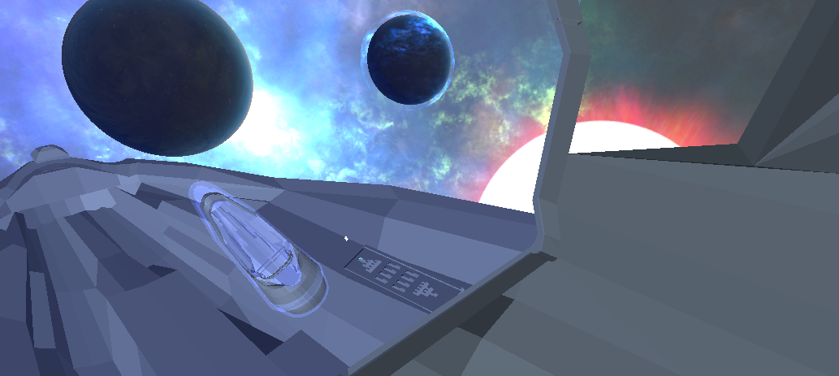

So that’s the game, or the beginning at least. The core feature I’m working on is this viewscreen, and it’s taking what can only be described as an inappropriate amount of effort.

**The effing Viewscreen**

The viewscreen grants the player the ability to toggle between a 2d-side scrolling arcade game and 3d-space flight simulator with a single button press. Sometimes it’s best to play in 2d, (like in an asteroid field,) as objects, ships, and bullets can fly at the pod from many different angles. Other times, (like when in a dogfight or flying into a giant planetoid,) the 3d view will be superior. The choice is always yours, and different play styles will demand different views.

On top of that, the view screen is capable of plotting paths through the entire galaxy and the current star system. It is able to zoom in and zoom out depending on how much sensor power you are willing to spend. Energy waste aside, maximum-distance scanning is a terrible idea, because the more you scan a system the more the ship’s sensors will act as a beacon for the military, thereby reducing your escape potential.

Aside from a screen, there will be at least 7 spacecraft panels in the spacecraft interior, showing readouts that relate to many of the ships sub systems. Lets take one panel as an example . . .

Thrusters / Spacecraft Dymanics and Control

This panel shows the status of all of the thrusters on the spaceship. (Currently there 10 external thrusters, some with multiple power levels.)

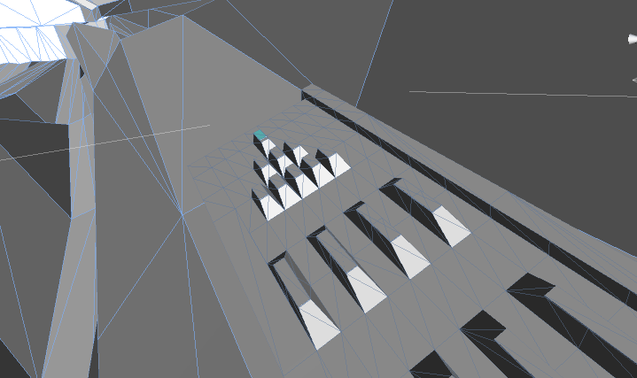

The panel shows the operating ability and current status of each external thruster. The ship’s navigation system is controlled with the arrow keys and mouse by the player in general. (And yes! you can press the thruster buttons manually—but there is no point past the extremely awesome novelty.)

When the player is using the **2d viewscreen mode or the 3d simulation mode** they can aim where they want with the mouse and use the keyboard to control movement just **like a first person shooter** in space. I,e, the 3d mode plays like Call of Duty and the 2d mode plays like an old game called Abuse.

The control system is not goddam magic.. When the arrow keys and mouse gives commands, the ship’s computer figures out (in real time, using machine learning,) which of the thrusters to fire on the outside of the spaceship to both orient the ship and generate the desired speed. Instead of having a fake-ish spaceship thet glides through space like magic, you will be playing a spacecraft that will handle exactly as if it was the real thing:

Video of a “bad” control system (what you currently see in every game:)

Video of the “real” think, which people have never seen in a space arcade game to my knowledge:

What’s more, the individual thrusters on the outside can be damaged. Here is the nose thruster:

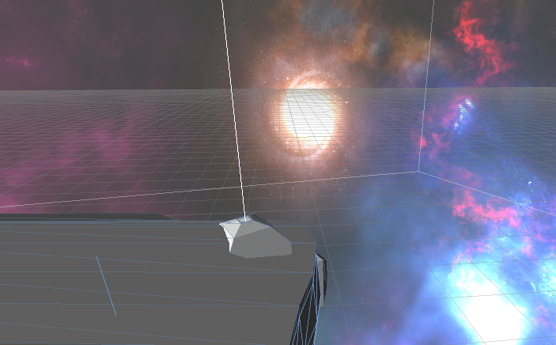

So you have to be careful. Lucky for you, S.A.M. is pretty smart. Even with a few broken sensors, she can usually figure out how to get you moving again, even it if isn’t as smooth as it was.

So I guess that’sa good initial taste. As soon as I have some cool videos you can expect to see some awesome spaceship updates. And I’ll be in touch soon. As you may have been able to tell, 3d art is not the point of the game, but really deep functionality and gameplay is. If you are into realistic, stressful, fast paced games that make a person yell “OMG IM GOING TO LOSE MY LEFT THRUSTER AND THE GREEN WORM SHIP WONT DIE” then you will love this game.

Thanks again,

Justin

P.S. At this point if you want to help me out send this email to people who might like this game, and tell them to sign up at [www.shiproguelike.com](http://www.shiproguelike.com). At some point in the next 2 months I’ll be distributing 20-30 alpha versions (first come first serve, with advanced warning,) and having a game party where we can talk nerd and have some fun, (with free booze and food.)