Test 01

*Tested UI to see if all elements were present*

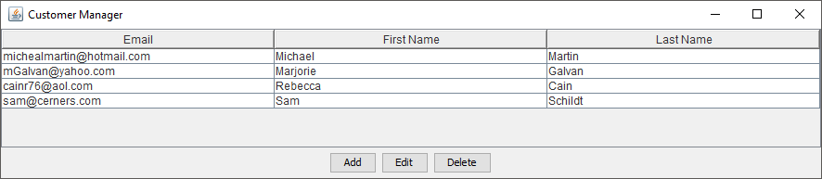

Test 02

*Tested add button functionality*

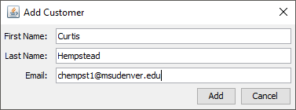

*Data was added correctly to the table and database*

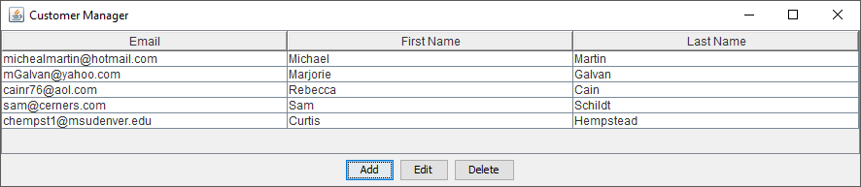

*Tested edit button functionality*

*Edit button prompt*

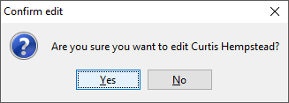

*Edit button fields*

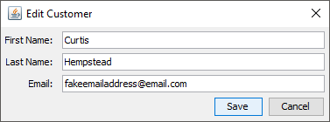

*Data was correctly edited in the database*

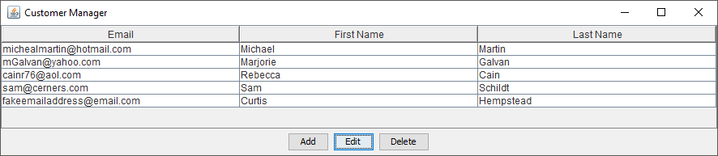

Test 03

*Tested delete button functionality*

*Data to be deleted selected*

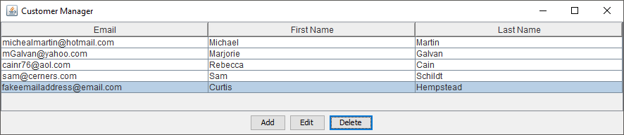

*Delete button prompt*

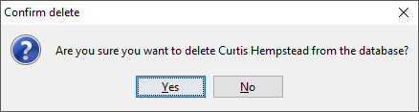

*Data was successfully deleted from the table and database*

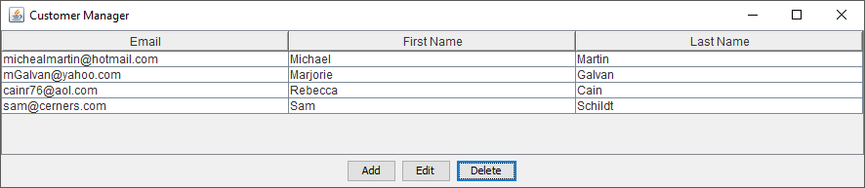

Test 04

*Tested edit and delete button functions when no data is selected*

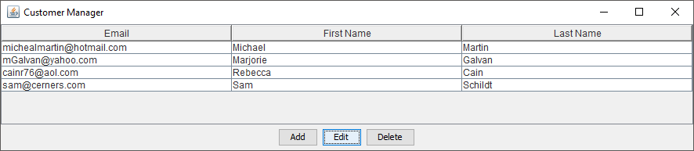

*Correct prompt is provided when clicking ‘Edit’ with no data selected*

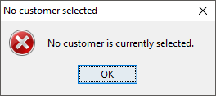

*Again, no data selected, attempting deletion*

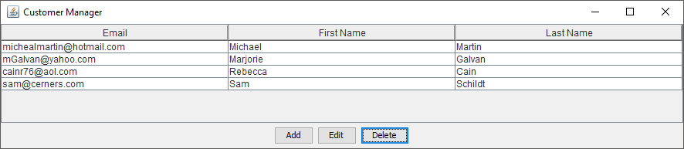

*Correct prompt is provided when clicking ‘Delete’ with no data selected*

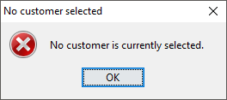

Test 05

*Tested scroll bar function when data run out of the window frame, scroll functioned appropriately*

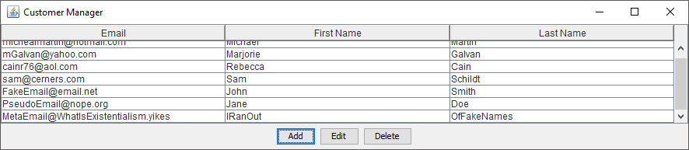

run:

BUILD SUCCESSFUL (total time: 5 minutes 12 seconds)