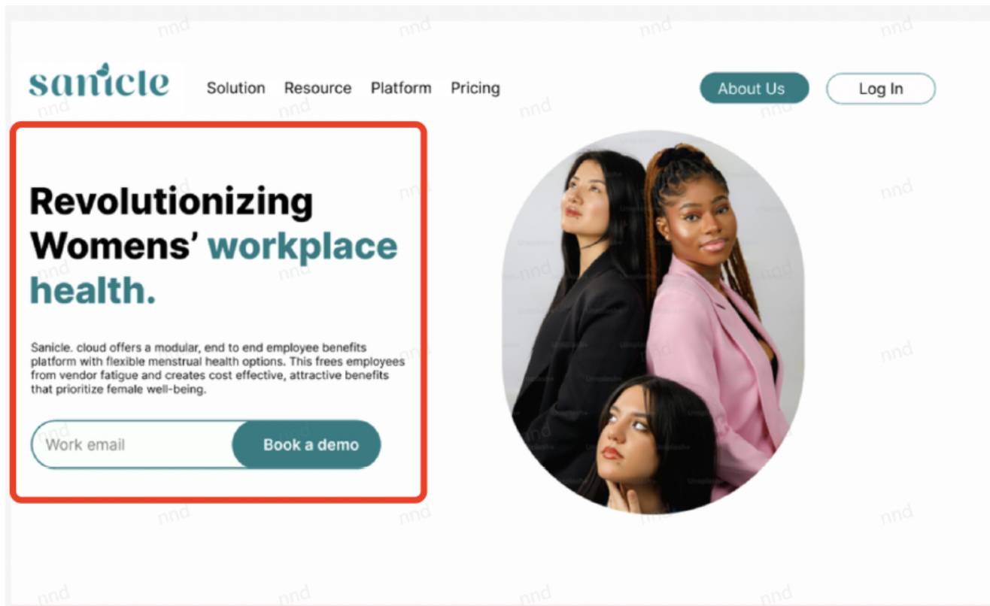

Transform Your Workplace: Boost Productivity with Women’s Health

Progressive businesses know that well-being drives performance. Sanicle.cloud empowers socially responsible employers with a seamless, data-driven health management solution that supports menstrual health, reduces absenteeism, and boosts productivity. **Because when employees feel their best, they do their best.**

**CTA优化**

保留“Book a Demo”**按钮**，文字改为：Free Demo Today

邮箱输入字段 “Get Started” or “Contact Us for a Quote”

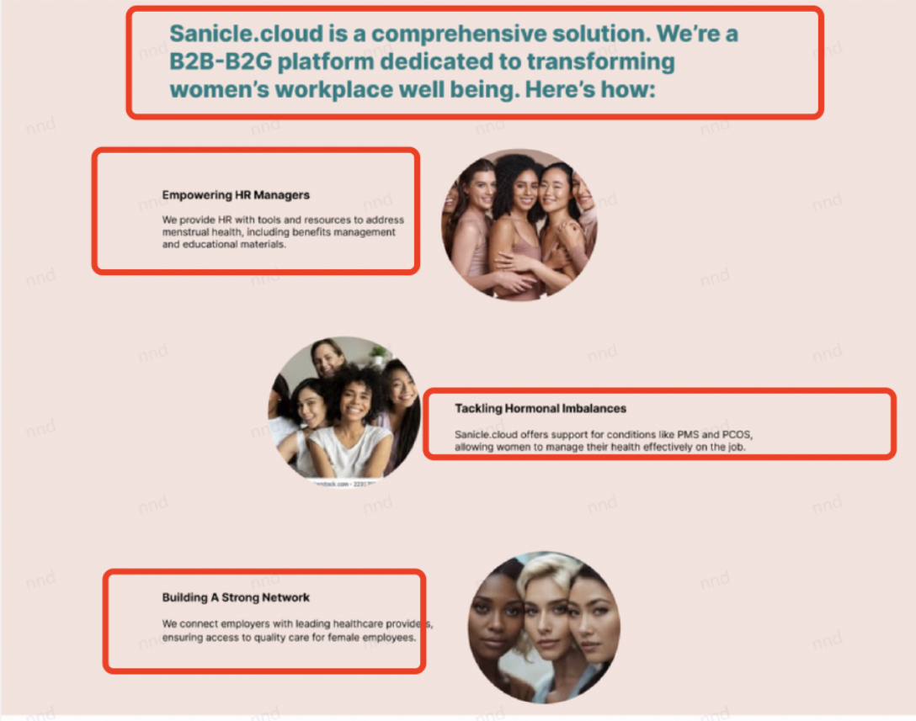

**标题：Drive Productivity and Inclusion with Women’s Health Solutions**

3个子模块：

**Personalized Cycle Tracking**

Our AI-driven cycle tracking predicts menstrual and menopausal patterns, helping women plan work and life effectively. Employers see reduced absenteeism and higher engagement – backed by data-driven insights

**Ask Sani: Your AI Health Companion**

Ask Sani, our discreet AI chatbot, provides 24/7 health education and support for menstrual and menopausal challenges. Employees feel supported, while you ensure privacy and compliance with zero data risks.

**Real-Time Health Support**

Offer instant access to gynecological and specialist consults through our platform. Reduce health delays, lower costs, and build a culture of care that aligns with your CSR goals

**Trust Signals & Additional Elements**

**3**.

添加隐私与合规性证明：页面底部 or侧边栏加入短语，如：

"100% Anonymous Data | GDPR & HIPAA Compliant | Trusted by 500+ Employers"

数据亮点：在关键位置插入统计数据，如：  
"Reduce absenteeism by 20% | Increase productivity by 15% | 95% employee satisfaction"

多语言支持提示：在导航栏或脚注添加：  
"Language"