Equipment Installation

Network Precheck Manual

Testing environment:

1. One Computer (laptop or desktop, windows 10, need administrator authority)
2. One network cable (connect local area internet or local store network by the switch or router equipment)
3. Confirmed that switch or router equipment can connect the international network

Testing step:

1. Connect the PC to the network cable, then check the network connection is normal. (for example，access google, facebook, baidu, sina or showtop homepage). If network access is not available, please contact local network management department.
2. Open the browser and access following the websites.
   1. <http://dslookup.instwall.com/>

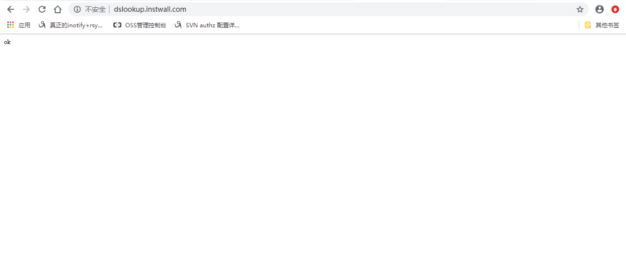

* 1. <http://dslookup.instwall.com:20060>

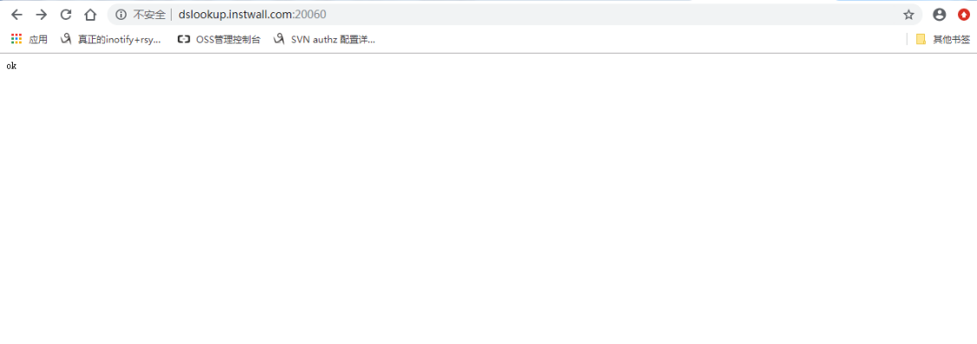

* 1. <http://dslookup.instwall.com:20061>

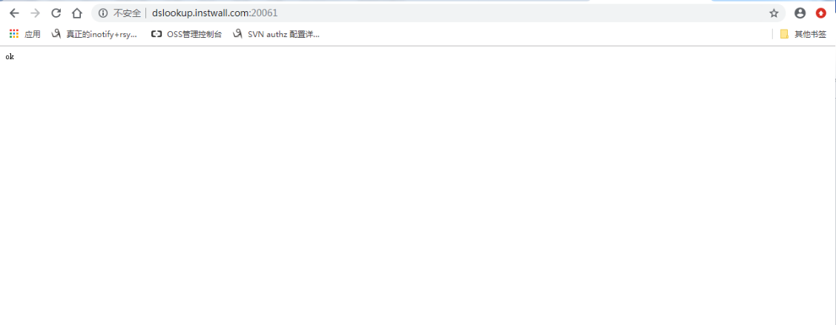

* If the word "ok" is returned on the browser, indicating that the access is normal.

* If not, please take the screenshot and contact local network management department.

1. Open the browser and access following the websites.
   1. [http://dscloud.instwall.com](http://dscloud.instwall.com/)

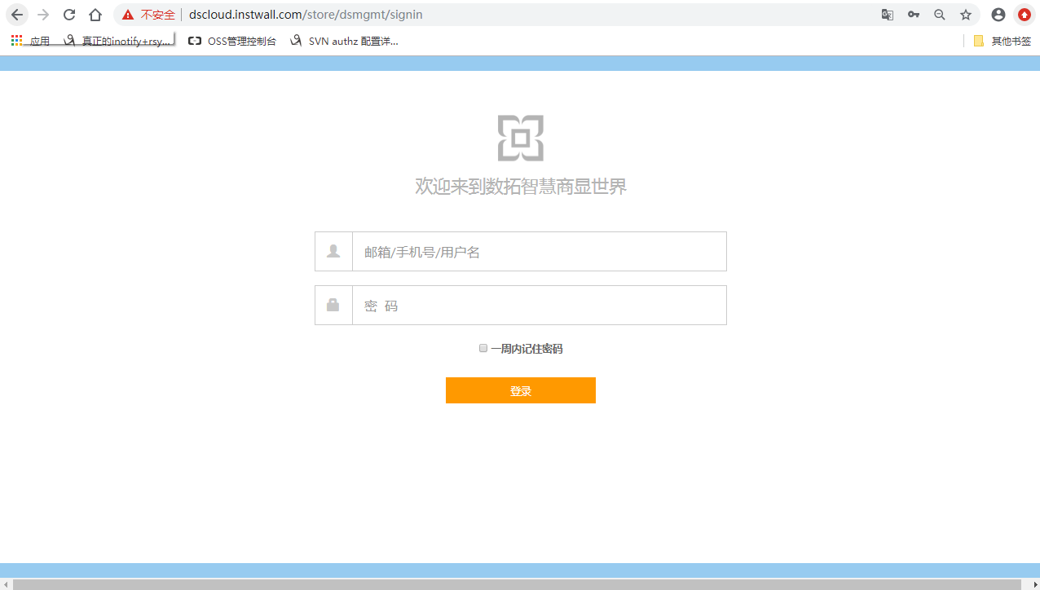

* 1. <https://dscloud.instwall.com/api/json>

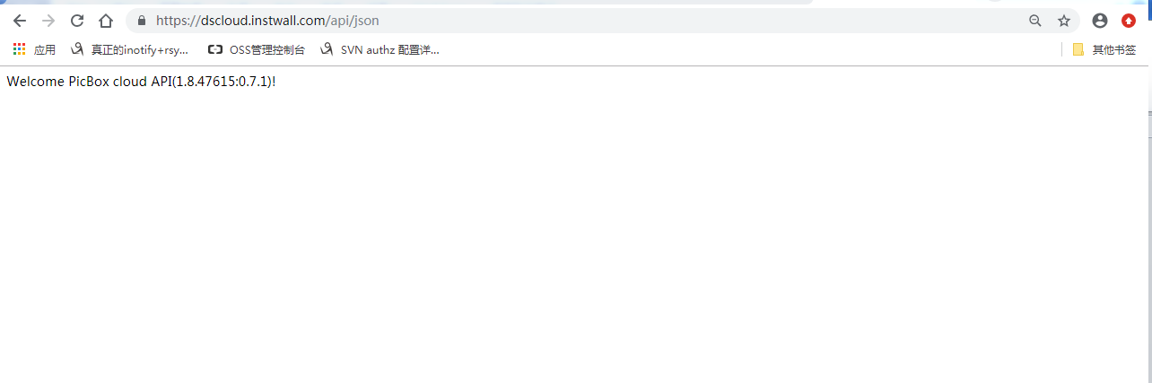

* If can’t, please take the screenshot and contact local network management department.

1. Open the browser and access following the websites.
   1. [https://dsauth.instwall.com](https://dsauth.instwall.com/)

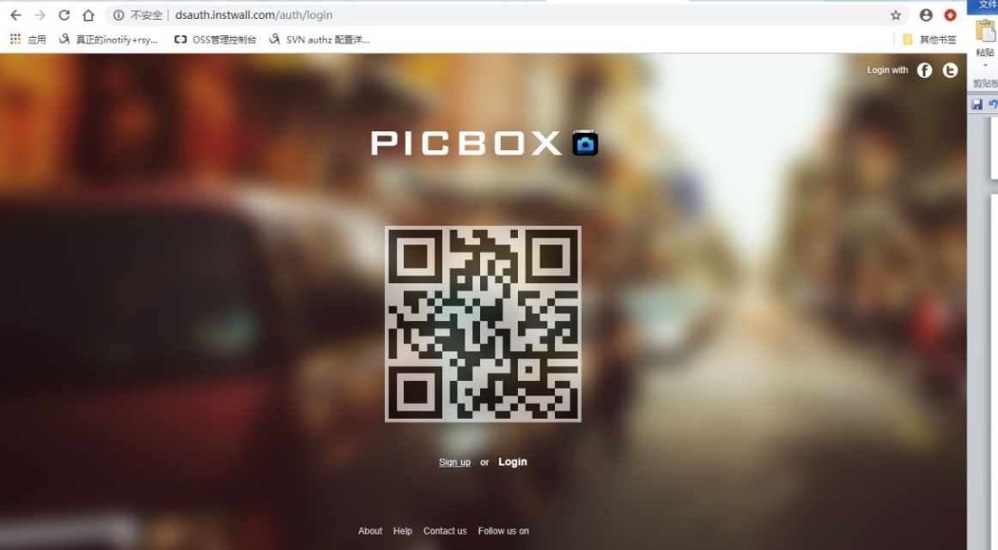

* If can’t, please take the screenshot and contact local network management department.

1. Open the browser and access following the websites.
   1. [http://oss-cn-hangzhou.aliyuncs.com](http://oss-cn-hangzhou.aliyuncs.com/)

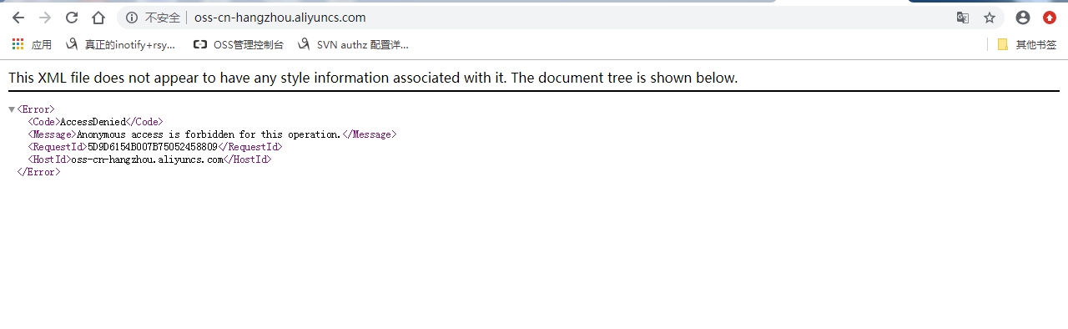

* If can’t, please take the screenshot and contact local network management department.

1. Installing the telnet command tools or using the default telnet command in windows. We also provide the download link here. (<http://www.instwall.com/apk/telnet.exe>), just double click this link you can get it.
   1. Open the telnet command.

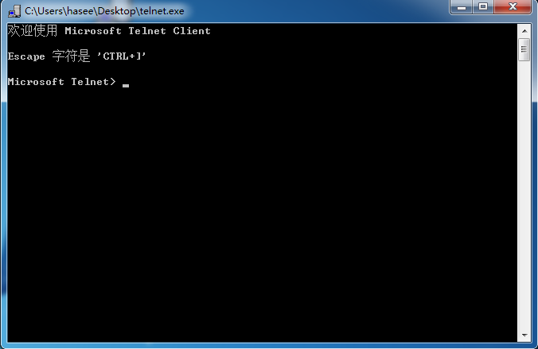

* 1. Input “open dim.instwall.com 5222” and enter

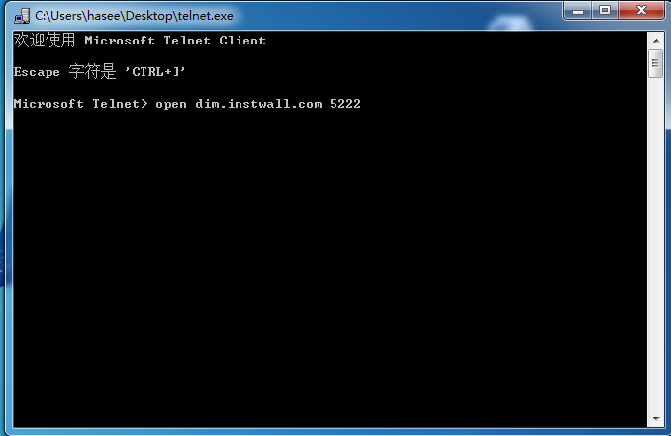

* 1. Input “open dim.instwall.com 443” and enter

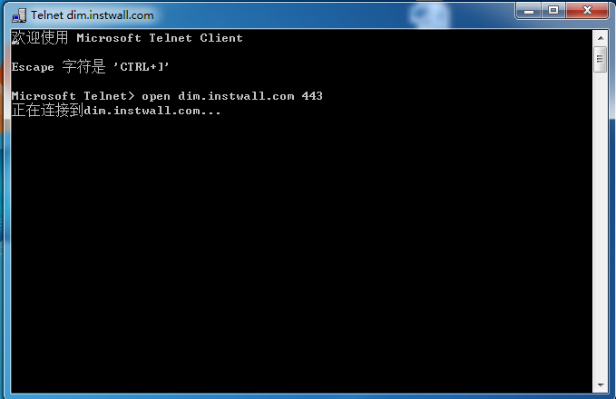

* Need wait 1-3 minutes for the response information.

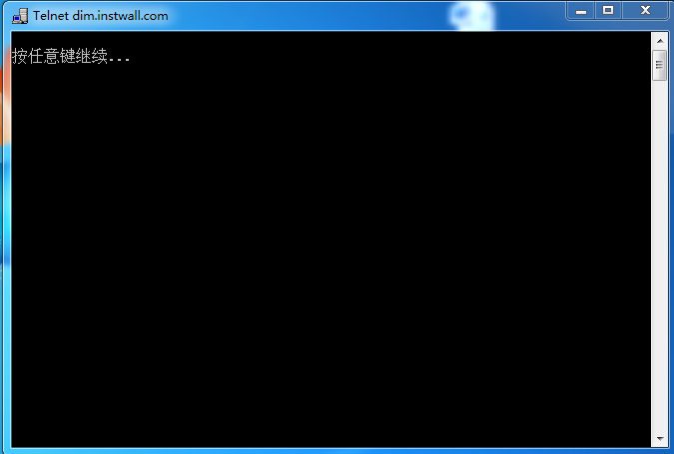

* If response like this, it’s meaning the connection is normal.

* If the response message meanings the port 5222 or the port 443 can not be connected, please take the screenshot and contact local network management department.