Standard Installation File

Network Arrangment

1、 External Network

Make sure Server’s Network can connect to External Network（File：Shutuo Network condition test）

http://note.youdao.com/noteshare?id=1758ea0f6a53910b230003b29a9a3622

2、Local area network

The network hardware installation of linkage screens refers to the file

<http://note.youdao.com/noteshare?id=1533272be68a7b58e08f142b9a40826a>

3、 Problems and the selutions

a. Linkage screens play the standby-mood video

b. The content doesn't update

c. The content doesn't play

d. Prepare a computer to check if the network port is loose

Solution：Run the test tool first，then judge and fix the problem depending on the test result

Set up the Box

1、Check the Box

Power on then check the box if start normal.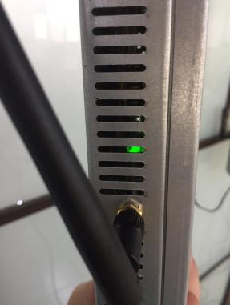

State instructions：When the green light twinkles，it means the power work normal

2、Set-up environment

a、Set up the box to a place easy to check，preventing dust and water，far away from external heat, dissipating heat well

b、Set HDMI line stable，don’t pull the line nor hang slack the line.

Tips: a. We suggest to expose the infrared receiver for debugging.

b. We suggest installing All-in-one TV to avoid the mechine was sealed

3、Set up the box

1、Insert one end of HDMI line to the screen’s HDMI IN port,and insert the other end to the HDMI out port of Shutuo box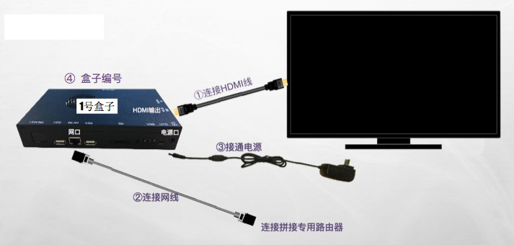

2、Insert the network line to the corresponding ports according to the nework line order number

3、The box connects the power and get power on

4、Mark each box in order number with lable paper

Note:Take a photo of the box position to submit to Shutuo file after this step

Check the set-up

1、Sign in Shutuo smart cloud

2、Enter “Device managment”, check “screen state”. It’s normal if it shows “on line”

3、 If the page show “off line”or “warning”, you can click “download finished” to check the details

4、Enter “fouction ctrollor” then click “start check”

State explaination

a、“On line”: Normal, Box is power on and the Network is clear

b、“Off line”: The network of the box is blocked or power off

Tips: It may delay to update the box state on the first page of “Device managment” and with “Power on test”as standard state

5、State Check

a、 Linkage screen video normal Play

b、Single screen content normal Play

Note：submit to Shutuo file after finishing Set-up step

6、Fill the installation confirm firm，（fill the following items and upload the corresponding photos to save history file）

a、construction time

b、construct by

c、construction Shop

d、Constructed linkage screen size

After-sales service

Hardware After-sales service（We suggest customers to buy more screens as a back-up，it can be determined by the number of screen in a shop or customer’s acception ）

Note: Led Linkage: Use Edge Fusion Device，Eg 1X2

Installation Notice

a、 The router used for linkage screen connect to a computer with network line, should be able to see the page: [dscloud.instwall.com](http://dscloud.instwall.com)

b、All the boxes and routers should be installed in one electric circuit and be controlled with a master switch.

c、All the screens shoulld be installed in one electric circuit and be controlled by another switch.

d、 The installing place for the router requires：prevent from dust and water，far away from heat

e、 HDMI Line doesn't be pulled or hanging slack

f、 The installing place for Shutuo Box requires：prevent from dust and water，far away from heat

g、The linkage videos player normally（No case of no playing video，no case of out-sync ）

h、Each single screen plays the contents which released by the cinema（No case of black screen and no case of seized screen）