**HPC_HW_Chap3_PartB**

**Chen Fang**

**Problem 3.8**

MPI_Scatter is shown in the figure. MPI_Gather is the same by reversing the arrow directions.

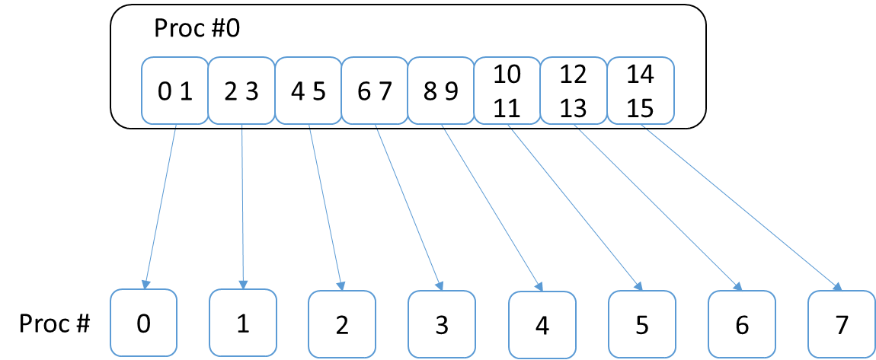

**Problem 3.11**

a.

for( int i = 1; i < n; ++i )

{

vector[i] += vector[i-1];

}

b.

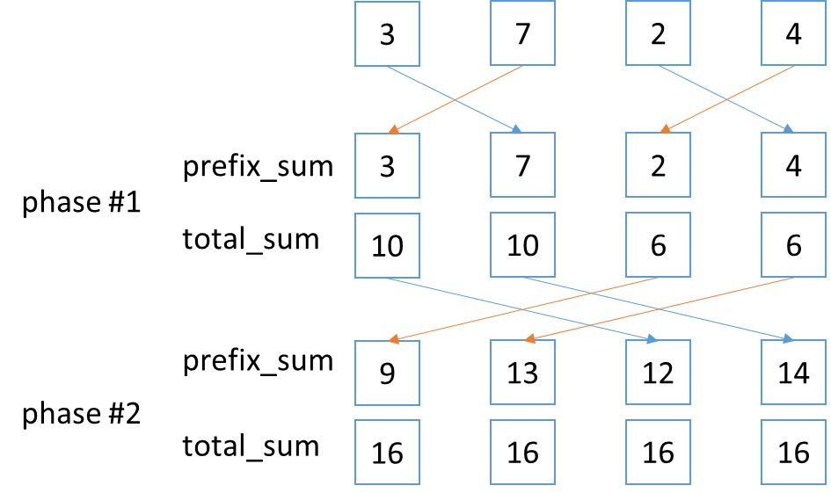

c.

In general case when n>p, n/p elements can be assigned to one core while the above algorithm is used. It can be easily proved with induction that the number of phases equals log2(n). Therefore, when n=2k, phase number = k.

**Problem 3.16**

