An AI-Based Virtual Tumor Cell Model to Simulate Subcellular Responses to Environmental Stress

Introduction
What is AIVC
An AIVC should be queryable with computational twins of today’s laboratory experiments, here called virtual instruments (VIs). We envision an AIVC as a comprehensive AI framework composed of several interconnected foundation models that represent dynamic biological systems at increasingly complex levels of organization—from molecules to cells, tissues, and beyond. Our approach has two main components: (1) a universal multi-modal multi-scale biological state representation and (2) a set of VIs, which are neural networks that manipulate or decode these representations.

Stress in tumor, Ref: Resilience in adversity: Exploring adaptive changes in cancer cells under stress
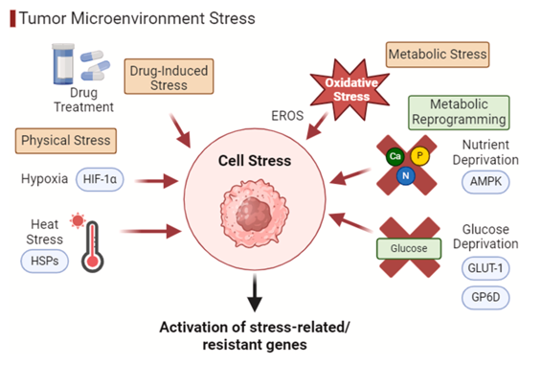
In the trajectory of cancer, cellular stress emerges as a determining factor in its progression. Neoplastic cells face a variety of environmental stimuli that trigger adaptive responses, aiming for their survival. Cancer cells are frequently exposed to a variety of environmental stressors, such as nutritional deficiencies, mechanical stress, hypoxia and acidosis. In addition, other types of stress, such as osmotic, mechanical, monotonic, and oscillatory, also play crucial roles in cellular behavior, influencing cell survival, migration, and proliferation, particularly in tumor contexts.

Furthermore, varied cellular phenotypes, such as epithelial- mesenchymal transition (EMT), exert a direct influence on the morphology and dynamics of these cells, affecting their migration and invasion capacity. In light of such complexity, understanding these processes is crucial for developing effective strategies to combat cancer. Within the dynamics of cellular plasticity, EMT plays a crucial role in driving tumor invasion and triggering cell migration. Once invading cells reach new locations, they are able to undergo a reverse transition - known as mesenchymal-epithelial transition (MET) - to form new colonies, fundamental in the formation of metastases.

Stress can also induce reactions such as the activation of the integrated stress response (ISR) in several types of cancer, being able to interrupt cellular translation. Aneuploidy also confers genomic plasticity on cancer cells, allowing them to adapt to stressful environments, and may represent a mutation-independent pathway to drug resistance. By investigating existing literature on the adaptive responses of neoplastic cells to various types of cellular stress, including metabolic, physical, and drug-induced stressors, we aspire to contribute to the development of novel therapeutic approaches and enhance the predictive accuracy of cancer outcomes.

Hypoxia
Cells subjected to hypoxia achieved higher survival rates compared to cells in normoxia.

Examples
Sarcomere and cytoskeleton genes, also known as actomyosin genes, play essential roles in cytomorphology, ranging from the response to mechanical stress to the regulation of motility and cell division. Nine of these genes were evaluated in twenty cancer lines
ACTG1, as frequently amplified and overexpressed in uterine cancers with poor prognosis. In this context, deregulation of this gene is associated with increased cell cycle activity and tumor plasticity,

Senescence is a cellular phenotype that occurs after stress is imposed on the cell, whether by a genotoxic insult, oxidative stress or replication exhaustion. This process can contribute to the development of premalignant and malignant lesions. Moreover, cancer cells can use senescence to resume their state of proliferation, increase tumor heterogeneity and evade antineoplastic therapies, such as radiotherapy and chemotherapy

Mechanical stress is more related to morphology
Mechanical stress involves the tension, compression, and shear forces that cells experience within their microenvironments. These are vital in determining cell behavior, including migration, proliferation, and differentiation. Nestor-Bergmann et al. (2019) pointed out that mechanical forces control mitotic orientation and tissue organization and how cells dynamically interact with their physical environment.

Cells respond to applied mechanical stress in a temporal and spatial manner, highly dependent on the type, magnitude, and rate of change of the applied force. Tensile stress stretches cells, typically activating mechanosensitive pathways that modulate cytoskeletal dynamics. Compression deforms cellular volume and pressure, which may influence gene expression and metabolic pathways.

Cellular responses to these stresses are highly dependent on the magnitude and rate of force application. Rapid mechanical changes often activate immediate responses, such as calcium influx through mechanosensitive ion channels, while sustained forces lead to long-term adaptations in cytoskeletal organization and gene expression. It often intersects with other forms of stress, such as oxidative and osmotic stress, creating complex cellular environments.

Mechanical stress has an important clinical relevance, especially regarding cancer development and treatment. Understanding how cells perceive mechanical forces allows for the possibility of disrupting the pathways used by tumor cells. Mechanical stress through physical compression or shear has been induced experimentally to make tumor cells sensitive to chemotherapy or radiation. Biomarkers that reflect responses to mechanical stress, for example, include cytoskeletal proteins and mechanosensitive signaling molecules, both of which can be applied to prognosis and therapy outcome predictions.

Monotonic stress refers to a constant force or continuous deformation applied to a material or biological tissue over time

Oscillatory stress is described as the periodic or cyclic forces to which cells are usually subjected in their microenvironment. Such oscillatory stresses may emanate from physiological events, like shear stress due to blood flow in endothelial cells, or respiratory movements generating cyclic tension in lung tissue

If p53 show high correlation with stress level?
p53 is a tumor suppressor gene fundamental in regulating the cellular response to stress, including the repair of DNA damage, induction of apoptosis and control of the cell cycle. In this sense, the cell cycle checkpoints, such as those dependent on p53, play a crucial role in preventing the development of tetraploid cancer cells.

Method
Goal
We will train a AIVC mode using subcellular-resolution spatial transcriptomics data (Xenium/5k). The input will be single-cell or bulk level gene and/or H&E patch for each cell. Our AIVC model will be able to predict the 1) stress scores and 2) subcellular response. The subcellular stress response will be activated pathways in nuclei, cytoplasm, and RNA aggregates patterns, from 50 hallmark pathways. 3) By manually manipulate the input (spatial context embedding), we can have a virtual stress model.
By applying our AIVC model to large cohort public scRNAseq data, we will construct virtual population with subcellular resolution. In turn, this enables us to conduct population-scale clinical discovery
Can we also provide uncertainty measurement?
We will focus on the following stress types:
1) Hypoxia stress: Based on gene expression.
2) Mechanical stress: Based on overall force in cell neighboring graph. High value at core.
3) Monotonic stress: Based on the directional force in neighborhood graph. High value at boundary.
4) Immune attach stress: Based on spatial proximality with activated immune cells (CD8+ T, NK, microphages with inflammation signal).
5) Oscillatory stress: Based on vessels. (Optional, based on Jiahui’s work)

Prosperities
1) Will be able to input gene and/or image.
2) Will be a multi-head VI model.
3) Use existing image and gene foundation models to extract embeddings.
4) Attention layer to determine which modality is important in each stress types.

Model training:
1) Datasets: 25 samples across 8 cancer types, ~ xxx cells.
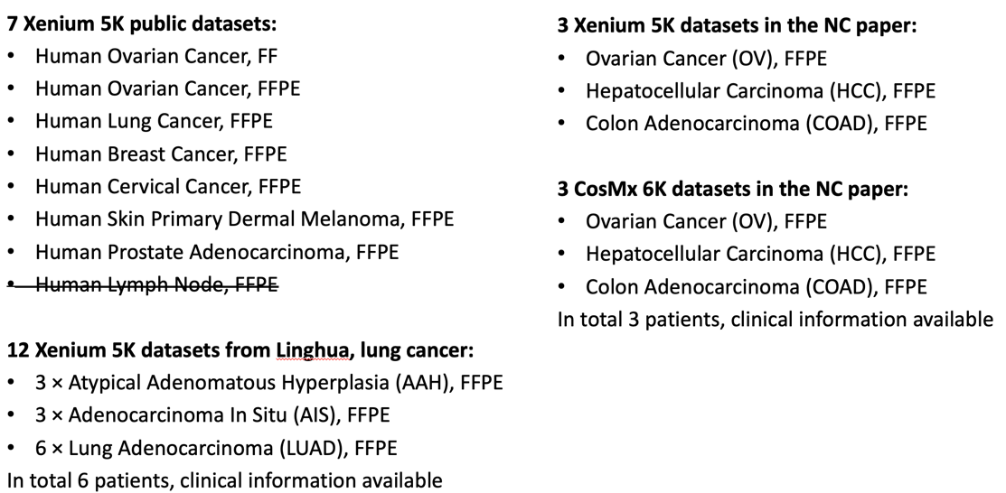

2) Cell type identification and only include tumor cells as training samples.

3) Define the stress score:
The training will use all tumor cell across samples, so first perform cell level normalization to make their gene expression value comparable. Check a few key genes’ expression to confirm, KRTxx, EPCAM. Define stress score, for hypoxia, use the 8 marker genes. For each tumor cell, defined its hypoxia score=2nd/3rd/4th highest expression among the markers. Score between 0 and 1.

4) Define the responses for each single cell at different sites:
Metrics to use: ssGSEA /GSVA / AUCell
For nuclei, cytoplasm, and RNA granule, may use different metrics.

5) Model structure:
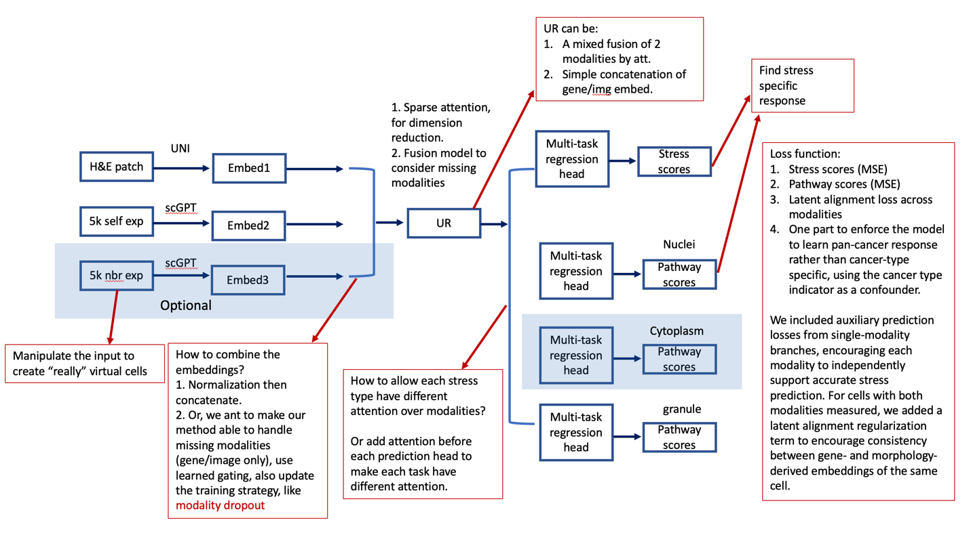

Evaluation
1) Hold-of some sample. Evaluate both stress score and pathway score. Consider turn pathway to binary then use ARAUC. How to separate the training and testing sets?
2) Single modality vs multi.
3) For each stress type, visiualize modality attention weight to enhance intrepretability, build trust in AIVC.
4) For each stree type, identify its related pathway in nuclei, cytoplasm and granule using correlation analysis.
5) If the single-modality performance is acceptable, we can apply to large scale H&E, scRNAseq data like TCGA.

Counterfactual simulations, a virtual stress model
1) Use AIVC model as a simulator, swap the spatial context embeddings, to see how the stress and response changes. (This does not change its own gene expression.)
2) Order cells by their predicted stress scores. Then check the gradient of their relevant responses.

