Uncovering the dark spatial transcriptome in polarized neuronal compartments with mcDETECT

Chenyang Yuan^{1,2}, Krupa Patel¹, Hongshun Shi^{1,3,4}, Hsiao-Lin V. Wang^{1,5}, Feng Wang¹, Ronghua Li^{1,5}, Yangping Li^{1†}, Victor G. Corces^{1,5}, Hailing Shi^{1,4,5}, Sulagna Das^{1,6}, Jindan Yu^{1,3,4}, Peng Jin^{1,5}, Bing Yao^{1 *} & Jian Hu^{1,2 *}

- Department of Human Genetics, Emory University School of Medicine, Atlanta, GA 30322, USA
- Department of Biostatistics and Bioinformatics, Rollins School of Public Health, Emory University, Atlanta, GA 30322, USA
- Department of Urology, Emory University School of Medicine, Atlanta, GA 30322, USA
- Winship Cancer Institute, Emory University School of Medicine, Atlanta, GA 30322, USA
- Emory Center for Neurodegenerative Diseases, Emory University School of Medicine, Atlanta, GA 30322, USA
- Department of Cell Biology, Emory University School of Medicine, Atlanta, GA 30322, USA
Deceased

* Correspondence:

Bing Yao, bing.yao@emory.edu

Jian Hu, jian.hu@emory.edu

Keywords:
spatial transcriptomics, dark spatial transcriptome, neuronal compartments, Alzheimer’s disease, machine learning
Abstract
Spatial transcriptomics (ST) is a powerful tool for studying the molecular basis of brain diseases. However, most current analyses focus on nuclear or somatic expression, overlooking distally localized mRNAs, known as the “dark spatial transcriptome.” These transcripts, which make up nearly 40% of the brain transcriptome, are packaged into RNA granules and transported to polarized neuronal structures critical for neuronal function. Here, we present mcDETECT, a machine learning framework that leverages in situ ST (iST) data to detect RNA granules and resolve their RNA composition. Applying mcDETECT to simulated and real datasets from multiple iST platforms, we demonstrate robust granule detection and molecular subtyping. Granule-informed downstream analysis further revealed functionally distinct neuropil microdomains not captured by somatic expression alone. In an Alzheimer’s disease (AD) mouse model, mcDETECT uncovered alterations in RNA granule distributions and associated neuropil microdomains prior to measurable neuronal loss, highlighting potential therapeutic targets for early AD pathology.
Introduction
Neurons are highly polarized cells with distal subcellular compartments—such as synapses, dendrites, and axons—that are essential for neural connectivity and communication. The discovery of messenger RNAs (mRNAs) localized near these compartments suggests that they achieve local autonomy by synthesizing key proteins locally to support plasticity and function^{1,2}. Conventional single-cell or single-nucleus RNA sequencing (sc/snRNA-seq) techniques fail to capture these spatially localized mRNAs because they are restricted to profiling transcripts within or close to the nucleus, leaving the mRNA pools in distal compartments undetected. To highlight this critical knowledge gap, Seth A. Ament and Alexandros Poulopoulos proposed the concept of the “brain’s dark transcriptome” to describe RNA localized to distal compartments³. Here, we use the term “dark spatial transcriptomics” to distinguish these poorly characterized extrasomatic RNAs from transcripts arising from unannotated genomic regions. The dark spatial transcriptome represents a hidden layer of transcriptional diversity that operates at a resolution beyond cell types or subtypes, offering molecular insights complementary to traditional sequencing approaches. Remarkably, this unexplored transcriptional pool is estimated to constitute ~40% of the total transcriptome in the adult mouse brain³⁻⁵, as demonstrated by both iST and fluorescence imaging of individually cultured neurons^{6,7}. These compartmentalized mRNAs are transcribed in the nucleus, assembled into RNA granules by RNA-binding proteins (RBP), and then transported to distal regions⁸. Despite extensive research on RNA granules in neurons, studies have predominantly focused on their RBP components^{9,10}, which are more amenable to tagging and detection. In contrast, the mRNA composition of these granules remains poorly characterized.

Recent advancements in spatial transcriptomics (ST) have enabled gene expression profiling with location information and transformed our understanding of tissue functional organization¹¹⁻¹⁶. In particular, in situ hybridization-based technologies (iST), such as STARmap¹⁷, seqFISH¹⁸⁻²⁰, and MERFISH^{21,22}, offer gene expression measurement at subcellular resolution. Building on these techniques, methods such as Baysor⁵, SSAM²³, JSTA²⁴, FICTURE²⁵, Bento²⁶ and ELLA²⁷ have recently been developed to analyze gene expression at the subcellular resolution. However, these methods primarily focus on mRNAs within the cell body and were not specifically designed to detect and biologically interpret discrete extrasomatic RNA granules in neuronal neuropil.

To fill this gap, we developed mcDETECT (multi-channel DEnsity-based spatial TranscriptomE ClusTering), a machine learning framework designed to study the dark spatial transcriptome related to polarized compartments in brain using iST data. mcDETECT first employs density-based clustering to pinpoint the locations of distal RNA granules in three-dimensional (3D) space. Subsequently, it assigns surrounding mRNA molecules to each granule to reconstruct their transcriptome profiles. We applied mcDETECT to simulated and real datasets generated using three widely used commercial iST platforms: Xenium 5K, MERSCOPE, and CosMx. These platforms differ in chemistry, gene panel size, and RNA capture efficiency, allowing us to evaluate the method generalizability. mcDETECT successfully identified multiple classes of RNA granules, each associated with distinct gene enrichment patterns suggestive of different functional roles. Importantly, these spatially resolved RNA granules reveal transcriptomic signatures of neuropil microdomains that are distinct from and complementary to those defined by somatic transcriptomes. To demonstrate mcDETECT’s utility in disease studies, we generated iST data from the widely used Alzheimer’s disease (AD) mouse model (5xFAD) using our custom panel enriched for synaptic, dendritic, and axonal genes. Using this dataset, mcDETECT identified changes in the abundance and molecular composition of RNA granules as indicators of early AD. These granule-level alterations also revealed shifts in neuropil microdomains that precede detectable changes in neuronal somata. Overall, mcDETECT opens a new avenue for the neuroscience community to profile the dark spatial transcriptome, uncover molecular insights, and identify potential RNA granule-level targets for therapeutic intervention in neurodegenerative diseases.

Results
Overview of mcDETECT
The workflow of mcDETECT is illustrated in Fig. 1. It begins from the raw iST transcript detection output, which consists of a list of individual mRNA molecules, each associated with a gene identity and a 3D spatial coordinate $(x, y, z)$ within the tissue. Each mRNA molecule is treated as a distinct point with its own 3D spatial coordinates, considering the thickness of the sample. Unlike many cell-type marker genes, which are typically found within the nucleus or soma, compartmentalized mRNAs often form small aggregates outside the soma (Fig. 1a). mcDETECT uses a density-based clustering²⁸ approach detailed in Fig. 1b to identify these extrasomatic aggregates. This involves calculating the Euclidean distance between mRNA points and defining the neighborhood of each point within a specified search radius. Following standard density-based clustering terminology, points are algorithmically categorized as core points, border points, or noise points based on their reachability from neighboring points. In the context of RNA granule detection, these correspond to transcripts in the dense interior of aggregates, at their periphery, and outside aggregates, respectively. mcDETECT recognizes each connected bundle of core and border points as an mRNA aggregate. To minimize false positives, it excludes aggregates that substantially overlap with somata, which are estimated by dilating the nuclear masks derived from DAPI staining. mcDETECT then repeats this process for multiple granule markers, merging aggregates from different markers that exhibit high spatial overlap (Fig. 1c). After aggregating across all markers, an additional filtering step removes aggregates containing mRNAs from negative control genes, which are known to be enriched exclusively in nuclei and somata. The remaining aggregates are considered individual RNA granules. As shown in Fig. 1d, mcDETECT then computes the minimum enclosing sphere for each aggregate to connect neighboring mRNA molecules from all measured genes and summarizes their counts, thereby defining the spatial transcriptome profile of individual RNA granules. mcDETECT also supports downstream applications, as illustrated in Fig. 1e. For example, it can classify RNA granules into molecular subtypes and further characterize their RNA composition. This further enables the identification of neuropil microdomains based on the composition of neighboring granules—information that cannot be resolved using somatic transcriptomes alone. By comparing disease and control tissues, mcDETECT can also identify granule-associated biomarkers, such as alterations in granule density linked to neurological disorders.

Selection of markers for distal RNA granules
The first step in mcDETECT is to select a set of marker genes associated with distal RNA granules. RNA granules are a diverse family and can be classified by their protein composition into stress granules, processing bodies, and transport granules. In most tissues, RNA granules represent a small fraction of the overall transcriptome. The brain, however, presents a notable exception. Due to the highly polarized architecture of neurons, transport granules constitute a much larger portion (~40%) of neuronal transcriptome³⁻⁵. This reflects their critical role in delivering mRNAs to distal neuronal compartments, such as synapses, dendrites, and axons, to support local protein synthesis. To capture these RNA granules, we compiled a list of markers associated with synaptic, dendritic, and axonal structures and functions, and enriched in neurons (Supplementary Note 1). As detailed in Supplementary Table 2, these markers have been reported in multiple studies, supporting their packaging into RNA granules for transport. To validate the subcellular enrichment patterns of our selected genes, we analyzed their RNA localization in brain datasets generated by three different iST platforms. As shown in Fig. 2a, across all three platforms, our selected genes exhibit significantly higher extrasomatic localization compared to other genes (one-sided t-test: p = 9.1 × 10⁻⁶, 0.0013, 0.0021 for Xenium 5K, MERSCOPE, and CosMx), confirming their preferential distribution to distal compartments, which is not captured by snRNA-seq (Supplementary Note 2). To further assess the functional relevance of these distally localized mRNAs, we analyzed their ribosome association using a mouse coronal hemisphere dataset generated using RIBOmap, a highly multiplexed 3D in situ technique for translatome profiling²⁹. For each gene, we quantified the relative proportion of ribosome-bound mRNAs in peripheral processes versus somata. Notably, the 26 genes that overlap with our target set demonstrate significantly greater ribosome association in peripheral compartments (median = 22.1%) compared to the remaining 5,387 genes (median = 18.3%, p = 0.00024; Fig. 2b). These results suggest that these distal mRNAs are actively translated in neuronal processes, supporting their functional role in shaping neuronal connectivity.

Simulation study
To evaluate the effectiveness of mcDETECT in identifying RNA granules, we conducted a simulation study to benchmark its performance. We simulated a 2000 × 2000 µm² tissue area with a thickness of 10.5 µm, mimicking the iST sample setting. Guided by mRNA spatial distribution patterns observed in real data, we simulated each gene’s overall mRNA transcript pattern as a combination of three biologically motivated spatial distributions, as illustrated in Fig. 2c: (1) complete spatial randomness (CSR), in which mRNA molecules are randomly distributed without aggregation, representing ambient transcripts or background signal; (2) RNA granule aggregation within the neuropil, in which mRNA molecules form local clusters with a mean radius of 1 µm, reflecting reported RNA granule size in previous studies³⁰⁻³³; and (3) aggregation within somata, in which mRNA molecules form larger clusters with a mean radius of 5.5 µm, matching observed soma sizes in the real dataset (Supplementary Note 3). Each gene was modeled as an overlay of these three spatial patterns but differed in its overall mRNA density, representing its expression level. We simulated three distally localized genes, denoted A, B, and C, with varying overall densities selected to match the observed expression levels of the granule marker genes Snap25, Slc17a7, and Dlg4, respectively, in a Xenium 5K dataset. Additional simulation settings are detailed in Supplementary Note 4. For each gene, we conducted 200 simulation runs and applied mcDETECT to detect the distal RNA granules. As illustrated in the bar plots in Fig. 2d, mcDETECT achieved overall F1 scores of 96.8%, 95.5%, and 90.8% for markers A, B, and C, respectively. Notably, mcDETECT was not only sensitive to true distal RNA granules—reflected by mean recalls of 94.5%, 93.6%, and 88.6%—but also effectively filtered out most somatic aggregates, as indicated by mean precisions of 99.1%, 97.6%, and 93.2% for markers A, B, and C, respectively.

The above simulation focused on detection using a single marker. In scenarios involving multiple granule markers, mcDETECT enhances statistical power by integrating aggregations from multiple markers while accounting for their colocalization patterns. To demonstrate this capability, we simulated a scenario with three distally localized genes, A, B, and C, whose mRNA molecules were visualized in red, green, and yellow in Fig. 2e. These three markers partially co-clustered in the 3D space, and using any single marker recovered only a subset of the total RNA granules, with a recall of approximately 60%. In contrast, when mcDETECT combined all three markers, it achieved a mean precision of 91.1%, a mean recall of 97.5%, and an F1 score of 94.2% across 200 simulation runs, as shown in the bar plot in Fig. 2f. We also compared mcDETECT with Baysor and SSAM under this simulation setting. As shown in Fig. 2g, mcDETECT identified 2,861 of 3,000 true granules, with 137 false positives. The original Baysor detected only 22 true granules and 975 false positives. After manual parameter tuning, Baysor detected 2,973 true granules, but produced 2,923 false positives. The original SSAM detected 2,425 true granules, but produced 26,801 false positives. After tuning, SSAM detected 2,396 true granules, with 2,118 false positives. Overall, although Baysor and SSAM can detect extrasomatic RNA, they produced substantially more false positives for RNA granule detection than mcDETECT. Because real datasets typically contain more genes and more complex spatial patterns than simulations, this performance gap may be even greater in practice. mcDETECT was also computationally more efficient, requiring 27 seconds per run, compared with 210 seconds for Baysor and 92 seconds for SSAM (Fig. 2h).

In most iST data analyses, the x–y plane typically spans a much larger area (e.g., 10 × 10 mm²) than the z-axis (~10 µm). As a result, many practical analyses treat each iST sample as two-dimensional (2D) sections and ignore their thickness³⁴⁻³⁶. By conducting additional simulations in a 2D setting, we demonstrate that omitting the z-axis can lead to false-positive RNA granule detection. This occurs because RNA projections are condensed into a 2D plane, making them appear aggregated when they are not in 3D (Supplementary Note 5).

Application to mouse brain 10x Xenium 5K data
To demonstrate the capabilities of mcDETECT on real data, we applied it to a dataset from a 9-week-old wild-type (WT) mouse brain, generated using the 10x Xenium 5K platform³⁷. This dataset has a broad coverage of 5,006 genes, including 24 granule markers that correspond to the overlap between our literature-curated marker list and this gene panel. Using these markers, mcDETECT identified 125,030 RNA granules across ten brain regions. As shown in Fig. 3a and Supplementary Table 5, these granules are more concentrated in the cortical layers, hippocampus (HPF), and olfactory areas (OLF). Directly evaluating the accuracy of granule detection in real data is challenging due to technical limitations in obtaining ground truth on the same iST slide. Unlike cells, granules are difficult to capture using protein staining due to their complex protein composition and lack of specific antibody markers. Therefore, we assessed the biological plausibility of mcDETECT’s output in two aspects. First, we examined granule size. As shown in Fig. 3b, 90% of detected granules had radii of 0.51–1.57 µm, with a median of 0.90 µm, consistent with previously reported granule sizes³⁰⁻³³. We then compared granule transcriptomic profiles with neuronal somata. As shown in Fig. 3c, detected granules were enriched for granule markers but showed sparse detection of neuronal marker genes used as negative controls³⁸⁻⁴¹, whereas somata expressed both marker sets. Together, these results suggest that mcDETECT identifies granule-sized RNA aggregates with transcriptomic profiles distinct from soma fragments or random cellular debris. In addition, we show that mcDETECT-identified granule-enriched genes exhibit distinct structural features, including longer gene spans and 3′ UTRs, consistent with existing literature and detailed in Supplementary Note 6.

After recovering granule locations, mcDETECT enables the construction of transcriptome profiles for individual RNA granules, facilitating subtype classification and functional analysis. The identified granules contain a median of 17 mRNA molecules per granule, with 57 genes detected in more than 5% of all granules. To study their molecular subtypes, we performed unsupervised K-Means clustering on granule-level gene enrichment profiles using the selected granule marker genes as features, and identified 15 initial clusters, visualized by t-SNE in Fig. 3d. Based on heatmap of selected markers in Fig. 3e, we further annotated the granules as enriched for pre-synaptic genes, post-synaptic genes, dendritic genes, or mixed types in Fig. 3f. We next demonstrate the biological significance of these granule subtypes by showing that they can serve as quantitative biomarkers of their associated functional compartments.

First, we calculated the density of synapse-associated granules (enriched for both pre- and post-synaptic genes) within each 50 × 50 µm² spot across ten major brain regions (Fig. 3g, left). Notably, these granule densities showed a strong correlation with synapse densities derived from age-matched WT mouse brains using volume electron microscopy and genetic labeling⁴² (Fig. 3g, right), with a weighted Spearman correlation coefficient of 0.98. This finding provides orthogonal validation of the accuracy of our granule detection method and underscores its biological significance as a proxy for synapse abundance.

Next, we examined the distinct patterns of pre- and post-synaptic granules. Because pre-synaptic granules localize near synapses in axonal shafts, whereas post-synaptic granules localize near synapses in dendritic shafts, their abundance reflects the local balance of axonal versus dendritic cytoplasm contributing to neuropil. This balance can serve as an indicator of structural and functional differences across brain regions. In Fig. 3h and Supplementary Note 7, mcDETECT revealed strong enrichment of both pre- and post-synaptic granules in the HPF, with slightly higher pre-synaptic granule abundance. This pattern is consistent with Mishchenko et al.⁴³ who analyzed four EM volumes of rat HPF-CA1 neuropil and found that axons occupy approximately 50% of neuropil volume, whereas dendrites occupy about 40% (Fig. 3i). At the hippocampal subfield level, mcDETECT showed the strongest pre-synaptic granule enrichment in CA3 compared to CA1/2. This pattern is consistent with CA3 circuit anatomy, where the neuropil is dominated by the dense mossy fiber (MF) axons projection from dentate gyrus granule cells. To provide quantitative support, we analyzed the 3D EM reconstruction of mouse CA3 from Zheng et al.⁴⁴. Within the measured region in Fig. 3j, they identified 158 inhibitory axons, 629 pyramidal dendrites, and 56,813 MF axons. The corresponding volumes were 0.1069 mm³ (inhibitory axon), 0.2434 mm³ (pyramidal dendrite), and 2.3195 mm³ (MF axon), yielding an axon-to-dendrite volume ratio of ~9.97:1 in CA3. This pronounced axonal dominance provides a mechanistic explanation for the strong pre-synaptic granule enrichment in CA3 detected by mcDETECT.

Another pattern in Fig. 3h was the enrichment of post-synaptic granules in isocortex. This observation is consistent with the MICrONS EM dataset⁴⁵, which quantified axonal and dendritic path lengths for 71,993 neurons in mouse visual cortex across layers 2–6 (Fig. 3k). Fig. 3l shows that neurons across layers 2–6 consistently have greater dendritic path length than axonal path length, supporting a greater dendritic contribution to the local neuropil. At the laminar level of the isocortex, mcDETECT identified a higher post-synaptic granule signal in the superficial layers (L2/3) than in the deeper layers (L4–L6), likely reflecting the convergence and elaboration of apical dendrites from pyramidal neurons across multiple layers within the upper cortex. This trend is supported by Fig. 3l, which shows greater dendritic path length in L2 and L3 (median = 3,761 and 3,549 nm) than in L4–L6 (median = 2,550, 3,581, and 2,617 nm, respectively). Another potential contributor is variation in synapse-type composition across cortical layers, as detailed in Supplementary Note 7. Together, these examples highlight that RNA granules detected by mcDETECT can serve as proxies for subcellular compartments, which are otherwise difficult to study directly because antibody-based isolation methods disrupt their native spatial context.

Comparing WT and AD mouse brains using MERSCOPE data with a customized gene panel
We next demonstrate mcDETECT’s ability to uncover disease-relevant insights through granule-level analysis. This task is challenging with existing iST data due to either limited granule marker coverage or shallow sequencing depth in high-coverage platforms such as Xenium 5K. To address such limitations, we designed a 290-gene panel tailored for profiling distal RNA granules (Supplementary Table 6), comprising 47 synaptic markers, 11 dendritic markers, and 8 axonal markers. The remaining genes include cell type and brain region markers, ensuring the panel remains compatible with standard analyses. Using this customized panel, we performed MERSCOPE iST experiments on coronal brain sections from two 8-week-old mice: one C57BL/6J (WT) and one early-onsite AD model (5xFAD). This time point corresponds to the pre-symptomatic stage of AD, when minimal neuronal degeneration is typically observed. Using the granule markers, mcDETECT identified a total of 1,080,146 RNA granules in the WT and AD samples (Fig. 4a). Compared to the Xenium 5K dataset, the higher granule count in MERSCOPE can be attributed to differences in tissue area, gene coverage, and platform-specific mRNA capture efficiency (Supplementary Note 8). To compare the WT and AD samples, we first evaluated potential granule-level batch effects. As shown in Fig. 4b, WT and AD granules had highly similar size distributions, with median radii of 0.93 µm and 0.95 µm, and a difference within 5% margin (two one-sided tests, TOST p < 2.2 × 10⁻¹⁶). Furthermore, t-SNE visualization based on gene enrichment revealed substantial intermixing of granules from both groups (Fig. 4c), indicating minimal batch effects and supporting subsequent joint analysis. Following the same analysis pipeline, we identified 15 initial granule clusters and annotated each as being enriched for pre-synaptic genes, post-synaptic genes, dendritic genes, or mixed types (Fig. 4d–f). Similar to the Xenium 5K data, the synaptic granules in the MERSCOPE WT sample also showed a strong correlation with synapse density (Supplementary Note 9).

We subsequently compared the distribution of RNA granules and their subtypes between WT and AD samples. As shown in Fig. 4g, the overall granule density was significantly reduced in the AD sample compared to WT, even after adjusting for differences in mRNA capture efficiency between the two experiments. This reduction was consistent across multiple brain regions, most notably in the isocortex, OLF, and cornu ammonis (HPF-CA). Neuronal densities within each brain region, however, remained largely unchanged (Fig. 4h). This discrepancy suggests that disruption of RNA granule transport may serve as an early and detectable hallmark of AD pathology, potentially preceding measurable neuronal loss. We further examined changes in granule subtype densities. As shown in Fig. 4i (left), the density of pre-synaptic granules was significantly reduced across all brain regions, with the most severe loss in the isocortex, OLF, and HPF-CA, regions previously reported to be most affected in early AD pathology^{46,47}. In contrast, post-synaptic granule density remained relatively stable, with no significant changes in these regions (Fig. 4i, right). This trend remained consistent after adjusting for ambient RNA signal (Supplementary Note 10). This differential response in pre- and post-synaptic RNA granules highlights the selective vulnerability of axonal RNA transport and pre-synaptic compartments in the isocortex, OLF and HPF-CA during early AD, consistent with prior studies showing that axonal dysfunction can precede neuronal cell death⁴⁸ and that pre-synaptic loss may emerge before substantial post-synaptic degeneration in AD mouse models⁴⁹. This trend was further confirmed using analyses of existing bulk and snRNA-seq data (Supplementary Note 11). Other granule subtypes, including those enriched for dendritic genes and mixed signals, also exhibited region-specific alterations in AD (Supplementary Note 12).

Although granule density is informative, the RNA content of individual granules is sparse, making it difficult to examine gene expression differences between WT and AD. To address this, mcDETECT incorporates a neuropil microdomain analysis by dividing neuropil regions into 50 × 50 × 10.5 µm³ bins. Because these bins contain more RNA than individual granules, they provide sufficient signal for further neuropil specialization characterization. Using isocortex as an example, we performed unsupervised clustering of total bin-level expression with SpaGCN and annotated the bins into laminar layers shared across the WT and AD samples (Fig. 5a). This shared laminar organization suggests that the overall gene expression, including both somatic and extrasomatic signals, is largely preserved between WT and AD samples. We next examined the granule subtype composition of each bin and used it for unsupervised clustering to identify neuropil microdomains. As shown in Fig. 5b, four microdomains were present in both samples but differed in their relative proportions, with microdomain 1 enriched in WT and microdomain 2 enriched in AD. The alluvial plot in Fig. 5c shows that microdomains 1 and 2 map mainly to cortical layers 5 and 6. The heatmap in Fig. 5d further shows that microdomain 1 is enriched in pre-synaptic granules, whereas microdomain 2 is enriched in post-synaptic and dendritic granules.

We next performed differential expression (DE) and gene set enrichment analyses (GSEA) using granule expression within these neuropil bins. This analysis revealed a clear contrast between the WT-enriched microdomain 1 and the AD-enriched microdomain 2. Microdomain 1 in Fig. 5e was featured by pathways related to active synaptic transmission and vesicle handling, including synaptic vesicle recycling, presynaptic endocytosis, synaptic vesicle exocytosis, membrane fusion, neurotransmitter transport, and neurotransmitter secretion (Fig. 5f). These pathways suggest that neurons in microdomain 1 maintain robust synaptic vesicle turnover and neurotransmitter release capacity, enabling normal neural communication. In contrast, microdomain 2 in Fig. 5g showed a shift away from synaptic vesicle release toward structural remodeling, particularly dendritic and spine-related changes. This pattern was highlighted by pathways such as cell morphogenesis, neuron projection organization, dendrite morphogenesis, dendritic spine development, cytoskeleton organization, and actin filament-based processes (Fig. 5h). Together, the opposing trajectories of microdomains 1 and 2 reveal a marked neuropil dysregulation, characterized by a shift away from efficient synaptic transmission toward structural remodeling. Such shift is consistent with early synaptic stress, loss of synaptic stability, and activation of compensatory or maladaptive programs involving neurite remodeling and dendritic spine reorganization in early AD⁵⁰⁻⁵². As a comparison, we also performed the same analysis using the combined somatic and non-somatic signals from the same bins, which yielded broader pathways dominated by fundamental neuronal processes. This highlights that the neuropil microdomain analysis enabled by mcDETECT reveals features that somatic-focused analyses miss.

Application to datasets with limited granule marker coverage
We have shown that mcDETECT accurately identifies distal RNA granules in the Xenium 5K and in-house MERSCOPE datasets. These datasets cover a number of granule markers, either through a broad gene coverage or a specialized panel. However, many existing brain iST datasets contain only 300–500 genes and are not specifically designed to profile distal RNA granules. To assess mcDETECT’s scalability under such constraints, we evaluated whether a focused subset of key granule genes could recover most RNA granules. In the Xenium 5K and in-house MERSCOPE samples, we first detected granules for each marker individually and then merged the aggregates in descending order of gene expression. As shown in Fig. 6a, the cumulative granule count plateaued after only a small number of top-expressed markers, with the top six accounting for over 80% of detected granules in all three datasets. Benchmarking further revealed that removing top-expressed markers such as Snap25 or Slc17a7 had minimal impact on the spatial granule distribution, which remained highly correlated with the full-marker results (Supplementary Note 13). These results demonstrate that mcDETECT remains effective even with limited marker coverage, thus enabling reanalysis of such datasets to gain deeper insights into brain organization and disease mechanisms.

To further illustrate this capability, we applied mcDETECT to two public mouse brain datasets generated using the CosMx⁵³ and MERFISH⁵⁴ platforms, each with limited coverage of canonical synaptic, dendritic, and axonal genes. Both the CosMx (Fig. 6b–d) and MERFISH (Fig. 6e–g) datasets showed results consistent with our earlier findings. Using 12 and 8 granule markers, respectively, mcDETECT identified 125,773 and 78,115 RNA granules in the CosMx and MERFISH datasets (Fig. 6b, 6e). The granule size distributions were similar to previous results (Fig. 6c, 6f). The granule and neuronal markers also showed distinct enrichment patterns between the identified granules and neuronal somata (Fig. 6d, 6g), highlighting that the granules are not soma fragments or random cellular debris. We further classified the granules into molecular subtypes based on the enrichment of available subtype-specific genes, identifying populations enriched for pre- and post-synaptic markers. Notably, the spatial distributions of these synaptic granules were highly correlated with regional synapse densities from volume electron microscopy and genetic labeling, yielding weighted Spearman correlation coefficients of 0.81 and 0.90, respectively. Together, these findings highlight mcDETECT’s versatility in recovering marker-supported RNA granules across diverse iST platforms, while noting that applications to sparse marker panels should be interpreted with caution. A full list of granule-enriched genes derived from the Xenium 5K dataset is provided in Supplementary Table 7 to help users evaluate the overlap with their own gene panels.

Discussion
We introduce mcDETECT, a machine learning framework designed to investigate the dark spatial transcriptome in iST data. Whereas most existing iST analysis tools focus on nuclear or somatic transcripts, they often overlook RNA localized in distal neuronal compartments. These RNAs, which comprise a substantial portion of the transcriptome, are packaged into granules and transported to subcellular compartments to support neuronal connectivity and communication. mcDETECT addresses this gap by identifying the spatial locations of RNA granules and reconstructing their transcriptome profiles from 3D subcellular mRNA distributions. In simulated data, mcDETECT demonstrated accurate RNA granule detection with minimal false positives compared to Baysor and SSAM. Using a Xenium 5K dataset, we further showed that RNA granules have clear biological relevance: their presence is quantitatively linked to cellular compartments, and their spatial organization relative to neurons reveals regulatory layers that somatic expression alone cannot capture.

To demonstrate mcDETECT’s utility in disease studies, we designed a specialized gene panel and generated MERSCOPE data from WT and AD mouse brains. Analysis of this in-house dataset revealed disease-associated granule subtypes and brain region-specific distributional changes between WT and AD. These alterations also uncovered neuropil microdomains that are diminished or expanded in the AD model. Such findings are not detectable through somatic expression analysis alone, positioning mcDETECT as a valuable and complementary tool for exploring the dark spatial transcriptome.

A key advantage of mcDETECT is that it does not require extensive marker coverage; fewer than ten marker genes are sufficient to identify most granules. This flexibility enables mcDETECT to be applied to iST datasets with diverse gene panels, including those with limited granule marker coverage. To demonstrate this, we analyzed four WT mouse brain datasets generated by different platforms, including Xenium 5K, MERSCOPE, MERFISH, and CosMx, and consistently identified RNA granules with similar size, distribution, and gene enrichment patterns. This capability facilitates re-analysis of existing datasets and provides deeper insight into RNA granule changes across various neurodegenerative diseases. Beyond neuron, with appropriate glial granule markers, mcDETECT can also study RNA granules in glial processes.

Despite its utility, mcDETECT has several limitations that suggest directions for future improvement. First, our method identifies RNA granules based on RNA spatial distribution, not RBPs. It relies on curated granule markers and cannot distinguish between bona fide RNA granules and clusters of RNAs localized within the same distal compartments, both of which are biologically meaningful structures. Currently, there are no techniques that can simultaneously identify RBPs and RNA molecules in a spatial context. Further investigation is needed as technologies continue to evolve. A second challenge is the inherently sparse nature of RNA granule expression. As reported previously, each granule typically contains only a small number of transcript copies³. Consequently, RNA granule profiles are much sparser than those derived from somatic expression, leading to weaker signals and complicating the identification of subtype-specific patterns. Finally, because this work is a computational method-focused study, our proof-of-concept comparison of early-stage AD and WT mouse brains was limited to a single sample per group. Future studies with larger sample sizes will be essential to validate our findings and to fully leverage mcDETECT for identifying diverse RNA granule subtypes and neuropil microdomains across different stages of AD. We anticipate that mcDETECT will serve as a novel and valuable tool for advancing our understanding of the dark spatial transcriptome. Ultimately, its findings may support early diagnosis and guide the development of RNA granule-targeted precision therapies for brain diseases.

Acknowledgements
J.H. was supported by Emory AI Humanity Initiative, Georgia Clinical & Translational Science Alliance, and R35GM159880. B.Y. was supported by R01MH117122, R01AG062577, R01AG064786, R01AG078937, and R01NS118819.

Author Contributions
This study was conceived and led by J.H. and B.Y. C.Y. designed the model and algorithm with input from J.H., implemented the mcDETECT software, and led data analyses with evaluation input from V.G.C., Hailing S., S.D., J.Y., P.J., and B.Y. K.P., Hongshun S., H.-L.V.W., F.W., and R.L. generated the MERSCOPE mouse brain data. Y.L. contributed to part of the data analysis. J.H. and C.Y. wrote the paper with feedback from all other co-authors.

Competing Interests
The authors declare no competing interests.
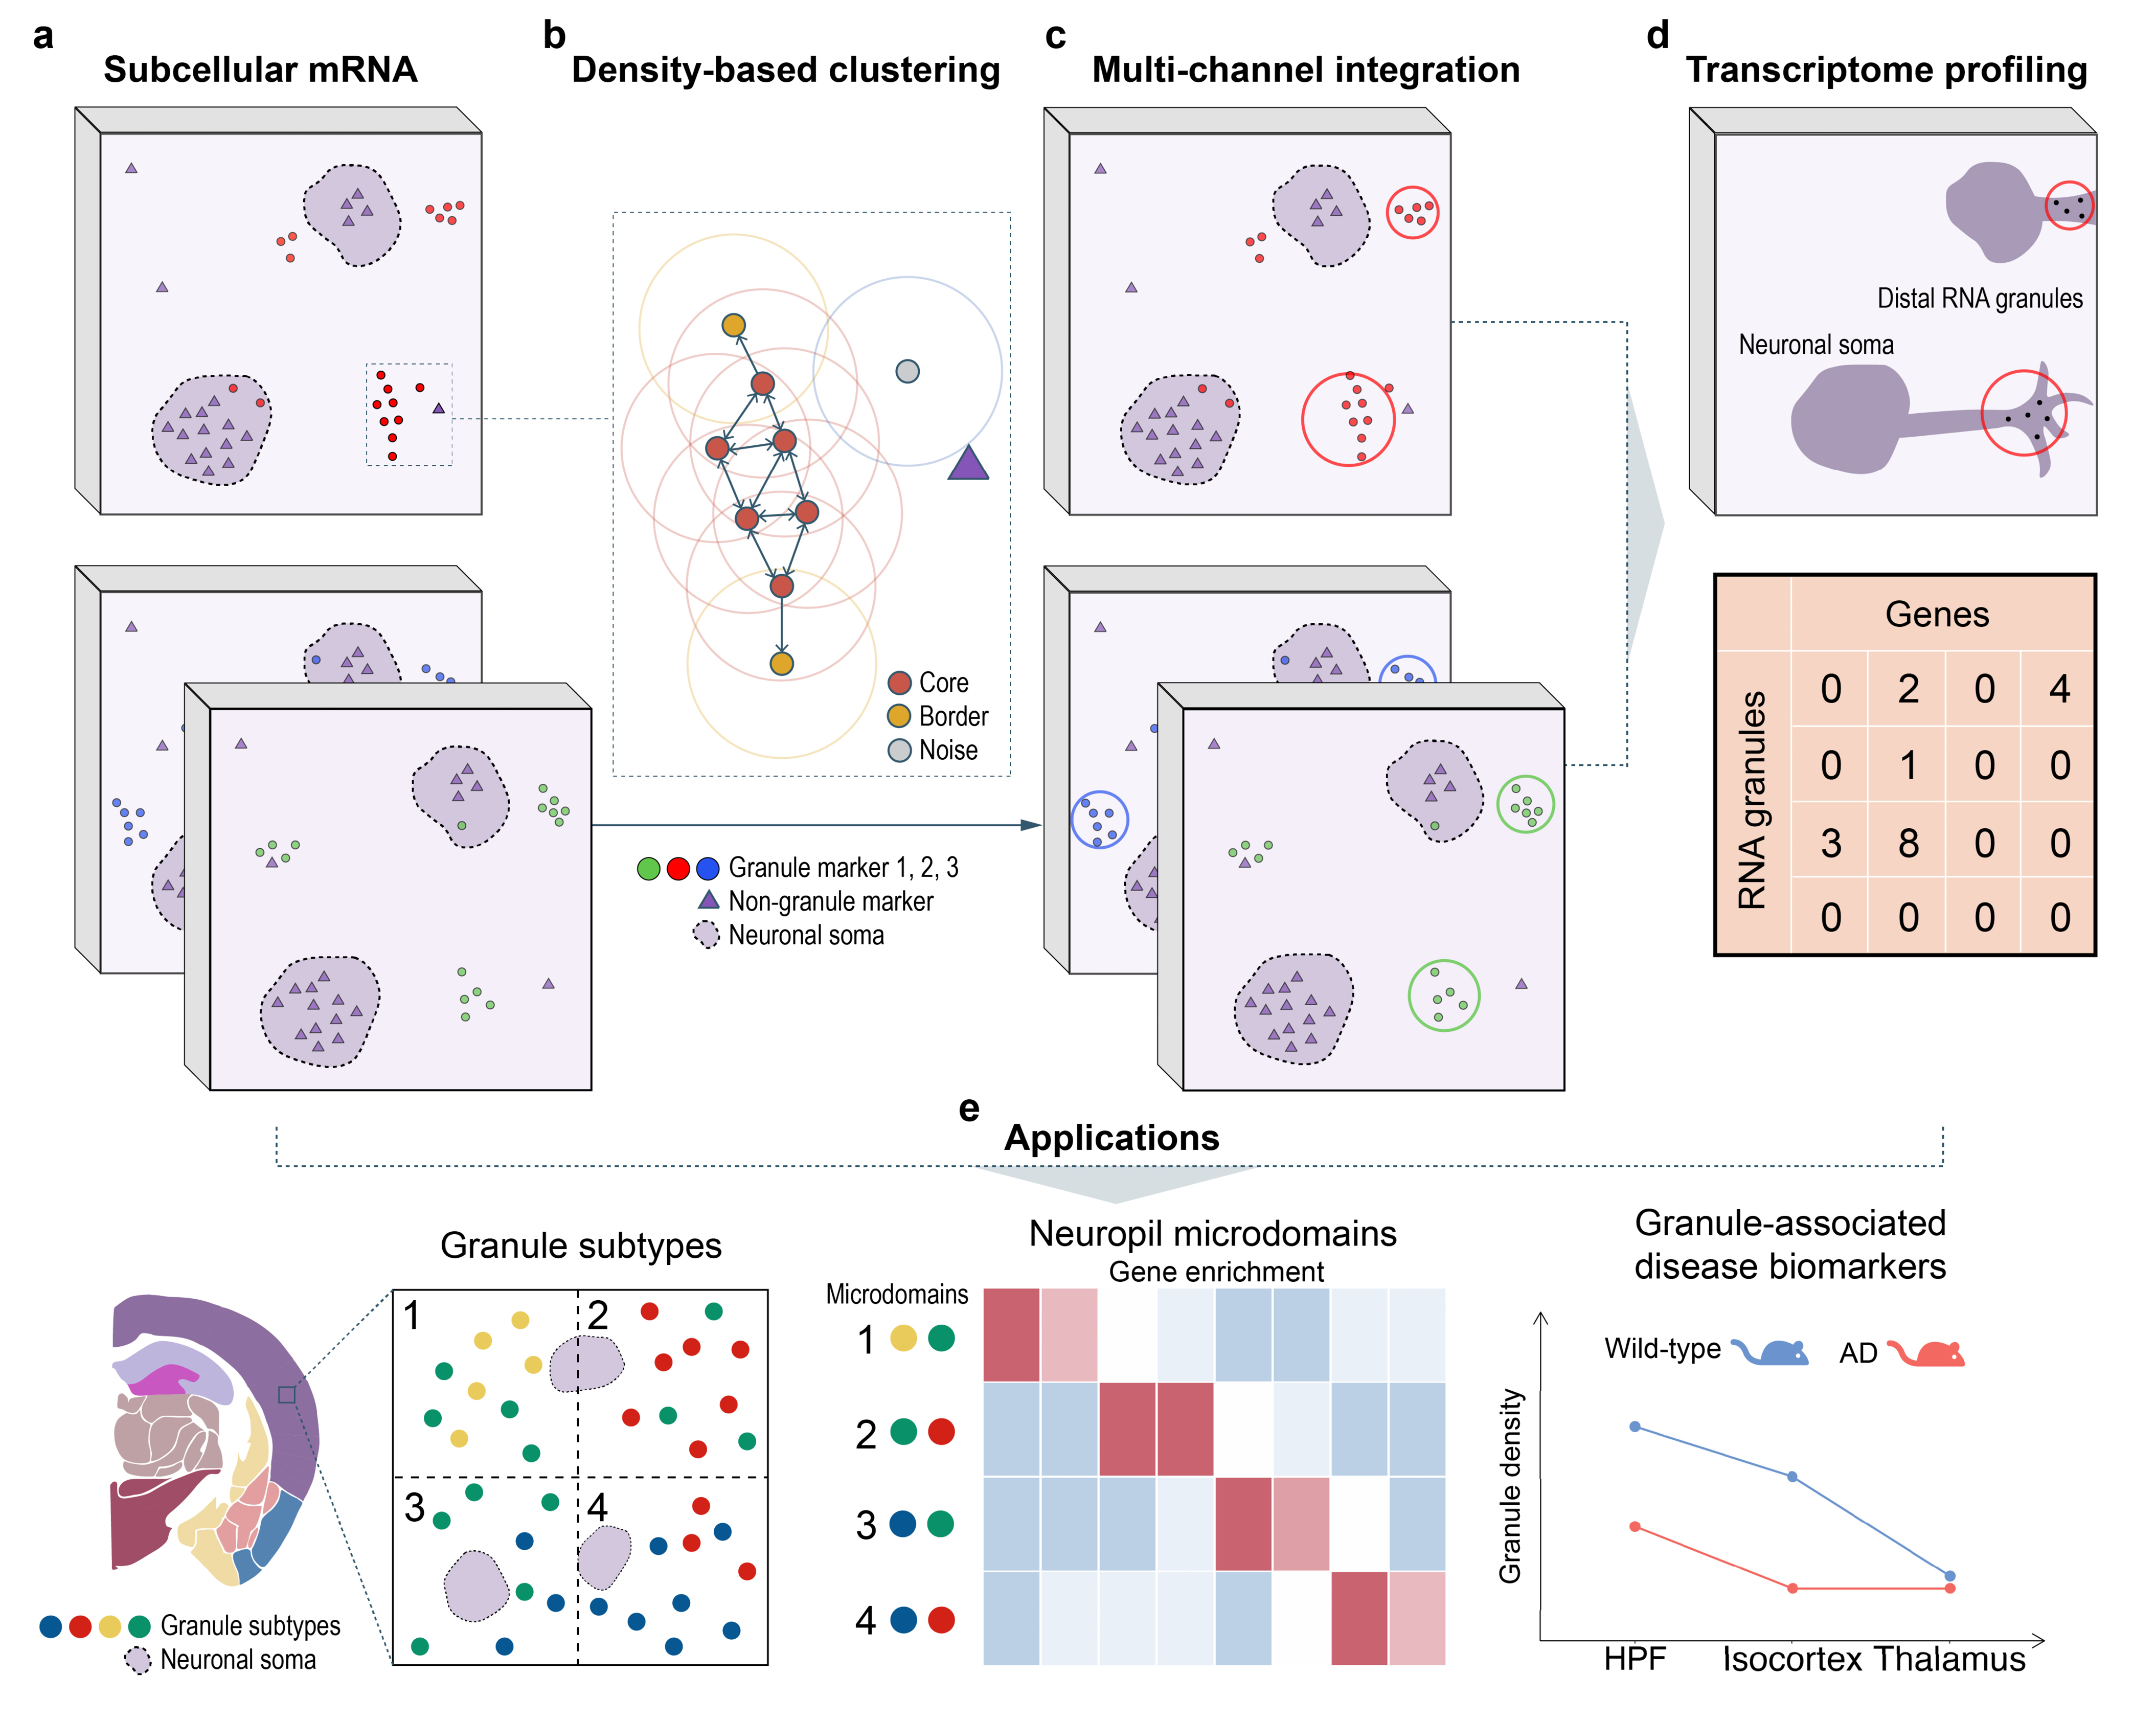
Fig. 1 | Workflow of mcDETECT. a. Schematic representation of the subcellular spatial distribution of compartmentalized mRNAs (red, blue, and green dots) and non-compartmentalized mRNAs (purple triangles) within neurons. b. mcDETECT applies a density-based clustering approach to identify extrasomatic mRNA aggregates for each distally localized gene. c. mcDETECT repeats this process for all distally localized genes, merges aggregates with significant spatial overlap, and identifies individual RNA granule locations. d. mcDETECT collects all mRNAs within the minimal enclosing sphere of each aggregate to construct the transcriptome profile of individual RNA granules. e. Example downstream applications of mcDETECT, including the identification of granule subtypes, granule-informed neuropil microdomains, and granule-associated disease biomarkers.
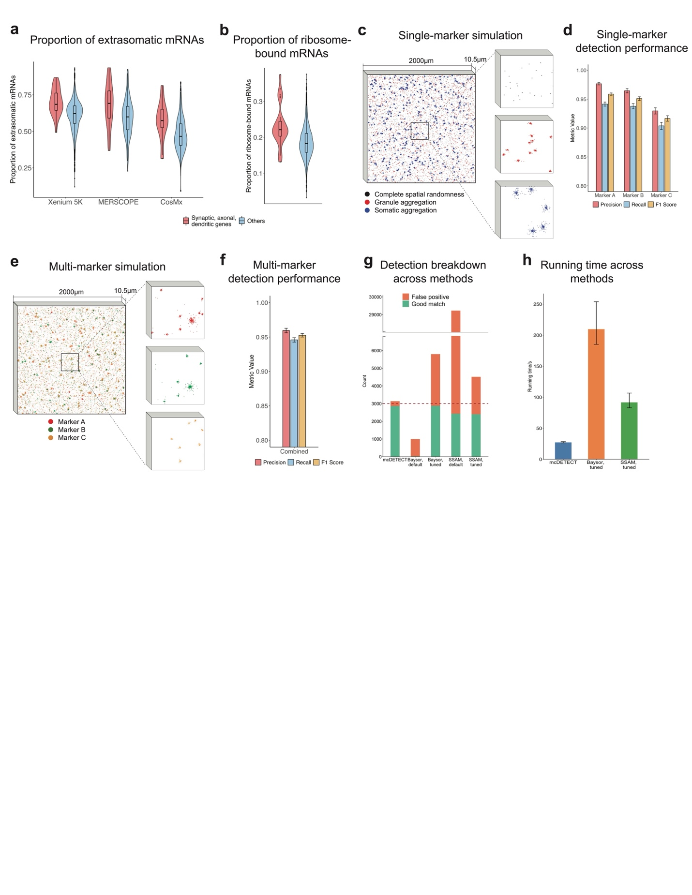
Fig. 2 | Granule marker selection and simulation study. a. Violin plot comparing the proportion of extrasomatic mRNAs for selected synaptic, dendritic, and axonal genes versus other genes in the Xenium 5K, MERSCOPE, and CosMx datasets. The lower and upper hinges in the embedded boxplot correspond to the first and third quartiles, and the center represents the median. The upper (lower) whisker extends from the hinge to the largest (smallest) value within 1.5 × the interquartile range. b. Violin plot comparing the proportion of ribosome-bound mRNAs in peripheral processes for selected synaptic, dendritic, and axonal genes versus other genes in the RIBOmap dataset. Embedded boxplot definitions are the same as those in a. c. Left: Simulation of a single granule marker in 3D space, where each dot represents a subcellular mRNA molecule. Black, red, and blue dots indicate complete spatial randomness (CSR), aggregation within distal compartments, and aggregation within somata, respectively. Right: Zoomed-in view of the three distribution patterns in a small region. d. Bar plot showing the detection precision, recall, and F1 score achieved by mcDETECT on the simulated 3D single-marker data across 200 simulation runs. Bar heights represent mean values, and error bars denote mean $±$ one standard deviation. e. Left: Simulation of three granule markers in 3D space, where each dot represents a subcellular mRNA molecule. Red, green, and orange dots indicate marker types A, B, and C, respectively. Right: Zoomed-in view of a small region stratified by marker type. f. Bar plot showing the detection precision, recall, and F1 score achieved by mcDETECT on the simulated 3D multi-marker data across 200 simulation runs. Bar plot definitions are the same as those in d. g. Bar plot showing the number of detected RNA aggregates by mcDETECT, Baysor, and SSAM, colored by whether aggregates are classified as good matches or false positives. h. Bar plot showing the running time across 200 runs for mcDETECT, Baysor, and SSAM. Bar height represents the mean running time, and error bars indicate the range across all runs.
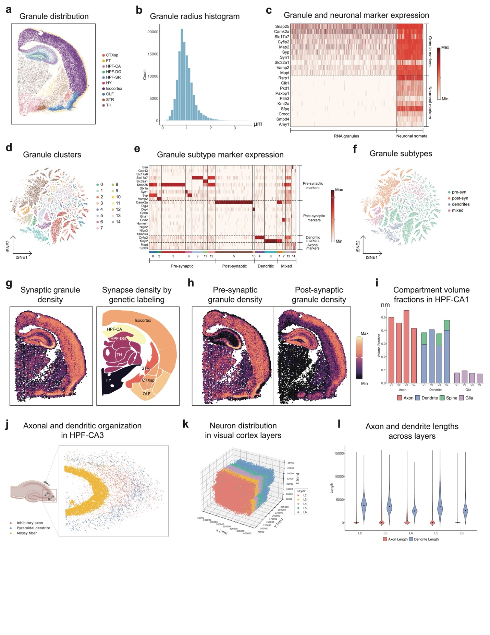
Fig. 3 | Application to the Xenium 5K dataset. a. Spatial map showing all RNA granules identified by mcDETECT across ten major brain regions: cortical subplate (CTXsp), fiber tracts (FT), cornu ammonis of the hippocampus (HPF-CA), dentate gyrus of the hippocampus (HPF-DG), stratum radiatum of the hippocampus (HPF-SR), hypothalamus (HY), isocortex, olfactory areas (OLF), striatum (STR), and thalamus (TH). b. Histogram showing the distribution of radii for all identified RNA granules. c. Heatmap showing the enrichment patterns of 10 granule markers and 10 neuronal markers in RNA granules and neuronal somata. Color represents the standardized enrichment level of each gene within each group. d. t-SNE plot of all RNA granules, colored by 15 clusters obtained from K-Means clustering based on enrichment of 24 granule-subtype-specific genes (pre-synaptic, post-synaptic, dendritic, and axonal). e. Heatmap showing the enrichment patterns of the 24 granule-subtype-specific genes across the 15 granule clusters. Color definitions are the same as those in c. f. t-SNE plot of all RNA granules, colored by four major granule subtypes defined by dominant subtype marker enrichment. g. Left: Spatial map showing the number of synaptic granules (i.e., pre- or post-synaptic) identified by mcDETECT in 50 × 50 µm² spots spanning the tissue slice. Right: Regional synapse densities estimated using volume electron microscopy and genetic labeling on a coronal slice corresponding to the approximate bregma position in a. h. Spatial maps showing the number of pre- and post-synaptic granules in each 50 × 50 µm² spot. i. Bar plot showing the axon, dendrite, spine, and glia volume fractions in HPF-CA1 from Mishchenko et al. j. Spatial map of axonal and dendritic compartments in mouse HPF-CA3 from Zheng et al. k. Spatial map of 71,993 neurons in mouse visual cortex across layers 2–6 in the MICrONS dataset. l. Violin plot comparing axonal and dendritic path lengths across cortical layers in the MICrONS dataset.
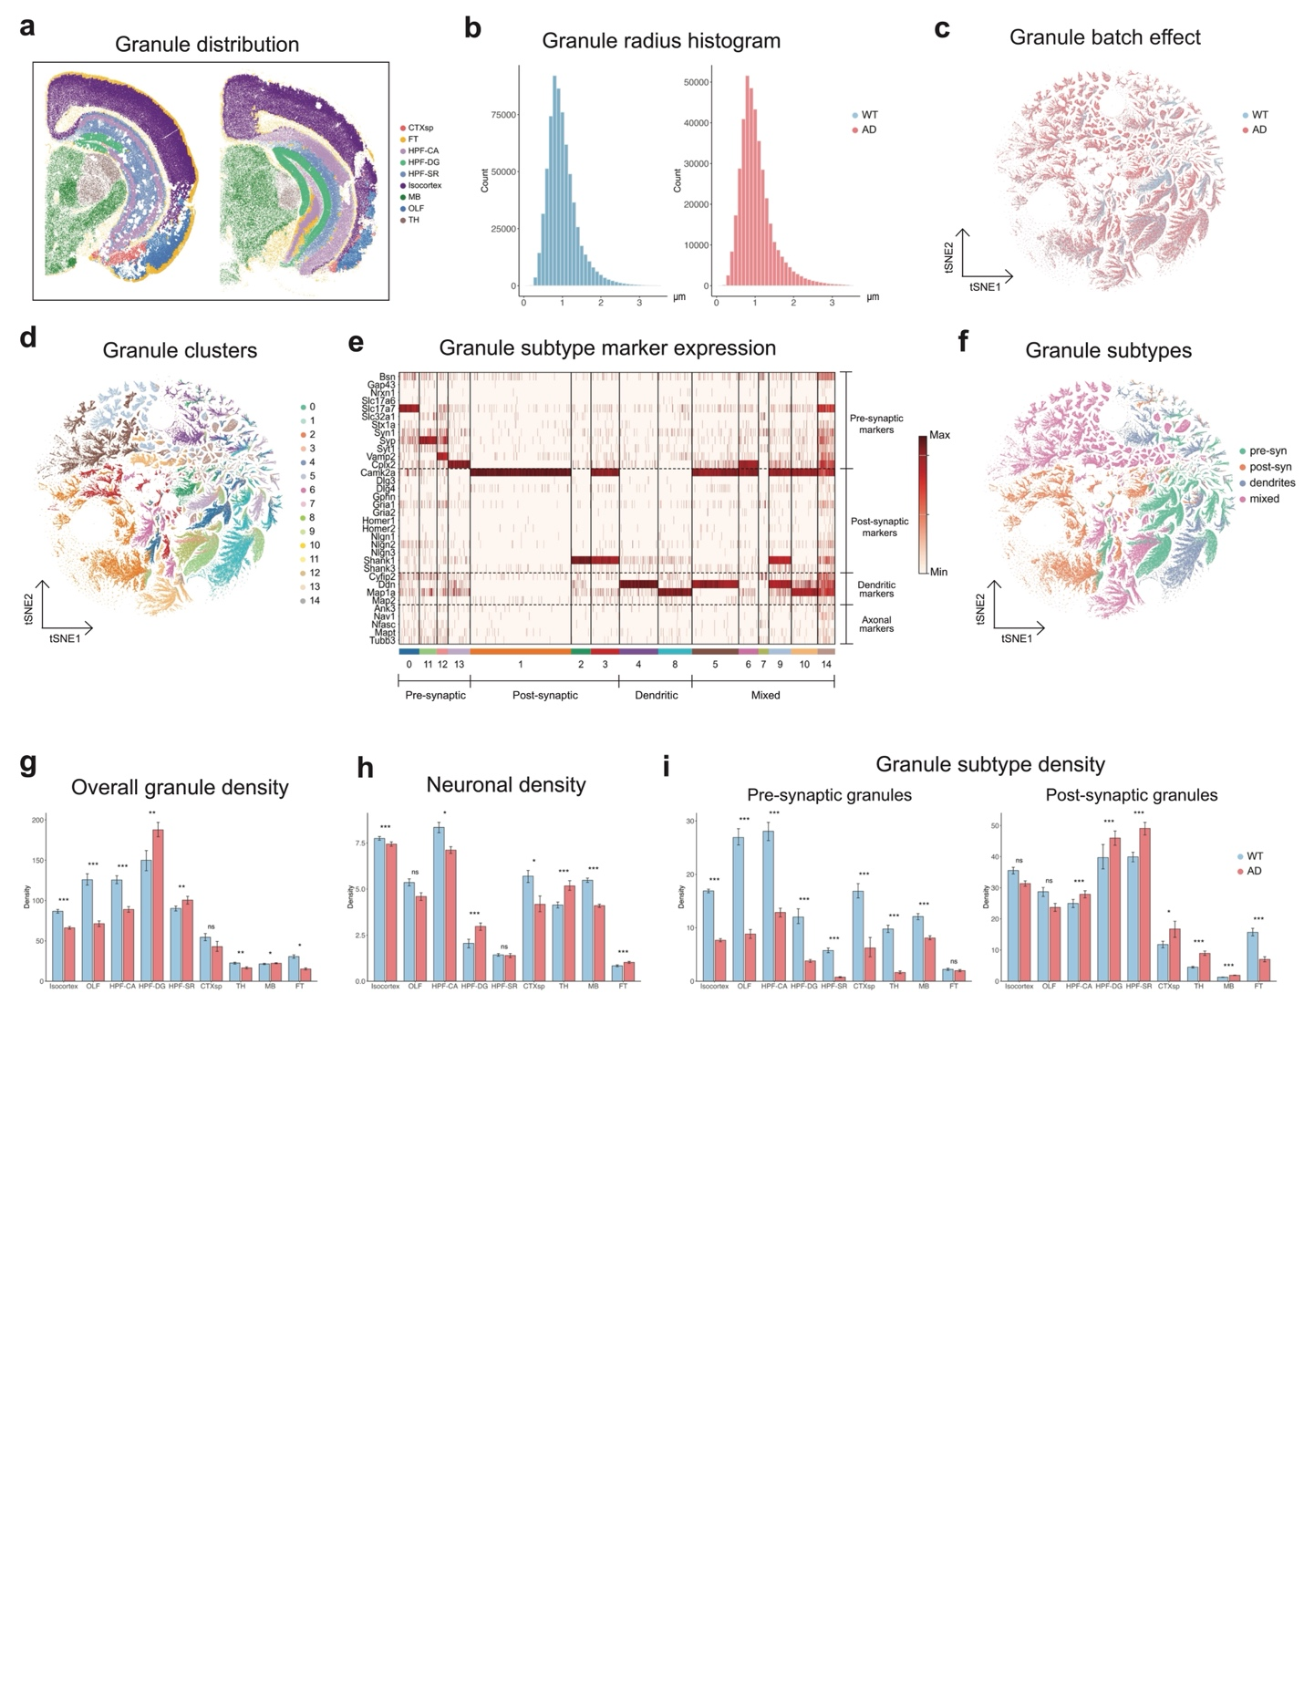
Fig. 4 | Granule alterations between wild-type (WT) and Alzheimer’s disease (AD) mouse brains in MERSCOPE datasets. a. Spatial map showing all RNA granules identified by mcDETECT in WT and AD samples across nine major brain regions: cortical subplate (CTXsp), fiber tracts (FT), cornu ammonis of the hippocampus (HPF-CA), dentate gyrus of the hippocampus (HPF-DG), stratum radiatum of the hippocampus (HPF-SR), isocortex, midbrain (MB), olfactory areas (OLF), and thalamus (TH). b. Density plots comparing the distribution of radii for all identified RNA granules between WT and AD samples. c. t-SNE plot of all RNA granules, colored by sample identity (WT vs AD). d. t-SNE plot of all RNA granules, colored by 15 clusters obtained from K-Means clustering based on enrichment of 34 granule-subtype-specific genes (pre-synaptic, post-synaptic, dendritic, and axonal). e. Heatmap showing the enrichment patterns of the 34 granule-subtype-specific genes across the 15 granule clusters. Color represents the standardized enrichment level of each gene within each group. f. t-SNE plot of all RNA granules, colored by four major granule subtypes defined by dominant subtype marker enrichment. g–i. Grouped bar plots comparing overall granule density, neuronal density, pre- and post-synaptic granule densities between WT and AD samples. RNA granule density is measured as the number of granules per 50 × 50 µm² spot. Bar heights represent mean spot-level densities, and error bars indicate bootstrap-based 95% confidence intervals from 500 resamples. ns: not significant; *: adjusted p < 0.05; **: adjusted p < 0.01; ***: adjusted p < 0.001.
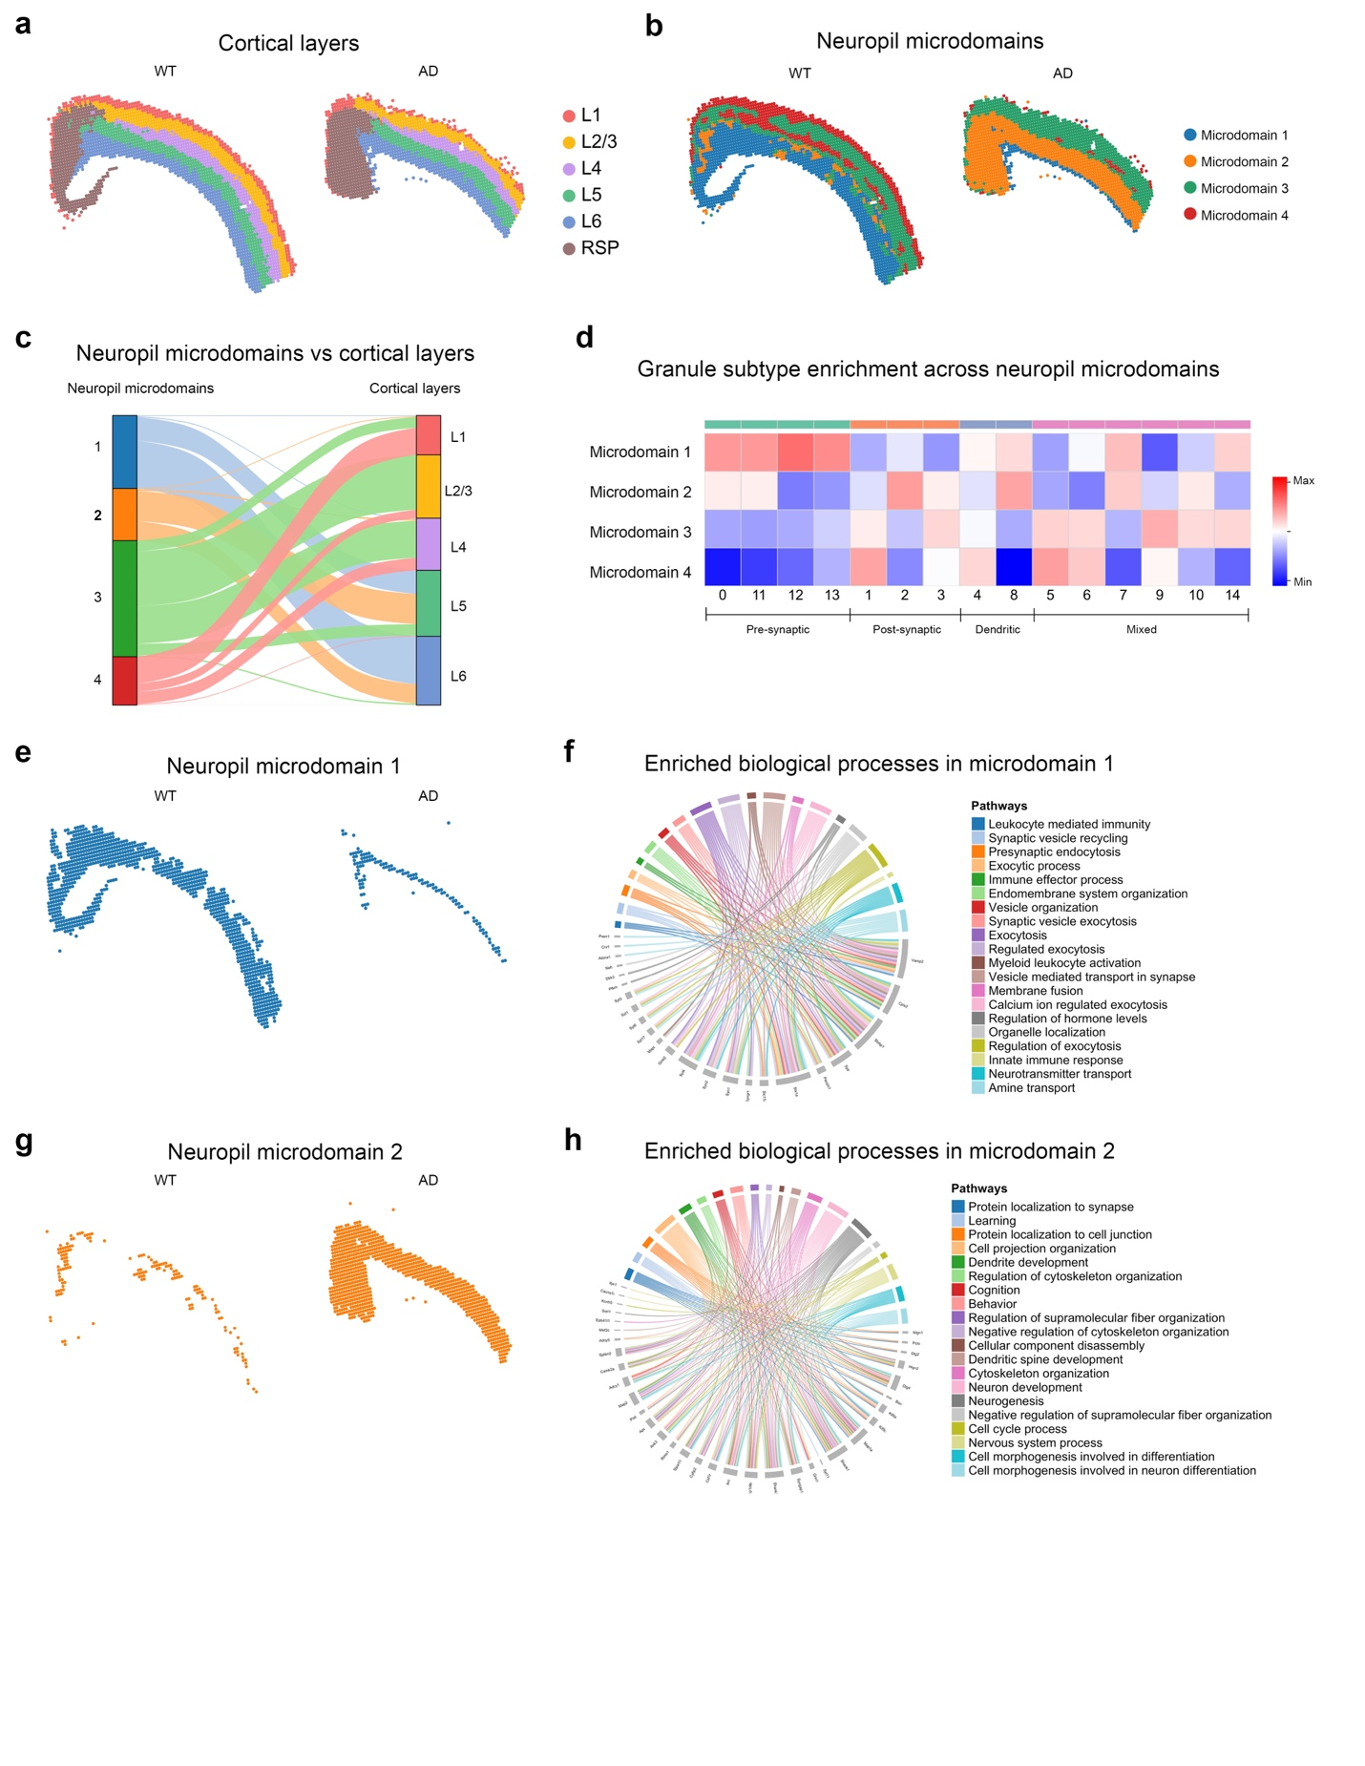
Fig. 5 | Cortical neuropil microdomain analysis between WT and AD mouse brains in MERSCOPE datasets. a. Identified shared laminar layers across WT and AD mouse brains based on total expression in 50 × 50 × 10.5 µm³ bins. b. Identified neuropil microdomains in both WT and AD mouse brain samples based on granule subtype composition in 50 × 50 × 10.5 µm³ bins. c. Alluvial plot illustrating the correspondence between neuropil microdomains and cortical layers. d. Heatmap showing the enrichment of granule subtypes in each neuropil microdomain. e. Spatial map showing the distribution of neuropil microdomain 1 in WT and AD samples. f. Chord diagram illustrating enriched biological processes and their associated genes in neuropil microdomain 1. g. Spatial map showing the distribution of neuropil microdomain 2 in WT and AD samples. h. Chord diagram illustrating enriched biological processes and their associated genes in neuropil microdomain 2.
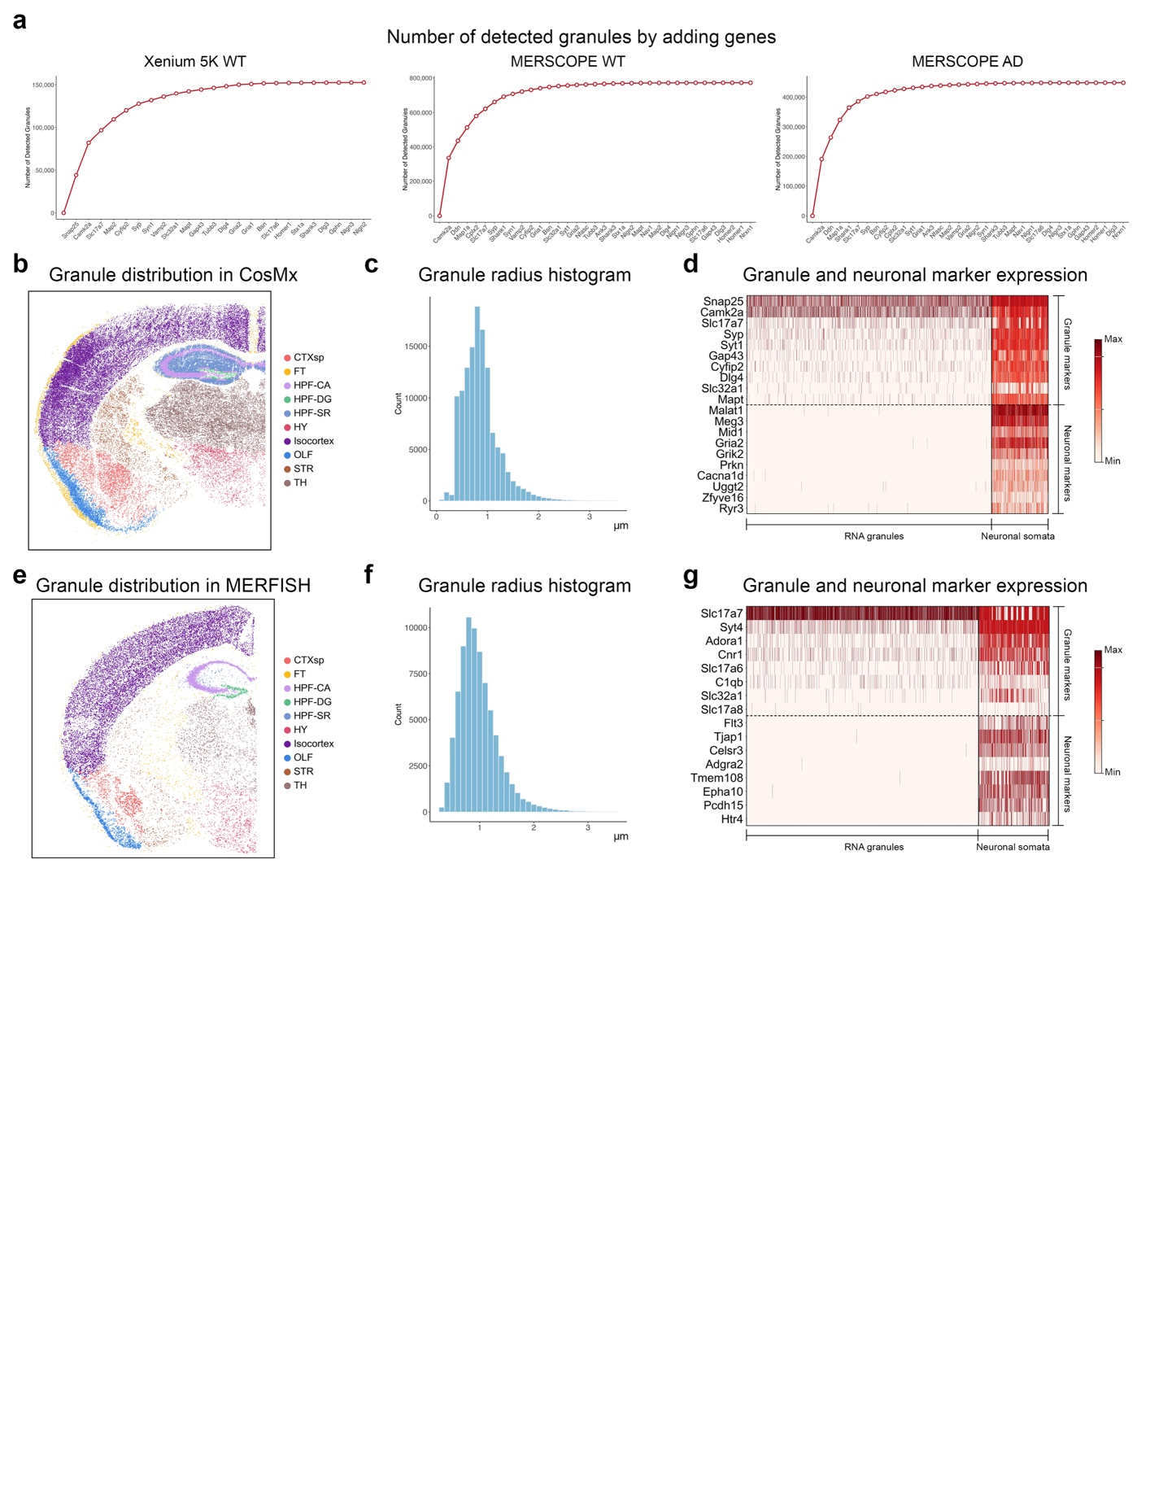
Fig. 6 | Benchmarking mcDETECT on datasets with limited granule marker coverage. a. Line plots showing the cumulative number of RNA granules identified by sequentially applying mcDETECT to individual granule markers and aggregating the results in the Xenium 5K, MERSCOPE WT, and MERSCOPE AD samples. b–d. Application to the CosMx dataset. b. Spatial map showing all RNA granules identified by mcDETECT across ten major brain regions: cortical subplate (CTXsp), fiber tracts (FT), cornu ammonis of the hippocampus (HPF-CA), dentate gyrus of the hippocampus (HPF-DG), stratum radiatum of the hippocampus (HPF-SR), hypothalamus (HY), isocortex, olfactory areas (OLF), striatum (STR), and thalamus (TH). c. Histogram showing the distribution of radii for all identified RNA granules. d. Heatmap showing the enrichment patterns of 10 granule markers and 10 neuronal markers in RNA granules and neuronal somata. Color represents the standardized enrichment level of each gene within each group. e–g. Application to the MERFISH dataset. e. Spatial map showing all RNA granules identified by mcDETECT across the same ten brain regions as in b. f. Histogram showing the distribution of radii for all identified RNA granules. g. Heatmap showing the enrichment patterns of 8 granule markers and 8 neuronal markers in RNA granules and neuronal somata. Color definitions are the same as those in d.
Methods
Input data
mcDETECT is designed to accommodate a wide range of iST datasets generated by multiple iST platforms. Most iST platforms provide a file that records each transcript together with its gene identity and the $(x, y, z)$ coordinates of the associated mRNA molecule, which serves as the primary input for identifying RNA granule locations. Some platforms also include a binary label indicating whether each mRNA molecule overlaps with a cell soma. In addition, mcDETECT requires a user-defined list of granule markers and negative control markers enriched in neuronal nuclei. We have summarized a set of distal RNA granule markers (Supplementary Tables 2 and 3) and negative controls (Supplementary Table 8), and users may retain those that are present in their iST dataset.

Preprocessing, filtering, and quality control
Preprocessing of iST data for mcDETECT involves constructing 3D transcript coordinates. For Xenium 5K, continuous 3D coordinates are directly provided by the platform, whereas for MERSCOPE/MERFISH and CosMx datasets, discrete 3D coordinates are constructed by stacking detections across multiple z-planes from the acquired image stacks. mcDETECT then operates directly on the resulting platform-processed transcript lists without additional spot-level or image-level filtering. For publicly released Xenium 5K, CosMx, and MERFISH datasets, no further transcript- or cell-level filtering is applied; for the in-house MERSCOPE dataset, cells with fewer than 25 detected transcripts are removed following vendor guidelines.

Generating in-soma labels
If the input transcript file lacks binary in-soma labels for transcripts, mcDETECT performs an embedded pre-processing step to generate them based on DAPI images. First, binary nuclear masks are obtained from the DAPI image using Gaussian-weighted adaptive thresholding (block size = 49). We then remove connected components smaller than 100 pixels to eliminate small noise fragments. Each retained nuclear mask is expanded by applying morphological dilation, following prior work by Qian et al.⁵⁵ and our own evaluation (Supplementary Note 14), to approximate the soma region. We apply a circular, disk-shaped structuring element with a radius of 5 pixels (approximately 0.5 µm) independently in each optical z-plane, yielding a conservative and isotropic approximation of the soma-proximal area. Transcript coordinates are then registered to the image coordinate system and overlaid onto the resulting binary soma mask. Any transcript whose coordinate falls within the dilated mask is labeled as “in-soma,” and all remaining transcripts are labeled as “extrasomatic.”

mcDETECT algorithm
mcDETECT is an end-to-end framework that processes transcript files from the iST platform along with user-defined granule markers, returning the spatial characteristics and transcriptome profiles of individual RNA granules. The complete mcDETECT algorithm consists of the following four steps:

Step 1: Density-based clustering on each single marker to identify extrasomatic aggregates
The fundamental step of mcDETECT is to identify extrasomatic aggregates of mRNAs in the input transcript file using a clustering strategy inspired by Density-Based Spatial Clustering with Applications of Noise⁵⁶. It operates based on two predefined parameters: the search radius $r$and the minimum number of samples $m$. Denote $T$ as the set of mRNAs from a granule marker, where each mRNA $t_{i}∈T$ has 3D spatial coordinates ${(x}_{i}, y_{i}, z_{i})$. We first calculate the Euclidean distance between all mRNA pairs $t_{i},t_{j}∈T$ by:
$$d(t_{i}, t_{j})=\sqrt{{{(x}_{i}-x_{j})}^{2}+{{(y}_{i}-y_{j})}^{2}+{{(z}_{i}-z_{j})}^{2}}.$$
The neighbors of $t_{i}$ are defined as the mRNAs falling within its neighborhood of radius $r$, and the number of its neighbors is recorded by:
$$N_{i}=\sum_{t_{j}∈T}{I(d(t_{i},t_{j})<r)},$$
where $I(∙)$ is the indicator function. Next, mcDETECT classifies the mRNAs within the set $T$ as core points, border points, and noise points according to the following criteria:
1) a point $t_{i}$ is a core point if the number of its neighbors exceeds or equals the minimum number of samples $m$, i.e., $N_{i}≥m$;
2) a point $t_{j}$ is directly reachable from a core point $t_{i}$ if it is within the neighborhood of $t_{i}$, i.e., $d(t_{i},t_{j})<r$;
3) a point $t_{j}$ is reachable from a core point $t_{i}$ if there is a path ${\{t}_{1},t_{2},⋯,t_{n}\}$ such that $t_{i}=t_{1}$ and $t_{j}=t_{n}$, where each point $t_{i+1}$ is directly reachable from point $t_{i}$ for $i∈\{1,⋯,n-1\}$;
4) a point $t_{j}$ is a border point if the number of its neighbors is less than the minimum number of samples $m$, i.e., $N_{j}<m$, but it is reachable from a core point $t_{i}$;
5) a point $t_{k}$ is a noise point if it is not reachable from any other point.
A core point forms a cluster along with all points that are reachable from it, possibly consisting of other core points and border points, and each cluster represents a distinct aggregate of mRNAs. Based on this paradigm, mcDETECT effectively extracts the pattern where mRNAs aggregate while excluding the dissociated mRNAs.

The selection of the search radius $r$and the minimum number of samples $m$ will affect the detection results. In this study, we set $r$ to 1.5 µm, considering the transcript distance (Supplementary Note 15) and typical size of RNA granules inferred from fluorescent puncta⁵⁷. The minimum number of samples $m$ is determined by mcDETECT through an automated procedure for each granule marker based on its transcript density. For a given granule marker, we first calculate its overall density $λ$ as:
$$λ=\frac{total number of mRNAs}{area of the tissue slice}.$$
RNA diffusion is minimal in iST data (Supplementary Note 10), but background signal still needs to be considered. As an optional procedure in mcDETECT, we assess whether the observed mRNA distribution deviates from background signal by comparing it against a complete spatial randomness (CSR) process. Under CSR, the number of mRNAs within a circular region of radius $r$ follows a Poisson distribution with mean $λπr^{2}$. To distinguish true aggregates from random dispersion, we define the ideal minimum number of samples $m^{*}$ as the value satisfying:
$$\operatorname{Pr}\left(Poisson\left(αλπr^{2}\right)≤m^{*}\right)=0.95,$$
where $α$ is a scaling factor used to adjust the density threshold for clustering. In this formulation, $m^{*}$ represents the number of transcripts that would be expected only 5% of the time under CSR, making it a conservative threshold for identifying true aggregates. In this optional CSR-based thresholding step, we set $α=0.5$ and find that the results are robust to alternative choices of $α$. Finally, in practice, the minimum number of samples $m$ is determined as:
$$m=\left\lfloor max\left.(m^{*},3)\right\rceil \right.,$$
where we apply a flooring threshold of 3 to ensure that identified aggregates contain at least three mRNAs, and round $m$ to its nearest integer. In conclusion, this data-driven parameter selection procedure allows mcDETECT to automatically determine the best search radius $r$and minimum number of samples $m$ to identify statistically significant aggregates for different input genes.

For each identified aggregate, mcDETECT constructs a minimum enclosing sphere that encompasses all associated mRNAs. The centroid and radius of this sphere serve as proxies for the location and size of the aggregate, respectively. Although the aggregates are initially defined using a single granule marker, the enclosing spheres allow for evaluating colocalization with other granule markers. The location, size, and granule marker composition are then recorded as spatial characteristics of the identified aggregates and are used for downstream filtering. Aggregates with an excessively large radius (4 µm) are discarded, as they likely represent cell fragments rather than distal RNA granules. In addition, mcDETECT evaluates the in-soma ratio of each aggregate using the intracellular position of mRNAs. Specifically, let $B={\{b}_{1},b_{2},⋯,b_{n}\}$ be the set of all granule marker mRNAs within the enclosing sphere. An aggregate is discarded if:
$$\frac{1}{n}\sum_{b_{i}∈B}{I(b_{i}∈soma)}≥τ,$$
where $τ$ is a user-defined threshold, whose value may vary depending on how in-soma labels are derived.
In this study, we set $τ=0.1$ to account for granules located near or partially overlapping the soma.

Step 2: Integrating aggregates from multiple markers
To reveal the overall distribution of RNA granules informed by all granule markers, mcDETECT integrates aggregates across multiple markers while accounting for their spatial colocalization. The integration proceeds in the order of marker expression intensity, consistent with previous reports that highly expressed markers tend to colocalize with other genes⁵⁷. This integration is performed using an iterative procedure based on the relative positions of spheres in 3D space. Specifically, let $s_{1}$ and $s_{2}$ represent two spheres derived from two different markers, with centroids $c_{1}$ and $c_{2}$, and radii $r_{1}$ and $r_{2}$, respectively. We first calculate the Euclidean distance between the centroids:
$$d(c_{1}, c_{2})=\sqrt{{{(x}_{1}-x_{2})}^{2}+{{(y}_{1}-y_{2})}^{2}+ {{(z}_{1}-z_{2})}^{2}},$$
where ${(x}_{1}, y_{1}, z_{1})$ and ${(x}_{2}, y_{2}, z_{2})$ are the 3D spatial coordinates of $c_{1}$ and $c_{2}$, respectively. Based on this inter-centroid distance, the relative positions of $s_{1}$ and $s_{2}$ are classified and handled as follows:
1) Disjoint: if $d(c_{1}, c_{2})≥r_{1}+r_{2}$, the spheres do not overlap, and both $s_{1}$ and $s_{2}$ are retained.
2) Contained: if $0≤d(c_{1}, c_{2})≤\left|r_{2} - r_{1}\right|$, the smaller sphere is considered contained within the larger one and is merged accordingly.
3) Intersecting: if ${|r}_{2} - r_{1}|<d(c_{1}, c_{2})<r_{1}+r_{2}$, the spheres partially overlap. If the overlap is deemed significant, defined as $d(c_{1}, c_{2})<{ρ∙(r}_{1}+r_{2})$, where $ρ$ is a threshold parameter, the mRNAs from $s_{1}$ and $s_{2}$ are merged, and a new enclosing sphere is computed. Otherwise, both aggregates are retained. In this study, we set $ρ=0.2$ to define “heavy overlap” and prevent merging of nearby but distinct RNA granules.
This integration procedure is robust to the choice of $ρ$ (Supplementary Note 16), and is applied iteratively across all pairs of granule marker-derived aggregates to ensure efficient consolidation of overlapping signals. mcDETECT also provides an alternative strategy in which all marker genes are merged into a single round of detection. This approach increases sensitivity but may introduce more false positives (Supplementary Note 17).

Step 3: Filtering based on negative control enrichment
Following multi-marker integration, mcDETECT performs an additional filtering step based on the enrichment of negative control markers. Based on previous studies, we select these marker genes to be enriched in neuronal nuclei compared to the cytoplasm^{1,29,58}. For each aggregate, mcDETECT counts the number of negative control mRNAs within its associated minimum enclosing sphere. An aggregate is discarded if the ratio of negative control mRNAs to granule marker mRNAs exceeds 10%. This step helps reduce false positives caused by cell fragments or nonspecific mRNA accumulation. A detailed ablation of the in-soma and negative control filters is provided in Supplementary Note 18 to demonstrate the effectiveness and robustness of the parameter settings.

Step 4: Constructing spatial transcriptome profiles for individual RNA granules
To build transcriptome profiles of the identified RNA granules, mcDETECT maps all mRNA transcripts from the iST dataset to the minimum enclosing spheres that represent individual RNA granules. An ablation study comparing alternative sphere-definition strategies is provided in Supplementary Note 19. For each granule, the number of mRNAs per gene is counted, resulting in a gene-by-granule count matrix. By combining this matrix with spatial coordinates, mcDETECT generates a comprehensive spatial transcriptome profile for RNA granules across the tissue section, which enables further investigations of granule heterogeneity and molecular alterations in neurodegenerative diseases.

Downstream analyses
RNA granule subtyping
To classify the identified RNA granules into molecular subtypes, we use a predefined panel of granule-subtype-specific genes, including markers for pre-synaptic, post-synaptic, dendritic, and axonal compartments, while minimizing potential optical crowding (Supplementary Note 20). We perform mini-batch K-Means clustering on the enrichment matrix of these genes across all granules, resulting in 15 initial granule clusters (Supplementary Note 21). By examining the enrichment patterns of subtype-specific markers within each cluster, we annotate the clusters as granule populations enriched for pre-synaptic, post-synaptic, dendritic genes, or mixed signals.

Spatial domain assignment
To identify spatial domains in an iST dataset, we first generate a 2D grid over the tissue section, where each grid spot represents a 50 × 50 µm² region. Next, we reconstruct spatial gene expression by mapping all mRNA transcripts onto these pseudo-spots. Using this spot-level gene expression matrix, we apply a spatial clustering method, SpaGCN⁵⁹, to identify distinct spatial domains. These domains are subsequently annotated as major brain regions based on anatomic maps from the Allen Mouse Brain Atlas. Finally, the assigned brain region labels for each pseudo-spot are propagated to all cells and RNA granules within that spot, enabling region-specific spatial analysis at multiple biological scales.

Calculating RNA granule density
The 50 × 50 µm² pseudo-spots are used as the smallest unit for summarizing granule density within the tissue region. The granule density at the spot level is calculated as the number of granules divided by the spot area. At the regional level, granule density is computed by averaging the spot-level densities across all spots within a given brain region.

To evaluate the agreement between regional synaptic granule densities estimated by mcDETECT and the synapse density derived from the genetic labeling approach from age-matched mice, we use a weighted Spearman correlation coefficient^{60,61}, accounting for the brain region area. Specifically, let $A=\left\{a_{1},…,a_{n}\right\}$ and $B=\left\{b_{1},…,b_{n}\right\}$ denote the granule densities across $n$ brain regions obtained from the two approaches, and let $\left\{w_{1},…,w_{n}\right\}$ represent the corresponding areas of these brain regions. We begin by computing the ranks $R_{A}=\left\{R(a_{1}),…,{R(a}_{n})\right\}$ and $R_{B}=\left\{R(b_{1}),…,{R(b}_{n})\right\}$. The weighted mean rank for group $A$ is calculated as ${\overline{R}}_{A}^{w}=\sum_{i=1}^{n}{w_{i}R(a_{i})}/\sum_{i=1}^{n}{w_{i}}$, and similarly for ${\overline{R}}_{B}^{w}$. The weighted Spearman correlation is then calculated as:
$$ρ_{S}^{w}=\frac{\sum_{i=1}^{n}{w_{i}(R\left(a_{i}\right)-{\overline{R}}_{A}^{w})(R\left(b_{i}\right)-{\overline{R}}_{B}^{w})}}{\sqrt{\sum_{i=1}^{n}{w_{i}{(R\left(a_{i}\right)-{\overline{R}}_{A}^{w})}^{2}∙\sum_{i=1}^{n}{w_{i}{(R\left(b_{i}\right)-{\overline{R}}_{B}^{w})}^{2}}}}} .$$
This weighted correlation provides a more accurate similarity measure between regional granule densities by assigning greater importance to brain regions with larger spatial coverage.
To compare granule densities between WT and AD samples, we first adjust for differences in capture efficiency between experiments. Specifically, we define a global capture efficiency coefficient as the ratio of the mean number of transcripts per spot across the tissue section in AD to that in WT, and rescale spot-level densities in the AD sample by this coefficient prior to comparison. We then perform spot-level statistical analyses to compare the density of each granule subtype between WT and AD within each brain region, with regional density defined as the mean across pseudo-spots, as described above. Variability is quantified using bootstrap-based 95% confidence intervals (500 resamples with replacement of pseudo-spots), with interval bounds defined by the 2.5th and 97.5th percentiles of the bootstrap distribution. Statistical comparisons are conducted using two-sample t-tests applied to log1p-transformed spot-level granule counts to stabilize variance. Because multiple hypothesis tests are performed across brain regions for each granule subtype, p-values are adjusted using the Bonferroni correction within each subtype. Statistical significance is determined based on Bonferroni-adjusted p-values unless otherwise specified.

Neuropil microdomain analysis
To characterize local neuropil microenvironment, we partition tissue volumes into $N$ non-overlapping three-dimensional (3D) bins of size 50 × 50 × 10.5 µm³, accounting for both in-plane spatial resolution and section thickness. For each bin $i$, let $G_{i}$ denote the set of RNA granules that fall within that local volume. Each granule $j∈G_{i}$ has a subtype label $s_{j}∈\{1,…,S\}$ derived from unsupervised clustering. We then construct a granule subtype embedding for each bin $u_{i}$, defined as the vector of granules subtypes counts in that bin. To reduce stochastic noise and enhance spatial continuity, we apply Gaussian smoothing across neighboring bins based on centroid-to-centroid distances. Let $N_{i}$ denote the set of first-order neighboring bins of bin $i$, i.e., within a radius $R=\sqrt{2}×50$ µm. The smoothed embedding is defined as:
$${\tilde{u}}_{i}=\sum_{k∈N_{i}}{ω_{ik}u_{k}}, where ω_{ik}=\frac{exp⁡(-\frac{d_{ik}^{2}}{2σ^{2}})}{\sum_{k^{'}∈N_{i}}{exp⁡(-\frac{d_{ik^{'}}^{2}}{2σ^{2}})}}.$$
Here, $d_{ik}$ denotes the Euclidean distance between the centroids of bins $i$ and $k$, and the kernel width is set to $σ=R/2$. Bins with no assigned granules are excluded from subsequent analysis. We then convert each smoothed embedding into a compositional representation by normalizing subtype counts:
$$e_{i}=\frac{{\tilde{u}}_{i}}{\sum_{s=1}^{S}{{\tilde{u}}_{is}}},$$
where $e_{i}∈R^{S}$ represents the relative abundance of granule subtypes within bin $i$, independent of absolute granule density.

To identify neuropil microdomains with distinct granule-defined microenvironments, we perform unsupervised clustering on the set of embeddings $\{e_{i}\}_{i=1}^{N}$. We first evaluate a range of cluster numbers using K-Means clustering, assessing within-cluster inertia. Based on the elbow method, we select an appropriate number of clusters ($K=4$ in this study) and apply standard K-Means to assign each bin to a microdomain. This procedure yields spatially coherent neuronal microdomains defined by differences in local RNA granule subtype composition across the 3D tissue volume.

Simulation
Simulation of a single granule marker
The simulation is performed over a 2000 × 2000 µm² area with a thickness of 10.5 µm, mimicking the scale of the Xenium platform. To model the subcellular mRNA distribution of a single granule marker, we assume it consists of three spatial components: complete spatial randomness (CSR), somatic aggregation, and extrasomatic aggregation. The simulation procedures for generating 3D coordinates $(x,y,z)$ for each mRNA follow the methodology described by Diggle⁶², as detailed below.

1) CSR. The CSR pattern is modeled using a homogeneous Poisson process, where the $x$, $y$, and $z$ coordinates are independently sampled from uniform distributions within the simulation bounds.

2) Somatic aggregation. This aggregation pattern is modeled using a Poisson cluster process. First, cell soma centroids are generated via a homogeneous Poisson process. A random number of mRNAs are then assigned to the vicinity of each centroid, forming clusters around them. The number of mRNAs per soma is sampled from a Poisson distribution. Distances $d$ between mRNAs and their corresponding soma centroids are independent and identically distributed (i.i.d.) exponential random variables. The directional angles of these distances are also i.i.d., determined by two uniform random variables: $φ$, the polar angle, ranging within $(0, π)$, and $ϕ$, the azimuthal angle, ranging within $(0, 2π)$. Consequently, the 3D offsets from soma centroids to mRNAs are given by:
$$x^{*}=d\sin{φ}\cos{ϕ},$$
$$y^{*}=d\sin{φ}\sin{ϕ},$$
$$z^{*}=d\cos{φ}.$$
The final coordinates $(x,y,z)$ of each mRNA are then calculated by adding the respective offsets to the soma centroid location. Repeating this for all somata yields the full clustering pattern within the simulated area. To simulate intrasomatic labeling, a binary in-soma label is assigned to each mRNA based on a Bernoulli distribution with success probability $p$, representing the likelihood that an mRNA resides within a soma. For each cluster, $p$ is independently sampled from a Beta distribution, producing a mean in-soma ratio of 95%. This stochastic construction introduces a softened but biologically realistic boundary between somatic and distal aggregates for testing mcDETECT’s soma filtering. Additionally, the distances $d$ are sampled from an exponential distribution such that the resulting aggregates have a characteristic size centered around 5.5 µm to mimic real data (Supplementary Note 3).

3) Extrasomatic aggregation. Extrasomatic aggregation follows the same procedure as somatic aggregation, with two key differences. First, the in-soma probability $p$ is sampled from a different Beta distribution, resulting in a lower average in-soma ratio of 5% (Supplementary Note 3). Second, the distances $d$ are sampled with a lower mean of 1 µm, reflecting reported RNA granule sizes.

In the simulation, 50% of transcripts follow complete spatial randomness (CSR), while the remaining 50% are evenly split between extrasomatic and somatic aggregates. These three spatial patterns are overlaid within the simulated area to generate the complete transcript distribution. A 2D version of the simulation can be generated by omitting the z-dimension.

Simulation of multiple granule markers
We consider three granule markers in the multi-marker scenario. As in the single-marker setting, each marker’s subcellular mRNA distribution follows one of three spatial patterns: CSR, somatic aggregation, or extrasomatic aggregation, with the latter two distinguished by differences in in-soma ratios and aggregate sizes. Additionally, we account for the colocalization patterns of multiple granule markers within somata and distal neuronal compartments. The simulation procedures for this scenario are detailed below:

1) CSR. CSR patterns are simulated independently for each granule marker.

2) Somatic aggregation. This aggregation pattern is modeled using a multi-sample Poisson cluster process. First, we generate cell soma centroid locations using a homogenous Poisson process. Then, we determine which of the three markers are expressed in each soma. Specifically, let $K$ be a categorical random variable representing the number of markers expressed in a given soma, drawn from the following probability mass function (pmf):
$$p\left(K=1\right)=0.8, p\left(K=2\right)=0.1, p\left(K=3\right)=0.1.$$
Given the value of $K$, we randomly select the corresponding markers and independently simulate each marker’s mRNA cluster following the procedures described in the single-marker setting. This results in clusters with diverse marker compositions.

3) Extrasomatic aggregation. This pattern follows the same procedures as somatic aggregation, with adjustments to reflect different biological characteristics. In particular, the in-soma ratios are lower, aggregate sizes are smaller, and the pmf of $K$ is modified to:
$$p\left(K=1\right)=0.4, p\left(K=2\right)=0.3, p\left(K=3\right)=0.3,$$
reflecting a higher degree of granule marker colocalization in distal neuronal compartments.

For both single-marker and multi-marker scenarios, we apply mcDETECT to the simulated mRNAs to recover the centroids of extrasomatic aggregates, which serve as ground truth. To evaluate the detection performance, we calculate the precision, recall, and F1 score based on whether these centroids are encompassed within the spheres identified by mcDETECT. The full simulation setup, including marker densities, the number of aggregates, and parameters for all distributions, is summarized in Supplementary Table 4.

MERSCOPE data generation
Animals
5xFAD transgenic mouse (Jax Strain# 034848) and C57BL/6J (Jax Strain# 000664) were obtained from Jackson Laboratory, bred and maintained at Emory University School of Medicine. The whole brains were collected at 8 weeks-age. All animal procedures and protocols were approved by the Emory University Institutional Animal Care and Use Committee (Protocol ID: PROTO201800040).

Transcardinal Perfusion
Mice were anesthetized with isoflurane and perfused with 25–30 mL cold phosphate buffered saline (1× PBS) at a constant flow rate of 5 mL/min for about 6–8 min. After perfusion, the whole brain was collected, transferred onto pre-chilled mouse brain matrices on ice and spliced around the region of interest. Then the brain slice was transferred into a plastic cryo-mold filled with prechilled OCT compound on ice and immediately immersed into prechilled isopentane into liquid nitrogen for about 1–1.5 min. After rapid freezing, placed the frozen tissue on dry ice, foil wrapped and stored at −80 °C freezer for long term.

Tissue preparation and hybridization for MERSCOPE
A 10 µm thick cryosection of a fresh frozen brain region from an 8-weeks age male 5xFAD heterozygous mouse and age-matched control wild-type littermates were prepared. The tissue section was mounted on the MERSCOPE slide stored at −20 °C for overnight, air dry for 5 min at RT and gently rinsed twice with 1× PBS for 5 min. Then, incubated for 15 min in 4% Pfa at RT and rinsed three times with 1× PBS for 5 min each. The section was stored in 70% ethanol at 4 °C.

Following the manufacturer’s protocol manual (Vizgen, MERSCOPE Fresh and Fixed Frozen Tissue Sample Preparation User Guide, 91600002, Rev F, 2023), the section was prepared for MERSCOPE probe hybridization. The MERSCOPE slide was removed from 70% ethanol, transferred into a small sterile petri dish with the tissue side facing up, and briefly rinsed once with 5 mL of Sample Prep Wash Buffer. Then, we aspirated the Sample Prep Wash Buffer and incubated the section in 5 mL of Formamide Wash Buffer at 37 °C for 30 min in a humidified incubator. After 30 min, the Formamide Wash Buffer was carefully aspirated from all around the section, and we added 50 µL of our predesigned 300-gene panel probe directly onto the tissue section. Then, we used tweezers to peel off the 2 × 2 cm² parafilm to carefully cover and seal the probe on the tissue section. We then sealed the petri dish and incubated the section at 37 °C for 36–48 hours in a humidified incubator.

After probe hybridization, the section was incubated twice in 5 mL of Formamide Wash Buffer at 47 °C for 30 min each. While incubating, we prepared the Gel Embedding Solution containing Gel Embedding Premix, 10% w/v ammonium persulfate solution, and N,N,N’,N’,-tetramethylethylethylenediamine (5 mL per sample) and placed it on ice until ready to use. Then, we prepared the Gel Coverslip by applying 100 µL of Gel Slick Solution onto the Gel Coverslip for at least 10 min at room temperature. After the second Formamide Wash Buffer incubation, we briefly washed the section with 5 mL of Sample Prep Wash Buffer. From the 5 mL of freshly prepared Gel Embedding Solution, we retained 100 µL and added the remaining solution into the petri dish containing our section, incubating it for 1 min at room temperature. Then, we transferred the Gel Embedding Solution into a waste 50 mL tube to monitor gel formation and applied 50 µL of the retained Gel Embedding Solution directly onto the tissue section. We gently wiped the coverslip to remove any residue, then lifted the coverslip using tweezers, ensuring that the Gel Slick-treated side faced downward toward the tissue. Using another tweezer to guide and angle the coverslip, we slowly mounted it onto the tissue section without trapping air bubbles. We adjusted the position of the coverslip so that it was centered on the MERSCOPE slide. Excess Gel Embedding Solution was removed by gently tapping on the coverslip and carefully aspirating the excess solution from the sides. Without disturbing the petri dish, we allowed 1.5 hours of incubation at room temperature for gel formation. After that, we used the sharpened tip of a hobby blade to carefully lift the coverslip and proceeded to the next step of clearing for non-resistant fresh frozen tissue.

We used prewarmed Clearing Premix at 37 °C for 30 min and prepared a 5 mL Clearing Solution containing the Clearing Premix and 50 µL of Proteinase K. The Clearing Solution was then added to the petri dish containing the section, after which we sealed the petri dish and placed it in a humidified 37 °C cell culture incubator for 24 hours or until the tissue section became transparent.

MERSCOPE imaging
To prepare our tissue section for imaging, we first stained it with DAPI and PolyT stain. We began by warming a water bath to 37 °C, ensuring the water level was adequate but did not cover the valve of the Imaging Cartridge. The Imaging Cartridge was placed in the water bath for 60 min to allow it to thaw. Additionally, the DAPI and PolyT Staining reagent were prewarmed for 10 min in a 37 °C water bath. Once the tissue was cleared and became transparent, we aspirated the Clearing Solution and washed the section twice with 5 mL of Sample Prep Wash Buffer. Then, we added 3 mL of prewarmed DAPI and PolyT Staining reagent and allowed it to incubate for 15 min on a rocker. This was followed by a wash with 5 mL of Formamide Wash Buffer, with a 10 min incubation. The section was washed again with 5 mL of Sample Prep Wash Buffer and left in the buffer until the MERSCOPE instrument was ready for imaging.

For MERSCOPE instrument operation and data acquisition, we followed the manufacturer’s protocol manual (Vizgen, MERSCOPE Instrument User Guide, 91600001, Rev H, 2023). Before starting the MERSCOPE run, we first washed the instrument according to the manual’s instructions. In this experiment, we did not perform the MERSCOPE Cell Boundary Stain or any additional antibody staining. We ensured that the Imaging Cartridge was completely thawed, then slowly inverted the Cartridge ten times to mix the reagents inside. The Cartridge was activated by piercing the foil at the Cartridge Activation Port with a clean pipette tip. Using a 1 mL pipette set to 1 mL, we carefully added all of the Imaging Activation Mix into the bottom of the Cartridge via the Activation Port and plunged the pipette ten times at a moderate speed to thoroughly mix the solution inside. Then, using a serological pipette, we carefully layered 15 mL of mineral oil over the liquid inside the Imaging Cartridge. The Imaging Cartridge was inserted into the MERSCOPE instrument, with the barcode side facing the front of the instrument.

Next, we assembled the MERSCOPE Flow Chamber parts along with the MERSCOPE Slide containing the tissue section in the correct orientation. The Flow Chamber was locked in place, and image acquisition proceeded according to the manual’s instructions. The total MERSCOPE imaging time for this experiment was approximately 24–36 hours, followed by data acquisition.

Data availability
We analyzed the following publicly available iST datasets: (1) Xenium 5K mouse brain data (https://www.10xgenomics.com/datasets/xenium-prime-fresh-frozen-mouse-brain); (2) CosMx mouse brain data (https://nanostring.com/products/cosmx-spatial-molecular-imager/ffpe-dataset/cosmx-smi-mouse-brain-ffpe-dataset/); (3) MERFISH mouse brain data (https://info.vizgen.com/mouse-brain-map). We also analyzed two in-house MERSCOPE mouse brain datasets, which have been uploaded to GEO (accession number: GSE292210) with restricted access. They will be made publicly available upon acceptance of the manuscript. Details of the datasets analyzed in this paper are described in Supplementary Table 1.

Software availability
An open-source implementation of the mcDETECT algorithm can be downloaded from GitHub: https://github.com/chen-yang-yuan/mcDETECT.
References
1 Glock, C. et al. The translatome of neuronal cell bodies, dendrites, and axons. Proceedings of the National Academy of Sciences 118, e2113929118 (2021).
2 de Queiroz, B. R. et al. Axonal RNA localization is essential for long-term memory. Nature Communications 16, 2560 (2025).
3 Ament, S. A. & Poulopoulos, A. The brain's dark transcriptome: Sequencing RNA in distal compartments of neurons and glia. Current opinion in neurobiology 81, 102725 (2023).
4 Shi, H. et al. Spatial atlas of the mouse central nervous system at molecular resolution. Nature 622, 552–561 (2023).
5 Petukhov, V. et al. Cell segmentation in imaging-based spatial transcriptomics. Nature biotechnology 40, 345–354 (2022).
6 Wang, G. et al. Spatial organization of the transcriptome in individual neurons. BioRxiv, 2020.2012. 2007.414060 (2020).
7 Cajigas, I. J. et al. The local transcriptome in the synaptic neuropil revealed by deep sequencing and high-resolution imaging. Neuron 74, 453–466 (2012).
8 Krichevsky, A. M. & Kosik, K. S. Neuronal RNA granules: a link between RNA localization and stimulation-dependent translation. Neuron 32, 683–696 (2001).
9 Elvira, G. et al. Characterization of an RNA granule from developing brain. Molecular & cellular proteomics 5, 635–651 (2006).
10 Bauer, K. E., de Queiroz, B. R., Kiebler, M. A. & Besse, F. RNA granules in neuronal plasticity and disease. Trends in Neurosciences 46, 525–538 (2023).
11 Liao, J., Lu, X., Shao, X., Zhu, L. & Fan, X. Uncovering an Organ's Molecular Architecture at Single-Cell Resolution by Spatially Resolved Transcriptomics. Trends Biotechnol 39, 43–58 (2021). https://doi.org/10.1016/j.tibtech.2020.05.006
12 Waylen, L. N., Nim, H. T., Martelotto, L. G. & Ramialison, M. From whole-mount to single-cell spatial assessment of gene expression in 3D. Commun Biol 3, 602 (2020). https://doi.org/10.1038/s42003-020-01341-1
13 Burgess, D. J. Spatial transcriptomics coming of age. Nat Rev Genet 20, 317 (2019). https://doi.org/10.1038/s41576-019-0129-z
14 Asp, M., Bergenstrahle, J. & Lundeberg, J. Spatially Resolved Transcriptomes-Next Generation Tools for Tissue Exploration. Bioessays 42, e1900221 (2020). https://doi.org/10.1002/bies.201900221
15 Crosetto, N., Bienko, M. & van Oudenaarden, A. Spatially resolved transcriptomics and beyond. Nat Rev Genet 16, 57–66 (2015). https://doi.org/10.1038/nrg3832
16 Moor, A. E. & Itzkovitz, S. Spatial transcriptomics: paving the way for tissue-level systems biology. Curr Opin Biotechnol 46, 126–133 (2017). https://doi.org/10.1016/j.copbio.2017.02.004
17 Wang, X. et al. Three-dimensional intact-tissue sequencing of single-cell transcriptional states. Science 361, eaat5691 (2018).
18 Lubeck, E., Coskun, A. F., Zhiyentayev, T., Ahmad, M. & Cai, L. Single-cell in situ RNA profiling by sequential hybridization. Nat Methods 11, 360–361 (2014). https://doi.org/10.1038/nmeth.2892
19 Shah, S., Lubeck, E., Zhou, W. & Cai, L. In Situ Transcription Profiling of Single Cells Reveals Spatial Organization of Cells in the Mouse Hippocampus. Neuron 92, 342–357 (2016). https://doi.org/10.1016/j.neuron.2016.10.001
20 Eng, C. L. et al. Transcriptome-scale super-resolved imaging in tissues by RNA seqFISH. Nature 568, 235–239 (2019). https://doi.org/10.1038/s41586-019-1049-y
21 Moffitt, J. R. et al. Molecular, spatial, and functional single-cell profiling of the hypothalamic preoptic region. Science 362 (2018). https://doi.org/10.1126/science.aau5324
22 Chen, K. H., Boettiger, A. N., Moffitt, J. R., Wang, S. & Zhuang, X. RNA imaging. Spatially resolved, highly multiplexed RNA profiling in single cells. Science 348, aaa6090 (2015). https://doi.org/10.1126/science.aaa6090
23 Park, J. et al. Cell segmentation-free inference of cell types from in situ transcriptomics data. Nature communications 12, 3545 (2021).
24 Littman, R. et al. Joint cell segmentation and cell type annotation for spatial transcriptomics. Molecular systems biology 17, e10108 (2021).
25 Si, Y. et al. FICTURE: scalable segmentation-free analysis of submicron-resolution spatial transcriptomics. Nature Methods 21, 1843–1854 (2024).
26 Mah, C., Ahmed, N. & Lam, D. Bento: A toolkit for subcellular analysis of spatial transcriptomics data. bioRxiv. Published online June 13, 2022.2006 (2022).
27 Wang, J. X. & Zhou, X. ELLA: Modeling Subcellular Spatial Variation of Gene Expression within Cells in High-Resolution Spatial Transcriptomics. bioRxiv, 2024.2009. 2023.614515 (2024).
28 Khan, K., Rehman, S. U., Aziz, K., Fong, S. & Sarasvady, S. in The fifth international conference on the applications of digital information and web technologies (ICADIWT 2014). 232–238 (IEEE).
29 Zeng, H. et al. Spatially resolved single-cell translatomics at molecular resolution. Science 380, eadd3067 (2023).
30 Kiebler, M. A. & Bauer, K. E. RNA granules in flux: dynamics to balance physiology and pathology. Nature Reviews Neuroscience 25, 711–725 (2024).
31 Brangwynne, C. P. et al. Germline P granules are liquid droplets that localize by controlled dissolution/condensation. Science 324, 1729–1732 (2009).
32 Bauer, K. E. et al. RNA supply drives physiological granule assembly in neurons. Nature Communications 13, 2781 (2022).
33 Shiina, N., Shinkura, K. & Tokunaga, M. A novel RNA-binding protein in neuronal RNA granules: regulatory machinery for local translation. Journal of Neuroscience 25, 4420–4434 (2005).
34 Zhang, M. et al. Molecularly defined and spatially resolved cell atlas of the whole mouse brain. Nature 624, 343–354 (2023).
35 Xia, C., Fan, J., Emanuel, G., Hao, J. & Zhuang, X. Spatial transcriptome profiling by MERFISH reveals subcellular RNA compartmentalization and cell cycle-dependent gene expression. Proceedings of the National Academy of Sciences 116, 19490–19499 (2019).
36 Salamon, J., Qian, X., Nilsson, M. & Lynn, D. J. Network visualization and analysis of spatially aware gene expression data with insitunet. Cell systems 6, 626–630. e623 (2018).
37 Dataset. Mouse brain hemisphere (coronal). 10x Genomics, Xenium 5K, https://www.10xgenomics.com/datasets/xenium-prime-fresh-frozen-mouse-brain (2024).
38 Cosker, K. E., Fenstermacher, S. J., Pazyra-Murphy, M. F., Elliott, H. L. & Segal, R. A. The RNA-binding protein SFPQ orchestrates an RNA regulon to promote axon viability. Nature neuroscience 19, 690–696 (2016).
39 Jakovcevski, M. et al. Neuronal Kmt2a/Mll1 histone methyltransferase is essential for prefrontal synaptic plasticity and working memory. Journal of Neuroscience 35, 5097–5108 (2015).
40 Jo, M. et al. The role of TDP-43 propagation in neurodegenerative diseases: integrating insights from clinical and experimental studies. Experimental & molecular medicine 52, 1652–1662 (2020).
41 Wang, J.-Y. et al. Sun1 deficiency leads to cerebellar ataxia in mice. Disease models & mechanisms 8, 957–967 (2015).
42 Santuy, A. et al. Estimation of the number of synapses in the hippocampus and brain-wide by volume electron microscopy and genetic labeling. Scientific Reports 10, 14014 (2020).
43 Mishchenko, Y. et al. Ultrastructural analysis of hippocampal neuropil from the connectomics perspective. Neuron 67, 1009–1020 (2010).
44 Zheng, Z. et al. Connectomic reconstruction from hippocampal CA3 reveals spatially graded mossy fiber inputs and selective feedforward inhibition to pyramidal cells. bioRxiv (2025).
45 Functional connectomics spanning multiple areas of mouse visual cortex. Nature 640, 435–447 (2025).
46 Whitesell, J. D. et al. Whole brain imaging reveals distinct spatial patterns of amyloid beta deposition in three mouse models of Alzheimer's disease. Journal of Comparative Neurology 527, 2122–2145 (2019).
47 Chen, C. et al. Early impairment of cortical circuit plasticity and connectivity in the 5XFAD Alzheimer’s disease mouse model. Translational Psychiatry 12, 371 (2022).
48 Stokin, G. B. et al. Axonopathy and transport deficits early in the pathogenesis of Alzheimer's disease. Science 307, 1282–1288 (2005).
49 Stephen, T.-L. et al. Imbalance in the response of pre-and post-synaptic components to amyloidopathy. Scientific reports 9, 14837 (2019).
50 Selkoe, D. J. Alzheimer's disease is a synaptic failure. Science 298, 789–791 (2002).
51 Bhembre, N., Bonthron, C. & Opazo, P. Synaptic compensatory plasticity in Alzheimer’s disease. Journal of Neuroscience 43, 6833–6840 (2023).
52 Boros, B. D., Greathouse, K. M., Gearing, M. & Herskowitz, J. H. Dendritic spine remodeling accompanies Alzheimer's disease pathology and genetic susceptibility in cognitively normal aging. Neurobiology of aging 73, 92–103 (2019).
53 Dataset. Mouse brain hemisphere (coronal). nanoString, CosMx, https://nanostring.com/products/cosmx-spatial-molecular-imager/ffpe-dataset/cosmx-smi-mouse-brain-ffpe-dataset/ (2024).
54 Dataset. Mouse brain (coronal). vizgen, MERFISH, https://info.vizgen.com/mouse-brain-map (2021).
55 Qian, X. et al. Spatial transcriptomics reveals human cortical layer and area specification. Nature 644, 153–163 (2025).
56 Ester, M., Kriegel, H.-P., Sander, J. & Xu, X. in kdd. 226–231.
57 Tarannum, R. et al. Multiplexed smFISH reveals the spatial organization of neuropil localized mRNAs is linked to abundance. bioRxiv, 2024.2007. 2013.603387 (2025).
58 Niu, M. et al. Droplet-based transcriptome profiling of individual synapses. Nature Biotechnology 41, 1332–1344 (2023).
59 Hu, J. et al. SpaGCN: Integrating gene expression, spatial location and histology to identify spatial domains and spatially variable genes by graph convolutional network. Nat Methods 18, 1342–1351 (2021). https://doi.org/10.1038/s41592-021-01255-8
60 Bailey, P., Emad, A., Zhang, T., Xie, Q. & Sikali, E. Weighted and Unweighted Correlation Methods for Large-Scale Educational Assessment: wCorr Formulas. AIR--NAEP Working Paper No. 2018-01. NCES Data R Project Series# 02. American Institutes for Research (2018).
61 Sanatgar, M., Dolati, A. & Amini, M. A general class of weighted rank correlation measures. arXiv preprint arXiv:2001.07298 (2020).
62 Diggle, P. J. Statistical analysis of spatial and spatio-temporal point patterns. (CRC press, 2013).

