Supplementary Information
Uncovering the dark spatial transcriptome in polarized neuronal compartments
with mcDETECT

Chenyang Yuan, Krupa Patel, Hongshun Shi, Hsiao-Lin V. Wang, Feng Wang, Ronghua Li, Yangping Li, Victor G. Corces, Hailing Shi, Sulagna Das, Jindan Yu, Peng Jin, Bing Yao* & Jian Hu*
Table of Contents
Supplementary Table 1. Datasets analyzed in this manuscript.
Supplementary Table 2. Marker genes used for RNA granule detection and subtyping.
Supplementary Table 3. Marker genes used for RNA granule detection in each dataset.
Supplementary Table 4. Simulation settings.
Supplementary Table 5. Regional granule density and one-versus-rest statistical tests.
Supplementary Table 6. Customized gene panel in the MERSCOPE experiment.
Supplementary Table 7. Granule-enriched genes and their prevalence.
Supplementary Table 8. List of negative control markers enriched in neuronal somata.
Supplementary Note 1. Granule markers are predominantly enriched in neurons.
Supplementary Note 2. Granule markers are captured by whole-cell but not nucleus-based transcriptomics.
Supplementary Note 3. Rationale for the simulation parameters.
Supplementary Note 4. Robustness of mcDETECT across simulation scenarios.
Supplementary Note 5. Simulation study in the 2D setting.
Supplementary Note 6. Structural features of granule-enriched genes.
Supplementary Note 7. Additional EM support for pre-/post-synaptic granule patterns.
Supplementary Note 8. RNA granule count discrepancy between Xenium 5K and MERSCOPE.
Supplementary Note 9. Synaptic granule density in the MERSCOPE WT sample.
Supplementary Note 10. RNA diffusion and ambient-RNA background.
Supplementary Note 11. Orthogonal validation of WT–AD differences using bulk and snRNA-seq.
Supplementary Note 12. Disease-associated alteration of other granule subtypes in MERSCOPE.
Supplementary Note 13. Removing top-expressed markers in RNA granule detection in Xenium 5K.
Supplementary Note 14. Approximating the soma by nuclear-mask dilation.
Supplementary Note 15. Selection of the search radius r.
Supplementary Note 16. Ablation of the multi-marker merging threshold ρ.
Supplementary Note 17. Merged-marker detection as an alternative strategy.
Supplementary Note 18. Ablation of the soma and negative-control filters.
Supplementary Note 19. Ablation of the granule sphere-definition strategy.
Supplementary Note 20. Coordinate collapse and molecular crowding.
Supplementary Note 21. Choice of the number of clusters K in granule subtyping.
Supplementary Table 1. Datasets analyzed in this manuscript.
Tissue | Data Source | Protocol | Mouse Model | Dataset Dimensions | Transcripts Count
Mouse brain hemisphere (coronal) | 10x Genomics (https://www.10x  genomics.com/  datasets/xenium-prime-fresh-frozen-mouse-brain) | Xenium 5K, fresh frozen | C57BL/6, male, 9 weeks | 5006 genes, 63173 cells, 14892 spots* | 186743974 transcripts, 70468619 (37.74%) unmapped to cells
Mouse brain hemisphere (coronal) | In-house | MERSCOPE, fresh frozen | C57BL/6J, female, 8 weeks | 290 genes, 104482 cells, 17667 spots | 103398068 transcripts, 59168101 (57.22%) unmapped to cells
 |  |  | 5xFAD, male, 8 weeks | 290 genes, 75848 cells, 12604 spots | 68876647 transcripts, 42839701 (62.20%) unmapped to cells
Mouse brain hemisphere (coronal) | nanoString ( https://nanostring.com/products/cosmx-spatial-molecular-imager/ffpe-dataset/cosmx-smi-mouse-brain-ffpe-dataset/) | CosMx, FFPE | C57BL/6, male, 7–8 weeks | 950 genes, 48180 cells, 16416 spots | 116084110 transcripts, 40588750 (34.96%) unmapped to cells
Mouse brain hemisphere (coronal) | Vizgen (https://info.vizgen.com/mouse-brain-map) | MERFISH, – | C57BL/6J, female, 6–8 weeks | 483 genes, 42089 cells, 15088 spots | 24045904 transcripts, –

* For all datasets, the pseudo-spots are 50 × 50 μm² square grids spanning the tissue slice (Methods).
Supplementary Table 2. Marker genes used for RNA granule detection and subtyping.
Subtype | Gene | Source Studies
Presynaptic (13) | Bsn | Cajigas et al.¹, Hafner et al.², Tarannum et al.³, Niu et al.⁴
 | Cplx2 | Cajigas et al., Niu et al.
 | Gap43 | Cajigas et al., Niu et al.
 | Nrxn1 | Cajigas et al., Niu et al.
 | Slc17a6 | Niu et al., Reimer⁵
 | Slc17a7 | Cajigas et al., Hafner et al., Niu et al., Zeng et al.⁶
 | Slc32a1 | Niu et al., Chaudhry et al.⁷
 | Snap25 | Cajigas et al., Niu et al.
 | Stx1a | Cajigas et al., Niu et al.
 | Syn1 | Cajigas et al., Niu et al., Zeng et al.
 | Syp | Cajigas et al., Niu et al.
 | Syt1 | Cajigas et al., Niu et al.
 | Vamp2 | Cajigas et al., Niu et al.
Postsynaptic (13) | Camk2a | Cajigas et al., Tarannum et al., Niu et al., Glock et al.⁸
 | Dlg3 | Cajigas et al., Niu et al.
 | Dlg4* | Cajigas et al., Tarannum et al., Niu et al., Zeng et al., Glock et al.
 | Gphn | Vlachos et al.⁹, Tretter et al.¹⁰
 | Gria1 | Cajigas et al., Zeng et al.
 | Gria2 | Cajigas et al., Diering and Huganir¹¹
 | Homer1 | Cajigas et al., Yoon et al.¹²
 | Homer2 | Cajigas et al., Niu et al., Zeng et al., Glock et al.
 | Nlgn1 | Cajigas et al., Niu et al.
 | Nlgn2 | Cajigas et al., Niu et al.
 | Nlgn3 | Uchigashima et al.¹³
 | Shank1 | Cajigas et al., Niu et al., Zeng et al., Glock et al.
 | Shank3 | Cajigas et al., Niu et al., Zeng et al., Glock et al.
Axonal (6) | Ank3 | Niu et al., Sobotzik et al.¹⁴
 | Mapt | Niu et al., Forrest et al.¹⁵
 | Nav1 | Sánchez-Huertas et al.¹⁶
 | Nfasc | Zonta et al.¹⁷
 | Sptbn4 | Wang et al.¹⁸
 | Tubb3 | Latremoliere et al.¹⁹
Dendritic (5) | Actb | Niu et al., Klein et al.²⁰
 | Cyfip2 | Tarannum et al., Niu et al.
 | Ddn | Tarannum et al, Niu et al.
 | Map1a | Niu et al., Takei et al.²¹
 | Map2 | Niu et al., DeGiosio et al.²²

*: Dlg4 is also considered a dendritic marker in this study.
Supplementary Table 3. Marker genes used for RNA granule detection in each dataset.
Dataset | Marker Genes
Xenium 5K (24) | Snap25, Camk2a, Slc17a7, Cyfip2, Map2, Syp, Syn1, Slc32a1, Vamp2, Mapt, Gria2, Gap43, Tubb3, Dlg4, Gria1, Bsn, Homer1, Slc17a6, Stx1a, Dlg3, Gphn, Shank3, Nlgn2, Nlgn3
MERSCOPE (34) | Camk2a, Cplx2, Slc17a7, Ddn, Syp, Map1a, Shank1, Syn1, Gria1, Gria2, Cyfip2, Vamp2, Bsn, Slc32a1, Nfasc, Syt1, Tubb3, Nav1, Shank3, Mapt, Stx1a, Nlgn2, Ank3, Nlgn1, Gphn, Nlgn3, Slc17a6, Gap43, Dlg3, Dlg4, Map2, Homer2, Homer1, Nrxn1
CosMx (15) | Snap25, Camk2a, Slc17a7, Syp, Syt1, Gap43, Cyfip2, Dlg4, Gria2, Slc32a1, Mapt, Homer1, Gria1, Nfasc, Gphn
MERFISH (8) | Slc17a7, Syt4, Adora1, Cnr1, Slc17a6, C1qb, Slc32a1, Slc17a8

– Blue: Not present in our compiled granule marker list (see Supplementary Table 2), but still related to synaptic, axonal, or dendritic function.
– Gray: Present in our compiled granule marker list, but not used for granule detection in this study due to limited marginal contribution (collectively accounting for less than 1% of all granules).
Supplementary Table 4. Simulation settings.
Overall Setting
Length (μm) |  | Width (μm) |  | Thickness(μm) |  |  | CSR points ratio |  |  | ESA points ratio |  |  | ISA points ratio
2000 |  | 2000 |  | 10.5 |  |  | 0.5 |  |  | 0.25 |  |  | 0.25
Single-Marker Aggregate
Marker type | Density (count/μm²) |  | Count |  |  | Mean radius D (μm) |  |  | Beta distribution parameters for  in-soma label
 |  |  | ESA |  | ISA | ESA |  | ISA | ESA |  |  | ISA
A | 0.08 |  | 5000 |  | 2000 | 1 |  | 4 | (1, 19) |  |  | (19, 1)
B | 0.04 |  | 3000 |  | 1200
C | 0.02 |  | 2000 |  | 800
Multi-Marker Aggregate
Marker type | Density (count/μm²) |  | Count |  |  | Mean radius D (μm) |  |  | Beta distribution parameters for  in-soma label |  |  | Probability of  {1, 2, 3} components
 |  |  | ESA |  | ISA | ESA |  | ISA | ESA |  | ISA | ESA |  | ISA
A | 0.08 |  | 5000 |  | 1000 | 1 |  | 4 | (1, 19) |  | (19, 1) | 0.4  0.3  0.3 |  | 0.8  0.1  0.1
B | 0.04
C | 0.02

Abbreviations:
– CSR: complete spatial randomness
– ESA: extrasomatic aggregates
– ISA: intrasomatic aggregates
Supplementary Table 5. Mean granule density per 50 × 50 μm² spot across brain regions and results of one-versus-rest statistical tests comparing each anatomical area with all remaining regions combined.

Granule subtype | Brain area | Mean count per spot (target) | Mean count per spot (rest) | t-statistic | p-value | Adjusted p-value | Enriched?
Overall | Isocortex | 22.393 | 8.486 | 85.992 | 0.00E+00 | 0.00E+00 | TRUE
 | OLF | 29.315 | 11.721 | 26.523 | 1.03E-95 | 1.03E-94 | TRUE
 | HPF-CA | 34.293 | 11.868 | 18.423 | 1.06E-49 | 1.06E-48 | TRUE
 | HPF-DG | 20.038 | 12.379 | 8.486 | 8.53E-13 | 8.53E-12 | TRUE
 | HPF-SR | 12.664 | 12.423 | 7.405 | 3.17E-13 | 3.17E-12 | TRUE
 | CTXsp | 12.563 | 12.437 | 5.932 | 1.63E-08 | 1.63E-07 | TRUE
 | STR | 7.445 | 13.020 | -11.484 | 2.10E-29 | 2.10E-28 | FALSE
 | TH | 5.528 | 14.064 | -26.277 | 7.36E-142 | 7.36E-141 | FALSE
 | HY | 6.105 | 13.037 | -14.792 | 7.13E-46 | 7.13E-45 | FALSE
 | FT | 2.572 | 14.593 | -65.397 | 0.00E+00 | 0.00E+00 | FALSE
Pre-synaptic | Isocortex | 10.160 | 3.791 | 76.495 | 0.00E+00 | 0.00E+00 | TRUE
 | OLF | 15.007 | 5.202 | 22.869 | 1.98E-77 | 1.98E-76 | TRUE
 | HPF-CA | 13.125 | 5.405 | 8.284 | 5.98E-15 | 5.98E-14 | TRUE
 | HPF-DG | 3.987 | 5.615 | 0.170 | 8.65E-01 | 1.00E+00 | TRUE
 | HPF-SR | 0.947 | 5.929 | -40.833 | 2.92E-208 | 2.92E-207 | FALSE
 | CTXsp | 6.930 | 5.581 | 7.321 | 9.98E-12 | 9.98E-11 | TRUE
 | STR | 3.087 | 5.894 | -13.893 | 2.19E-41 | 2.19E-40 | FALSE
 | TH | 4.171 | 5.938 | -0.824 | 4.10E-01 | 1.00E+00 | FALSE
 | HY | 3.540 | 5.796 | -5.911 | 4.42E-09 | 4.42E-08 | FALSE
 | FT | 0.800 | 6.650 | -74.810 | 0.00E+00 | 0.00E+00 | FALSE
Post-synaptic | Isocortex | 6.175 | 2.228 | 51.827 | 0.00E+00 | 0.00E+00 | TRUE
 | OLF | 5.024 | 3.279 | 20.035 | 1.30E-65 | 1.30E-64 | TRUE
 | HPF-CA | 9.996 | 3.176 | 23.036 | 5.74E-66 | 5.74E-65 | TRUE
 | HPF-DG | 8.937 | 3.306 | 7.512 | 7.71E-11 | 7.71E-10 | TRUE
 | HPF-SR | 9.513 | 2.916 | 35.092 | 5.52E-163 | 5.52E-162 | TRUE
 | CTXsp | 1.373 | 3.382 | -4.530 | 1.09E-05 | 1.09E-04 | FALSE
 | STR | 1.384 | 3.579 | -13.308 | 1.29E-38 | 1.29E-37 | FALSE
 | TH | 0.171 | 4.098 | -76.967 | 0.00E+00 | 0.00E+00 | FALSE
 | HY | 0.072 | 3.660 | -77.695 | 0.00E+00 | 0.00E+00 | FALSE
 | FT | 1.311 | 3.795 | -27.280 | 4.55E-148 | 4.55E-147 | FALSE

Supplementary Table 6. Customized gene panel in the MERSCOPE experiment (separate file).
Supplementary Table 7. Granule-enriched genes derived from the Xenium 5K dataset and their prevalence in detected granules (separate file).
Supplementary Table 8. List of negative control markers enriched in neuronal somata (separate file).
Supplementary Note 1. Granule markers are predominantly enriched in neurons.

Distal RNA localization is not unique to neurons; other brain cell types with extended processes, such as astrocytes and microglia, can also localize mRNAs to distal compartments. We therefore verified that the granule markers used in this study are enriched predominantly in neurons rather than in other cell types.

We examined their expression patterns using independent scRNA-seq datasets from WT mouse cortex and hippocampus reported by Saunders et al.²³ and Yao et al.²⁴ Cells were first classified into neuronal and non-neuronal populations based on the marker genes used in Saunders et al. We then compared the expression of the 37 selected RNA granule marker genes between neuronal and non-neuronal cells using dot plots. As shown in Fig. S1, across all sequencing platforms and in both the hippocampus and cortex, most markers showed strong enrichment in neurons and minimal expression in non-neuronal cell types. These results support the conclusion that the RNA granules detected by our marker set are predominantly neuronal.

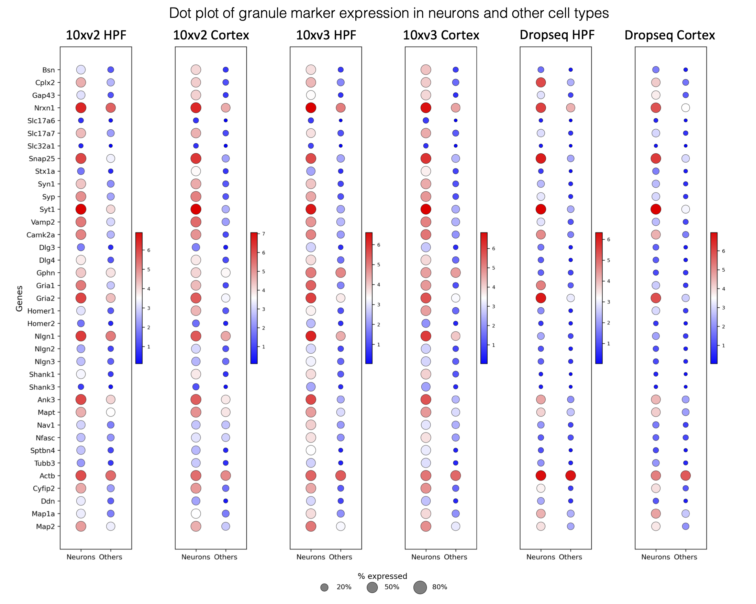
Fig. S1. Dot plots comparing the expression of the 37 selected granule markers across neuronal and non-neuronal cell types in mouse brain scRNA-seq datasets.
Supplementary Note 2. Granule markers are captured by whole-cell but not nucleus-based transcriptomics.

We assessed whether the RNA granule marker genes identified in our study are captured across different transcriptomic technologies. Because bulk RNA-seq and scRNA-seq profile whole-cell transcriptomes, we expected these approaches to capture a higher fraction of RNA granule-associated transcripts, whereas snRNA-seq, which measures nuclear RNA, would underrepresent them.

To validate this, we analyzed WT samples from bulk RNA-seq (Forner et al.²⁵), scRNA-seq (Saunders et al.²³; Yao et al.²⁴), and snRNA-seq (Habib et al.²⁶; Zhou et al.²⁷). Among the 16,165 genes shared across datasets, all 37 RNA granule marker genes were present. For each sample, we calculated the proportion of total UMI counts contributed by RNA granule markers. As shown in Fig. S2, RNA granule markers accounted for ~2.1% of total expression in bulk RNA-seq, ~2.4–2.6% in scRNA-seq (with protocol-dependent variation), and ~1.7% in snRNA-seq on average. This trend was consistent in both the hippocampus and cortex, with scRNA-seq showing proportions most similar to bulk RNA-seq and snRNA-seq showing the lowest values. These results support the hypothesis that RNA granule marker genes are predominantly cytoplasmic and are efficiently captured by whole-cell, but not nucleus-based, transcriptomic methods.

Notably, publicly available scRNA-seq studies of the brain remain substantially fewer than snRNA-seq studies. This imbalance largely reflects technical challenges: mature neuronal cell bodies exhibit large, complex morphologies that are difficult to dissociate intact, whereas nuclei can be robustly isolated with minimal bias. As a consequence, many existing studies rely on snRNA-seq and therefore systematically overlook extrasomatic RNA granules, underscoring the need for methods such as mcDETECT that recover granule-associated signals missed by nucleus-based profiling.

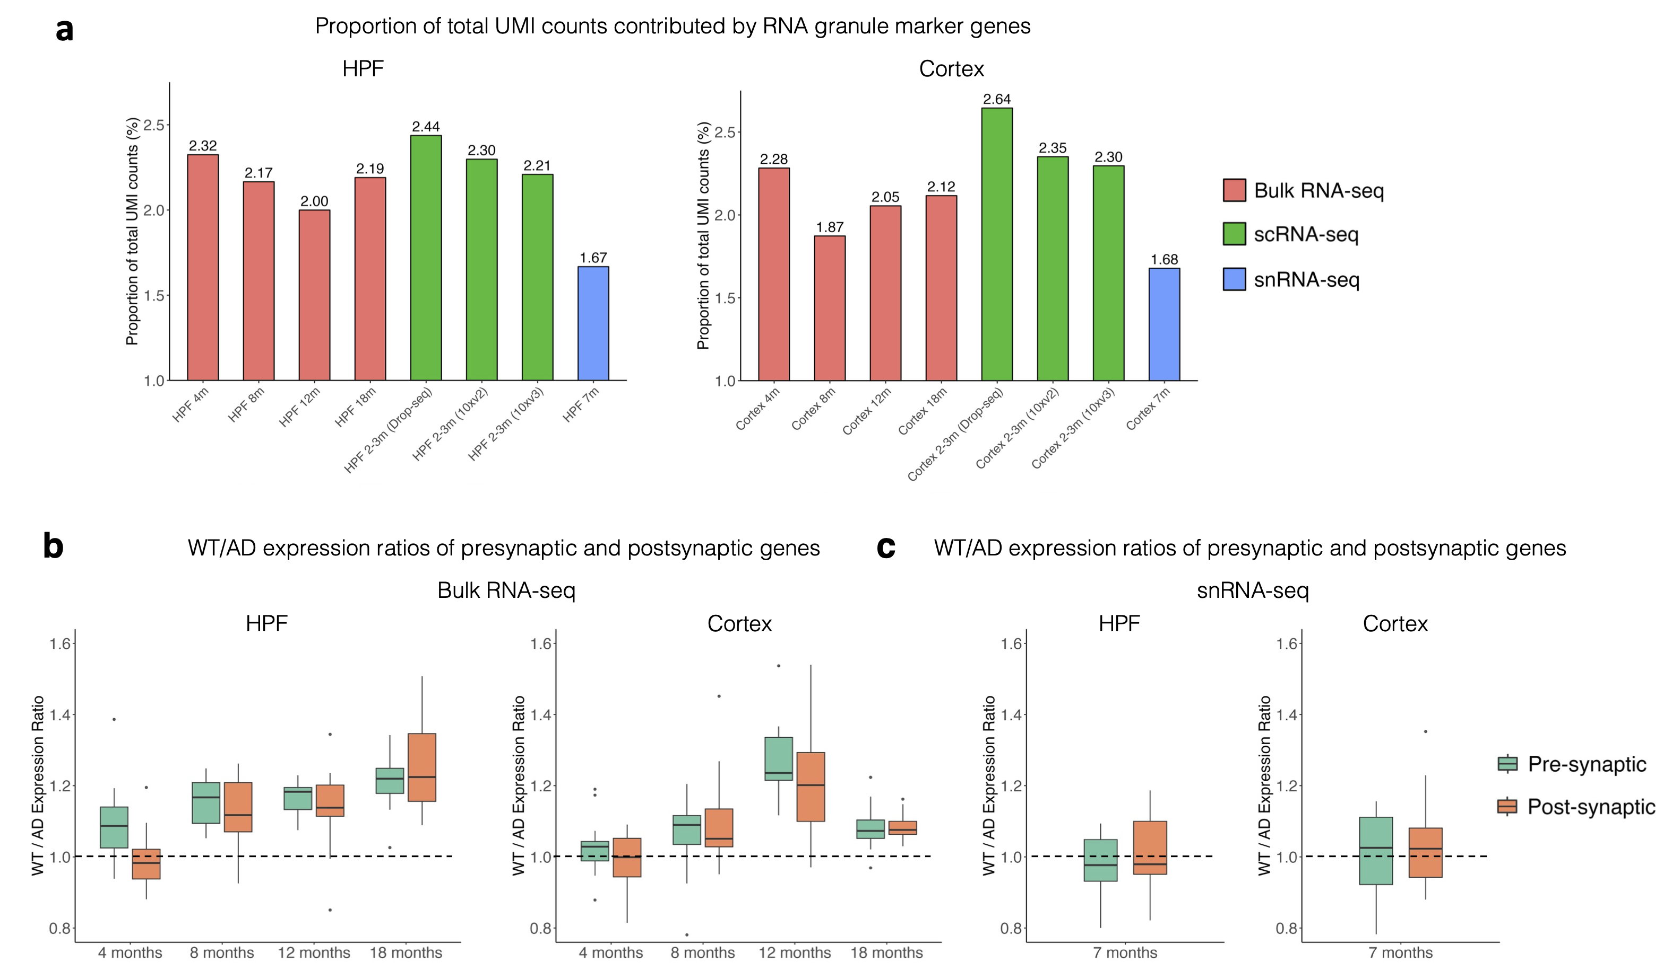
Fig. S2. Proportion of total UMI counts contributed by RNA granule marker genes in the hippocampus (left) and cortex (right) across different sequencing technologies.
Supplementary Note 3. Rationale for the simulation parameters.

The simulation parameters were chosen to reflect properties observed in the real data.

Soma-overlap ratio for distal aggregates. In the simulation, each transcript belonging to a distal aggregate carries a binary label indicating whether it overlaps with the soma. This overlap represents a conservative scenario in which some distal RNA granules may be close to, or partially overlap with, the soma. To obtain a data-driven estimate, we used the MERSCOPE WT sample to empirically assess how often distal aggregates partially overlap with somata. Because no ground truth is available for real data, we performed permissive detection by running mcDETECT without any in-soma filtering, thereby identifying both somatic and extrasomatic aggregates, and computed each aggregate's soma-overlap ratio, defined as the fraction of transcripts overlapping the soma mask. As shown in Fig. S3a, the distribution of soma-overlap ratios exhibited two peaks, one at 0 and another at 1. The peak at 1 represents aggregates located entirely within somata, whereas the remaining aggregates were considered extrasomatic. Among all extrasomatic aggregates, 96.2% were entirely extrasomatic (soma-overlap ratio of 0) and only 3.8% showed any partial soma overlap, indicating that partial overlap between distal granules and somata is rare. We therefore set the in-soma fraction for distal aggregates to 5%, representing rare near-soma or soma-touching cases.

Soma and granule size. To estimate soma size, we examined the soma size distribution in the real data. In the Xenium 5K dataset, soma masks were obtained from the original data release and had an average area of 90.23 μm². For the MERSCOPE WT sample, we generated dilated nuclear masks, which had an average area of 96.82 μm². Based on these values, we set the mean radius of simulated soma-associated aggregates to 5.5 μm, yielding an average area of 97.66 μm² that closely matches the empirically observed soma sizes (Fig. S3b). For distal aggregates, references on their size are limited; most existing studies characterize RNA granule size by measuring fluorescent puncta of RNA-binding proteins rather than the RNA component itself²⁸⁻³¹, with reported radii generally ranging from 0.1 to 2 μm. We therefore used 1 μm as the mean radius for simulated distal RNA aggregates. The values of 5.5 μm and 1 μm do not represent fixed radii assigned to every cluster; rather, they describe the mean size scale of the resulting simulated aggregates, with individual aggregates exhibiting a range of sizes around these values.

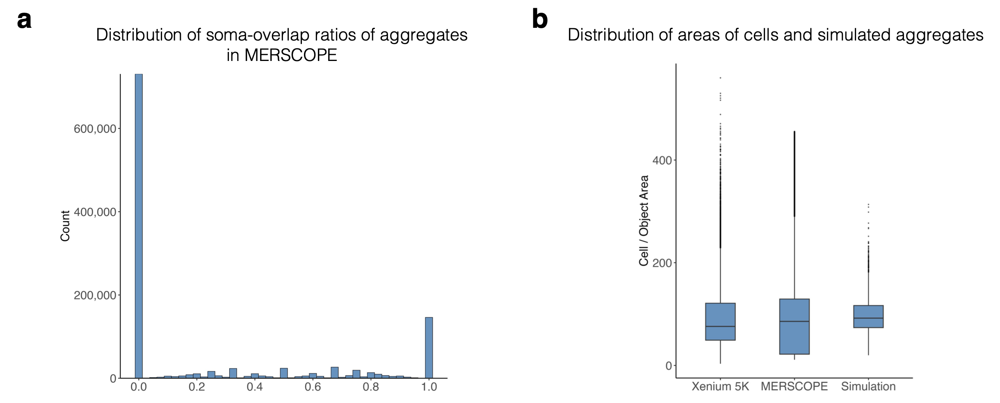
Fig. S3. a. Histogram showing the distribution of soma-overlap ratios of aggregates detected in the MERSCOPE WT sample using mcDETECT without in-soma filtering. b. Boxplot comparing the distribution of soma areas in the Xenium 5K, MERSCOPE WT, and simulated data.
Supplementary Note 4. Robustness of mcDETECT across simulation scenarios.

We further evaluated mcDETECT across a broad range of simulation settings to confirm that its performance is not tuned to a narrow or favorable regime.

Mixture composition. Because the relative proportions of complete spatial randomness (CSR), extrasomatic aggregates, and somatic aggregates directly determine the signal-to-noise ratio, we performed two complementary experiments. First, we varied the CSR fraction (0.2, 0.3, 0.4, 0.5, and 0.6) while keeping the extrasomatic and somatic fractions equal within the remaining transcripts, using markers A, B, and C. For each setting, we ran 100 simulation replicates and summarized the mean precision, recall, and F1 score (Fig. S4a). As the CSR fraction increased, all three metrics remained relatively stable, indicating that mcDETECT is robust to increasing levels of diffuse background noise. Second, we fixed the CSR fraction at 0.5 and varied the relative proportions of extrasomatic and somatic aggregates, testing extrasomatic aggregate fractions from 0.1 to 0.4. As shown in Fig. S4b, the mean precision, recall, and F1 score across 100 simulation runs remained stable, demonstrating that mcDETECT is not sensitive to the relative balance between distal and somatic aggregates.

Marker expression levels. We considered a more challenging scenario by adding three markers, D, E, and F, with much lower overall transcript densities and fewer extrasomatic and somatic aggregates (Fig. S4c). These markers were designed to mimic granule markers with moderate to low expression in real iST data. For each marker, we performed 200 independent simulation runs and applied mcDETECT to recover distal aggregates. As shown in Fig. S4d, as the overall transcript density decreased from marker A to marker F, all performance metrics gradually declined because of the progressively weaker signal. Importantly, even for the sparsest marker, marker F, mcDETECT maintained precision of approximately 90%, indicating a well-controlled false discovery rate, while recall remained above 60%. Together, markers A–F span a wide and biologically realistic range of expression levels, demonstrating that mcDETECT remains robust across a broad parameter regime.

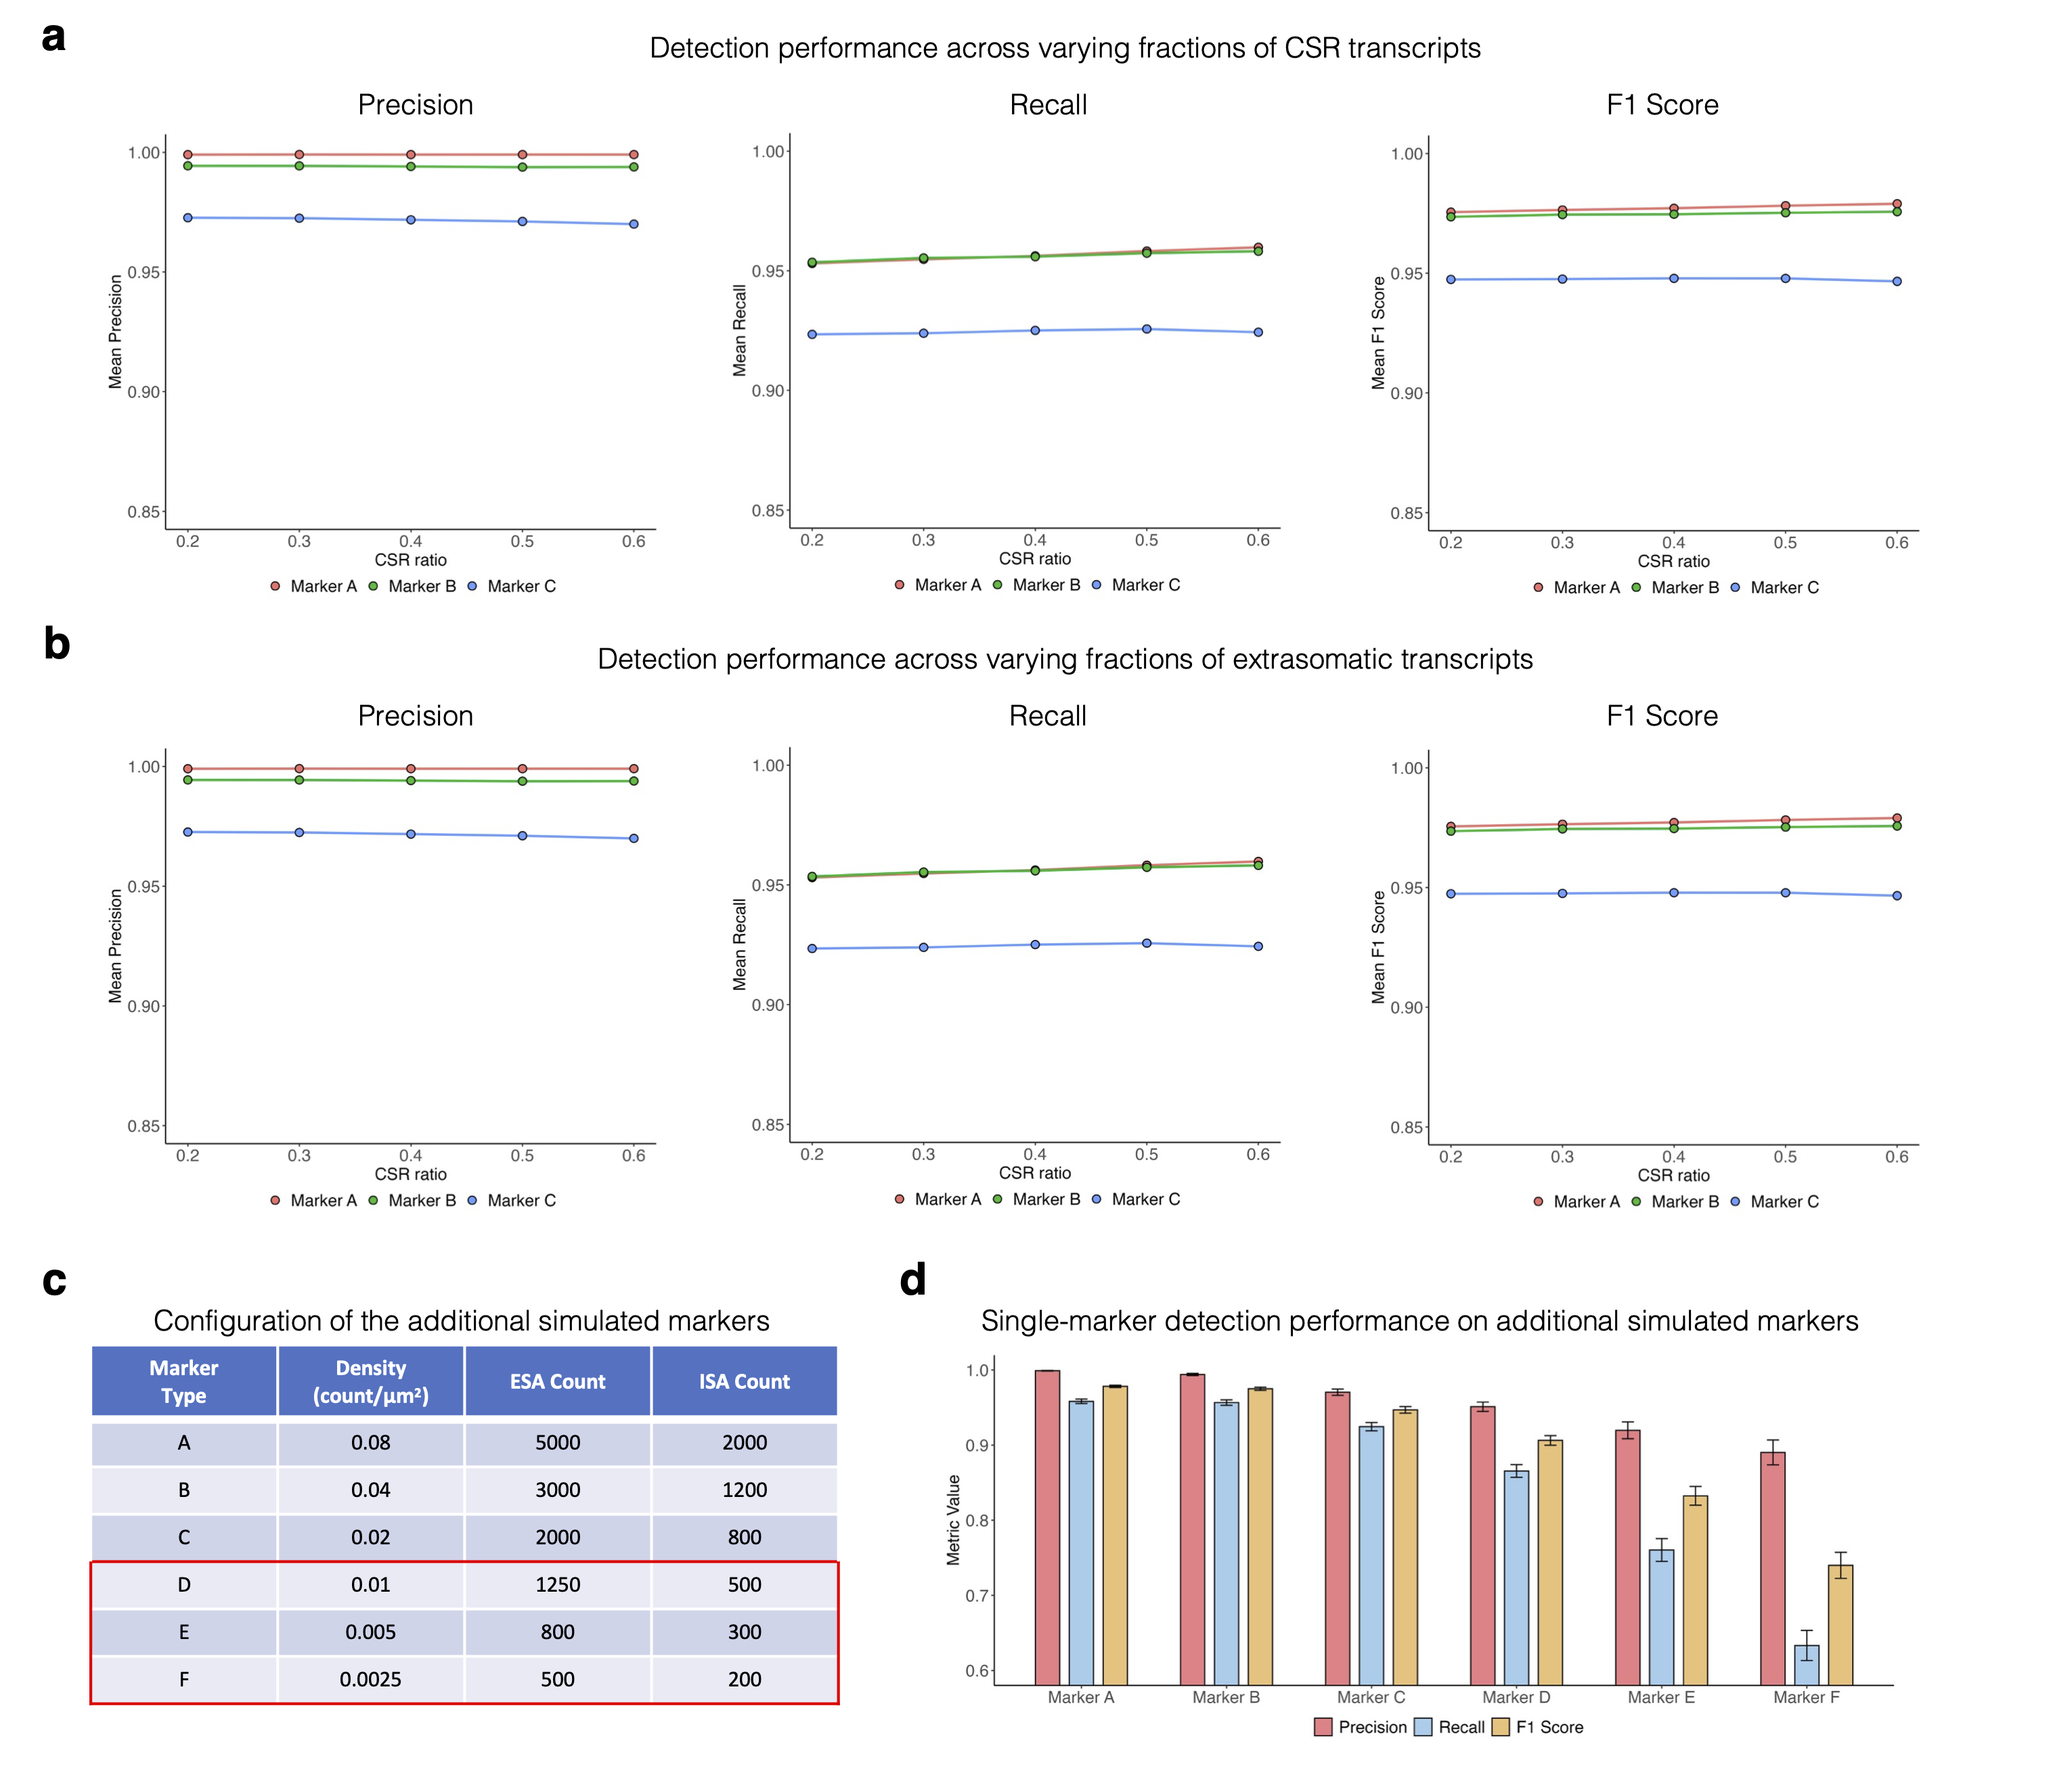

Fig. S4. a. Line plots showing detection precision, recall, and F1 score across a range of CSR fractions, stratified by markers A, B, and C; dots represent the mean of each metric across 100 simulation runs. b. Line plots showing detection precision, recall, and F1 score across a range of extrasomatic aggregate fractions, stratified by markers A, B, and C; dots represent the mean across 100 simulation runs. c. Table summarizing the density, extrasomatic aggregate (ESA) counts, and intrasomatic aggregate (ISA) counts of simulated markers A–F. d. Bar plot showing the detection precision, recall, and F1 score achieved by mcDETECT on simulated 3D single-marker data for markers A–F across 200 simulation runs. Bar heights represent mean values, and error bars denote mean ± one standard deviation.
Supplementary Note 5. Simulation study in the 2D setting.

Contrasting the 3D setting, we conducted a similar simulation for each individual granule marker but suppressed the z-axis, treating all mRNAs as distributed in a 2D plane, as shown in Fig. S5a. The resulting detection accuracy, precision, and recall are displayed in Fig. S5b. Notably, across all three granule markers, the accuracy and precision remarkably drop compared to the 3D setting, since the randomly spread mRNA points became denser in 2D and mcDETECT falsely identified them as aggregates. Similarly, for the multi-marker scenario in 2D illustrated in Fig. S5c, mcDETECT generated higher false positives compared to 3D, resulting in reduced mean accuracy (93.2%) and precision (93.1%), as shown in Fig. S5d. In summary, the simulation study demonstrates that mcDETECT is more effective in 3D than in 2D at accurately recovering true RNA granule locations and excluding nuclear aggregates and random debris.

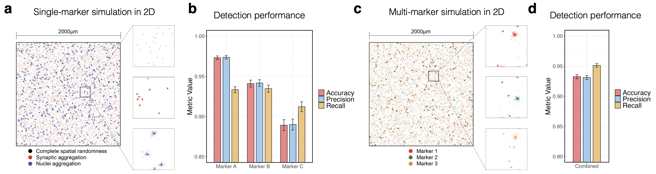
Fig. S5. a. Left: Simulation of a single granule marker in 2D space, where each dot represents a subcellular mRNA molecule. Black, red, and blue dots indicate complete spatial randomness (CSR), aggregate within distal compartments, and aggregate within somata, respectively. Right: Zoomed-in view of the three distribution patterns in a small region. b. Bar plot showing the detection accuracy, precision, and recall achieved by mcDETECT on the simulated 2D single-marker data across 200 simulation runs. Bar heights represent mean values, and error bars denote mean ± one standard deviation. c. Left: Simulation of three granule markers in 2D space, where each dot represents a subcellular mRNA molecule. Red, green, and orange dots indicate marker types A, B, and C, respectively. Right: Zoomed-in view of a small region stratified by marker type. d. Bar plot showing the detection accuracy, precision, and recall achieved by mcDETECT on the simulated 2D multi-marker data across 200 simulation runs. Bar plot definitions are the same as in b.
Supplementary Note 6. Structural features of granule-enriched genes.

Existing studies have reported two recurring observations regarding neuronal granule-enriched genes: (1) they tend to have longer overall transcript spans³²⁻³⁴, and (2) they tend to have longer 3′ untranslated regions (UTRs)³⁵⁻³⁸ that allow for more extensive post-transcriptional regulation. To assess whether the mcDETECT results are consistent with these previously reported properties, we focused on genes measured in the Xenium 5K dataset, which provides broader gene coverage than the MERSCOPE panel. Within this dataset, we defined granule-enriched genes as the top 240 genes detected in more than 2% of granules and used the remaining 4,696 genes as the comparison group.

We derived gene structural features from the mm39 mouse genome annotation using Bioconductor in R. As shown in Fig. S6a, mcDETECT-identified granule-enriched genes have longer overall gene spans than other genes (median: 41,730 vs 24,804 bp; one-sided p = 1.81 × 10⁻⁷). Because each gene can have multiple isoforms, we used the longest annotated transcript as the representative isoform for each gene. Granule-enriched genes also showed longer representative isoform lengths (Fig. S6b; median: 3,810 vs 3,195.5 bp; one-sided p = 6.57 × 10⁻⁷) and longer 3′ UTR lengths in the representative isoform (Fig. S6c; median: 1,514 vs 1,064 bp; one-sided p = 2.19 × 10⁻⁸). These findings are consistent with prior studies showing that RNA granule-associated transcripts often have longer transcript bodies and 3′ UTRs.

In addition to these previously reported properties, we examined other structural features that have been less well characterized. Granule-enriched genes showed slightly longer 5′ UTRs in their representative isoforms (Fig. S6d; median: 229.5 vs 197 bp; one-sided p = 7.9 × 10⁻⁵) and contained more exons (Fig. S6e; median: 12 vs 9; one-sided p = 3.68 × 10⁻⁸). They also tended to have more annotated isoforms than other genes (Fig. S6f; median: 6 vs 4; one-sided p = 2.18 × 10⁻¹²).

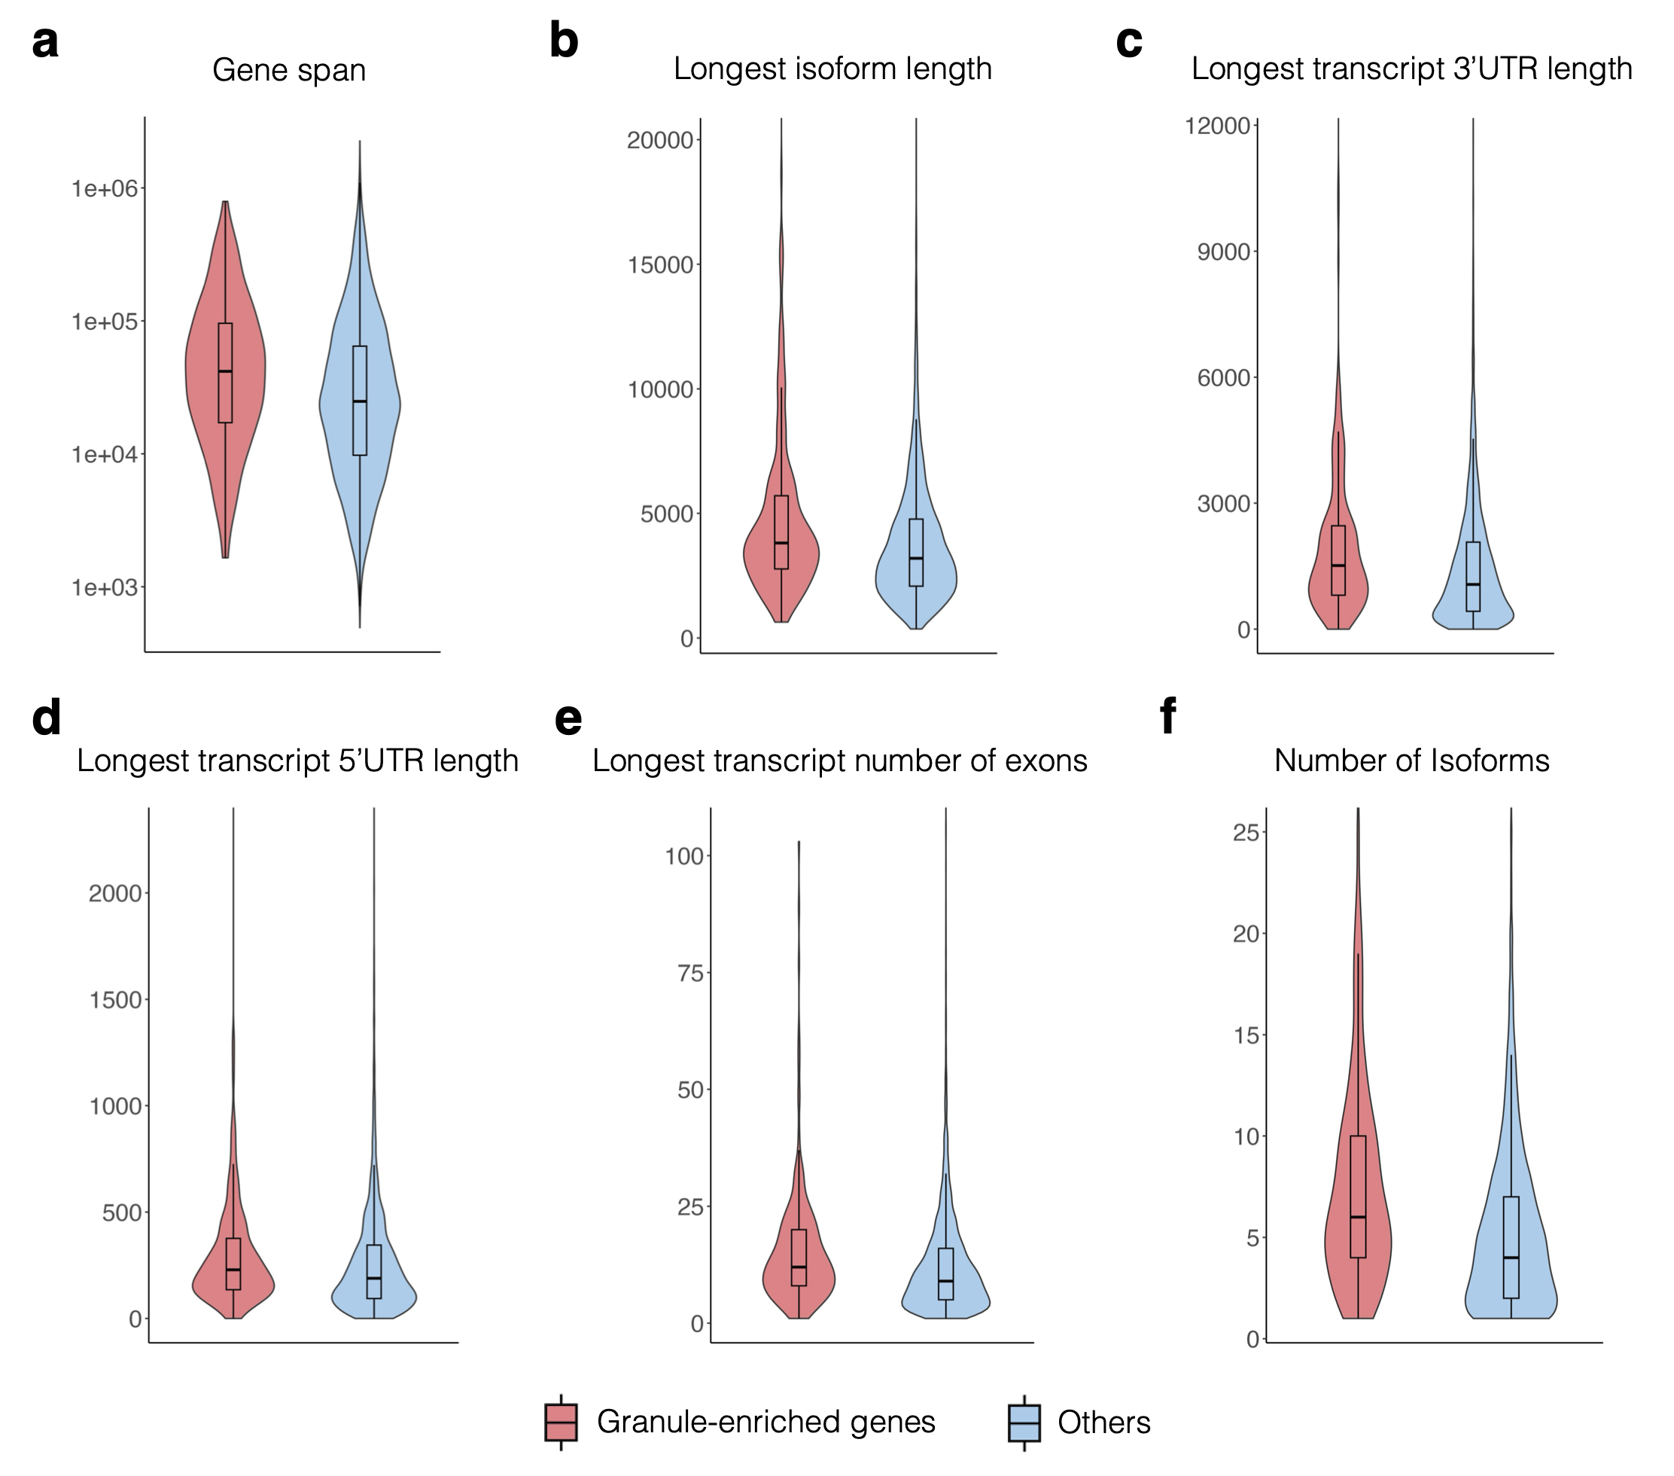
Fig. S6. Violin plots comparing gene structural features between mcDETECT-identified granule-enriched genes and other genes. a. Overall gene span. b. Longest isoform length. c. 3′ UTR length of the longest isoform. d. 5′ UTR length of the longest isoform. e. Number of exons in the longest isoform. f. Number of annotated isoforms per gene. For visualization, the top 0.1% of extreme values were trimmed from each distribution.
Supplementary Note 7. Additional EM support for pre-/post-synaptic granule patterns.

To further support the interpretation that the regional and laminar patterns of pre- and post-synaptic granules reflect the local balance of axonal versus dendritic cytoplasm in the neuropil, we examined additional electron microscopy (EM) evidence beyond the analyses shown in the main figure (Fig. 3i–l).

Within the hippocampus, pre-synaptic granules were particularly abundant in the stratum pyramidale, likely reflecting the high density of perisomatic synapses in this layer. These synapses provide strong axonal input but contribute limited dendritic cytoplasmic volume, because the postsynaptic side is located primarily on the soma^{39,40} and is therefore excluded from granule detection.

At the laminar level within the isocortex, the higher post-synaptic granule signal in the superficial layers (L2/3) than in the deeper layers (L4–L6) may be further explained by variation in synapse-type composition across cortical layers. Santuy et al.⁴¹ reported a higher fraction of asymmetric synapses (AS) relative to symmetric synapses (SS) in layers 2/3 than in layers 4–6 (Fig. S7). Because AS are characterized by more prominent post-synaptic densities than SS, their enrichment in superficial layers may contribute to the elevated post-synaptic granule signal detected by mcDETECT.

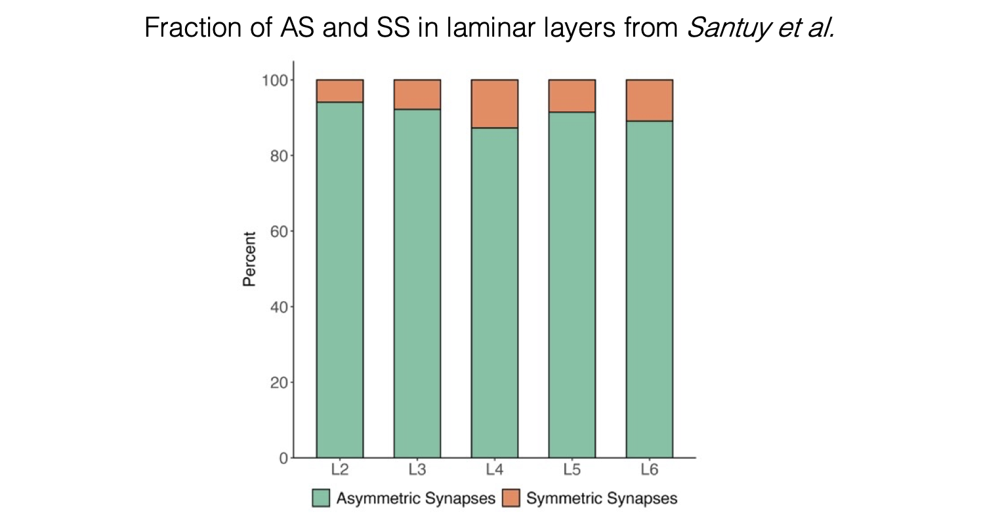
Fig. S7. Laminar distribution of asymmetric and symmetric synapses in the isocortex from Santuy et al.
Supplementary Note 8. RNA granule count discrepancy between Xenium 5K and MERSCOPE.

mcDETECT identified 125,030 RNA granules in the Xenium 5K dataset. In comparison, it identified 681,337 and 398,809 RNA granules in the MERSCOPE WT and AD samples, respectively. This discrepancy can be attributed to the following factors: (1) the input granule marker lists were different; (2) the MERSCOPE slices were positioned closer to the caudal end of the mouse brain than the Xenium 5K sample; and (3) MERSCOPE generally exhibits higher mRNA capture efficiency than Xenium 5K.

To quantify this difference, we first conducted a global comparison of all genes in both datasets. The average mRNA count per cell was 0.33 in Xenium 5K and 1.19 in the MERSCOPE WT sample, highlighting substantial platform variation. Next, we focused on the 166 genes shared between the two datasets and assessed their average mRNA counts per spot to eliminate potential bias from cell segmentation. As shown in the overlaid bar plot in Fig. S8, most genes exhibited higher average mRNA counts per spot in MERSCOPE than in Xenium 5K, with an average fold increase of 3.27. For Camk2a, one of the strongest synaptic markers, the fold increase reached 3.89. Since mcDETECT relies on subcellular mRNA enrichment for granule identification, higher mRNA capture efficiency naturally results in higher RNA granule counts.

To partially account for these differences, we used one dataset as an anchor. For each dataset compared with the anchor, we first retained only the genes shared between the two datasets. We then calculated the mean transcript count per spot in both datasets and derived a scaling factor as the ratio of the anchor mean to the mean of the dataset being compared. The granule density in the dataset being compared was then multiplied by this scaling factor. We note that this adjustment provides only a rough normalization and cannot fully correct for differences in gene panel design, platform chemistry, imaging depth, optical crowding, or sample quality. Therefore, cross-platform comparisons of raw granule counts should be interpreted with caution.

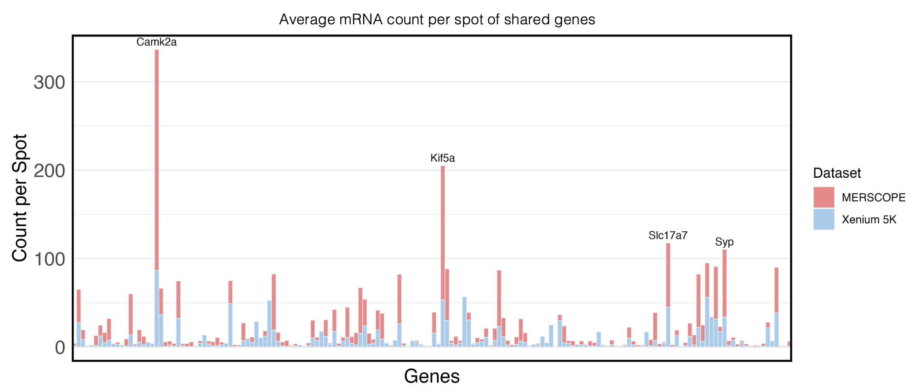
Fig. S8. Bar plot showing the average mRNA count per spot for the 166 shared genes between the Xenium 5K (blue) and the MERSCOPE WT sample (red). The bars are overlaid for direct comparison. Genes with an average mRNA count per spot exceeding 100 in the MERSCOPE WT sample are annotated.
Supplementary Note 9. Synaptic granule density in the MERSCOPE WT sample.

To demonstrate the biological relevance of the granule subtypes identified in the MERSCOPE WT sample, we quantified the density of synapse-associated granules (enriched for both pre- and post-synaptic genes) within each 50 × 50 μm² spot across nine major brain regions (Fig. S9, left). We compared these granule densities with synapse densities from an age-matched, similarly positioned WT mouse brain section, measured using volume electron microscopy and genetic labeling (Fig. S9, right), and found a weighted Spearman correlation coefficient of 0.96.

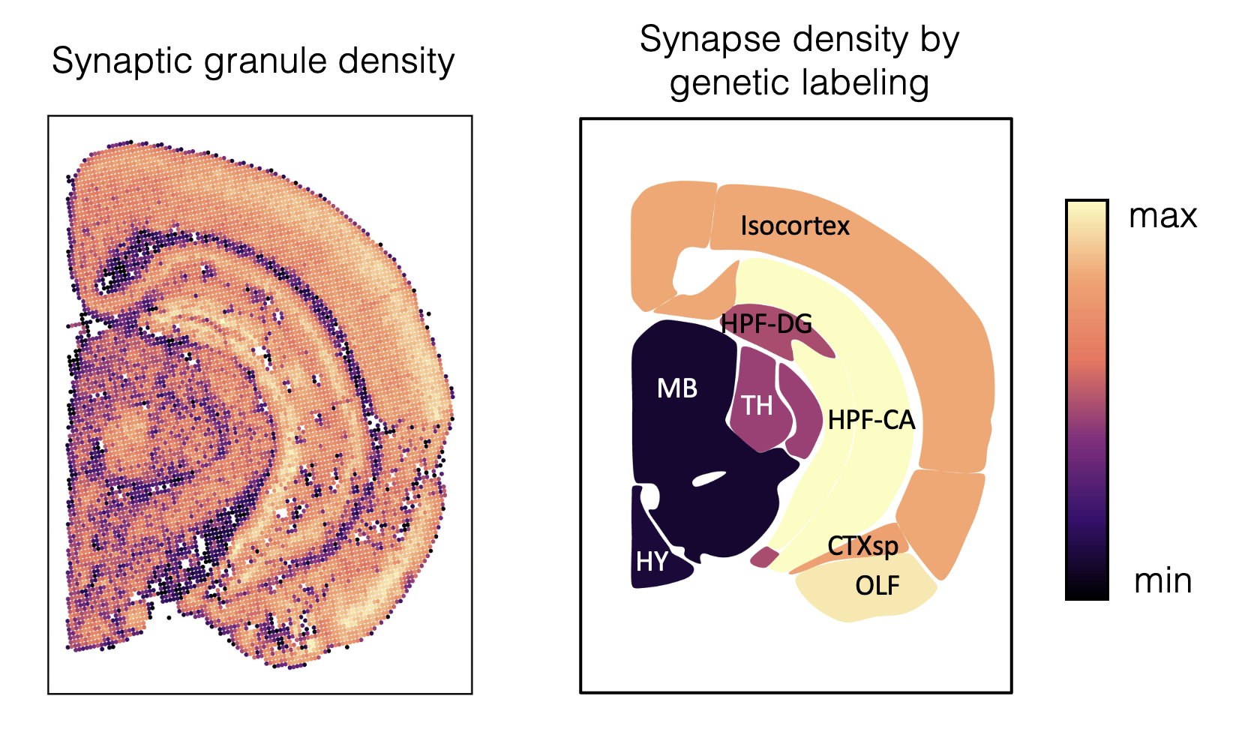
Fig. S9. Left: spatial map showing the number of synaptic granules (i.e., pre- or post-synaptic) identified by mcDETECT in 50 × 50 μm² spots spanning the tissue slice. Right: regional synapse densities estimated using volume electron microscopy and genetic labeling on a coronal slice corresponding to the approximate bregma position in Fig. 4a.
Supplementary Note 10. RNA diffusion and ambient-RNA background.

All spatial transcriptomics technologies are affected to some degree by local RNA diffusion and ambient background signal. We address these two issues separately.

RNA diffusion is negligible in imaging-based in situ spatial transcriptomics. RNA diffusion is most pronounced in sequencing-based ST assays, such as 10x Visium, where tissue permeabilization or lysis can release RNA that may physically diffuse before capture. In contrast, the imaging-based ST techniques used in this study, including Xenium and MERFISH, are less susceptible to diffusion because they do not rely on RNA release from permeabilized tissue; instead, they use fixation and in situ hybridization to immobilize RNA targets and thereby tightly constrain physical diffusion.

This conclusion is supported by prior literature. A 2025 review by Ge et al.⁴² characterizes RNA diffusion in MERFISH as "ultralow" relative to sequencing-based protocols. Wang et al.⁴³ reported that, in MERFISH, each mRNA is anchored to the expandable gel at a single location via its poly(A) tail, which helps preserve transcript position during processing. Consistent with these features, both MERFISH and Xenium have been used to resolve subcellular structures at the micrometer scale: Xia et al.⁴⁴ combined MERFISH with ER (KDEL) immunolabeling and DAPI to segment the ER and nucleus in individual U-2 OS cells and quantify gene-wise enrichment across subcellular compartments; Salas et al.⁴⁵ benchmarked 25 Xenium datasets across tissues and species and concluded that Xenium supports accurate subcellular structure discovery; and Henze et al.⁴⁶ used MERFISH and smFISH to study RNA transcripts localized to microglial processes. These results demonstrate that in situ hybridization-based spatial transcriptomics has minimal diffusion and can accurately characterize subcellular transcript distributions.

We further quantified RNA diffusion using in-house data. STARmap data were generated from cultured Neuro2a cells; because STARmap uses the same fixation strategy and a hybridization protocol similar to that of MERSCOPE, it serves as an appropriate reference system. To assess potential diffusion, we examined Malat1, a lncRNA known to be strictly enriched in the nucleus. As shown in Fig. S10, Malat1 transcripts (green) were almost exclusively localized within DAPI-positive nuclear regions (blue) across all cultured cells. Quantitatively, 99.978% of pixels containing Malat1 signal overlapped with DAPI, indicating that nearly all detected Malat1 transcripts remained within nuclei. This highly restricted localization pattern indicates that RNA diffusion is minimal in iST.

Fig. S10. DAPI staining and Malat1 transcripts in cultured Neuro2a cells.

mcDETECT corrects for ambient RNA background via a CSR-based filtering model. Unlike diffusion, ambient RNA arises from sources such as damaged or dying cells, cellular debris, or extracellular vesicles, and typically contributes a weak but unavoidable background signal. To account for this, mcDETECT assumes that each granule marker comprises three components: nuclear aggregation, RNA-granule aggregation, and a low-level ambient background modeled as complete spatial randomness (CSR). mcDETECT applies a CSR-based, gene-specific threshold to filter out aggregate calls that can be explained by background signal. Under the CSR assumption, the number of ambient mRNAs within a circular region of radius r follows a Poisson distribution with mean λπr². The ideal minimum transcript count m* is defined as the value satisfying $\operatorname{Pr}\left(Poisson\left(αλπr^{2}\right)≤m^{*}\right)=0.95$, where α is a scaling factor used to adjust the density threshold. In this formulation, counts greater than m* would be expected only 5% of the time under CSR, making m* a conservative threshold for identifying true aggregates. Because λ is gene-specific, the threshold varies with each gene's overall expression level and allows for higher ambient background in highly expressed genes. The low false-positive rate of mcDETECT under this filtering step (Fig. 2d–g) indicates that the background signal is well controlled.

Granule density changes are robust to ambient RNA. To evaluate whether the observed disease-associated changes in synaptic granule density could be explained by ambient RNA, we performed a regression-based analysis. For each brain region and granule subtype, we modeled per-spot granule density as a function of disease status while adjusting for the local ambient expression of the corresponding granule marker genes, where ambient expression was defined as bin-level extrasomatic RNA not assigned to detected granules. We then compared the effect of disease status from this adjusted model with that from the original, unadjusted analysis. As summarized in the table below, for pre-synaptic granules the disease-associated reduction remained significant in most brain regions after adjustment, and the direction of the effect was unchanged; the only exception was FT, where the original effect size was already close to zero (β = 0.0007). For post-synaptic granules, the isocortex and OLF were no longer significant after adjustment, and these two regions also had the smallest effect sizes in the original analysis; results for the remaining regions were unchanged in both statistical significance and effect-size direction. Together, these results indicate that the observed disease-associated changes in granule density remain robust after adjusting for ambient RNA expression. The three tests that changed from significant to non-significant after adjustment are shown in bold.

 |  | Full model (adjusted for ambient signal) |  |  |  |  | Unadjusted model
Granule subtype | Brain area | Beta  ambient | P-value  ambient | Beta  AD | P-value  AD | P-value  level AD | Beta  AD | P-value  AD | P-value  level AD
Pre-synaptic | CTXsp | 0.807 | 1.41E-40 | -0.859 | 9.35E-19 | *** | -1.157 | 6.64E-20 | ***
 | FT | 0.237 | 9.18E-282 | -0.090 | 0.000135 | *** | -0.0007 | 0.980 | ns
 | HPF-CA | 1.061 | 3.65E-148 | -0.672 | 9.87E-71 | *** | -0.734 | 9.06E-59 | ***
 | HPF-DG | 1.135 | 6.26E-90 | -1.065 | 1.06E-82 | *** | -0.949 | 4.56E-46 | ***
 | HPF-SR | 0.479 | 1.09E-54 | -0.994 | 6.09E-98 | *** | -0.986 | 1.42E-85 | ***
 | Isocortex | 0.824 | 0 | -0.580 | 2.88E-210 | *** | -0.827 | 2.79E-306 | ***
 | MB | 0.612 | 4.70E-299 | -0.355 | 3.24E-41 | *** | -0.287 | 1.59E-20 | ***
 | OLF | 0.888 | 9.80E-162 | -0.668 | 1.97E-45 | *** | -0.948 | 4.44E-43 | ***
 | TH | 0.588 | 2.24E-51 | -1.363 | 1.92E-85 | *** | -1.287 | 9.46E-63 | ***
Post-synaptic | CTXsp | 0.786 | 3.03E-48 | 0.591 | 5.93E-13 | *** | 0.301 | 0.006 | **
 | FT | 0.462 | 0 | -0.567 | 1.02E-47 | *** | -0.389 | 1.21E-15 | ***
 | HPF-CA | 1.074 | 3.54E-217 | 0.2352 | 4.53E-16 | *** | 0.173 | 6.00E-06 | ***
 | HPF-DG | 0.625 | 6.34E-16 | 0.375 | 7.06E-07 | *** | 0.439 | 2.14E-08 | ***
 | HPF-SR | 1.015 | 0 | 0.323 | 1.22E-32 | *** | 0.341 | 4.99E-14 | ***
 | Isocortex | 1.213 | 0 | 0.351 | 1.77E-65 | *** | -0.013 | 0.621 | ns
 | MB | 0.198 | 1.98E-74 | 0.177 | 5.39E-22 | *** | 0.199 | 2.45E-25 | ***
 | OLF | 1.080 | 4.0e-312 | 0.362 | 3.49E-29 | *** | 0.022 | 0.745 | ns
 | TH | 0.484 | 1.25E-54 | 0.561 | 2.90E-28 | *** | 0.624 | 1.64E-26 | ***
Table. Regression analysis of AD-associated changes in synaptic granule density with and without adjustment for ambient RNA. ns: not significant; *: p < 0.05; **: p < 0.01; ***: p < 0.001.

Neuropil microdomain differences are not driven by ambient RNA. To assess whether the neuropil microdomain differences could be driven by systematic differences in ambient RNA, we performed parallel differential expression and gene set enrichment analyses using ambient RNA signals in the two microdomains. In contrast to the granule-based analysis, ambient expression did not recover any pathway signatures for microdomain 1, consistent with the interpretation that ambient RNA primarily represents background rather than pathway-specific granule biology. For microdomain 2, ambient expression identified a different set of pathways, with only 5 of the top 20 pathways shared between the two analyses (dendrite development, behavior, dendritic spine development, nervous system process, and cognition); the pathways uniquely enriched in the ambient signal were primarily associated with broad neuronal functions. Together, these results support the conclusion that the observed AD-associated microdomain shift reflects granule-resolved molecular organization rather than ambient RNA signals.
Supplementary Note 11. Orthogonal validation of WT–AD differences using bulk and snRNA-seq.

A key observation from our MERSCOPE data is that pre-synaptic RNA granules exhibit a pronounced decrease in the AD (5xFAD) brain at 8 weeks of age, especially in the cortex and hippocampus (HPF), whereas post-synaptic RNA granules show smaller changes. We evaluated whether this differential trend could be independently recapitulated in bulk RNA-seq and snRNA-seq data. Because both mouse age and brain region are confounders, we focused on age-matched datasets when possible. Specifically, we analyzed the bulk RNA-seq dataset from Forner et al.²⁵, which includes WT and 5xFAD mice from the cortex and HPF at 4, 8, 12, and 18 months. For snRNA-seq, we selected datasets from WT and 5xFAD mice at 7 months of age, from the HPF (Habib et al.²⁶) and cortex (Zhou et al.²⁷).

Because bulk RNA-seq captures extrasomatic RNA, it is expected to reflect the overall trends observed in our iST data, although signal averaging across cell types is expected to reduce their contrast. We focused on pre-synaptic and post-synaptic RNA granule-associated genes. Raw counts were normalized to TPM to make expression values comparable across samples. For each gene, we computed the WT/AD ratio of mean expression at each time point, defined as the mean expression in WT samples divided by the mean expression in AD samples at that time point. Higher values indicate greater enrichment in WT relative to AD and therefore a stronger reduction in the AD condition. As shown in Fig. S11a (left), pre-synaptic genes exhibited higher WT/AD ratios than post-synaptic genes in the HPF at 4 months (mean: 1.10 vs. 0.996), suggesting that pre-synaptic granule changes occur as an early event. From 8 to 18 months, post-synaptic markers began to decline in AD and eventually reached a similar magnitude of reduction as pre-synaptic genes by 18 months (1.27 vs. 1.12 at 8 months; 1.16 vs. 1.13 at 12 months; both ≈ 1.25 at 18 months). Similar trends are observed in the cortex (Fig. S11a, right). Together, these results indicate that pre-synaptic granule-associated genes are more strongly reduced in 5xFAD mice at early disease stages (2–4 months) than post-synaptic granule-associated genes, consistent with our MERSCOPE observations at 8 weeks.

Next, we examined the two snRNA-seq datasets. In principle, snRNA-seq profiles nuclear RNA only and therefore cannot capture cytoplasmic pre-synaptic or post-synaptic RNA changes between WT and AD. We first identified neuronal nuclei using marker genes reported by Zhou et al., then adopted a pseudobulk strategy to enable a comparison analogous to the bulk TPM-based analysis: raw UMI counts were summed across neuronal nuclei at the sample level and normalized by total library size to obtain counts per million (CPM), and WT/AD ratios were computed using the same formulation as in the bulk analysis. As shown in Fig. S11b (left), in the HPF dataset from Habib et al., the pre-synaptic gene set exhibits a mean WT/AD ratio of 0.976 and the post-synaptic gene set a mean ratio of 1.006, indicating little to no difference in nuclear expression between WT and AD. Similarly, in the cortex dataset from Zhou et al. (Fig. S11b, right), the mean WT/AD ratios are 1.012 for pre-synaptic genes and 1.044 for post-synaptic genes. In contrast to the trends observed in the bulk RNA-seq data at 8 months, these results indicate that the differential signal primarily arises from extrasomatic RNA rather than nuclear RNA, further supporting the conclusion from our iST analysis that compartment-specific, extrasomatic RNA granule alterations occur in AD in both the HPF and cortex.

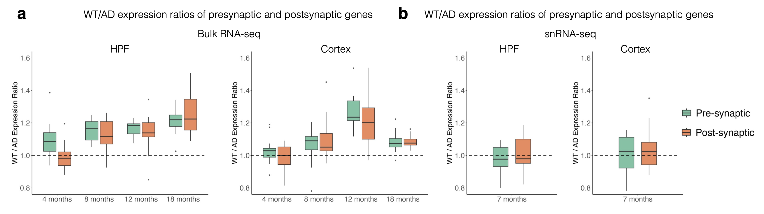
Fig. S11. WT/AD expression ratio of pre-synaptic and post-synaptic granule marker genes in a. bulk RNA-seq and b. snRNA-seq datasets.
Supplementary Note 12. Disease-associated alteration of other granule subtypes in MERSCOPE.

In addition to granules enriched for pre- and post-synaptic genes, other subtypes, including those enriched for dendritic genes and those with mixed signals, also showed region-specific density changes in AD. As illustrated in Fig. S12 (left), dendritic granules exhibited a marked decline in HPF-CA, but a significant expansion in HPF-DG and MB. Mixed-signal granules, in contrast, displayed significant reductions across most brain regions, with the exception of HPF-DG and HPF-SR, where densities were significantly elevated (Fig. S12, right). However, given the non-uniform changes observed for dendritic granules and the ambiguous identity of mixed-signal granules, the biological significance of these alterations in AD remains unclear and warrants further investigation.

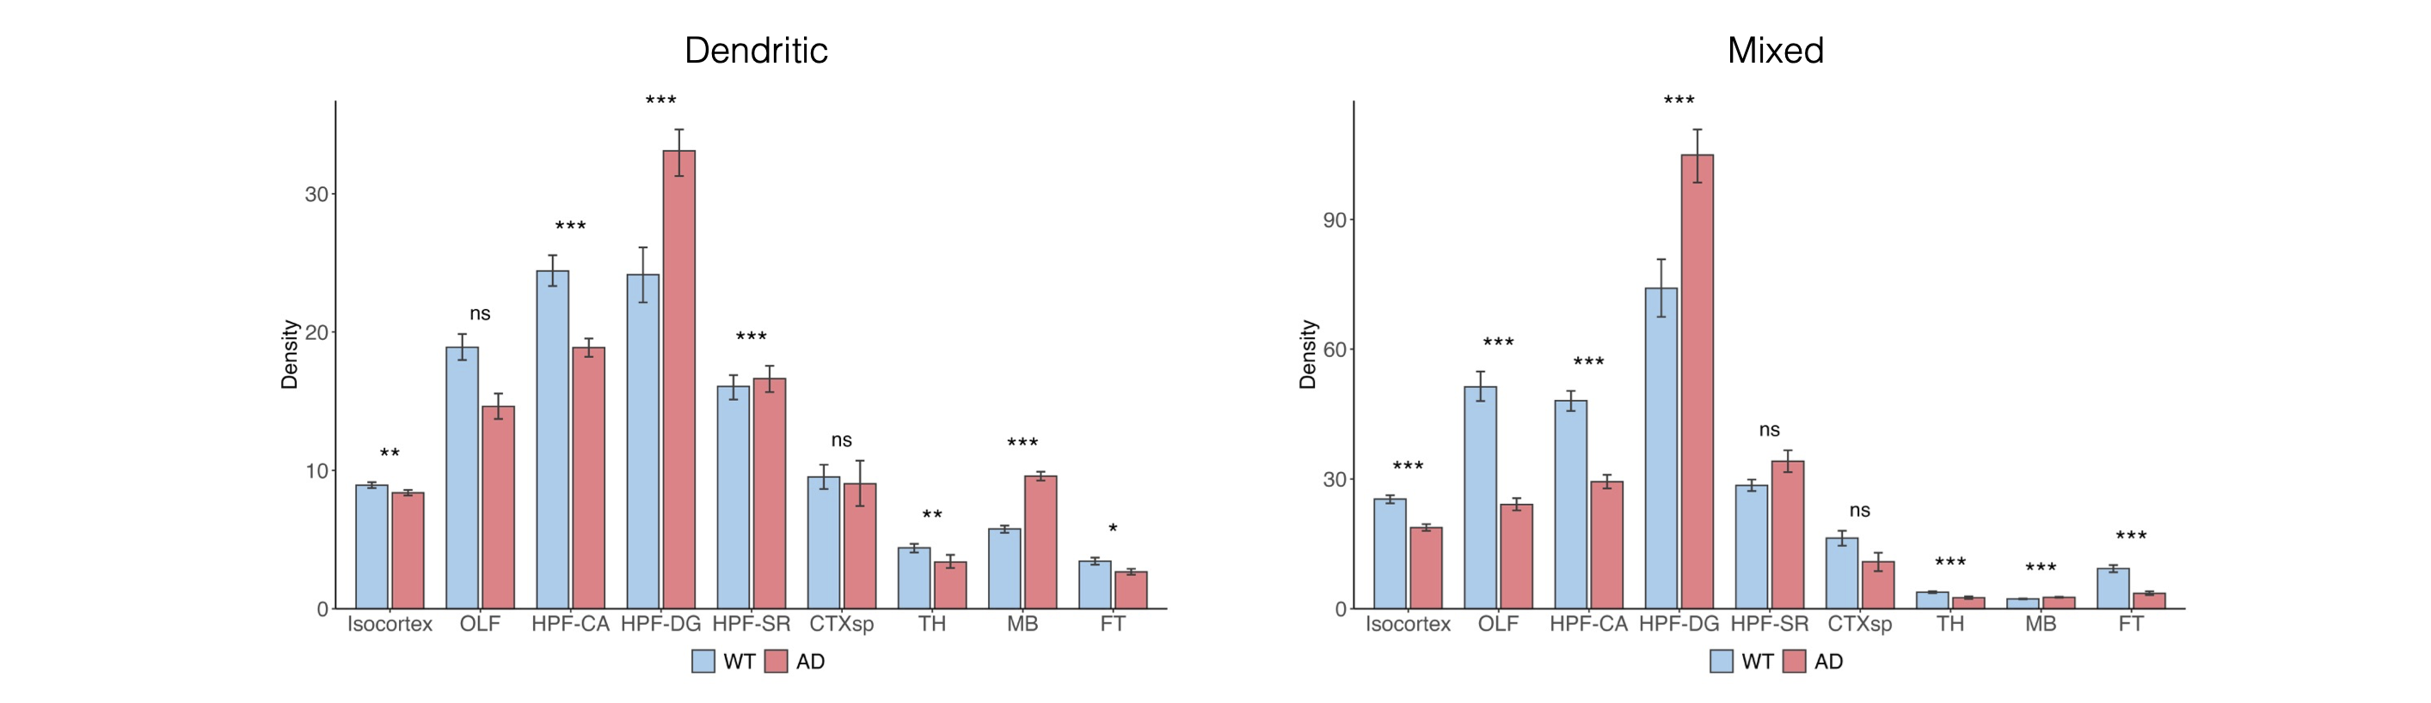
Fig. S12. Grouped bar plots comparing dendritic (left) and mixed-signal (right) granule densities between WT and AD samples. RNA granule density is measured as the number of granules per 50 × 50 μm² spot. Bar heights represent mean spot-level densities, and error bars indicate bootstrap-based 95% confidence intervals from 500 resamples. ns: not significant; *: adjusted p < 0.05; **: adjusted p < 0.01; ***: adjusted p < 0.001.
Supplementary Note 13. Removing top-expressed markers in RNA granule detection in Xenium 5K.

To assess the robustness of mcDETECT in the absence of strong markers, we benchmarked the spatial granule distributions obtained from the full marker list against those derived after removing Snap25 or Slc17a7, two of the top-expressed genes in the Xenium 5K dataset. As shown in Fig. S13, exclusion of either marker had little effect: regional granule densities remained highly correlated with the full-marker results, with Pearson correlations of 0.987 and 0.995, respectively. This robustness arises because mcDETECT leverages colocalization patterns across multiple granule markers, allowing it to infer underlying granule locations even when individual strong markers are absent.

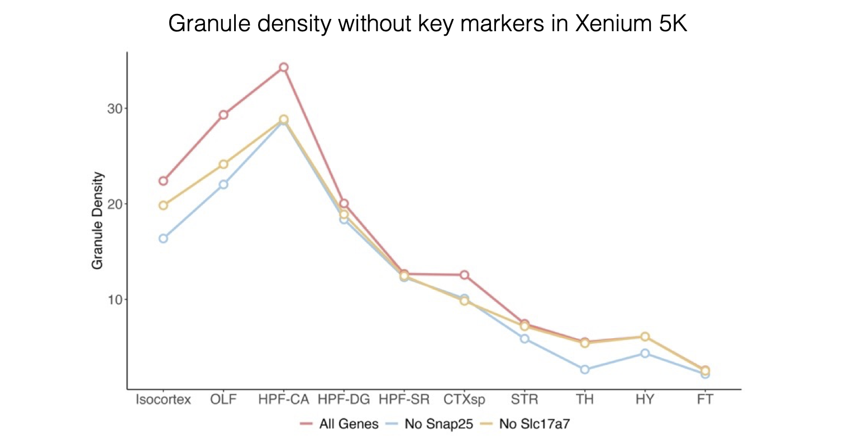
Fig. S13. Line plots comparing regional granule density trends in the Xenium 5K dataset using the full granule marker list, with Snap25 excluded, and with Slc17a7 excluded.
Supplementary Note 14. Approximating the soma by nuclear-mask dilation.

To distinguish extrasomatic from in-soma transcripts, mcDETECT approximates the soma by dilating nuclear masks derived from DAPI staining. During method development, several alternative nucleus-to-soma expansion approaches were considered, including contour expansion, watershed- or Voronoi-based partitioning using nuclear centroids, and learning-based segmentation tools such as Cellpose. We chose a simple dilation-based approach for three reasons: it requires only the DAPI channel, whereas learning-based methods often require additional staining channels or training data; its performance was stable and satisfactory upon visual inspection; and dilation is computationally efficient. Because the soma mask is an independent input to mcDETECT, users may also supply soma masks generated by alternative methods.

We justified this soma approximation in two ways. First, the method is adapted from Qian et al.⁴⁷, who used the same dilation strategy for MERSCOPE image analysis and showed that it stably recruited additional transcripts around each nucleus while preserving cell-type assignments based on transcriptomic profiles. Second, in the Xenium 5K mouse brain dataset analyzed here, cell soma masks were provided directly by the official 10x Genomics release, where cell boundaries were defined using a multimodal antibody stain mix (DAPI for nuclei; ATP1A1, E-cadherin, and CD45 for membranes) integrated by a machine-learning-based segmentation algorithm. We compared the soma boundaries generated by our dilation-based approach in the MERSCOPE WT data with the 10x Genomics-provided soma boundaries in the Xenium 5K data.

As shown in Fig. S14a, the soma masks in the Xenium dataset had an average area of 90.23 μm², while those in the MERSCOPE WT sample had an average area of 96.82 μm²; the two datasets showed similar soma-area distributions and comparable mean values. We also compared per-gene in-soma ratios computed using MERSCOPE masks without dilation, MERSCOPE masks with dilation, and Xenium 5K soma masks. As shown in Fig. S14b, compared with the no-dilation masks, the dilated masks consistently recruited more transcripts into the soma-proximal region across genes, and the resulting in-soma ratio distribution closely matched that observed in the Xenium 5K dataset. Importantly, granule markers still showed significantly lower in-soma ratios than other genes. Together, these results indicate that the dilation-based approach provides a reasonable approximation of the cell soma while preserving the expected relative subcellular localization patterns.

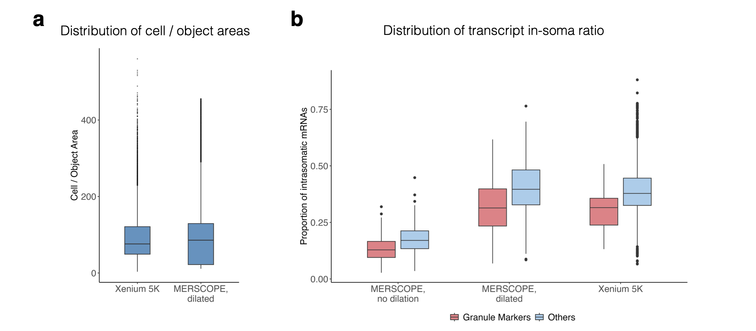
Fig. S14. a. Boxplot comparing soma areas from the Xenium 5K dataset with soma masks approximated by dilation in the MERSCOPE WT sample. b. Boxplot comparing the proportion of in-soma mRNAs for selected granule markers and other genes across MERSCOPE masks without dilation, MERSCOPE masks with dilation, and Xenium 5K soma masks. Boxplots show the median, interquartile range, whiskers within 1.5× the interquartile range, and individual outliers.
Supplementary Note 15. Selection of the search radius r.

The search radius r is an important parameter because it determines which RNA transcripts are considered neighbors and therefore affects the detected granule size. To guide its selection, we analyzed three representative granule markers, Snap25, Camk2a, and Slc17a7, in the Xenium 5K dataset. For each extrasomatic transcript, we calculated the distance to its nearest transcript of the same gene. As shown in Fig. S15, the median nearest-neighbor distance ranged from 1.3 to 1.7 μm across these marker genes. This suggests that 1.3–1.7 μm is a reasonable range for r: a smaller radius may miss true neighboring transcripts, whereas a larger radius may erroneously connect nearby transcripts and reduce specificity. We therefore selected r = 1.5 μm as the default value, which allows most transcripts to have at least one same-gene neighbor contributing to aggregate formation while producing granules within a biologically plausible size range.

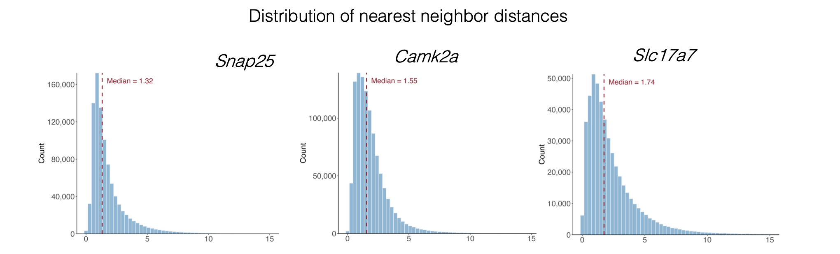
Fig. S15. Distribution of nearest-neighbor distances for Snap25, Camk2a, and Slc17a7 in the Xenium 5K dataset.
Supplementary Note 16. Ablation of the multi-marker merging threshold ρ.

A central step in mcDETECT integrates aggregates detected from multiple markers via 3D sphere-based merging, controlled by the threshold ρ ∈ [0, 1], where ρ = 0 indicates no merging and larger values are more permissive; at ρ = 1, any aggregates that touch are merged. We evaluated the effect of ρ in three scenarios.

First, using simulated multi-marker data with known ground truth (3,000 aggregates, each composed of at least one of three markers A, B, and C), we ran mcDETECT while varying ρ from 0 to 1 in steps of 0.1. As shown in Fig. S16a, with no merging (ρ = 0), mcDETECT detected ~5,000 aggregates, exceeding the ground truth because a true aggregate can be detected multiple times across markers. Increasing ρ to 0.1 sharply reduced detections to 3,602, and at the default ρ = 0.2 detections dropped to 3,083, close to the ground-truth count; further increases produced only a gradual decline. These results show that merging is essential for removing redundant detections and that performance is robust to the exact choice of ρ.

Second, on the MERSCOPE WT mouse brain dataset (20 granule markers), we varied ρ across 0, 0.2, 0.4, and 0.6. Increasing ρ led to only modest changes in the number of detected granules (755,794 at ρ = 0; 741,370 at ρ = 0.2; 729,086 at ρ = 0.4; 706,298 at ρ = 0.6; Fig. S16b). Key downstream granule properties remained stable across ρ values: the mean number of transcripts per granule (Fig. S16c), the mean number of detected genes per granule (Fig. S16d), and the granule subtype composition (Fig. S16e) showed only minor changes, and synapse-related granules remained highly correlated with synapse density across all tested ρ values (Pearson's r > 0.9; Fig. S16f).

Third, we tested whether varying ρ affected granule-level differences between WT and AD samples. Repeating granule detection, classification, and subtyping across ρ values, the significant reduction in pre-synaptic granule density and the relative stability of post-synaptic granule density were consistently recovered (Fig. S16g). Together, this ablation demonstrates that the merging step effectively removes redundantly counted granules and that downstream conclusions—granule counts, subtype composition, spatial correlation with synapse density, and WT–AD separability—are robust to the choice of ρ, supporting ρ = 0.2 as the default.

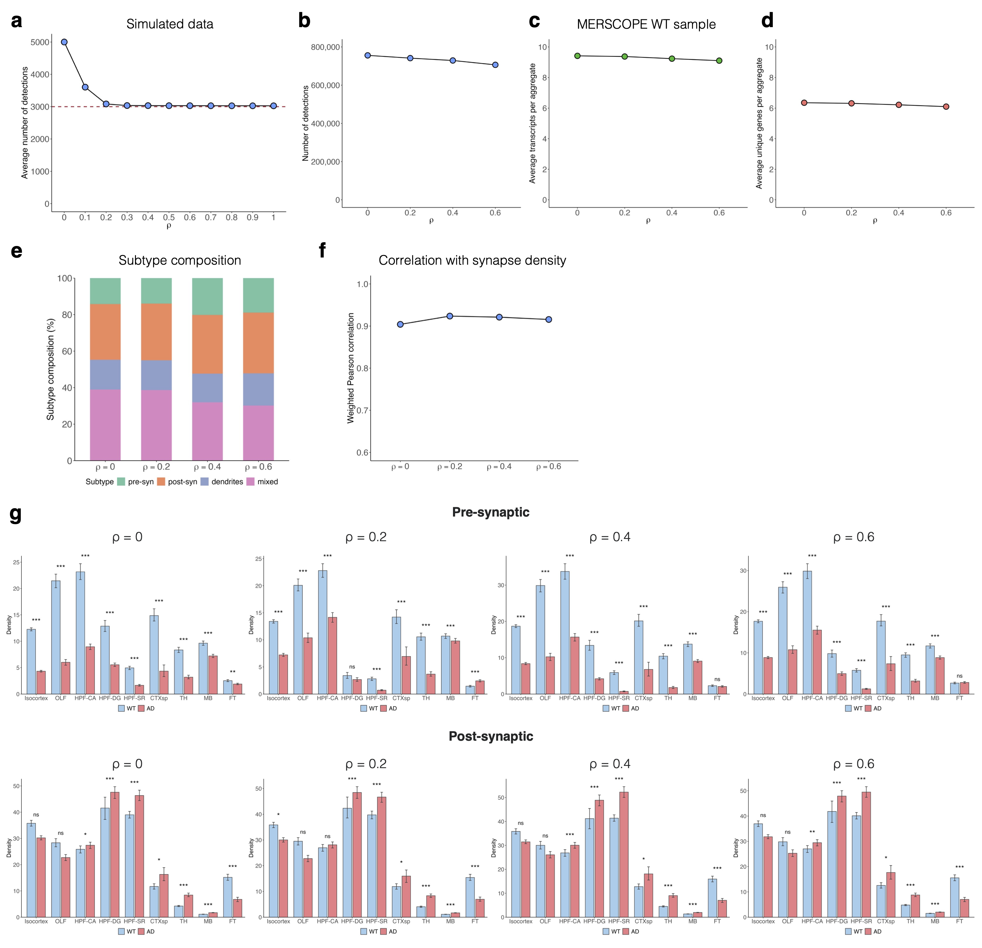
Fig. S16. Robustness of granule detection to the choice of the merging threshold ρ. a. Line plot showing the number of detected granules at different ρ values in simulated data; the red line indicates the ground-truth count of 3,000 granules. b–f. Number of detected granules (b), mean number of transcripts per granule (c), mean number of detected genes per granule (d), granule subtype composition (e), and correlation between synapse-related granule density and synapse density (f) at different ρ values in the MERSCOPE WT mouse brain dataset. g. Grouped bar plots comparing pre- and post-synaptic granule densities between WT and AD samples across different ρ values. Bar heights represent mean spot-level densities, and error bars indicate bootstrap-based 95% confidence intervals from 500 resamples. ns: not significant; *: adjusted p < 0.05; **: adjusted p < 0.01; ***: adjusted p < 0.001.
Supplementary Note 17. Merged-marker detection as an alternative strategy.

By default, mcDETECT seeds granule detection through per-gene spatial clustering of predefined marker genes, which enables stringent, gene-specific control of false positives but may miss granules that do not contain an aggregate of any single marker gene. As an alternative, mcDETECT also provides an option to perform granule detection using merged marker-gene sets rather than per-gene detection alone.

Using the Xenium 5K dataset as an example, Fig. S17a shows granule detection under the per-gene and merged-marker approaches. The merged-marker approach identified additional candidate granules, increasing the total from 125,030 to 166,375. Fig. S17b shows that granules identified by both approaches were enriched for granule marker genes and showed minimal enrichment of negative-control genes, consistent with the design of mcDETECT.

We further performed granule subtype classification under both approaches (Fig. S17c). The numbers of pre-synaptic, post-synaptic, and dendritic granules changed relatively modestly (from 56,301 to 32,741, from 33,672 to 26,138, and from 18,805 to 20,631, respectively), whereas mixed-type granules accounted for most of the overall increase, rising from 16,241 (13.0%) to 86,866 (52.2%). This pattern is expected because merged-marker detection is more likely to capture random RNA aggregations containing markers from multiple subtypes or to merge nearby aggregates into a single detected granule, which is then classified as mixed type.

We also evaluated whether synapse-associated granule density remained consistent with synapse density across brain regions. As shown in Fig. S17d, the per-gene approach showed a strong correlation with regional synapse density (Spearman's ρ = 0.99), which remained high but decreased slightly under the merged-marker approach (Spearman's ρ = 0.95). Overall, the merged approach increases sensitivity but may also introduce false positives or merge multiple neighboring granules into one. It is provided as an optional feature for users who are particularly interested in mixed granule subtypes or who desire greater detection sensitivity.

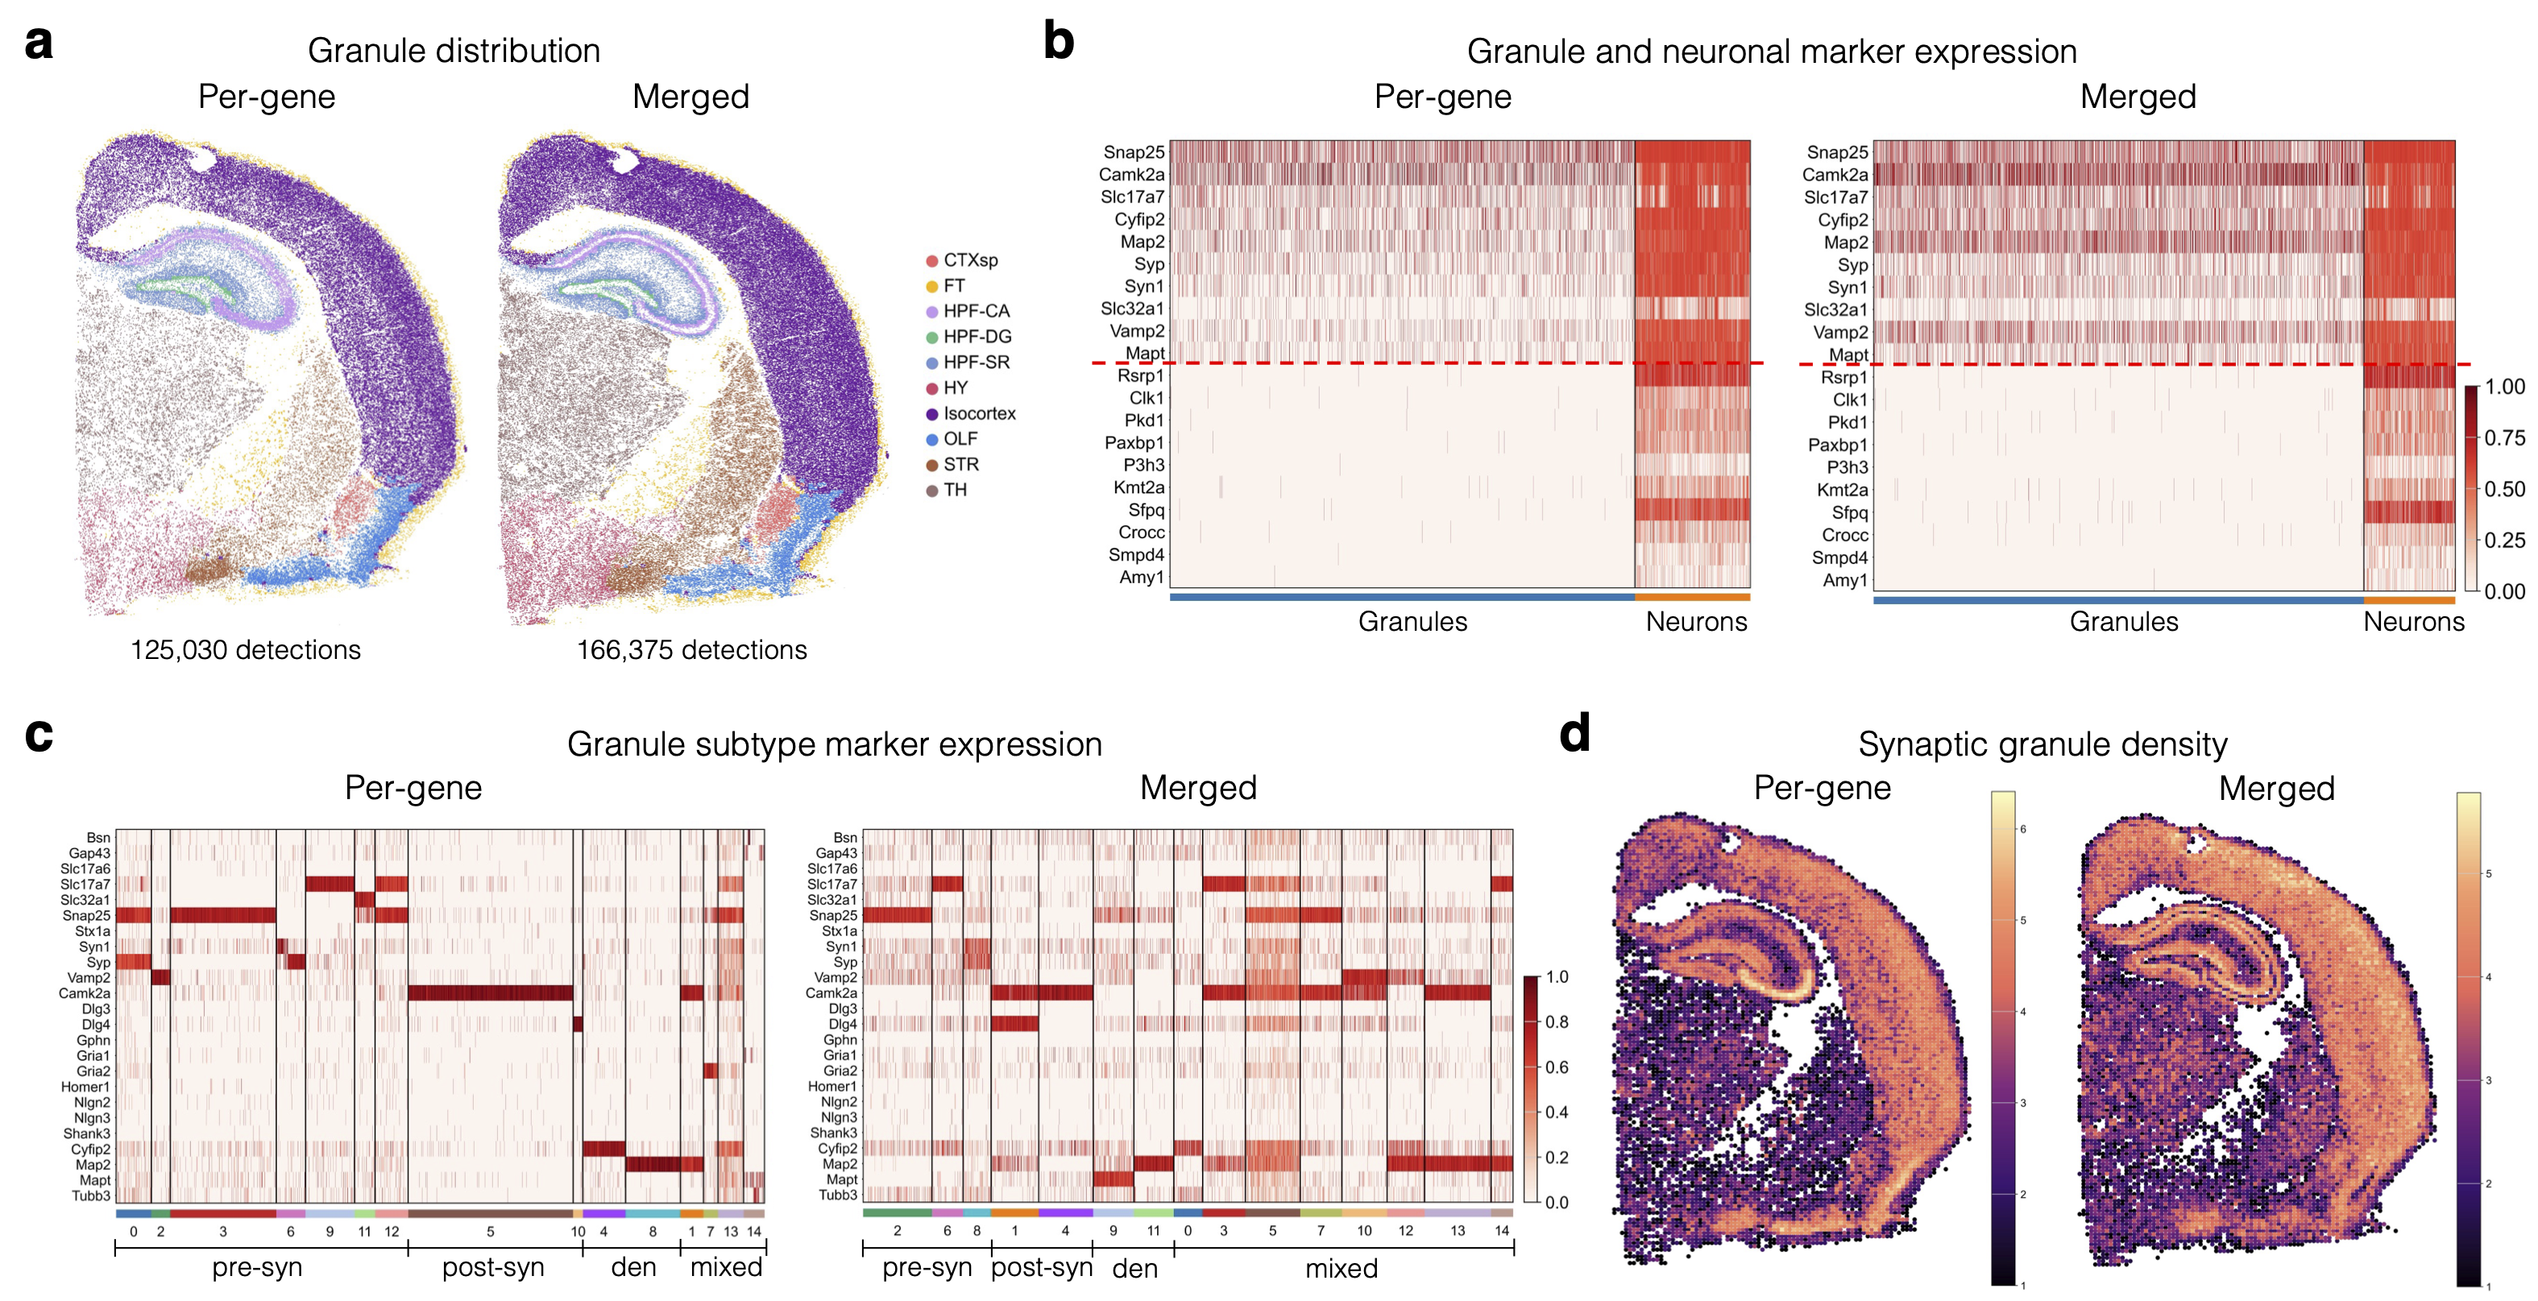
Fig. S17. Comparison of per-gene-based detection and merged-marker detection. a. Spatial map showing RNA granules identified with per-gene-based and merged-marker detection. b. Heatmap showing the enrichment patterns of granule markers and neuronal markers in RNA granules and neuronal somata. c. Heatmap showing the enrichment patterns of granule-subtype-specific genes across granule clusters. d. Spatial map showing the number of synaptic granules identified with per-gene-based and merged-marker detection in 50 × 50 μm² spots.
Supplementary Note 18. Ablation of the soma and negative-control filters.

mcDETECT applies two filtering steps to determine which aggregates are retained as bona fide distal RNA granules: a soma-overlap filter, controlled by τ ∈ [0, 1] (smaller values impose stricter filtering), and a negative-control filter, controlled by κ ∈ [0, 1] (smaller values impose stricter filtering). We systematically benchmarked both steps using the MERSCOPE WT mouse brain sample, evaluating three metrics: the number of detected granules, the mean in-soma transcript fraction (granule–soma separation), and the mean negative-control transcript fraction (marker enrichment specificity).

Soma filtering only. As τ decreased, the number of detected granules decreased monotonically (Fig. S18a, left), accompanied by a substantial reduction in soma contamination (Fig. S18a, middle) and a gradual reduction in negative-control signal (Fig. S18a, right). Without soma filtering (τ = 1), mcDETECT identified 1,149,541 granules, with a mean in-soma transcript fraction of 24.8% and a mean negative-control fraction of 5.5%. At the default threshold (τ = 0.1), mcDETECT detected 737,063 granules, with an in-soma fraction below 1% and a negative-control fraction of 1.8%, supporting the effectiveness of soma filtering for removing soma-associated fragments.

Negative-control filtering only. As κ decreased, both the number of detected granules and the contamination metrics declined (Fig. S18b). Without negative-control filtering (κ = 1), mcDETECT identified 1,149,541 granules, with a mean in-soma fraction of 24.8% and a mean negative-control fraction of 5.5%. At the default threshold (κ = 0.1), mcDETECT detected 942,824 granules, with an in-soma fraction of 18.9% and a mean negative-control fraction below 1%, indicating that negative-control filtering effectively removes detections likely arising from debris or nonspecific background.

Combined filtering. Fixing κ = 0.1 and varying τ, decreasing τ reduced both the number of detected granules (Fig. S18c, left) and the in-soma transcript fraction (Fig. S18c, middle) with a much flatter slope than soma filtering alone, while the negative-control fraction remained low across all τ values (Fig. S18c, right). The in-soma fraction dropped below 1% by τ = 0.2, indicating that combining the two filters efficiently removes soma-associated fragments and improves robustness to the choice of τ.

Downstream effects. Across four representative settings—no filtering (τ = 1, κ = 1), negative-control filtering only (τ = 1, κ = 0.1), in-soma filtering only (τ = 0.1, κ = 1), and the default (τ = 0.1, κ = 0.1)—the pre-synaptic, post-synaptic, and dendritic granule subtypes were stable, whereas the mixed subtype showed some fluctuation (Fig. S18d), and the correlation between synapse-associated granule density and synapse density remained consistently high (~0.9; Fig. S18e). Finally, the reduction in pre-synaptic granule density and the stability of post-synaptic granule density between WT and AD were consistent across all four settings (Fig. S18f). Together, both filters effectively remove nonspecific granules, mcDETECT is robust to the choice of τ and κ, and the synapse-density correlations, regional granule densities, and subtype distributions are not driven by any specific filter setting, supporting the default settings of τ = 0.1 and κ = 0.1.

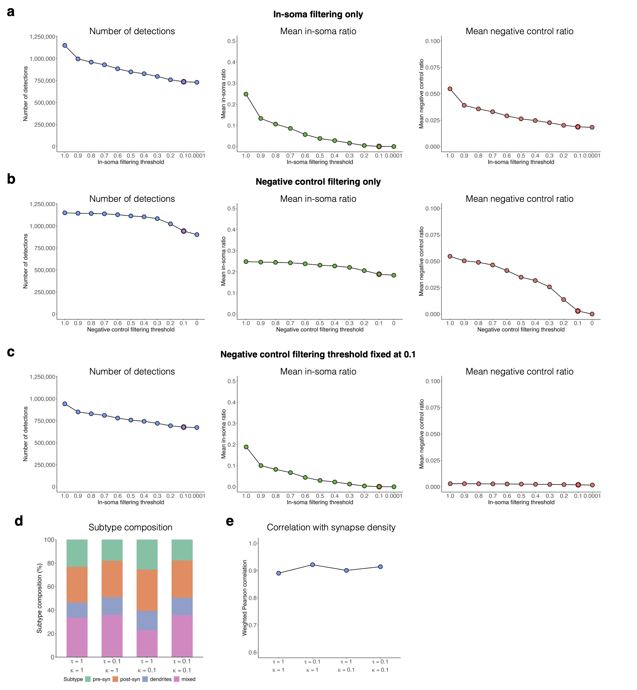
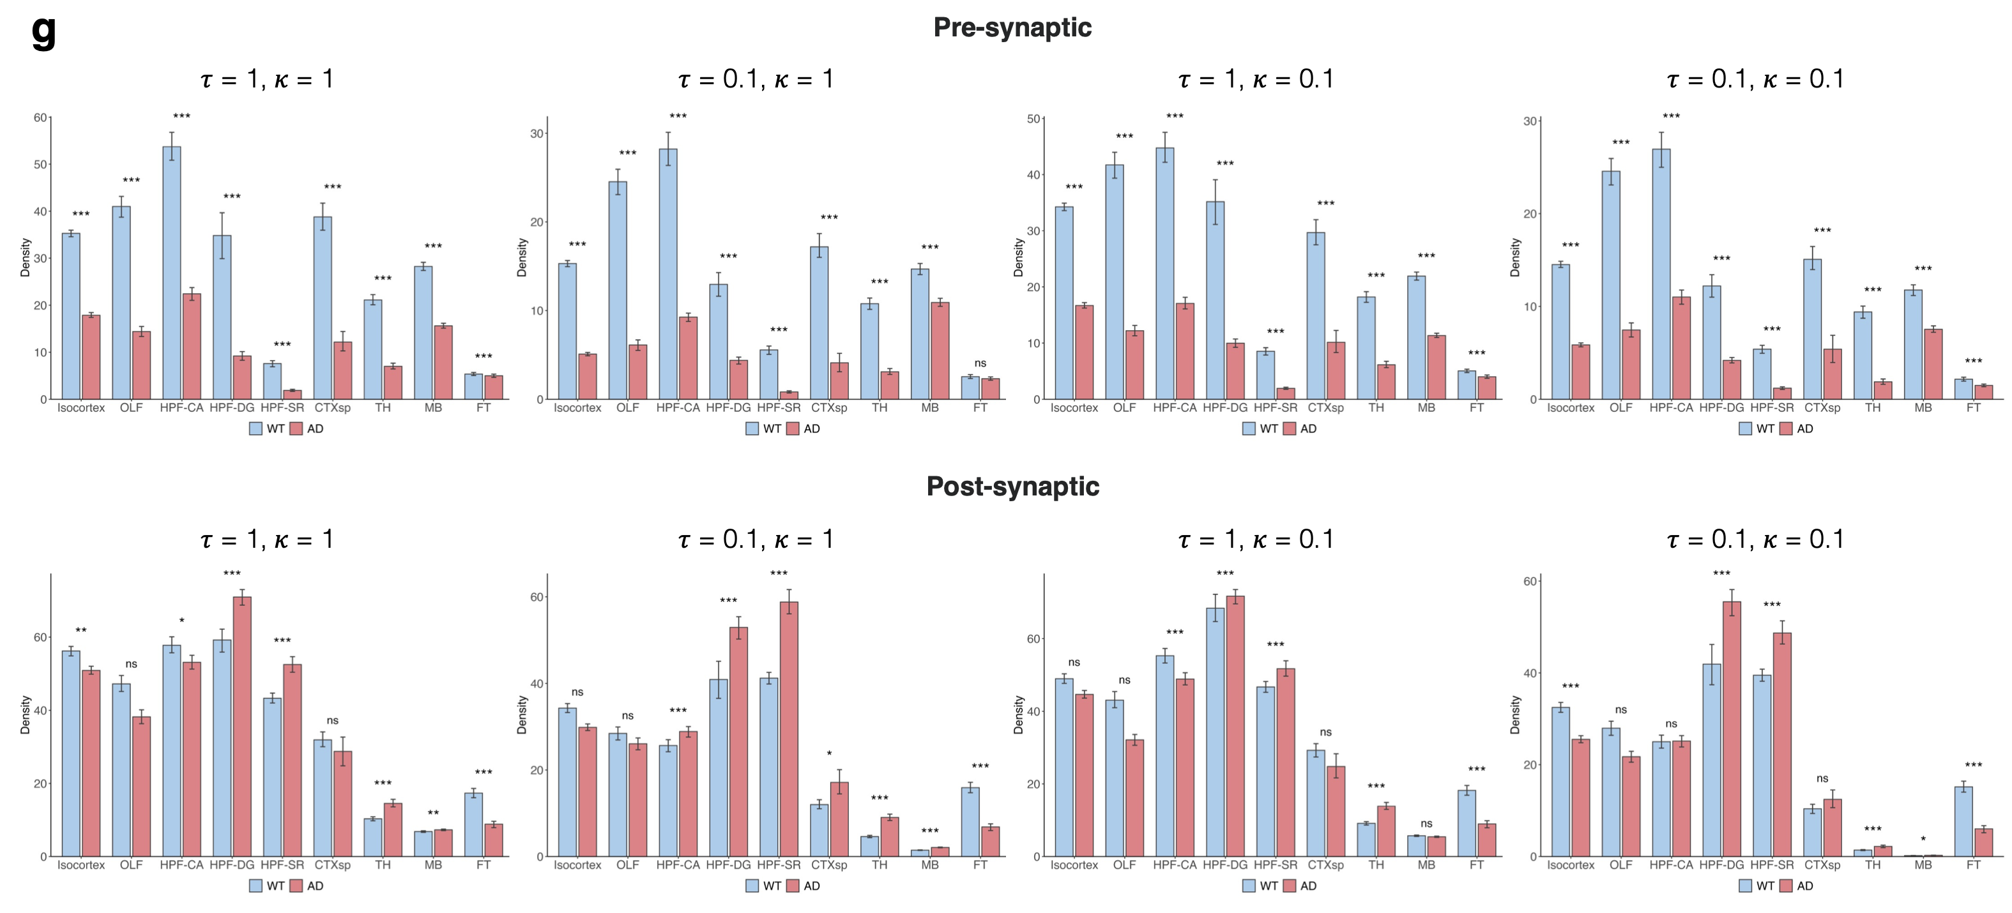
Fig. S18. Ablation study of soma filtering and negative-control filtering using the MERSCOPE WT sample. a–c. Number of detected granules (left), mean in-soma transcript fraction (middle), and mean negative-control fraction (right) across filtering settings: varying τ (a), varying κ (b), and fixed κ = 0.1 with varying τ (c). d. Granule subtype composition across filtering settings. e. Correlation between synapse-associated granule density and synapse density across filtering settings. f. Grouped bar plots comparing pre- and post-synaptic granule densities between WT and AD samples across different combinations of τ and κ. Bar heights represent mean spot-level densities, and error bars indicate bootstrap-based 95% confidence intervals from 500 resamples. ns: not significant; *: adjusted p < 0.05; **: adjusted p < 0.01; ***: adjusted p < 0.001.
Supplementary Note 19. Ablation of the granule sphere-definition strategy.

mcDETECT defines each RNA granule using the minimum enclosing sphere of its constituent aggregate and collects all mRNAs within that sphere to construct the granule transcriptome. To assess the impact of this choice, we performed an ablation on the MERSCOPE WT sample using four sphere-definition strategies: (1) the default, which uses the minimum enclosing sphere computed for each aggregate; (2) a fixed-radius strategy, which uses a constant radius equal to the mean radius of all minimum enclosing spheres; (3) an expanded strategy, which increases each sphere's radius by 20%; and (4) a shrunken strategy, which decreases each sphere's radius by 20%. Summary statistics for each strategy are shown in the table below.

Setting | Mean number of transcripts | Mean number of unique genes | Mean in-soma ratio | Mean negative-control ratio | Gene expression correlation
Default | 8.68 | 5.80 | 0.05% | 0.19% | 1.0
Fixed | 6.08 | 4.57 | 0.10% | 0.51% | 0.61
Expand | 13.17 | 7.82 | 0.26% | 0.69% | 0.83
Shrink | 4.83 | 3.95 | 0.02% | 0.20% | 0.80
Table. Summary of granule statistics in the MERSCOPE WT sample using different sphere settings.

Granule composition. Compared with the default, the fixed-radius strategy slightly reduced both the number of transcripts per granule (8.68 to 6.08) and the number of unique genes per granule (5.80 to 4.57; Fig. S19a, left and middle). Expanding the spheres increased the average content to 13.17 transcripts and 7.82 genes per granule, whereas shrinking the spheres reduced it to 4.83 transcripts and 3.95 genes per granule. Gene-wise Pearson correlations of granule-level expression with the default strategy showed that the expanded and shrunken strategies remained highly concordant (mean = 0.83 and 0.80, respectively), indicating that uniformly scaling sphere sizes mainly changes the total number of captured transcripts while preserving relative gene-enrichment patterns; in contrast, the fixed-radius strategy showed only moderate agreement (mean = 0.61; Fig. S19a, right).

Granule–soma specificity. Under all four strategies, more than 99% of granules contained no in-soma reads or negative-control transcripts (Fig. S19b). However, the expanded-sphere strategy produced a substantially higher mean in-soma ratio (0.26%) and a higher mean negative-control ratio (0.69%) than the other strategies, indicating that although expanding the radius increases transcript counts, it reduces granule specificity by incorporating transcripts more likely to originate from somata or background.

Granule subtypes and synapse correlations. The default and fixed-radius strategies produced similar subtype distributions, whereas the expanded-sphere strategy identified more mixed granules (because larger spheres captured additional background transcripts) and the shrunken-sphere strategy assigned more granules to the "other" category (because the reduced radius weakened gene-enrichment signals; Fig. S19c). The correlation between synapse density and synapse-associated granules was high for the default, fixed-radius, and expanded strategies (~0.9) and slightly lower for the shrunken strategy (0.88; Fig. S19d).

WT versus AD. The reduction in pre-synaptic granules between WT and AD was consistent across all four strategies, with most comparisons showing the same level of significance, and post-synaptic granules showed little difference under all settings (Fig. S19e). Collectively, the default strategy achieves an optimal balance between transcriptomic completeness and granule–soma specificity, avoiding the sparsity introduced by the fixed-radius or shrunken strategies and the reduced specificity observed under radius expansion, and the main conclusions are not sensitive to the sphere-definition strategy.

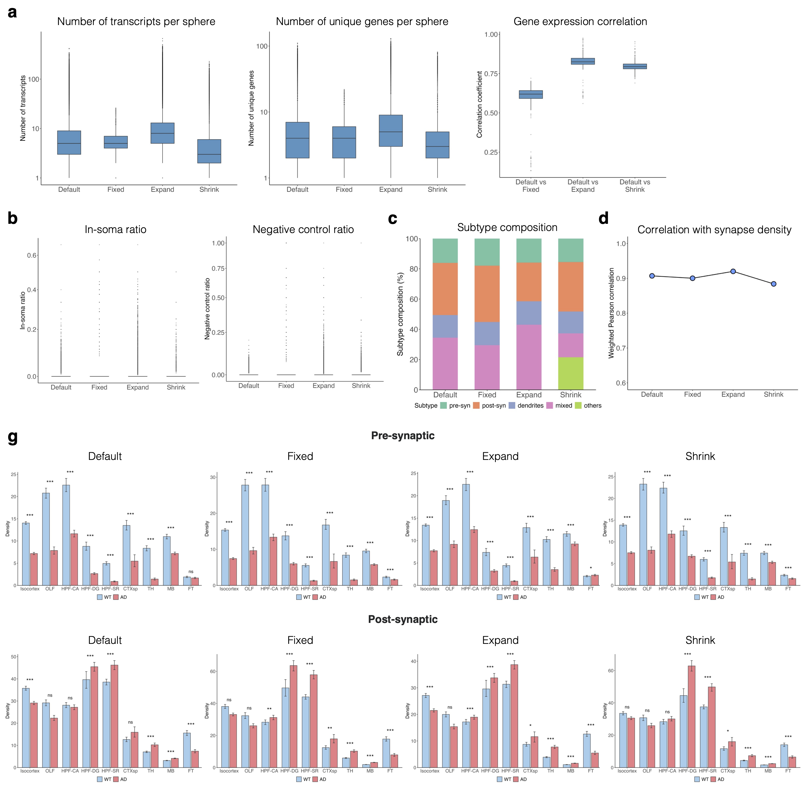
Fig. S19. Ablation analysis of granule sphere-definition strategies. a. Boxplots comparing the number of transcripts per granule (left) and the number of unique genes per granule (middle) across four sphere-definition strategies; the right panel shows the gene-wise Pearson correlation between granule-level expression under each strategy and the default strategy. b. Boxplots comparing the in-soma ratio (left) and negative-control ratio (right) across the four strategies. c. Granule subtype composition across the four strategies. d. Correlation between synapse-associated granule density and synapse density across the four strategies. e. Grouped bar plots comparing pre- and post-synaptic granule densities between WT and AD samples across the four strategies. Bar heights represent mean spot-level densities, and error bars indicate bootstrap-based 95% confidence intervals from 500 resamples. ns: not significant; *: adjusted p < 0.05; **: adjusted p < 0.01; ***: adjusted p < 0.001.
Supplementary Note 20. Coordinate collapse and molecular crowding.

In imaging-based in situ ST, each gene is detected through gene-specific optical barcodes, so coordinate collapse—multiple transcripts assigned to indistinguishable coordinates—is primarily a concern for transcripts from the same gene rather than different genes. This issue is addressed mainly during gene panel design. In our MERSCOPE dataset, the total panel abundance was constrained to < 9,000 FPKM following Vizgen's guidelines, and highly abundant genes were either excluded or assigned to sequential imaging panels to reduce molecular crowding and minimize the probability that nearby transcripts would be assigned indistinguishable coordinates.

To confirm that coordinate collapse is rare, we assessed potential transcript collapsing in the MERSCOPE WT sample using Camk2a, one of the most highly expressed genes in our panel, as a representative example. For each Camk2a transcript, we calculated the average distance to its five nearest neighboring Camk2a transcripts. As shown in Fig. S20, the nearest-neighbor distance distribution was centered above 1 μm, with only 0.01% of distances below 0.1 μm. In contrast, the finest coordinate resolution in the x- and y-directions was 0.00003 μm, far below the observed transcript-to-transcript distances. These results indicate that coordinate collapse is rare and unlikely to affect granule detection.

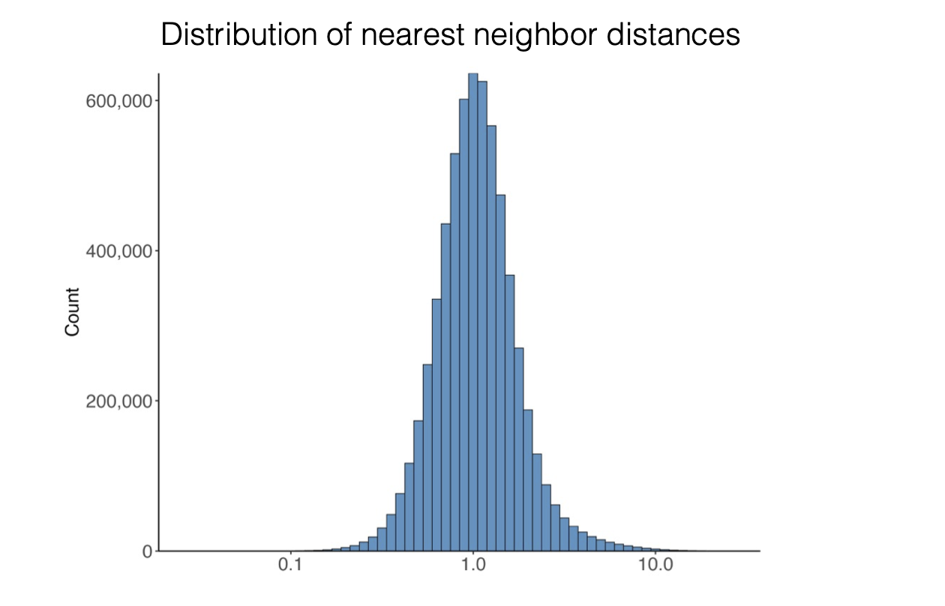
Fig. S20. Histogram showing the distribution of distances between each Camk2a transcript and its five nearest neighboring Camk2a transcripts in the MERSCOPE WT sample.
Supplementary Note 21. Choice of the number of clusters K in granule subtyping.

Granule subtyping in mcDETECT begins with unsupervised K-Means clustering, which is then collapsed into biologically interpretable compartment-associated subtypes (pre-synaptic, post-synaptic, dendritic, and mixed). Because granule-level expression profiles are much sparser than single-cell profiles, t-SNE was used only for visualization and not to determine the number of clusters. The initial choice of K = 15 was intended as a conservative over-partitioning step; in principle, other reasonably large values (K > 10) would serve the same purpose by allowing the initial clusters to be grouped into the four interpretable subtypes.

To test whether the four granule subtypes were sensitive to the choice of K, we repeated K-Means clustering on the combined MERSCOPE WT and AD datasets using K = 20 and K = 25 and compared the results with the default K = 15, annotating clusters with the same marker-based criteria. As shown in Fig. S21a, subtype assignments were largely consistent across K values, with agreement rates of 89.0% for K = 20 and 89.1% for K = 25, indicating that higher K values mainly subdivide existing groups rather than changing the four broad subtype assignments.

We also evaluated clustering behavior using inertia and stability analyses. The inertia curve (Fig. S21b) shows a rapid decrease up to approximately K = 15, followed by a slower, near-linear decline, suggesting that most structured heterogeneity is captured within K = 15–20. We assessed cluster stability by running mini-batch K-Means with five independent random seeds for each K and computing the mean pairwise adjusted Rand index (ARI; Fig. S21c). ARI increased substantially at small K values and reached a high, relatively stable range around K = 14–18 before gradually declining at larger K values, indicating reproducible clustering solutions in this range. K = 15 lies within this stable plateau rather than representing a sharp optimum, with nearby K values showing similar inertia and stability. We therefore selected K = 15 as a representative value.

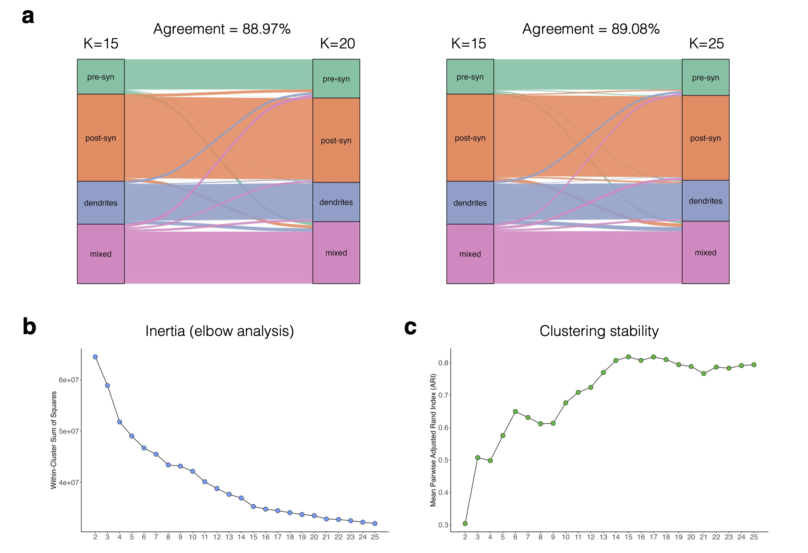
Fig. S21. Choice of the number of clusters K in granule subtyping. a. Alluvial diagrams showing the consistency of granule subtype annotations across K-Means resolutions: K = 15 versus K = 20 (left) and K = 15 versus K = 25 (right). b. Elbow plot showing the within-cluster sum of squares (inertia) as a function of the number of clusters (K = 2–25). c. Cluster stability across random initializations: for each K, mini-batch K-Means was run with five independent random seeds and the mean pairwise adjusted Rand index (ARI) across runs was computed.
References
1. Cajigas, I. J. et al. The Local Transcriptome in the Synaptic Neuropil Revealed by Deep Sequencing and High-Resolution Imaging. Neuron 74, 453–466 (2012).
2. Hafner, A.-S., Donlin-Asp, P. G., Leitch, B., Herzog, E. & Schuman, E. M. Local protein synthesis is a ubiquitous feature of neuronal pre- and postsynaptic compartments. Science 364, eaau3644 (2019).
3. Tarannum, R. et al. Multiplexed smFISH reveals the spatial organization of neuropil localized mRNAs is linked to abundance. Preprint at https://doi.org/10.1101/2024.07.13.603387 (2025).
4. Niu, M. et al. Droplet-based transcriptome profiling of individual synapses. Nat. Biotechnol. 41, 1332–1344 (2023).
5. Reimer, R. J. SLC17: A functionally diverse family of organic anion transporters. Mol. Aspects Med. 34, 350–359 (2013).
6. Zeng, H. et al. Spatially resolved single-cell translatomics at molecular resolution. Science 380, eadd3067 (2023).
7. Chaudhry, F. A. et al. The Vesicular GABA Transporter, VGAT, Localizes to Synaptic Vesicles in Sets of Glycinergic as Well as GABAergic Neurons. J. Neurosci. 18, 9733–9750 (1998).
8. Glock, C. et al. The translatome of neuronal cell bodies, dendrites, and axons. Proc. Natl. Acad. Sci. 118, e2113929118 (2021).
9. Vlachos, A., Reddy-Alla, S., Papadopoulos, T., Deller, T. & Betz, H. Homeostatic regulation of gephyrin scaffolds and synaptic strength at mature hippocampal GABAergic postsynapses. Cereb. Cortex 23, 2700–2711 (2013).
10. Tretter, V. E. et al. Gephyrin, the enigmatic organizer at GABAergic synapses. Front. Cell. Neurosci. 6, (2012).
11. Diering, G. H. & Huganir, R. L. The AMPA Receptor Code of Synaptic Plasticity. Neuron 100, 314–329 (2018).
12. Yoon, S. et al. Homer1 promotes dendritic spine growth through ankyrin-G and its loss reshapes the synaptic proteome. Mol. Psychiatry 26, 1775–1789 (2021).
13. Uchigashima, M., Cheung, A. & Futai, K. Neuroligin-3: A Circuit-Specific Synapse Organizer That Shapes Normal Function and Autism Spectrum Disorder-Associated Dysfunction. Front. Mol. Neurosci. 14, 749164 (2021).
14. Sobotzik, J.-M. et al. AnkyrinG is required to maintain axo-dendritic polarity in vivo. Proc. Natl. Acad. Sci. 106, 17564–17569 (2009).
15. Forrest, S. L. et al. Cell-specific MAPT gene expression is preserved in neuronal and glial tau cytopathologies in progressive supranuclear palsy. Acta Neuropathol. (Berl.) 146, 395–414 (2023).
16. Sánchez-Huertas, C. et al. The +TIP Navigator-1 is an actin-microtubule crosslinker that regulates axonal growth cone motility. J. Cell Biol. 219, e201905199 (2020).
17. Zonta, B. et al. A Critical Role for Neurofascin in Regulating Action Potential Initiation through Maintenance of the Axon Initial Segment. Neuron 69, 945–956 (2011).
18. Wang, C.-C. et al. βIV Spectrinopathies Cause Profound Intellectual Disability, Congenital Hypotonia, and Motor Axonal Neuropathy. Am. J. Hum. Genet. 102, 1158–1168 (2018).
19. Latremoliere, A. et al. Neuronal-Specific TUBB3 Is Not Required for Normal Neuronal Function but Is Essential for Timely Axon Regeneration. Cell Rep. 24, 1865-1879.e9 (2018).
20. Klein, M. E., Younts, T. J., Castillo, P. E. & Jordan, B. A. RNA-binding protein Sam68 controls synapse number and local β-actin mRNA metabolism in dendrites. Proc. Natl. Acad. Sci. U. S. A. 110, 3125–3130 (2013).
21. Takei, Y., Kikkawa, Y. S., Atapour, N., Hensch, T. K. & Hirokawa, N. Defects in Synaptic Plasticity, Reduced NMDA-Receptor Transport, and Instability of Postsynaptic Density Proteins in Mice Lacking Microtubule-Associated Protein 1A. J. Neurosci. 35, 15539–15554 (2015).
22. DeGiosio, R. A. et al. More than a marker: potential pathogenic functions of MAP2. Front. Mol. Neurosci. 15, 974890 (2022).
23. Saunders, A. et al. Molecular diversity and specializations among the cells of the adult mouse brain. Cell 174, 1015–1030.e16 (2018).
24. Yao, Z. et al. A high-resolution transcriptomic and spatial atlas of cell types in the whole mouse brain. Nature 624, 317–332 (2023).
25. Forner, S. et al. Systematic phenotyping and characterization of the 5xFAD mouse model of Alzheimer’s disease. Sci. Data 8, 270 (2021).
26. Habib, N. et al. Disease-associated astrocytes in Alzheimer’s disease and aging. Nat. Neurosci. 23, 701–706 (2020).
27. Zhou, Y. et al. Human and mouse single-nucleus transcriptomics reveal TREM2-dependent and TREM2-independent cellular responses in Alzheimer’s disease. Nat. Med. 26, 131–142 (2020).
28. Kiebler, M. A. & Bauer, K. E. RNA granules in flux: dynamics to balance physiology and pathology. Nat. Rev. Neurosci. 25, 711–725 (2024).
29. Brangwynne, C. P. et al. Germline P granules are liquid droplets that localize by controlled dissolution/condensation. Science 324, 1729–1732 (2009).
30. Bauer, K. E. et al. RNA supply drives physiological granule assembly in neurons. Nat. Commun. 13, 2781 (2022).
31. Shiina, N., Shinkura, K. & Tokunaga, M. A novel RNA-binding protein in neuronal RNA granules: regulatory machinery for local translation. J. Neurosci. 25, 4420–4434 (2005).
32. Hale, C. R. et al. FMRP regulates mRNAs encoding distinct functions in the cell body and dendrites of CA1 pyramidal neurons. eLife 10, e71892 (2021).
33. Hacisuleyman, E. et al. Neuronal activity rapidly reprograms dendritic translation via eIF4G2: uORF binding. Nat. Neurosci. 27, 822–835 (2024).
34. Sawicka, K. et al. FMRP has a cell-type-specific role in CA1 pyramidal neurons to regulate autism-related transcripts and circadian memory. eLife 8, e46919 (2019).
35. Tushev, G. et al. Alternative 3′ UTRs modify the localization, regulatory potential, stability, and plasticity of mRNAs in neuronal compartments. Neuron 98, 495–511.e6 (2018).
36. Bae, B. & Miura, P. Emerging roles for 3′ UTRs in neurons. Int. J. Mol. Sci. 21, 3413 (2020).
37. Kiltschewskij, D. J., Harrison, P. F., Fitzsimmons, C., Beilharz, T. H. & Cairns, M. J. Extension of mRNA poly(A) tails and 3′ UTRs during neuronal differentiation exhibits variable association with post-transcriptional dynamics. Nucleic Acids Res. 51, 8181–8198 (2023).
38. Han, T. W. et al. Cell-free formation of RNA granules: bound RNAs identify features and components of cellular assemblies. Cell 149, 768–779 (2012).
39. Megías, M., Emri, Z., Freund, T. & Gulyás, A. Total number and distribution of inhibitory and excitatory synapses on hippocampal CA1 pyramidal cells. Neuroscience 102, 527–540 (2001).
40. Takács, V. T., Szőnyi, A., Freund, T. F., Nyiri, G. & Gulyás, A. I. Quantitative ultrastructural analysis of basket and axo-axonic cell terminals in the mouse hippocampus. Brain Struct. Funct. 220, 919–940 (2015).
41. Santuy, A., Rodriguez, J., DeFelipe, J. & Merchan-Perez, A. Volume electron microscopy of the distribution of synapses in the neuropil of the juvenile rat somatosensory cortex. Brain Struct. Funct. 223, 77–90 (2018).
42. Ge, Q. et al. Enhancing RNA Capture Efficiency in Spatial Transcriptomics: A Review of Innovative Technologies and Strategies. Int. J. Mol. Sci. 26, 11076 (2025).
43. Wang, G., Moffitt, J. R. & Zhuang, X. Multiplexed imaging of high-density libraries of RNAs with MERFISH and expansion microscopy. Sci. Rep. 8, 4847 (2018).
44. Xia, C., Fan, J., Emanuel, G., Hao, J. & Zhuang, X. Spatial transcriptome profiling by MERFISH reveals subcellular RNA compartmentalization and cell cycle-dependent gene expression. Proc. Natl. Acad. Sci. 116, 19490–19499 (2019).
45. Marco Salas, S. et al. Optimizing Xenium In situ data utility by quality assessment and best-practice analysis workflows. Nat. Methods 22, 813–823 (2025).
46. Henze, D. E., Tsai, A. P., Wyss-Coray, T. & Quake, S. R. Simultaneous spatial transcriptomics and morphology profiling as tools to explore how microglia change with age. Nat. Aging 1–17 (2026).
47. Qian, X. et al. Spatial transcriptomics reveals human cortical layer and area specification. Nature 644, 153–163 (2025).

