

User Interface Idea - Patient Version

Polarity Filter



Platform Filter



Demographic Filter Age Gender Region Disease

50+ M any any

Aspirin



(the researcher version is probably more important, and I will work on it now)

John Doe

Browse by Drug

Add to my watchlist

Aspirin

Males of age 50 and above think aspirin is…

(hover to view source sentences)

+: cheap

+: easily available

+: effective

+: safe

-: many side-effects

-: tastes bad

-: not reimbursed by insurance

-: ineffective

Aspirin, or acetylsalicylic acid (ASA), is commonly used as a pain reliever for minor aches and pains and to reduce fever.

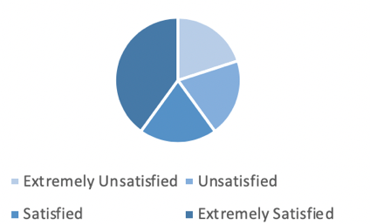

Browse by Patient Groups

Explore Preference

My Watchlist

Timeline Overview

**. . . . .**

Explore Top-voted Posts

Naproxen

**Relevant Posts**

**. . . . .**

… I think aspirin is great… It is cheap …



… I am happy with aspirin’s effectiveness …

… I don’t like aspirin … It gives me headaches …



… aspirin is not reimbursed by my insurer …



# Health Economics Query Requirements

1) Sentences that contain at least two different aspects that can be linked to a specific drug, along with the aspects, associated opinions/polarities, forum ID, post ID, timestamp, and user demographics/characteristics if available.

2) Sentiment for DrugA associated with mentions by female patients over age 55 (presumably this would return a table with each row being an aspect-opinion dyad extracted from the text, right?), along with timestamp, forum ID, and user demographics/characteristics if available.

3) Volume of posts with at least one mention of DrugB over time in ForumX, independently of whether the drug or specific reference was extracted as an aspect by ABSApp

4) RA forum users who mentioned at least one drug that was extracted as an aspect by ABSApp in at least one of their posts, along with a list of all the drugs each user mentioned and associated sentiments (if available).

# Refined Database Schema for Aspect Categorization

(EduCloud Virtual Machine will be made available later this week, approx. Feb 21st)

All Code for generating SQL statements for populating the database: <http://bit.ly/2V4RXWV>

Parsing Reddit Flairs in r/MultipleSclerosis

Flair Example

flair

parse

result

Age = 0 if unknown

Profile Example

HealthUnlocked Profile:

