实验五 文件与流
班级：计算机科学与技术21（4）班 学号：2021329600006
姓名：陈昊天

一、实验目的
- 掌握文件类的使用；
- 掌握文件流的操作；
- 掌握文本数据的读写；
- 掌握LINQ的用法；
- 复习WPF编程，了解图表的显示方法。

二、实验内容
- 假设有一个文本文件"book.txt"在C#程序相同目录下，里面存放着大量的复数数据，形式如：
41, 49; 10, 73; 45, 30; 17, 87
35, 17; 7, 18; 35, 40; 16, 5
55, 45; 13, 76; 41, 37; 16, 6
每行数据含多个组，每组数以分号“;”分隔；组内以逗号","分隔，前一个数为复数实部，后一个数为复数虚部。要求：
1）从文件中读取所有的复数，以Tuple（元组）的形式存入一个列表(List)中，并提示用户已读入多少个复数。
2）从中选取模最大的复数并将它输出。复数的实部与虚部的平方和的正的平方根就是一个复数的模。
3）基于Dictionary，统计模在[0, 10), [10, 20), [20, 30)…等各区间的复数的数量，字典的键可以是整数如0、10、20…，也可以是字符串“0-10”、“10-20”等。输出各区间统计结果。
模在[0, 10)区间的有1个
模在[10, 20)区间的有2个
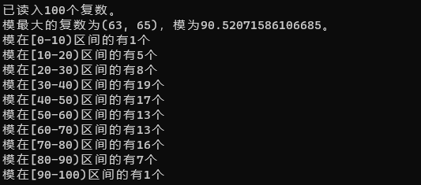

internal class Program {
static void Main(string[] args) {
List<Tuple<double, double>> complexNumbers = new List<Tuple<double, double>>();

using (StreamReader reader = new StreamReader(@"E:\Projects\Github\c-sharp\5-1\book.txt")) {
string line;
while ((line = reader.ReadLine()) != null) {
string[] groups = line.Split(";");
foreach (string group in groups) {
string[] parts = group.Split(",");
double real = double.Parse(parts[0].Trim());
double imaginary = double.Parse(parts[1].Trim());
complexNumbers.Add(Tuple.Create(real, imaginary));
}
}
}
Console.WriteLine($"已读入{complexNumbers.Count}个复数。");

Tuple<double, double> maxComplexNumber = null;
double maxMagnitude = double.MinValue;
foreach (Tuple<double, double> complexNumber in complexNumbers) {
double magnitude = Math.Sqrt(Math.Pow(complexNumber.Item1, 2) + Math.Pow(complexNumber.Item2, 2));
if (magnitude > maxMagnitude) {
maxMagnitude = magnitude;
maxComplexNumber = complexNumber;
}
}
Console.WriteLine($"模最大的复数为({maxComplexNumber.Item1}, {maxComplexNumber.Item2})，模为{maxMagnitude}。");

Dictionary<string, int> magnitudeCounts = new Dictionary<string, int>();
for (int i = 0; i < 10; i++) {
magnitudeCounts.Add($"{i * 10}-{(i + 1) * 10}", 0);
}
foreach (Tuple<double, double> complexNumber in complexNumbers) {
double magnitude = Math.Sqrt(Math.Pow(complexNumber.Item1, 2) + Math.Pow(complexNumber.Item2, 2));
foreach (string range in magnitudeCounts.Keys) {
string[] limits = range.Split('-');
double lowerLimit = double.Parse(limits[0]);
double upperLimit = double.Parse(limits[1]);
if (magnitude >= lowerLimit && magnitude < upperLimit) {
magnitudeCounts[range]++;
break;
}
}
}

foreach (var pair in magnitudeCounts) {
Console.WriteLine($"模在[{pair.Key})区间的有{pair.Value}个");
}
}
}

- 利用LINQ技术查询Racer对象
已有Racer类和冠军车手数据，在racer.txt文件中，进行以下查询，并打印结果：
- 查询来自德国的所有世界冠军，并按胜利场数降序排列。
输出结果时，可用Console.WriteLine("{0:A}", racer)。
- 使用方法语法重写这个查询。即racers.Where(…).Orderby(…)
- 体会LINQ的推迟查询：
首先建立查询，查出所有胜利场数超过10的车手，打印；
然后将所有英国（UK）车手的国名改为“English”；
再次打印本查询结果。观察同一查询的不同执行结果。
- 查出首发场数超过100，并且胜利场数超过20的车手的姓名（包含名和姓）。
- 基于现有数据，输出曾出过冠军的国家。
- 统计德国人的胜利总场数。
- 进行投影查询，输出人名与首发胜率，人名包含名和姓，首发胜率为Wins除以Starts。
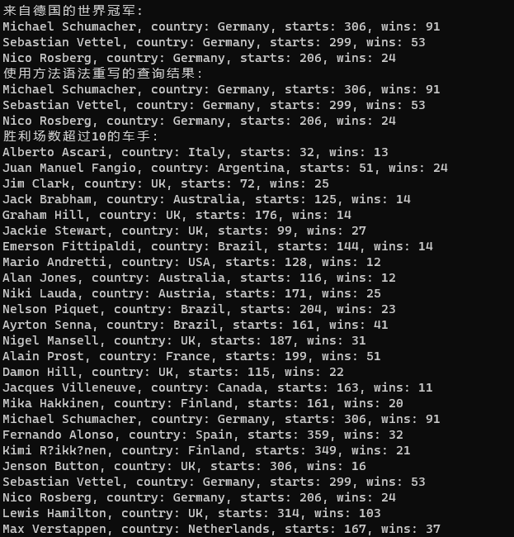
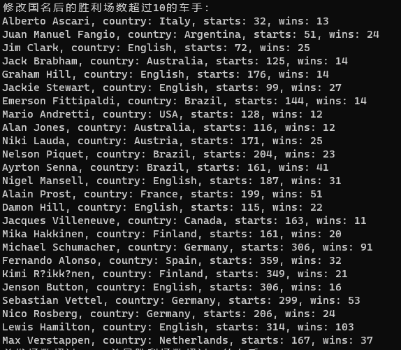
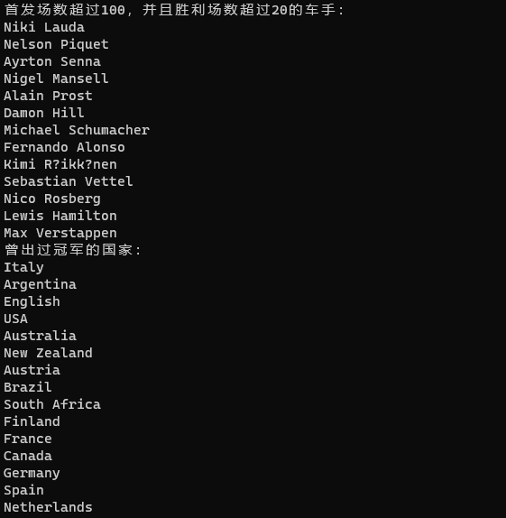
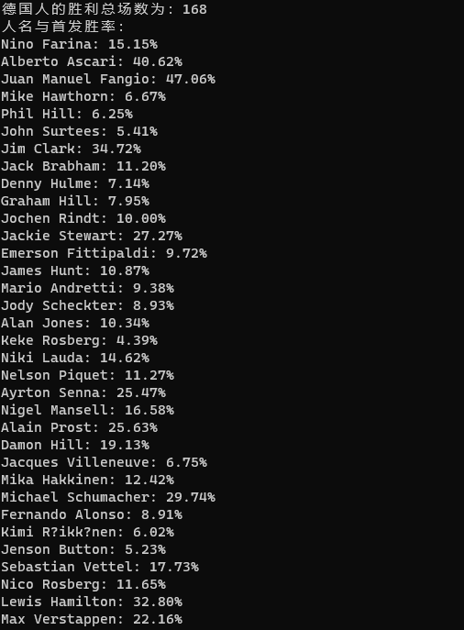
using System;
using System.Collections.Generic;
using System.Linq;

public class Racer : IComparable<Racer>, IFormattable {
public Racer(string firstName = null, string lastName = null, string country = null, int starts = 0, int wins = 0, IEnumerable<int> years = null, IEnumerable<string> cars = null) {
this.FirstName = firstName;
this.LastName = lastName;
this.Country = country;
this.Starts = starts;
this.Wins = wins;

var yearsList = new List<int>();
foreach (var year in years) {
yearsList.Add(year);
}
this.Years = yearsList.ToArray();
var carList = new List<string>();
foreach (var car in cars) {
carList.Add(car);
}
this.Cars = carList.ToArray();
}
public string FirstName { get; set; }
public string LastName { get; set; }
public string Country { get; set; }
public int Wins { get; set; }//夺冠场数
public int Starts { get; set; }//首发场数
public string[] Cars { get; private set; }//赛车手获得冠军那一年使用的所有车型
public int[] Years { get; private set; }//赛车手获得冠军的年份

public override string ToString() {
return String.Format("{0} {1}", FirstName, LastName);
}

public int CompareTo(Racer? other) => LastName.CompareTo(other?.LastName);

public string ToString(string format) => ToString(format, null);

public string ToString(string? format, IFormatProvider? formatProvider) =>
format switch {
null => ToString(),
"N" => ToString(),
"F" => FirstName,
"L" => LastName,
"C" => Country,
"S" => Starts.ToString(),
"W" => Wins.ToString(),
"A" => $"{FirstName} {LastName}, country: {Country}, starts: {Starts}, wins: {Wins}",
_ => throw new FormatException($"Format {format} not supported")
};

public static List<Racer> GetChampions() => new()
{
new("Nino", "Farina", "Italy", 33, 5, new[] { 1950 }, new[] { "Alfa Romeo" }),
new("Alberto", "Ascari", "Italy", 32, 13, new[] { 1952, 1953 }, new[] { "Ferrari" }),
new("Juan Manuel", "Fangio", "Argentina", 51, 24, new int[] { 1951, 1954, 1955, 1956, 1957 }, new string[] { "Alfa Romeo", "Maserati", "Mercedes", "Ferrari" }),
new("Mike", "Hawthorn", "UK", 45, 3, new int[] { 1958 }, new string[] { "Ferrari" }),
new("Phil", "Hill", "USA", 48, 3, new int[] { 1961 }, new string[] { "Ferrari" }),
new("John", "Surtees", "UK", 111, 6, new int[] { 1964 }, new string[] { "Ferrari" }),
new("Jim", "Clark", "UK", 72, 25, new int[] { 1963, 1965 }, new string[] { "Lotus" }),
new("Jack", "Brabham", "Australia", 125, 14, new int[] { 1959, 1960, 1966 }, new string[] { "Cooper", "Brabham" }),
new("Denny", "Hulme", "New Zealand", 112, 8, new int[] { 1967 }, new string[] { "Brabham" }),
new("Graham", "Hill", "UK", 176, 14, new int[] { 1962, 1968 }, new string[] { "BRM", "Lotus" }),
new("Jochen", "Rindt", "Austria", 60, 6, new int[] { 1970 }, new string[] { "Lotus" }),
new("Jackie", "Stewart", "UK", 99, 27, new int[] { 1969, 1971, 1973 }, new string[] { "Matra", "Tyrrell" }),
new("Emerson", "Fittipaldi", "Brazil", 144, 14, new int[] { 1972, 1974 }, new string[] { "Lotus", "McLaren" }),
new("James", "Hunt", "UK", 92, 10, new int[] { 1976 }, new string[] { "McLaren" }),
new("Mario", "Andretti", "USA", 128, 12, new int[] { 1978 }, new string[] { "Lotus" }),
new("Jody", "Scheckter", "South Africa", 112, 10, new int[] { 1979 }, new string[] { "Ferrari" }),
new("Alan", "Jones", "Australia", 116, 12, new int[] { 1980 }, new string[] { "Williams" }),
new("Keke", "Rosberg", "Finland", 114, 5, new int[] { 1982 }, new string[] { "Williams" }),
new("Niki", "Lauda", "Austria", 171, 25, new int[] { 1975, 1977, 1984 }, new string[] { "Ferrari", "McLaren" }),
new("Nelson", "Piquet", "Brazil", 204, 23, new int[] { 1981, 1983, 1987 }, new string[] { "Brabham", "Williams" }),
new("Ayrton", "Senna", "Brazil", 161, 41, new int[] { 1988, 1990, 1991 }, new string[] { "McLaren" }),
new("Nigel", "Mansell", "UK", 187, 31, new int[] { 1992 }, new string[] { "Williams" }),
new("Alain", "Prost", "France", 199, 51, new int[] { 1985, 1986, 1989, 1993 }, new string[] { "McLaren", "Williams" }),
new("Damon", "Hill", "UK", 115, 22, new int[] { 1996 }, new string[] { "Williams" }),
new("Jacques", "Villeneuve", "Canada", 163, 11, new int[] { 1997 }, new string[] { "Williams" }),
new("Mika", "Hakkinen", "Finland", 161, 20, new int[] { 1998, 1999 }, new string[] { "McLaren" }),
new("Michael", "Schumacher", "Germany", 306, 91, new int[] { 1994, 1995, 2000, 2001, 2002, 2003, 2004 }, new string[] { "Benetton", "Ferrari" }),
new("Fernando", "Alonso", "Spain", 359, 32, new int[] { 2005, 2006 }, new string[] { "Renault" }),
new("Kimi", "Räikkönen", "Finland", 349, 21, new int[] { 2007 }, new string[] { "Ferrari" }),
new("Jenson", "Button", "UK", 306, 16, new int[] { 2009 }, new string[] { "Brawn GP" }),
new("Sebastian", "Vettel", "Germany", 299, 53, new int[] { 2010, 2011, 2012, 2013 }, new string[] { "Red Bull Racing" }),
new("Nico", "Rosberg", "Germany", 206, 24, new int[] { 2016 }, new string[] { "Mercedes" }),
new("Lewis", "Hamilton", "UK", 314, 103, new int[] { 2008, 2014, 2015, 2017, 2018, 2019, 2020 }, new string[] { "McLaren", "Mercedes" }),
new("Max", "Verstappen", "Netherlands", 167, 37, new int[] { 2021, 2022 }, new string[] { "Red Bull Racing" })
};
}

internal class Program {
static void Main(string[] args) {
List<Racer> racers = Racer.GetChampions();

var germanChampions = from racer in racers
where racer.Country == "Germany"
orderby racer.Wins descending
select racer;
Console.WriteLine("来自德国的世界冠军: ");
foreach (var racer in germanChampions) {
Console.WriteLine("{0:A}", racer);
}

var germanChampions2 = racers.Where(racer => racer.Country == "Germany")
.OrderByDescending(racer => racer.Wins);
Console.WriteLine("使用方法语法重写的查询结果：");
foreach (var racer in germanChampions2) {
Console.WriteLine("{0:A}", racer);
}

var query1 = from racer in racers
where racer.Wins > 10
select racer;
Console.WriteLine("胜利场数超过10的车手：");
foreach (var racer in query1) {
Console.WriteLine("{0:A}", racer);
}

foreach (var racer in racers.Where(racer => racer.Country == "UK")) {
racer.Country = "English";
}

Console.WriteLine("修改国名后的胜利场数超过10的车手：");
foreach (var racer in query1) {
Console.WriteLine("{0:A}", racer);
}

var query2 = from racer in racers
where racer.Starts > 100 && racer.Wins > 20
select racer.FirstName + " " + racer.LastName;
Console.WriteLine("首发场数超过100，并且胜利场数超过20的车手：");
foreach (var name in query2) {
Console.WriteLine(name);
}

var countries = racers.Select(racer => racer.Country).Distinct();
Console.WriteLine("曾出过冠军的国家：");
foreach (var country in countries) {
Console.WriteLine(country);
}

int germanWins = racers.Where(racer => racer.Country == "Germany")
.Sum(racer => racer.Wins);
Console.WriteLine("德国人的胜利总场数为：{0}", germanWins);

var query3 = from racer in racers
select new {
Name = racer.FirstName + " " + racer.LastName,
WinPercentage = (double)racer.Wins / racer.Starts
};
Console.WriteLine("人名与首发胜率：");
foreach (var result in query3) {
Console.WriteLine("{0}: {1:P}", result.Name, result.WinPercentage);
}
}
}

- 分析上证指数
现有上证指数历年数据，现对其开展分析，并以WPF图表展示分析结果。
3.1 首先准备展示界面
1）新建项目，最好选择WPF应用（.Net Framework），避免出现兼容性问题
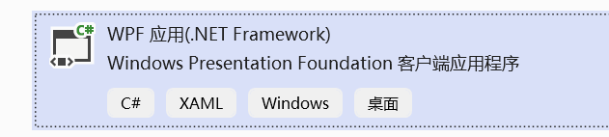
2）打开NuGet包管理器，导入上面的包。
NuGet程序包就好比前端开发中的npm包，Java开发中的Maven或者Gradle，它们都是管理自己语言领域的程序依赖包的工具。负责控制程序包版本，维护包与包之间的依赖，有了包管理工具，你可以快速地安装包，还原包等。
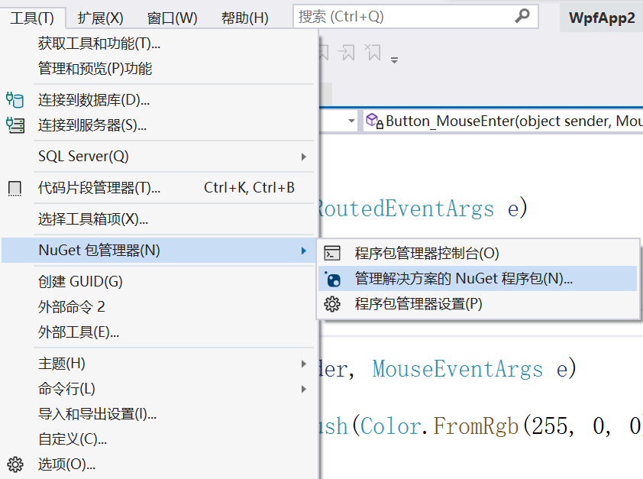
3）搜索livechart，选择LiveCharts.Wpf包，安装到本项目
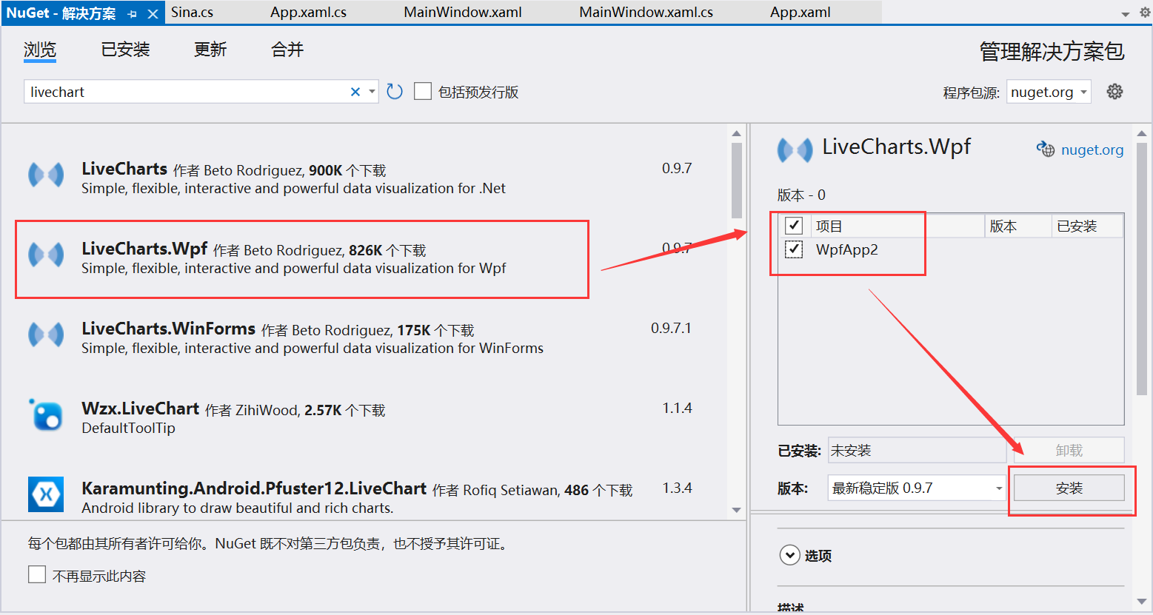
4）打开左侧工具箱，查看是否有LiveCharts的控件，如果没有，可以手动加入：
- 右键点击工具箱，选择“添加选项卡”，为选项卡设置名字；
- 右键点击该选项卡，选择“选择项…”；
- 在弹出的对话框“WPF组件”页下，点击“浏览…”，点位到自己创建的项目文件中，在Debug目录下会有LiveCharts.dll文件，选中该文件；
- 返回“选择工具箱项”对话框，LiveCharts所带的控件默认都已选中，确认并返回即可。
5）设计界面，在左侧工具箱中将CartesianChart（即折线图）拖到右侧界面中。
如果没有在工具箱中添加控件，则需要手动在顶部添加：
xmlns:lvc="clr-namespace:LiveCharts.Wpf;assembly=LiveCharts.Wpf"
在界面部分，添加：
<lvc:CartesianChart x:Name="chart1" >
< lvc:CartesianChart.AxisY>
<lvc:Axis Title="价格" />
<lvc:Axis Title="交易量" Position="RightTop" MinValue="0"/>
</lvc:CartesianChart.AxisY>
<lvc:CartesianChart.Series>
<lvc:LineSeries Values="1,2,3,4,5,6"/>
<lvc:LineSeries Values="2,4,6,8,10,12"/>
</lvc:CartesianChart.Series>
</lvc:CartesianChart>
其中包含两个Y轴，一个在左，一个在右。
运行程序。如果能正常运行，则界面上将出现折线图形。
3.2 其次开展数据分析
1）创建一个结构，用于保存股票数据：
struct StockPrice
{
public DateTime date;
public double 开盘价;
public double 最高价;
public double 最低价;
public double 收盘价;
public double 涨跌额;
public double 涨跌幅;
public double 振幅;
public double 总手;
public double 金额;
}
2）为Window的Loaded事件建立响应函数，基于StreamReader从文件中读出所有股票数据。
文件中第一行标明数据含义，其余各行每项数据以”\t”分隔。
时间 开盘 最高 最低 收盘 涨跌 涨幅% 振幅% 总手(万) 金额(亿)
1990-12-19,三 96.05 99.98 95.79 99.98 -- -- -- 49400 494311
1990-12-20,四 104.30 104.39 99.98 104.39 +4.41 4.41 4.41 8400 84992
将所有的数据读出，存入List<StockPrice>列表中。
3）由于股票数据所跨时间段很长，因此只能显示一部分。为此基于LINQ技术进行查询，查询结果放入List列表中，再按如下方法显示在图上：
chart1.AxisX.Clear();
Axis dateAxis = new Axis();
dateAxis.Labels = values3;
chart1.AxisX.Add(dateAxis); //为X轴设置时间标签
chart1.Series.Clear();
ColumnSeries columnSeries = new ColumnSeries();//创建柱状图
columnSeries.Values = new ChartValues<double>(amountValues);
columnSeries.ScalesYAt = 1; //折线图数据依右侧Y轴
chart1.Series.Add(columnSeries);
LineSeries lineseries = new LineSeries();//创建拆线图
lineseries.Values = new ChartValues<double>(priceValues);
lineseries.ScalesYAt = 0;//折线图数据依左侧Y轴
chart1.Series.Add(lineseries);
4）以上功能是以事件形式进行数据查询与展示，以下提供以数据绑定方法进行展示。
首先，在XAML中建立数据绑定：
<live:CartesianChart Series="{Binding StockCollection}">
然后，在cs文件中加上属性：
public SeriesCollection StockCollection { get; set; }
接着，在窗口构造函数中添加如下代码，意味着从窗口类自己寻找数据（本程序演示用，可以这么做；实践中数据显示与数据本身要区分开来）
DataContext = this;
最后，只需给相关方法中添加代码，修改StockCollection内容即可。修改后，由于数据被绑定到显示控件，控件将自动更新。
StockCollection.Clear();
StockCollection.Add(
new ColumnSeries
{
Title = "交易量",
Values = new ChartValues<double>(values2),
ScalesYAt = 1
});
StockCollection.Add(
new LineSeries
{
Title = "收盘价",
Values = new ChartValues<double>(values1),
ScalesYAt = 0
});
5）可对该程序功能进行增强，如改进图表展示样式，让用户手动选择起止时间，展示一些信息，展示更多的价格数据，展示几日平均线等。（下面的图形供参考）
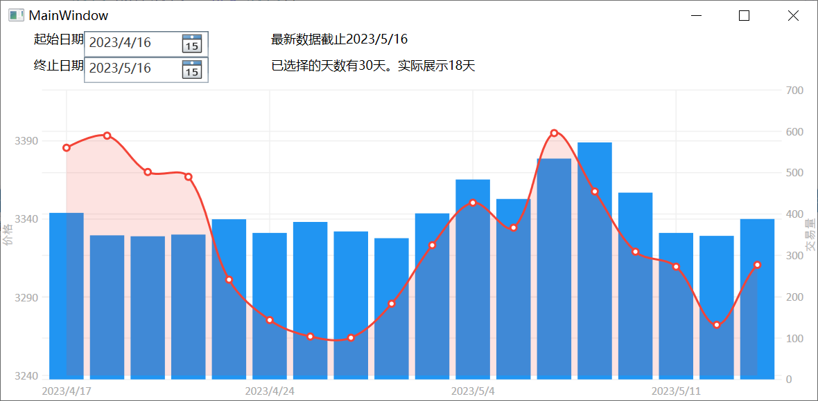
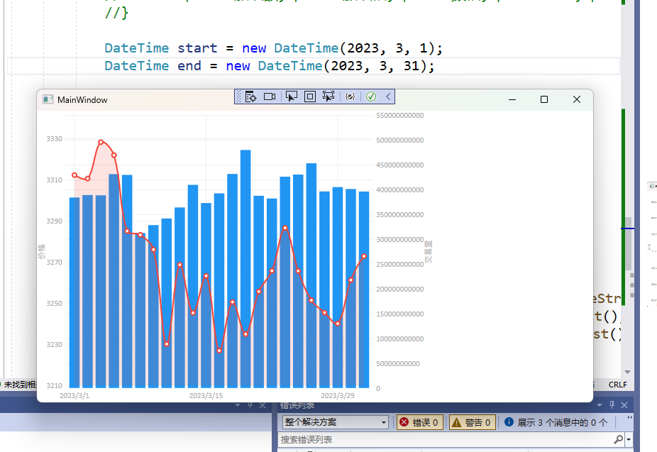
using LiveCharts.Wpf.Charts.Base;
using LiveCharts.Wpf;
using LiveCharts;
using System;
using System.Collections.Generic;
using System.IO;
using System.Linq;
using System.Text;
using System.Threading.Tasks;
using System.Windows;
using System.Windows.Controls;
using System.Windows.Data;
using System.Windows.Documents;
using System.Windows.Input;
using System.Windows.Media;
using System.Windows.Media.Imaging;
using System.Windows.Navigation;
using System.Windows.Shapes;

namespace _5_3 {
/// <summary>
/// MainWindow.xaml 的交互逻辑
/// </summary>

struct StockPrice {
public DateTime date;
public double 开盘价;
public double 最高价;
public double 最低价;
public double 收盘价;
public double 涨跌额;
public double 涨跌幅;
public double 振幅;
public double 总手;
public double 金额;
}

public partial class MainWindow : Window {
public MainWindow() {
InitializeComponent();
}

private void Grid_Loaded(object sender, RoutedEventArgs e) {

}

private void Window_Loaded(object sender, RoutedEventArgs e) {

List<StockPrice> prices = new List<StockPrice>();
using (StreamReader reader = new StreamReader(@"E:\Projects\Github\c-sharp\5-3\data.txt")) {
// 读取并忽略第一行
reader.ReadLine();
while (!reader.EndOfStream) {
string line = reader.ReadLine();
string[] fields = line.Split('\t');

//Console.WriteLine(fields[0]);
if (string.IsNullOrEmpty(fields[0])) {
break;
}
fields[0] = fields[0].Substring(0, 10);
//return;
DateTime date = DateTime.Parse(fields[0]);
double open = double.Parse(fields[1]);
double high = double.Parse(fields[2]);
double low = double.Parse(fields[3]);
double close = double.Parse(fields[4]);
double change = fields[5] == "--" ? 0 : double.Parse(fields[5]);
double changePercent = fields[6] == "--" ? 0 : double.Parse(fields[6]);
double amplitude = fields[7] == "--" ? 0 : double.Parse(fields[7]);
double volume = double.Parse(fields[8]);
double amount = double.Parse(fields[9]);

StockPrice price = new StockPrice {
date = date,
开盘价 = open,
最高价 = high,
最低价 = low,
收盘价 = close,
涨跌额 = change,
涨跌幅 = changePercent,
振幅 = amplitude,
总手 = volume,
金额 = amount
};
prices.Add(price);
}
}

//foreach (StockPrice price in prices) {
// Console.WriteLine("{0}\t{1}\t{2}\t{3}\t{4}\t{5}\t{6}\t{7}\t{8}\t{9}",
// price.date, price.开盘价, price.最高价, price.最低价, price.收盘价,
// price.涨跌额, price.涨跌幅, price.振幅, price.总手, price.金额);
//}

DateTime start = new DateTime(2023, 3, 1);
DateTime end = new DateTime(2023, 3, 31);

//List<StockPrice> prices = ... // 从文件中读取所有股票数据

// 查询指定时间段内的股票数据
var query = from p in prices
where p.date >= start && p.date <= end
select p;

// 将查询结果存储到列表中
List<StockPrice> results = query.ToList();

// 根据查询结果生成图表数据
List<string> values3 = results.Select(p => p.date.ToShortDateString()).ToList();
List<double> amountValues = results.Select(p => p.金额).ToList();
List<double> priceValues = results.Select(p => p.收盘价).ToList();

chart1.AxisX.Clear();
Axis dateAxis = new Axis();
dateAxis.Labels = values3;
chart1.AxisX.Add(dateAxis); //为X轴设置时间标签
chart1.Series.Clear();
ColumnSeries columnSeries = new ColumnSeries();//创建柱状图
columnSeries.Values = new ChartValues<double>(amountValues);
columnSeries.ScalesYAt = 1; //折线图数据依右侧Y轴
chart1.Series.Add(columnSeries);
LineSeries lineseries = new LineSeries();//创建拆线图
lineseries.Values = new ChartValues<double>(priceValues);
lineseries.ScalesYAt = 0;//折线图数据依左侧Y轴
chart1.Series.Add(lineseries);
}
}
}

<Window
xmlns="http://schemas.microsoft.com/winfx/2006/xaml/presentation"
xmlns:x="http://schemas.microsoft.com/winfx/2006/xaml"
xmlns:d="http://schemas.microsoft.com/expression/blend/2008"
xmlns:mc="http://schemas.openxmlformats.org/markup-compatibility/2006"
xmlns:local="clr-namespace:_5_3"
xmlns:Wpf="clr-namespace:LiveCharts.Wpf;assembly=LiveCharts.Wpf" x:Class="_5_3.MainWindow"
xmlns:lvc="clr-namespace:LiveCharts.Wpf;assembly=LiveCharts.Wpf"
mc:Ignorable="d"
Title="MainWindow" Height="450" Width="800" Loaded="Window_Loaded">
<Grid Loaded="Grid_Loaded">
<Grid.ColumnDefinitions>
<ColumnDefinition Width="57*"/>
<ColumnDefinition Width="23*"/>
</Grid.ColumnDefinitions>

<lvc:CartesianChart x:Name="chart1" >
<lvc:CartesianChart.AxisY>
<lvc:Axis Title="价格" />
<lvc:Axis Title="交易量" Position="RightTop" MinValue="0"/>
</lvc:CartesianChart.AxisY>
<lvc:CartesianChart.Series>
<lvc:LineSeries Values="1,2,3,4,5,6"/>
<lvc:LineSeries Values="2,4,6,8,10,12"/>
</lvc:CartesianChart.Series>
</lvc:CartesianChart>

</Grid>
</Window>

三、实验心得与体会
通过本次实验，我掌握了文件类的使用、文件流的操作、文本数据的读写、LINQ的用法以及WPF编程中图表的显示方法。这些技能对于开发实际应用非常有帮助。
在第一部分的实验中，我学会了如何读取文本文件中的数据，并将数据以Tuple的形式存入List中，并通过Dictionary对数据进行分组统计。这个实验让我更好地理解了文件流的操作和LINQ的用法。
在第二部分的实验中，我学会了如何使用LINQ技术查询Racer对象，并进行排序、投影和分组统计。这个实验让我更好地理解了LINQ的几种常用操作方法，并意识到LINQ的惰性查询特性。
在第三部分的实验中，我学会了如何使用LiveCharts.Wpf包来展示数据分析结果。通过这个实验，我对WPF编程和数据分析有了更深入的了解，并且学会了如何将LINQ查询结果与图表控件结合使用。

