浙 江 理 工 大 学

实
践
工
作
日
志

学 院：_____________ ____________________
年 级：
计算机科学与技术
2021
专 业：
姓 名：
陈昊天
学 号：
2021329600006
实践时间： 2024 年 5 月 21 日至 2024 年 5 月 23 日

实 践 工 作 日 志
2024年05月21日
今日完成实操1-Linux的第一个模块。
模块一 环境搭建
1 安装Hyper-V
在控制面板-程序-启用或关闭WIndows功能中启用Hyper-V
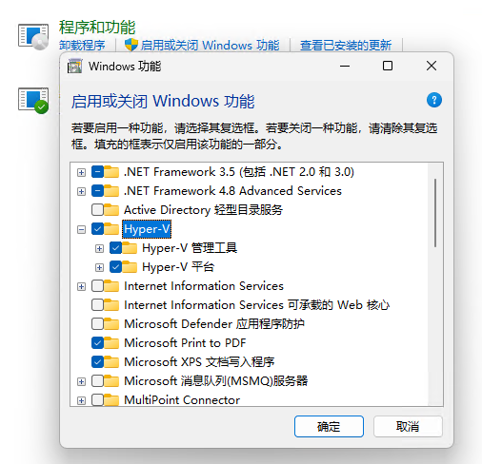
2 安装Debian 12
在 https://www.debian.org/download.zh-cn.html 下载Debian 12镜像，并创建虚拟机。
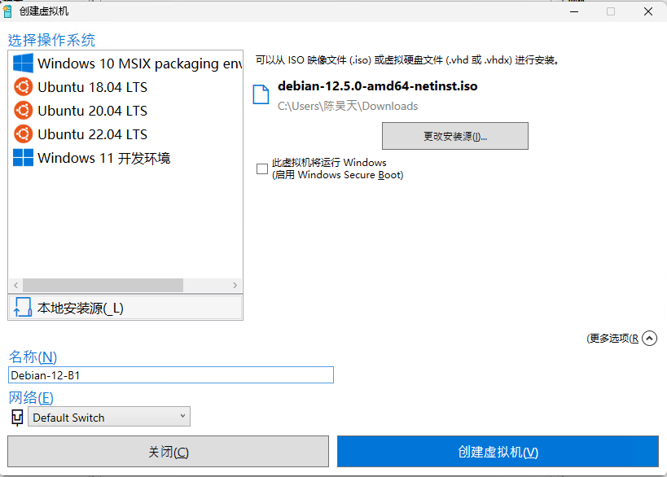
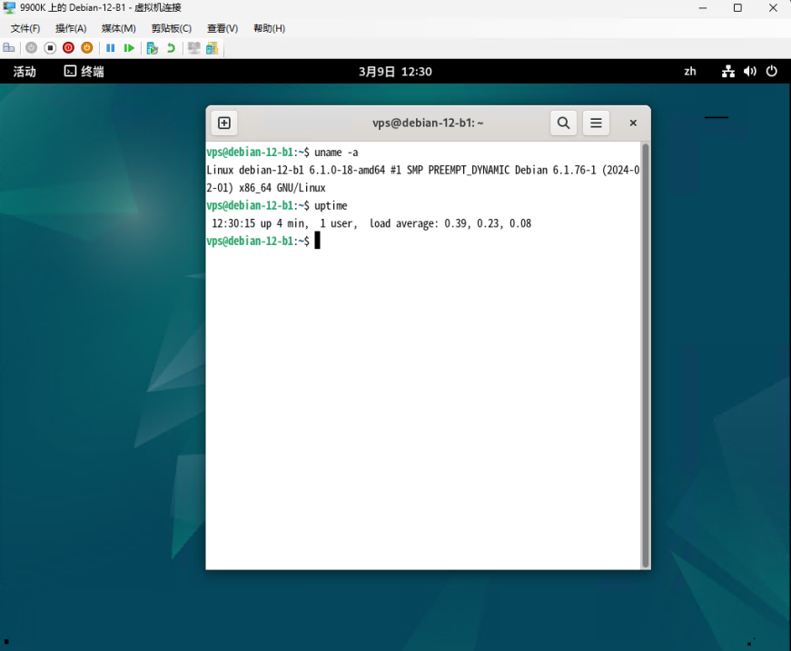

3 复制2台镜像机

导出虚拟机，然后再导入虚拟机

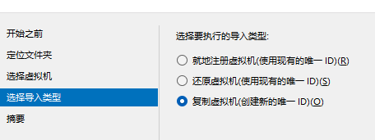
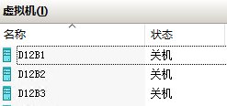

4 网络配置和系统管理操作 ，采用NAT模式，要求三台互相可ping通
新建内部虚拟交换机（NAT），分配到3台虚拟机
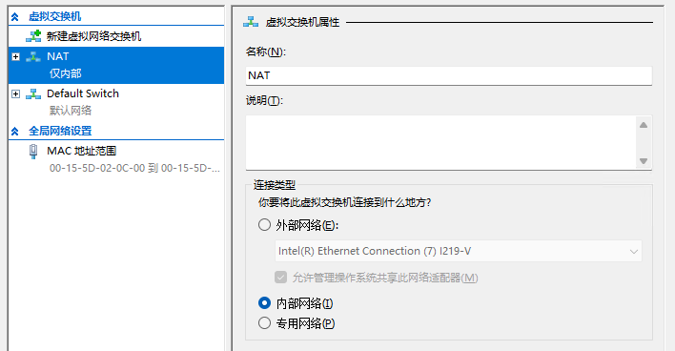
设置虚拟交换机，手动设置IP地址
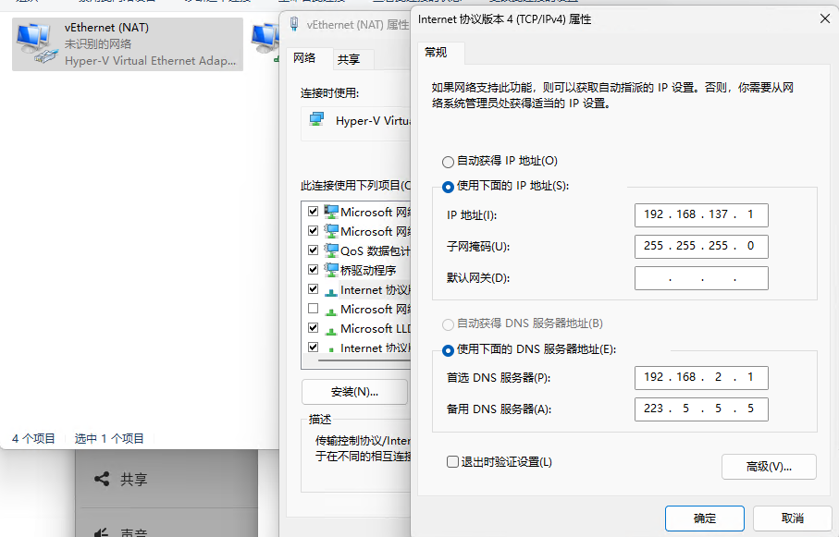
在3台虚拟机内分别手动设置IP地址为192.168.137.21，192.168.137.22，192.168.137.23
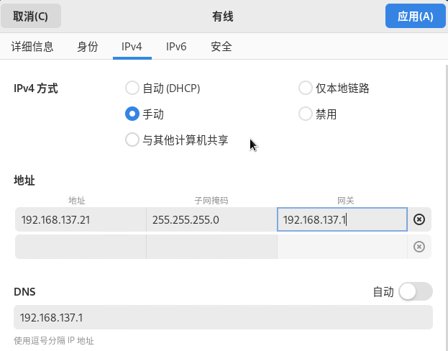
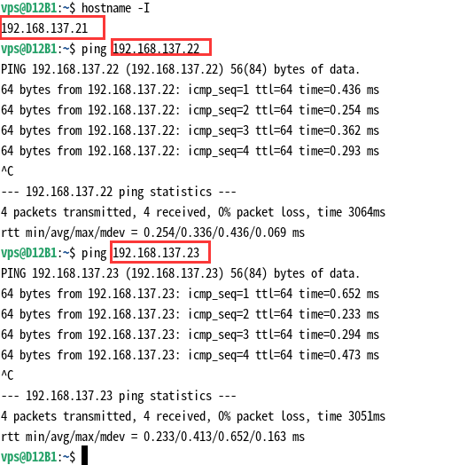

5 安装Termius远程登录

在虚拟机上安装openssh-server
apt update
apt install openssh-server
修改/etc/ssh/sshd_config，使允许root登录
修改 PermitRootLogin 属性为 yes，随后重启ssh
随后在Termius上填写虚拟机IP地址、root密码即可远程登陆

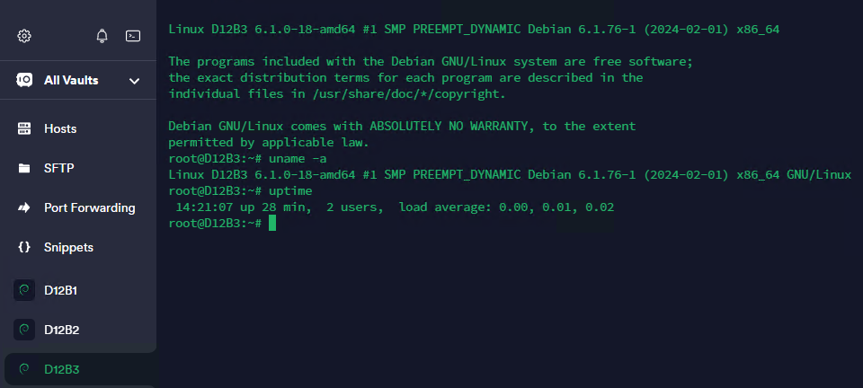

指导老师评语：

实 践 工 作 日 志
2024年05月22日
今日完成实操1-Linux的第二个模块的前半部分。
模块二 linux常用命令

功能 | 步骤 | 结果
分区格式化和挂载 | 使用lsblk列出所有可用的块设备 | root@D12B1:~# lsblk  NAME MAJ:MIN RM SIZE RO TYPE MOUNTPOINTS  sda 8:0 0 127G 0 disk  |-sda1 8:1 0 512M 0 part /boot/efi  |-sda2 8:2 0 125.5G 0 part /  `-sda3 8:3 0 976M 0 part [SWAP]  sdb 8:16 0 1G 0 disk
分区格式化和挂载 | 使用fdisk /dev/sdb创建分区 | root@D12B1:~# fdisk /dev/sdb  Welcome to fdisk (util-linux 2.38.1).  Changes will remain in memory only, until you decide to write them.  Be careful before using the write command.  Device does not contain a recognized partition table.  Created a new DOS (MBR) disklabel with disk identifier 0xec07a6c4.  Command (m for help): g  Created a new GPT disklabel (GUID: AA5EC750-BD2D-5A47-84BD-87304C4727C4).  Command (m for help): n  Partition number (1-128, default 1):  First sector (2048-2097118, default 2048):  Last sector, +/-sectors or +/-size{K,M,G,T,P} (2048-2097118, default 2095103):  Created a new partition 1 of type 'Linux filesystem' and of size 1022 MiB.  Command (m for help): w  The partition table has been altered.  Calling ioctl() to re-read partition table.  Syncing disks.
分区格式化和挂载 | 使用mkfs格式化分区 | root@D12B1:~# mkfs.ext4 /dev/sdb1  mke2fs 1.47.0 (5-Feb-2023)  Discarding device blocks: done  Creating filesystem with 261632 4k blocks and 65408 inodes  Filesystem UUID: 801282f5-1f3b-4022-8454-1dc589827c7c  Superblock backups stored on blocks:  32768, 98304, 163840, 229376  Allocating group tables: done  Writing inode tables: done  Creating journal (4096 blocks): done  Writing superblocks and filesystem accounting information: done
分区格式化和挂载 | 使用mount挂载分区 | root@D12B1:~# mkdir /mnt/mydisk  root@D12B1:~# mount /dev/sdb1 /mnt/mydisk  root@D12B1:~# df -h  Filesystem Size Used Avail Use% Mounted on  udev 919M 0 919M 0% /dev  tmpfs 191M 980K 190M 1% /run  /dev/sda2 124G 6.0G 111G 6% /  tmpfs 951M 0 951M 0% /dev/shm  tmpfs 5.0M 0 5.0M 0% /run/lock  /dev/sda1 511M 5.9M 506M 2% /boot/efi  tmpfs 191M 44K 190M 1% /run/user/0  tmpfs 191M 60K 190M 1% /run/user/113  /dev/sdb1 988M 24K 921M 1% /mnt/mydisk
进程线程类 | 使用ps aux | grep xxx 查看xxx相关进程 | root@D12B1:~# ps aux | grep gnome  Debian-+ 702 0.0 0.4 159644 8192 tty1 Ssl+ 14:37 0:00 /usr/libexec/gdm-wayland-session dbus-run-session -- gnome-session --autostart /usr/share/gdm/greeter/autostart  Debian-+ 708 0.0 0.0 6260 1492 tty1 S+ 14:37 0:00 dbus-run-session -- gnome-session --autostart /usr/share/gdm/greeter/autostart  Debian-+ 714 0.0 1.1 520956 22372 tty1 Sl+ 14:37 0:00 /usr/libexec/gnome-session-binary --autostart /usr/share/gdm/greeter/autostart  Debian-+ 747 0.2 12.4 5267812 242040 tty1 Sl+ 14:37 0:02 /usr/bin/gnome-shell  Debian-+ 877 0.0 1.4 2793204 29104 tty1 Sl+ 14:37 0:00 /usr/bin/gjs /usr/share/gnome-shell/org.gnome.Shell.Notifications  Debian-+ 880 0.0 0.4 164312 9444 tty1 Sl+ 14:37 0:00 /usr/libexec/at-spi2-registryd --use-gnome-session  Debian-+ 1101 0.0 1.6 2727652 31480 tty1 Sl+ 14:37 0:00 /usr/bin/gjs /usr/share/gnome-shell/org.gnome.ScreenSaver  root 1175 0.0 0.0 3324 1444 pts/0 S+ 14:56 0:00 grep gnome
进程线程类 | 使用pkill终止进程 | root@D12B1:~# tmux  [detached (from session 0)]  root@D12B1:~# ps aux | grep tmux  root 1181 0.0 0.2 9044 3924 ? Ss 14:58 0:00 tmux  root 1189 0.0 0.0 3324 1408 pts/0 S+ 14:59 0:00 grep tmux  root@D12B1:~# pkill tmux  root@D12B1:~# ps aux | grep tmux  root 1195 0.0 0.0 3324 1488 pts/0 S+ 14:59 0:00 grep tmux
进程线程类 | 使用lsof -i:端口号 查看端口占用情况 | root@D12B1:~# lsof -i:22  COMMAND PID USER FD TYPE DEVICE SIZE/OFF NODE NAME  sshd 612 root 3u IPv4 19913 0t0 TCP *:ssh (LISTEN)  sshd 612 root 4u IPv6 19915 0t0 TCP *:ssh (LISTEN)  sshd 648 root 4u IPv4 15136 0t0 TCP D12B1:ssh->9900K:62018 (ESTABLISHED)
目录和文件操作 | pwd 显示当前工作目录的绝对路径 | root@D12B1:~# pwd  /root
目录和文件操作 | ls 列出目录的内容 | root@D12B1:/# ls -a  . bin etc initrd.img.old lost+found opt run sys var  .. boot home lib media proc sbin tmp vmlinuz  .cache dev initrd.img lib64 mnt root srv usr vmlinuz.old  root@D12B1:/#
目录和文件操作 | cd 切换目录 | root@D12B1:/# cd /etc  root@D12B1:/etc#
目录和文件操作 | mkdir 创建一个新的目录 | root@D12B1:~# mkdir test  root@D12B1:~# ls  test  root@D12B1:~#
目录和文件操作 | rmdir 删除一个空的目录 | root@D12B1:~# rmdir test  root@D12B1:~# ls  root@D12B1:~#
目录和文件操作 | touch 创建空文件 | root@D12B1:~# touch 1.txt  root@D12B1:~# ls  1.txt  root@D12B1:~#
目录和文件操作 | cp 复制文件或目录 | root@D12B1:~# cp 1.txt 2.txt  root@D12B1:~# ls  1.txt 2.txt
目录和文件操作 | rm 移除文件或目录 | root@D12B1:~# rm 1.txt  root@D12B1:~# ls  2.txt
目录和文件操作 | mv 移动文件与目录或重命名 | root@D12B1:~# mv 2.txt 3.txt  root@D12B1:~# ls  3.txt  root@D12B1:~#
目录和文件操作 | cat 查看文件内容 | root@D12B1:~# echo 123 >> 3.txt  root@D12B1:~# cat 3.txt  123
目录和文件操作 | more 文件内容分屏查看器 | root@D12B1:~# more 3.txt
目录和文件操作 | less 分屏显示文件内容 | root@D12B1:~# less 3.txt
目录和文件操作 | echo输出内容到控制台 | root@D12B1:~# echo 123  123
目录和文件操作 | head 显示文件头部内容 | root@D12B1:~# head 3.txt  123
目录和文件操作 | tail 输出文件尾部内容 | root@D12B1:~# tail 3.txt  123
目录和文件操作 | > 输出重定向和 >> 追加 | root@D12B1:~# echo 123456 > 3.txt  root@D12B1:~# cat 3.txt  123456  root@D12B1:~# echo 666 >> 3.txt  root@D12B1:~# cat 3.txt  123456  666  root@D1
目录和文件操作 | ln 软链接 | root@D12B1:~# ln -s 3.txt 4.txt  root@D12B1:~# ls  3.txt 4.txt  root@D12B1:~# cat 4.txt  123456  666  root@D12B1:~#
目录和文件操作 | history 查看已经执行过历史命令 | root@D12B1:~# history  1 cd  2 apt install openssh-server  3 vim /etc/ssh/sshd_config  4 apt install vim  5 vim /etc/ssh/sshd_config  6 systemctl restart ssh  7 uname -a  8 uptime  9 tmux  10 apt install tmux  11 tmux
时间日期类 | date 显示当前时间 | root@D12B1:~# date  Sat Mar 9 15:33:34 CST 2024
时间日期类 | ncal 查看日历 | root@D12B1:~# ncal  March 2024  Su 3 10 17 24 31  Mo 4 11 18 25  Tu 5 12 19 26  We 6 13 20 27  Th 7 14 21 28  Fr 1 8 15 22 29  Sa 2 9 16 23 30
用户管理命令 | useradd 添加新用户 | root@D12B1:~# useradd test
用户管理命令 | passwd 设置用户密码 | root@D12B1:~# passwd test  New password:  Retype new password:  passwd: password updated successfully
用户管理命令 | id 查看用户是否存在 | root@D12B1:~# id test  uid=1001(test) gid=1001(test) groups=1001(test)
用户管理命令 | cat /etc/passwd 查看创建了哪些用户 | root@D12B1:~# cat /etc/passwd  root:x:0:0:root:/root:/bin/bash  daemon:x:1:1:daemon:/usr/sbin:/usr/sbin/nologin  bin:x:2:2:bin:/bin:/usr/sbin/nologin  sys:x:3:3:sys:/dev:/usr/sbin/nologin  sync:x:4:65534:sync:/bin:/bin/sync  games:x:5:60:games:/usr/games:/usr/sbin/nologin  man:x:6:12:man:/var/cache/man:/usr/sbin/nologin  lp:x:7:7:lp:/var/spool/lpd:/usr/sbin/nologin  mail:x:8:8:mail:/var/mail:/usr/sbin/nologin  news:x:9:9:news:/var/spool/news:/usr/sbin/nologin  uucp:x:10:10:uucp:/var/spool/uucp:/usr/sbin/nologin  proxy:x:13:13:proxy:/bin:/usr/sbin/nologin  www-data:x:33:33:www-data:/var/www:/usr/sbin/nologin  backup:x:34:34:backup:/var/backups:/usr/sbin/nologin  list:x:38:38:Mailing List Manager:/var/list:/usr/sbin/nologin  irc:x:39:39:ircd:/run/ircd:/usr/sbin/nologin  _apt:x:42:65534::/nonexistent:/usr/sbin/nologin  nobody:x:65534:65534:nobody:/nonexistent:/usr/sbin/nologin  systemd-network:x:998:998:systemd Network Management:/:/usr/sbin/nologin  tss:x:100:107:TPM software stack,,,:/var/lib/tpm:/bin/false  systemd-timesync:x:997:997:systemd Time Synchronization:/:/usr/sbin/nologin  messagebus:x:101:108::/nonexistent:/usr/sbin/nologin  usbmux:x:102:46:usbmux daemon,,,:/var/lib/usbmux:/usr/sbin/nologin  sshd:x:103:65534::/run/sshd:/usr/sbin/nologin  dnsmasq:x:104:65534:dnsmasq,,,:/var/lib/misc:/usr/sbin/nologin  avahi:x:105:112:Avahi mDNS daemon,,,:/run/avahi-daemon:/usr/sbin/nologin  speech-dispatcher:x:106:29:Speech Dispatcher,,,:/run/speech-dispatcher:/bin/false  fwupd-refresh:x:107:115:fwupd-refresh user,,,:/run/systemd:/usr/sbin/nologin  saned:x:108:117::/var/lib/saned:/usr/sbin/nologin  geoclue:x:109:118::/var/lib/geoclue:/usr/sbin/nologin  polkitd:x:996:996:polkit:/nonexistent:/usr/sbin/nologin  rtkit:x:110:119:RealtimeKit,,,:/proc:/usr/sbin/nologin  colord:x:111:120:colord colour management daemon,,,:/var/lib/colord:/usr/sbin/nologin  gnome-initial-setup:x:112:65534::/run/gnome-initial-setup/:/bin/false  Debian-gdm:x:113:121:Gnome Display Manager:/var/lib/gdm3:/bin/false  vps:x:1000:1000:vps,,,:/home/vps:/bin/bash  test:x:1001:1001::/home/test:/bin/sh
用户管理命令 | su 切换用户 | root@D12B1:~# su test  $
用户管理命令 | userdel 删除用户 | root@D12B1:~# userdel test
用户管理命令 | who 查看登录用户信息 | root@D12B1:~# who am i  root pts/0 Mar 9 14:37 (192.168.2.12)  root@D12B1:~# whoami  root
用户管理命令 | sudo 设置普通用户具有root权限 | root@D12B1:~# useradd bigdata  root@D12B1:~# passwd bigdata  New password:  Retype new password:  passwd: password updated successfully  root@D12B1:~# vi /etc/sudoers  root@D12B1:~# su bigdata  $ pwd  /root  $ sudo touch 1.txt  $
用户管理命令 | usermod 修改用户（modify） | root@D12B1:~# useradd test  root@D12B1:~# usermod -g root test

指导老师评语：

实 践 工 作 日 志
2024年05月23日
今日完成实操1-Linux的第二个模块的后半部分。

用户组管理命令 | groupadd 新增组 | root@D12B1:~# groupadd testgroup
用户组管理命令 | groupdel 删除组 | root@D12B1:~# groupdel testgroup
用户组管理命令 | groupmod 修改组 | root@D12B1:~# groupmod -n ttt testgroup
用户组管理命令 | cat /etc/group 查看创建了哪些组 | root@D12B1:~# cat /etc/group  root:x:0:  daemon:x:1:  bin:x:2:  sys:x:3:  adm:x:4:  tty:x:5:  disk:x:6:  lp:x:7:  mail:x:8:  news:x:9:  uucp:x:10:  man:x:12:  proxy:x:13:  kmem:x:15:  dialout:x:20:  fax:x:21:  voice:x:22:  cdrom:x:24:vps  floppy:x:25:vps  tape:x:26:  sudo:x:27:  audio:x:29:vps  dip:x:30:vps  www-data:x:33:  backup:x:34:  operator:x:37:  list:x:38:  irc:x:39:  src:x:40:  shadow:x:42:  utmp:x:43:  video:x:44:vps  sasl:x:45:  plugdev:x:46:vps  staff:x:50:  games:x:60:  users:x:100:vps  nogroup:x:65534:  systemd-journal:x:999:  systemd-network:x:998:  crontab:x:101:  input:x:102:  sgx:x:103:  kvm:x:104:  render:x:105:  netdev:x:106:vps  tss:x:107:  systemd-timesync:x:997:  messagebus:x:108:  _ssh:x:109:  ssl-cert:x:110:  bluetooth:x:111:vps  avahi:x:112:  lpadmin:x:113:vps  pipewire:x:114:  fwupd-refresh:x:115:  scanner:x:116:saned,vps  saned:x:117:  geoclue:x:118:  polkitd:x:996:  rtkit:x:119:  colord:x:120:  Debian-gdm:x:121:  vps:x:1000:  gnome-initial-setup:x:995:  bigdata:x:1001:  test:x:1002:  ttt:x:1003:
文件权限类 | 文件属性 | root@D12B1:~# ls -l  total 4  -rw-r--r-- 1 root root 0 Mar 9 15:45 1.txt  -rw-r--r-- 1 root root 11 Mar 9 15:31 3.txt  lrwxrwxrwx 1 root root 5 Mar 9 15:32 4.txt -> 3.txt
文件权限类 | chmod 改变权限 | root@D12B1:~# chmod 777 1.txt  root@D12B1:~# ls -l  total 4  -rwxrwxrwx 1 root root 0 Mar 9 15:45 1.txt  -rw-r--r-- 1 root root 11 Mar 9 15:31 3.txt  lrwxrwxrwx 1 root root 5 Mar 9 15:32 4.txt -> 3.txt
文件权限类 | chown 改变所有者（属主） | root@D12B1:~# chown bigdata 1.txt  root@D12B1:~# ls -l  total 4  -rwxrwxrwx 1 bigdata root 0 Mar 9 15:45 1.txt  -rw-r--r-- 1 root root 11 Mar 9 15:31 3.txt  lrwxrwxrwx 1 root root 5 Mar 9 15:32 4.txt -> 3.txt
文件权限类 | chgrp 改变所属组 | root@D12B1:~# chgrp root 1.txt  root@D12B1:~# ls -l  total 4  -rwxrwxrwx 1 bigdata root 0 Mar 9 15:45 1.txt  -rw-r--r-- 1 root root 11 Mar 9 15:31 3.txt  lrwxrwxrwx 1 root root 5 Mar 9 15:32 4.txt -> 3.txt
搜索查找类 | find 查找文件或者目录 | root@D12B1:~# find ./ -name 1.txt  ./1.txt
搜索查找类 | locate快速定位文件路径 | root@D12B1:~# updatedb  /usr/bin/find: '/run/user/113/gvfs': Permission denied  root@D12B1:~# locate 1.txt  /home/vps/.mozilla/firefox/y1a0d2u1.default-esr/pkcs11.txt  /root/1.txt  /usr/share/doc/debian/constitution.1.1.txt.gz  /usr/share/doc/debian/social-contract.1.1.txt.gz  /usr/share/doc/kbd/charsets/iso8859-1.txt.gz  /usr/share/doc/kbd/charsets/iso8859-11.txt.gz  /usr/share/doc/libsane-common/teco/teco1.txt.gz  /usr/share/vim/vim90/doc/ft_ps1.txt  /usr/share/vim/vim90/doc/gui_x11.txt  /usr/share/vim/vim90/doc/usr_01.txt  /usr/share/vim/vim90/doc/usr_11.txt  /usr/share/vim/vim90/doc/usr_21.txt  /usr/share/vim/vim90/doc/usr_31.txt  /usr/share/vim/vim90/doc/usr_41.txt  /usr/share/vim/vim90/doc/usr_51.txt
搜索查找类 | grep过滤查找及“|”管道符 | root@D12B1:~# ls | grep -n 1.txt  1:1.txt  root@D12B1:~#
压缩和解压类 | gzip/gunzip 压缩 | root@D12B1:~# gzip 1.txt  root@D12B1:~# ls  1.txt.gz 3.txt 4.txt  root@D12B1:~# gunzip 1.txt.gz  root@D12B1:~# ls  1.txt 3.txt 4.txt
压缩和解压类 | zip/unzip 压缩 | root@D12B1:~# rm -rf ./*  root@D12B1:~# touch 1.txt  root@D12B1:~# touch 2.txt  root@D12B1:~# zip 3.zip 1.txt 2.txt  adding: 1.txt (stored 0%)  adding: 2.txt (stored 0%)  root@D12B1:~# ls  1.txt 2.txt 3.zip  root@D12B1:~# unzip 3.zip  Archive: 3.zip  replace 1.txt? [y]es, [n]o, [A]ll, [N]one, [r]ename: A  extracting: 1.txt  extracting: 2.txt  root@D12B1:~#
压缩和解压类 | tar 打包 | root@D12B1:~# tar -zcvf all.tar.gz ./*  ./1.txt  ./2.txt  ./3.zip  root@D12B1:~# ls  1.txt 2.txt 3.zip all.tar.gz  root@D12B1:~# rm 1.txt 2.txt 3.zip  root@D12B1:~# tar -zxvf all.tar.gz  ./1.txt  ./2.txt  ./3.zip  root@D12B1:~# ls  1.txt 2.txt 3.zip all.tar.gz  root@D12B1:~#
系统定时任务 | crond 服务管理 | root@D12B1:~# service cron restart
系统定时任务 | crontab 定时任务设置 | root@D12B1:~# crontab -e  no crontab for root - using an empty one  Select an editor. To change later, run 'select-editor'.  1. /bin/nano <---- easiest  2. /usr/bin/vim.basic  3. /usr/bin/vim.tiny  Choose 1-3 [1]: 2  crontab: installing new crontab
apt软件包管理 | apt update更新软件包列表 | root@D12B1:~# apt update  Hit:1 http://mirrors.ustc.edu.cn/debian bookworm InRelease  Hit:2 http://mirrors.ustc.edu.cn/debian bookworm-updates InRelease  Hit:3 http://security.debian.org/debian-security bookworm-security InRelease  Reading package lists... Done  Building dependency tree... Done  Reading state information... Done  All packages are up to date.
apt软件包管理 | apt upgrade升级软件包 | root@D12B1:~# apt upgrade  Reading package lists... Done  Building dependency tree... Done  Reading state information... Done  Calculating upgrade... Done  0 upgraded, 0 newly installed, 0 to remove and 0 not upgraded.
apt软件包管理 | apt install安装新的软件包 | root@D12B1:~# apt install nginx  Reading package lists... Done  Building dependency tree... Done  Reading state information... Done  The following additional packages will be installed:  nginx-common  Suggested packages:  fcgiwrap nginx-doc  The following NEW packages will be installed:  nginx nginx-common  0 upgraded, 2 newly installed, 0 to remove and 0 not upgraded.  Need to get 640 kB of archives.  After this operation, 1696 kB of additional disk space will be used.  Do you want to continue? [Y/n]  Get:1 http://mirrors.ustc.edu.cn/debian bookworm/main amd64 nginx-common all 1.22.1-9 [112 kB]  Get:2 http://mirrors.ustc.edu.cn/debian bookworm/main amd64 nginx amd64 1.22.1-9 [527 kB]  Fetched 640 kB in 0s (4555 kB/s)  Preconfiguring packages ...  Selecting previously unselected package nginx-common.  (Reading database ... 157709 files and directories currently installed.)  Preparing to unpack .../nginx-common_1.22.1-9_all.deb ...  Unpacking nginx-common (1.22.1-9) ...  Selecting previously unselected package nginx.  Preparing to unpack .../nginx_1.22.1-9_amd64.deb ...  Unpacking nginx (1.22.1-9) ...  Setting up nginx-common (1.22.1-9) ...  Created symlink /etc/systemd/system/multi-user.target.wants/nginx.service -> /lib/systemd/system/nginx.service.  Setting up nginx (1.22.1-9) ...  Upgrading binary: nginx.  Processing triggers for man-db (2.11.2-2) ...  root@D12B1:~#
apt软件包管理 | apt remove卸载软件包 | root@D12B1:~# apt remove nginx  Reading package lists... Done  Building dependency tree... Done  Reading state information... Done  The following package was automatically installed and is no longer required:  nginx-common  Use 'apt autoremove' to remove it.  The following packages will be REMOVED:  nginx  0 upgraded, 0 newly installed, 1 to remove and 0 not upgraded.  After this operation, 1362 kB disk space will be freed.  Do you want to continue? [Y/n]  (Reading database ... 157759 files and directories currently installed.)  Removing nginx (1.22.1-9) ...  Processing triggers for man-db (2.11.2-2) ...  root@D12B1:~#
apt软件包管理 | apt purge完全卸载软件包 | root@D12B1:~# apt purge nginx  Reading package lists... Done  Building dependency tree... Done  Reading state information... Done  Package 'nginx' is not installed, so not removed  The following package was automatically installed and is no longer required:  nginx-common  Use 'apt autoremove' to remove it.  0 upgraded, 0 newly installed, 0 to remove and 0 not upgraded.
apt软件包管理 | apt autoremove自动删除不再需要的软件包 | root@D12B1:~# apt autoremove  Reading package lists... Done  Building dependency tree... Done  Reading state information... Done  The following packages will be REMOVED:  nginx-common  0 upgraded, 0 newly installed, 1 to remove and 0 not upgraded.  After this operation, 334 kB disk space will be freed.  Do you want to continue? [Y/n]  (Reading database ... 157753 files and directories currently installed.)  Removing nginx-common (1.22.1-9) ...  root@D12B1:~#
Shell编程 | helloworld | root@D12B1:~# touch helloworld.sh  root@D12B1:~# vim helloworld.sh  root@D12B1:~# chmod +x helloworld.sh  root@D12B1:~# ./helloworld.sh  Hello, world!
Shell编程 | 位置参数变量 | #!/bin/bash  greeting="Hello"  echo $greeting  echo "Positional Parameters:"  echo "1st: $1"  echo "2nd: $2"  echo "3rd: $3"  echo "All positional parameters: $*"  echo "Number of positional parameters: $#"
Shell编程 | 运算符 | root@D12B1:~# S=$[(2+3)*4]  root@D12B1:~# echo $S  20
Shell编程 | 判断语句 | root@D12B1:~# ls  1.sh 1.txt 2.txt 3.zip all.tar.gz helloworld.sh  root@D12B1:~# [ 1.txt ] && echo true  true
Shell编程 | 流程控制 | #!/bin/bash  if [ $1 -eq "123" ]  then  echo "123"  elif [ $1 -eq "456" ]  then  echo "456"  else  echo "789"  fi
Shell编程 | case 语句 | #!/bin/bash  case $1 in  "1")  echo "1"  ;;  "2")  echo "2"  ;;  *)  echo "other"  ;;  esac
Shell编程 | for 循环 | #!/bin/bash  for i in "$*"  do  echo "The num is $i "  done  for j in "$@"  do  echo "The num is $j"  done
Shell编程 | while 循环 | #!/bin/bash  s=0  i=1  while [ $i -le 100 ]  do  s=$[$s+$i]  i=$[$i+1]  done  echo $s
Shell编程 | read读取控制台输入 | #!/bin/bash  read -t 7 -p "please 7 miao input your name " NAME  echo $NAME
Shell编程 | 系统函数 | root@D12B1:~# basename /root/1.txt  1.txt
Shell编程 | 自定义函数 | #!/bin/bash  function sum()  {  s=0  s=$[ $1 + $2 ]  echo "$s"  }  read -p "Please input the number1: " n1;  read -p "Please input the number2: " n2;  sum $n1 $n2;

指导老师评语：

