The exercises of Chapter Two
2.1 Write regular expression for the following character sets, or give reasons why no regular expression can be written:

a. All strings of lowercase letters that begin and end in a.
解答：所有以小写字母开头和结尾的字符串，即
^ [a-z].*[a-z]$

c. All strings of digits that contain no leading zeros
解答：所有不包含前导零的数字字符串，即
[1-9][0-9]*

e. All strings of digits such that all the 2’s occur before all the 9’s
解答：所有数字字符串，其中所有的 2 都出现在所有的 9 之前，即
^(?!.*9.*2)[0-9]*$

g. All strings of a’s and b’s that contain an odd number of a’s or an odd number of b’s(or both)
解答：所有包含奇数个a或奇数个b（或两者都有）的由a和b组成的字符串。
这个问题无法通过单个正则表达式解决，因为正则表达式没有直接的方式来计数并检查奇偶性。我们需要两个正则表达式来分别匹配包含奇数个a或奇数个b的字符串，然后通过逻辑或（|）将它们结合起来。但是，即使这样，我们也不能同时检查a和b的奇偶性。因此，对于这个问题，我们无法写出单个正则表达式。
i. All strings of a’s and b’s that contain exactly as many a’s as b’s
解答：所有包含相同数量 a 和 b 的字符串，由 a 和 b 组成，即
^(?:(a(b|$))|(b(a|$)))*$

2.2 Write English descriptions for the languages generated by the following regular expressions:

a. (a|b)*a(a|b|ε)

The language consists of strings that start with any number of occurrences of either 'a' or 'b', followed by at least one 'a', and ending with any number of occurrences of either 'a', 'b', or the empty string (i.e., the string can end with zero, one, or multiple occurrences of 'a' or 'b').

c. (aa|b)*(a|bb)*

The language consists of strings that start with any number of occurrences of either 'aa' or 'b', followed by any number of occurrences of either 'a' or 'bb'.

2.12 a. Use Thompson’s construction to convert the regular expression (a|b)*a(a|b|ε) into an NFA.
b. Convert the NFA of part (a) into a DFA using the subset construction.
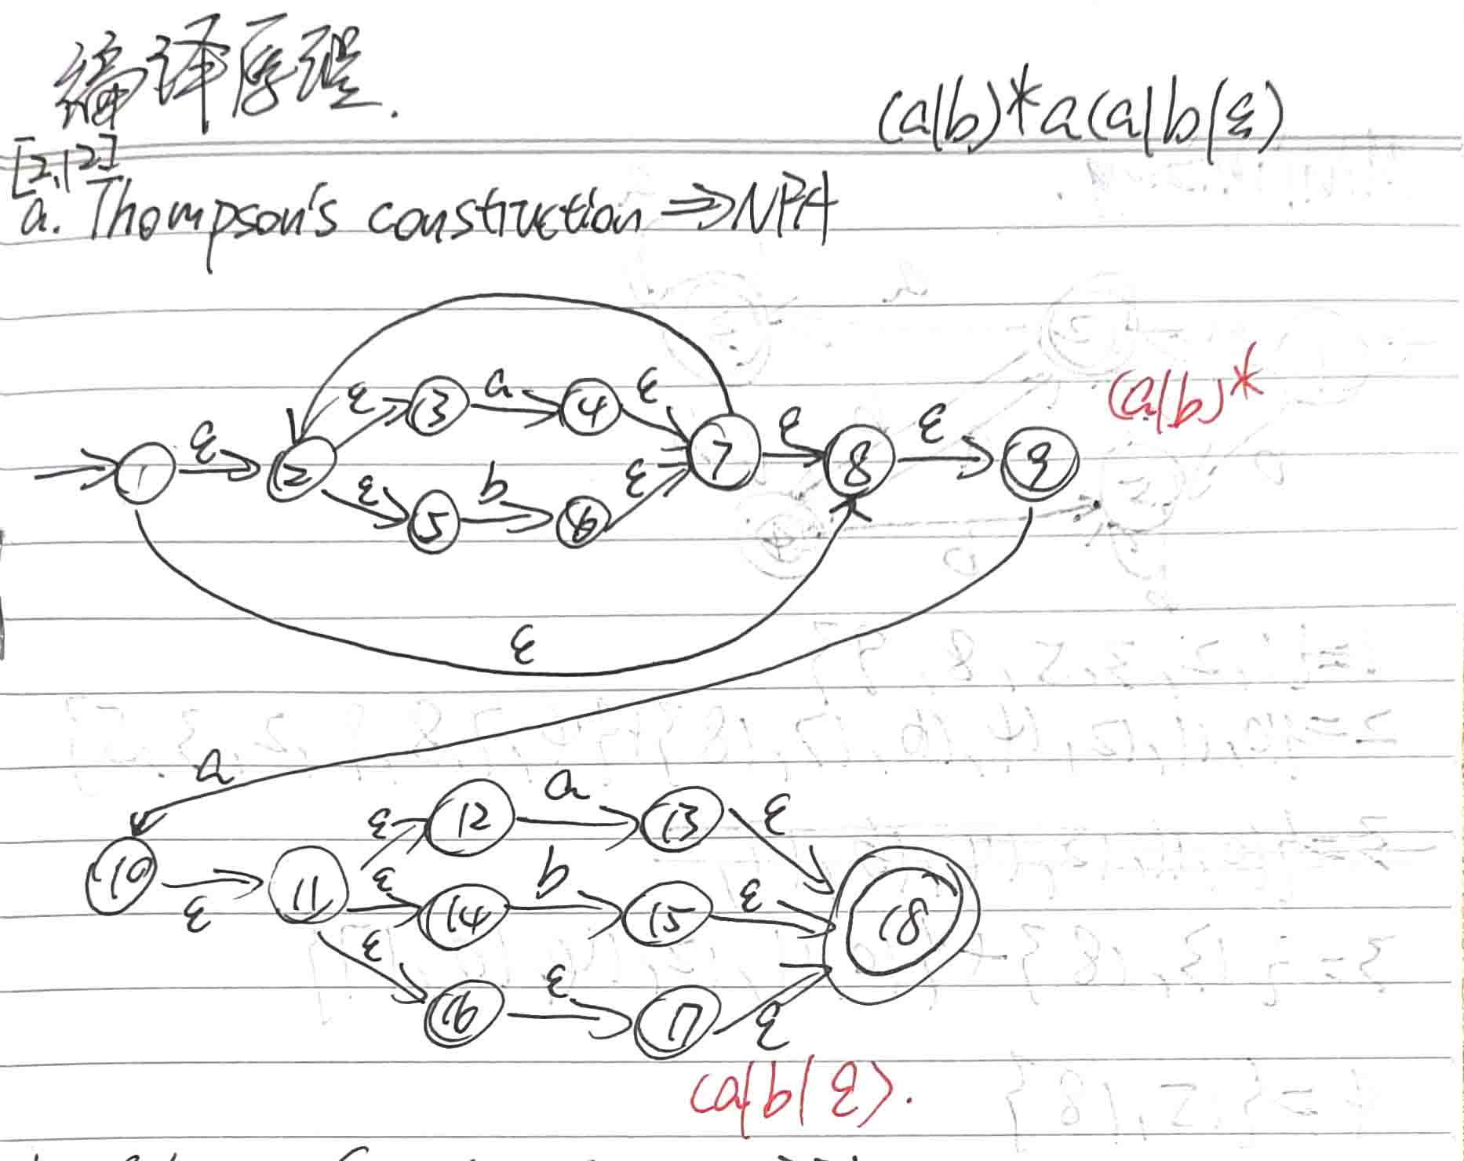

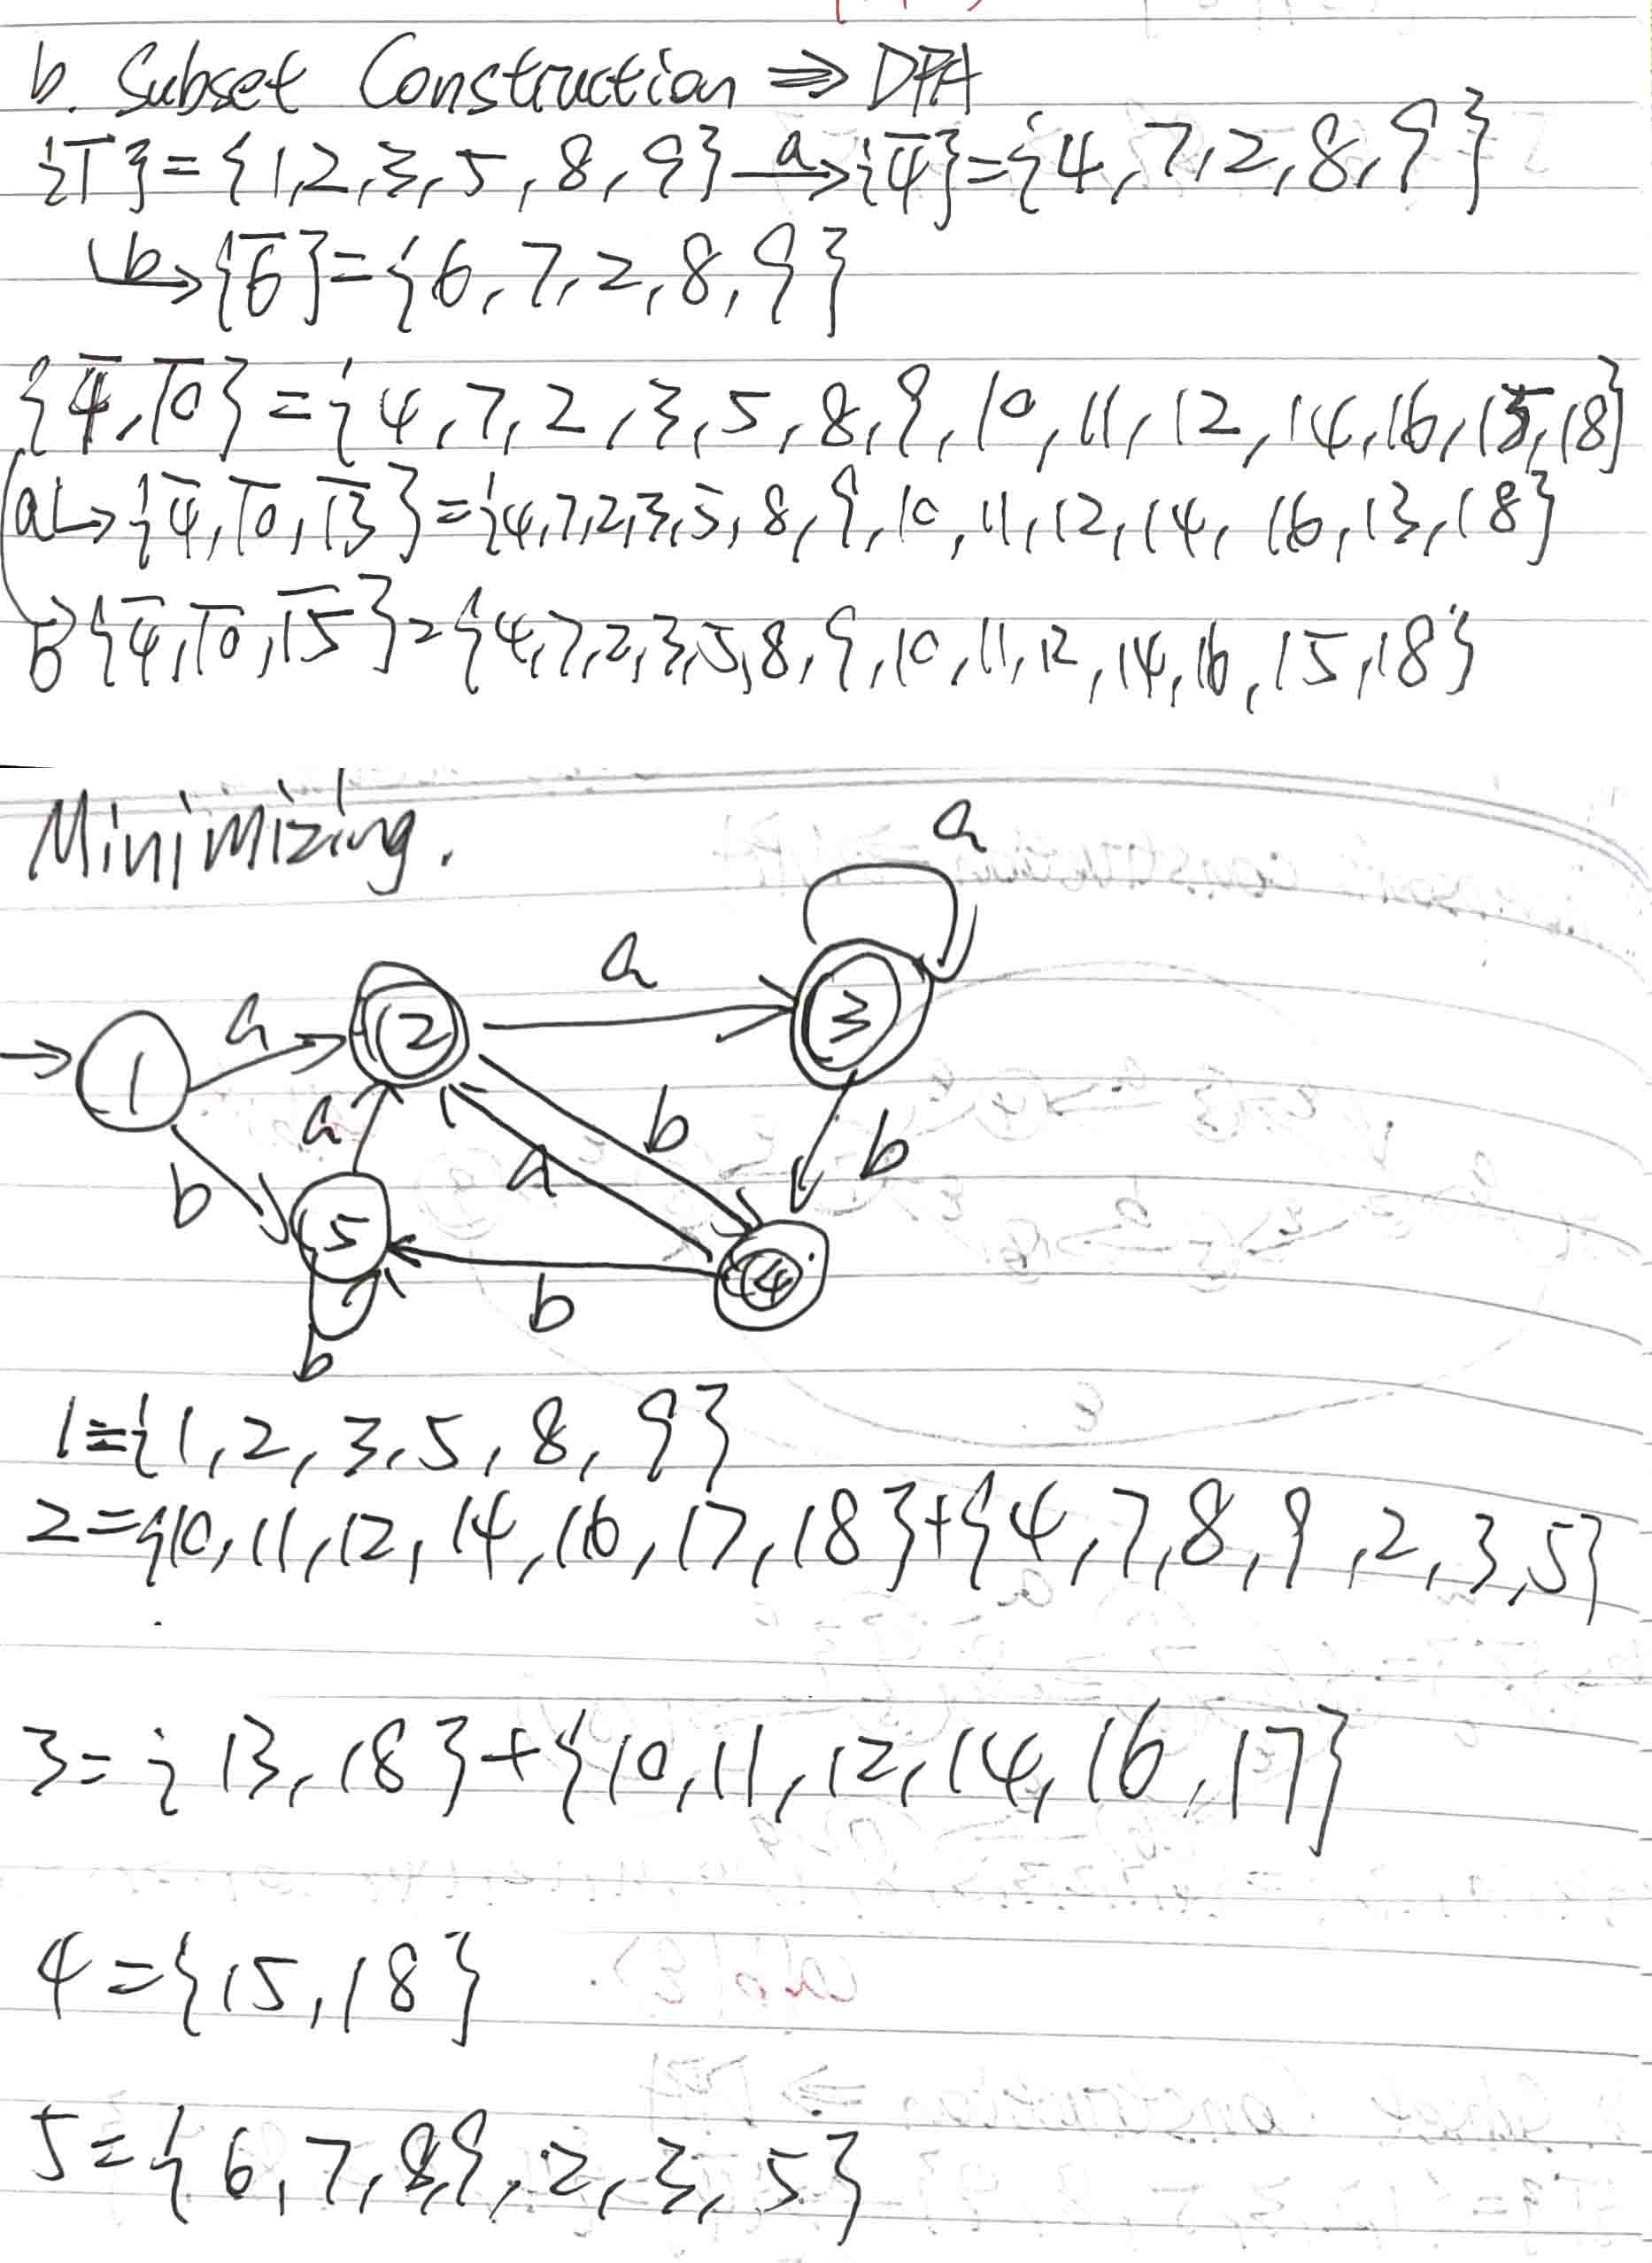
2.16 Apply the state minimization algorithm of section 2.4.4 to the following DFAs:
c
c
1
2
4
3
5
a
b

(a)

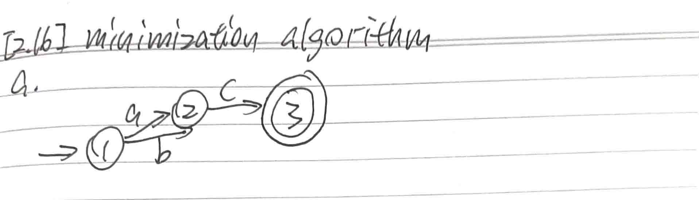

(b)
c
c
1
2
4
3
5
a
b

