浙江理工大学2022—2023学年第 1 学期
《操作系统（全英文）》期末试卷（ B ）卷标准答案和评分标准

一、选择题（每题2分，共30分）
1、 D | 2、 A | 3、 B | 4、 D | 5、 D
6、 D | 7、 A | 8、 A | 9、 B | 10、D
11、B | 12、C | 13、D | 14、C | 15、D

二．填空题（每空1分，共20分）
第1题：_Hierarchical__，___Hashed___，_____Inverted page table 。
第2题：_____basic file system__________，____logical file system____________。
第3题：______49_______，___685__________。
第4题：__interprocess communication ，_shared memory，_message passing 。
第5题： clock ，___stack__________。
第6题： microkernel 。
第7题： read write ， write execute 。
第8题： Long-term scheduler ， Short-term scheduler 。
第9题： Virtual memory 。第10题： 20 ， 23 。
评分标准说明： 每空1分，所有小题错则扣全分。

三 、名词解释（每题2分，共10分）
1. System calls provide an interface to the services made available by an operating system, it is the programmatic way in which a computer program requests a service from the kernel of the operating system it is executed on (1 point). This may include hardware-related services creation and execution of new processes, and communication with integral kernel services such as process scheduling (1 point).

2. When each process in a group of processes waits indefinitely for the resources that are occupied and never released by another process in the process, the system is in a deadlock state, referred as deadlock (2 points).

3. As processes are loaded and removed from memory, the free memory space is broken into little pieces. Total memory space exists to satisfy a request, but it is not contiguous, the storage is fragmented into a large number of small holes (2 points).

4. Program is passive entity stored on disk (executable file). Process is active entity with a program counter specifying the next instruction to execute and a set of associated resources (2 points).

5. A semaphore is an integer variable or an abstract data type used to control access to critical section for a process, or a common resource by multiple processes in a concurrent system such as a multitasking operating system. This variable is used to solve critical section problems and to achieve process synchronization in the multitasking environment (2 points).

四、简答题 (共20分)
1. The value of time slice is related to the efficiency of computer system and user satisfaction, so the value of time slice should be determined according to the response time and the number of processes entering the system required by the process. If the system is required to respond quickly, the time slice is smaller, which reduces the turnaround time and allows the process to respond as quickly as possible. If the number of processes is small, the time slice can be larger, which can reduce the times of process scheduling and improve the efficiency of the system. However, it should be noted that when the time slice value is too large, the algorithm degenerates into a first-come-first-served algorithm. Time slice value is too small, increasing system overhead. (4 points)

2. TLB is associative high-speed memory, typically small (64 to 1,024 entries). Each entry in the TLB consists of two parts: a key (or tag) and a value. The TLB contains only a few of the page-table entries. When a logical address is generated by the CPU, its page number is presented to the TLB. If the page number is found, its frame number is immediately available and is used to access memory. If the page number is not in the TLB (TLB miss), a memory reference to the page table must be made. Add the page number and frame number to the TLB for faster access next time. (3 points)

3. (1) (1) We check an internal table (usually kept with the process control block) for this process to determine whether the reference was a valid or an invalid memory access. (1 point)
(2) If the reference was invalid, we terminate the process. If it was valid, but we have not yet brought in that page, we now page it in. (1 point)
(3) We find a free frame (by taking one from the free-frame list, for example).(1 point)
(4) We schedule a disk operation to read the desired page into the newly allocated frame.(1 point)
(5) When the disk read is complete, we modify the internal table kept with the process and the page table to indicate that the page is now in memory. (1 point)
(6) We restart the instruction that was interrupted by the trap. The process can now access the page as though it had always been in memory. (1 point)
4. The OS saves the state of PC and user stack pointer of the currently executing process, and transfers control to the kernel interrupt handler. The interrupt handler saves the state of registers in the process PCB. The OS invokes the scheduler to determine the next process to execute, then retrieves the state of the next process from its PCB, and restores the registers. In general, when a context switch occurs, the kernel saves the context of the old process in its PCB and loads the saved context of the new process scheduled to run (4 points).

5. (1) The system-call interface intercepts function calls in the API and invokes the necessary system call within the operating system (1 point).
(2) Typically, a number is associated with each system call, and the system-call interface maintains a table indexed according to these numbers (1 point).
(3) The system call interface then invokes intended system call in OS kernel and returns status of the system call and any return values. (1 point).
评分标准说明：第4题少写一个死锁原因扣1分，死锁条件扣0.5分。

五． 综合题（每题10分，共20分）
1.(1) (6 points)
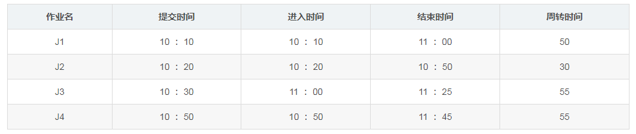
(2) Average turnaround time: (50+30+55+55)/4=47.5min (4 points)
2. (1). The values of Need for processes P1 through P5 respectively are (0, 0, 1, 2), (0, 6, 5, 2), (0, 6, 5, 6), (1, 7, 5, 0), and (2, 3, 5, 6) (4 points).
The safe sequence is {P1, P4, P5, P2, P3}(3 points).
(2). If P3 makes a Request(1,2,2,2), the system cannot allocate resources to it, because if P3 makes a request, the remaining resources in the system are (0,4,0,0). In this case, the resources in the system cannot meet the resource request of any process. As a result, the system enters an insecure state and is prone to deadlock. (3 points).
评分标准说明：第1题Gantt chart进程顺序出错酌情扣分；第2题矩阵计算错误扣4分，序列错误扣3分，请求判断不对扣全分。

