**实验2：简单控件与Activity的使用**

学号： 姓名：

班级： 联系电话：

日期：2023.10.7

一、实验内容

1. 模仿手机中计算器软件，开发一个具有基本运算功能的简单计算器。界面由自己设计，实现基本的加减乘除功能，其他运算功能可选做。
2. 模仿“学习强国”APP的首页定时跳转功能，同时完成信息在两个Activity间的传递。要求：首页显示一张图片和一句诗词（图片和诗词自己选定），首页显示5秒倒计时后自动跳转到第二页面，在首页使用intent将诗词发送到第二页，在第二页读出首页发送来的诗词，并显示在第二页。

二、实验报告

1. 实验步骤与过程
2. 计算器

效果图：

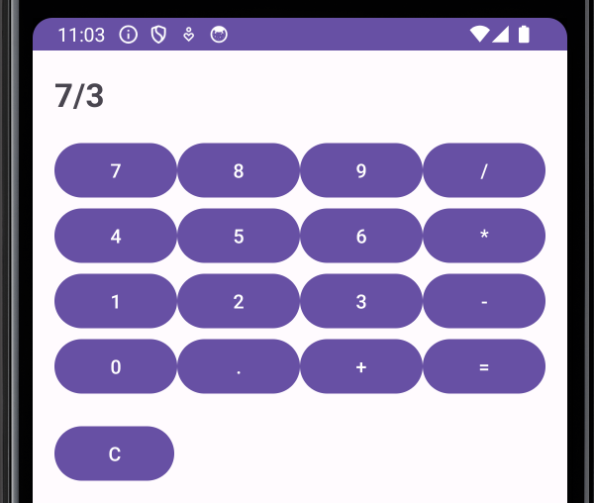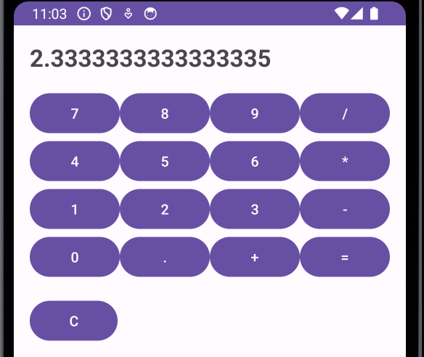

**MainActivity.java**

**package** com.example.calculator;  
  
**import** android.os.Bundle;  
**import** android.view.View;  
**import** android.widget.Button;  
**import** android.widget.TextView;  
**import** net.objecthunter.exp4j.ExpressionBuilder;  
  
  
**import** androidx.appcompat.app.AppCompatActivity;  
  
**public class** MainActivity **extends** AppCompatActivity **implements** View.OnClickListener {  
  
 **private** TextView **resultTextView**;  
 **private** StringBuilder **equationBuilder**;  
  
 @Override  
 **protected void** onCreate(Bundle savedInstanceState) {  
 **super**.onCreate(savedInstanceState);  
 setContentView(R.layout.*activity_main*);  
  
 **resultTextView** = findViewById(R.id.*resultTextView*);  
 **equationBuilder** = **new** StringBuilder();  
  
 Button button0 = findViewById(R.id.*button0*);  
 Button button1 = findViewById(R.id.*button1*);  
 Button button2 = findViewById(R.id.*button2*);  
 Button button3 = findViewById(R.id.*button3*);  
 Button button4 = findViewById(R.id.*button4*);  
 Button button5 = findViewById(R.id.*button5*);  
 Button button6 = findViewById(R.id.*button6*);  
 Button button7 = findViewById(R.id.*button7*);  
 Button button8 = findViewById(R.id.*button8*);  
 Button button9 = findViewById(R.id.*button9*);  
 Button buttonDot = findViewById(R.id.*buttonDot*);  
 Button buttonAdd = findViewById(R.id.*buttonAdd*);  
 Button buttonSubtract = findViewById(R.id.*buttonSubtract*);  
 Button buttonMultiply = findViewById(R.id.*buttonMultiply*);  
 Button buttonDivide = findViewById(R.id.*buttonDivide*);  
 Button buttonEquals = findViewById(R.id.*buttonEquals*);  
 Button buttonClear = findViewById(R.id.*buttonClear*);  
  
 button0.setOnClickListener(**this**);  
 button1.setOnClickListener(**this**);  
 button2.setOnClickListener(**this**);  
 button3.setOnClickListener(**this**);  
 button4.setOnClickListener(**this**);  
 button5.setOnClickListener(**this**);  
 button6.setOnClickListener(**this**);  
 button7.setOnClickListener(**this**);  
 button8.setOnClickListener(**this**);  
 button9.setOnClickListener(**this**);  
 buttonDot.setOnClickListener(**this**);  
 buttonAdd.setOnClickListener(**this**);  
 buttonSubtract.setOnClickListener(**this**);  
 buttonMultiply.setOnClickListener(**this**);  
 buttonDivide.setOnClickListener(**this**);  
 buttonEquals.setOnClickListener(**this**);  
 buttonClear.setOnClickListener(**this**);  
 }  
  
 @Override  
 **public void** onClick(View v) {  
 Button button = (Button) v;  
 String buttonText = button.getText().toString();  
  
 **switch** (buttonText) {  
 **case "="**:  
 calculateResult();  
 **break**;  
 **case "C"**:  
 clearEquation();  
 **break**;  
 **default**:  
 **equationBuilder**.append(buttonText);  
 updateResultText();  
 **break**;  
 }  
 }  
  
 **private void** calculateResult() {  
 String equation = **equationBuilder**.toString();  
  
 **try** {  
 **double** result = evaluateEquation(equation);  
 **resultTextView**.setText(String.*valueOf*(result));  
 } **catch** (Exception e) {  
 **resultTextView**.setText(**"Error"**);  
 }  
 }  
  
 **private double** evaluateEquation(String equation) {  
 **return new** ExpressionBuilder(equation).build().evaluate();  
 }  
  
 **private void** clearEquation() {  
 **equationBuilder**.setLength(0);  
 updateResultText();  
 }  
  
 **private void** updateResultText() {  
 **resultTextView**.setText(**equationBuilder**.toString());  
 }  
}

**Activity_main.xml**

*<?***xml version="1.0" encoding="utf-8"***?>*<**LinearLayout xmlns:android="http://schemas.android.com/apk/res/android"  
 xmlns:tools="http://schemas.android.com/tools"  
 android:layout_width="match_parent"  
 android:layout_height="match_parent"  
 android:orientation="vertical"  
 android:padding="16dp"  
 tools:context=".MainActivity"**>  
  
 <**TextView  
 android:id="@+id/resultTextView"  
 android:layout_width="match_parent"  
 android:layout_height="wrap_content"  
 android:layout_marginBottom="16dp"  
 android:textSize="24sp"  
 android:textStyle="bold"** />  
  
 <**LinearLayout  
 android:layout_width="match_parent"  
 android:layout_height="wrap_content"  
 android:orientation="horizontal"**>  
  
 <**Button  
 android:id="@+id/button7"  
 android:layout_width="0dp"  
 android:layout_height="wrap_content"  
 android:layout_weight="1"  
 android:text="7"** />  
  
 <**Button  
 android:id="@+id/button8"  
 android:layout_width="0dp"  
 android:layout_height="wrap_content"  
 android:layout_weight="1"  
 android:text="8"** />  
  
 <**Button  
 android:id="@+id/button9"  
 android:layout_width="0dp"  
 android:layout_height="wrap_content"  
 android:layout_weight="1"  
 android:text="9"** />  
  
 <**Button  
 android:id="@+id/buttonDivide"  
 android:layout_width="0dp"  
 android:layout_height="wrap_content"  
 android:layout_weight="1"  
 android:text="/"** />  
 </**LinearLayout**>  
  
 <**LinearLayout  
 android:layout_width="match_parent"  
 android:layout_height="wrap_content"  
 android:orientation="horizontal"**>  
  
 <**Button  
 android:id="@+id/button4"  
 android:layout_width="0dp"  
 android:layout_height="wrap_content"  
 android:layout_weight="1"  
 android:text="4"** />  
  
 <**Button  
 android:id="@+id/button5"  
 android:layout_width="0dp"  
 android:layout_height="wrap_content"  
 android:layout_weight="1"  
 android:text="5"** />  
  
 <**Button  
 android:id="@+id/button6"  
 android:layout_width="0dp"  
 android:layout_height="wrap_content"  
 android:layout_weight="1"  
 android:text="6"** />  
  
 <**Button  
 android:id="@+id/buttonMultiply"  
 android:layout_width="0dp"  
 android:layout_height="wrap_content"  
 android:layout_weight="1"  
 android:text="*"** />  
 </**LinearLayout**>  
  
 <**LinearLayout  
 android:layout_width="match_parent"  
 android:layout_height="wrap_content"  
 android:orientation="horizontal"**>  
  
 <**Button  
 android:id="@+id/button1"  
 android:layout_width="0dp"  
 android:layout_height="wrap_content"  
 android:layout_weight="1"  
 android:text="1"** />  
  
 <**Button  
 android:id="@+id/button2"  
 android:layout_width="0dp"  
 android:layout_height="wrap_content"  
 android:layout_weight="1"  
 android:text="2"** />  
  
 <**Button  
 android:id="@+id/button3"  
 android:layout_width="0dp"  
 android:layout_height="wrap_content"  
 android:layout_weight="1"  
 android:text="3"** />  
  
 <**Button  
 android:id="@+id/buttonSubtract"  
 android:layout_width="0dp"  
 android:layout_height="wrap_content"  
 android:layout_weight="1"  
 android:text="-"** />  
 </**LinearLayout**>  
  
 <**LinearLayout  
 android:layout_width="match_parent"  
 android:layout_height="wrap_content"  
 android:orientation="horizontal"**>  
  
 <**Button  
 android:id="@+id/button0"  
 android:layout_width="0dp"  
 android:layout_height="wrap_content"  
 android:layout_weight="1"  
 android:text="0"** />  
  
 <**Button  
 android:id="@+id/buttonDot"  
 android:layout_width="0dp"  
 android:layout_height="wrap_content"  
 android:layout_weight="1"  
 android:text="."** />  
  
 <**Button  
 android:id="@+id/buttonAdd"  
 android:layout_width="0dp"  
 android:layout_height="wrap_content"  
 android:layout_weight="1"  
 android:text="+"** />  
  
 <**Button  
 android:id="@+id/buttonEquals"  
 android:layout_width="0dp"  
 android:layout_height="wrap_content"  
 android:layout_weight="1"  
 android:text="="** />  
 </**LinearLayout**>  
  
 <**Button  
 android:id="@+id/buttonClear"  
 android:layout_width="wrap_content"  
 android:layout_height="wrap_content"  
 android:layout_marginTop="16dp"  
 android:text="C"** />  
  
</**LinearLayout**>

还需要在build.gradle.kts中添加 implementation("net.objecthunter:exp4j:0.4.8") 依赖

1. 学习心得