# 目标成绩： A

# 大数据实验报告（实验1）

 班级 21计算机（4）班  学号 2021329600006 姓名 陈昊天

实验时间： 2024.03.12

一、实验名称：LINUX实操

LINUX实操

二、实验目的

要求学生具备进行大数据系统环境操作（Hadoop）中所需要的基本环境的配置能力，获得Linux系统的虚拟机安装，NAT配置、远程登录、脚本编写和脚本运行的基本能力。为此完成以下二个模块的工作：

**模块一 环境搭建**

1 环境搭建虚拟机

2 安装CentOS

3 复制2台镜像机

4 网络配置和系统管理操作 ，采用NAT模式，要求三台互相可ping通

5 安装secureCRT远程登录

**模块二 linux常用命令**

1、常用基本命令

2、软件包管理

3、Shell编程

三、实验设计

**模块一 环境搭建**

**1 安装Hyper-V**

在控制面板-程序-启用或关闭Windows功能中启用Hyper-V。

**2 安装Debian 12**

在 https://www.debian.org/download.zh-cn.html 下载Debian 12镜像，并创建虚拟机。

**3 复制2台镜像机**

导出虚拟机，然后再导入虚拟机。重复1次。注意选择导入类型为创建唯一ID

**4 网络配置和系统管理操作 ，采用NAT模式，要求三台互相可ping通**

新建内部虚拟交换机（NAT），分配到3台虚拟机。

设置虚拟交换机，手动设置IP地址

在3台虚拟机内分别手动设置IP地址为192.168.137.21，192.168.137.22，192.168.137.23。子网掩码为255.255.255.0。网关为192.168.137.1。

**5 安装Termius远程登录**

在虚拟机上安装openssh-server

apt update

apt install openssh-server

修改/etc/ssh/sshd_config，使允许root登录

修改 PermitRootLogin 属性为 yes，随后重启ssh

随后在Termius上填写虚拟机IP地址、root密码即可远程登陆

四、实验效果及结果分析：

**模块一 环境搭建**

**1 安装Hyper-V**

在控制面板-程序-启用或关闭WIndows功能中启用Hyper-V

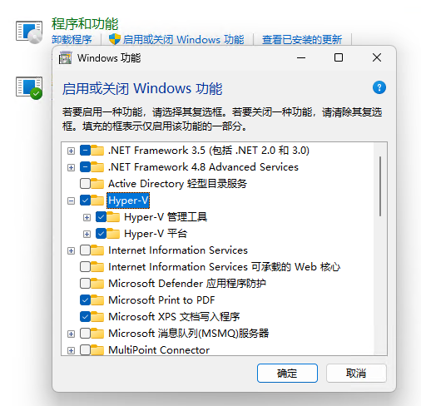

**2 安装Debian 12**

在 <https://www.debian.org/download.zh-cn.html> 下载Debian 12镜像，并创建虚拟机。

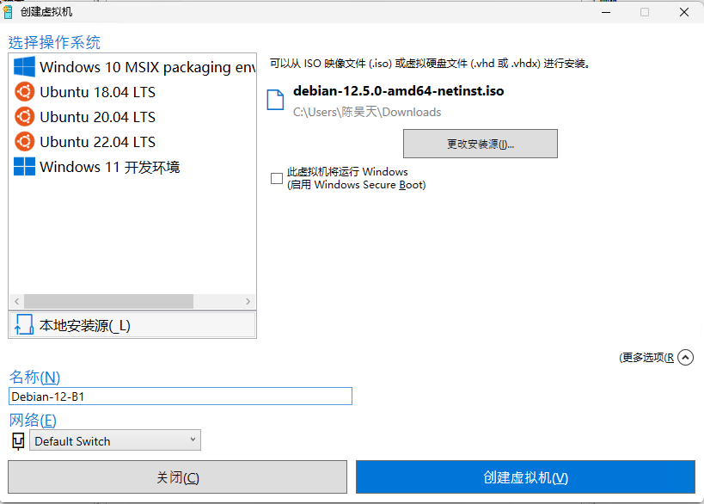

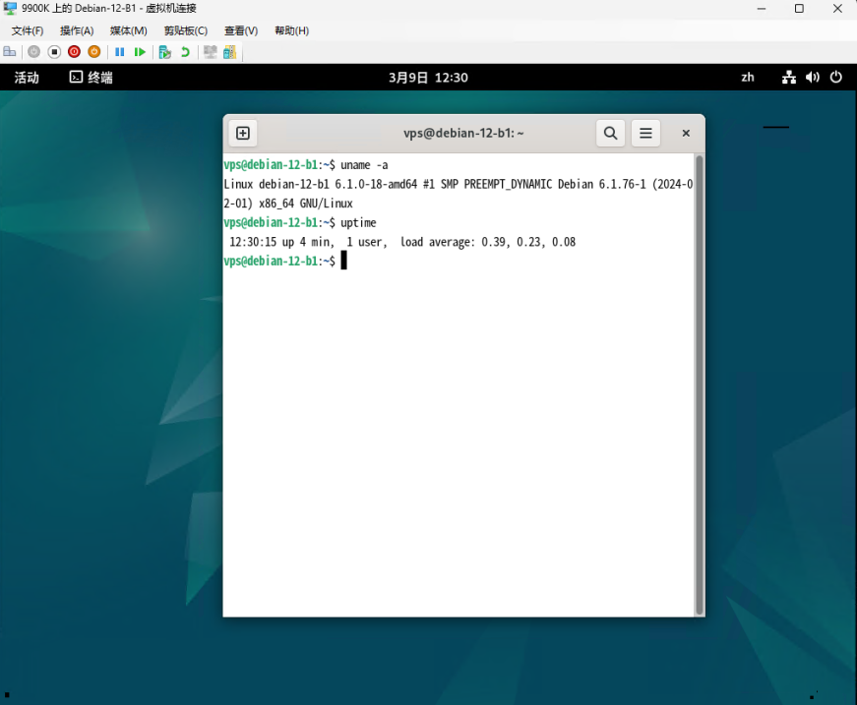

**3 复制2台镜像机**

导出虚拟机，然后再导入虚拟机

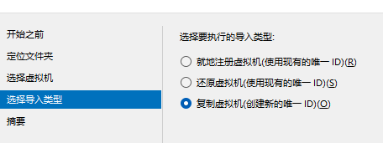

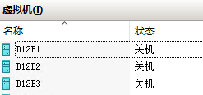

**4 网络配置和系统管理操作 ，采用NAT模式，要求三台互相可ping通**

新建内部虚拟交换机（NAT），分配到3台虚拟机

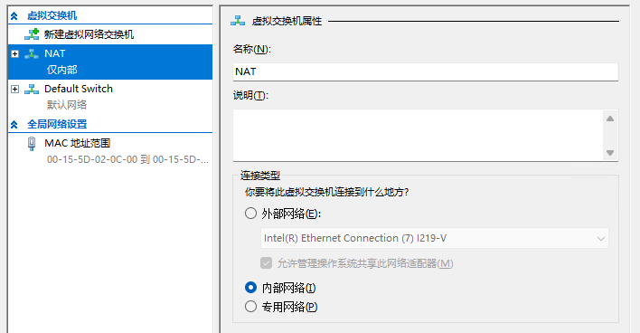

设置虚拟交换机，手动设置IP地址

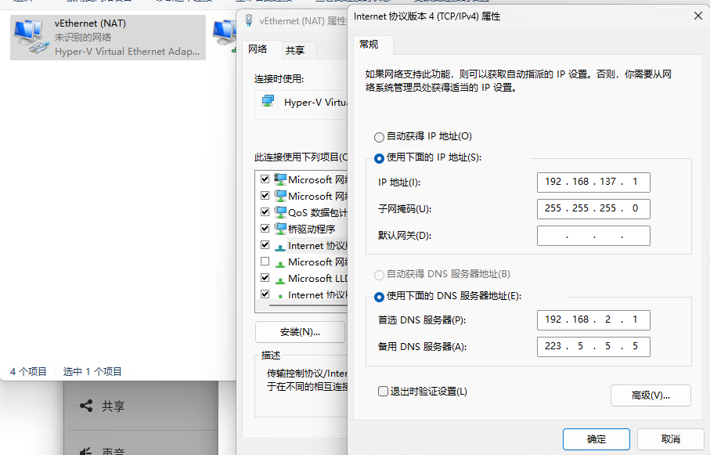

在3台虚拟机内分别手动设置IP地址为192.168.137.21，192.168.137.22，192.168.137.23

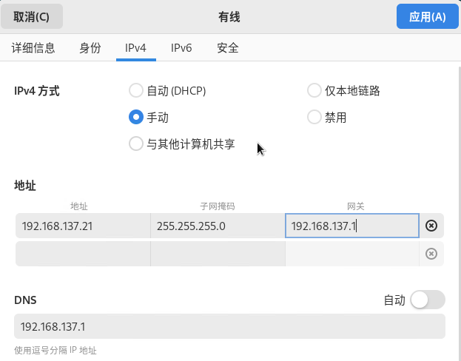

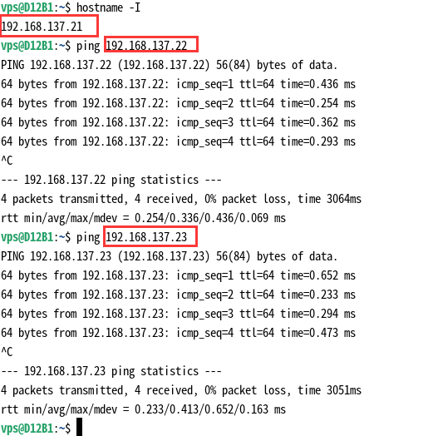

**5 安装Termius远程登录**

在虚拟机上安装openssh-server

apt update

apt install openssh-server

修改/etc/ssh/sshd_config，使允许root登录

修改 PermitRootLogin 属性为 yes，随后重启ssh

随后在Termius上填写虚拟机IP地址、root密码即可远程登陆

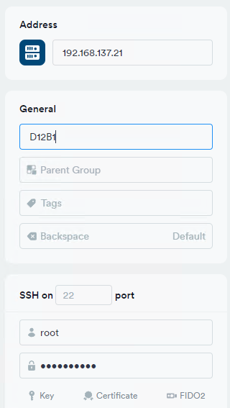

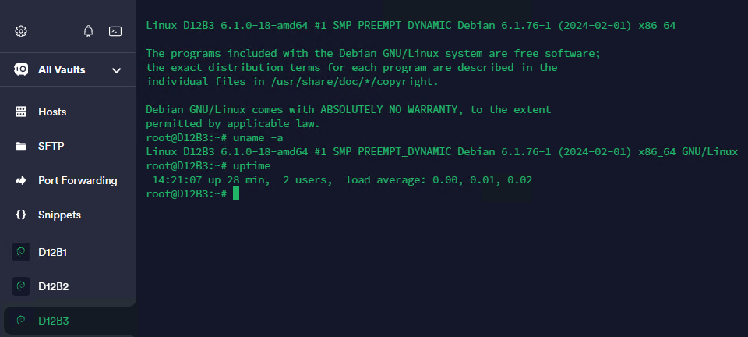

**模块二 linux常用命令**

|  |  |  |
| --- | --- | --- |
| 功能 | 步骤 | 结果 |
| 分区格式化和挂载 | 使用lsblk列出所有可用的块设备 | root@D12B1:~# lsblk NAME MAJ:MIN RM SIZE RO TYPE MOUNTPOINTS sda 8:0 0 127G 0 disk  |-sda1 8:1 0 512M 0 part /boot/efi |-sda2 8:2 0 125.5G 0 part / `-sda3 8:3 0 976M 0 part [SWAP] sdb 8:16 0 1G 0 disk |
| 使用fdisk /dev/sdb创建分区 | root@D12B1:~# fdisk /dev/sdb  Welcome to fdisk (util-linux 2.38.1). Changes will remain in memory only, until you decide to write them. Be careful before using the write command.  Device does not contain a recognized partition table. Created a new DOS (MBR) disklabel with disk identifier 0xec07a6c4.  Command (m for help): g Created a new GPT disklabel (GUID: AA5EC750-BD2D-5A47-84BD-87304C4727C4).  Command (m for help): n Partition number (1-128, default 1):  First sector (2048-2097118, default 2048):  Last sector, +/-sectors or +/-size{K,M,G,T,P} (2048-2097118, default 2095103):   Created a new partition 1 of type 'Linux filesystem' and of size 1022 MiB.  Command (m for help): w The partition table has been altered. Calling ioctl() to re-read partition table. Syncing disks. |
| 使用mkfs格式化分区 | root@D12B1:~# mkfs.ext4 /dev/sdb1 mke2fs 1.47.0 (5-Feb-2023) Discarding device blocks: done  Creating filesystem with 261632 4k blocks and 65408 inodes Filesystem UUID: 801282f5-1f3b-4022-8454-1dc589827c7c Superblock backups stored on blocks:   32768, 98304, 163840, 229376  Allocating group tables: done  Writing inode tables: done  Creating journal (4096 blocks): done Writing superblocks and filesystem accounting information: done |
| 使用mount挂载分区 | root@D12B1:~# mkdir /mnt/mydisk root@D12B1:~# mount /dev/sdb1 /mnt/mydisk root@D12B1:~# df -h Filesystem Size Used Avail Use% Mounted on udev 919M 0 919M 0% /dev tmpfs 191M 980K 190M 1% /run /dev/sda2 124G 6.0G 111G 6% / tmpfs 951M 0 951M 0% /dev/shm tmpfs 5.0M 0 5.0M 0% /run/lock /dev/sda1 511M 5.9M 506M 2% /boot/efi tmpfs 191M 44K 190M 1% /run/user/0 tmpfs 191M 60K 190M 1% /run/user/113 /dev/sdb1 988M 24K 921M 1% /mnt/mydisk |
| 进程线程类 | 使用ps aux | grep xxx 查看xxx相关进程 | root@D12B1:~# ps aux | grep gnome  Debian-+ 702 0.0 0.4 159644 8192 tty1 Ssl+ 14:37 0:00 /usr/libexec/gdm-wayland-session dbus-run-session -- gnome-session --autostart /usr/share/gdm/greeter/autostart Debian-+ 708 0.0 0.0 6260 1492 tty1 S+ 14:37 0:00 dbus-run-session -- gnome-session --autostart /usr/share/gdm/greeter/autostart Debian-+ 714 0.0 1.1 520956 22372 tty1 Sl+ 14:37 0:00 /usr/libexec/gnome-session-binary --autostart /usr/share/gdm/greeter/autostart Debian-+ 747 0.2 12.4 5267812 242040 tty1 Sl+ 14:37 0:02 /usr/bin/gnome-shell Debian-+ 877 0.0 1.4 2793204 29104 tty1 Sl+ 14:37 0:00 /usr/bin/gjs /usr/share/gnome-shell/org.gnome.Shell.Notifications Debian-+ 880 0.0 0.4 164312 9444 tty1 Sl+ 14:37 0:00 /usr/libexec/at-spi2-registryd --use-gnome-session Debian-+ 1101 0.0 1.6 2727652 31480 tty1 Sl+ 14:37 0:00 /usr/bin/gjs /usr/share/gnome-shell/org.gnome.ScreenSaver root 1175 0.0 0.0 3324 1444 pts/0 S+ 14:56 0:00 grep gnome |
| 使用pkill终止进程 | root@D12B1:~# tmux [detached (from session 0)] root@D12B1:~# ps aux | grep tmux root 1181 0.0 0.2 9044 3924 ? Ss 14:58 0:00 tmux root 1189 0.0 0.0 3324 1408 pts/0 S+ 14:59 0:00 grep tmux root@D12B1:~# pkill tmux root@D12B1:~# ps aux | grep tmux root 1195 0.0 0.0 3324 1488 pts/0 S+ 14:59 0:00 grep tmux |
| 使用lsof -i:端口号 查看端口占用情况 | root@D12B1:~# lsof -i:22 COMMAND PID USER FD TYPE DEVICE SIZE/OFF NODE NAME sshd 612 root 3u IPv4 19913 0t0 TCP *:ssh (LISTEN) sshd 612 root 4u IPv6 19915 0t0 TCP *:ssh (LISTEN) sshd 648 root 4u IPv4 15136 0t0 TCP D12B1:ssh->9900K:62018 (ESTABLISHED) |
| 目录和文件操作 | pwd 显示当前工作目录的绝对路径 | root@D12B1:~# pwd  /root |
| ls 列出目录的内容 | root@D12B1:/# ls -a . bin etc initrd.img.old lost+found opt run sys var .. boot home lib media proc sbin tmp vmlinuz .cache dev initrd.img lib64 mnt root srv usr vmlinuz.old root@D12B1:/# |
| cd 切换目录 | root@D12B1:/# cd /etc root@D12B1:/etc# |
| mkdir 创建一个新的目录 | root@D12B1:~# mkdir test root@D12B1:~# ls test root@D12B1:~# |
| rmdir 删除一个空的目录 | root@D12B1:~# rmdir test root@D12B1:~# ls root@D12B1:~# |
| touch 创建空文件 | root@D12B1:~# touch 1.txt root@D12B1:~# ls 1.txt root@D12B1:~# |
| cp 复制文件或目录 | root@D12B1:~# cp 1.txt 2.txt root@D12B1:~# ls 1.txt 2.txt |
| rm 移除文件或目录 | root@D12B1:~# rm 1.txt root@D12B1:~# ls 2.txt |
| mv 移动文件与目录或重命名 | root@D12B1:~# mv 2.txt 3.txt root@D12B1:~# ls 3.txt root@D12B1:~# |
| cat 查看文件内容 | root@D12B1:~# echo 123 >> 3.txt root@D12B1:~# cat 3.txt 123 |
| more 文件内容分屏查看器 | root@D12B1:~# more 3.txt |
| less 分屏显示文件内容 | root@D12B1:~# less 3.txt |
| echo输出内容到控制台 | root@D12B1:~# echo 123  123 |
| head 显示文件头部内容 | root@D12B1:~# head 3.txt 123 |
| tail 输出文件尾部内容 | root@D12B1:~# tail 3.txt 123 |
| > 输出重定向和 >> 追加 | root@D12B1:~# echo 123456 > 3.txt root@D12B1:~# cat 3.txt 123456 root@D12B1:~# echo 666 >> 3.txt root@D12B1:~# cat 3.txt 123456 666 root@D1 |
| ln 软链接 | root@D12B1:~# ln -s 3.txt 4.txt root@D12B1:~# ls 3.txt 4.txt root@D12B1:~# cat 4.txt 123456 666 root@D12B1:~# |
| history 查看已经执行过历史命令 | root@D12B1:~# history  1 cd  2 apt install openssh-server  3 vim /etc/ssh/sshd_config  4 apt install vim  5 vim /etc/ssh/sshd_config  6 systemctl restart ssh  7 uname -a  8 uptime  9 tmux  10 apt install tmux  11 tmux |
| 时间日期类 | date 显示当前时间 | root@D12B1:~# date Sat Mar 9 15:33:34 CST 2024 |
| ncal 查看日历 | root@D12B1:~# ncal  March 2024  Su 3 10 17 24 31 Mo 4 11 18 25  Tu 5 12 19 26  We 6 13 20 27  Th 7 14 21 28  Fr 1 8 15 22 29  Sa 2 9 16 23 30 |
| 用户管理命令 | useradd 添加新用户 | root@D12B1:~# useradd test |
| passwd 设置用户密码 | root@D12B1:~# passwd test New password:  Retype new password:  passwd: password updated successfully |
| id 查看用户是否存在 | root@D12B1:~# id test uid=1001(test) gid=1001(test) groups=1001(test) |
| cat /etc/passwd 查看创建了哪些用户 | root@D12B1:~# cat /etc/passwd  root:x:0:0:root:/root:/bin/bash daemon:x:1:1:daemon:/usr/sbin:/usr/sbin/nologin bin:x:2:2:bin:/bin:/usr/sbin/nologin sys:x:3:3:sys:/dev:/usr/sbin/nologin sync:x:4:65534:sync:/bin:/bin/sync games:x:5:60:games:/usr/games:/usr/sbin/nologin man:x:6:12:man:/var/cache/man:/usr/sbin/nologin lp:x:7:7:lp:/var/spool/lpd:/usr/sbin/nologin mail:x:8:8:mail:/var/mail:/usr/sbin/nologin news:x:9:9:news:/var/spool/news:/usr/sbin/nologin uucp:x:10:10:uucp:/var/spool/uucp:/usr/sbin/nologin proxy:x:13:13:proxy:/bin:/usr/sbin/nologin www-data:x:33:33:www-data:/var/www:/usr/sbin/nologin backup:x:34:34:backup:/var/backups:/usr/sbin/nologin list:x:38:38:Mailing List Manager:/var/list:/usr/sbin/nologin irc:x:39:39:ircd:/run/ircd:/usr/sbin/nologin _apt:x:42:65534::/nonexistent:/usr/sbin/nologin nobody:x:65534:65534:nobody:/nonexistent:/usr/sbin/nologin systemd-network:x:998:998:systemd Network Management:/:/usr/sbin/nologin tss:x:100:107:TPM software stack,,,:/var/lib/tpm:/bin/false systemd-timesync:x:997:997:systemd Time Synchronization:/:/usr/sbin/nologin messagebus:x:101:108::/nonexistent:/usr/sbin/nologin usbmux:x:102:46:usbmux daemon,,,:/var/lib/usbmux:/usr/sbin/nologin sshd:x:103:65534::/run/sshd:/usr/sbin/nologin dnsmasq:x:104:65534:dnsmasq,,,:/var/lib/misc:/usr/sbin/nologin avahi:x:105:112:Avahi mDNS daemon,,,:/run/avahi-daemon:/usr/sbin/nologin speech-dispatcher:x:106:29:Speech Dispatcher,,,:/run/speech-dispatcher:/bin/false fwupd-refresh:x:107:115:fwupd-refresh user,,,:/run/systemd:/usr/sbin/nologin saned:x:108:117::/var/lib/saned:/usr/sbin/nologin geoclue:x:109:118::/var/lib/geoclue:/usr/sbin/nologin polkitd:x:996:996:polkit:/nonexistent:/usr/sbin/nologin rtkit:x:110:119:RealtimeKit,,,:/proc:/usr/sbin/nologin colord:x:111:120:colord colour management daemon,,,:/var/lib/colord:/usr/sbin/nologin gnome-initial-setup:x:112:65534::/run/gnome-initial-setup/:/bin/false Debian-gdm:x:113:121:Gnome Display Manager:/var/lib/gdm3:/bin/false vps:x:1000:1000:vps,,,:/home/vps:/bin/bash test:x:1001:1001::/home/test:/bin/sh |
| su 切换用户 | root@D12B1:~# su test $ |
| userdel 删除用户 | root@D12B1:~# userdel test |
| who 查看登录用户信息 | root@D12B1:~# who am i root pts/0 Mar 9 14:37 (192.168.2.12) root@D12B1:~# whoami root |
| sudo 设置普通用户具有root权限 | root@D12B1:~# useradd bigdata root@D12B1:~# passwd bigdata New password:  Retype new password:  passwd: password updated successfully root@D12B1:~# vi /etc/sudoers root@D12B1:~# su bigdata $ pwd  /root $ sudo touch 1.txt $ |
| usermod 修改用户（modify） | root@D12B1:~# useradd test root@D12B1:~# usermod -g root test |
| 用户组管理命令 | groupadd 新增组 | root@D12B1:~# groupadd testgroup |
| groupdel 删除组 | root@D12B1:~# groupdel testgroup |
| groupmod 修改组 | root@D12B1:~# groupmod -n ttt testgroup |
| cat /etc/group 查看创建了哪些组 | root@D12B1:~# cat /etc/group root:x:0: daemon:x:1: bin:x:2: sys:x:3: adm:x:4: tty:x:5: disk:x:6: lp:x:7: mail:x:8: news:x:9: uucp:x:10: man:x:12: proxy:x:13: kmem:x:15: dialout:x:20: fax:x:21: voice:x:22: cdrom:x:24:vps floppy:x:25:vps tape:x:26: sudo:x:27: audio:x:29:vps dip:x:30:vps www-data:x:33: backup:x:34: operator:x:37: list:x:38: irc:x:39: src:x:40: shadow:x:42: utmp:x:43: video:x:44:vps sasl:x:45: plugdev:x:46:vps staff:x:50: games:x:60: users:x:100:vps nogroup:x:65534: systemd-journal:x:999: systemd-network:x:998: crontab:x:101: input:x:102: sgx:x:103: kvm:x:104: render:x:105: netdev:x:106:vps tss:x:107: systemd-timesync:x:997: messagebus:x:108: _ssh:x:109: ssl-cert:x:110: bluetooth:x:111:vps avahi:x:112: lpadmin:x:113:vps pipewire:x:114: fwupd-refresh:x:115: scanner:x:116:saned,vps saned:x:117: geoclue:x:118: polkitd:x:996: rtkit:x:119: colord:x:120: Debian-gdm:x:121: vps:x:1000: gnome-initial-setup:x:995: bigdata:x:1001: test:x:1002: ttt:x:1003: |
| 文件权限类 | 文件属性 | root@D12B1:~# ls -l total 4 -rw-r--r-- 1 root root 0 Mar 9 15:45 1.txt -rw-r--r-- 1 root root 11 Mar 9 15:31 3.txt lrwxrwxrwx 1 root root 5 Mar 9 15:32 4.txt -> 3.txt |
| chmod 改变权限 | root@D12B1:~# chmod 777 1.txt root@D12B1:~# ls -l total 4 -rwxrwxrwx 1 root root 0 Mar 9 15:45 1.txt -rw-r--r-- 1 root root 11 Mar 9 15:31 3.txt lrwxrwxrwx 1 root root 5 Mar 9 15:32 4.txt -> 3.txt |
| chown 改变所有者（属主） | root@D12B1:~# chown bigdata 1.txt root@D12B1:~# ls -l total 4 -rwxrwxrwx 1 bigdata root 0 Mar 9 15:45 1.txt -rw-r--r-- 1 root root 11 Mar 9 15:31 3.txt lrwxrwxrwx 1 root root 5 Mar 9 15:32 4.txt -> 3.txt |
| chgrp 改变所属组 | root@D12B1:~# chgrp root 1.txt root@D12B1:~# ls -l total 4 -rwxrwxrwx 1 bigdata root 0 Mar 9 15:45 1.txt -rw-r--r-- 1 root root 11 Mar 9 15:31 3.txt lrwxrwxrwx 1 root root 5 Mar 9 15:32 4.txt -> 3.txt |
| 搜索查找类 | find 查找文件或者目录 | root@D12B1:~# find ./ -name 1.txt ./1.txt |
| locate快速定位文件路径 | root@D12B1:~# updatedb /usr/bin/find: '/run/user/113/gvfs': Permission denied root@D12B1:~# locate 1.txt /home/vps/.mozilla/firefox/y1a0d2u1.default-esr/pkcs11.txt /root/1.txt /usr/share/doc/debian/constitution.1.1.txt.gz /usr/share/doc/debian/social-contract.1.1.txt.gz /usr/share/doc/kbd/charsets/iso8859-1.txt.gz /usr/share/doc/kbd/charsets/iso8859-11.txt.gz /usr/share/doc/libsane-common/teco/teco1.txt.gz /usr/share/vim/vim90/doc/ft_ps1.txt /usr/share/vim/vim90/doc/gui_x11.txt /usr/share/vim/vim90/doc/usr_01.txt /usr/share/vim/vim90/doc/usr_11.txt /usr/share/vim/vim90/doc/usr_21.txt /usr/share/vim/vim90/doc/usr_31.txt /usr/share/vim/vim90/doc/usr_41.txt /usr/share/vim/vim90/doc/usr_51.txt |
| grep过滤查找及“|”管道符 | root@D12B1:~# ls | grep -n 1.txt 1:1.txt root@D12B1:~# |
| 压缩和解压类 | gzip/gunzip 压缩 | root@D12B1:~# gzip 1.txt root@D12B1:~# ls 1.txt.gz 3.txt 4.txt root@D12B1:~# gunzip 1.txt.gz  root@D12B1:~# ls 1.txt 3.txt 4.txt |
| zip/unzip 压缩 | root@D12B1:~# rm -rf ./* root@D12B1:~# touch 1.txt root@D12B1:~# touch 2.txt root@D12B1:~# zip 3.zip 1.txt 2.txt  adding: 1.txt (stored 0%)  adding: 2.txt (stored 0%) root@D12B1:~# ls 1.txt 2.txt 3.zip root@D12B1:~# unzip 3.zip Archive: 3.zip replace 1.txt? [y]es, [n]o, [A]ll, [N]one, [r]ename: A  extracting: 1.txt   extracting: 2.txt  root@D12B1:~# |
| tar 打包 | root@D12B1:~# tar -zcvf all.tar.gz ./* ./1.txt ./2.txt ./3.zip root@D12B1:~# ls 1.txt 2.txt 3.zip all.tar.gz root@D12B1:~# rm 1.txt 2.txt 3.zip  root@D12B1:~# tar -zxvf all.tar.gz  ./1.txt ./2.txt ./3.zip root@D12B1:~# ls 1.txt 2.txt 3.zip all.tar.gz root@D12B1:~# |
| 系统定时任务 | crond 服务管理 | root@D12B1:~# service cron restart |
| crontab 定时任务设置 | root@D12B1:~# crontab -e  no crontab for root - using an empty one  Select an editor. To change later, run 'select-editor'.  1. /bin/nano <---- easiest  2. /usr/bin/vim.basic  3. /usr/bin/vim.tiny  Choose 1-3 [1]: 2 crontab: installing new crontab |
| apt软件包管理 | apt update更新软件包列表 | root@D12B1:~# apt update Hit:1 http://mirrors.ustc.edu.cn/debian bookworm InRelease Hit:2 http://mirrors.ustc.edu.cn/debian bookworm-updates InRelease  Hit:3 http://security.debian.org/debian-security bookworm-security InRelease  Reading package lists... Done Building dependency tree... Done Reading state information... Done All packages are up to date. |
| apt upgrade升级软件包 | root@D12B1:~# apt upgrade Reading package lists... Done Building dependency tree... Done Reading state information... Done Calculating upgrade... Done 0 upgraded, 0 newly installed, 0 to remove and 0 not upgraded. |
| apt install安装新的软件包 | root@D12B1:~# apt install nginx Reading package lists... Done Building dependency tree... Done Reading state information... Done The following additional packages will be installed:  nginx-common Suggested packages:  fcgiwrap nginx-doc The following NEW packages will be installed:  nginx nginx-common 0 upgraded, 2 newly installed, 0 to remove and 0 not upgraded. Need to get 640 kB of archives. After this operation, 1696 kB of additional disk space will be used. Do you want to continue? [Y/n]  Get:1 http://mirrors.ustc.edu.cn/debian bookworm/main amd64 nginx-common all 1.22.1-9 [112 kB] Get:2 http://mirrors.ustc.edu.cn/debian bookworm/main amd64 nginx amd64 1.22.1-9 [527 kB] Fetched 640 kB in 0s (4555 kB/s) Preconfiguring packages ... Selecting previously unselected package nginx-common. (Reading database ... 157709 files and directories currently installed.) Preparing to unpack .../nginx-common_1.22.1-9_all.deb ... Unpacking nginx-common (1.22.1-9) ... Selecting previously unselected package nginx. Preparing to unpack .../nginx_1.22.1-9_amd64.deb ... Unpacking nginx (1.22.1-9) ... Setting up nginx-common (1.22.1-9) ... Created symlink /etc/systemd/system/multi-user.target.wants/nginx.service -> /lib/systemd/system/nginx.service. Setting up nginx (1.22.1-9) ... Upgrading binary: nginx. Processing triggers for man-db (2.11.2-2) ... root@D12B1:~# |
| apt remove卸载软件包 | root@D12B1:~# apt remove nginx Reading package lists... Done Building dependency tree... Done Reading state information... Done The following package was automatically installed and is no longer required:  nginx-common Use 'apt autoremove' to remove it. The following packages will be REMOVED:  nginx 0 upgraded, 0 newly installed, 1 to remove and 0 not upgraded. After this operation, 1362 kB disk space will be freed. Do you want to continue? [Y/n]  (Reading database ... 157759 files and directories currently installed.) Removing nginx (1.22.1-9) ... Processing triggers for man-db (2.11.2-2) ... root@D12B1:~# |
| apt purge完全卸载软件包 | root@D12B1:~# apt purge nginx Reading package lists... Done Building dependency tree... Done Reading state information... Done Package 'nginx' is not installed, so not removed The following package was automatically installed and is no longer required:  nginx-common Use 'apt autoremove' to remove it. 0 upgraded, 0 newly installed, 0 to remove and 0 not upgraded. |
| apt autoremove自动删除不再需要的软件包 | root@D12B1:~# apt autoremove Reading package lists... Done Building dependency tree... Done Reading state information... Done The following packages will be REMOVED:  nginx-common 0 upgraded, 0 newly installed, 1 to remove and 0 not upgraded. After this operation, 334 kB disk space will be freed. Do you want to continue? [Y/n]  (Reading database ... 157753 files and directories currently installed.) Removing nginx-common (1.22.1-9) ... root@D12B1:~# |
| Shell编程 | helloworld | root@D12B1:~# touch helloworld.sh root@D12B1:~# vim helloworld.sh  root@D12B1:~# chmod +x helloworld.sh  root@D12B1:~# ./helloworld.sh  Hello, world! |
| 位置参数变量 | #!/bin/bash greeting="Hello" echo $greeting echo "Positional Parameters:" echo "1st: $1" echo "2nd: $2" echo "3rd: $3" echo "All positional parameters: $*" echo "Number of positional parameters: $#" |
| 运算符 | root@D12B1:~# S=$[(2+3)*4] root@D12B1:~# echo $S 20 |
| 判断语句 | root@D12B1:~# ls 1.sh 1.txt 2.txt 3.zip all.tar.gz helloworld.sh root@D12B1:~# [ 1.txt ] && echo true true |
| 流程控制 | #!/bin/bash  if [ $1 -eq "123" ] then  echo "123" elif [ $1 -eq "456" ] then   echo "456" else  echo "789" fi |
| case 语句 | #!/bin/bash  case $1 in "1")  echo "1" ;;  "2")  echo "2" ;; *)  echo "other" ;; esac |
| for 循环 | #!/bin/bash for i in "$*"  do  echo "The num is $i "  done  for j in "$@"  do  echo "The num is $j"  done |
| while 循环 | #!/bin/bash s=0 i=1 while [ $i -le 100 ] do  s=$[$s+$i]  i=$[$i+1] done  echo $s |
| read读取控制台输入 | #!/bin/bash  read -t 7 -p "please 7 miao input your name " NAME echo $NAME |
| 系统函数 | root@D12B1:~# basename /root/1.txt 1.txt |
| 自定义函数 | #!/bin/bash function sum() {  s=0  s=$[ $1 + $2 ]  echo "$s" }  read -p "Please input the number1: " n1; read -p "Please input the number2: " n2; sum $n1 $n2; |

1. 实验结论

关于实验问题：实验成功地完成了Linux环境搭建和Linux常用命令的学习，具体包括在Linux系统上安装和配置虚拟机、进行网络配置、实现远程登录、以及通过各种命令进行文件管理、进程管理、权限设置、软件包管理和基本的Shell编程。

关于实验假设：本次实验是验证性实验，通过一系列的步骤进行Linux相关操作。通过模块一和模块二的任务，能够熟练进行Linux系统的基本操作和编写简单的Shell脚本。

关于新知识：从实验中学到了如何在Linux系统中进行环境搭建，包括虚拟机安装、网络配置、远程登录设置，如何使用Linux常用命令进行日常的系统管理和维护任务。学习了Shell编程的基本概念和一些简单的脚本示例，增强了解决问题和自动化任务处理的能力。

关于错误的原因：在模块一中，实验使用Hyper-V + Debian 12的组合进行操作，需要克服的困难包括Hyper-V内部虚拟网卡的创建和修改、内存的动态分配、虚拟机的导入和导出、Debian网络接口配置等。这些问题通过论坛和搜索引擎都能得到妥善的解决，具体的解决方案在报告的第四部分有所体现。