Introduction – Single Molecule AI-assisted RaT omics (SMART) Core .|
We thank the reviewers for their positive and constructive feedback. We are particularly encouraged that the reviewers recognized the major strengths of the Single Molecule AI-assisted RaT omics (SMART) Core, including its cutting-edge technologies, innovative use of AI, and potential to generate valuable data and tools for the research community. The reviewers' recognition of our strong leadership and contributions to rat genomics is also greatly appreciated. We address the primary concerns raised by the reviewers below.
Scientific Rationale for Selected Brain Regions. We proposed to focus our study on the nucleus accumbens (NAc), medial prefrontal cortex (mPFC), and amygdala (Amy). The scientific rationale for selecting these regions was discussed in detail in the Overall document. In short, these regions were chosen because they form the core of the brain's mesocorticolimbic reward system, which is critical for the development of SUD. They are also the most common brain regions interrogated by our supported grants, making them ideal for creating a dataset of maximal relevance and enabling powerful, cross-core, multi-omics data integration. The NAc is a critical component of the brain's reward system. The NAc shell is primarily involved in emotional and motivational processes and shows heightened responsiveness to drug-induced dopamine release (Pontieri et al. 1995). In contrast, the NAc core regulates conditioned behaviors and learned responses related to substance use, mediating drug-seeking behavior influenced by cues (Ito et al. 2004). The mPFC is critical for the development and persistence of SUDs, as it regulates executive functions, decision-making, and inhibitory control. These cognitive processes are often impaired in individuals with SUDs, contributing to compulsive drug-seeking behaviors. The amygdala is central to the development of SUD by modulating emotional processes like fear, stress, and reward. The basolateral amygdala encodes emotional memories and links them to reward-related stimuli, which enhances drug-seeking behaviors. Conversely, the central amygdala regulates stress and anxiety responses (Schmeichel et al. 2017). Due to the limited anatomical precision of tissue dissection and requirements of input material for omics assays, our bulk RNAseq and proteomic (SAM core) studies will not be subregion specific. However, our snRNA-seq will provide cell-type specific data.
Discordance Between Proteomic and Transcriptomic Data. Reviewers pointed out the need for a clearer strategy for addressing discordance between RNA and protein levels. We view the discordance between transcript and protein abundance as a biological signal that points to important post-transcriptional regulatory events. The SMART Core is uniquely positioned to investigate this through the lens of epitranscriptomic data obtained from direct RNA sequencing using Nanopore technology. Some epitranscriptomic marks have a deterministic effect on protein expression. For example, Pseudouridine (Ψ) in mRNA consistently enhances protein output by altering the mRNA structure to increase both its stability and translation efficiency (Karikó et al. 2008). In contrast, other marks are more context-dependent. N6-methyladenosine (m6A), for instance, acts as a molecular switch whose function is dictated by "reader" proteins. When read by YTHDF2, the mRNA is targeted for degradation, reducing protein output. When read by proteins like IGF2BP, the mRNA is stabilized and translated more efficiently (Wei 2024). By using direct RNA sequencing to map these crucial and functionally distinct epitranscriptomic marks, the SMART Core will provide a mechanistic framework for understanding this discordance. We will collaborate with the SAM Core to integrate genomic, epigenomic, transcriptomic, epitrascriptomic, and proteomic datasets using methods such as Multi-Omics Factor Analysis (MOFA). This unsupervised framework deconvolves complex variation into interpretable latent factors, connecting upstream genetic drivers to downstream regulatory consequences and transforming a potential analytical challenge into a novel discovery tool for regulatory mechanisms in SUD.
Relevance of Rat Models to Human Genetic Variation. We selected 10 inbred rat strains for our Nexus panel that represent a wide range of genetic variation in both the outbred heterogenous stock rats and the inbred HRDP. These strains also represent a full spectrum of SUD-related phenotypes. For instance, BN and F344 exhibit some of the lowest levels of intravenous nicotine intake, whereas SHR ranks among the highest (Chen et al. 2012). Similarly, ACI and SHR show some of the highest oxycodone intake, while BN and M520 fall at the lowest end, with the other strains distributed across the intermediate range (Sharp et al. 2025). Finally, these strains also harbor high-impact variants (e.g., those altering protein sequence) in 19 genes whose human orthologs have reached genome-wide significance in SUD GWAS. These include four genes for opioid use disorder (ARHGAP15, KDM4A, RABEPK, TANK), 16 genes significant for both alcohol and nicotine use (e.g., TANK, WNT3, DPYD), and additional genes linked to cannabis use disorder (e.g., METTL15). Together, the breadth of behavioral spectrum and the presence of conserved genetic risk factors in the Nexus Panel a powerful and translationally relevant resource for studying the genetic basis of human SUD.
Clarification of Animal Age. A discrepancy was noted regarding the age of the animals to be used in our studies (90 days versus 160-180 days). We apologize for this error in the application. The correct age for the proposed experiments is 160-180 days. This age corresponds to adulthood in rats and is in agreement with the lengthy chronic self-administration studies most of our Supported Grants use.
PROJECT SUMMARY – Single Molecule AI-assisted RaT omics (SMART) Core .|
Substance use disorders (SUDs) are highly complex and heterogeneous and are influenced by genetic/DNA variants and by environmental factors, such as development, sex, and exposure history. The long-term potential of precision medicine to improve prevention and treatment of SUDs depends on gaining a much better understanding of the underlying biological pathways that influence behavior. The goal of the NIDA Core Center of Excellence in Omics, Systems Genetics, and the Addictome (OSGA Center) is to build and empower a community of SUD researchers to use large-scale data approaches for establishing and testing causal links between molecular traits and SUD-related behaviors in rodent models and for translating these findings to human clinical SUD prevention and treatment. The Single Molecule AI-assisted RaT omics (SMART) Core seeks to amplify research impact by promoting the use of cutting-edge long-read genomic, epigenomic, transcriptomic, and epitranscriptomic data and tools among the NIDA-funded research community. Understanding the molecular mechanisms underlying SUD through DNA and RNA variations is crucial for predicting vulnerability and progression of the disorder. The SMART Core leverages Oxford Nanopore technology (ONT) community through the International Rat Omics Consortium (IROC). The IROC, organized by Chen (PI of SMART Core), provides a forum for discussing rat genomics and facilitates updates to the rat reference genome. This aim ensures that the NIDA community remains informed about advancements in rat genomics and fosters interactions between genomic and SUD researchers. Aim 2: Data - Generate brain region-specific single-molecule long-read sequencing data from multiple rat strains with contrasting SUD-related phenotypes. Using ONT, we will produce comprehensive whole-genome CpG methylation profiles and direct RNA-sequencing data and snRNA-seq data from ten inbred rat strains (Nexus Panel) and Sprague-Dawley rats, focusing on the nucleus accumbens, prefrontal cortex, and amygdala—regions often studied in NIDA-funded projects. Aim 3: Tools - Analyze sequencing data using conventional and AI-assisted tools to extract biological insights and integrate findings with existing literature. Additionally, we will implement a Retrieval-Augmented Generation method using large language models to summarize knowledge on genes of interest and generate hypotheses on their contributions to SUD. In summary, the SMART Core will collaborate with NIDA-funded projects using rat models to investigate the genetic basis of SUD. By providing enhanced access to comprehensive rat genomic data and brain region- and cell-type-specific epigenomic and transcriptomic data, the SMART Core aims to improve the accuracy of genetic mapping studies and enhance their translational value, ultimately advancing our understanding of SUD.
SPECIFIC AIMS – Single Molecule AI-assisted RaT omics (SMART) Core .
The goal of the NIDA Core Center of Excellence in Omics, Systems Genetics, and the Addictome (OSGA Center) is to build and empower a community of SUD researchers to use large-scale data approaches for establishing and testing causal links between molecular traits and SUD-related behaviors in rodent models and for translating these findings to human clinical SUD prevention and treatment. The Single Molecule AI-assisted RaT omics (SMART) Core will support this mission by actively engaging with the broader NIDA-funded community, promoting the adoption of long-read sequencing technologies, generating comprehensive genomic, epigenomic, transcriptomic, and epitranscriptomic datasets, and providing both conventional and AI-assisted analytic tools.
Genetic, epigenetic, transcriptomic and epitranscriptomic variations are known to contribute to SUD vulnerability and progression. Single-molecule long-read technologies offer an unprecedented opportunity to investigate these molecular underpinnings. These methods allow for the accurate detection of chemical modifications, transcript isoforms, and other features relevant to gene regulation in SUD. We have successfully sequenced DNA molecules using Oxford Nanopore Technology (ONT) platform to obtain reads averaging 70-90 kilobases (kB) in length and identified several types of chemical modifications. We also sequenced RNA directly to obtain accurate information on isoforms, polyA site usage, polyA length, and single-base chemical modifications, all of which are crucial for SUD. Furthermore, we have adopted a workflow that generates single nuclei RNAseq (snRNA-seq) libraries without specialized instruments and sequenced them using both short- and long-read technologies.
Advances in data analysis, particularly the integration of artificial intelligence (AI) with statistical methods, have created new opportunities for interpreting complex omics data. For instance, neural networks trained on DNA sequences can enhance the prediction of regulatory element function, while models trained on single-cell RNA-sequencing (scRNA-seq) data can improve automated cell-type annotation. Moreover, large language models (LLMs) provide a powerful means to synthesize information from vast biomedical literature, aiding in candidate gene identification and hypothesis generation. The SMART Core will harness these analytical advances to support the NIDA community through three Specific Aims:
Aim 1 - Community: Enhance Access to Rat Genomic Resources for the NIDA Community through the International Rat Omics Consortium (IROC).
The IROC, founded by Saba (contact MPI, Co-Director) and colleagues and led by Chen (MPI, Co-Director and Lead of SMART Core), has been the forum for discussing rat genomics work and facilitated the upgrade of the rat reference genome from Rnor_6.0 to mRatBN7.2 and to GRCr8. We will leverage this established consortium to provide the NIDA community with the latest updates in rat genomics and pangenomics. IROC will serve as a central point for interaction and collaboration between genomics experts and SUD researchers.
Aim 2 - Data: Generate brain region-specific single-molecule long-read sequencing data from multiple strains of rats with divergent SUD-related phenotypes.
We will use ONT to generate whole-genome CpG methylation and direct RNA-sequencing data from the Nexus Panel of ten inbred rat strains with divergent genetics and SUD-related phenotypes, including founders of the Heterogeneous Stock (HS) and parental strains of two recombinant inbred panels. Sprague-Dawley rats, widely used in SUD research, will also be included. To resolve cell-type specificity, we will produce short- and long-read snRNA-seq data, focusing on the nucleus accumbens, prefrontal cortex, and amygdala, highly relevant for SUD.
Aim 3 - Tools: Analyze sequencing data using conventional and AI-assisted tools to extract biological insights and integrate findings with existing literature.
We will supplement standard bioinformatics and statistical analyses with advanced AI-driven approaches. Existing deep learning models (e.g., AlphaGenome, DeepSEA, DNA Hyena, scGPT) will be adapted and fine-tuned using rat-specific genomic and transcriptomic data to improve downstream analyses such as variant effect prediction and cell type annotation. We will also implement a Retrieval-Augmented Generation (RAG) framework that utilizes LLMs to synthesize existing literature on genes of interest and to generate novel, testable hypotheses regarding their roles in SUD.
Expected outcomes: (1) monthly virtual and yearly in-person meetings for IROC; (2) foundational multi-omic dataset from the Nexus panel encompassing single-molecule, long-read data with strain, sex, and brain region specificity (DNA methylation; RNA modifications; single nuclei RNA) (3) fine-tuned DNA language models to predict variant effects (4) fine-tuned scGPT applications to annotate cell types, (5) large language models to link candidate genes SUD literature to enable the generation of new hypotheses

RESEARCH STRATEGY – Single Molecule AI-assisted RaT omics (SMART) Core .

Significance .|

The goal of the SMART core is to promote the adoption of cutting-edge long-read genomic, epigenomic, and transcriptomic data and tools for laboratory rats, making these resources accessible to Supported Grants and the broader research community to enhance the outcomes of their research. Below are several avenues through which the SMART core aims to positively impact Supported Grants and future grant applications:

Promote the adoption of latest genomic standards. The SMART core has been instrumental in recent advancements of rat reference genomes and will continue to leverage its international and national collaborations to further refine rat genomic resources. These upgraded references represent a substantial improvement over previous versions. The SMART core aims to facilitate the adoption of these cutting-edge resources among NIDA-funded SUD researchers by eliminating technical and resource barriers through monthly virtual meetings, annual in-person meetings, and specialized workshops. Additionally, the SMART core seeks to deepen the engagement of NIDA researchers in the development of future rat genomic resources, including emerging pangenome and pantranscriptome approaches.

Improving studies associating phenotypes with genotypes. The SMART core provides a powerful platform for identifying candidate genes from quantitative trait loci (QTL) regions. The SMART core will generate highly accurate genetic variants from inbred strains of rats based on the latest rat reference genome and predict the effect of these variants, encompassing both coding and non-coding regions. The former serves as the foundation of association mapping, while the latter is a key criterion in selecting candidate genes.

Expanding the complexity of gene expression and regulation. For researchers interested in gaining deeper insights into specific candidate genes, such as those implicated in a phenotype, the SMART core offers an abundance of information, including DNA and RNA base modifications, such as 5-methylcytosine (5-mC), 5-hydroxymethylcytosine (5-hmC), 6-methyladenine (6-mA), etc., alternative transcript expression, alternative polyadenylation (APA), polyA length, and cell-type-specific expression. Many of these features have critical functional implications, while the functions of others remain poorly understood. These data will be available for ten genetically diverse inbred strains with varying SUD phenotypes (Nexus Panel), as well as for commonly used Sprague Dawley rats, in both males and females. These insights will aid in the selection of candidate genes and help generate more precise hypotheses on the roles these genes may play in SUD phenotypes.

Adding isoforms to snRNA-seq. Current standard snRNA-seq is typically 3' biased. The SMART core will generate both short- and long-read snRNA-seq data from the same cDNA library, enabling the isoform usage measured in long-read data to be accurately projected into the short-read dataset. This enriched isoform information will enhance the accuracy and relevance of short-read snRNA-seq datasets.

Improving analysis of short-read RNA-seq data. We will be generating strain- and brain-region-specific reference transcriptomes from our direct RNA-seq data. Although unconventional, these customized references can be used to more accurately quantify short-read RNA-seq data, akin to the idea of mapping RNA-seq data to strain-specific genomes or the developing pan-transcriptome approach.

AI-assisted hypothesis generation. Generating strong, testable hypotheses regarding the role of candidate genes in SUD phenotypes requires extensive knowledge. The SMART core will leverage existing text mining tools designed to mine the PubMed abstract database for SUD-related information, along with the latest LLMs that excel at logical reasoning, to generate specific hypotheses supported by relevant literature. The reasoning capabilities of LLMs can further deduce causal hypotheses that potentially explain findings derived from other hypotheses. This functionality will enhance the efficiency and precision of hypothesis generation.
Release of tools and data. We have a strong track record of making our data, tools, and results available to the research community. In collaboration with the Admin Core, will continue this tradition by depositing data to the SRA, publishing software on GitHub, and making analyzed results available via our REST-API for integration with websites such as PhenoGen, GeneNetwork, and the Rat Genome Database (RGD)
Training and outreach. In collaboration with the entire center, the SMART core will provide hands-on instruction in omics analyses for NIDA grantees and trainees. For example, we will collaborate with the Admin Core by providing webinars related to related to ONT sequencing, alternative splicing, polyadenylation analysis, and understanding AI tools. We will host interns from the Building LeGenDS program in the SAM Core and we will contribute in-kind activities, such as frozen rat tissues and access to time on our Oxford Nanopore sequencer, to the Pilot core.
The SMART core is committed to advancing epigenomic and transcriptomic research by making comprehensive data, resources, and analysis tools widely accessible, facilitating cost-effective and efficient studies, and providing robust training to the next generation of researchers.

Innovation
1. Community-centric resource dissemination: The SMART core collaborates closely with the International Rat Omics Consortium (IROC) to ensure that the NIDA-funded research community has seamless access to the latest advancements in sequencing technologies, genome assemblies, pangenome graphs, and genome annotations. Additionally, the SMART core functions as an educational hub, providing training and support to help NIDA researchers effectively adopt these advanced tools.
2. Nanopore DNA modified bases profiling: The SMART core will profile DNA methylation patterns, including 5-mC, 5-hmc, and 6-mA. These data will enable the exploration of epigenetic markers that are only beginning to be understood in the context of SUD.
3. Direct RNA sequencing: The SMART core uses direct RNA sequencing to capture full-length RNA molecules. This allows for precise characterization of transcript isoforms, single-base chemical modifications, and accurate polyadenylation length estimation. By analyzing different brain regions involved in SUD across a diverse genetic background, this approach offers a comprehensive view of the transcriptomic landscape, facilitating the identification of nuanced regulatory mechanisms contributing to SUD.
4. Long-read snRNA-seq: The SMART core will generate long-read snRNA-seq data from multiple brain regions of a genetically diverse panel of inbred rat strains (Nexus Panel). These data will enable the identification of cell-type- and isoform-specific expression patterns, deepening our understanding of cellular heterogeneity in SUD.
5. Integration of AI in large-scale data analysis: The SMART core will incorporate many deep learning models, such as Enformer, DeepSEA, and test DNA foundational models, such as DNA Hyena and scGPT for downstream applications. This integration of AI will significantly enhance the accuracy and efficiency of data analysis, leading to more precise biological insights.
6. Ontology-based retrieval-augmented generation (RAG): The SMART core will develop an AI pipeline that integrates information retrieval based on SUD-specific ontology using the RAG framework. This method aims to identify candidate genes in genetic studies of SUD and generate and rank testable, novel hypotheses.
7. Synergistic integration for enhanced SUD research: The SMART core uniquely combines cutting-edge data generation, AI-assisted data analysis, and diverse perspectives from the research community to create a synergistic research environment. This integration amplifies research capabilities by enabling comprehensive exploration of genomic, epigenomic, and transcriptomic landscapes. We anticipate that this collaborative framework will accelerate discovery, ensure robust and reproducible findings, and improve our understanding of SUD, potentially leading to the development of novel therapeutic approaches.
Approach

Specific Aim 1. Community: Enhance Access to Rat Genomic Resources for the NIDA Community through the International Rat Omics Consortium (IROC).
RATIONALE. A precise reference genome and gene annotation are crucial for all omics studies. Most analyses of omics data begin by mapping sequences to a reference genome, transcriptome, or translated proteome. Errors or gaps in the references can lead to misalignment of reads, incorrect variant calling, and inaccurate quantification, ultimately compromising the validity of downstream analyses. Thus, ensuring the completeness and accuracy of the reference genome, as well as the gene annotations, is essential for generating reliable insights and maximizing the impact of any omics study.
The genome of Rattus norvegicus was initially sequenced using tissue from the inbred BN/NHsdMcwi strain (Gibbs et al. 2004). Several updates followed over the next decade (Worley et al. 2008; Twigger et al. 2008; van Heesch et al. 2013). Since 2014, the Rnor_6.0 assembly has been widely used despite known issues (Ramdas et al. 2019). In 2020, mRatBN7.2 was introduced as the new reference, with the IROC community correcting structural errors before release (Howe et al. 2021). Further evaluation revealed 129,000 potential base-level errors due to PacBio CLR data (de Jong et al. 2024). The latest assembly, GRCr8, largely used PacBio HiFi data and was led by Doris et al. (Kalbfleisch et al. 2024). Ongoing work by the Doris and Chen teams are focused on telomere-to-telomere assemblies for various inbred rat strains.
Beyond a single reference genome. There is growing recognition that a single reference cannot capture the full genetic diversity within a species. This limitation can bias read alignment, variant detection, and gene expression analysis, especially when studying diverse populations. Pangenomics addresses these challenges by integrating multiple genomes into a graph-based structure representing all known genetic variants (Eizenga et al. 2020). Pantranscriptomics extends these approaches to transcriptomes, better capturing transcript diversity (Sibbesen et al. 2023).
Accurate gene annotation is equally important. Identifying the locations of genes within a genome, finding the coding and non-coding regions, and defining different transcripts are fundamental aspects of omics analysis. Authoritative annotations are provided by RefSeq and Ensembl; however, discrepancies exist between them. Most notably, there are differences in transcript annotation. However, issues such as the same gene being assigned different names or different sequences being assigned to the same gene often go unnoticed (de Jong et al. 2024). Understanding these differences is crucial for the reproducibility of findings.
There are many challenges in the adoption of new reference genomes. Despite the benefits of updated reference genomes, many studies continue to use outdated versions. Transitioning to a new reference genome often involves the remapping of sequencing data, recalculation of variants, and even updating workflows, all of which require a considerable amount of time and resources. Researchers not working with the genome directly are often unaware of how new reference genomes can impact their studies, which further impeded the adoption of new references (Lansdon et al. 2021). Therefore, there is a critical need for targeted training programs to enhance the understanding of reference genomes and their annotations.
PREVIOUS WORK. The IROC was originally established by Saba, Williams and others as a means of bringing like-minded researchers together. Since 2019, the monthly virtual meetings of IROC have been organized by Chen, the lead of the SMART core. These meetings attracted approximately 50 participants from a diverse range of institutions. In the United States, these include PIs and trainees from the Medical College of Wisconsin, University of Colorado, University of California, University of Memphis, University of Michigan, University of Tennessee, University of Texas, University of Washington, Washington State University, as well as program officials from the NIDA. Internationally, the consortium includes researchers from the Czech Academy of Sciences, University of Groningen, University of Helsinki, and the Wellcome Sanger Institute. Key contributors also include leaders from the Rat Genome Database (RGD), the European Bioinformatics Institute (EBI), and the National Center for Biotechnology Information (NCBI). This diverse and collaborative network underscores IROC's commitment to fostering global partnerships and advancing the field of rat genomics.
A significant topic of discussion in the initial IROC meetings was the assembly errors in Rnor_6.0. Collaborative efforts between RGD and the Darwin Tree Project led to the development of the 7th reference assembly. Led by Chen, the IROC team conducted preliminary assessments using rat genetic markers and whole genome sequencing (WGS) data. These analyses corrected some structural errors in the draft assembly (Howe et al. 2021). Following the official release of mRatBN7.2, and its annotation by NCBI and EBI, the team conducted a comprehensive comparison of Rnor_6.0 and mRatBN7.2 using multi-omics datasets, including WGS, RNA-seq, expression quantitative trait loci (QTL) mapping, snRNA-seq, snATAC-seq, transcription start sites, and alternative polyadenylation sites. In all the comparisons, we found using mRatBN7.2 improved the accuracy of the results. This collaborative effort culminated in a consortium publication in Cell Genomics (de Jong et al. 2024). Thereafter, discussion shifted to the GRCr8 assembly effort lead by Doris and team, telomere-to-telomere (T2T) genomes being assembled by the Doris team and Chen team, as well as efforts by Chen/Garrison/Williams on rat pan-genome assemblies. Additionally, over 500 inconsistencies between the RefSeq and Ensembl annotations on neuroscience-related genes were identified by Chen, et al. These discrepancies have been prioritized by the HAVANA team at the EBI for manual curation.
PLAN FOR FUTURE WORK. NIDA animal genetics experts, though skilled in their field, may lack familiarity with genomics and its broader implications. While genetics and genomics are related, they are distinct disciplines requiring specialized approaches. Understanding the genome is crucial for advancing genetic studies, especially for researchers working with laboratory rats, where genomic research has traditionally lagged but is rapidly evolving. To bridge this gap, targeted education and training are essential. Establishing a regular forum for experts and users of both genetics and genomics to share insights is vital. By expanding the IROC team to include the broader NIDA animal genetics community, we can connect genomics experts with end-users and foster meaningful collaborations.
Planned topics for future IROC meetings. The upcoming IROC meetings will explore cutting-edge topics in omics studies. We are planning to discuss the following topics in the coming years.T2T genome assemblies. All traditional reference genomes contain gaps (GRCr8 has over 270 gaps). Many of these gaps contain repetitive sequences that regulate gene expression. T2T genomes are assembled using highly accurate long read HiFi data from Pacific Biosciences (PacBio) and the gaps are closed using ultralong (i.e. >100kb) ONT data (Nurk et al. 2022). Doris and Chen are now assembling T2T genomes for different inbred strains of rats. Pangenomics and Pantranscriptomics. These graph-based models, though still evolving, provide a more comprehensive view of genetic and transcript diversity across rat populations. With the increased interest about the human pangenome reference consortium (HPRC) effort, of which Prins (Admin core) is a contributor (Liao et al. 2023), many researchers are now interested in applying these methods in rat because they hold great promise for capturing a more comprehensive view of genomic and transcriptomic variations. Single-cell omics. The platforms for cell-type specific omics studies are expanding. New methods now enable analysis of chromatin accessibility (Fang et al. 2021), 3D chromatin interactions (Rappoport et al. 2023), and DNA methylation (Liu et al. 2021). Moreover, the development of spatial transcriptomics techniques has further enhanced the study of gene expression within the context of tissue architecture. In parallel, long-read sequencing methods are also being used to obtain full-length transcripts, providing a more nuanced understanding of transcript isoforms and gene expression dynamics (see Aim 2).Epigenomics and epitranscriptomics. Long-read adaptations of classic short-read methods, such as pore-C (Zhong et al. 2023) and fiber-seq (Stergachis et al. 2020), provide more accurate insights into epigenetic mechanisms. Native DNA or RNA sequencing can now detect several base-level modifications, which significantly affect transcript expression. The field of epitranscriptomics (Cerneckis et al. 2024), exploring RNA base modifications, is emerging as a new frontier. AI and Machine Learning. The integration of AI and machine learning into omic data analysis is transforming bioinformatics. These methods are paving the way for novel discoveries. By leveraging sophisticated algorithms, similar to those employed in natural language processing, novel methods are being developed to decode the intricate language of DNA, RNA, and epigenetic modifications.
Invite leading experts in omics for enhanced scientific discourse. In planning our meetings, we will extend invitations to leading experts in omics to ensure a comprehensive and insightful discourse. Past contributors to the IROC includes Dr. Kerstin Howe, Head of Production Genomics at Wellcome Sanger Institute and a leader in the Darwin Tree of Life project; Dr. Karen Miga, a leader in the Human T2T project; Dr. Erik Garrison, a pioneer in pangenomics; Dr. Peter Doris, leading the GRCr8 assembly; Dr. Terence Murphy, who head the RefSeq Eukaryotes initiative; Dr. Anne Kwitek, who leads the RGD and the Alliance of Genome Resource; and Ziga Avsec, who leads the development of Enformer/AlphaGenome at Google Deepmind. We will continue to invite eminent scholars and researchers who have significantly contributed to the field, ensuring that our meetings remain at the forefront of scientific innovation and collaboration.
Encouraging the NIDA animal genetics community to attend IROC meetings. To increase engagement from the NIDA animal genetics community, we will host one annual in-person meeting that features hands-on workshops, expert-led seminars, and panel discussions on cutting-edge genomic tools. The meeting will be planned to be part of the regular meetings that many NIDA funded groups will attend, such as the NIDA genetic meeting, or the Complex Trait Consortium meeting. They will focus on practical skills such as transitioning to new genome assemblies, snRNA-seq analysis, or analysis of direct RNA-seq data, etc. These meetings will also have planned dedicated networking sessions where researchers can share their experiences and foster collaborations between labs, both nationally and internationally.
EXPECTED OUTCOMES, PITFALLS, AND ALTERNATIVES. We anticipate a significant enhancement in the ability of NIDA animal genetics researchers to integrate the latest genomics into their work with laboratory rats. We expect a wider adoption and dissemination of cutting-edge genomic techniques, leading to increased collaboration and knowledge exchange within the community. Furthermore, there will be a broader adoption of AI and machine learning in genomics, facilitating more sophisticated data analysis and interpretation. We also foresee greater engagement from the NIDA animal genetics community, fostering a more robust and interconnected research environment. Several challenges may impede the adoption of new references and technologies. These include the learning curve associated with advanced genomic techniques. To address this, we will implement incremental training programs that gradually introduce researchers to these techniques. Another challenge is limited access to specialized equipment and computational infrastructure. To counter this, we will encourage collaborations that allow for the sharing of equipment and computational resources and explore new methods that do not require sophisticated instruments, such as Split-Seq for snRNA-seq (see Aim 2). Additionally, the limited availability of time for PIs may hinder their direct engagement with new genomic techniques. Recognizing this, we will focus on engaging trainees who can attend meetings and training sessions on behalf of their labs and fostering the development of the next generation of genomic researchers.
RATIONALE. Genomic technologies fueled the advancements in SUD research. Each major advancement in sequencing technology has provided new insights into the genetic variants, gene expression, and regulation associated with SUD-related traits. In the 1990s, the introduction of PCR and Sanger sequencing allowed the investigation of candidate genes such as DRD2, DRD4, 5-HTTLPR, and OPRM1 (Blum et al. 1990; Jiang et al. 2023). The sequencing of the human genome in the early 2000s (Lander et al. 2001; Venter et al. 2001) offered a new framework for identifying genes linked to SUD. The advent of microarray technology (Fodor et al. 1991) facilitated transcriptomic studies (Watson et al. 1998) and enabled genome-wide association studies (GWAS) (Zhang et al. 2010). These studies have identified numerous genes associated with cigarette smoking (Thorgeirsson et al. 2008; Tobacco and Genetics Consortium 2010; Liu et al. 2019; Chen et al. 2023), opioid use disorder (Zhou et al. 2020), as well as cocaine use disorder (Gelernter et al. 2014). The introduction of next-generation sequencing platforms (Shendure & Ji 2008) has led to innovation in methods investigating the genome, transcriptome, and epigenome (Muenstermann & Clemens 2024). These methods have revealed extensive alternative splicing of OPRM1 (Pasternak 2018), key transcription factors in cocaine addiction (Teague & Nestler 2022), and the role of non-coding RNAs in SUD (Mayfield 2017) .

Specific Aim 2. Data: Generate brain region-specific single-molecule long-read sequencing data from multiple strains of rats with contrasting addiction phenotypes.
Single molecule long read nucleotide sequencing drives the next frontier of scientific breakthroughs. Traditional sequencing requires aggregated signals from at least 1000 copies of the same DNA (Fujiki et al. 2019). New technologies now allow for the accurate sequencing of single DNA or RNA molecules. PacBio and ONT are the leading providers of this technology. PacBio sequencing produces reads with lengths of 15–30 kb. When using circular consensus sequencing (HiFi), the base accuracy is approximately 99.9%. The high cost of PacBio's instruments limits them to specialized sequencing centers. In contrast, ONT reads range from 10 kb to over 1 Mb, with base accuracy around 99%. These ultralong data are crucial for the T2T assembly. ONT offers a variety of instruments accessible to both small laboratories and large sequencing centers.
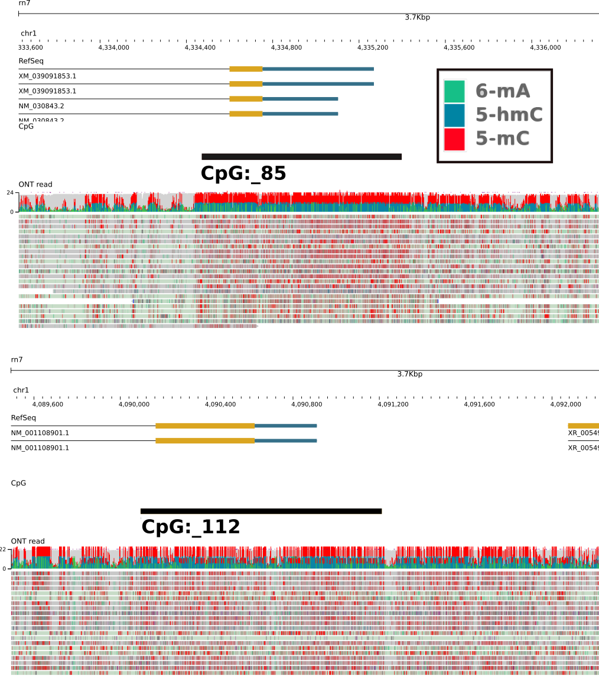 | 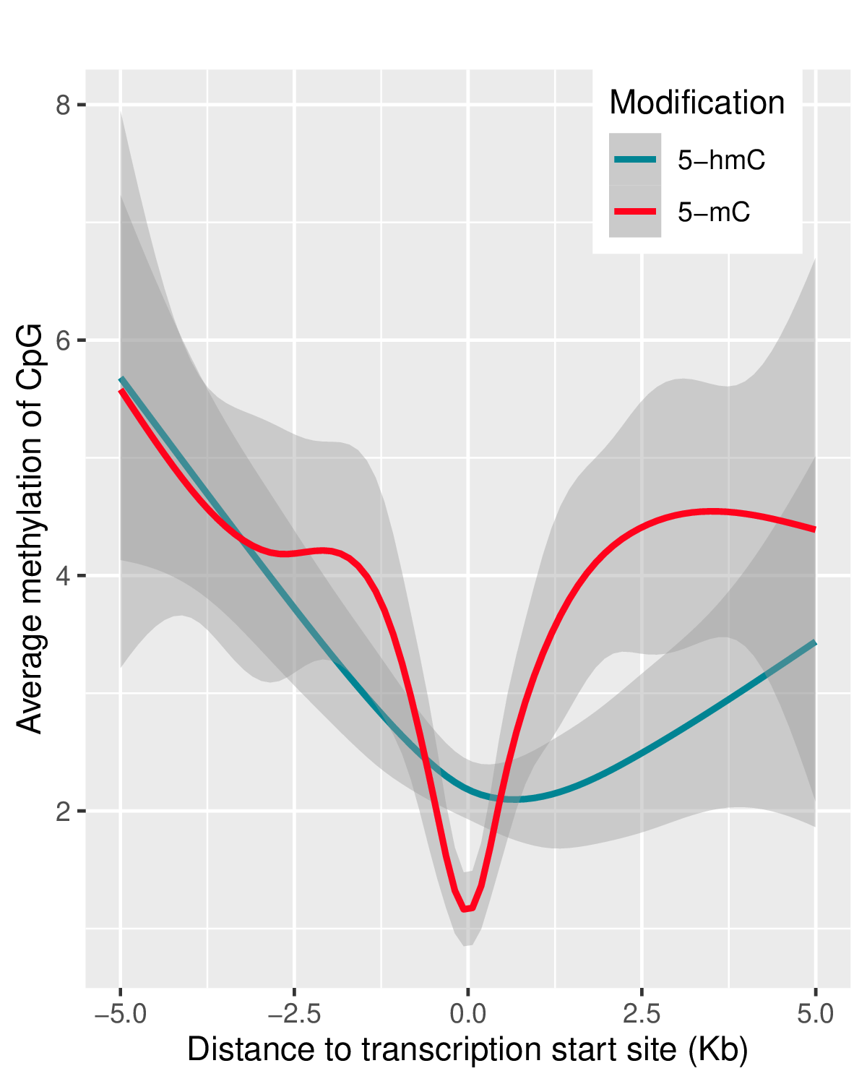 | 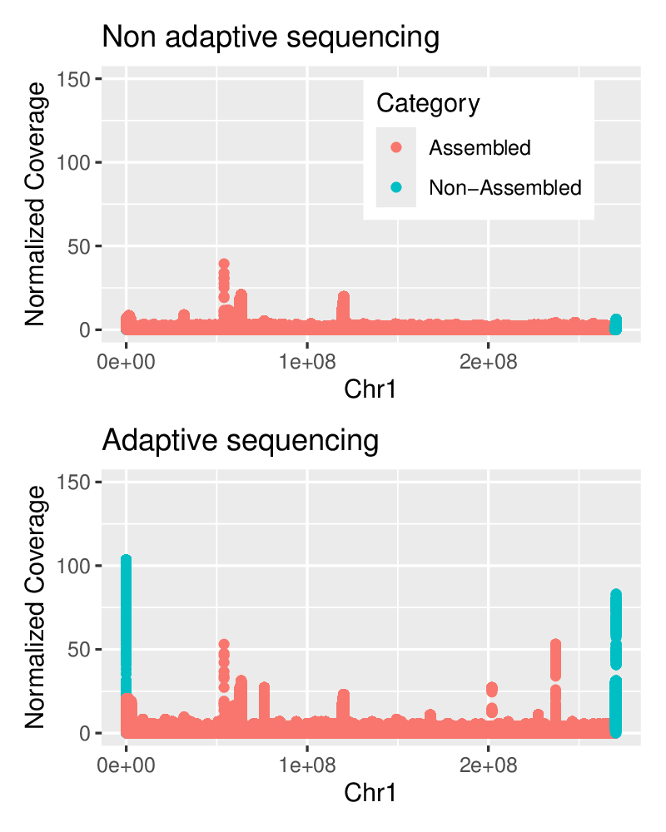
Figure 1 Base modifications detected in ONT sequencing reads across two CpG regions | Figure 2. CpG methylation status near transcription start sites. | Figure 3. Adaptive sequencing enriches the collection of data from the target (non-assembled) regions.
Genome-wide detection of 5-mC at single base resolution has been a challenging task for NGS. When sequencing naive DNA, both PacBio and ONT platforms can identify 5-mC using machine learning algorithms. ONT, in particular, excels at this by detecting 5-mC, 5-hmC, and 6-mA in DNA and a few additional modifications in RNA. The significance of these base modifications in SUD is increasingly recognized (Sadakierska-Chudy et al. 2017; Rompala et al. 2023). Adaptive sampling, a software-enabled method for nanopore sequencing, facilitates the enrichment of targets, such as CpG islands. The library is prepared and loaded as usual. During sequencing, real-time data from each pore is used to reject off-target strands, allowing only target strands to pass through (Kovaka et al. 2020). This method has been employed to significantly enrich the reads of CpG islands from whole-genome libraries (Wang et al. 2024).
Single-molecule sequencing is also advancing RNA-seq. Traditional RNA-seq (as well as PacBio IsoSeq), converts RNA to cDNA to construct the sequencing library. ONT offers a dedicated flow cell for sequencing RNA directly, which not only yields long read but also detects multiple base modifications. These long-read RNA data significantly enhance the analysis of fusion transcripts (Gordon et al. 2015), long non-coding RNA (lncRNA) (Chao et al. 2018), natural antisense transcripts (Zhang et al. 2018), and alternative splicing (Wang et al. 2016). In addition, direct RNA-seq detects multiple features that affect mRNA stability, translation efficiency, and protein abundance. These include alternative polyadenylation (APA) sites, the length of polyA tails, and base modifications (Arora et al. 2021). For example, Pseudouridine (Ψ) in mRNA enhances protein output by increasing the stability of mRNA and its translation efficiency (Karikó et al. 2008). Other epitranscriptomic marks, such as m6A, are more context-dependent. Its function is dictated by "reader" proteins. When read by YTHDF2, the mRNA is targeted for degradation. When read by proteins like IGF2BP, the mRNA is stabilized and translated more efficiently (Wei 2024). Although there is promising evidence that RNA modifications are involved in SUD (Satterlee et al. 2014), much remains to be discovered. Most importantly, all these layers of information can be extracted from a single direct RNA-seq dataset.
RNA-seq at individual cell resolution. Advancements in microfluidics have enabled single-cell RNA sequencing, which provides critical insights into the heterogeneity of cellular populations (Kolodziejczyk et al. 2015). Given the inherent difficulty of isolating intact single neurons with intricate morphology from adult brains, neuroscientists have increasingly been using single nuclei for these analyses. Achieving cell-level resolution is particularly crucial for the study of SUD, as the brain comprises a highly heterogeneous population of cells, including numerous neuronal subtypes that exhibit diverse transcriptomic changes in responses to drug exposure, withdrawal, and relapse. For example, (Phillips et al. 2023) demonstrated that D1 medium spiny neurons in the striatum exhibit unique transcriptional changes in response to cocaine, highlighting the potential of snRNA-seq to reveal specific cellular responses to addictive substances. As summarized in the Overall section, three of the 12 Supported Grants (Wang, Sanna, Akil) are generating short read snRNA data. To enhance these studies, we have optimized a commercial pipeline that uses combinatorial barcoding techniques (i.e., Split-seq, from Parse Biosciences) to generate a library that is compatible for both short read and long-read sequencing.
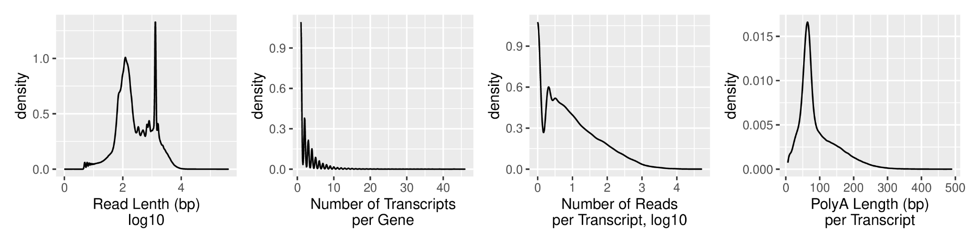
Figure 4 Summary density plots of direct RNA-seq data.
PREVIOUS WORK. The Chen lab has successfully established many ONT sequencing methods.
1. Single molecule adaptive DNA sequencing and modified base calling. As part of our work in assembling T2T genomes of rats, we generated a large amount of ONT ultralong data. Using ONT Dorado (v0.7.4), we called modified bases, including 5-mC, 5-hmC, and 6-mA. ONT Modkit was used to extract the locations of these base modifications for visualization using JBrowse2. Two selective CpG islands are shown in Figure 1. The RefSeq Track and the CpG Track highlight the locations of CpG island relative to the transcripts. The Reads Track displays a dense alignment of sequencing reads, color-coded to indicate detected base modifications. We analyzed the methylation located within CpG islands across chromosome 1. Both 5-mC and 5-hmC methylation levels declined sharply at the TSS (Figure 2), which agrees with the association between CpG hypomethylation and active gene transcription (Akbari et al. 2021). Additionally, we tested adaptive sequencing in our T2T work to enrich the collection of data from target regions (in this case, assembly gaps). Figure 3 demonstrates that this approach effectively enriches non-assembled genomic regions. We also have used adaptive sequencing to validate structural variants (Villani et al. 2024). We plan to apply this enrichment strategy to preferentially collect DNA sequencing data from CpG islands. In summary we are well-positioned to conduct whole-genome, single-base resolution profiling of 5-mC, 5-hmC, and 6-mA DNA methylation.
2. Direct RNA-seq. We used the ONT RNA flow cell to generate a direct RNA-seq dataset from nucleus accumbens of an adult male inbred rat. Figure 4 provides summaries of read length, number of transcripts per gene, number of reads per transcript, and polyA length per transcript. We conducted a preliminary gene ontology analysis and found a significant enrichment of protein-coding, catalytic activity, and cytoplasmic localization among genes with extended polyA tails. Conversely, genes with shorter polyA tails demonstrate enrichment in ribosomal components and translation-related processes. Dorado currently supports the detection of four RNA modifications: 5-mC, 6-mA, pseudouridine, and inosine. Rich information for each gene can be extracted and visualized in a genome browser, such as JBrowse2. One specific example for Ncam1, showing different expression levels between 9 isoforms, usage of different polyadenylation sites, and base modifications is shown in Figure 5. These data underscore the complexity of RNA biology and highlight the utility of direct RNA-seq in studying the role of epitranscriptome in SUD.
3. snRNA-seq. Using the Split-seq combinatorial barcoding kit, we generated snRNA-seq data from rat nucleus accumbens, amygdala, and prefrontal cortex. Each region was sampled from 3-5 rats. We profiled approximately 2,000 nuclei per biological sample. Using Illumina instruments, we obtained 87,000 reads per nucleus. We analyzed the data using the ParseBio pipeline, followed by additional analysis in Seurat. We detected about 5,000 genes per nucleus. To complement these short-read sequencing data, we also constructed an ONT library from the same cDNA used for the prefrontal cortex library. We detected 1,500 transcript per nucleus at a sequence depth of 5,000 reads. The mean read length was 669 bp (interquartile range: [399, 776], max: 124,605bp) providing a strong founda- tion for detailed isoform analysis. Using Seurat, we identified multiple distinct cell types for each brain region (Figure 6).
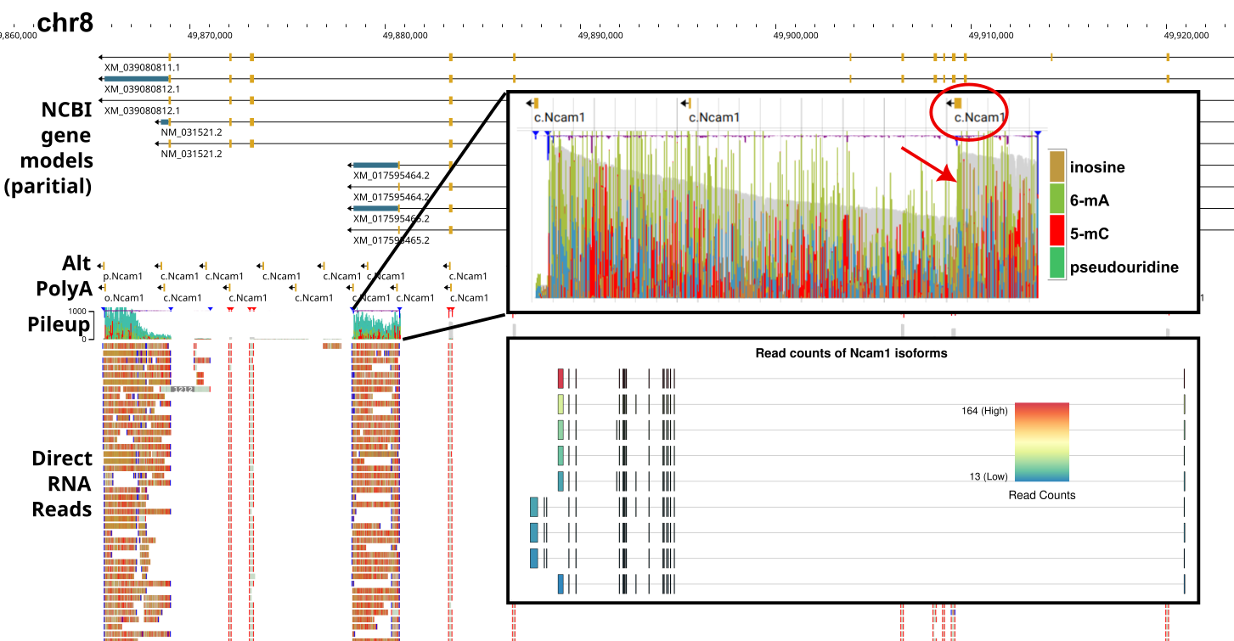
Figure 5. Rich data for Ncam1 from direct RNA-seq. The top track displays RefSeq transcript models. The 2nd track shows APA sites annotated using transcriptome termini site sequencing. A zoomed-in summary of the pileup view highlights base modifications. Note the sharp rise (arrow) in the gray background representing read coverage, which aligns with one of the APA (circle). Using Flair, we identified nine isoforms that are expressed, with each isoform color-coded to represent the number of reads assigned.
PLAN FOR FUTURE WORK. Experimental design. We will generate data using ONT single-molecule long-read sequencing for three analyses: 1) whole-genome single base-resolution CpG methylation sequencing with adaptive sequencing to achieve approximately 20x coverage per CpG island; 2) direct RNA-seq to obtain 5 million reads per sample, roughly equivalent to 20-30 million paired-end 150 bp reads (Sessegolo et al. 2019; Mock et al. 2023); 3) collect snRNA-seq data from 2000-3000 nuclei per sample, with each brain region receiving 50,000 short reads and 10,000 ONT long reads.
Similar to the SAM core, we will focus on the Nexus Panel of 10 inbred rat strains designed by the OSGA: ACI/EurMcwi, BN/NHsdMcwi, BUF/Mna, F344/DuCrl, M520/NRrrcMcwi, MR/NRrrc, WKY/NHsd, WAG/RijCrl, SHR/OlaIpcvMcwi, and LE/StmMcwi. As discussed in detail the Overall document, these strains represent the majority of genetic diversity found in laboratory rats, and much of the genetic variants relevant to the Supported Grants. These strains also show divergent SUD-related phenotypes and contain mutations in genes reached genome-wide significance in human SUD GWAS for opioids, smoking, cannabis, and alcohol use. Additionally, we will include the outbred Sprague Dawley rats, which are used by two of the Supported Grants (Wang, Akil). For each strain, we will collect data from three brain regions: the nucleus accumbens, the prefrontal cortex, and the amygdala. The relevance of these three brain regions to SUD are described in detail in the Overall document. We will include six rats from each strain (3F and 3M).
Methods. 1. Animals: The Chen lab maintains all proposed inbred strains using breeders obtained from the Medical College of Wisconsin, with reimportation occurring annually to prevent genetic drift. Similarly Sprague Dawley rats will also be bred in the Chen lab using breeders from Inotiv. Adult offspring aged approximately 160-180 days (matching the age of rats in most supported grants) will be used. In addition, we will produce all the rats used by the SAM core , including F1s, and dissect all brain regions. To reduce batch effects, we will study 1-2 rats per sex per strain annually, ensuring each strain is examined across all five years.
2. Brain region dissection: Coronal sections (100 μm) will be cut using a cryostat at -10°C. Dissection will occur on a -20°C freezing stage. A video projection system will display the section image on a monitor overlaid with a size-adjusted brain atlas to ensure anatomical accuracy (Munro et al. 2022). Brain tissue from each hemisphere will be isolated with sharp forceps (0.2 mm tips), placed in frozen microcentrifuge tubes, and stored at -80°C. This method will also provide samples for proteomics studies by the SAM core. Each assay—DNA, RNA, proteome—will use samples from different rats to ensure sufficient samples are available. 3. DNA sequencing: DNA will be extracted using the NEB Monarch Genomic DNA Purification Kit. It will be sheared with a Covaris g-TUBE to achieve fragment sizes of 10–15 kb. Approximately 1.5-2 µg of DNA will be barcoded and used as input for the ONT Ligation Sequencing Kit. Libraries will be loaded onto a Promethion flow cell and sequenced using a P2Solo device for 48 hours. For adaptive sampling a BED file with CpG islands annotated in mRatBN7.2/rn7 (we anticipate GRCr8 will be available from UCSC soon) will be downloaded from UCSC and provided to MinKnow software.
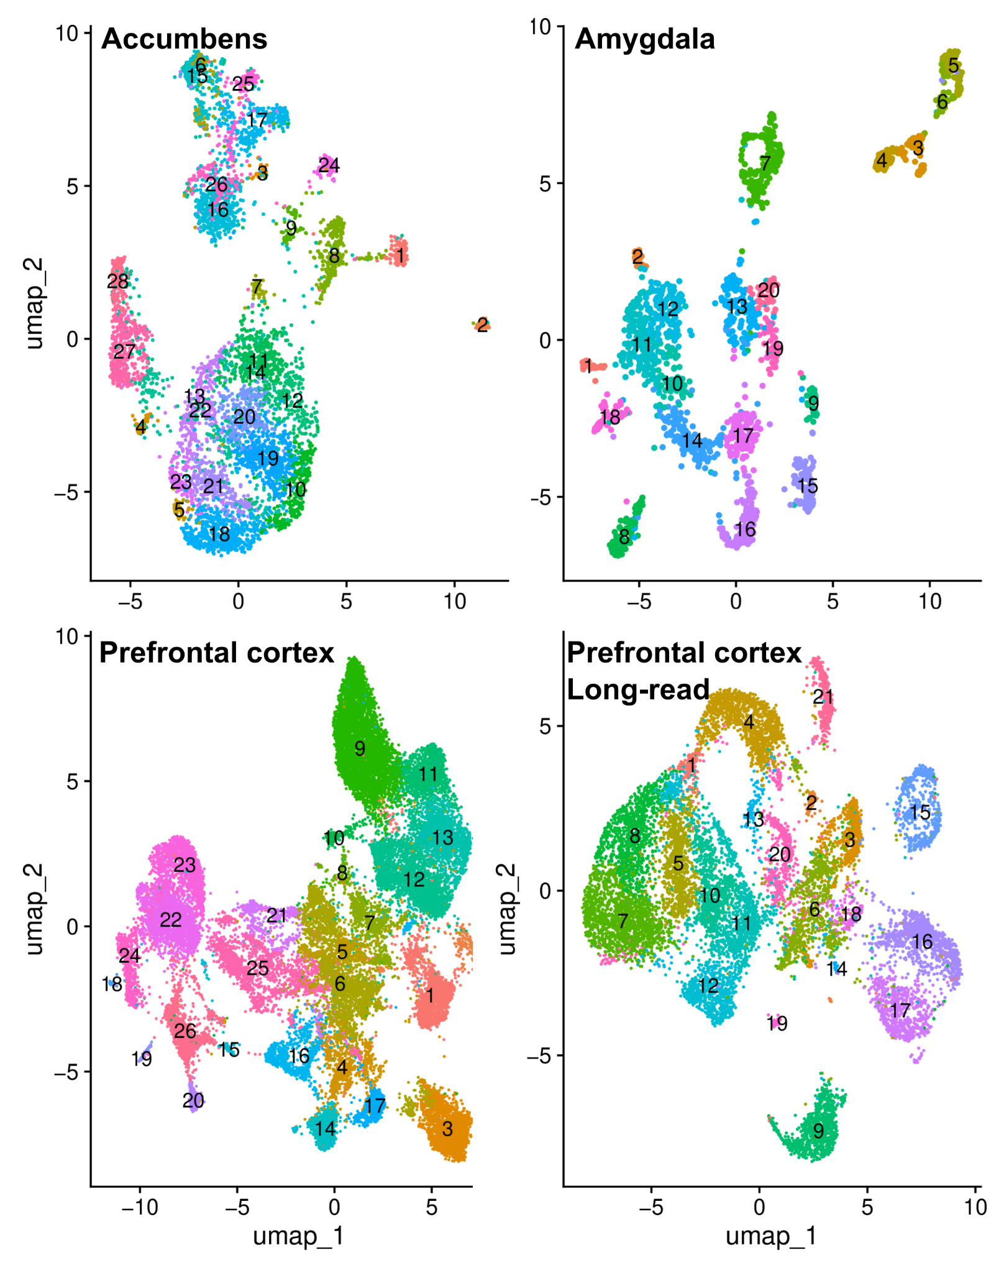
Figure 6. snRNA-seq of three brain regions. The prefrontal cortex cDNA library was also sequenced using the ONT platform to generate long read data.
4. Direct RNA sequencing: RNA will be extracted using the TRIzol protocol, including optional steps for high-fat content samples. Library preparation will be performed on 1 µg of total RNA using the ONT Direct RNA Sequencing Kit. Libraries will be quantified via the Qubit High Sensitivity RNA assay and sequenced on a PromethION flow cell for 55-60 hours.
5. snRNA sequencing: Single-nuclei suspensions will be prepared using the 10X Genomics Nuclei Isolation Kit. We optimized tissue input (20-30 mg), debris removal (10-min centrifugation), and lysis time (4 minutes). Nuclei will be fixed using the Parse Nuclei Fixation Kit and stored at -80°C. The Parse Evercode WT Kit will be used for combinatorial barcoding, ensuring unique barcodes for cDNA from each nucleus. The cDNA library will be sequenced on an Illumina instrument. Additionally, an ONT library will be prepared and sequenced on the Promethion flow cell.
6. In kind support for Pilot Projects. Sequencing data from user provided samples will be generated using 4 promethion flow cells per project (approx $5000 in supply costs, likely to yield 1160 Tb of data). We will support three projects. Frozen tissue (e.g. brains) from the Nexus Panel will also be provided as requested.
Data Analysis. DNA methylation. To detect 5-mC, 5-hmC, and 6-mA modifications, we will first use ONT Dorado to call bases using modified base models. This produces bam files that record base modifications in the MM:Z and MM:L fields. Subsequently, reads will be aligned to the GRCr8 reference sequence. We will then use ONT Modkit to generate pileups of CG dinucleotide methylation in the bedMethyl format. Differential modification will be assessed using the "dmr pair" function of Modkit or the R DSS (Feng et al. 2014) package. Dr. Kechris (Admin Core) has extensive expertise in analyzing DNA methylation data and will be consulted on these analysis.
Direct RNA-seq. Dorado will produce BAM files containing modified base information. We will use Flair (Tang et al. 2020) to create a transcriptome that includes both RefSeq-annotated detected in our sample and assemble novel transcripts. Flair will also quantify transcript counts and identify differential expression and splicing events. Modkit will be used to analyze differential base modifications, including 5-mC, 6-mA, pseudouridine, and inosine. These modifications will be aggregated over different parts of the transcript, including 5’UTR, start codon, exons, transcripts, stop code, and 5’UTR. PolyA length will be called using Dorado. APA sites will be analyzed using Aptardi, a machine learning based tool developed by a team led by Saba (Co-Director of the P30) (Lusk et al. 2021). Visualization of these data will be performed using JBrowse2 or IGV. Additionally, lncRNA will be analyzed using tools such as FEELnc (Wucher et al. 2017).
snRNA-seq. The ParseBio pipeline will generate a cell expression matrix. We will analyze this data in Seurat (Hafemeister & Satija 2019) for dimension reduction and clustering, using SCCAF (Miao et al. 2020) to determine the number of clusters. Cell types will be annotated with scGPT (Cui et al. 2024) and validated against existing publications. Differential gene expression will be analyzed using the pseudo-bulk pipeline in EdgeR. We will test two methods to integrate short and long-read data: a) Merging raw data to conduct a unified analysis (since they are from the same cDNA library and share the same barcode); b) analyze them separately but then merge them in Seurat or Harmony (Korsunsky et al. 2019). We will then extract raw reads for each cell type based on barcodes and analyze cell-type specific transcripts using the Flair pipeline. More specifically, we will quantify the expression of each transcript for each cell type, using a custom reference transcriptome generated from direct RNA-seq of the same strain/sex/brain region.
Strain and sex differences. We will use standard statistical methods to summarize different omics features (e.g. CpG methylation, polyA length, etc) based on strain and sex. Statistical differences between stains and sex will also be analyzed across the entire data set. In addition, the inherent structure of the data (strain, sex, rat, brain region) will be explored by the SAM core using hierarchical linear mixed models.
Multiomic integration with SAM core. While many studies report a poor overall correlation between protein and mRNA levels (Fortelny et al. 2017), the underlying regulatory mechanisms remain unclear. We are well-positioned to mechanistically dissect this discordance by leveraging a comprehensive multi-omic dataset encompassing genomics (mutations), epigenomics (5-mC, 5-hmC, etc.), full-length transcriptomics (splicing, 3’UTR variations, etc.), epitranscriptomics (m6A, Pseudouridine, etc), and proteomics. These data will be generated from three brain regions across 10-strain Nexus Panel (n=6 per strain; 3F, 3M).
The entire analytical pipeline will be conducted in close collaboration with SAM and Admin Core to ensure statistical rigor and robust implementation. To integrate these data, we will employ Multi-Omics Factor Analysis (MOFA) (Argelaguet et al. 2018; Argelaguet et al. 2020), a powerful unsupervised framework that deconvolves complex variation into a set of interpretable latent factors. Each factor is defined by two components: (i) factor values, which score the activity of the underlying process in each sample, and (ii) factor weights, which quantify the contribution of each omic feature to that process. We will first use the factor values to perform unsupervised clustering, revealing data-driven groupings of samples based on their shared molecular signatures. We will then interpret the biological meaning of these clusters by inspecting the feature weights of the underlying factors, allowing us to deconstruct specific post-transcriptional programs.
For example, a factor might be driven by high weights for a set of synaptic proteins, their cognate m6A marks, and a canonical "reader" like IGF2BP2 or YTHDF2, confirming a known regulatory pathway. Alternatively, a factor linking m6A to protein abundance without high weights for a canonical reader would suggesting the mechanism is mediated by (a) an alternative reader, (b) post-translational regulation of reader activity, or (c) a reader-independent change in mRNA structure.
To identify the ultimate upstream drivers of these signatures, we will correlate the factor values with strain-specific genetic and epigenetic variants. This analysis will be strategically focused on two high-priority gene sets: (1) the "actor" genes with high weights in the defining MOFA factors, and (2) the "regulator" genes that encode the m6A machinery. This integrated approach connects specific genetic and epigenetic variants to their downstream regulatory consequences, ultimately revealing the potential multi-omic mechanisms driving the divergent SUD-related behaviors identified by our supported grants. The SAM Core will conduct additional analyses using deep learning and non-linear factor analysis. The results and interpretations will be compared systematically to identify both convergent and unique findings.
Data sharing: In addition to deposit raw data into SRA, processed data will be provided to the community by the Admin Core through web interface and REST-API (Drs. Prins and Mahaffey)
EXPECTED OUTCOMES, PITFALLS, AND ALTERNATIVES. We anticipate to generate a comprehensive multi-omic dataset by leveraging our established expertise in rat breeding, brain dissection, and nanopore sequencing. This dataset will offer a detailed understanding of gene complexity, including transcript isoforms, expression levels, DNA/RNA modifications, APA usage, and polyA tail lengths. These data will cover three key brain regions relevant to SUD phenotypes across a diverse panel of inbred rodent strains with varying self-administration behaviors and fully sequenced genomes (de Jong et al. 2024). This foundational resource is expected to aid six of our Supported Grants in identifying and prioritizing candidate genes from genetic mapping studies, enabling the formulation of more specific hypotheses. Furthermore, the inclusion of founders of the HS rats facilitates the integration of these molecular insights into broader genetic studies at the HS P30 Center (see LoS from Palmer). The long-read snRNA-seq data will also enhance three ongoing projects by providing a higher resolution of transcript diversity within specific cell types, complementing existing short-read datasets.
Several potential limitations have been considered. First, brain regions will be profiled as a whole, which may obscure transcriptional or epigenomic differences between subregions. Future studies using spatial transcriptomics will address this limitation. Second, the sample size (n=6 3F, 3M) is modest for detecting subtle sex differences within a single strain. However, the design, which includes 11 strains, provides sufficient power to identify generalizable sex differences across strains. Technical limitations of nanopore long-read sequencing include the potential for truncated or incomplete reads and a base-level accuracy (99%) that is slightly lower than short-read technologies (99.9%). However, recent improvements to sequencing kits (e.g., RNA004) have mitigated read truncation, and occasional base errors are expected to have a minimal impact on RNA-based analyses. Moreover, emerging methods are expected to further enhance data accuracy to levels surpassing current standards (Stanojević, Lin, et al. 2024)

Specific Aim 3. Tools: Analyze sequencing data using conventional and AI-assisted tools to extract biological insights and integrate findings with existing literature.
RATIONALE. AI refers to the simulation of human cognitive functions using computer systems. Here, we define AI as encompassing methods such as classical machine learning, various deep learning models, and LLMs. These tools are typically developed by training mathematical models using large datasets, which are often annotated with specific outcomes (e.g., electrical signals detected at a single nanopore annotated to indicate whether a cytosine is modified by a methyl group at the 5-position). These methods are particularly effective at capturing high-dimensional and non-linear relationships within complex datasets. Though still evolving, numerous AI tools have been developed for genetics and genomics, such as calling genetic variants (Yun et al. 2021), identifying base modifications (Stanojević, Li, et al. 2024), predicting the function of genetic variants (Yang et al. 2024), classifying cell types in scRNA-seq data (Cui et al. 2024), predicting 3D structures of proteins and nucleic acids (Abramson et al. 2024), etc.
The development of LLMs represents a major milestone in AI. Traditional keyword-based text mining methods often struggle to fully capture the contextual subtleties of scientific literature. In contrast, LLMs demonstrate superior capabilities in interpreting nuanced scientific discourse. However, LLMs have a notable limitation: their knowledge is constrained by a cutoff date during training. One solution is to augment LLMs with external information, supplied alongside a prompt specifying the task. This approach, known as Retrieval Augmented Generation (RAG) (Thomo 2024), also reduces the likelihood of LLMs providing misleading information. Combining RAG with an LLM with strong reasoning capabilities (such as GPT-5, Gemini-2.5pro, Opus4.1 or DeepSeekV3.1) has the potential to create a tool that can link disparate pieces of scientific information within biomedical literature to generate novel hypotheses.
The concept of treating DNA, RNA, and protein sequences as forms of a biological “language” has opened new avenues for AI applications. Genomic foundation models such as DNABert (Zhou et al. 2024), Nucleotide Transformer (Dalla-Torre et al. 2023), DNA Hyena (Nguyen et al. 2023), and Evo (Nguyen et al. 2024) predict various genomic features and their functions, including enhancers, regulatory regions, epigenetic marks, and even protein functions. Additionally, AI-based tools have been developed for analyzing snRNA-seq data. For instance, scBERT and scGPT are capable of cell type annotation, data integration, perturbation response prediction, and gene network inference. These innovations in AI are significantly advancing our ability to interpret complex biological data, offering new insights into genomic function and regulation.
PREVIOUS WORK. Chen began working on natural language processing in the early 2000s, when he developed a web service Chilibot (Chen & Sharp 2004), which conducts pairwise PubMed queries of user provide genes and keywords to retrieve relevant abstracts. A linguistic analysis is then conducted to allow rule-based classification of relationships between the queried words. A graph is produced to summarize the relationships, which links to the sentences and to PubMed. Chilibot also uses the "ABC" principle (Swanson 1986) to generate hypothesis on the relationships between items A and C based on knowledge that A affects B and B affects C. For example, we identified 15 hypotheses using literature with specific cutoff dates, which were later validated in more recent studies (Chen & Sharp 2004).
We recently published an updated version, called GeneCup (Gunturkun et al. 2022), to better suit the need for identifying candidate genes from genetic association studies. GeneCup works on a locally hosted mirror of PubMed to increase the speed of data retrieval. Additionally, we created an ontology for SUD related keywords to enable comprehensive queries and improve reproducibility. SUD-related human GWAS results have also been integrated into the results. Lastly, we developed a convolutional neural network to disambiguate the word "stress," which is used to describe both cellular stress, such as oxidative stress, and systemic stress, such as those mediated by activation of the hypothalamic-pituitary-adrenal axis.
Chen is part of a team that developed a deep learning pipeline to transfer cell type labels between scRNA-seq datasets (Madadi et al. 2022). The model learns transcriptomic patterns from a dataset with labeled cell types and then uses this knowledge to identify cell types and subtypes in unseen datasets. The mean accuracy of our model (based on a 70/30 split) was 92%. Chen also participated in an evaluation of six open-source LLMs with relatively small parameter sizes for classifying PubMed abstracts (Raja et al. 2024). These models can be used without expensive GPUs. We found that the Bidirectional and Auto-Regressive Transformers model showed the most promising results for the article type classification, achieving 0.91 recall and 0.93 precision.
Additionally, Chen and team have trained convolutional neural networks to detect social behavior from videos of rodents (Chen 2018), and to detect structural variants from whole genome sequencing data (Gunturkun et al. 2021). Saba (Co-Director) and her team have also developed a deep learning model to predict polyadenylation sites (Lusk et al. 2021). Prins and Williams (Admin core) are actively developing methods that use LLMs to analyze genetic and genomic data (Madadi et al. 2023). Thus, the Center has strong expertise in applying machine learning/AI methods in genetics and genomics, as well as in literature mining.
PLAN FOR FUTURE WORK. We plan to establish three main AI-assisted analysis pipelines to enhance the analysis of rat omics data: 1) predicting the effects of genetic variants in rat populations; 2) harmonizing the snRNA-seq data; 3) integrating literature to generate specific hypotheses on the role of genes in SUD.
Variant effect prediction. We aim to predict the effects of genetic variants across 120 inbred rat strains. IROC has already collected all sequence data and deposited them in SRA (de Jong et al. 2024). We will map these data to the latest rat reference genome. SNPs and indels for each sample will be called using DeepVariant (Poplin et al. 2018). GLNexus will then be used to generate a joint variant set across the entire population. Next, we will annotate and predict the effects of these variants using standard tools like SNPEff (Cingolani et al. 2012) or ANNOVAR (Wang et al. 2010), Enembl predictor (McLaren et al. 2016) which rely on gene annotations. For variants in protein-coding genes, we will use specialized tools such as PolyPhen-2 (Adzhubei et al. 2010) or SIFT (Ng & Henikoff 2003) to predict their impact on protein function.
For non-coding variants, we will employ machine learning models to predict their regulatory effects. Over 400 tools for this have been cataloged (Lin et al. 2024). Most are trained exclusively on human data. Given the species-specific nature of non-coding sequences and the lack of experimental epigenetic data (e.g., ChIP-seq or ATAC-seq) for rats, we will utilize Enformer (Avsec et al. 2021) and its successor, AlphaGenome (Avsec et al. 2025), to predict regulatory impacts in the rat genome. Subsequently, we will adapt and train DeepSEA (Zhou & Troyanskaya 2015), a widely used variant effect predictor based on convolutional neural networks, using the results of Enformer/AlphaGenome, to further evaluate the functional consequences of non-coding variants. We will compare the conservation of the affected regions across species using phastCons and phyloP (Ramani et al. 2019). Regions identified as non-conserved will be flagged for further scrutiny.
We will also evaluate DNA models, such as DNAHyena (Nguyen et al. 2023), to assess their effectiveness in predicting the effects of rat variants. For example, we can continue to train the model using a dataset that includes sequences and their annotated functional consequences derived from more traditional methods. Subsequently, we can test the "fine-tuned" model with new sequences to obtain their annotations. Alternatively, we can project sequences containing alternative alleles and reference alleles into the high-dimensional space of the model and calculate the distance between them. We can then correlate these distances with different functional consequences. These methods are still evolving, and we will closely follow the literature to adapt them for use in rat genomics data.
snRNA-seq integration. Cell type annotation through manual curation of signature genes based on literature is a labor-intensive process with low reproducibility. To address this, many automated methods have been developed. For example, scGPT (Cui et al., 2024) is a foundational model pre-trained on 33 million cells, which can be further fine-tuned for each tissue. We have started testing scGPT and found having matching gene lists between datasets is critical for the accuracy of annotation. To incorporate the isoform information from long-read data in our dataset (source) into those from the Supported Grants (target), we need to harmonize the cell types between the datasets without reanalyzing the target dataset, ensuring that existing analyses are not affected. Chen is a co-author on a method that can be used for this purpose (Madadi et al., 2023). These strategies will allow us to maximize the utility of both short- and long-read data while ensuring consistent, high-quality cell type annotation across all datasets.
Ontology-Based RAG. Generating hypotheses regarding the role of candidate genes in SUD requires significant domain expertise. LLMs are not suitable for this task directly because they lack the most current knowledge and the ability to provide reliable citations. We therefore evaluated various RAG configurations. Our initial approach involved creating a vector embedding from the entire collection of PubMed Central full-text articles. This allows for the retrieval of relevant text chunks based on the semantic meaning of query terms, while also retaining the corresponding PMCID for citation. These retrieved chunks, along with a prompt designed for SUD-related hypothesis generation, were then submitted to a range of open-source LLMs. We found LLMs trained on logic and mathematics produced hypotheses of comparable quality to those from commercial models with advanced reasoning capabilities. In parallel, we are integrating LLM-calling capabilities into GeneCup, our existing literature mining tool for SUD based on PubMed abstracts. Interestingly, a keyword ontology-based approach, which extracts sentences containing SUD-related terms (e.g., drugs, brain regions, cell types, stress), has demonstrated strong performance (Figure 7). This is likely because sentences containing both the target gene and a related keyword have a high signal-to-noise ratio (Ding et al. 2002). Therefore, a promising strategy is to compile all GeneCup-retrieved sentences for the gene, including their PMIDs, and use this collection as part of a prompt for a reasoning-focused LLM. This approach will generate hypotheses about the gene's potential role in SUD, with the included PMIDs providing a verifiable source of information. Future refinements will enhancing the prompt to disambiguate synonyms, summarize the functional relevance and limitations of current knowledge before proceeding to hypothesis generation. We will evaluate the performance of different approaches by restricting the literature to a specific date (e.g., before year 2000) and quantifying the novelty and accuracy of the generated hypotheses based on the current knowledge, as we did previously (Chen & Sharp 2004).
EXPECTATIONS, PITFALLS, AND LIMITATIONS. The SMART Core will deliver three key outcomes: 1) a collaborative community of NIDA-funded SUD researchers with access to state-of-the-art rat genomic resources and long-read sequencing expertise, facilitated through IROC; 2) a foundational multi-omic dataset from diverse rat strains, encompassing single-molecule, long-read data with strain, sex, and brain region specificity to enable identification of candidate genes and pathways relevant to addiction; and 3) a suite of advanced analytical tools, including AI-assisted resources, to predict variant effects, annotate cell types, and generate new hypotheses. We have identified several potential challenges: the reduced applicability of genomic models trained on human or mouse data to the rat genome, which we will address by leveraging the growing body of rat-specific experimental data to fine tune more precise models; and the risk that LLMs could generate plausible-sounding but incorrect statement. We will mitigate this risk by ensuring that PMIDs are always associated with the appropriate text and provide software to facilitates human evaluations (e.g., https://github.com/chen42/SourceCery). The field of AI is advancing rapidly. We will keep up with the pace through our participation in communities like the Trillium Parameter Consortium. We will regularly evaluate, and integrate emerging technologies and analytical tools, including the use of AI agents, to ensure the NIDA-funded research community is equipped with the most advanced and effective resources available.
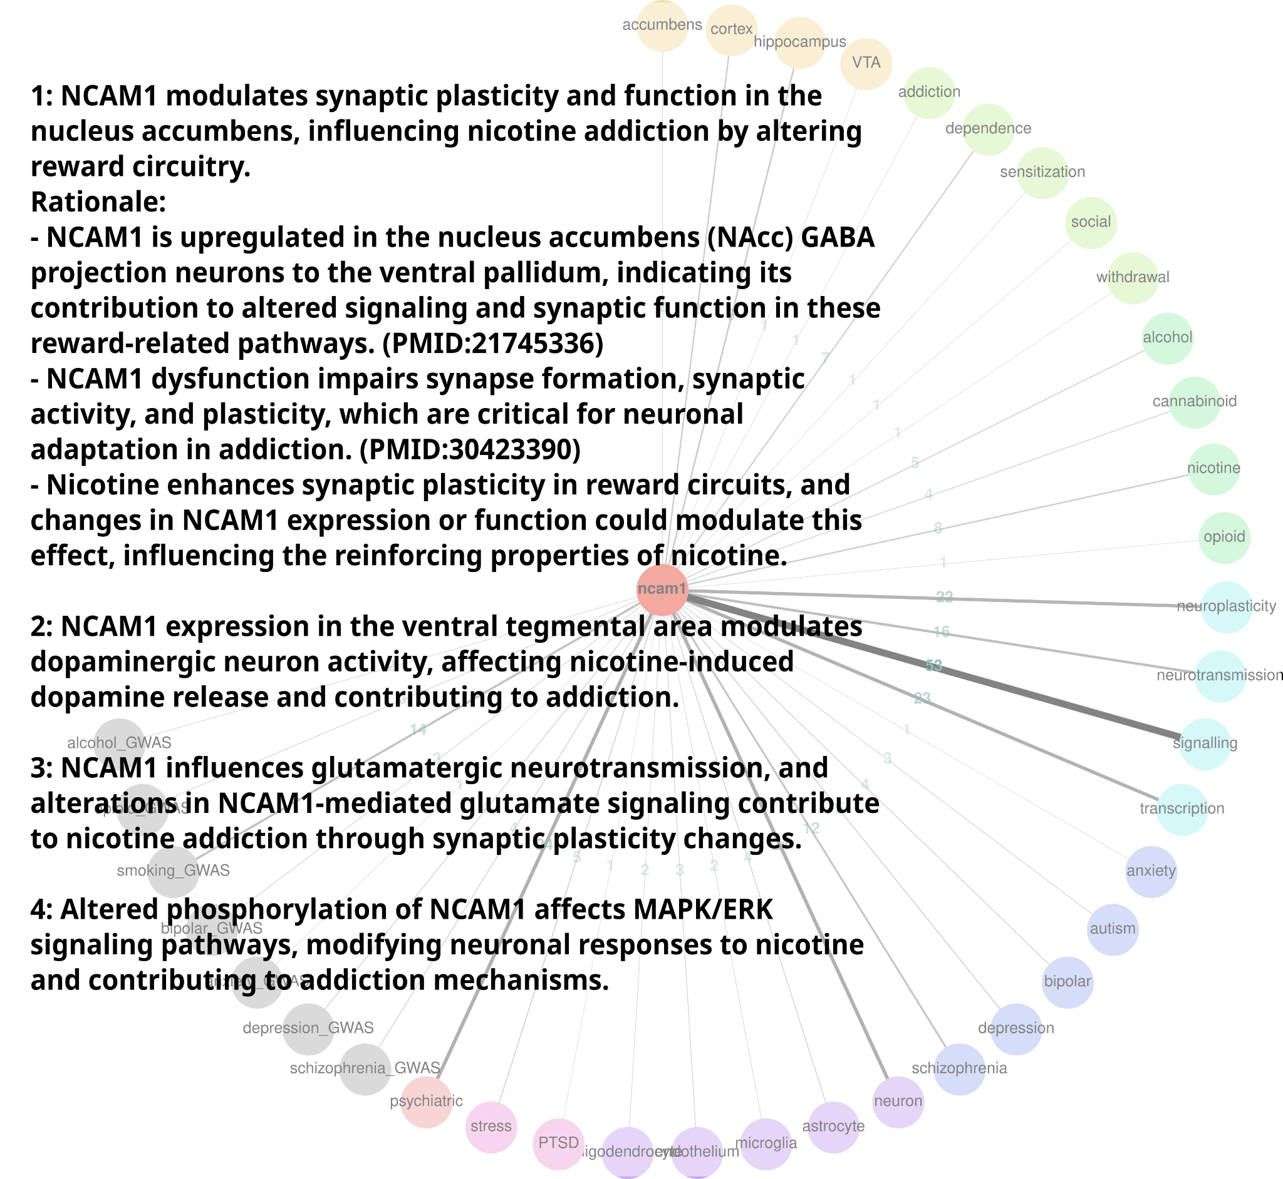
Figure 7. Automatic hypothesis generation. GeneCup was used to retrieve literature for Ncam1. Thickness of lines indicate the number of sentences. We submitted a total of 119 sentences containing Ncam1 and one of the keywords to an LLM and prompted it to generate hypotheses on nicotine addiction (inset). PMIDs from GeneCup were carried over to the final output. The methods further hypothesized that the MAPK/ ERK mechanism could be the cause of other hypothesized mechanisms and described literature evidence (not shown due to limited space).

References – Single Molecule AI-assisted RaT omics (SMART) Core .
Abramson, J. et al., 2024. Accurate structure prediction of biomolecular interactions with AlphaFold 3. Nature. Available at: http://dx.doi.org/10.1038/s41586-024-07487-w.
Adzhubei, I.A. et al., 2010. A method and server for predicting damaging missense mutations. Nature methods, 7(4), pp.248–249.
Akbari, V. et al., 2021. Megabase-scale methylation phasing using nanopore long reads and NanoMethPhase. Genome biology, 22(1), p.68.
Argelaguet, R. et al., 2020. MOFA+: a statistical framework for comprehensive integration of multi-modal single-cell data. Genome biology, 21(1), p.111.
Argelaguet, R. et al., 2018. Multi-Omics Factor Analysis-a framework for unsupervised integration of multi-omics data sets. Molecular systems biology, 14(6), p.e8124.
Arora, A. et al., 2021. The role of alternative polyadenylation in the regulation of subcellular RNA localization. Frontiers in genetics, 12, p.818668.
Avsec, Ž. et al., 2025. AlphaGenome: advancing regulatory variant effect prediction with a unified DNA sequence model. bioRxiv, p.2025.06.25.661532. Available at: https://www.biorxiv.org/content/10.1101/2025.06.25.661532v2.abstract [Accessed September 22, 2025].
Avsec, Ž. et al., 2021. Effective gene expression prediction from sequence by integrating long-range interactions. Nature methods, 18(10), pp.1196–1203.
Blum, K. et al., 1990. Allelic association of human dopamine D2 receptor gene in alcoholism. JAMA: the journal of the American Medical Association, 263(15), pp.2055–2060.
Cerneckis, J. et al., 2024. The rise of epitranscriptomics: recent developments and future directions. Trends in pharmacological sciences, 45(1), pp.24–38.
Chao, Y. et al., 2018. Analysis of transcripts and splice isoforms in red clover (Trifolium pratense L.) by single-molecule long-read sequencing. BMC plant biology, 18(1), p.300.
Chen, F. et al., 2023. Multi-ancestry transcriptome-wide association analyses yield insights into tobacco use biology and drug repurposing. Nature genetics, 55(2), pp.291–300.
Chen, H. et al., 2012. Genetic factors control nicotine self-administration in isogenic adolescent rat strains. PloS one, 7(8), p.e44234.
Chen, H., 2018. Yorodent, Github. Available at: https://github.com/chen42/Yorodent [Accessed September 22, 2018].
Chen, H. & Sharp, B.M., 2004. Content-rich biological network constructed by mining PubMed abstracts. BMC bioinformatics, 5, p.147.
Cingolani, P. et al., 2012. A program for annotating and predicting the effects of single nucleotide polymorphisms, SnpEff: SNPs in the genome of Drosophila melanogaster strain w1118; iso-2; iso-3. Fly, 6(2), pp.80–92.
Cui, H. et al., 2024. scGPT: toward building a foundation model for single-cell multi-omics using generative AI. Nature methods, 21(8), pp.1470–1480.
Dalla-Torre, H. et al., 2023. The Nucleotide Transformer: Building and Evaluating Robust Foundation Models for Human Genomics. Genomics. Available at: https://www.biorxiv.org/content/10.1101/2023.01.11.523679v3.
Ding, J. et al., 2002. Mining MEDLINE: abstracts, sentences, or phrases? Pacific Symposium on Biocomputing. Pacific Symposium on Biocomputing, pp.326–337.
Eizenga, J.M. et al., 2020. Pangenome Graphs. Annual review of genomics and human genetics, 21, pp.139–162.
Fang, R. et al., 2021. Comprehensive analysis of single cell ATAC-seq data with SnapATAC. Nature communications, 12(1), p.1337.
Feng, H., Conneely, K.N. & Wu, H., 2014. A Bayesian hierarchical model to detect differentially methylated loci from single nucleotide resolution sequencing data. Nucleic acids research, 42(8), p.e69.
Fodor, S.P. et al., 1991. Light-directed, spatially addressable parallel chemical synthesis. Science, 251(4995), pp.767–773.
Fortelny, N. et al., 2017. Can we predict protein from mRNA levels? Nature, 547(7664), pp.E19–E20.
Fujiki, R., Ikeda, M. & Ohara, O., 2019. Short DNA probes developed for sample tracking and quality assurance in gene panel testing. The Journal of molecular diagnostics: JMD, 21(6), pp.1079–1094.
Gelernter, J. et al., 2014. Genome-wide association study of cocaine dependence and related traits: FAM53B identified as a risk gene. Molecular psychiatry, 19(6), pp.717–723.
Gibbs, R.A. et al., 2004. Genome sequence of the Brown Norway rat yields insights into mammalian evolution. Nature, 428(6982), pp.493–521.
Gordon, S.P. et al., 2015. Widespread polycistronic transcripts in fungi revealed by single-molecule mRNA sequencing. PloS one, 10(7), p.e0132628.
Gunturkun, M.H. et al., 2022. GeneCup: mining PubMed and GWAS catalog for gene–keyword relationships. G3 Genes|Genomes|Genetics, 12(5), p.jkac059.
Gunturkun, M.H. et al., 2021. SVJAM: Joint analysis of structural variants using linked read sequencing data. Available at: http://dx.doi.org/10.1101/2021.11.02.467006.
Hafemeister, C. & Satija, R., 2019. Normalization and variance stabilization of single-cell RNA-seq data using regularized negative binomial regression. Genome biology, 20(1), p.296.
van Heesch, S. et al., 2013. Improving mammalian genome scaffolding using large insert mate-pair next-generation sequencing. BMC genomics, 14, p.257.
Howe, K. et al., 2021. The genome sequence of the Norway rat, Rattus norvegicus Berkenhout 1769. Wellcome open research, 6, p.118.
Ito, R., Robbins, T.W. & Everitt, B.J., 2004. Differential control over cocaine-seeking behavior by nucleus accumbens core and shell. Nature neuroscience, 7(4), pp.389–397.
Jiang, Z., Chen, Z. & Chen, X., 2023. Candidate gene-environment interactions in substance abuse: A systematic review. PloS one, 18(10), p.e0287446.
de Jong, T.V. et al., 2024. A revamped rat reference genome improves the discovery of genetic diversity in laboratory rats. Cell genomics, 4(4), p.100527.
Kalbfleisch, T.S. et al., 2024. Three decades of rat genomics: approaching the finish(ed) line. Physiological genomics. Available at: http://dx.doi.org/10.1152/physiolgenomics.00110.2024.
Karikó, K. et al., 2008. Incorporation of pseudouridine into mRNA yields superior nonimmunogenic vector with increased translational capacity and biological stability. Molecular therapy: the journal of the American Society of Gene Therapy, 16(11), pp.1833–1840.
Kolodziejczyk, A.A. et al., 2015. The technology and biology of single-cell RNA sequencing. Molecular cell, 58(4), pp.610–620.
Korsunsky, I. et al., 2019. Fast, sensitive and accurate integration of single-cell data with Harmony. Nature methods, 16(12), pp.1289–1296.
Kovaka, S. et al., 2020. Targeted nanopore sequencing by real-time mapping of raw electrical signal with UNCALLED. Nature biotechnology. Available at: http://dx.doi.org/10.1038/s41587-020-0731-9.
Lander, E.S. et al., 2001. Initial sequencing and analysis of the human genome. Nature, 409(6822), pp.860–921.
Lansdon, L.A. et al., 2021. Factors affecting migration to GRCh38 in laboratories performing clinical next-generation sequencing. The Journal of molecular diagnostics: JMD, 23(5), pp.651–657.
Liao, W.-W. et al., 2023. A draft human pangenome reference. Nature, 617(7960), pp.312–324.
Lin, Y.-J. et al., 2024. Variant Impact Predictor database (VIPdb), version 2: trends from three decades of genetic variant impact predictors. Human genomics, 18(1), p.90.
Liu, H. et al., 2021. DNA methylation atlas of the mouse brain at single-cell resolution. Nature, 598(7879), pp.120–128.
Liu, M. et al., 2019. Association studies of up to 1.2 million individuals yield new insights into the genetic etiology of tobacco and alcohol use. Nature genetics. Available at: http://dx.doi.org/10.1038/s41588-018-0307-5.
Lusk, R. et al., 2021. Aptardi predicts polyadenylation sites in sample-specific transcriptomes using high-throughput RNA sequencing and DNA sequence. Nature communications, 12(1), p.1652.
Madadi, Y. et al., 2023. Artificial Intelligence Models for Cell Type and Subtype Identification Based on Single-Cell RNA Sequencing Data in Vision Science. IEEE/ACM transactions on computational biology and bioinformatics / IEEE, ACM, 20(5), pp.2837–2852.
Madadi, Y. et al., 2022. Detecting Retinal Neural and Stromal Cell Classes and Ganglion Cell Subtypes Based on Transcriptome Data with Deep Transfer Learning. Bioinformatics . Available at: http://dx.doi.org/10.1093/bioinformatics/btac514.
Mayfield, R.D., 2017. Emerging roles for ncRNAs in alcohol use disorders. Alcohol , 60, pp.31–39.
McLaren, W. et al., 2016. The Ensembl Variant Effect Predictor. Genome biology, 17(1), p.122.
Miao, Z. et al., 2020. Putative cell type discovery from single-cell gene expression data. Nature methods, 17(6), pp.621–628.
Mock, A. et al., 2023. Transcriptome profiling for precision cancer medicine using shallow nanopore cDNA sequencing. Scientific reports, 13(1), p.2378.
Muenstermann, C. & Clemens, K.J., 2024. Epigenetic mechanisms of nicotine dependence. Neuroscience and biobehavioral reviews, 156(105505), p.105505.
Munro, D. et al., 2022. The regulatory landscape of multiple brain regions in outbred heterogeneous stock rats. Nucleic acids research, 50(19), pp.10882–10895.
Ng, P.C. & Henikoff, S., 2003. SIFT: Predicting amino acid changes that affect protein function. Nucleic acids research, 31(13), pp.3812–3814.
Nguyen, E. et al., 2023. HyenaDNA: Long-range genomic sequence modeling at single nucleotide resolution. arXiv [cs.LG]. Available at: http://arxiv.org/abs/2306.15794.
Nguyen, E. et al., 2024. Sequence modeling and design from molecular to genome scale with Evo. Synthetic Biology. Available at: https://www.biorxiv.org/content/10.1101/2024.02.27.582234v2.
Nurk, S. et al., 2022. The complete sequence of a human genome. Science, 376(6588), pp.44–53.
Pasternak, G.W., 2018. Mu opioid pharmacology: 40 years to the Promised Land. Advances in pharmacology, 82, pp.261–291.
Phillips, R.A., 3rd et al., 2023. Distinct subpopulations of D1 medium spiny neurons exhibit unique transcriptional responsiveness to cocaine. Molecular and cellular neurosciences, 125, p.103849.
Pontieri, F.E., Tanda, G. & Di Chiara, G., 1995. Intravenous cocaine, morphine, and amphetamine preferentially increase extracellular dopamine in the “shell” as compared with the “core” of the rat nucleus accumbens. Proceedings of the National Academy of Sciences of the United States of America, 92(26), pp.12304–12308.
Poplin, R. et al., 2018. A universal SNP and small-indel variant caller using deep neural networks. Nature biotechnology. Available at: http://dx.doi.org/10.1038/nbt.4235.
Raja, H. et al., 2024. Automated Category and Trend Analysis of Scientific Articles on Ophthalmology Using Large Language Models: Development and Usability Study. JMIR formative research, 8, p.e52462.
Ramani, R. et al., 2019. PhastWeb: a web interface for evolutionary conservation scoring of multiple sequence alignments using phastCons and phyloP. Bioinformatics , 35(13), pp.2320–2322.
Ramdas, S. et al., 2019. Extended regions of suspected mis-assembly in the rat reference genome. Scientific data, 6(1), p.39.
Rappoport, N. et al., 2023. Single cell Hi-C identifies plastic chromosome conformations underlying the gastrulation enhancer landscape. Nature communications, 14(1), p.3844.
Rompala, G. et al., 2023. Profiling neuronal methylome and hydroxymethylome of opioid use disorder in the human orbitofrontal cortex. Nature communications, 14(1), p.4544.
Sadakierska-Chudy, A. et al., 2017. Increased 5-hydroxymethylation levels in the hippocampus of rat extinguished from cocaine self-administration. Hippocampus, 27(7), pp.811–821.
Satterlee, J.S. et al., 2014. Novel RNA modifications in the nervous system: form and function. The Journal of neuroscience: the official journal of the Society for Neuroscience, 34(46), pp.15170–15177.
Schmeichel, B.E. et al., 2017. Hypocretin Neurotransmission Within the Central Amygdala Mediates Escalated Cocaine Self-administration and Stress-Induced Reinstatement in Rats. Biological psychiatry, 81(7), pp.606–615.
Sessegolo, C. et al., 2019. Transcriptome profiling of mouse samples using nanopore sequencing of cDNA and RNA molecules. Scientific reports, 9(1), p.14908.
Sharp, B.M. et al., Inbred rat heredity and sex affect oral oxycodone self-administration and augmented intake in long sessions: correlations with anxiety and novelty-seeking. PLoS ONE, p.Accepted. 2025
Shendure, J. & Ji, H., 2008. Next-generation DNA sequencing. Nature biotechnology, 26(10), pp.1135–1145.
Sibbesen, J.A. et al., 2023. Haplotype-aware pantranscriptome analyses using spliced pangenome graphs. Nature methods, 20(2), pp.239–247.
Stanojević, D., Li, Z., et al., 2024. Rockfish: A transformer-based model for accurate 5-methylcytosine prediction from nanopore sequencing. Nature communications, 15(1), p.5580.
Stanojević, D., Lin, D., et al., 2024. Telomere-to-telomere phased genome assembly using error-corrected Simplex nanopore reads. bioRxiv, p.2024.05.18.594796. Available at: https://www.biorxiv.org/content/10.1101/2024.05.18.594796v1 [Accessed June 25, 2024].
Stergachis, A.B. et al., 2020. Single-molecule regulatory architectures captured by chromatin fiber sequencing. Science, 368(6498), pp.1449–1454.
Swanson, D.R., 1986. Undiscovered Public Knowledge. The Library quarterly, 56(2), pp.103–118.
Tang, A.D. et al., 2020. Full-length transcript characterization of SF3B1 mutation in chronic lymphocytic leukemia reveals downregulation of retained introns. Nature communications, 11(1), p.1438.
Teague, C.D. & Nestler, E.J., 2022. Key transcription factors mediating cocaine-induced plasticity in the nucleus accumbens. Molecular psychiatry, 27(1), pp.687–709.
Thomo, A., 2024. PubMed Retrieval with RAG Techniques. Studies in health technology and informatics, 316, pp.652–653.
Thorgeirsson, T.E. et al., 2008. A variant associated with nicotine dependence, lung cancer and peripheral arterial disease. Nature, 452(7187), pp.638–642.
Tobacco and Genetics Consortium, 2010. Genome-wide meta-analyses identify multiple loci associated with smoking behavior. Nature genetics, 42(5), pp.441–447.
Twigger, S.N. et al., 2008. What everybody should know about the rat genome and its online resources. Nature genetics, 40(5), pp.523–527.
Venter, J.C. et al., 2001. The sequence of the human genome. Science, 291(5507), pp.1304–1351.
Villani, F. et al., 2024. Pangenome reconstruction in rats enhances genotype-phenotype mapping and novel variant discovery. Genomics. Available at: https://www.biorxiv.org/content/10.1101/2024.01.10.575041v1.
Wang, B. et al., 2016. Unveiling the complexity of the maize transcriptome by single-molecule long-read sequencing. Nature communications, 7, p.11708.
Wang, K., Li, M. & Hakonarson, H., 2010. ANNOVAR: functional annotation of genetic variants from high-throughput sequencing data. Nucleic acids research, 38(16), p.e164.
Wang, Z. et al., 2024. Adapting nanopore sequencing basecalling models for modification detection via incremental learning and anomaly detection. Nature communications, 15(1), p.7148.
Watson, A. et al., 1998. Technology for microarray analysis of gene expression. Current opinion in biotechnology, 9(6), pp.609–614.
Wei, G., 2024. RNA m6A modification, signals for degradation or stabilisation? Biochemical Society transactions, 52(2), pp.707–717.
Worley, K.C., Weinstock, G.M. & Gibbs, R.A., 2008. Rats in the genomic era. Physiological genomics, 32(3), pp.273–282.
Wucher, V. et al., 2017. FEELnc: a tool for long non-coding RNA annotation and its application to the dog transcriptome. Nucleic acids research, 45(8), p.e57.
Yang, J. et al., 2024. De novo prediction of functional effects of genetic variants from DNA sequences based on context-specific molecular information. Frontiers in systems biology, 4. Available at: https://www.frontiersin.org/journals/systems-biology/articles/10.3389/fsysb.2024.1402664/full.
Yun, T. et al., 2021. Accurate, scalable cohort variant calls using DeepVariant and GLnexus. Bioinformatics , 36(24), pp.5582–5589.
Zhang, H. et al., 2018. Transcriptome characterization of moso bamboo (Phyllostachys edulis) seedlings in response to exogenous gibberellin applications. BMC plant biology, 18(1), p.125.
Zhang, L., Zhang, W. & Chen, K., 2010. Search for cancer risk factors with microarray-based genome-wide association studies. Technology in cancer research & treatment, 9(2), pp.107–121.
Zhong, J.-Y. et al., 2023. High-throughput Pore-C reveals the single-allele topology and cell type-specificity of 3D genome folding. Nature communications, 14(1), p.1250.
Zhou, H. et al., 2020. Association of OPRM1 Functional Coding Variant With Opioid Use Disorder: A Genome-Wide Association Study. JAMA psychiatry , 77(10), pp.1072–1080.
Zhou, J. & Troyanskaya, O.G., 2015. Predicting effects of noncoding variants with deep learning-based sequence model. Nature methods, 12(10), pp.931–934.
Zhou, Z. et al., 2024. DNABERT-2: Efficient foundation model and benchmark for multi-species genomes. International Conference on Learning Representations. Available at: https://arxiv.org/html/2306.15006v2.

