Exponential Distribution and Central Limit Theorem

Jenhau Chen

February 15, 2016

# Overview

This is a simulation to demonstrate Central Limit Theorem by using Exponential Distribution, which has the following properties:

* **PDF $λe^{−λx}$**
* **CDF $1−e^{−λx}$**
* **Mean $λ^{−1}$**
* **Variance $λ^{−2}$**
* **Standard Deviation $λ^{−1}$**

# Simulations

I will be setting $λ=0.2$ with $40$ observations in each simulation. $1000$ simulations will be executed. According to the Law of Large Numbers, or LLN, the mean should converge to the theorectical mean.

# simulation parameters  
# number of observations  
n = 40  
# number of simulations  
sim_n = 1000  
# rate  
lambda = 0.2  
  
# Theoretical mean  
mu = lambda^(-1)  
  
# Theoretical variance  
sigma_sq = lambda^(-2)  
  
# Theoretical standard deviation  
sigma = lambda^(-1)  
  
# Standard Error  
se = lambda^(-1)/sqrt(n)  
  
# set the seed so our random generation is reproducible  
set.seed(40)  
  
mean_distribution = NULL  
var_distribution = NULL  
sd_distribution = NULL  
clt_distribution = NULL

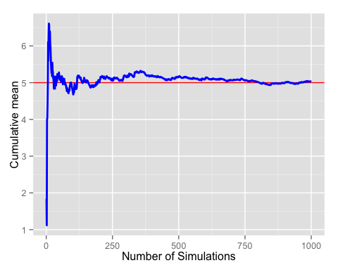

Now start the simulation for mean and variance. Since I have controlled the seed, **rexp** will always generate the same set of random variables and the results are comparable. If the seed isn't controlled, each **rexp** call will gerenrate its own random variables and the **mean** and **variance** will have nothing to do with each other.

for(i in 1: sim_n) {  
 mean_distribution = c(mean_distribution, mean(rexp(n, lambda)))  
}  
  
mean_df = data.frame(x = mean_distribution)  
  
for(i in 1: sim_n) {  
 var_distribution = c(var_distribution, var(rexp(n, lambda)))  
}  
  
var_df = data.frame(x = var_distribution)  
  
for(i in 1: sim_n) {  
 sd_distribution = c(sd_distribution, sd(rexp(n, lambda)))  
}  
  
sd_df = data.frame(x = sd_distribution)

# Sample Mean vs Theoretical Mean

When comparing with the theoretical mean, $λ^{−1}=1/0.2=5$, the following plot shows the sample mean converging to the theoretical mean:

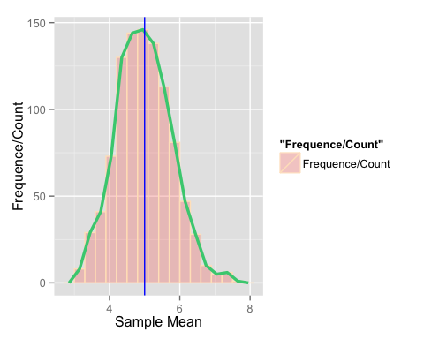

# Sample Variance vs Theoretical Variance

Similiarly when comparing with the theoretical variance, $λ^{−2}=(1/0.2)^{2}=25$, the following plot shows the sample variance converging to the theoretical variance:

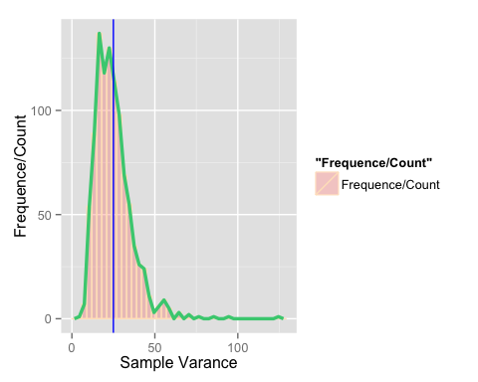

However notice the long tail on the right. I believe it is due to how variance is calculated. If I use standard deviation instead, the plot becomes more Gaussian:

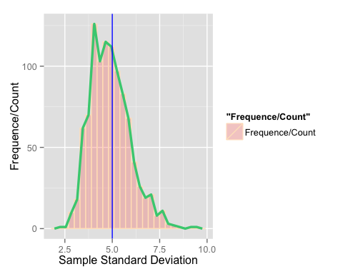

# Distribution

According to Central Limit Theorem, CLT, I am expecting the reuslt closely match with a standard normal distribution. I demonstrated this point using a density plot:

## Sample Mean vs. Normal Density

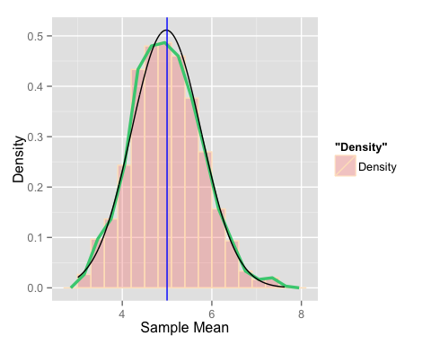

## Sample Variance vs. Normal Density

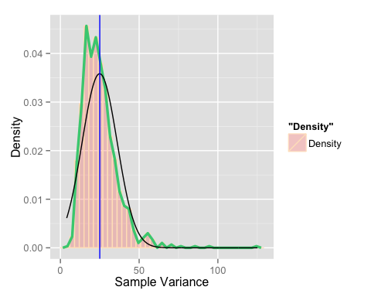

## Sample Standard Deviation vs. Normal Density

Again I don't like seeing the long tail so I am using standard deviation distribution to validate CLT: 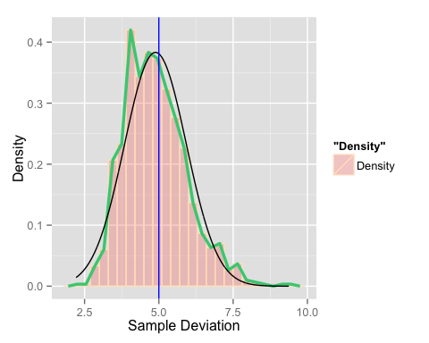

## Normalized Distribution

Lastly according to CLT, I am expecting

$$\frac{{\overline{X}}_{n}−μ}{σ/\sqrt{n}}=\frac{\sqrt{n}({\overline{X}}_{n}−μ)}{σ}=\frac{Estimate−Meanofestimate}{Std.Err.ofestimate}$$

has a distribution like that of a standard normal for large $n$.

Playing with the similuation data again, I have the following plot which validates this point:

for(i in 1: sim_n) {  
 clt_distribution = c(clt_distribution, (mean_distribution[i] - mu)/se)  
}  
clt_df = data.frame(x = clt_distribution)

