飞检抽样（2.8.0版本）：

<http://192.168.8.112:18008/swagger-ui.html#!/public-controller/jobCalculateScoreUsingPOST>

2.9.0飞检抽样：

<http://192.168.8.112:18008/swagger-ui.html#!/public-controller/jobCalculateScoreUsingPOST>

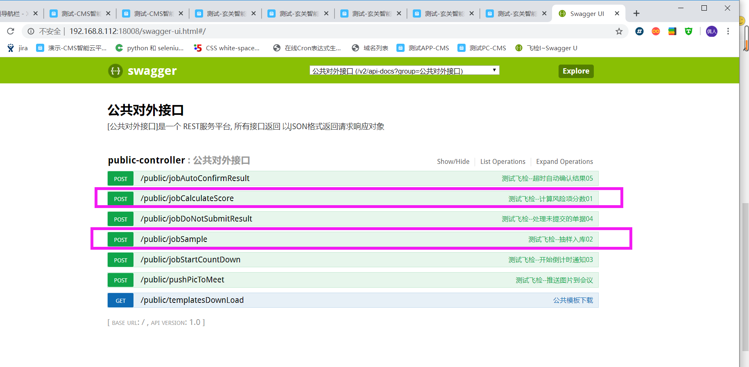

2.9.1飞检抽样（赵浩本机）

<http://192.168.3.178:18008/swagger-ui.html#!/public-controller/jobSampleUsingGET>

<http://192.168.8.112:18008/swagger-ui.html#!/public-controller/jobSampleUsingGET（测试环境）>

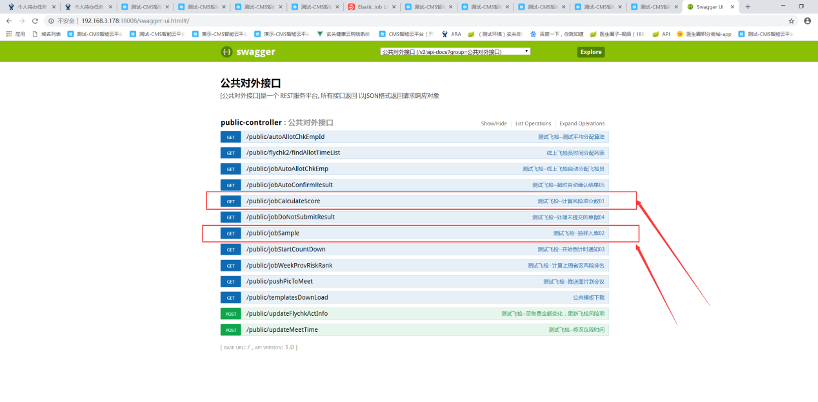

线上飞检的，还需要触发自动分配飞机员

