AdsManager

Adsmanager is used to manage the google admob.

1. Go to Tools 🡪 GameDesign.

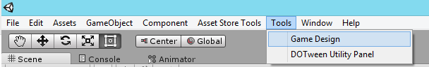

1. Activate admob ads and leaderboard from here , you also have other features too.

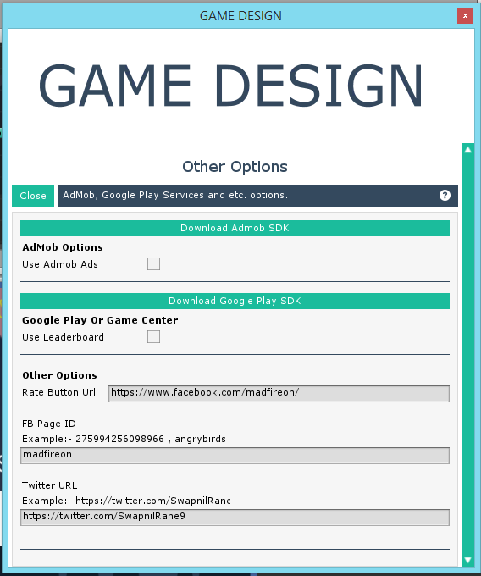

To use the ads you have 3 methods

ShowInterstitial() , ShowBannerAds().

You need to call this methods in other scripts to show ads eg: AdsManager.instance. ShowBannerAds();

AdsManager.instance. ShowInterstitial()

Put the admob code in if statement so that if player buy remove ads then it wont show.

If(GameManager.instance.canShowAds == true)

{

}

Note:- Banner ads are shown without calling any code , to hide banner ads use the bannerhide method and to show again use the show method.