Level Info

Scripts:-

1. LevelScrollList – This script creates the button for the level menu.

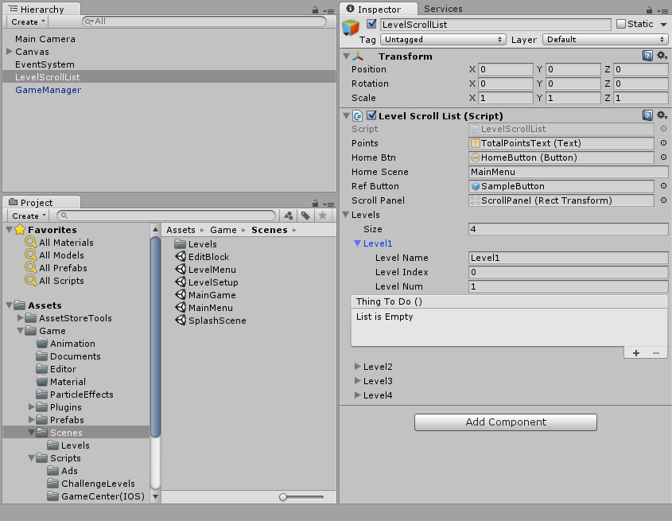

1. LevelCreator – This script creates the level by spawning specified object (blocks , hexa , starLine).

The positioning is done by the script no need to specify.

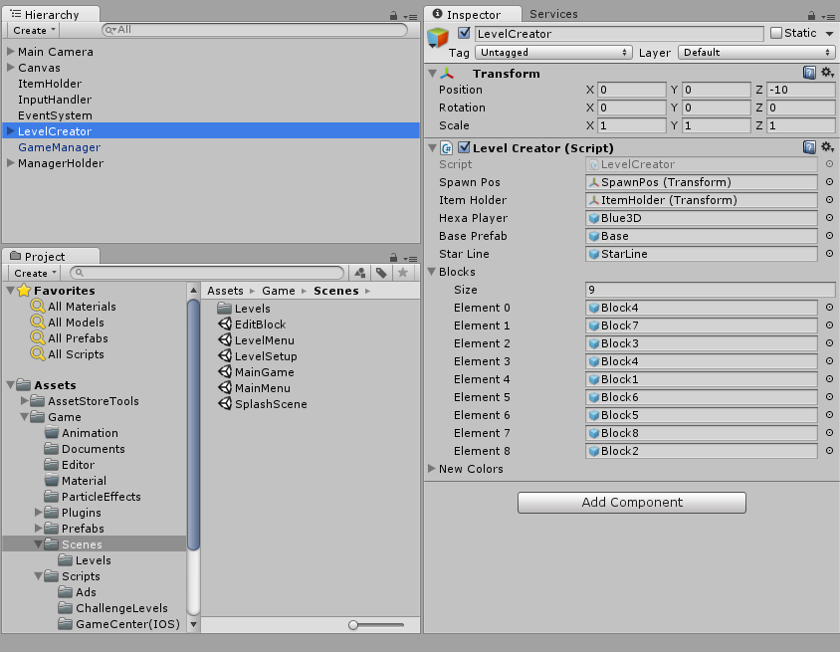

1. LevelGuiManager:- This script handles the gui of level.

