

Hexa!

Thanks for downloading the asset , for any help contact me at [madfireongames@gmail.com](mailto:madfireongames@gmail.com)

Scripts

GameManager – This script controls the game from start to end. It keep track of game , saves and loads the data , and do many important functions.

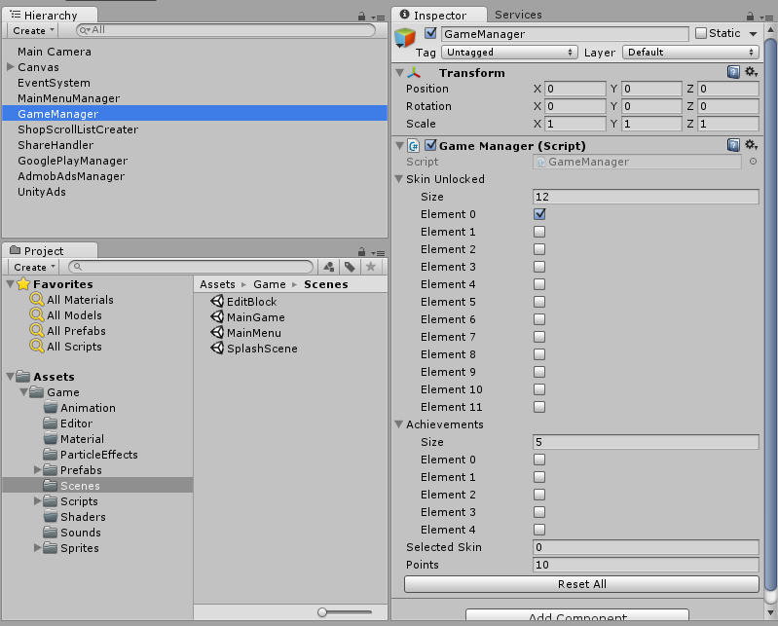

MainMenuManager- This script controls the function of the buttons in the main menu. Here you assign the buttons are write the function for them.

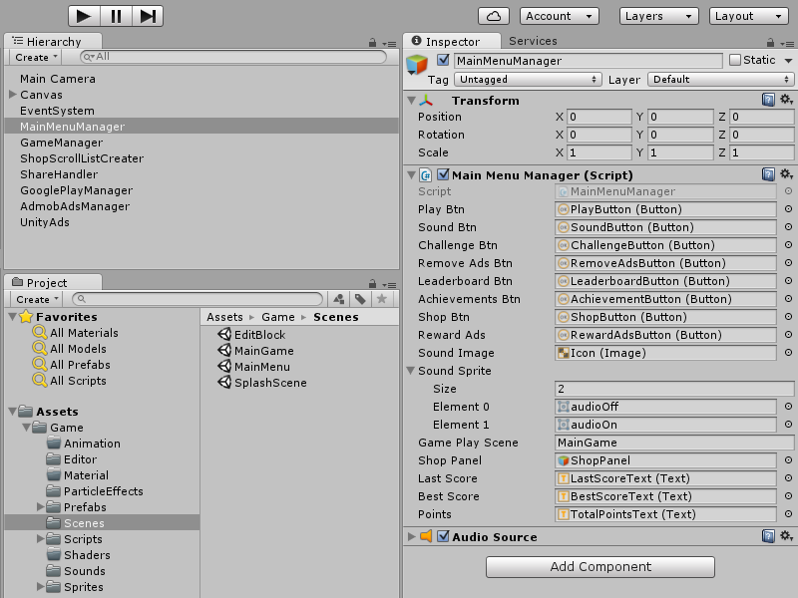

InGameGuiManager- This script controls the gui of the game play scene.

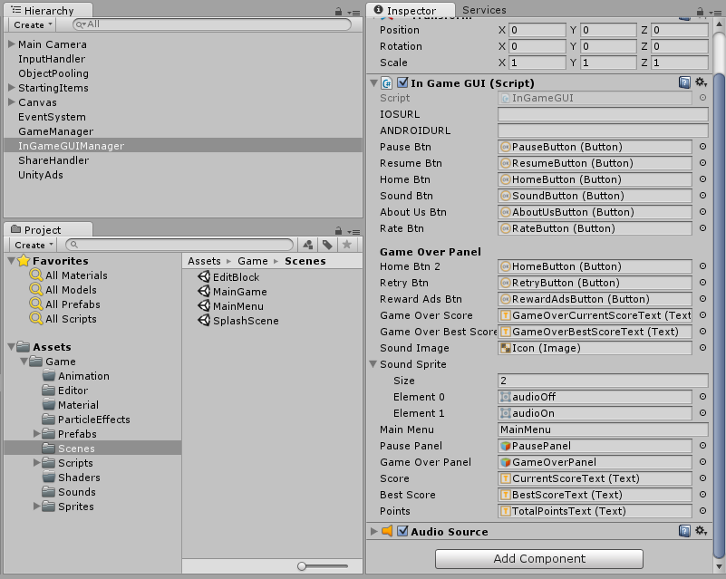

ObjectPooling – This creates the clone of object to be used repeatedly in the game. This help in increase in the smoothness of game.

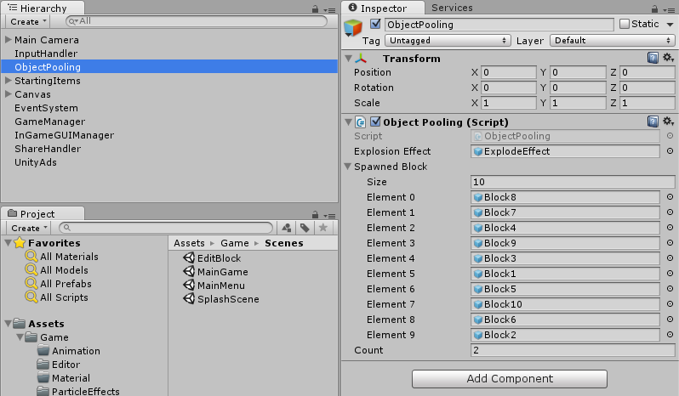

CreateScrollList – This script controls the in game shop.

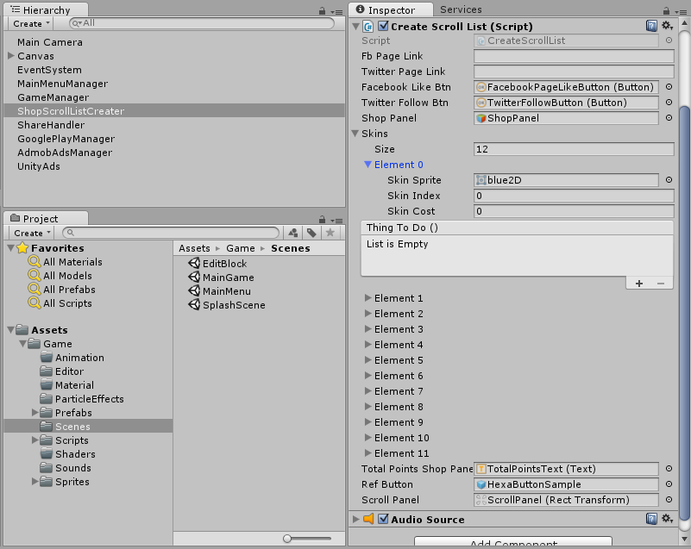

ShareScreenShot – This script handles the share score function , it works only for android and not on iOS.

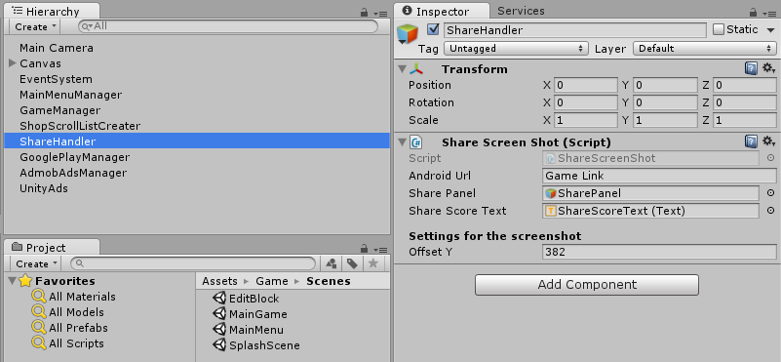

Important GameObject

MainCamera– This gameobject in the game play scene has two important objects 1) Gravity Activator 2) BlockSpawner

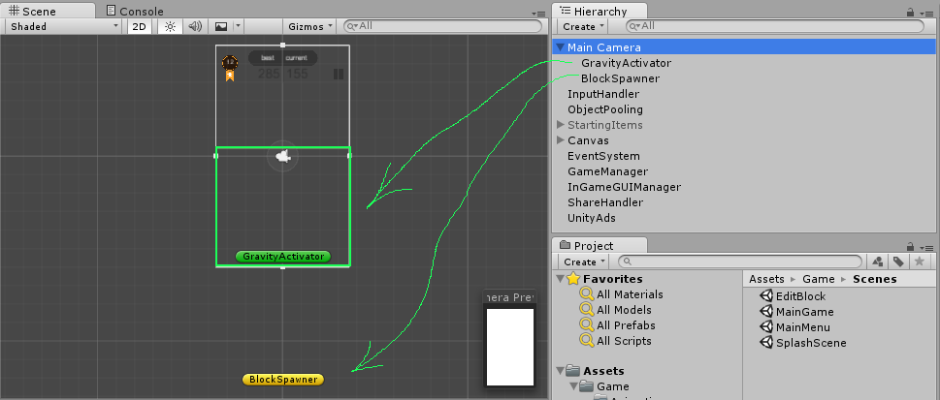

StartingItems– This gameobject in the game play scene has 5 position as children 1 for hexa object and 4 for block objects

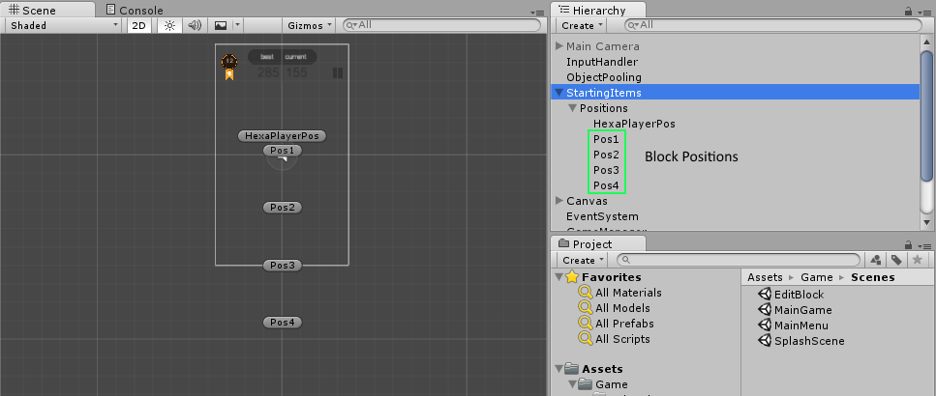

Some More Important– This gameobjects are important object for ads , play service and \*One more object call Purchaser is also present which handles unity iap\*

