Chen Eliyahou 312490675

Noam Simon 208388850

Report:

1. The threshold was a different likelihood value of 0.01 between iterations.
   1. Likelihood per iteration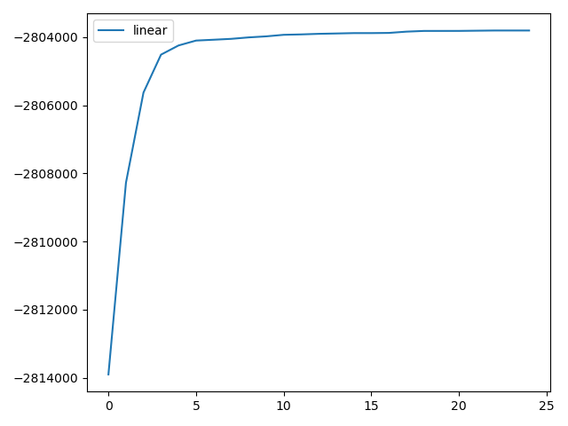
   2. Perplexity pre iteration: 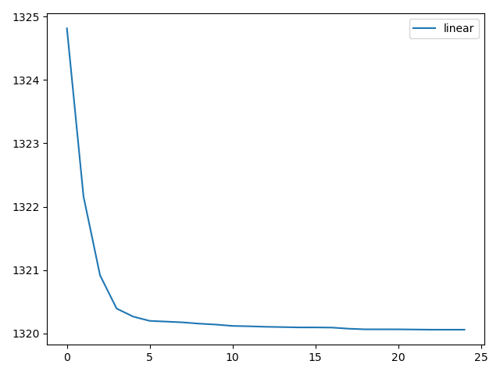
2. confusion matrix:

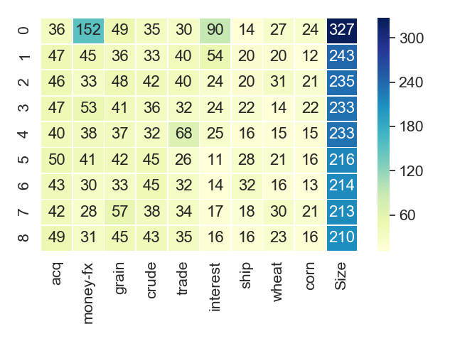

1. 9 histograms of topics, one for each cluster:

1. Acc: 0.2711864406779661
   1. K = 10
   2. vocabulary size after filtering - 6,800
   3. lambda: 0.001