**ASSIGNMENT**

**--DAY 1 – Introduction to SQL and relational databases.**

1.Write a SQL query to fetch all the columns from table “employee”.

Ans.



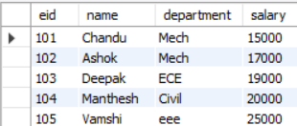

2. Write a SQL query to insert a new record into the “employee” table.

Ans

 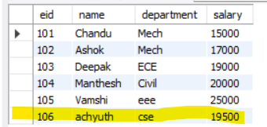

3. Write a SQL query to update the “quantity” column of the “products” table to 10 where the “productid” is 4.

Ans.



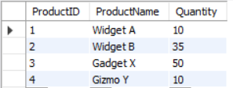

4. Write a SQL query to delete all the records from the “orders” table where the “status” is ‘canceled’.

Ans.



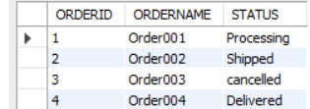 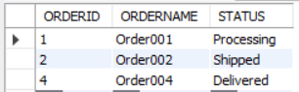

**--DAY 2—Filtering and Sorting data.**

1. Write a SQL query to retrieve all the columns from the “products” table where the “category” is ‘electronics’ and the price is less than 1000.

Ans.



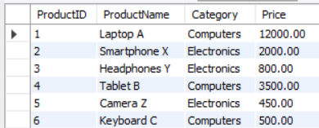

 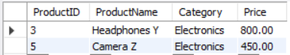

1. Write a SQL query to retrieve the names of all customers from the ‘customers’ table in alphabetical order.

Ans.

 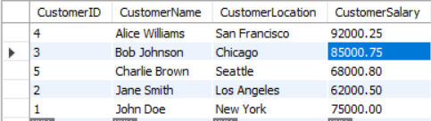

1. Write a SQL query to retrieve the total number of orders from the orders table.

Ans.





**--DAY 3--Joining Tables.**

1. Write a SQL query to retrieve the product name, Category and supplier name from the “products”, “categories” and “suppliers” tables, joining them on appropriate columns.

Ans.

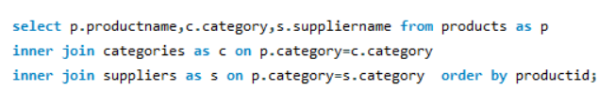

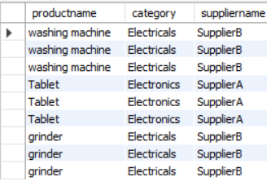

1. Write a SQL query to retrieve the employee name and Department name from the “employees” and “department” tables, joining them on the ‘department_id’ column.

Ans.

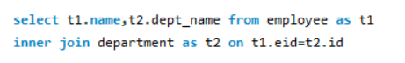

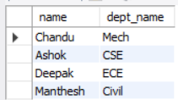

1. Write a SQL query to retrieve the customer name and order amount from the customers and orders tables, joining them on the customer ID column and only including orders with amounts greater than 1000.

Ans.

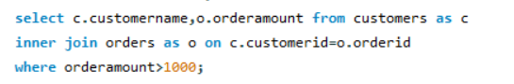

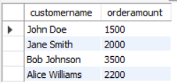

**--DAY 4-- Aggregating the data.**

1. Write a SQL query to retrieve the average price of products in each category from the “products” table.

Ans.



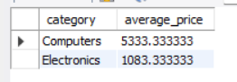

1. Write a SQL query to retrieve the maximum salary for each department from the “employees” table.

Ans. 

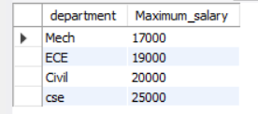

3. Write a SQL query to retrieve the total revenue generated by each customer from the “products” and “customers” tables.

Ans. 

