

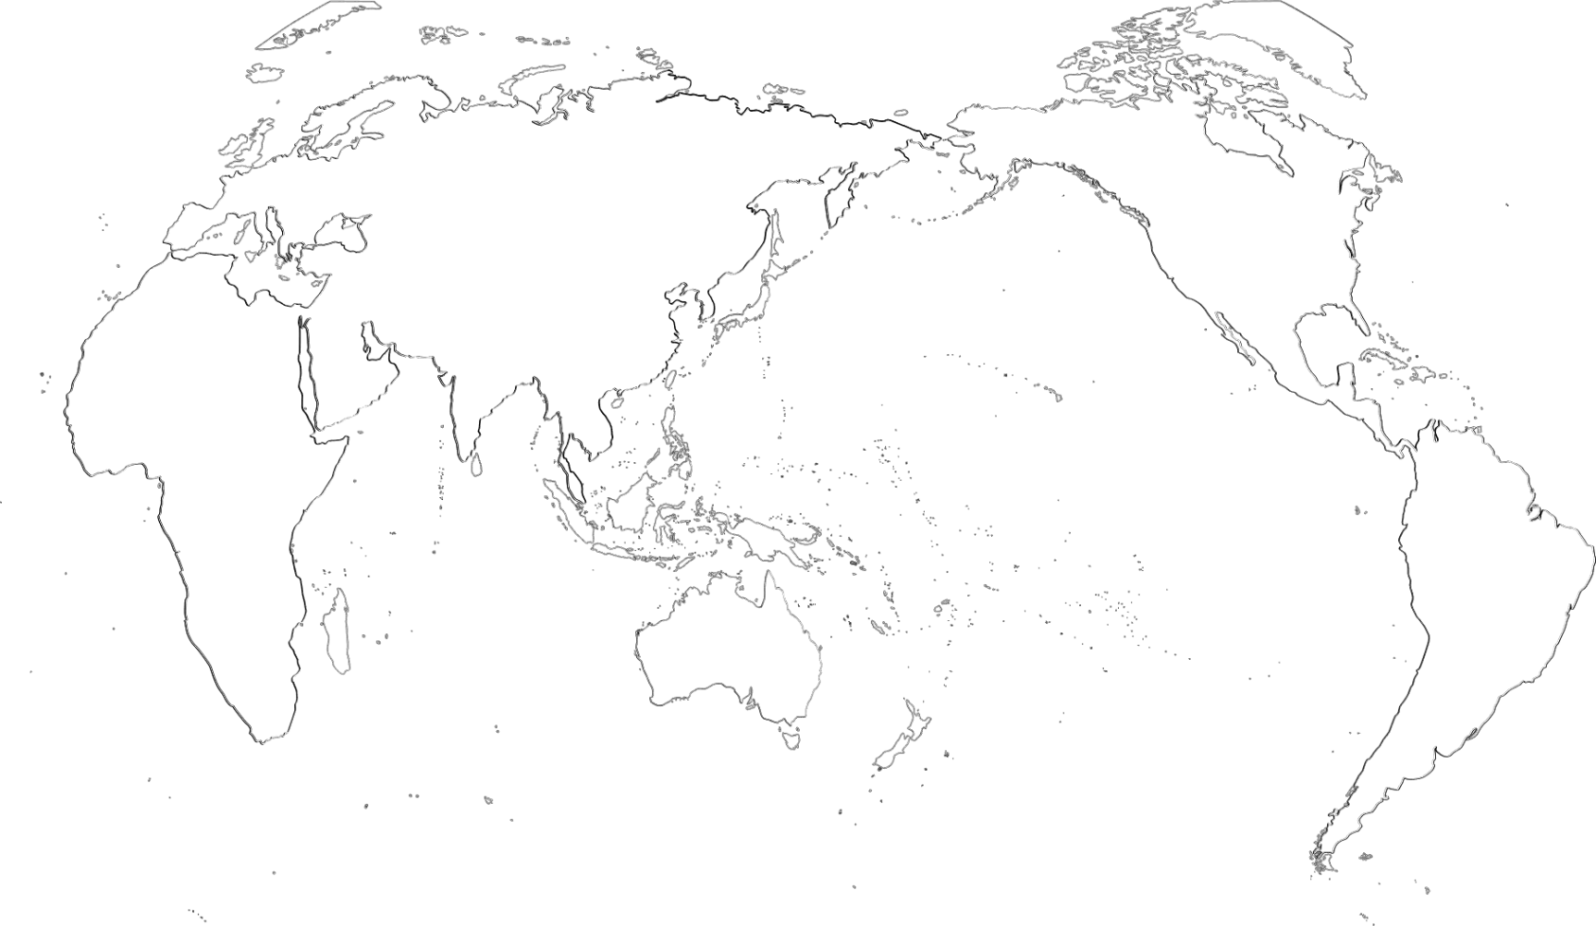

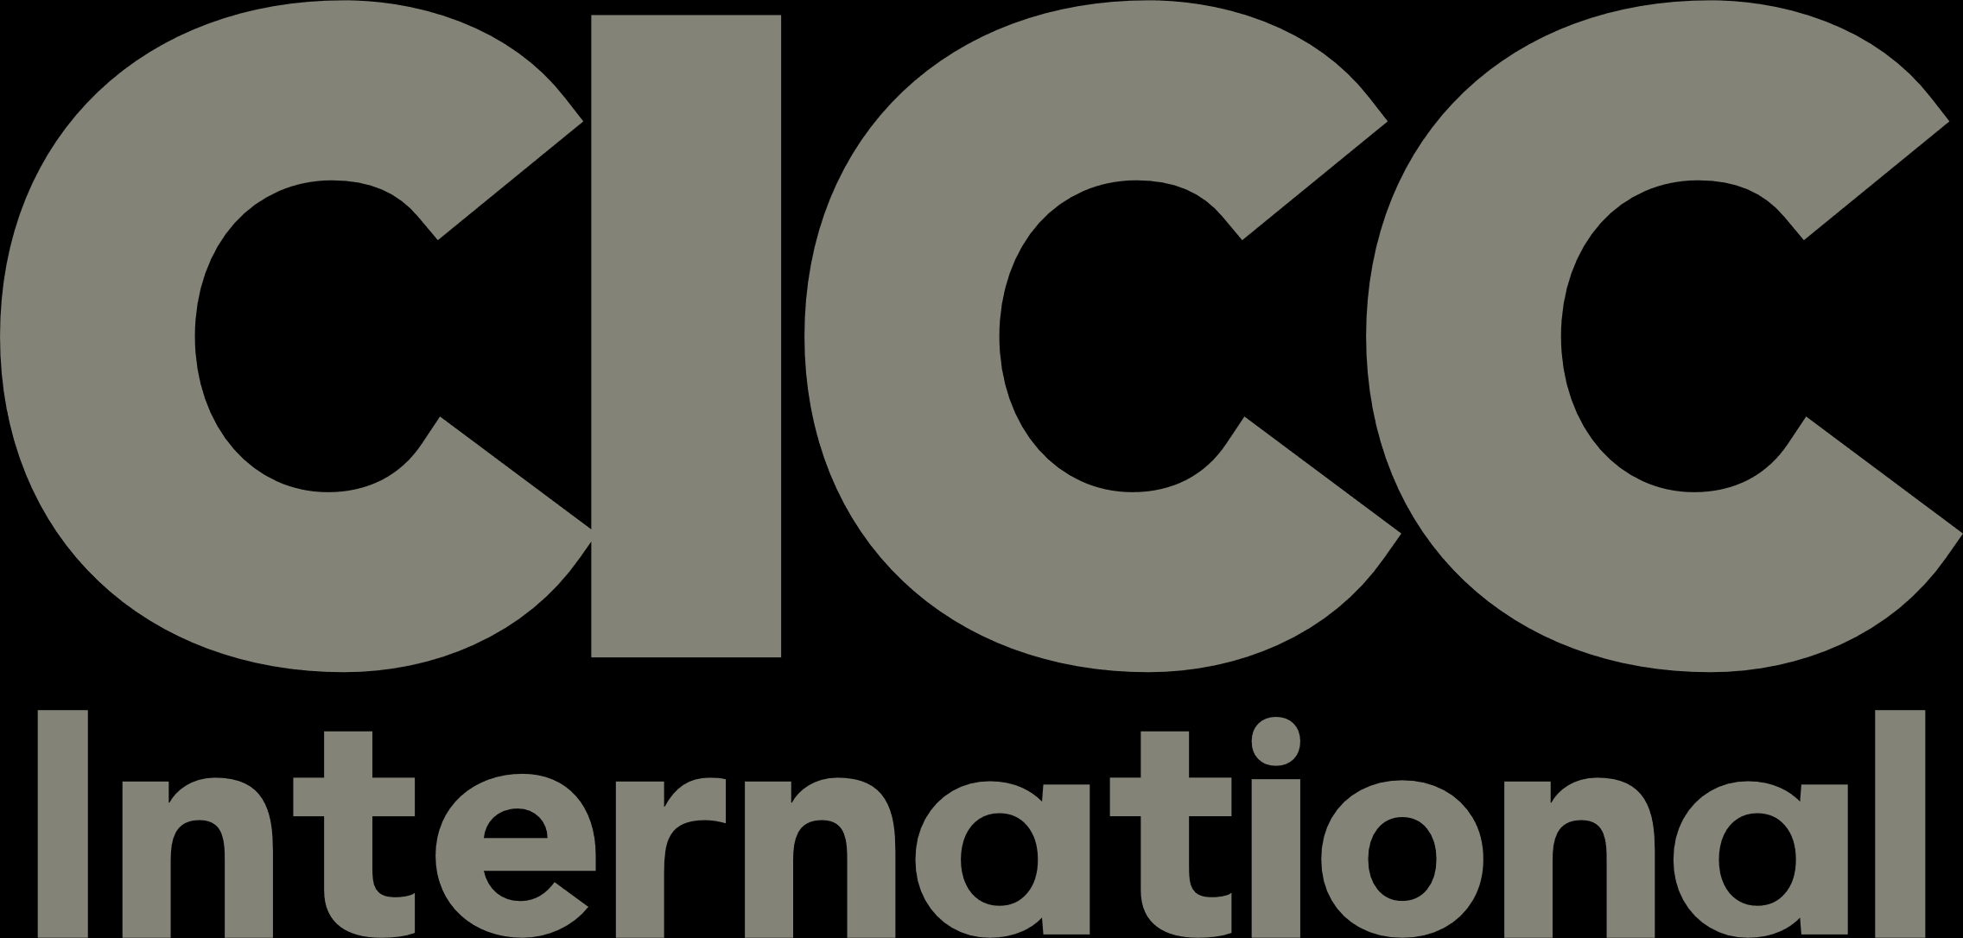
Global Markets
News Digest

Issue 136
Apr 15, 2026 – Apr 21, 2026

Newsletter Highlights
Saudi Arabia………………………………………………………………………………………….P2
China's global leading copper tube and rod supplier Hailiang will set up a USD 566 million copper processing JV in Saudi Arabia with investment firm Rawas
Saudi steel maker Al Yamamah Steel signed a USD 33.59 million contract with China Power Construction subsidiary SEPCO III to supply wind towers for the Yanbu wind farm
Saudi Arabia’s PIF board approved and announced the 2026–2030 strategy with a three-portfolio investment framework
Saudi Arabia’s PIF will increase its stake in US EV maker Lucid by buying USD 550 million of convertible preferred stock alongside Uber’s USD 200 million commitment
China-based AI agent company CREAO AI raised a USD multi-million round co-led by Saudi Aramco-backed Prosperity7 Ventures, bringing its past-year funding to more than USD 30 million
UAE…………………………………………………………………………………………………….P3
Abu Dhabi-listed Borouge signed a 50:50 JV agreement with China’s Wanrong New Materials to develop a greenfield cracker and polyethylene complex in Fujian
The UAE Ministry of Investment signed an MoU with China’s Jereh Group to build an integrated clean energy and industrial platform, including SMRs, anode materials, and battery recycling
China’s Didi, Pony.ai, and Baidu’s Apollo Go are expanding in the UAE as they advance testing and commercial rollouts in Dubai and Abu Dhabi
UAE investor EIIC acquired a minority stake in Denmark-headquartered Joe & The Juice at a USD 1.80 billion valuation, while General Atlantic remains the majority shareholder
Kazakhstan ……………………………………………….………………………………………..P4

Tencent invests USD 518 million in Kazakhstan’s leading fintech company Kaspi.kz

Kazakhstan delegation attends SCO phytosanitary mechanism meeting and holds bilateral talks with Chinese representatives

Beijing launches first scheduled Central Asia freight train to Almaty, to operate weekly on regular basis

Kazakhstan sets target to increase transit transport volume to 55 million tons, accelerating push for Eurasian hub status
South Korea……………………………………………….………………………………………... P5
South Korean IT solutions provider Samsung SDS partners with KKR, secures USD 820 million investment to accelerate AI push
South Korean budget coffee chain operator MGC Global bids for South Korean convenience supermarket chain Homeplus Express, likely to form consortium with external financial investor
South Korean private equity firm Orchestra PE sells KFC Korea to U.S. alternative asset management giant Carlyle Group for USD 135 million
Bain Capital sells entire stake in Korea Zinc to Meritz Securities for USD 350 million as ally Hanwha Group explores exit

Saudi Arabia
China's global leading copper tube and rod supplier Hailiang will set up a USD 566 million copper processing JV in Saudi Arabia with investment firm Rawas
On April 14, China’s Hailiang, a global leading supplier of copper tubes and rods, said it will partner with Saudi strategic investment and development company Rawas National Investment Holding to establish a USD 566 million copper materials processing joint venture in Saudi Arabia to invest in, build, and operate a new copper project. Hailiang plans to sign an investment agreement to set up the JV, with Hailiang holding 51% and Rawas holding 49%, while the company did not disclose when the agreement will be signed. The project will be located at Dammam Port and is designed for 150,000 tonnes of annual processing capacity, including copper tubes, copper busbars, refined recycled copper, and copper foil. (Source: Yicai, Apr 14, 2026)
Saudi steel maker Al Yamamah Steel signed a USD 33.59 million contract with China Power Construction subsidiary SEPCO III to supply wind towers for the Yanbu wind farm
On April 15, Saudi steel maker Al Yamamah Steel Industries Co. said it has signed a nine-month contract with EPC contractor SEPCO III (Shandong Electric Power Construction Corporation No. 3), a subsidiary of China Electric Power Construction Corporation, to supply steel wind towers for the Yanbu wind farm in Madinah Province. The contract is valued at SAR 126 million (USD 33.59 million), and the company said deliveries will start this month, with the financial impact to be reflected in its Q2 2026 results. SEPCO III was awarded the EPC contract in July 2025 for the 700 MW Yanbu Wind IPP, which is being developed by a consortium of Japan’s Marubeni and Saudi Arabia’s Ajlan & Bros Holding. (Source: Zawya, April 15, 2026)
Saudi Arabia’s PIF board approved and announced the 2026-2030 strategy with a three-portfolio investment framework
In April, Saudi Arabia’s Public Investment Fund (PIF) said its board, chaired by Crown Prince and Prime Minister Mohammed bin Salman, approved and announced the PIF 2026-2030 strategy. PIF said the strategy focuses on maximizing financial returns, improving investment efficiency, and increasing private-sector participation, and it groups investments into the Vision, Strategic, and Financial portfolios. PIF said the Vision Portfolio will support six domestic ecosystems, including tourism and entertainment, urban development, advanced manufacturing, industrials and logistics, clean energy and water and renewable infrastructure, and NEOM, while also highlighting progress such as assets under management rising from USD 150 billion in 2015 to more than USD 900 billion and annualized shareholder returns above 7% since 2017. (Source: Business Wire, Apr 16, 2026)
Saudi Arabia’s PIF will increase its stake in US EV maker Lucid by buying USD 550 million of convertible preferred stock alongside Uber’s USD 200 million commitment
On April 15, Saudi Arabia’s Public Investment Fund (PIF) said its subsidiary Ayar Third Investment Company will purchase USD 550 million of Lucid Group’s convertible preferred stock, increasing the sovereign wealth fund’s investment in the US electric vehicle maker. Uber will also commit an additional USD 200 million and raise its purchase commitment to at least 35,000 Lucid vehicles. The funding is expected to strengthen Lucid’s finances as it seeks to expand its robotaxi fleet. (Source: Zawya, April 15, 2026)
China-based AI agent company CREAO AI raised a USD multi-million round co-led by Saudi Aramco-backed Prosperity7 Ventures, bringing its past-year funding to more than USD 30 million
On April 14, China-based AI agent company CREAO AI said it closed a USD multi-million financing round co-led by Prosperity7 Ventures, a diversified VC fund backed by Saudi Aramco, and Matrix Partners China, with participation from existing investors including Yunqi Partners, Lishi Capital, GL Ventures, Sequoia China, and Huaye Tiancheng Capital. The company said it has raised more than USD 30 million in total over the past year and is building an “Agent OS” that turns executed tasks into reusable, persistent agent apps that can run on schedules without human intervention. (Source: Prosperity7, April 14, 2026)
UAE
Abu Dhabi-listed Borouge signed a 50:50 JV agreement with China’s Wanrong New Materials to develop a greenfield cracker and polyethylene complex in Fujian
On April 17, Abu Dhabi-listed petrochemicals company Borouge said it has signed a 50:50 joint venture agreement with China’s Wanrong New Materials, a subsidiary of Shanghai-listed Wanhua Chemical Group, to develop a greenfield cracker and polyethylene complex in Fujian, China. Borouge said the JV agreement is subject to regulatory approvals and sets out the governance and financing structure for the project’s next development steps. No financial details were disclosed, and the parties had launched a joint feasibility study in July 2024 for a 1.60 million tonnes-per-year specialty polyolefin complex in Fuzhou, Fujian. (Source: Zawya, April 17, 2026)
The UAE Ministry of Investment signed an MoU with China’s Jereh Group to build an integrated clean energy and industrial platform, including SMRs, anode materials, and battery recycling
On April 16, The UAE Ministry of Investment said it has signed a memorandum of understanding with China’s Jereh Group to develop an integrated clean energy and industrial platform in the UAE. Jereh’s plan includes phased deployment of Small Modular Reactor (SMR) technology over the next three to five years, an anode material manufacturing facility targeting 100,000 tonnes per annum, and lithium battery recycling capabilities. A ministry official said UAE–China trade surpassed USD 100 billion in 2024. (Source: Zawya, April 16, 2026)
China’s Didi, Pony.ai, and Baidu’s Apollo Go are expanding in the UAE as they advance testing and commercial rollouts in Dubai and Abu Dhabi
As of now, CNBC reported that at least three Chinese robotaxi companies are moving forward with expansion plans in the Middle East, with the UAE emerging as a key launch market. Didi said it plans to begin its first overseas robotaxi test in the UAE later in 2026, according to a company statement tied to a UAE–China business cooperation forum held in Beijing. The report also said WeRide has launched fully driverless, fare-charging robotaxi service in parts of Dubai with rides bookable via Uber’s app, while Pony.ai is pursuing commercial operations and Baidu’s Apollo Go said users in Dubai can hail fully driverless rides through its app, with Dubai indicating an initial rollout of 50 vehicles and plans to scale to more than 1,000 over the next few years. (Source: CNBC, Apr 15, 2026)
UAE investor EIIC acquired a minority stake in Denmark-headquartered Joe & The Juice at a USD 1.80 billion valuation, while General Atlantic remains the majority shareholder
On April 16, UAE’s Emirates International Investment Company (EIIC) has acquired a minority stake in Joe & The Juice, the Denmark-headquartered hospitality chain majority-owned by US investment firm General Atlantic, valuing the company at USD 1.80 billion. EIIC, the investment arm of Abu Dhabi-based National Holding Group, said the investment will help accelerate the brand’s expansion through new global store openings, while CEO Thomas Noroxe said it will scale the company’s franchised operations. Joe & The Juice operates more than 480 stores across 23 markets and generated approximately USD 500 million in 2025 revenue. (Source: Zawya, April 17, 2026)
Kazakhstan
Tencent invests USD 518 million in Kazakhstan’s leading fintech company Kaspi.kz
On April 20, Tencent Holdings, together with Kaspi.kz Co-Founder and CEO Mikheil Lomtadze and key members of the senior management team, completed the purchase of 6 million American Depositary Shares (ADSs) from Baring Fintech Venture Funds, representing approximately 3.2% of Kaspi.kz with a market value of about USD 518 million based on Friday’s closing price. This marks Tencent’s first investment in Kazakhstan and its second in Central Asia, following its lead in an equity financing round in Uzbek fintech and e-commerce company Uzum last year. Kaspi.kz is Kazakhstan’s leading payment, marketplace and fintech ecosystem operator, serving more than 25 million consumers and 900,000 merchants across Kazakhstan and Türkiye. Baring Fintech Venture Funds remains a shareholder in the company after the transaction. (Source: Bloomberg, April 20, 2026)
Kazakhstan delegation attends SCO phytosanitary mechanism meeting and holds bilateral talks with Chinese representatives
On April 20, a delegation from Kazakhstan’s Ministry of Agriculture traveled to Bishkek, Kyrgyzstan to attend the third meeting of the Shanghai Cooperation Organization (SCO) member states’ phytosanitary mechanism. Murat Irgibayev, Vice Chairman of the State Inspection Committee for Agro-Industrial Complex of Kazakhstan’s Ministry of Agriculture, represented Kazakhstan at the meeting. Discussions focused on strengthening regional phytosanitary security, unifying technical standards and information exchange among member states. Participants jointly signed a protocol establishing cooperation mechanisms to facilitate agricultural product trade among member states. During the meeting, discussions were also made on expanding the scale of Kazakh agricultural exports to China, ensuring supply stability, systematizing export procedures and aligning them with international standards. (Source: Kazakhstan Embassy in China, April 20, 2026)
Beijing launches first scheduled Central Asia freight train to Almaty, to operate weekly on regular basis
On April 20, the X9305 Central Asia freight train, loaded with auto parts, machinery equipment and other goods, departed from Liangxiang Station of China Railway Beijing Group, heading to Almaty, Kazakhstan, with a total journey time of approximately 10 days. This marks Beijing’s first scheduled Central Asia freight train service. The service is jointly developed by China Railway Beijing Group and Beijing International Land Port and will operate on a regular weekly basis going forward. The “five priorities” measures will be implemented throughout the train’s operation to provide green channel support for efficient service. (Source: Kazakhstan Embassy in China, April 20, 2026)
Kazakhstan sets target to increase transit transport volume to 55 million tons, accelerating push for Eurasian hub status
On April 14, Kazakhstan’s Minister of Transport Nurlan Sauranbayev chaired a special meeting to study implementation of government tasks on enhancing national transport and transit potential, proposing a target to increase national transit transport volume to 55 million tons. The meeting focused on discussing centering on improving transport sector operational efficiency, accelerating infrastructure project construction and advancing digital reforms. Kazakhstan will prioritize development of major international transport corridors, accelerate modernization of transport infrastructure, with particular attention to railway projects, modernization of highway border crossings, development of maritime infrastructure and promotion of digital solutions in international transport. The government also proposed increasing the capacity of interstate border crossing points to 100 million tons annually to facilitate international transport development and simplify customs procedures. (Source: Kazakhstan Embassy in China, April 14, 2026)

Korea
South Korean IT solutions provider Samsung SDS partners with KKR, secures USD 820 million investment to accelerate AI push
On April 15, South Korean IT solutions provider Samsung SDS announced a strategic partnership with KKR, with its board approving the issuance of KRW 1.20 trillion (USD 820 million) in convertible bonds to be acquired by KKR’s managed fund. Samsung SDS plans to combine the newly secured funds with its existing cash reserves of KRW 6.40 trillion (USD 4.30 billion) to invest in AI infrastructure, strengthen its AI transformation (AX) business competitiveness, and pursue global expansion, physical AI and stablecoin businesses. KKR will serve as an advisor to Samsung SDS for six years on M&A, capital utilization and identifying global growth opportunities. Samsung SDS is currently advancing South Korea’s national AI computing center project (expected completion in 2028) and the Gumi AI data center (expected completion in 2029) and partnered with OpenAI at the end of last year to target the Korean AX market. (Source: Seoul Economic Daily, April 15, 2026)
South Korean budget coffee chain operator MGC Global bids for South Korean convenience supermarket chain Homeplus Express, likely to form consortium with external financial investor
On April 17, South Korean budget coffee chain operator MGC Global, which operates the MEGA MGC COFFEE brand with over 4,000 stores, participated in the bidding for Homeplus Express, a South Korean convenience supermarket chain, with the market expecting a transaction price of approximately KRW 300 billion (USD 205 million). MGC Global holds KRW 185.4 billion in cash and cash equivalents, yet its short-term borrowings reached KRW 105.7 billion, with 82% of total financial liabilities maturing in the first half of this year. Market analysis suggests MGC Global is highly likely to form a consortium with an external financial investor. Its parent company Woo Yoon owns real estate with a book value exceeding KRW 150 billion (USD 103 million), which could serve as collateral. (Source: Chosun Biz, April 17, 2026)
South Korean private equity firm Orchestra PE sells KFC Korea to U.S. alternative asset management giant Carlyle Group for USD 135 million
On April 18, South Korean private equity firm Orchestra Private Equity announced it has sold its 100% stake in KFC Korea, a fast-food chain operator with over 200 outlets across South Korea, to U.S. alternative asset management giant Carlyle Group for approximately KRW 200 billion (USD 135 million). This represents nearly a threefold increase from the KRW 73 billion (USD 50 million) Orchestra PE paid to acquire the business from KG Group in April 2023. The transaction closed following final payment on Friday, delivering an internal rate of return (IRR) of approximately 50%. During Orchestra PE’s ownership, KFC Korea achieved a compound annual revenue growth rate of 23%, while earnings before interest, tax, depreciation and amortization (EBITDA) increased 3.20 times .(Source: KED Global, April 18, 2026)
Bain Capital sells entire stake in Korea Zinc to Meritz Securities for USD 350 million as ally Hanwha Group explores exit
On April 16, Bain Capital announced it has sold its entire 2.01% stake in Korea Zinc Inc., the world’s largest zinc and lead smelter, to South Korean securities firm Meritz Securities for KRW 514.1 billion (USD 350 million). Bain Capital acquired the stake from KG Group in April 2023 for KRW 429.5 billion (USD 292 million). The transaction, completed on April 8 through a block deal at KRW 1,226,827 (USD 833) per share, represented a 23% discount from the closing price and delivered an annual return in the mid-10% range. Simultaneously, Hanwha Group, another long-time ally holding a combined 7.70% stake in Korea Zinc as of end-December 2025, has been working with Hong Kong-based asset managers to explore a sale of shares valued at about KRW 2.50 trillion (USD 1.70 billion). (Source: KED Global, April 16, 2026)

Disclaimer
The content of this material is compiled based on public market information or information disclosed by other third parties. Data sources include Bloomberg, WIND, CFETS, Exchange platforms, public news website, etc. CICC does not make any explicit or implicit statements about the accuracy, reliability, timeliness and completeness of relevant information and data. The information and data do not belong to the research report issued by CICC, does not constitute investment advice, and does not represent any views or opinions of CICC. All the information, data, etc. displayed on this material are for reference only, and do not constitute a recommendation for any underlying investment and bond issuer, nor does it constitute an offer, invitation to offer, commitment, recommendation and financial, legal, tax and investment advice or other suggestions. The information, viewpoints and data in this material may be no longer accurate or valid due to changes or other factors in the market after the date of release, but CICC does not undertake to update inaccurate or outdated information, viewpoints and data. The information provided in this material is for reference only. Anyone relying on any information, viewpoints and data in this material is at his or her own risks and has nothing to do with CICC. The copyright of the information in this material belongs to CICC or related parties. No institution or individual shall be allowed to forward, copy, reproduce, publish, print or quote in any form without written permission.

