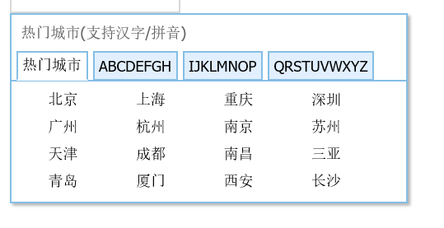

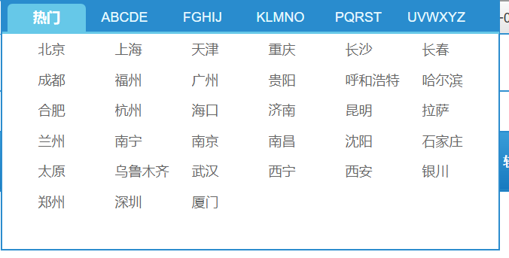

‘长春|changchun|cc’,’福州|fuhzou|fz’,’贵阳|guiyang|gy’,’呼和浩特|huhehaote|hhht’,’哈尔滨|haerbin|heb’,’合肥|hefei|hf’,’海口|haikou|hk’,’济南|jinan|jn’,’昆明|kuning|km’,’拉萨|lasa|ls’,’兰州|lanzhou|lz’,’南宁|nanning|nn’,’沈阳|shenyang|sy’,’石家庄|shijiazhuang|sjz’,’太原|taiyuan|ty’,’乌鲁木齐|wulumuqi|wlmq’,’武汉|wuhan|wh’,’西宁|xining|xn’,’银川|yinchuan|yc’,’郑州|zhenzhou|zz’,