RegimeLens

AI Tool for Asset-Level Market Regime Detection

Reflections:

Through the development of RegimeLens using Product Vision and User Story Mapping, I realized that Agile thinking is fundamentally about disciplined scope control and value prioritization rather than technical sophistication.

Initially, my inclination was to focus on advanced machine learning architectures such as transformers or reinforcement learning. However, once I structured the Product Vision Board and defined clear user personas, it became evident that interpretability and clarity deliver more value than predictive complexity. This shift in perspective demonstrates one of Agile’s core principles: customer value over technical elegance.

Building the backbone features forced me to think in terms of user journey rather than system components. Instead of asking, “What models can I implement?”, I began asking, “What does the user need to understand first?” This reorientation transformed the product from a predictive system into an explainable analytical tool.

The MVP slicing process was the most intellectually valuable step. By drawing a horizontal cut across the story map, I had to distinguish between value-enabling features and value-enhancing features. This exercise highlighted the importance of incremental delivery, risk reduction, and early validation, pillars of Agile delivery.

Overall, this assignment reinforced that Agile development is not about moving fast, it is about building the right thing, at the right time, with controlled complexity and measurable value delivery.

Questions :

What is the importance of using a user persona in building the user story mapping?

User personas anchor product decisions in real user contexts rather than abstract assumptions.
In Agile product development, personas serve as decision filters. They influence backlog prioritization, acceptance criteria definition, and MVP slicing. Without personas, teams often optimize for technical possibilities instead of user value.
For RegimeLens, defining both non-technical investors and technically skilled but finance-inexperienced users clarified that:
- Simplicity outweighs automation
- Visualization outweighs raw model output
- Explanation outweighs prediction
The persona transformed story mapping from a feature listing exercise into a user-centered design process. It ensured that every user story answered the fundamental Agile question: “Who is this for, and what problem does it solve?”
Thus, personas operationalize empathy in Agile planning.

How do you think user story mapping helps you to achieve the triad of feasibility, engineering, and usability?

User story mapping acts as a bridge between product strategy and technical execution.
Feasibility
By organizing stories from high-level activities down to granular tasks, story mapping exposes dependencies, complexity layers, and risk concentrations. This allows early validation of whether the scope is technically achievable within constraints.
Engineering Clarity
Story mapping decomposes large features into implementable slices. It creates natural sprint boundaries and supports incremental architecture design. Engineers can clearly see which components must exist before others.
Usability
Because the map is structured around the user journey (left to right flow), it prevents teams from optimizing backend systems while neglecting user interaction flow. The product remains experience-driven rather than technology-driven.
In RegimeLens, story mapping ensured:
- Data retrieval precedes clustering
- Clustering precedes visualization
- Visualization precedes explanation
This preserved logical progression while balancing technical feasibility with user clarity.
User story mapping, therefore, operationalizes the Agile balance between business value, technical constraints, and human-centered design.

What is the significance of minimum viable product release?

The MVP is a strategic risk-management mechanism, not merely a reduced feature set.
Its significance lies in:
- Early validation of value proposition
- Reduction of technical and market risk
- Controlled investment of time and effort
- Enabling iterative learning cycles
For RegimeLens, the MVP focuses strictly on:
- Asset selection
- Basic indicator generation
- Regime clustering
- Color-coded visualization
This ensures the core hypothesis is validated:
“Users want clear and interpretable regime detection.”
Advanced features such as reinforcement learning, multi-asset comparison, or interactive dashboards are deferred because they increase complexity without validating the primary user need.
In Agile philosophy, the MVP transforms uncertainty into validated knowledge. It is the smallest experiment that tests product viability while preserving optionality for future iterations.

Through building the Product Vision and user story mapping for RegimeLens, I realized that clarity of user needs is more important than technical complexity. At first, I focused on advanced AI models, but defining the target personas helped me understand that interpretability and visualization are the real priorities.
Creating the backbone features structured the product logically and kept the focus on regime explanation rather than price prediction. Slicing the MVP was especially important because it forced me to identify what truly delivers value and remove unnecessary complexity.
This process strengthened my understanding of Agile thinking: start simple, focus on user value, and iterate gradually.

Problem Statement
Financial markets are complex, data-intensive, and highly dynamic systems. Traditional financial analysis tools often assume that market behavior is stable over time. However, markets operate under different regimes (e.g., high volatility, low volatility, trending, or sideways periods). Models that ignore regime shifts often fail in real-world conditions due to non-stationarity and structural changes.

Product Vision Board
VISION

Our vision is to build an explainable AI-based tool that allows users to observe financial markets through the lens of regime analysis. RegimeLens helps users identify and understand market regimes at the individual asset level rather than predicting price direction.

TARGET GROUP  1, Non-technical individual investors  People who want simple explanations and visual insights.  2, Technical users without financial experience  People who understand AI / data but want to learn how it applies to finance. | NEEDS  Many existing tools focus solely on prediction or trading signals. Users need a system that explains market behavior rather than automating decisions. They require:  • Clear identification of market regimes  • Detection of regime transitions  • Visual and interpretable explanations  • Educational transparency | PRODUCT  RegimeLens is an AI-based market regime analysis tool that:  • Allows users to select any single asset (stock, index, or cryptocurrency)  • Automatically generates technical features  • Applies clustering techniques to identify market regimes  • Visualizes regimes directly on price charts  • Provides human-readable summaries for each regime  The system focuses on interpretability and education rather than trade execution. | BUSINESS GOALS  From a course and project perspective, RegimeLens enables our team to:  • Demonstrate Agile development in a data-driven project  • Apply machine learning in a realistic and scoped manner  • Align user needs with technical implementation  • Build a foundation extendable to forecasting, portfolio analytics, or risk management

Personas 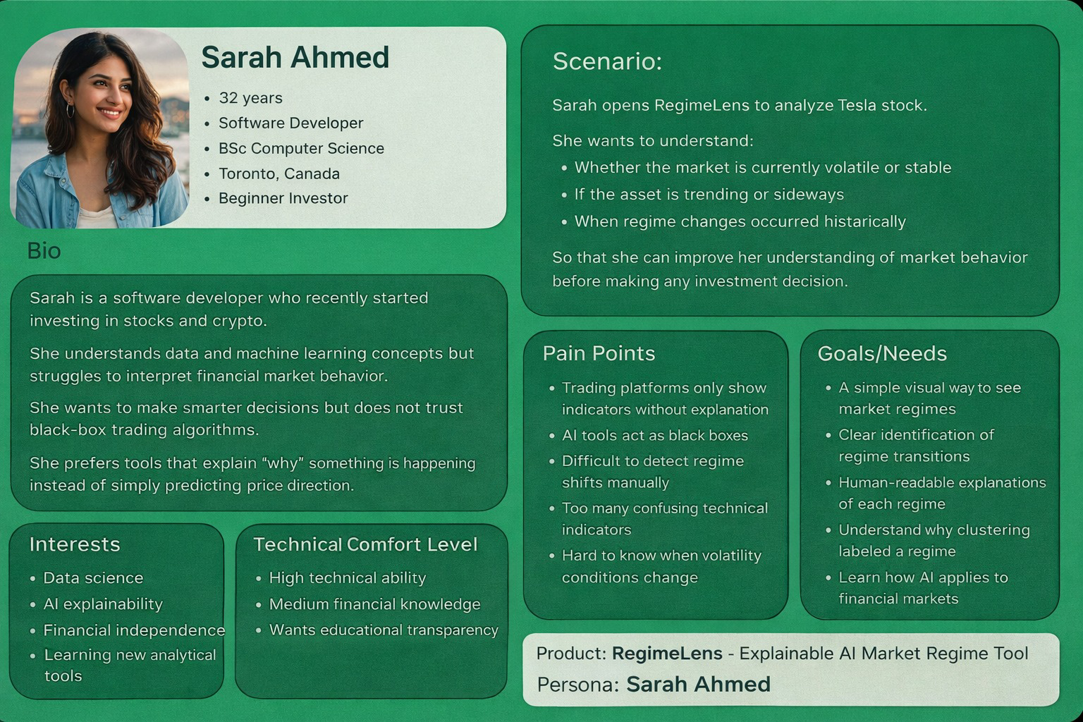

User Story Mapping
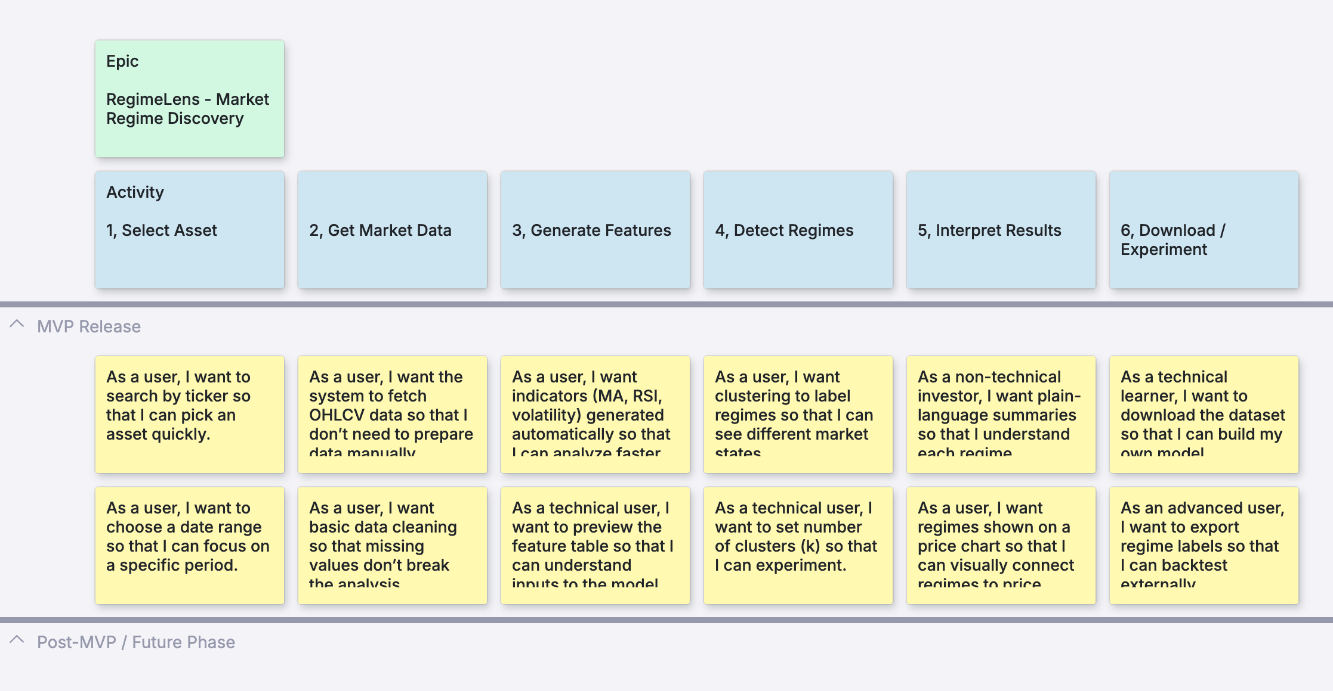

Product Backlog Items
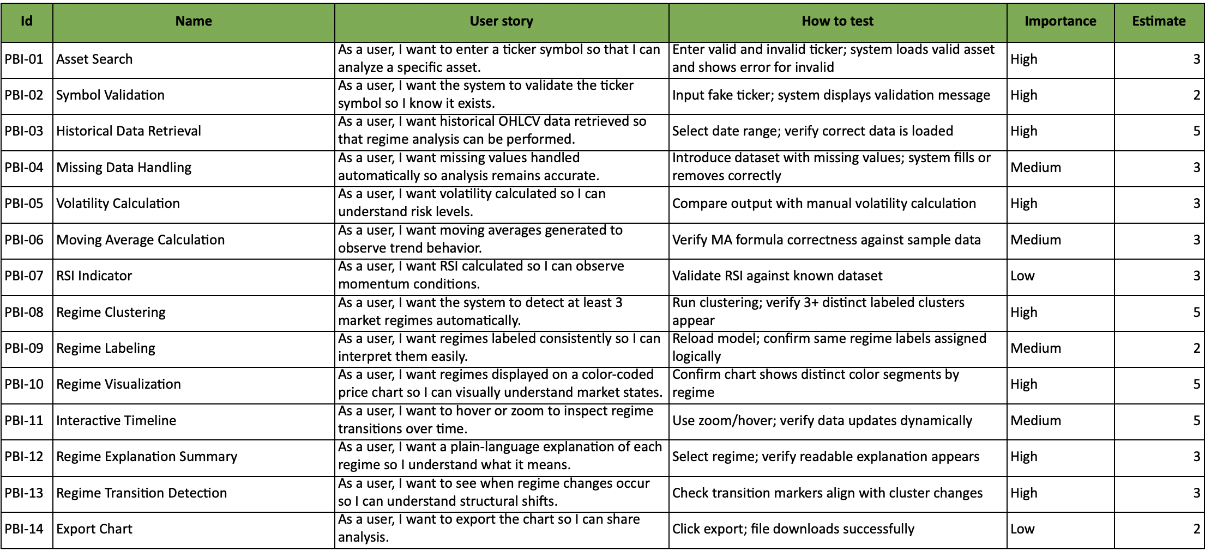

MVP – Minimum Viable Product
The MVP of RegimeLens is a web-based prototype that allows users to:
- Select a financial asset
- Automatically retrieve historical market data
- Generate basic technical indicators
- Apply a clustering model to identify market regimes
- Visualize detected regimes using a color-coded price chart
The MVP focuses on delivering clear and interpretable market state detection rather than advanced predictive trading strategies.
It prioritizes simplicity, transparency, and educational value for non-technical investors and technical learners without financial background.

Research Summary
Research Paper Link | Problem Statement Identified | Tech Solutions Proposed | Dataset Used in the Paper | Future Work
DeepLOB: Deep Convolutional Neural Networks for Limit Order Books (Zhang et al., 2018)  _FullLinks https://arxiv.org/abs/1808.03668 | Handcrafted features fail to capture complex spatial and temporal patterns in limit order book data. | CNN-based spatial feature extraction combined with LSTM temporal modeling in an end-to-end framework. | High-frequency limit order book data from the London Stock Exchange (LSE). | Evaluate robustness across markets and incorporate realistic transaction costs.
FinRL: A Deep Reinforcement Learning Library for Automated Stock Trading in Quantitative Finance (Yang et al., 2020)  https://arxiv.org/abs/2011.09607 | Financial reinforcement learning lacks standardized benchmarks and reproducible evaluation. | Unified RL framework with standard environments, datasets, and evaluation metrics. | US stock market OHLCV data (e.g., Dow Jones 30 constituents). | Improve generalization to unseen market regimes and extreme events.
FinRL Contests: Benchmarking Data-Driven Financial Reinforcement Learning Agents (Yang et al., 2024)  https://arxiv.org/html/2504.02281v3 | Inconsistent experimental settings make comparison of trading agents unreliable. | Competition-style benchmark with fixed datasets, rolling windows, and standardized metrics. | Dow Jones 30 stock data with rolling train-validation-test splits. | Enhance robustness under non-stationary and volatile market conditions.
StockNet: Predicting Stock Price Movement with Twitter Sentiment (Xu & Cohen, 2018)  https://arxiv.org/abs/1801.07890 | Price-only prediction models ignore information embedded in social media sentiment. | Neural models integrating historical prices with Twitter-based sentiment signals. | StockNet dataset: historical prices aligned with Twitter data. | Extend to multi-source text data and improve noise handling.
BERTweet: A Pre-trained Language Model for English Tweets (Nguyen et al., 2020)  https://arxiv.org/abs/2005.10200 | Generic language models perform poorly on informal social media text. | Domain-specific transformer pre-training on large-scale Twitter data. | 850M English tweets collected between 2012–2019. | Adapt models for finance-specific sentiment analysis.
Stockformer: A Transformer-Based Framework for Stock Time Series Forecasting (2025)  https://arxiv.org/abs/2502.09625 | Single-asset forecasting ignores cross-asset dependencies. | Multivariate Transformer architecture for financial time series modeling. | Multi-asset stock price data from public financial APIs. | Investigate dynamic retraining and improved temporal encoding.
LSTM-Based Deep Learning Models for Nonlinear Financial Time Series Forecasting (Fischer & Krauss, 2018)  https://www.sciencedirect.com/science/article/pii/S0378426618300235 | Linear models cannot capture nonlinear patterns in stock prices. | Long Short-Term Memory (LSTM) neural networks for sequential modeling. | S&P 500 constituent stock price data. | Integrate macroeconomic and fundamental variables.
Temporal Fusion Transformers for Interpretable Multi-Horizon Time Series Forecasting (Lim et al., 2021)  https://arxiv.org/abs/1912.09363 | Standard sequence models struggle with long-term dependencies and interpretability. | Attention-based temporal fusion transformer architecture. | Multiple real-world financial and economic time series datasets. | Improve explainability and scalability for financial applications.
A Dual-Stage Attention-Based Recurrent Neural Network for Time Series Prediction (Qin et al., 2017)  https://arxiv.org/abs/1704.02971 | RNN models treat all historical inputs equally. | Dual-stage attention mechanism to focus on relevant features and time steps. | Stock prices and technical indicator datasets. | Apply attention mechanisms to cross-market forecasting.
Market Regime Detection Using Hidden Markov Models (Nystrup et al., 2015)  https://www.sciencedirect.com/science/article/pii/S0377221715000833 | Assuming a single market regime leads to unstable trading strategies. | Hidden Markov Models for detecting latent market states. | Equity index return time series. | Combine regime detection with dynamic portfolio allocation.
Risk-Sensitive Reinforcement Learning Applied to Trading (Moody & Saffell, 2001)  https://papers.nips.cc/paper/2001/file/4f6ffe13a5d75b2d6a39286b6e39d7c8-Paper.pdf | Profit-only optimization ignores downside risk. | Risk-adjusted reward functions in reinforcement learning. | Simulated and historical financial market data. | Design more realistic and practical risk measures.
Time-Series Generative Adversarial Networks (TimeGAN) (Yoon et al., 2019)  https://arxiv.org/abs/1907.05321 | Limited historical data reduces model robustness. | GAN-based framework for generating realistic synthetic time series. | Financial and non-financial time series datasets. | Improve conditional generation and realism of synthetic data.

