SWE40006 – Software Deployment and Evolution
Deployment Portfolio Task 2
Daniel Johannson Tan (105075074)
Semester 2
Submission Date: 31 August 2026

Target Level: 2.3 (D)
Task 2.1 URL: https://webapplication120260831174846-gxh5fbb6e9eqgnet.australiasoutheast-01.azurewebsites.net
Task 2.2 URL: https://studentregistrationapp-e8dqafdje3b4cddu.australiasoutheast-01.azurewebsites.net
2.2: - WebApplication_2._2

Table of Contents
Task 2.1 3
Step 1: Create a new project, name and additional information 3
Step 2: running the application, and set up an account 5
Step 3: making an azure account 8
Task 2.2 14
Step 1: Create new project 15
Step 2: Codes 18
Step 3: Publish 27
Task 2.3 32
Step 1: Configure App Settings 32
Step 2: App Service Logs 34
Step 3: Health Check 36

Task 2.1
In Task 2.1, we deployed a basic ASP.NET Core web application to Microsoft Azure using Visual Studio. This involved setting up an Azure account, creating a publish profile, and publishing the application to Azure App Service. The objective was to verify that the application was successfully deployed and publicly accessible through a live URL.

Step 1: Create a new project, name and additional information
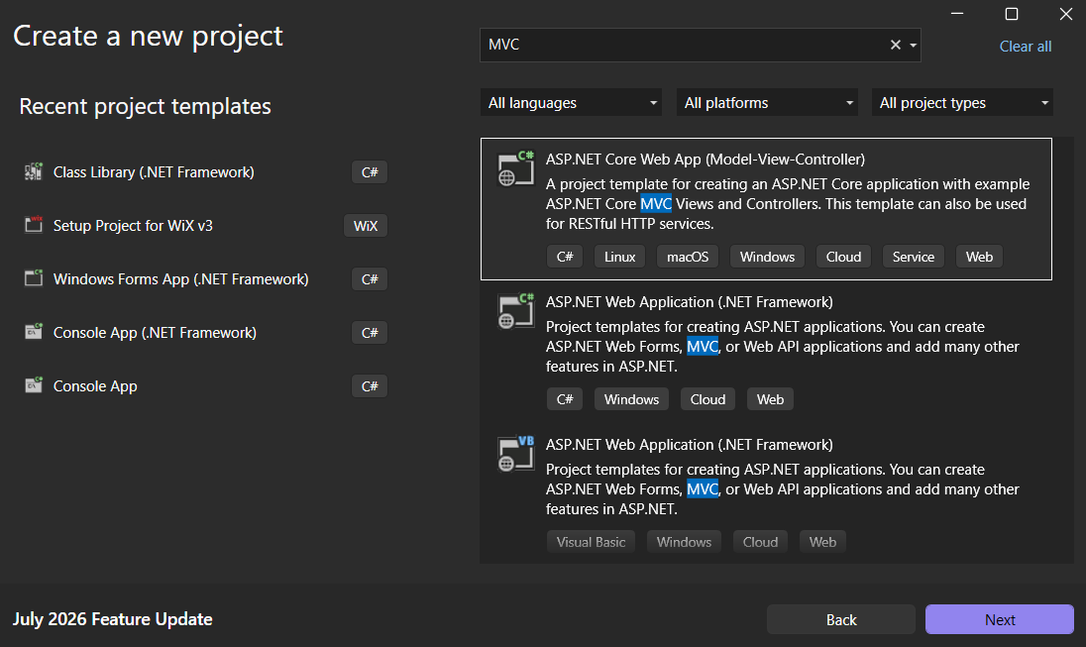
Figure 1: Create a new Project
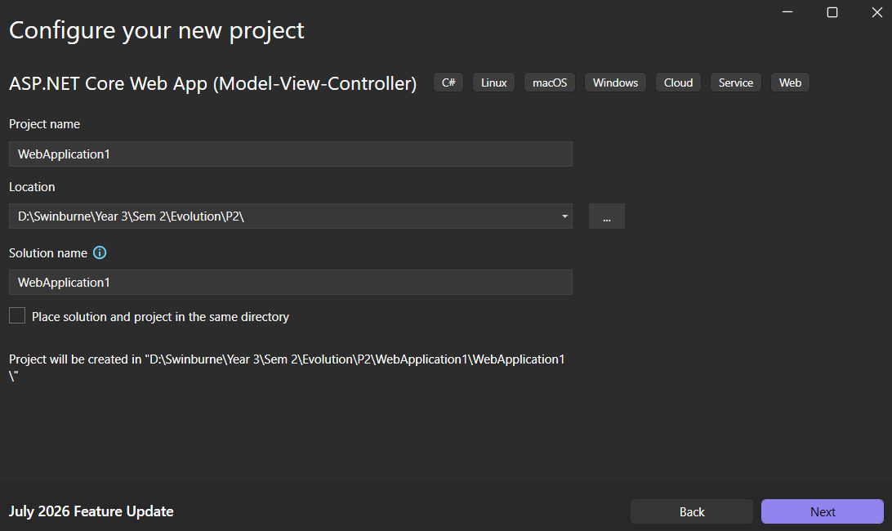
Figure 2
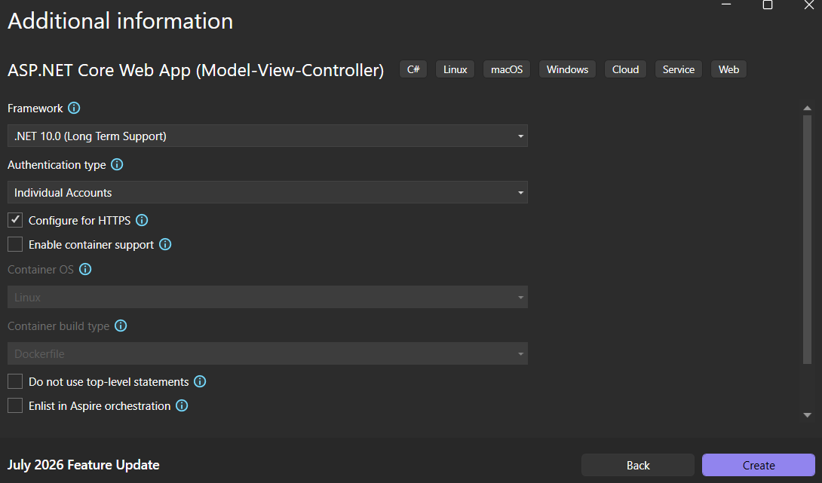
Figure 3

Step 2: running the application, and set up an account
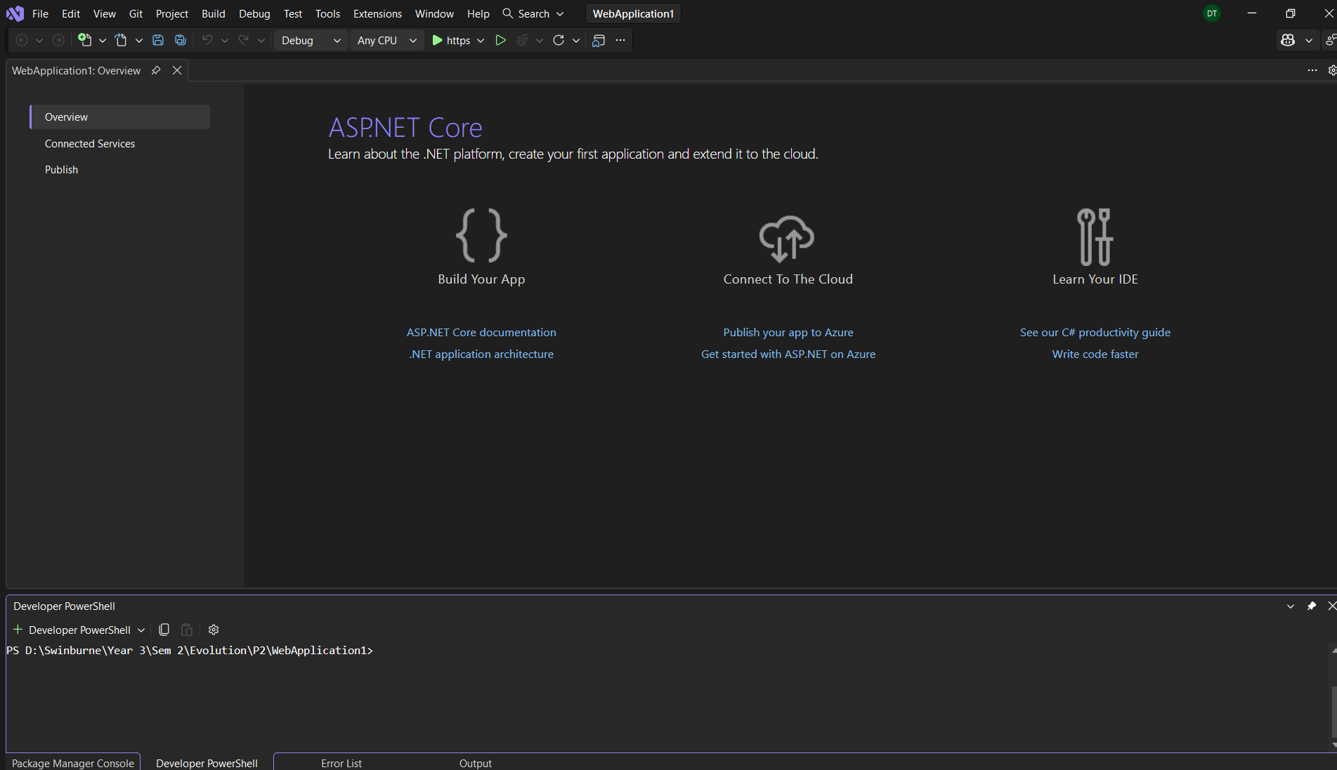
Figure 4: dashboard, run the application without debugging

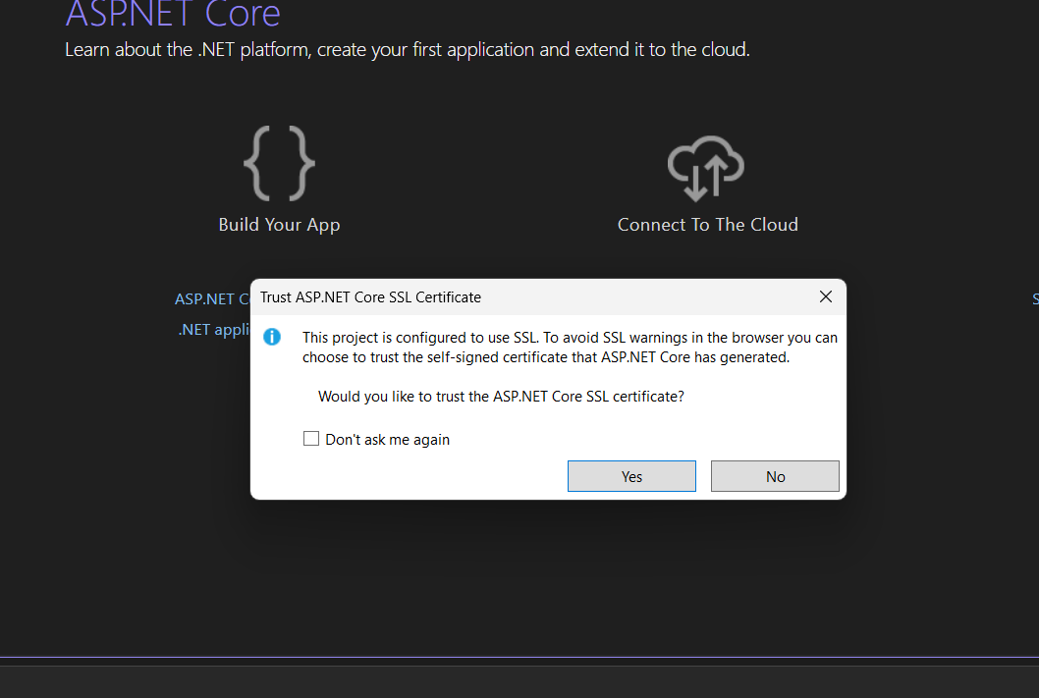
Figure 5: accepting SSL Certificate

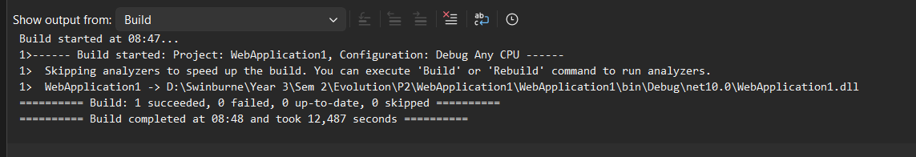
Figure 6
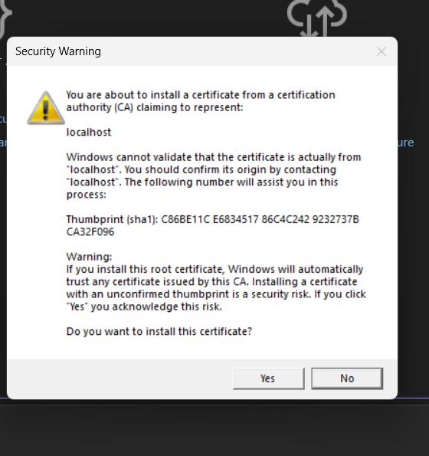
Figure 7: install certificate

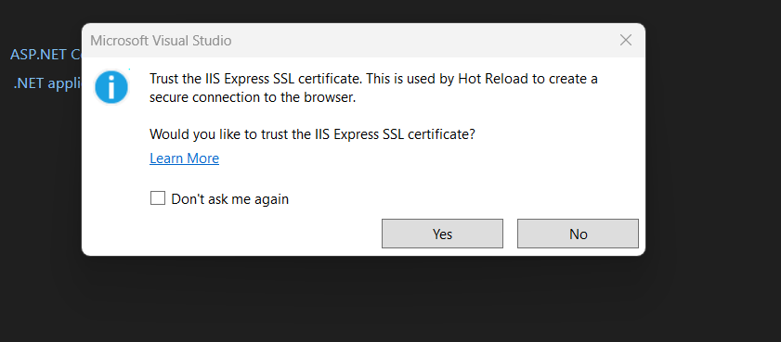
Figure 8: Click yes to trust the IIS Express SSL certificate
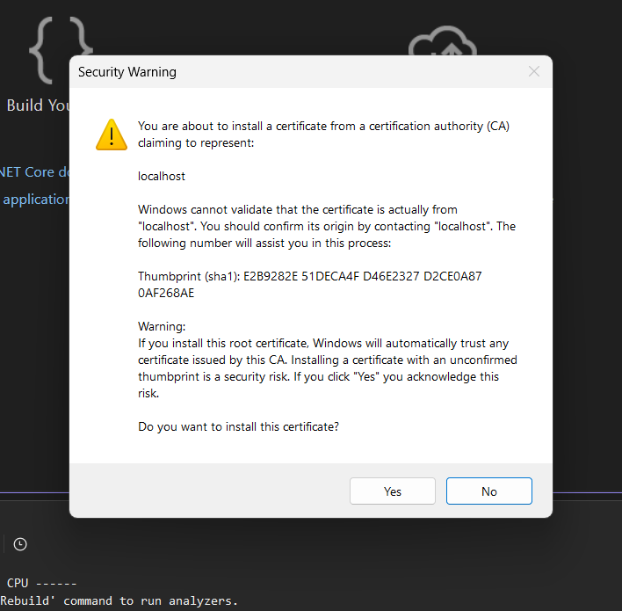
Figure 9
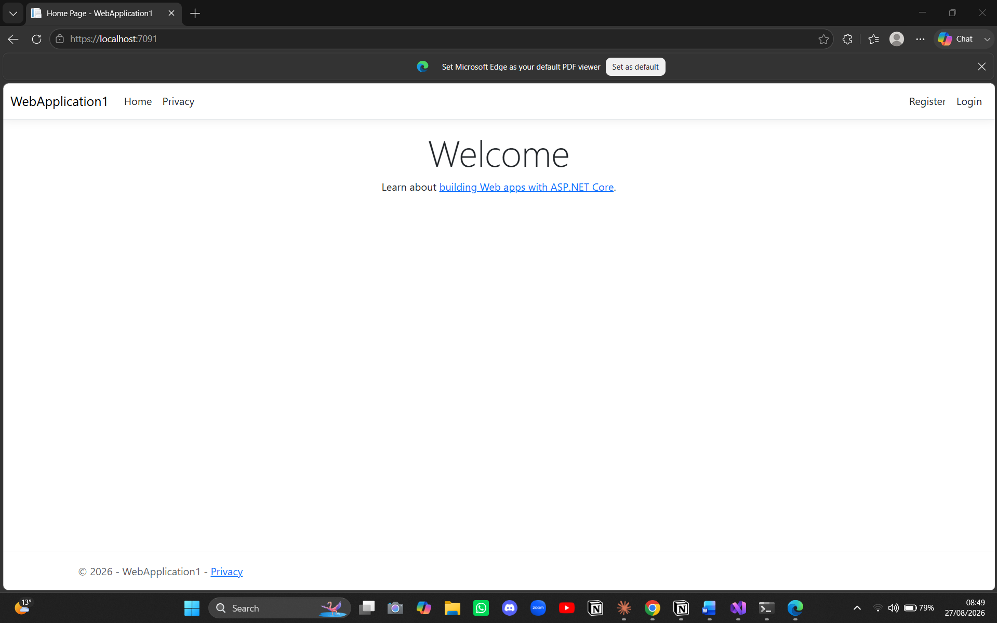
Figure 10: how it looks like when running using localhost

Step 3: making an azure account
Click on the project and then select publish, select azure and then azure app service (windows)
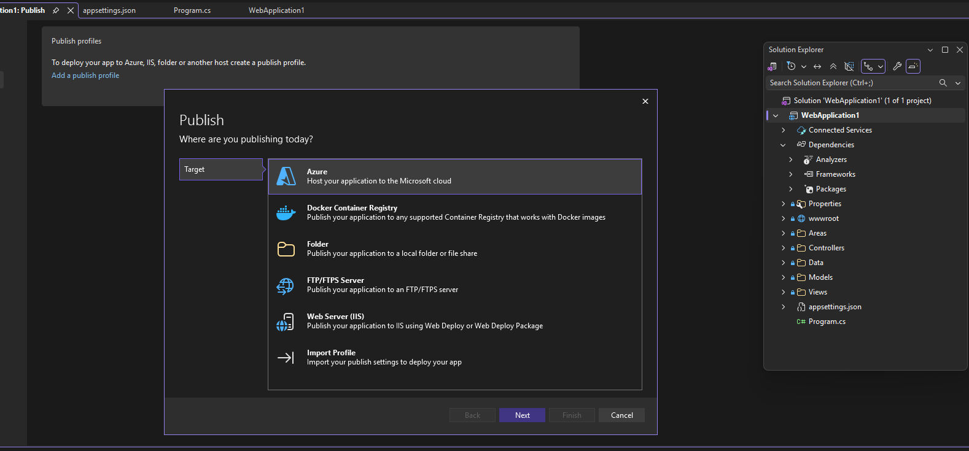
Figure 11: select Azure
e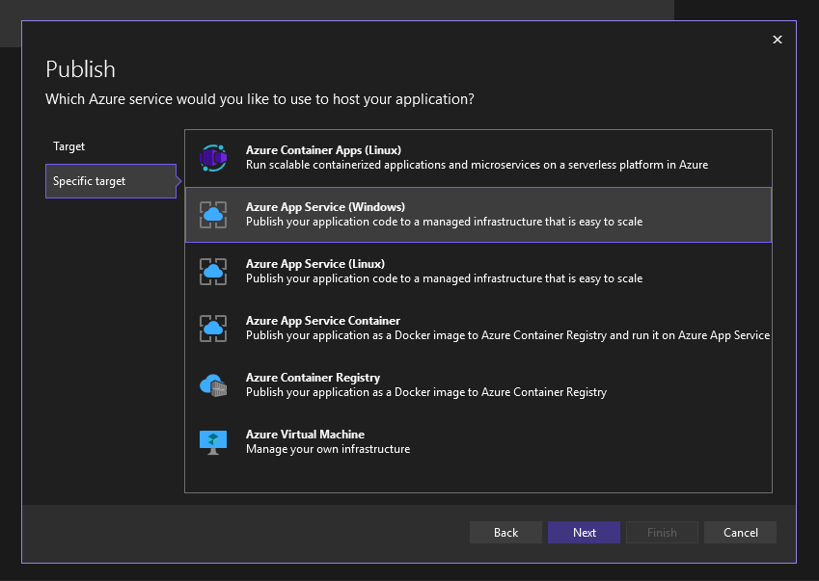
Figure 12: Select Azure App Service (windows)
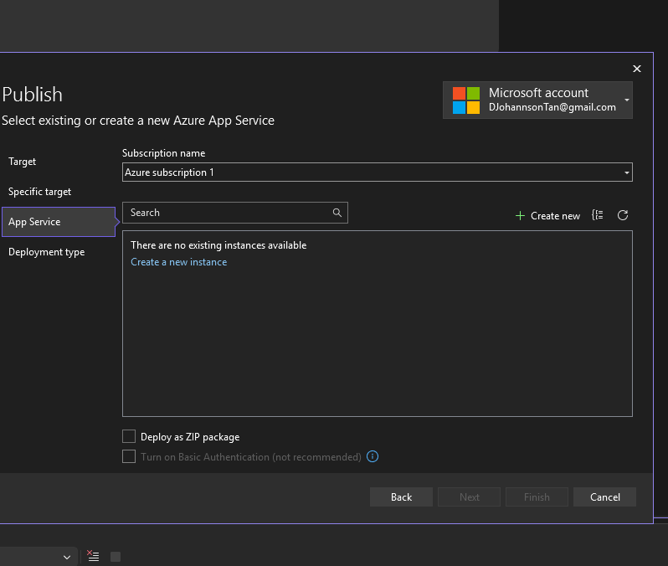
Figure 13: Create a new instance
In this step after selecting create a new instance it will ask to add account or make a new account, at first I used Swinburne account and it was not eligible for the free subscription so I switched to personal account
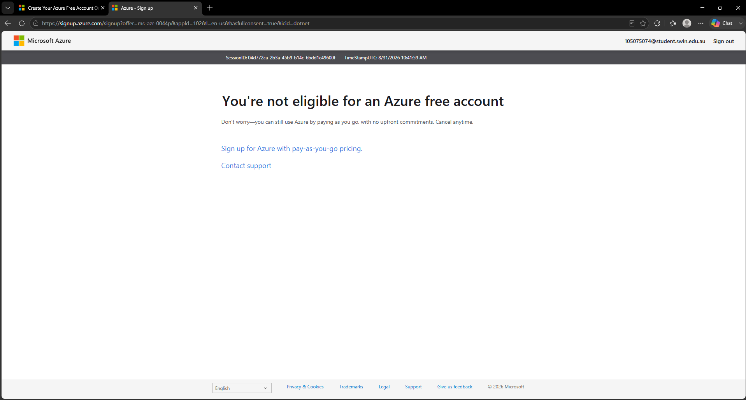
Figure 14: Swinburne Account is not eligible for Azure free account
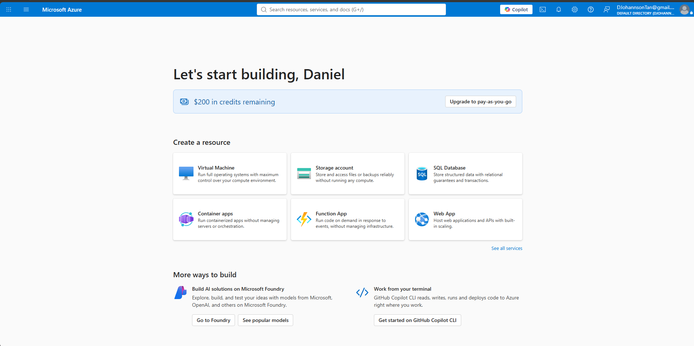
Figure 15: Created a new account using personal account and it is eligible for the free azure subscription

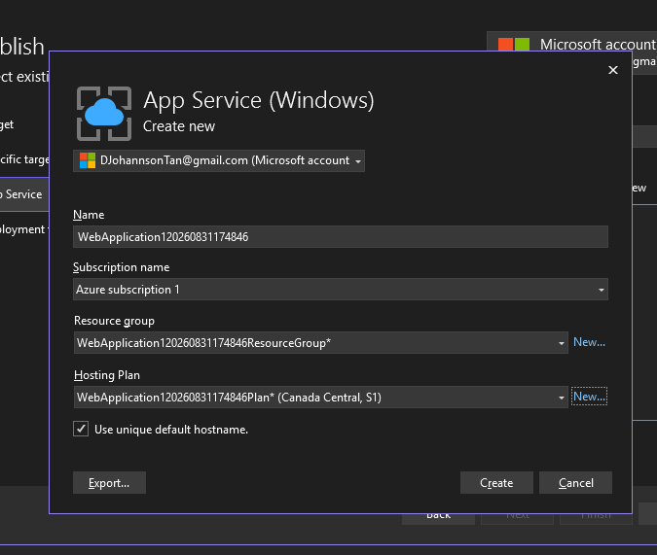
Figure 16: make sure the subscription name is “Azure subscription 1” and selected “Canada Central as Hosting Plan”
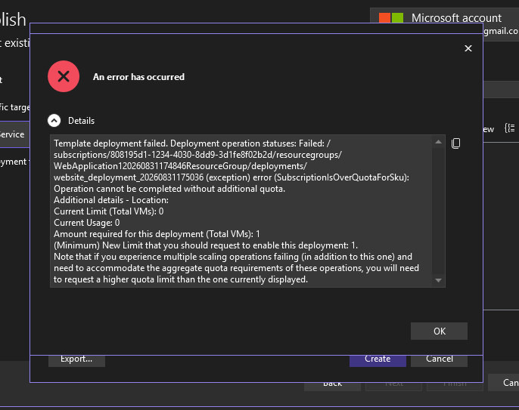
Figure 17: Hosting Plan was not eligible (Canada Central)
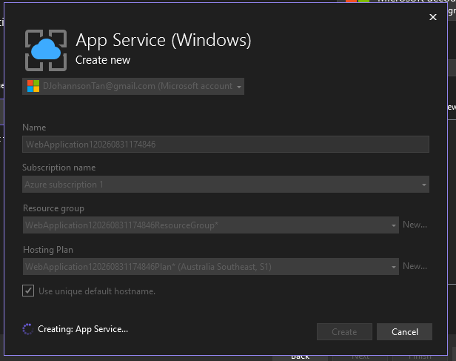
Figure 18: Switch Hosting Plan to Australia Southeast (it works)
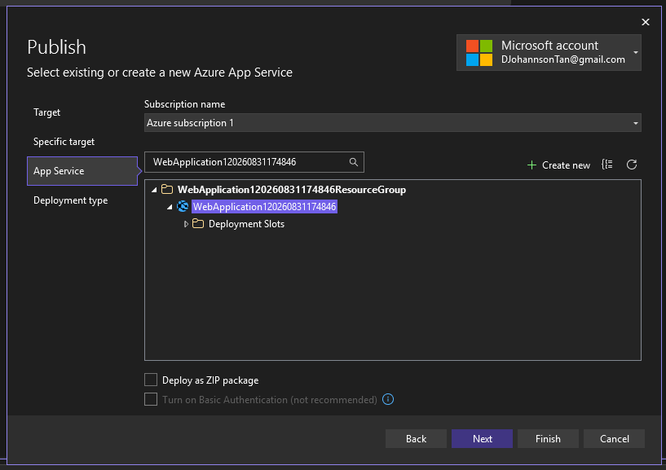
Figure 19: Finish publish
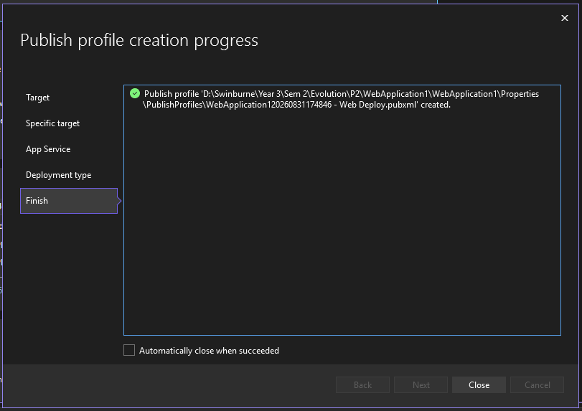
Figure 20: Publish Finished
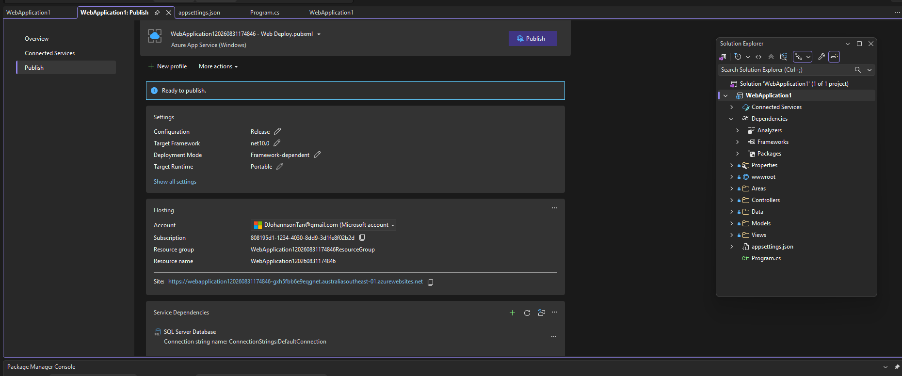
Figure 21: page where it brings when it finishes the publish and, on the page, can be found “Site: …” the site that brings to see the application deployed in Azure
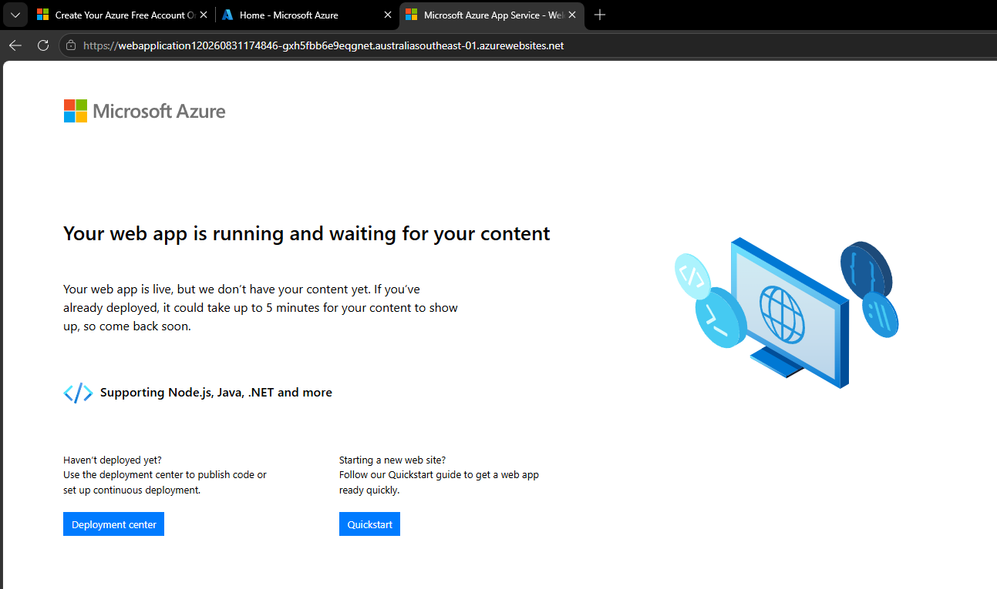
Figure 22: The page after clicking on the URL
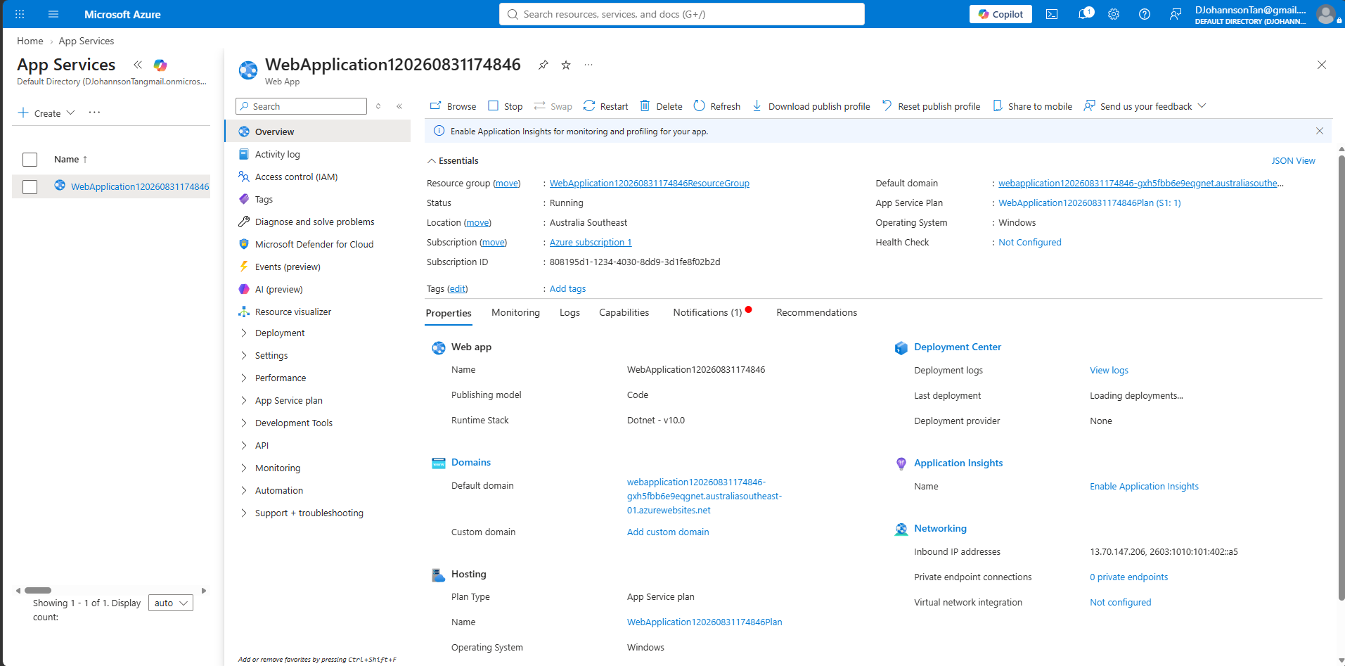
Figure 23: Azure portal

Task 2.2
For 2.2 we will be making a simple app using C# and publish it to azure

Step 1: Create new project
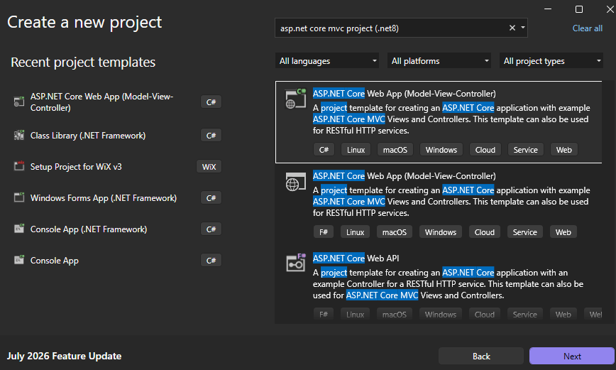
Figure 1: create a new project
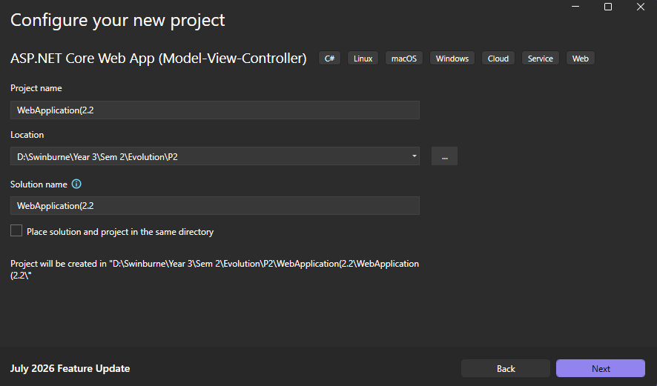
Figure 2: select a name
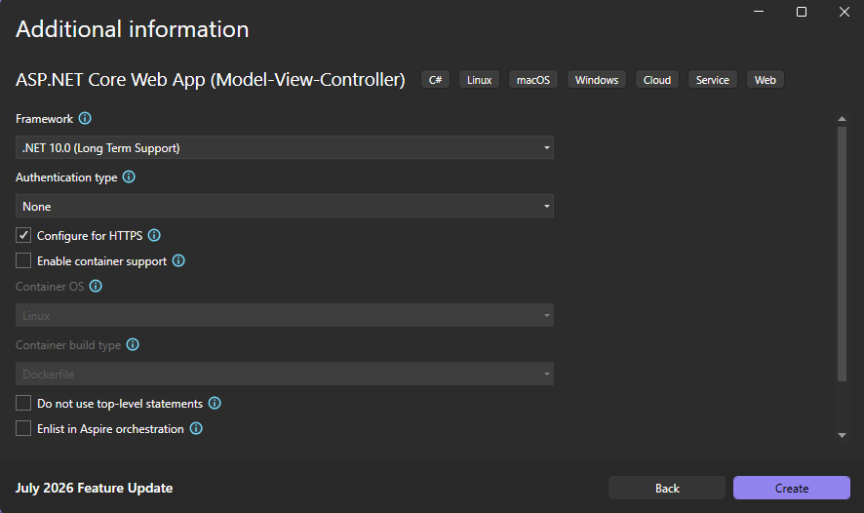
Figure 3: Create
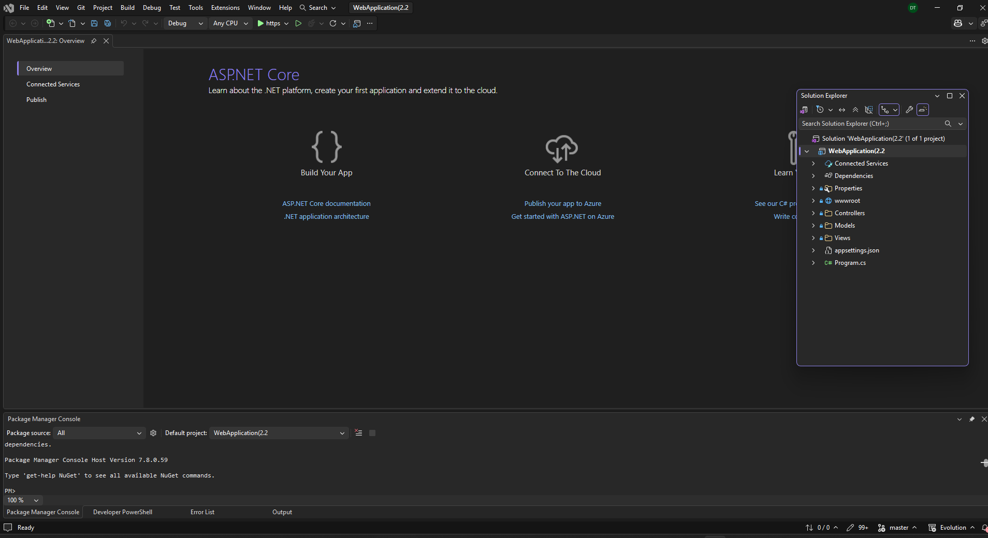
Figure 4: make a new file or project
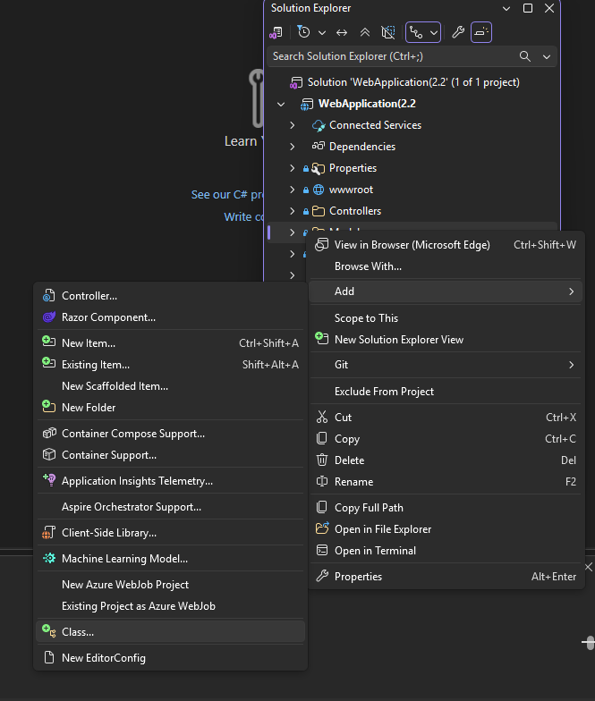
Figure 5: on the right side find models and then right click and select add>class
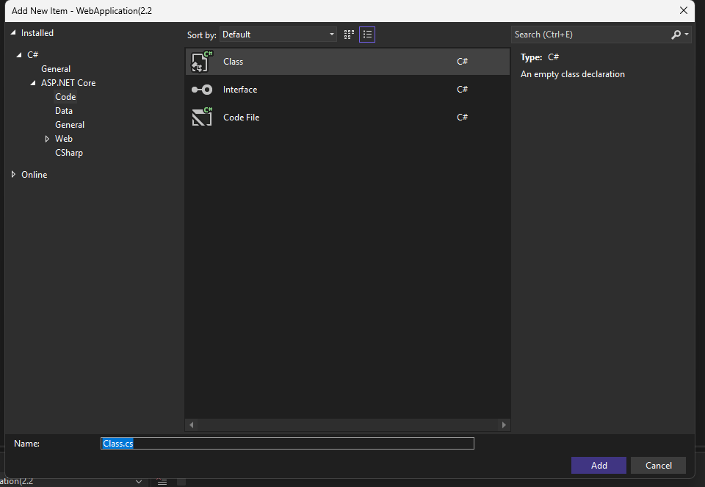

Step 2: Codes
Figure 6: create the class (rename it to the name wanted)
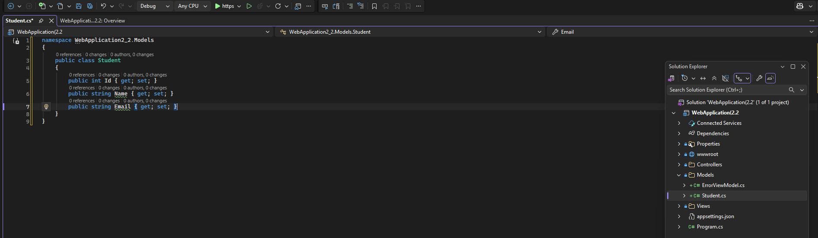
Figure 7: code for Student.cs
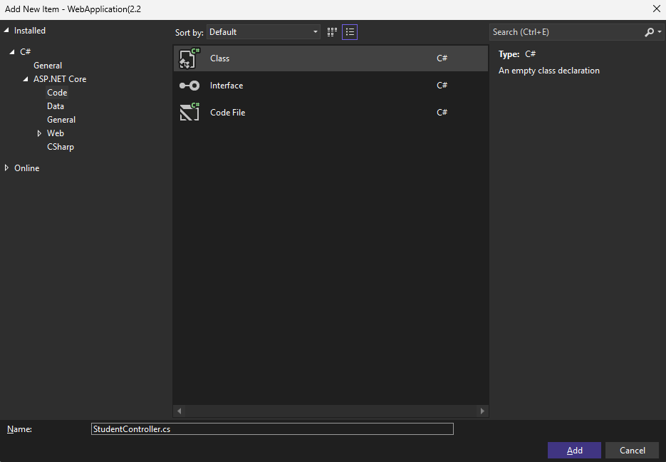
Figure 8: following the previous step create a StudentController.cs but select Controllers instead of Models
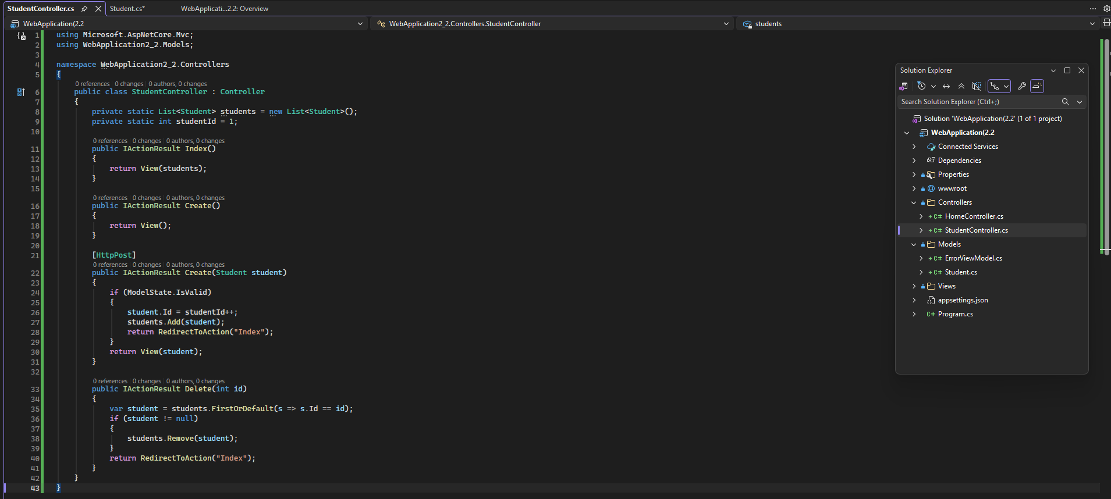
Figure 9: Code for StudentController.cs
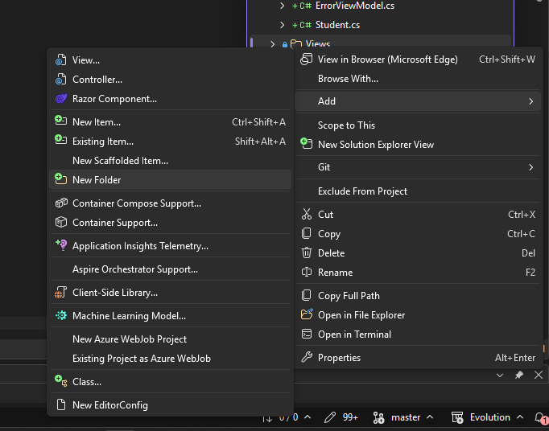
Figure 10: On the right side, right click on views and add new folder name it Student
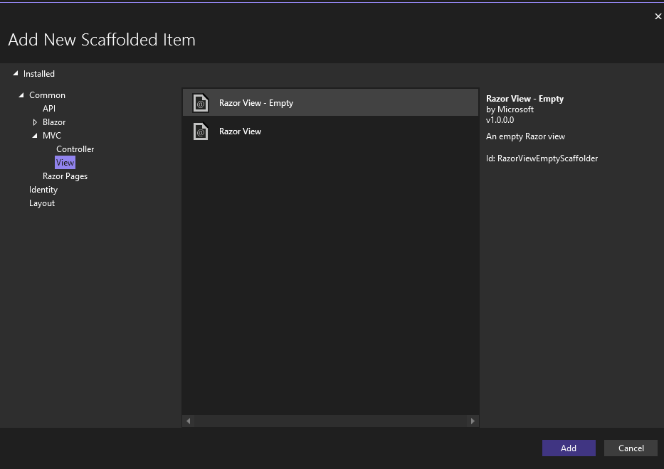
Figure 11: right click on the Student folder just created and then add>view and add
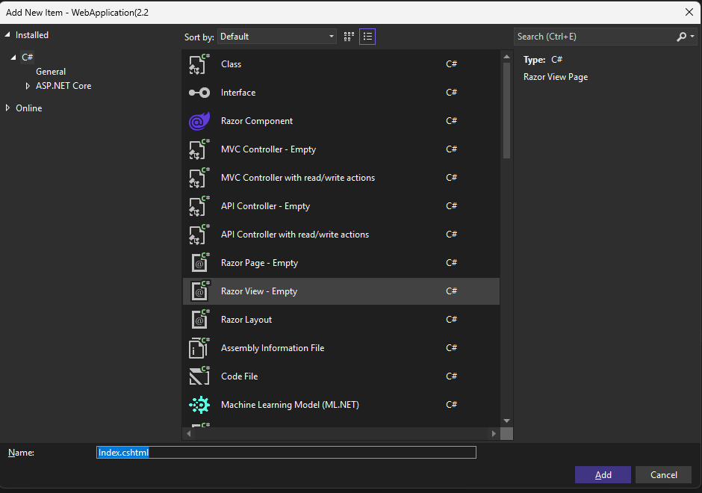
Figure 12: name it Index.cshtml and then add
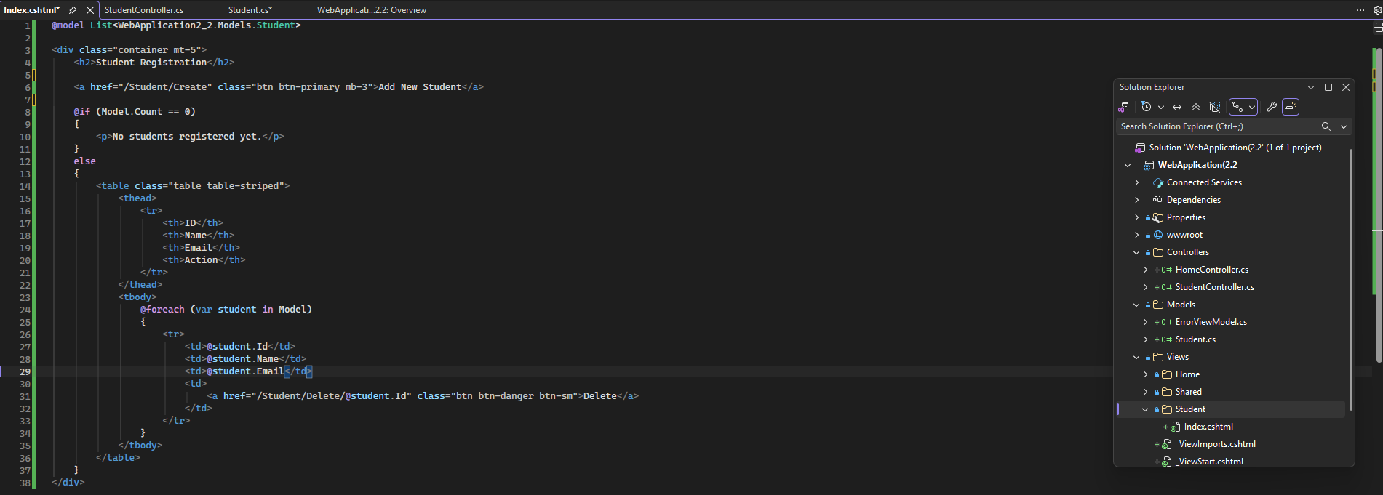
Figure 13: put into Index.cshtml
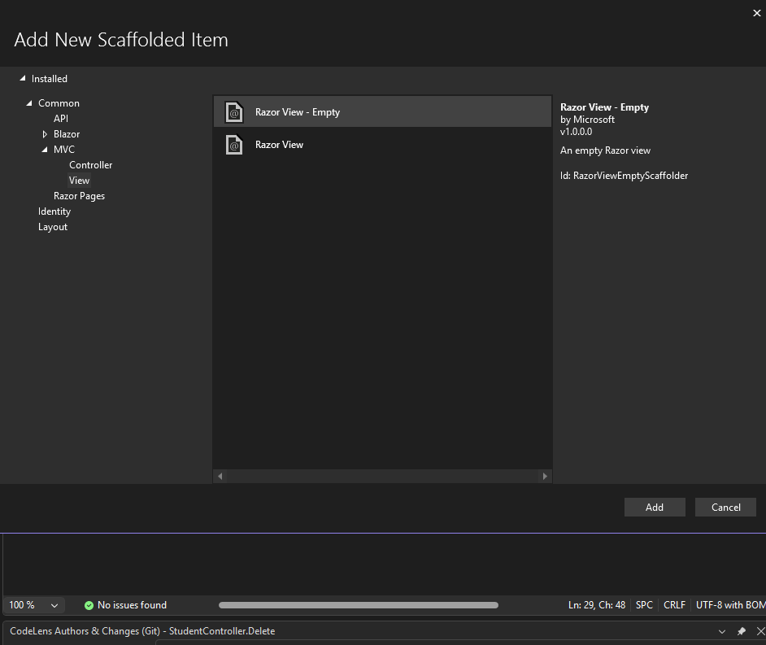
Figure 14: right click on student folder again, and select view
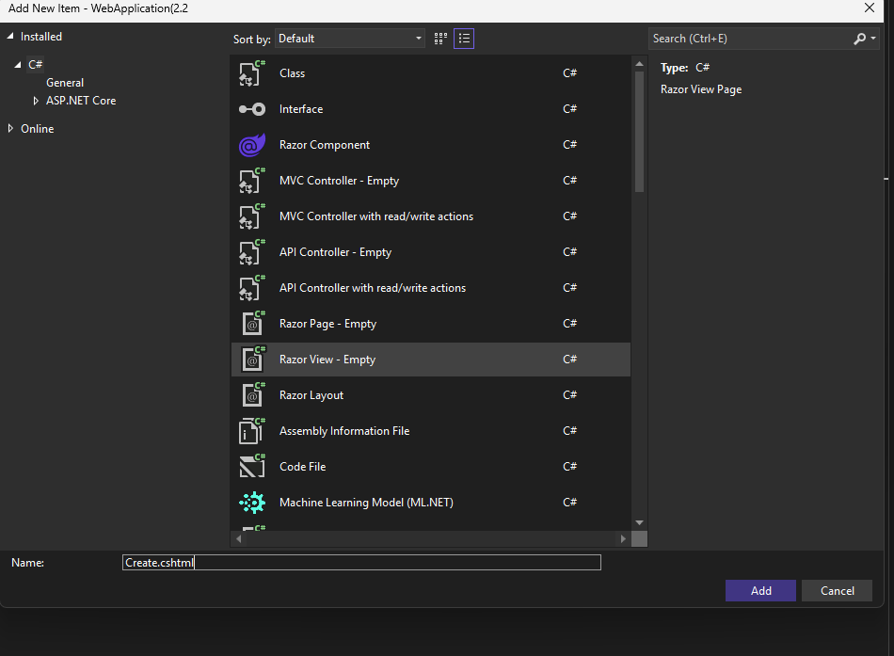
Figure 15: create and add (name it Create.cshtml)
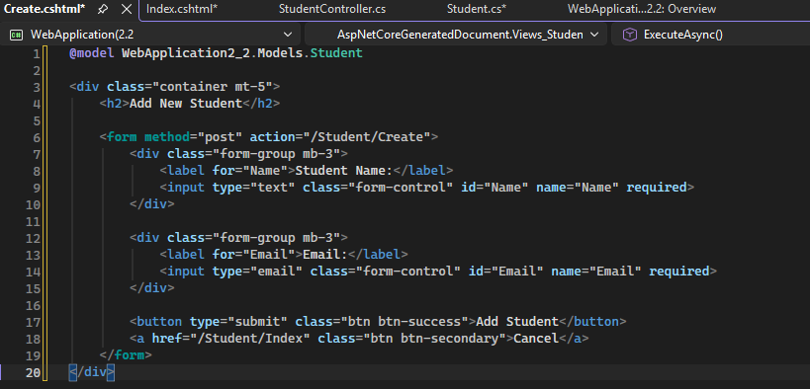
Figure 16: put into Create.cshtml
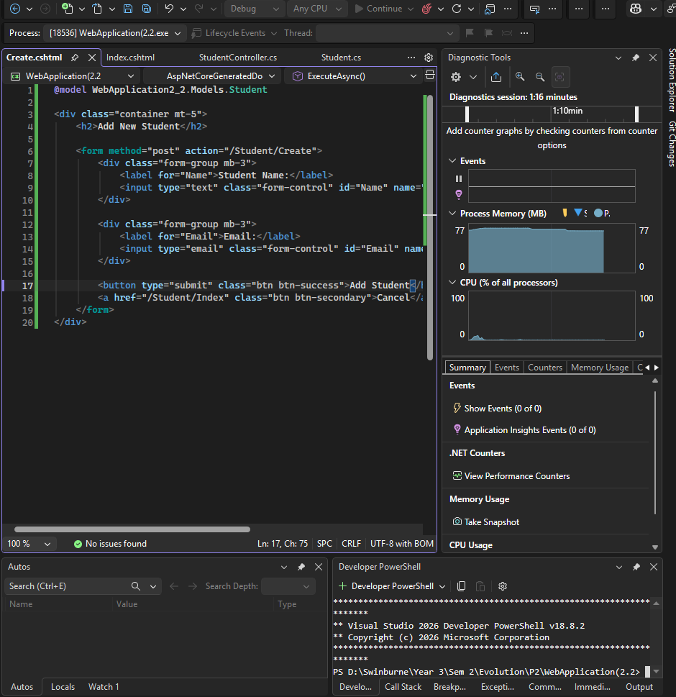
Figure 17: Run it and see from the web
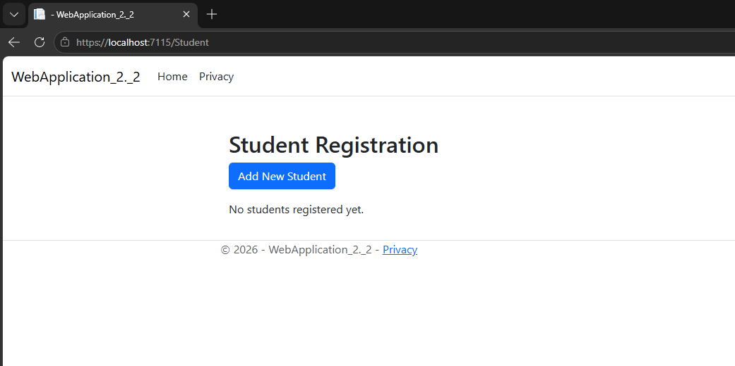
Figure 18: Web application on the web (if doesn’t show this use - WebApplication_2._2)
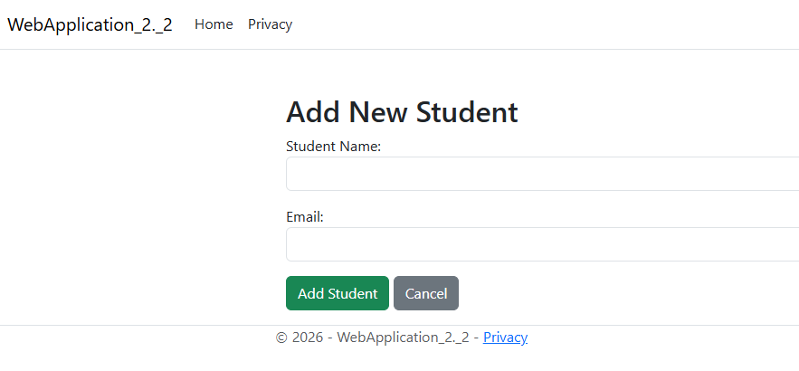
Figure 19: Add new Student
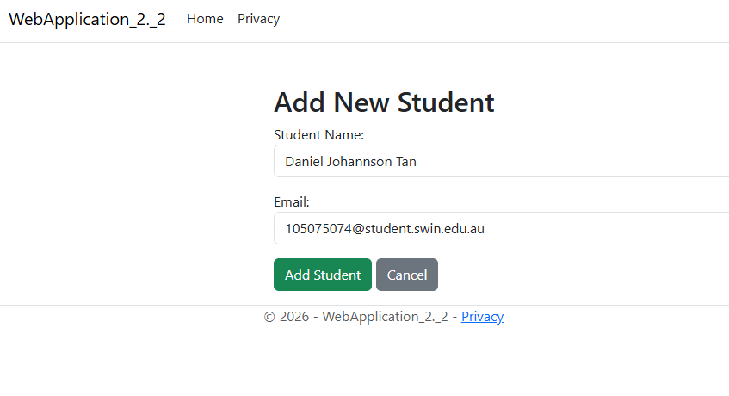
Figure 20: Fill in information, and then click on Add Student
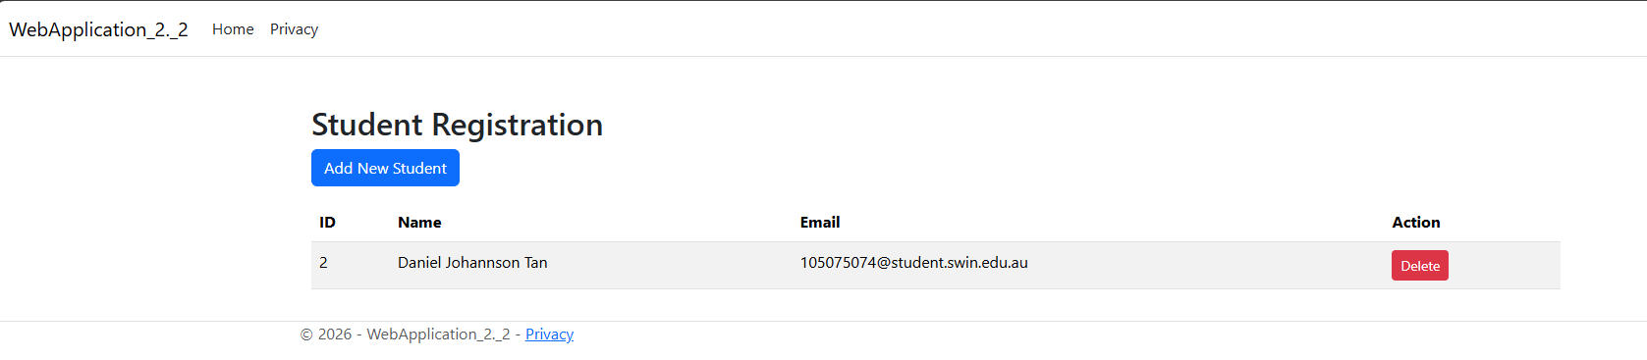Figure 21: Student Created
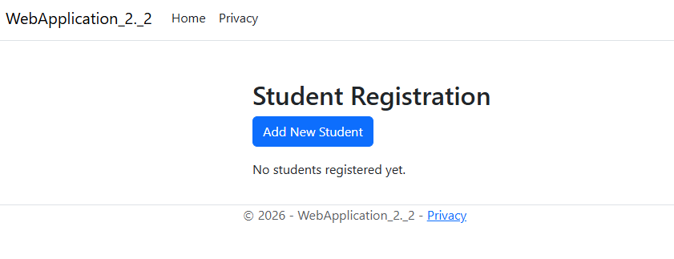
Figure 22: click on delete-to-delete Students information

Step 3: Publish
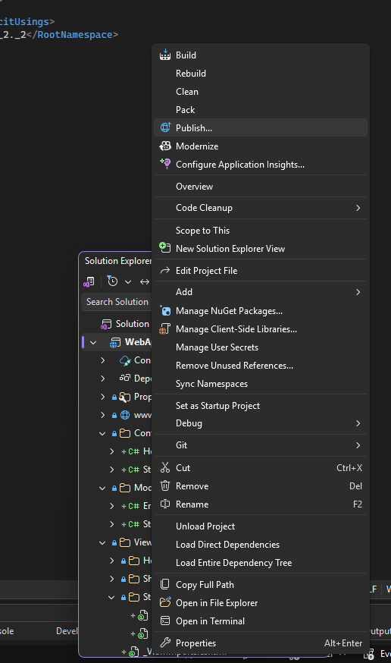
Figure 23: After making sure everything is correct and running publish to Azure (right click on the project and select publish)
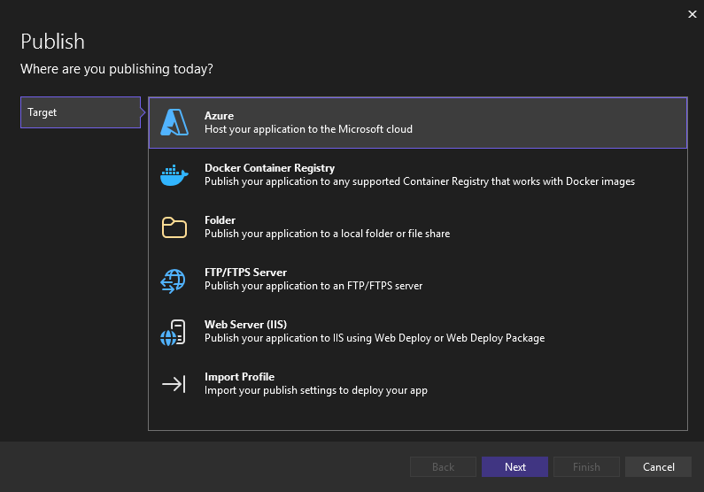
Figure 24: Select Azure
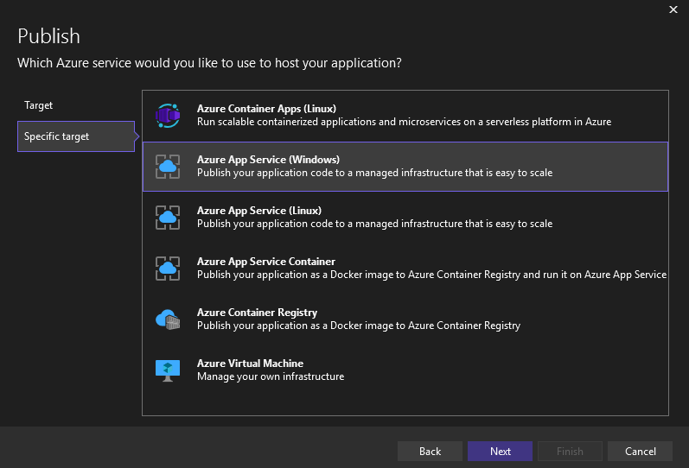
Figure 25: select Azure App Service (Windows)
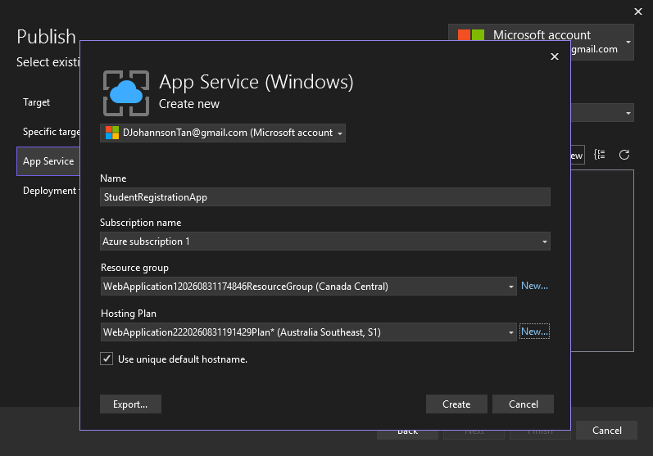
Figure 26: Make sure you select the correct account, and then click on create a new instance and name it StudentRegistrationApp (or any name)and then select the Hosting Plan and create
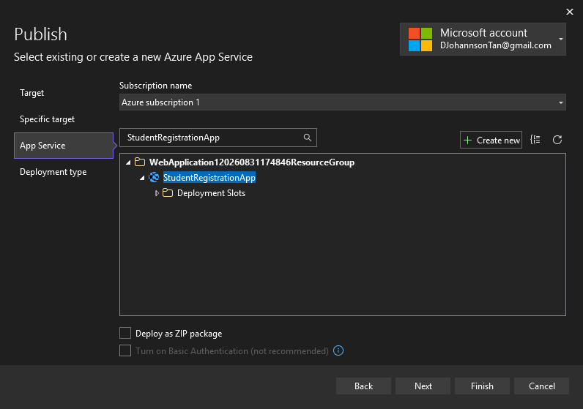
Figure 27: Click Finish
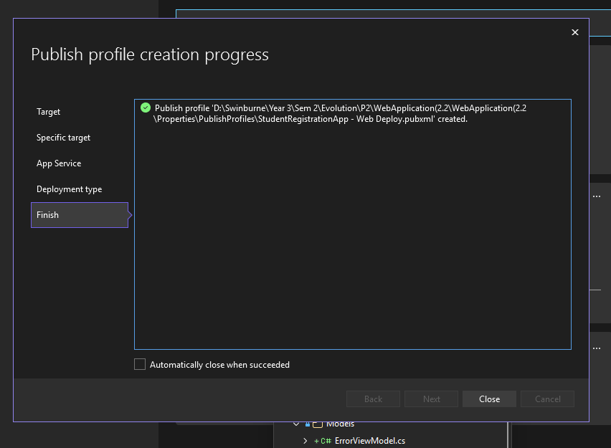
Figure 28: wait until it finishes to deploy
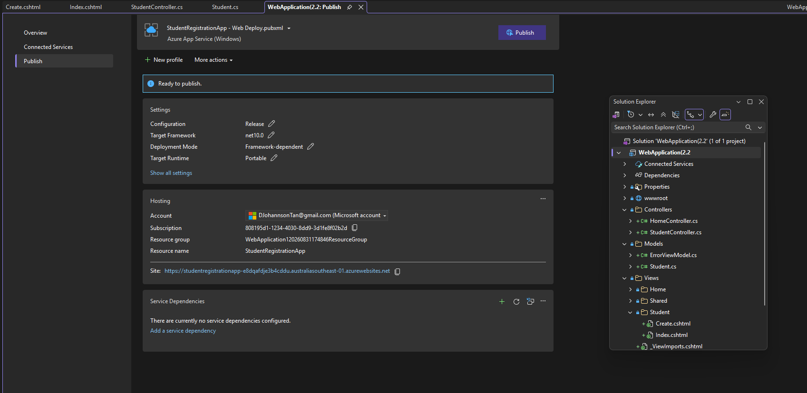
Figure 29: find the URL on the page and click on it to be directed to the web
URL: https://studentregistrationapp-e8dqafdje3b4cddu.australiasoutheast-01.azurewebsites.net

Task 2.3
For Task 2.3 we will be implementing an active health check or Azure App Service Logging

Step 1: Configure App Settings
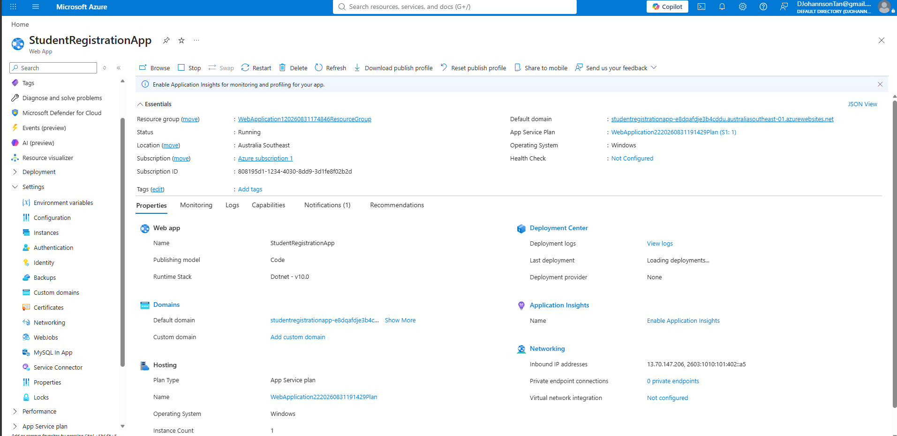
Figure 1: go into your StudentRegistrationApp and on the left side click on Settings
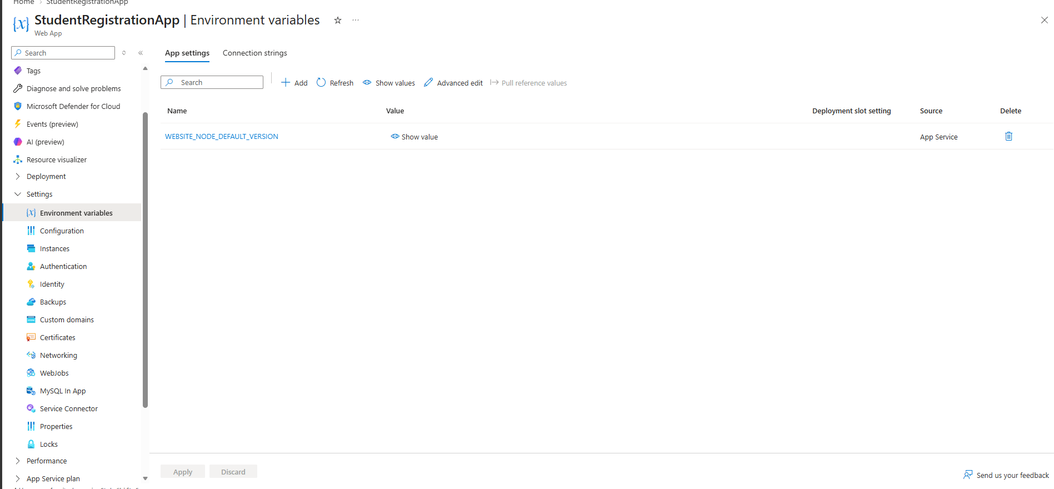
Figure 2: find Environmental Variables
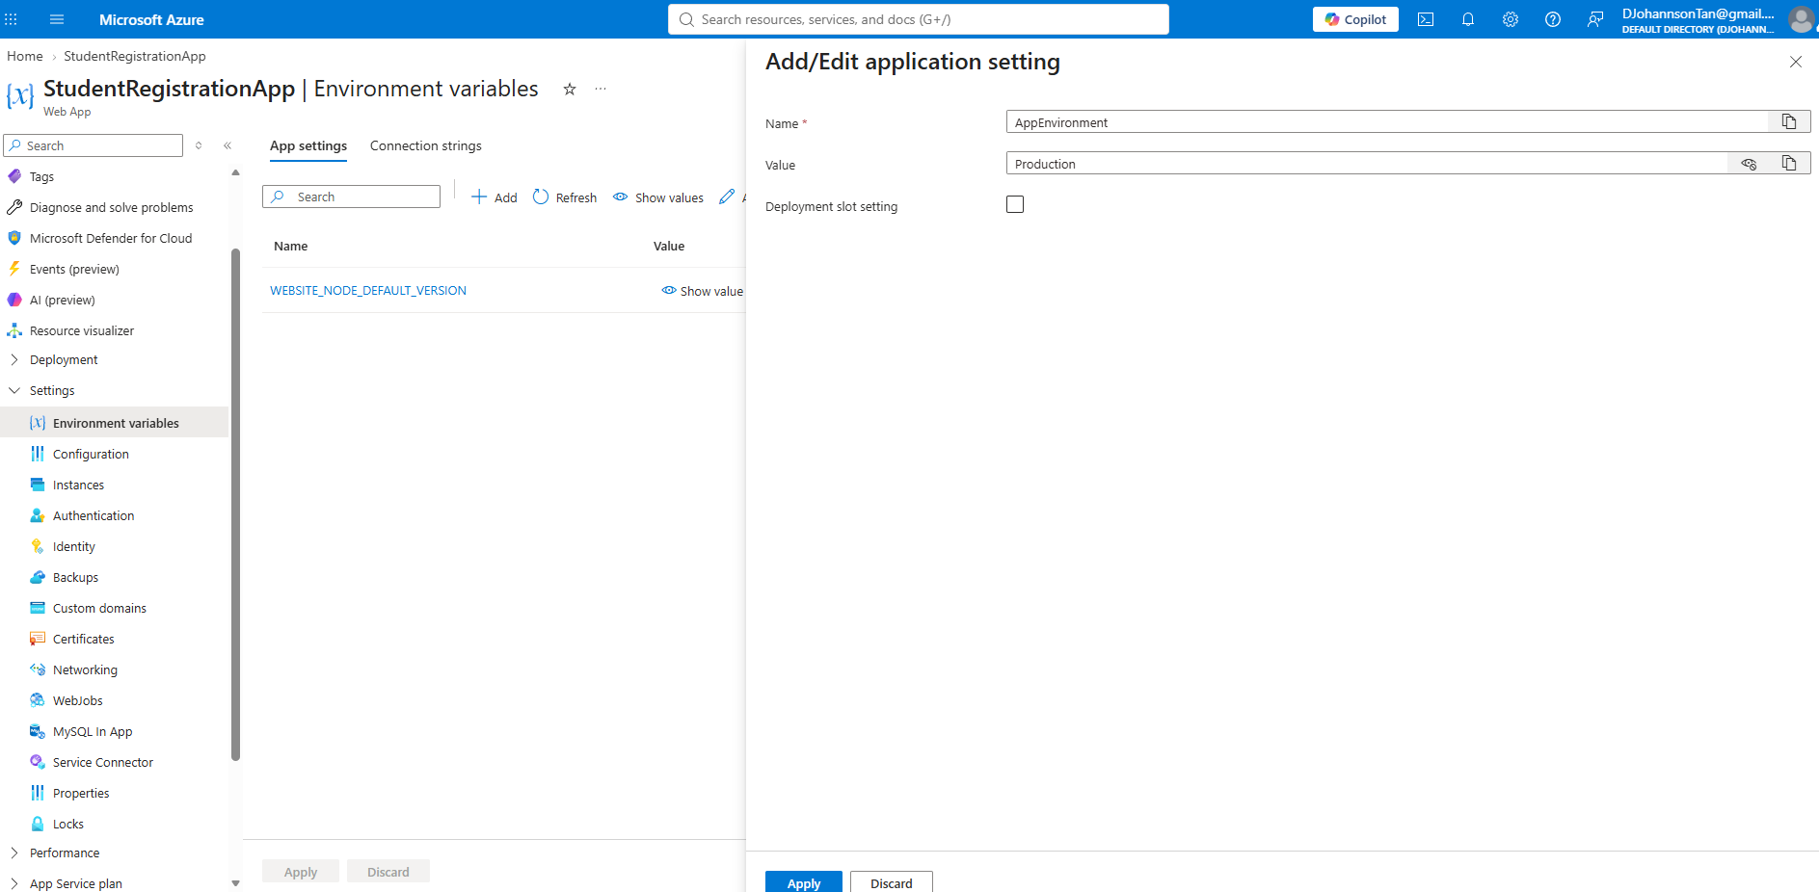
Figure 3: Click on add and then fill the Name and Value and Apply
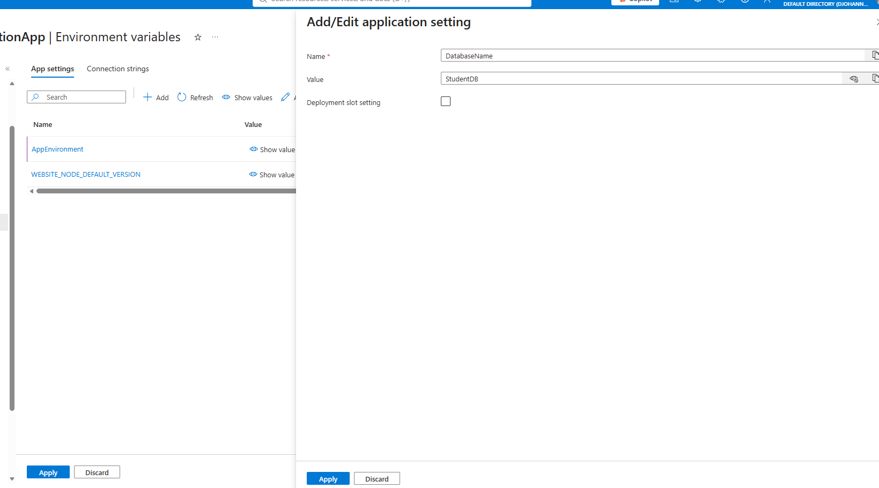
Figure 4: add another one and fill the Name and Value and then Apply
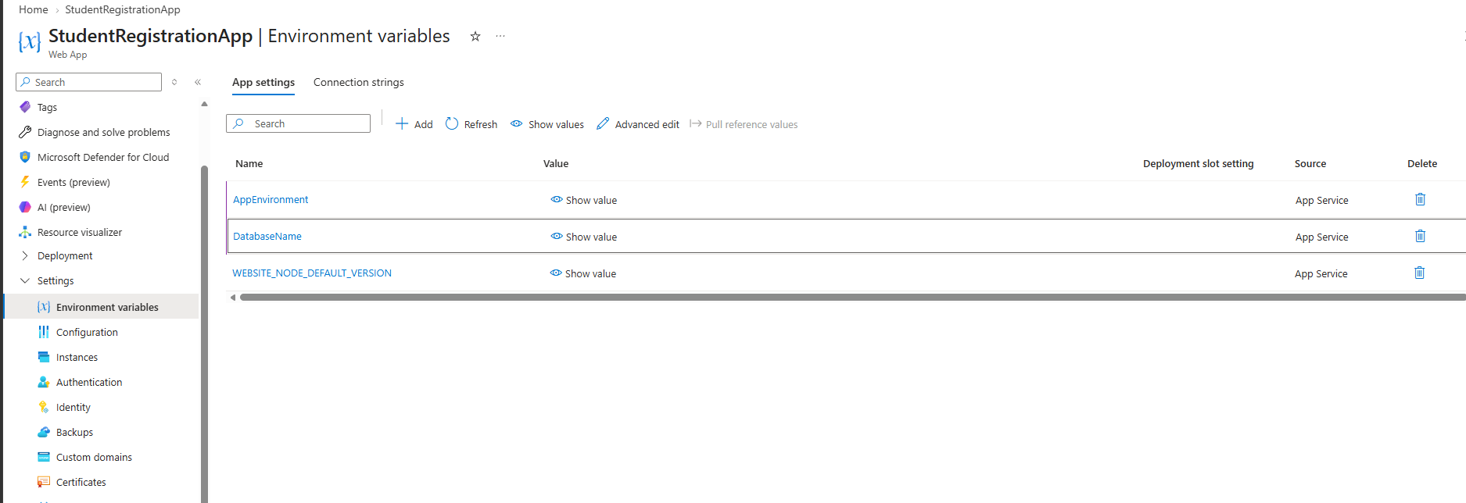
Figure 5: you should see it added after adding them in and then click on Apply on the bottom left

Step 2: App Service Logs
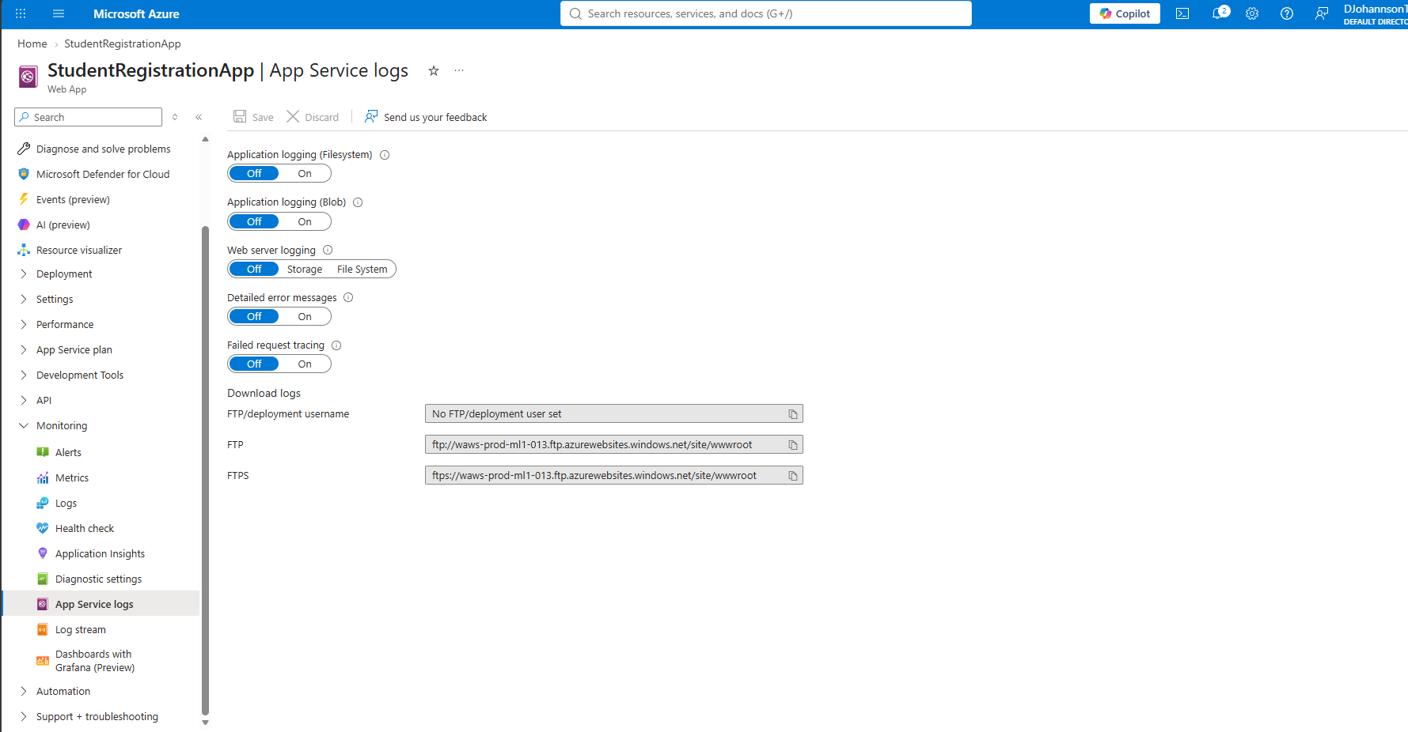
Figure 6: on the left side find Monitor and click on App Service Logs
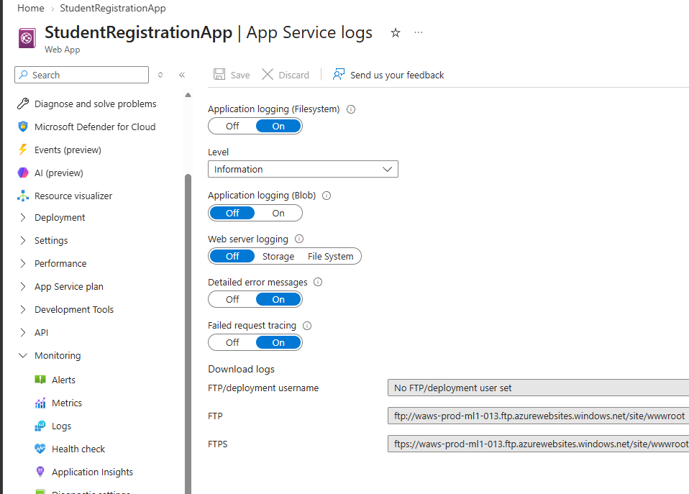
Figure 7: set everything to on except for Application logging and web server logging
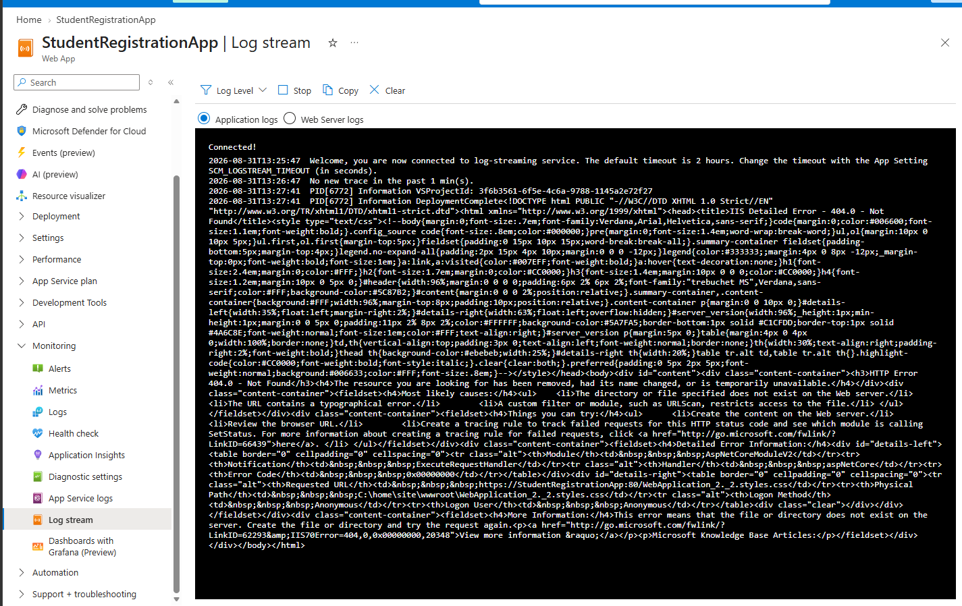
Figure 8: find Log Stream on the left side and check on it

Step 3: Health Check
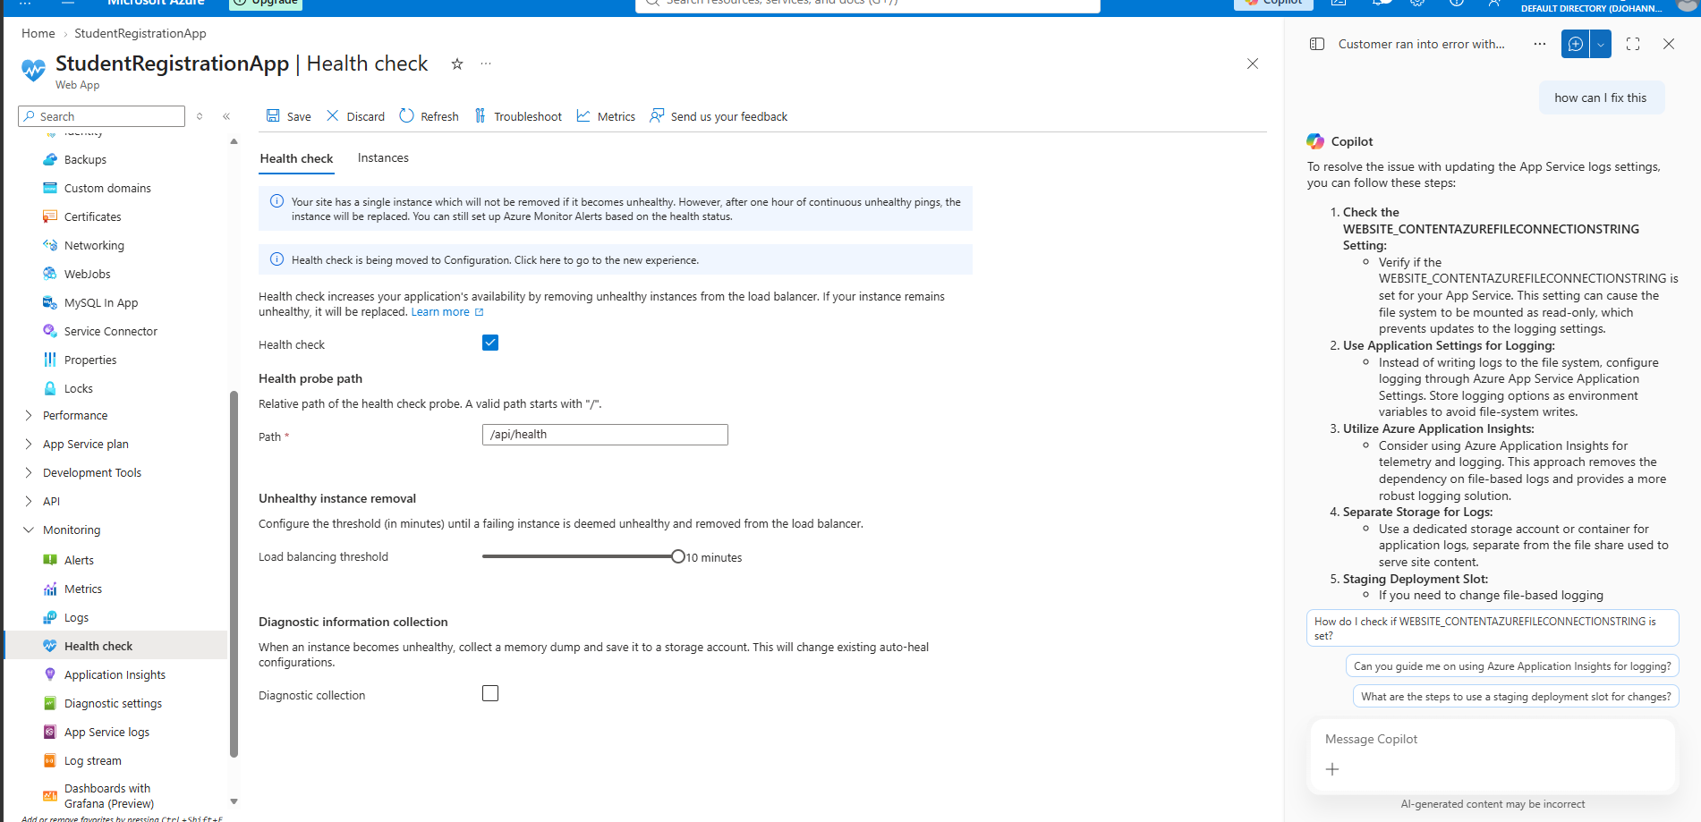
Figure 9: go to the left side and find monitoring and click on Health Check and then for the path put (/api/health) and save
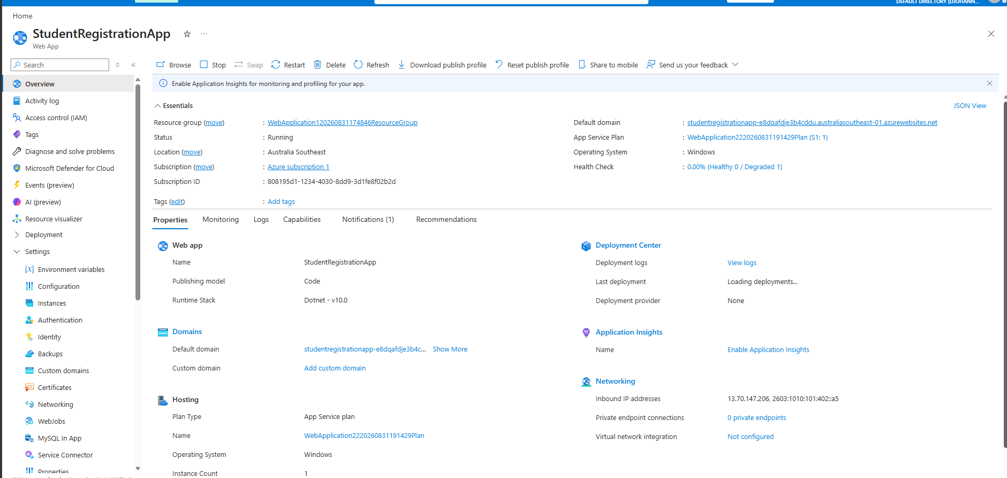
Figure 10: go back to overview and check the Health Check (healthy/unhealthy)

