SWE40006 – Software Deployment and Evolution
Deployment Portfolio Task 1
Daniel Johannson Tan (105075074)
Semester 2
Submission Date: 21 August 2026

Target Level: 1.4 (HD)
GitHub: https://github.com/chenchartist/Software-deployment-and-evolution

Table of Contents
1.1 Sample App 3
1.2 Simple Text Processor 6
1.3 Adding DLLs 10
1.4 GitHub Release + WinGet 15

Sample App
For the first task I followed the instruction given in the assignment to download all the necessary software, like visual studio, Wix, etc; and building a simple Sample app to print out some sentences like “Hello World”
- Code for SampleApp
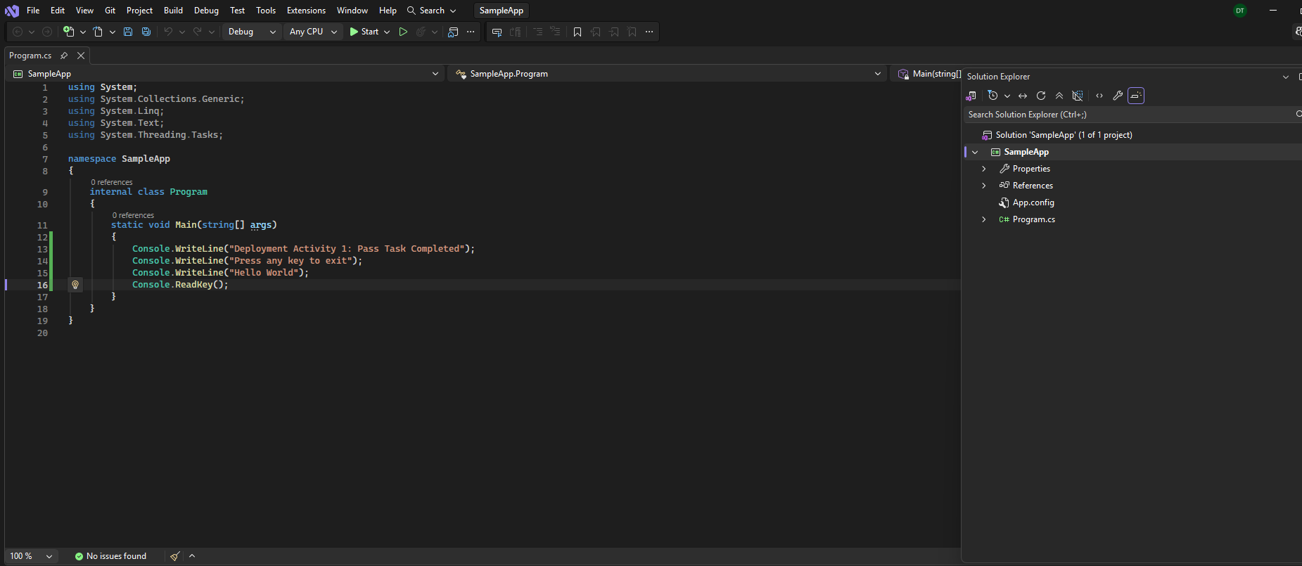
- Building SampleApp
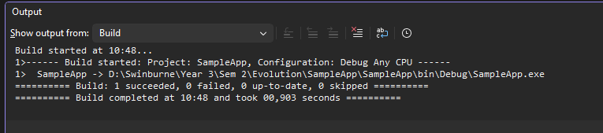
- Folder consisting of SampleApp.exe
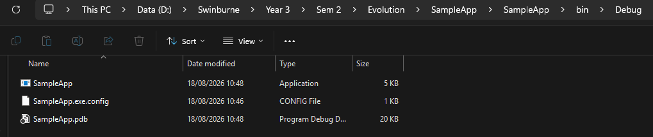
- Setting up for SampleAppSetup
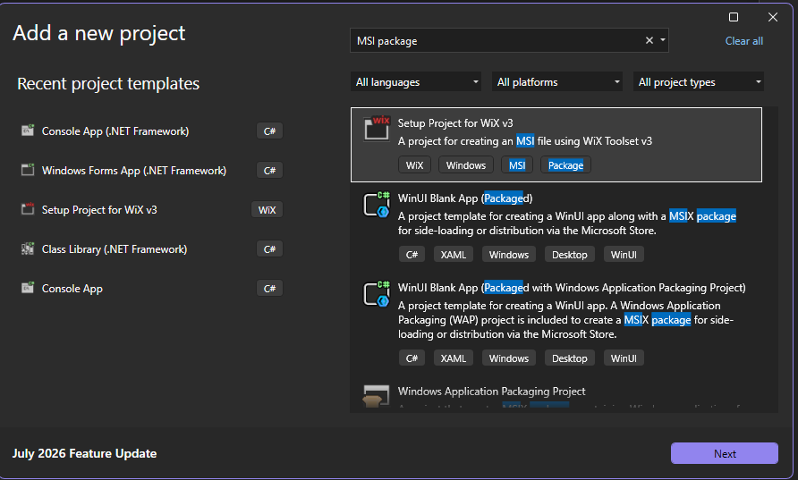
- Add reference
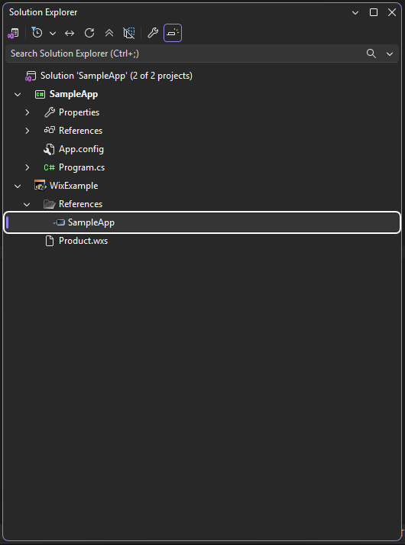
- SampleAppSetup (Product.wxs)
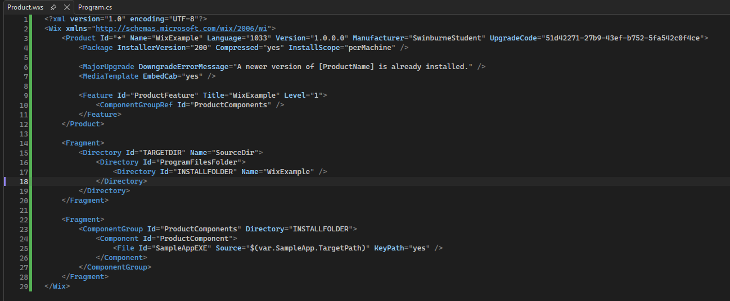
- Build setup outcome
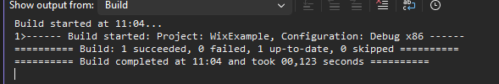
- Run the window installer
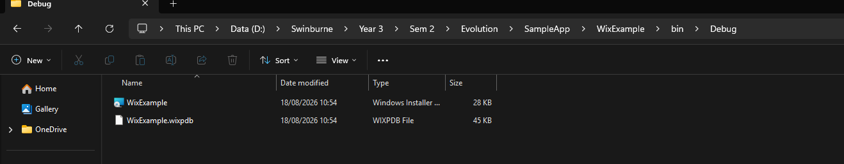
- File in C Drive, Program files
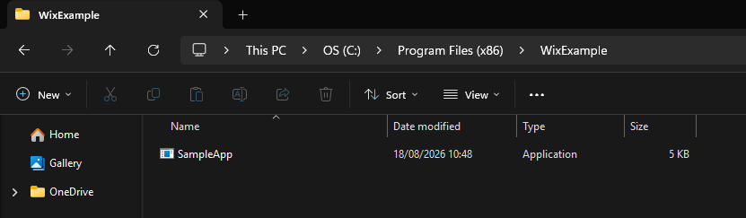
- Output
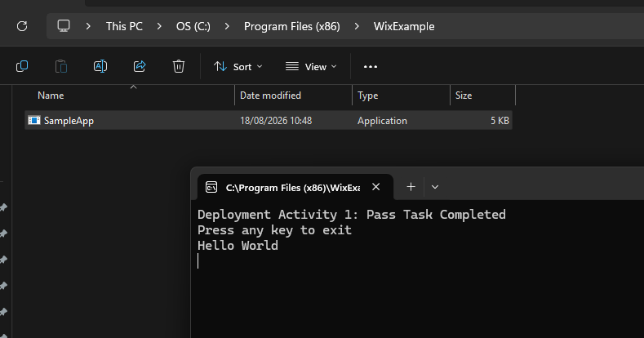
#instalation
1. go to SampleApp folder and there will be WixExample folder go in go to bin/release/ and then find the Window Installer or WixExample
2. click on it and wait for the download
3. go to C drive
4. find program files and then find WixExample
5. Run the Application

Simple Text Processor
For Task 1.2 I made a simple text processor where the user can type in the words or sentences, they want and simply press the count words button and the software will count how many words has been typed into the text box.
- Code (Program.cs)
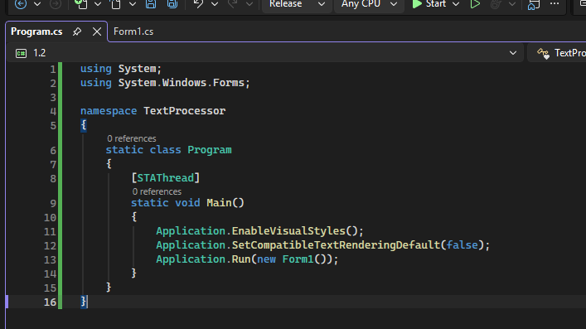
- Code (Form1.cs)
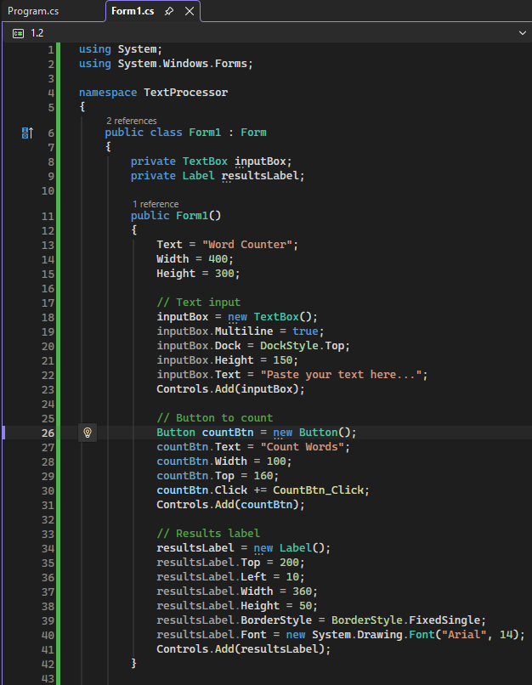
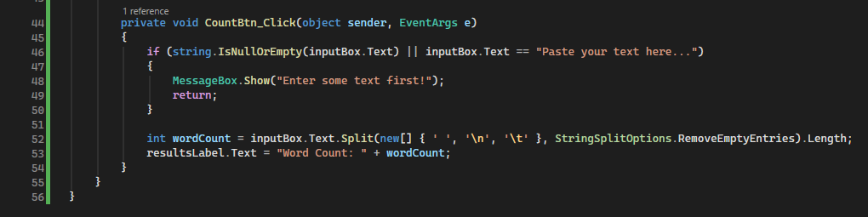
- Build
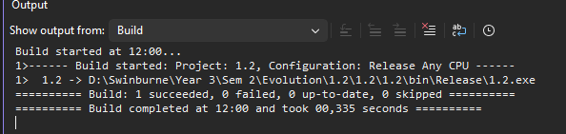
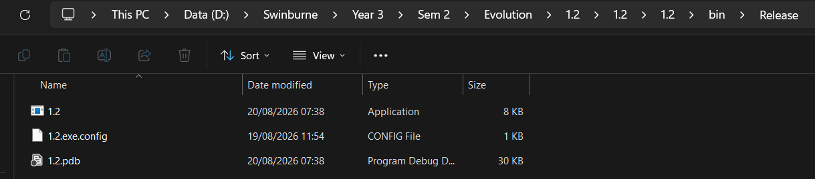
- 1.2 setup (Product.wxs, add 1.2 as reference)
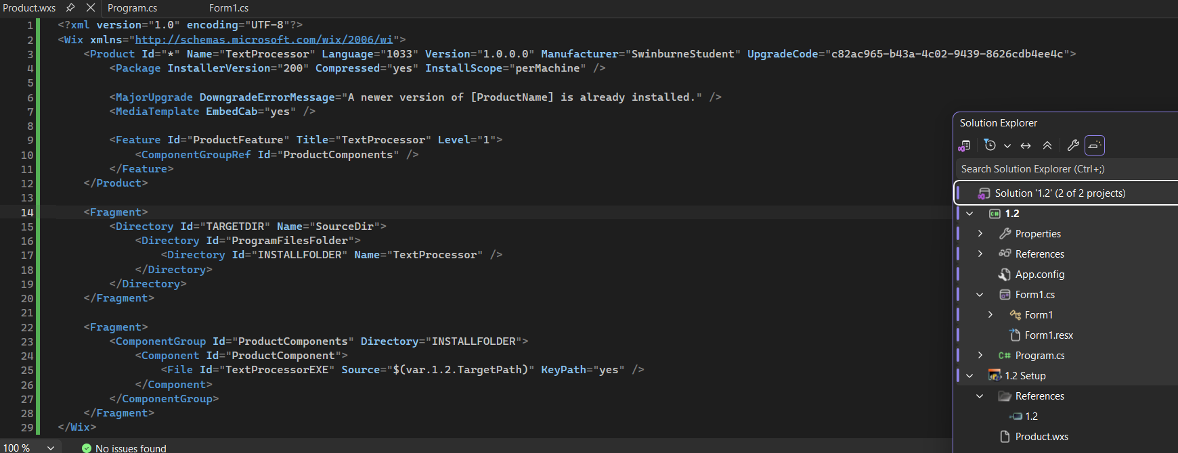
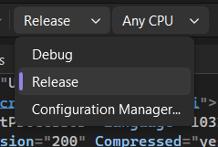
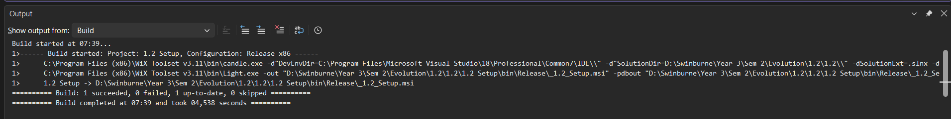
- Windows installer
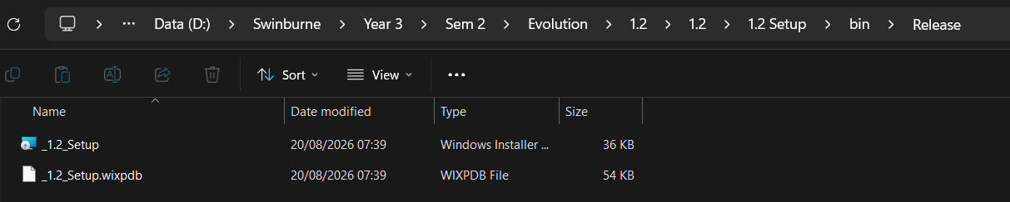
- App (file location in C drive, and app output)
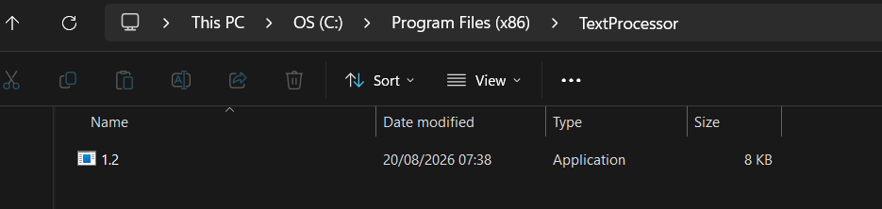
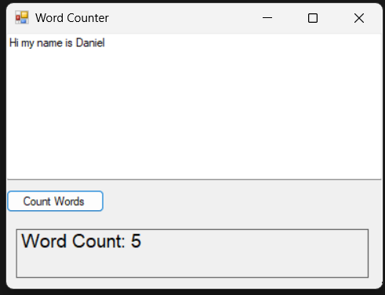

1.3 Adding DLLs
for 1.3 I created 2 libraries and add into the code from Task 1.2 (TextProcessorLibrary and TextProcessorsUtils)
- TextProcessorsLibrary
- Contains the WordCounter Class, which counts the number of words in the input text
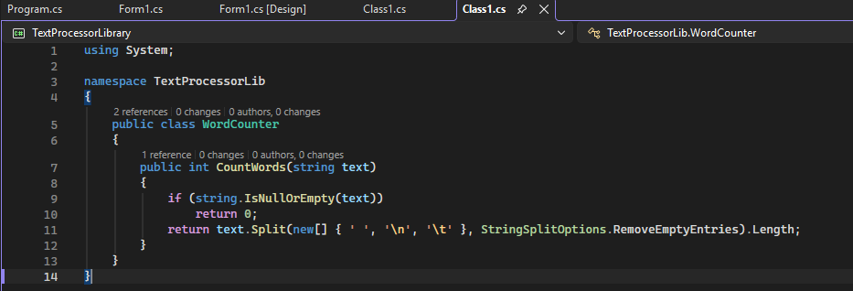
- TextProcessorsUtils
- Contains the TextValidator class, which validates that the user has entered valid text before counting.
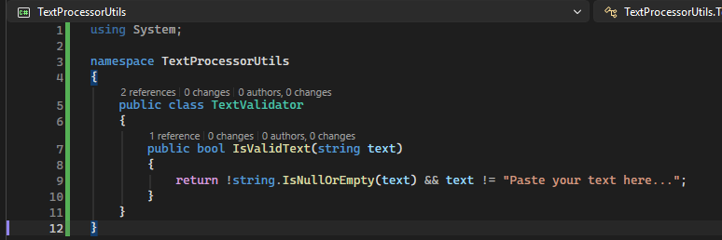
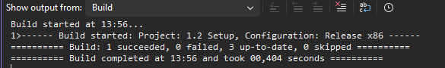
- Updated Form1.cs
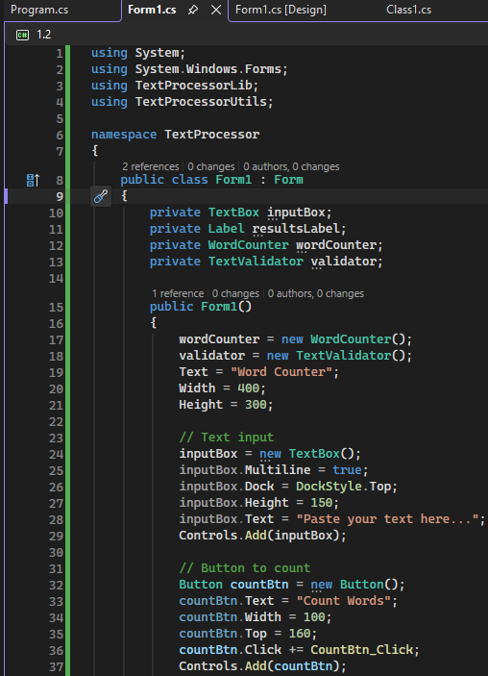
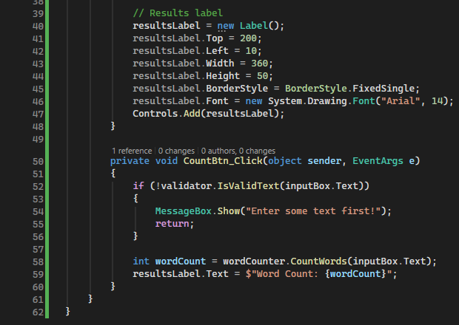
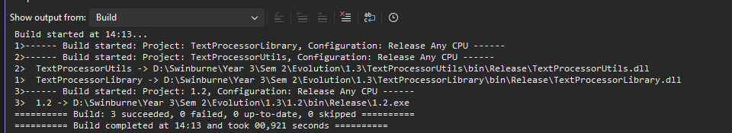
- Setup
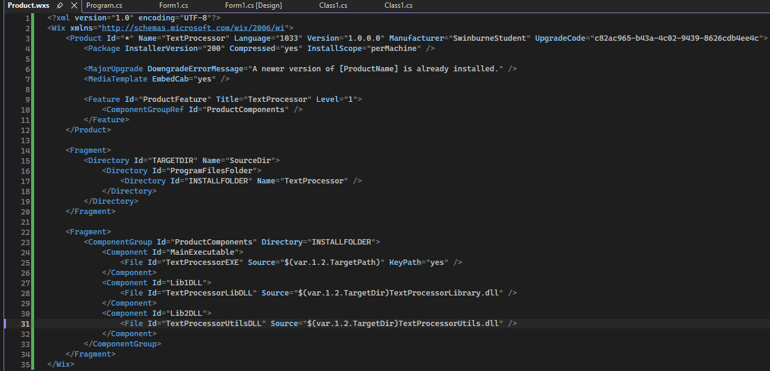
- Output
Download the application
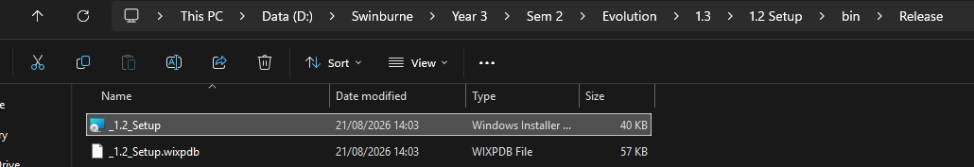
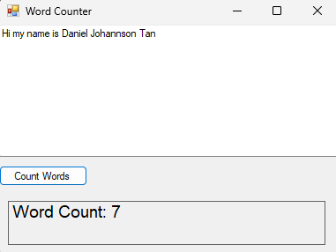
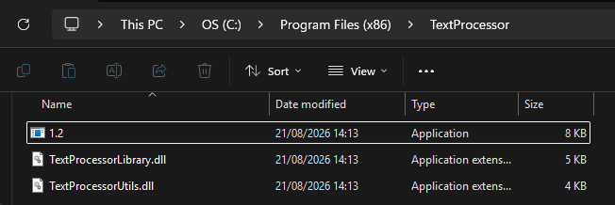

In this 1.3 I also clean before building it again to deletes all the old compiled files from the previous build; and also delete the app from the previous download
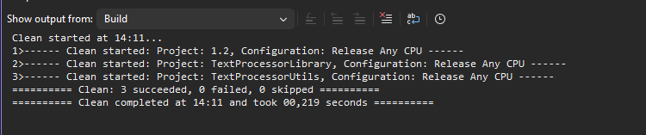
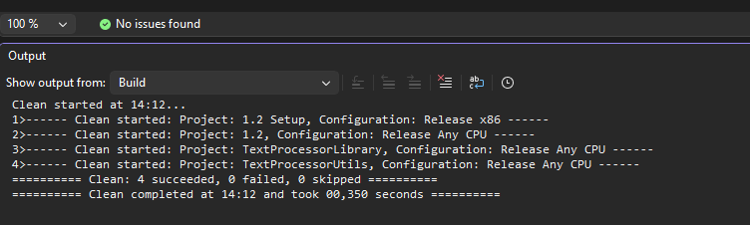

1.4 GitHub Release + WinGet
For 1.4 we will be releasing the code on GitHub and create a manifest on WinGet
Step by step
- Create GitHub release
- Go to GitHub repository, on the right side click on release, click on create a new release, select your file, publish release
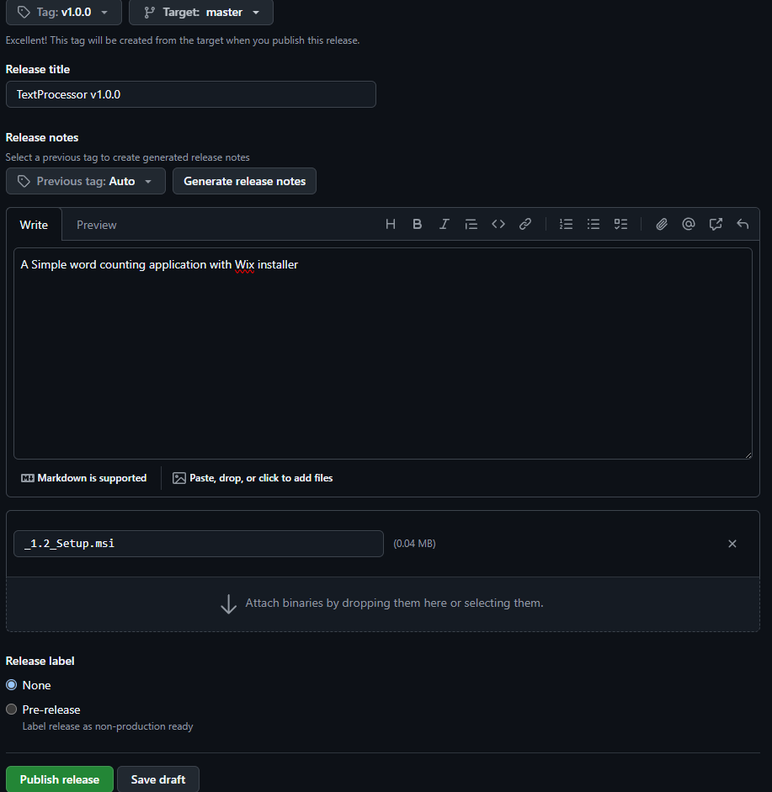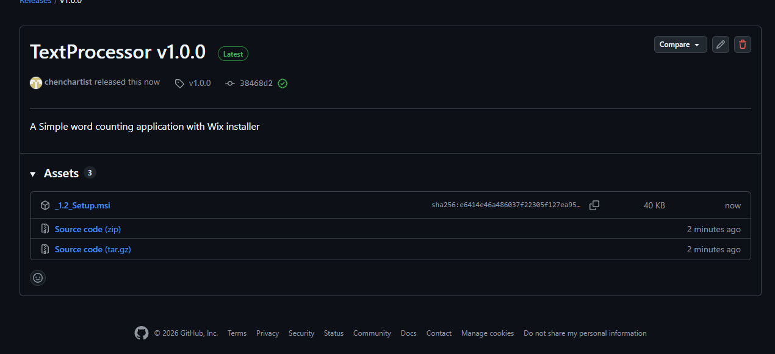
- Get the SHA, keep it, will need for the manifest file
(sha256:e6414e46a486037f22305f127ea95c7e0bedd9f396d498f5df766e734e9bffd8)
- Create Manifest (the .yaml content), and put in the sha in InstallerSha256
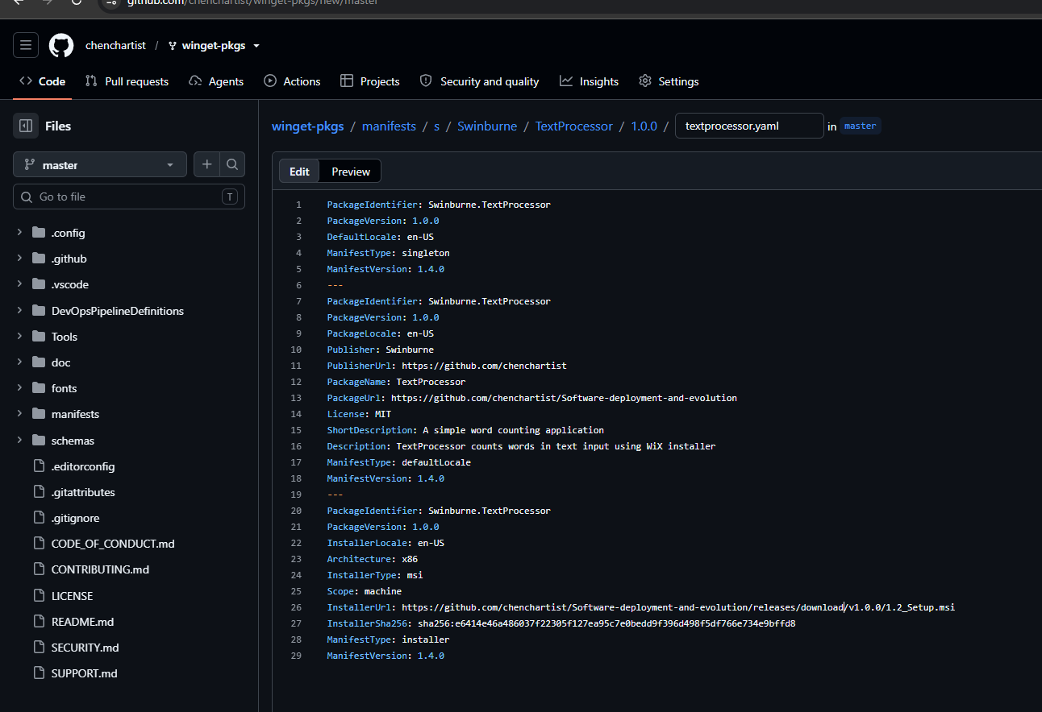
- Go to “wingetpkgs-fork” and fork ur github [username]/winget-pkgs
- Click “add-file” > “create new file”
- Copy the Yaml content
- Commit changes
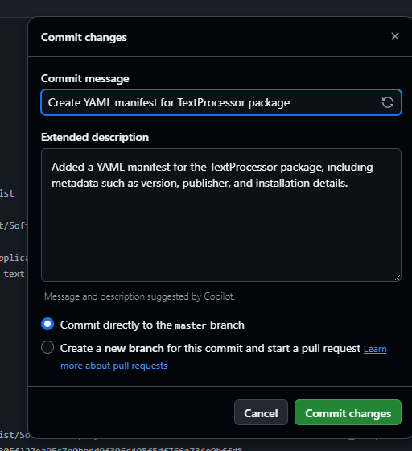
- Comparing changes
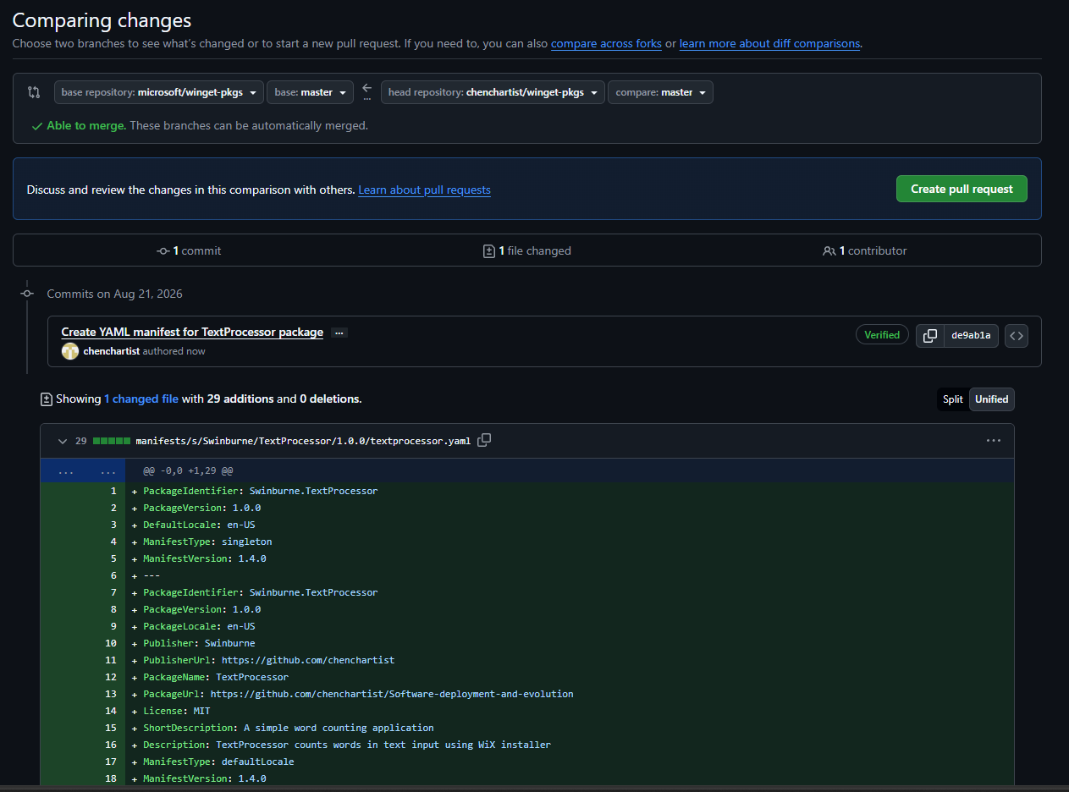
- Create pull request
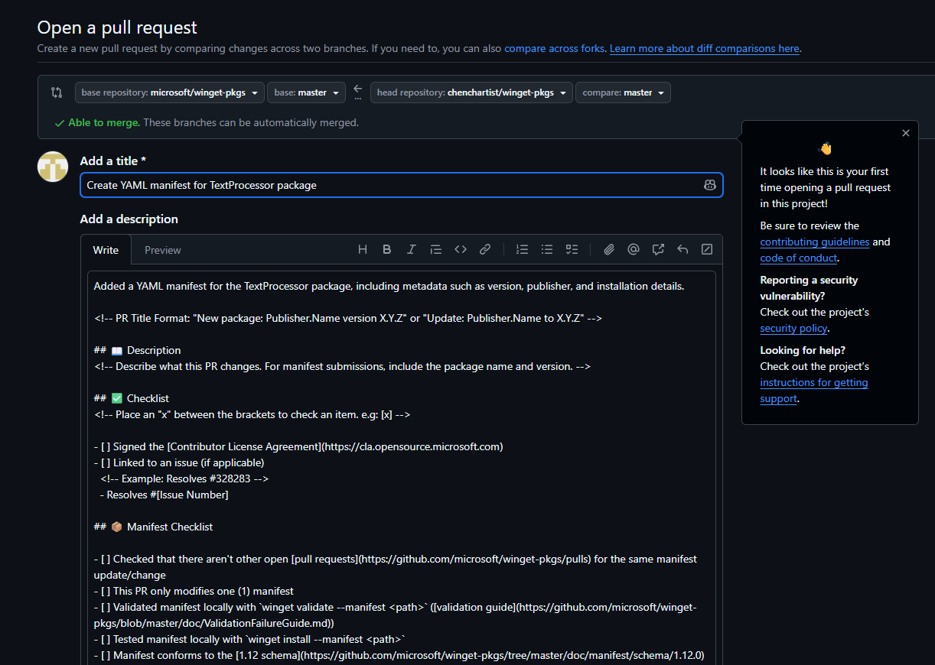
- Create Title and write description, submit pull request to Microsoft
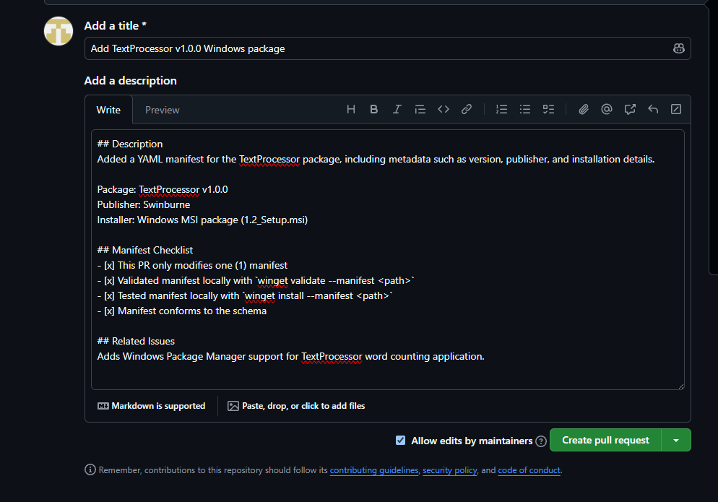
- Created
