SWE40006 – Software Deployment and Evolution
Deployment Portfolio Task 1
Daniel Johannson Tan (105075074)
Semester 2
Submission Date: 18 August 2026

Target Level: 1.4 (HD)

1.1
Code for SampleApp
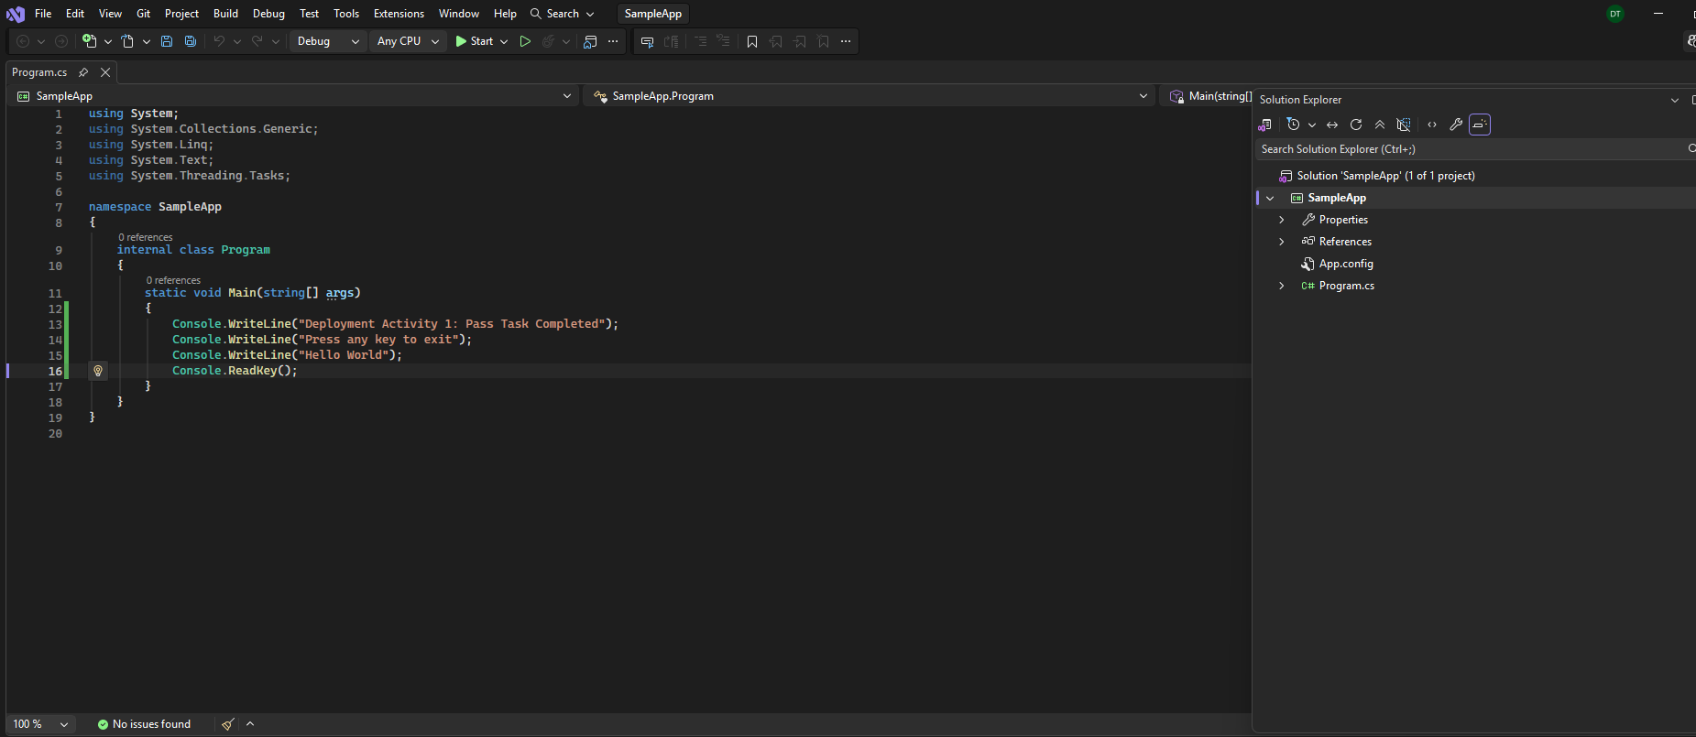
Building SampleAp
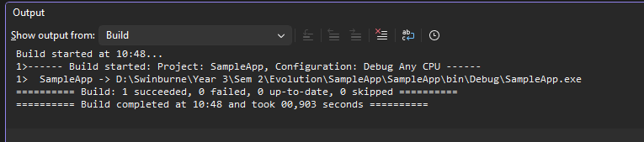
Folder consisting of SampleApp.exe
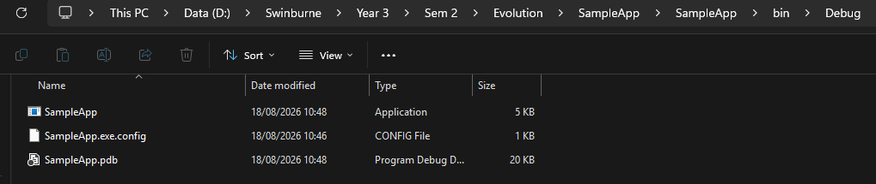
Setting up for SampleAppSetup
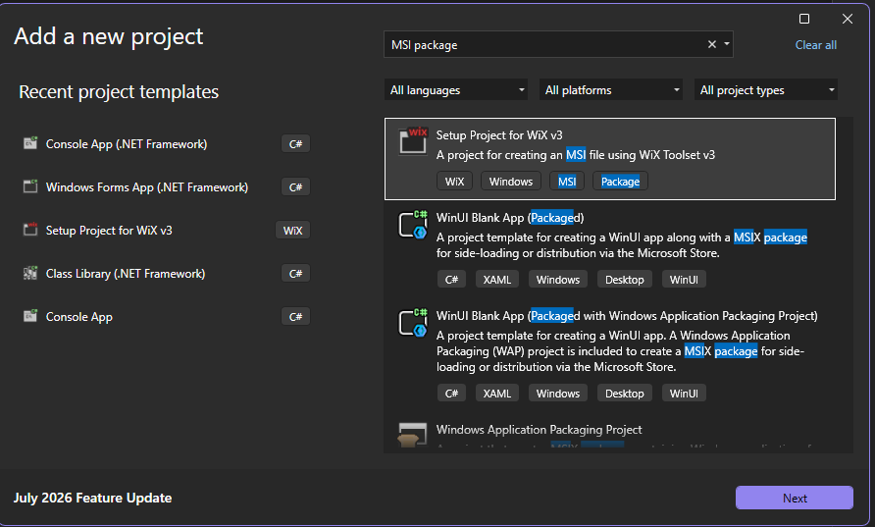
Add reference
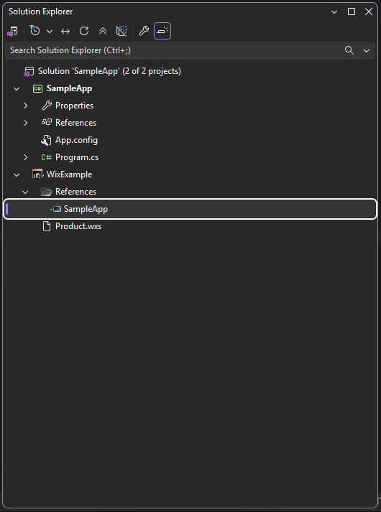
SampleAppSetup (Product.wxs)
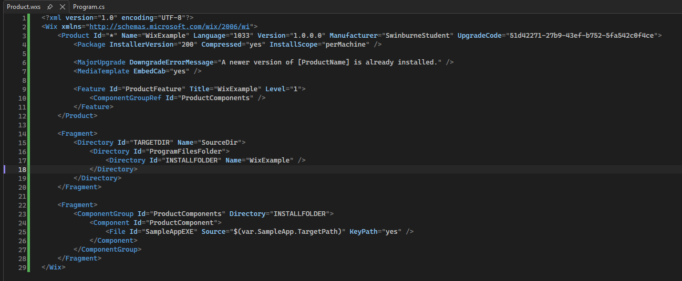
Build setup outcome
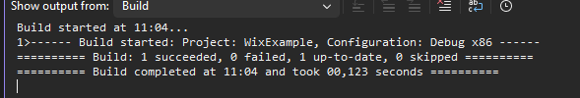
Run the window installer
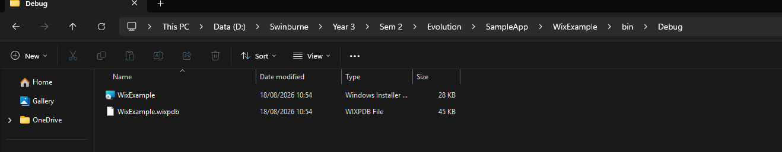
File in C Drive, Program files
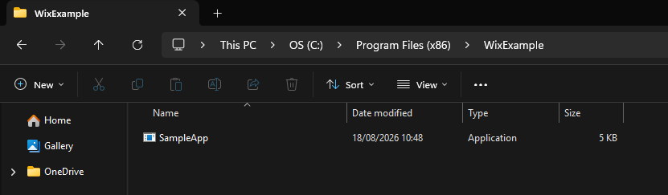
Output
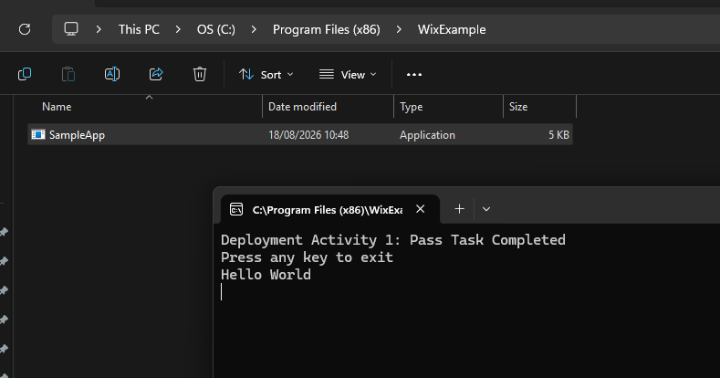

1.2 (simple text processor)
Code (Program.cs)
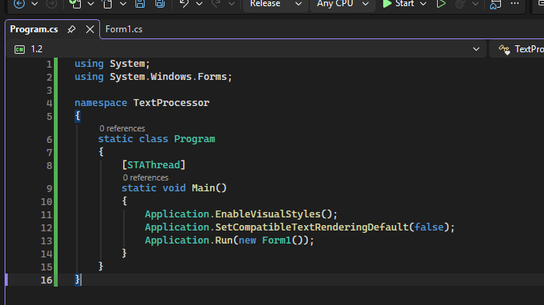
Code (Form1.cs)
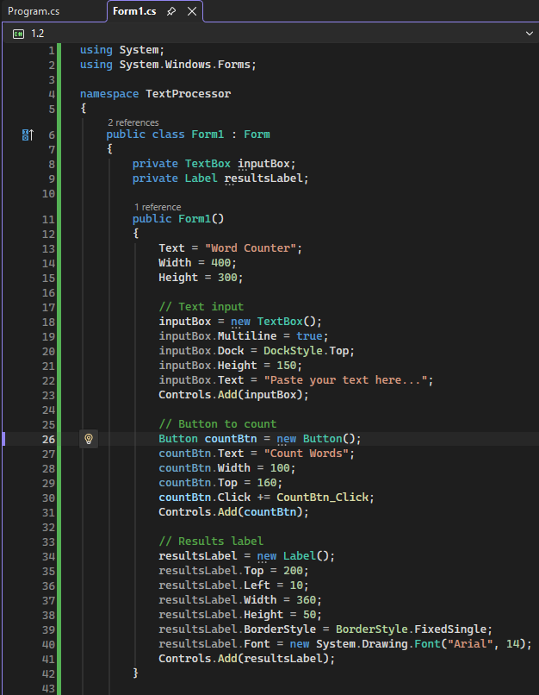
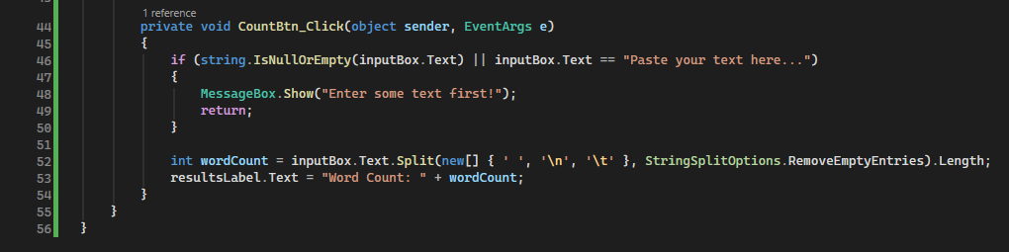
Build
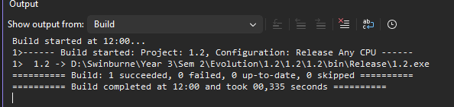

1.3

