**Please finish all the steps below before test !**

1. Common:
2. Open the file in script “/common/common.ini”. Modify the items
3. Change the “NETWORK_TYPE” to the network type you need for test. All the type are “2G/3G/LTE/All/WiFi”. You could delete some if not needed. The type string need to split by “/”. You don’t have to delete some items in “/common/Stabilty.ini” if  you just don’t need to test one  network type. The script could fetch the test times  automatically for the setting of “NETWORK_TYPE”. The top 4 scripts  could be tested in other network type
4. Change the “Tel_receive_num” to the a number which can be automatically answered and "msg_receive_num" a number which can  receive messages.
5. Change ‘wifi_name’ and ‘wifi_password’ to a useful WiFi network
6. Change the ‘address’ to the Email address of receive the emails, it could be more than one and separated by ‘,’
7. Change the “TEST_PLACE” to the US if test not in China.
8. Modify the values for items in script “/common/Stability.ini” if need change the test times for some cases.
9. Unlock screen, Keep in Vertical screen
10. Enter ‘Settings’
11. 🡪’ Developer options’ 🡪enable ‘Stay awake’ and ‘USB debugging ’
12. (Option)🡪’Date & time’ 🡪’Automatic network time and date ’or set to the current time and date
13. 🡪’Display’🡪Set ‘Brightness level’ to the lowest and ‘Sleep’ to ‘Never’
14. 🡪’Sound & notification’🡪 Set all Sound to the lowest
15. (Option) ‘Wi-Fi’🡪Turn on Wi-Fi and connect to a network
16. (Option)Security🡪Screen lock🡪Choose ‘None’
17. 01.Telephony
18. A SIM card in,
19. One ‘.vcf ’ file contains contacts more than test ‘DelContactsTimes’ and ‘***ContactsCal’. Name is from ‘Autotest000051’ to ‘Autotest000100’. The call numbers should be automatically answered when you were calling such as ‘10010’
20. Open Contacts once to set all the permission:

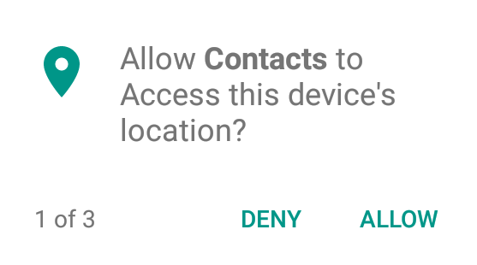

1. Empty the contacts
2. At least one call history in call history

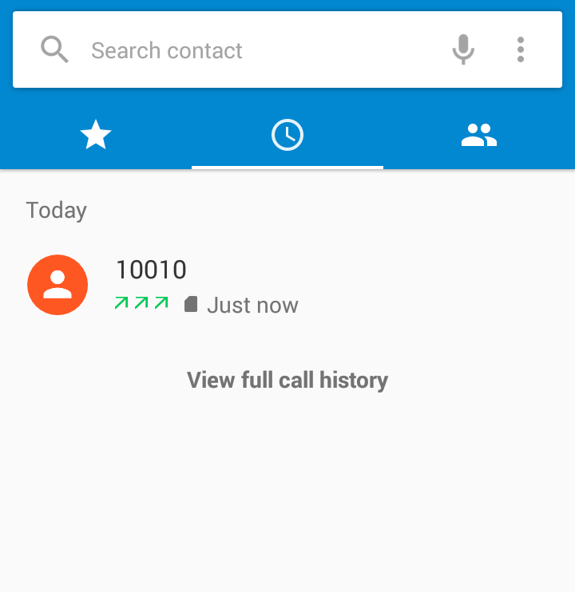

1. 02_Messaging.
2. A SIM card in, Delete all the messaging before
3. Add 4 new Messaging and sent to different receiver.

The 4 Messaging from top to bottom is : MMS with Audio(About 10 seconds), MMS with Video(About 10 seconds), MMS with Picture, SMS (It’s need to send form SMS to MMS with Audio)

Delete the video, photo and voice files in Gallery(If they are stored) and Sound Recorder after Send all the MMS.

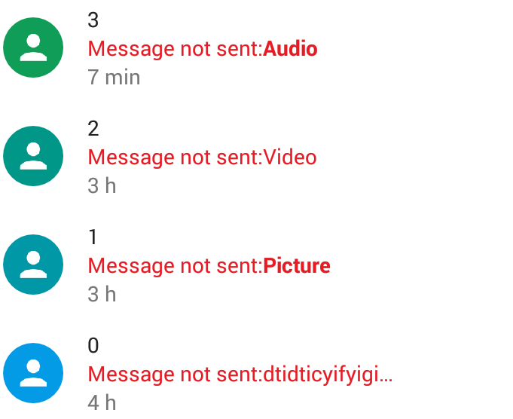

1. 03.Email
2. Add an email Account.
3. Empty the ‘Outbox’, ‘Sent’ and ‘Trash’ in the Account.
4. Preloading two and only two emails in ‘Inbox’: The first is ‘only text’ and the second is ‘with 5M attachment’
5. Click ‘×’ if the ‘Inbox’ synchronize first time as it show in the blow screenshot
6. Open account settings, Set ‘Sync frequency’ to ‘Never’, ‘Sync emails from:’ to ‘All’, Disable ’Sync contacts’ and ‘Sync calendar’, Enable ’Sync email’ and ‘Download attachments’

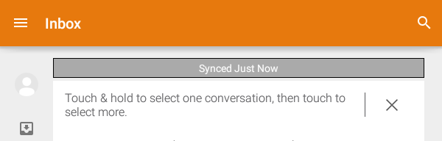

1. 04.Browser
2. Open Chrome, Add 5 bookmarks, such as: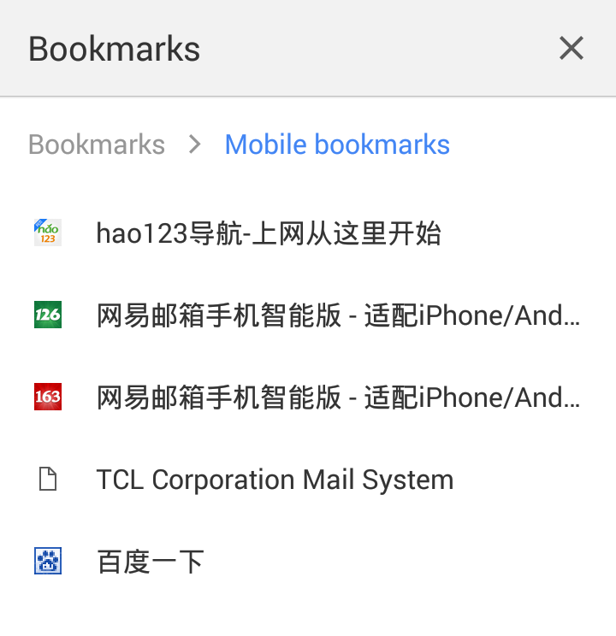
3. Remove the “Sync you bookmarks” in “Bookmarks” menu by click “NO, THANKS”

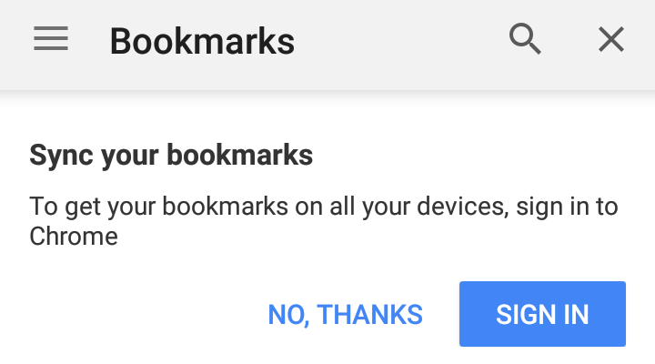

1. Change the Search engine and Home page to other instead of “Google” if test in China.
2. 05.PIM

Open ‘Calendar’ once, Skip all the guide

: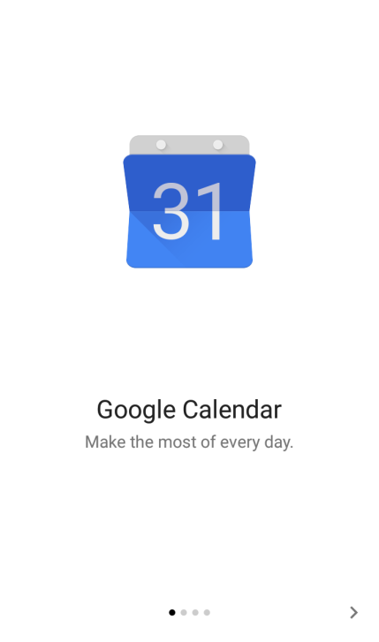.

1. 06.Multi-Media
2. Open Camera, Click the prompt info ‘NO THANKS’, ’OK’, etc.. Make sure in preview screen.

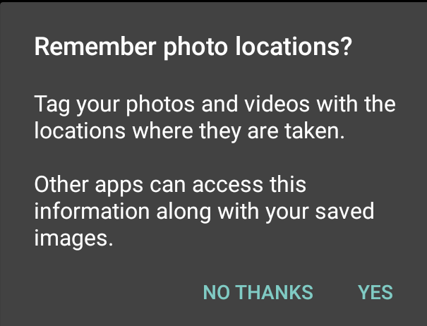

1. (Option)If there are more than one player. In Camera 🡪Recording a video🡪 Swipe to preview🡪 Play the video🡪 Choose ‘Video player’🡪 ‘ALWAYS’ 🡪 Exit Camera
2. Open ‘Sound Recorder’ once to allow all the permission: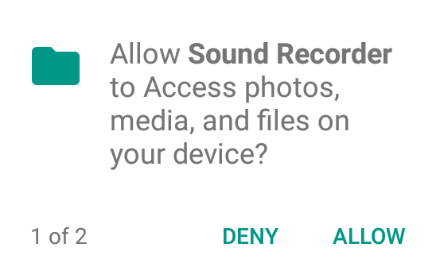
3. Open ‘Mix’ once in homepage 🡪click twice to open the app,🡪click “GET STARTED”
4. Copy 5 music files (more than 30 seconds) into the folder “Music” in phone storage and check it can be play in ‘Mix’

(If there are recording files in it, delete them.)

1. 10.filemanager
2. Open ‘Filemanager’ once to allow all the permission:

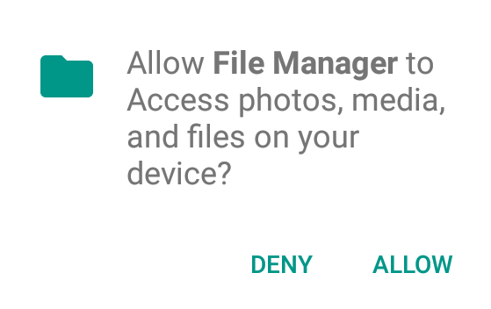

1. Put a video file(*.mp4, more than 30 seconds) into the folder “Movies”  , a picture file(*.jpg) into the folder “Pictures” and a music file (*.mp3, more than 30 seconds) into the folder "Music" in the phone  storage. Create the folders “Movies”,“Pictures”and “Music" to the phone storage root path if they are not existed.

(If the music file is already put in when set Mix, no need to put more)

1. Open the file “*.mp4” , “*.mp3”and “*.jpg” once. Click “OK” or other prompt if need confirm.

If need to choose player, choosing any one will be OK. (Best choose the Gallery, Mix, VideoPlayer)