BATools: An R Package for Whole Genomic Analysis with Bayesian Models

Chunyu Chen, Lei Zhou, Robert J. Tempelman

2015-12-16

The package BATools is used to perform genome-wide association using a various Bayesian models. It is a implemented using both Markov Chain Monte Carlo (MCMC) and expectation maximization (EM) algorithm.

The basic functions in BATools is bafit, which fits a genomic selection model using different prior selection. The main characteristic of this package are:

* Fit model with different prior specification including the Antedependence model
* Flexibility to choose between MCMC and EM algorithm, both of which are able to estimate the hyperparameters
* Accepts gpData objects from package synbreed as input data. It can also use numeric and matrix as input
* It is computationally efficient
* GWA using EM BayesA/C (under development)

## 1. Introduction

Whole genome prediction (WGP) is an evolutionary development in animal breeding. Currently, many models have been developed for WGP, which included rrBLUP, BayesA, BayesB, BayesC, Bayesian Lasso, Antedepedence BayesA/B (Meuwissen et al. 2001, VanRaden 2008, de los Campos et al. 2009, Habier et al. 2011, and Yang and Tempelman 2012). The major difference of these models are different prior assumptions on marker effects. Software packages like BGLR and GenSel implement BayesA, BayesB and Bayes Lasso model using MCMC algorithm. No public software is available to implement Antedependence models. At the same time, no R package is available for implement BayesA/C using EM algorithm for animal breeding. BATools package provides tools to fit Antedependence models in addition to some of the most popular models and provider faster EM algorithms to fit the model. The table below is a comparison between BATools and BGLR:

|  |  |  |
| --- | --- | --- |
| Model/Algorithms | MCMC | EM |
| rrBLUP | BATools/BGLR | BATools |
| BayesA | BATools/BGLR | BATools |
| BayesB | BATools/BGLR | under development |
| BayesC | BATools/BGLR | BATools |
| Bayesian Lasso | BATools/BGLR | under development |
| AnteBayesA | BATools | under development |
| AnteBayesB | BATools | under development |

## 2. Basic Model

The basic model used by BATools is:

$$y=X⋅b+Z⋅g+e,$$

where:

* $y$ is the vector of response variables
* $X⋅b$ models the fixed effects
* $g$ is the SNP marker effect and $Z$ is corresponding genotype matrix of $n⋅m$
* $e$ are the vector of effects residual, $e∼N\left(0,Iσ_{e}^{2}\right)$

Notice that for different models, the priors on $g_{i}$ are different:

* rrBLUP: $g_{j}∼N\left(0,Iσ_{g}^{2}\right)$
* BayesA: $g_{j}∼N\left(0,Dσ_{g}^{2}\right)$, where $D=\{τ_{1},τ_{2},...,τ_{m}\}$ and $τ_{j}∼χ^{-2}\left(ν_{g},ν_{g}\right)$
* BayesB: $g_{j}∼N\left(0,Dσ_{g}^{2}\right)$, where $D=\{τ_{1},τ_{2},...,τ_{m}\}$ and
$$τ_{j}=\{\begin{matrix}0 & withprobability & π \\ ∼χ^{-2}\left(ν_{g},ν_{g}\right) & withprobability & 1-π\end{matrix}$$

* BayesC: $g_{i}∼N\left(0,Dσ_{g}^{2}\right)$, where $D=\{τ_{1}+\frac{1-τ_{1}}{c},τ_{2}+\frac{1-τ_{2}}{c},...,τ_{m}+\frac{1-τ_{m}}{c}\}$ and $τ_{j}∼Bernoulli(π)$, $τ_{j}=0,1$
* Bayesian Lasso: $g_{j}∼N\left(0,Dσ_{g}^{2}\right)$, where $D=\{τ_{1},τ_{2},...,τ_{m}\}$ and $τ_{j}∼Exp\left(λ^{2}\right)$

Furthermore, the Antedepedence models specify correlation structure for $g$ based on the relative physical location of SNP markers along the chromosome :

$$g_{j}=\{\begin{matrix}δ_{j} & if & j=1 \\ t_{j,j-1}δ_{j-1}+δ_{j} & if & 2≤j≤m\end{matrix}$$

where $t_{j,j-1}∼N\left(μ_{t},σ_{t}^{2}\right)$

## 3. BATools example

In BATools, we adhered the data structure of the object gpData in the synbreed package. The input and output objects are named as baData and BAout, which are R object class list. Therefore, users can directly use synbreed object as the input for BATools, and vice versa. More detailed explanation about baData and BAout can be found in the package manual file.

We will use a toy dataset from the MSUPRP population to illustrate the use of BATools

### Load packages and data

library(BATools)  
data("MSUPRP_sample")  
summary(MSUPRP_sample)

## object of class 'gpData'   
## covar   
## No. of individuals 253   
## phenotyped 176   
## genotyped 251   
## pheno   
## No. of traits: 3   
##   
## ph_24h temp_24h driploss   
## Min. :5.190 Min. :1.100 Min. :0.000   
## 1st Qu.:5.450 1st Qu.:1.600 1st Qu.:0.560   
## Median :5.540 Median :1.900 Median :0.940   
## Mean :5.552 Mean :1.983 Mean :1.141   
## 3rd Qu.:5.640 3rd Qu.:2.300 3rd Qu.:1.545   
## Max. :6.350 Max. :3.400 Max. :4.330   
## NA's :35 NA's :18 NA's :18   
##   
## geno   
## No. of markers 20597   
## genotypes 0 1 2   
## frequencies 0.287 0.404 0.308   
## NA's 0.000 %  
## map   
## No. of mapped markers 20597   
## No. of chromosomes 18   
##   
## markers per chromosome   
##   
## 1 2 3 4 5 6 7 8 9 10 11 12 13 14 15   
## 1968 1419 1261 1559 1076 1143 1289 939 1426 958 936 833 1319 1263 1079   
## 16 17 18   
## 972 739 418   
##   
## pedigree   
## Number of   
## individuals 253   
## males : 98 , females : 155   
## Par 1 (sire) 10   
## Par 2 (dam) 44   
## generations 3

Then we can create the data object used in BATools by create.baData. In this example we treat the sex as fixed effects

pheno<-data.frame(MSUPRP_sample$pheno[,,])   
geno<-MSUPRP_sample$geno[,seq(1,dim(MSUPRP_sample$geno)[2],20)]   
ped<-MSUPRP_sample$pedigree  
map=MSUPRP_sample$map  
sex<-ped$sex  
sex<-as.factor(sex)  
x<-model.matrix( ~ sex -1,contrasts.arg=list(sex=contrasts(sex, contrasts=F)))  
colnames(x)<-c("female","male")  
rownames(x)<-ped$ID  
pig=create.baData(pheno=pheno,geno=geno,map=map,pedigree=ped,fixed=x,makeAinv=F)

### Set up initial values for the model

We choose to demonstrate how to fit BayesA using MCMC and EM. We start with MCMC:

init=set_init(pig,df=5,pi_snp=1,h2=0.5,c=NULL,model="BayesA",centered=T,trait="driploss")  
run_para=list(niter=5000,burnIn=2500,skip=10)  
print_mcmc=list(piter=2500)  
update_para=list(df=FALSE,scale=TRUE,pi=FALSE)  
op<-create.options(model="BayesA",method="MCMC",ante=FALSE,priors=NULL,init=init,  
 update_para=update_para,run_para=run_para,save.at="BayesA",cv=NULL,print_mcmc=print_mcmc)

### Fit the model

We then fit the model using MCMC for the trait driploss with the above setups:

ba<-bafit(dataobj=pig,op=op,trait="driploss")

## iter= 2500 vare= 0.363131 scale= 0.00049178   
## timepercycle= 0.001 estimated time left= 1.26 seconds   
## iter= 5000 vare= 0.36142 scale= 0.00037677   
## timepercycle= 0.001 estimated time left= 0 seconds

ba

## BATools analysis of trait: driploss   
##   
## estimated fixed effects:  
## female male   
## 1.0076589 0.8685423   
##   
## estimated hyperparameters:  
## vare scale   
## 0.3807336238 0.0003754588   
##   
## effective sample size for hyperparameters:   
## vare scale   
## 99.05445 14.79361

### Graphics

We can obtain the traceplot for MCMC:

par(mar=c(2,2,2,2))  
baplot(dataobj=pig,BAout=ba,type="trace",op=op)

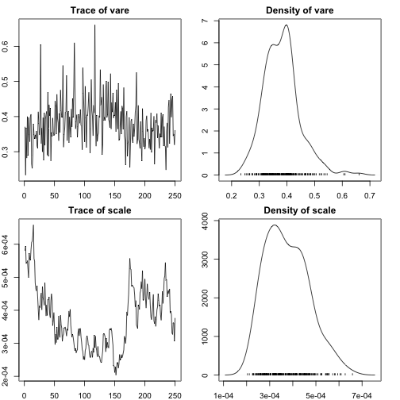

### EM algorithm

To use the EM algorithm in BATools, we first run an analysis using rrBLUP:

##################run rrBLUP REML#####################  
init=set_init(pig,df=5,scale=NULL,vare=NULL,pi_snp=1,h2=0.5,c=NULL,model="rrBLUP",centered=T,trait="driploss")  
run_para=list(maxiter=100)  
update_para=list(df=FALSE,scale=TRUE)  
op<-create.options(model="rrBLUP",method="EM",ante=FALSE,priors=NULL,init=init,  
update_para=update_para,run_para=run_para,save.at="rrBLUP",  
cv=NULL,print_mcmc=NULL,convcrit=1E-4)  
  
rr<-bafit(dataobj=pig,op=op,trait="driploss")

## rrBLUP iter= 1   
## Residual Variance is 0.3916505 Scale is 0.0004661316  
## Convergence criteria is 1e-04 and current value is 1e+10  
## rrBLUP iter= 2   
## Residual Variance is 0.3884433 Scale is 0.0005341798  
## Convergence criteria is 1e-04 and current value is 0.008258348  
## rrBLUP iter= 3   
## Residual Variance is 0.3900734 Scale is 0.0005310876  
## Convergence criteria is 1e-04 and current value is 0.004179042  
## rrBLUP iter= 4   
## Residual Variance is 0.3899009 Scale is 0.0005317811  
## Convergence criteria is 1e-04 and current value is 0.0004426353  
## rrBLUP iter= 5   
## Residual Variance is 0.3899315 Scale is 0.00053166  
## Convergence criteria is 1e-04 and current value is 7.85073e-05  
##   
## rrBLUP converged after 5 iterations at 7.85073e-05

rr

## BATools analysis of trait: driploss   
##   
## estimated fixed effects:  
## female male   
## 1.170468 1.040369   
##   
## SD  
## female male   
## 1.302095 1.303128   
##   
## estimated hyperparameters:  
## vare scale   
## 0.38993150 0.00053166

Then we use rrBLUP results as starting values for EM BayesA:

init=set_init(pig,df=5,scale=rr$hyper_est[2],vare=rr$hyper_est[1],g=rr$ghat,b=rr$betahat,pi_snp=1,h2=0.5,model="BayesA",centered=T,trait="driploss",from="rrBLUP")  
run_para=list(maxiter=100)  
update_para=list(df=FALSE,scale=TRUE,pi=FALSE)  
op<-create.options(model="BayesA",method="EM",ante=FALSE,priors=NULL,init=init,D="V",update_para=update_para,run_para=run_para,save.at="BayesA",cv=NULL,print_mcmc=NULL)  
ba_em<-bafit(dataobj=pig,op=op,trait="driploss")

## BayesA EM iter= 1   
## Residual Variance is 0.3863244 Scale is 0.0005531357  
## Convergence criteria is 1e-04 and current value is 1e+10  
## BayesA EM iter= 2   
## Residual Variance is 0.3848432 Scale is 0.0006469239  
## Convergence criteria is 1e-04 and current value is 0.003856724  
## BayesA EM iter= 3   
## Residual Variance is 0.3837225 Scale is 0.0006529888  
## Convergence criteria is 1e-04 and current value is 0.002920448  
## BayesA EM iter= 4   
## Residual Variance is 0.3820295 Scale is 0.0006576012  
## Convergence criteria is 1e-04 and current value is 0.004441596  
## BayesA EM iter= 5   
## Residual Variance is 0.3818452 Scale is 0.0006579109  
## Convergence criteria is 1e-04 and current value is 0.0004826109  
## BayesA EM iter= 6   
## Residual Variance is 0.3816379 Scale is 0.0006585268  
## Convergence criteria is 1e-04 and current value is 0.0005430623  
## BayesA EM iter= 7   
## Residual Variance is 0.3816101 Scale is 0.000658589  
## Convergence criteria is 1e-04 and current value is 7.292798e-05  
##   
## BayesA converged after 7 iterations at 7.292798e-05

ba_em

## BATools analysis of trait: driploss   
##   
## estimated fixed effects:  
## female male   
## 1.168412 1.036599   
##   
## SD  
## female male   
## 1.340235 1.341329   
##   
## estimated hyperparameters:  
## vare scale   
## 0.381610104 0.000658589

### Graphics

Let's look at the estimated phenotypes v.s. true phenotypes for EM:

We can also compare the difference bewteen MCMC and EM:

plot(ba$ghat,ba_em$ghat,xlab="MCMC",ylab="EM",main="BayesA MCMC v.s. EM")  
abline(a=0,b=1)

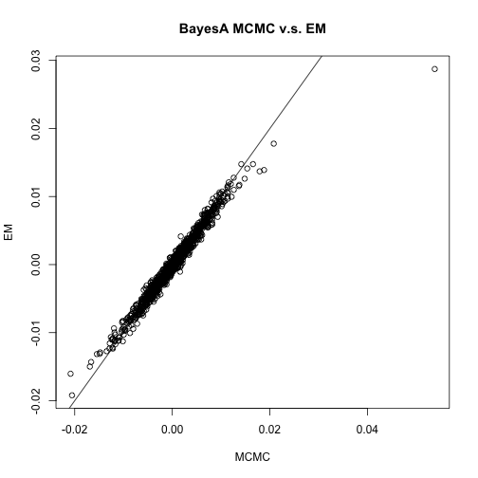

### BayesC

Running BayesC is similar to running BayesA:

init=list(df=5,scale=0.2,pi=0.1,c=1000)  
run_para=list(niter=5000,burnIn=2500,skip=1)  
print_mcmc=list(piter=2500)  
update_para=list(df=F,scale=T,pi=T)  
priors=list(shape_scale=5,rate_scale=0.1,alphapi=1,betapi=9)  
op<-create.options(model="SSVS",method="MCMC",  
ante=FALSE,priors=NULL,init=init,update_para=update_para,  
run_para=run_para,save.at="SSVS",cv=NULL,print_mcmc=print_mcmc)  
bc<-bafit(dataobj=pig,op=op,trait="driploss")

## iter= 2500 vare= 0.381399 scale= 0.54617948   
## timepercycle= 0.001 estimated time left= 2.17 seconds   
## iter= 5000 vare= 0.435129 scale= 0.15898421   
## timepercycle= 0.001 estimated time left= 0 seconds

bc

## BATools analysis of trait: driploss   
##   
## estimated fixed effects:  
## female male   
## 1.419105 1.301665   
##   
## estimated hyperparameters:  
## vare scale pi   
## 0.391820171 0.518879688 0.002254755   
##   
## effective sample size for hyperparameters:   
## vare scale pi   
## 105.24617 20.19238 146.48470

init=set_init(pig,df=5,scale=rr$hyper_est[2],vare=rr$hyper_est[1],  
g=rr$ghat,beta=rr$betahat,pi_snp=0.05,h2=0.5,c=1000,model="SSVS",  
centered=T,trait="driploss",from="rrBLUP")  
run_para=list(maxiter=100)  
update_para=list(df=FALSE,scale=TRUE,pi=T)  
op<-create.options(model="SSVS",method="EM",ante=FALSE,priors=NULL,  
 init=init,update_para=update_para,run_para=run_para,save.at="SSVS",  
 cv=NULL,print_mcmc=NULL,convcrit=1E-4)  
bc_em<-bafit(dataobj=pig,op=op,trait="driploss")

## SSVS EM iter= 1   
## Residual Variance is 0.435391 Scale is 0.02920585  
## Convergence criteria is 1e-04 and current value is 1e+10  
## SSVS EM iter= 2   
## Residual Variance is 0.4393395 Scale is 0.06430095  
## Convergence criteria is 1e-04 and current value is 0.07953811  
## SSVS EM iter= 3   
## Residual Variance is 0.4070716 Scale is 0.1329879  
## Convergence criteria is 1e-04 and current value is 0.1772093  
## SSVS EM iter= 4   
## Residual Variance is 0.3837358 Scale is 0.2655403  
## Convergence criteria is 1e-04 and current value is 0.1775111  
## SSVS EM iter= 5   
## Residual Variance is 0.3783207 Scale is 0.2394833  
## Convergence criteria is 1e-04 and current value is 0.05943913  
## SSVS EM iter= 6   
## Residual Variance is 0.377587 Scale is 0.2433619  
## Convergence criteria is 1e-04 and current value is 0.008787261  
## SSVS EM iter= 7   
## Residual Variance is 0.377706 Scale is 0.2429965  
## Convergence criteria is 1e-04 and current value is 0.0008555282  
## SSVS EM iter= 8   
## Residual Variance is 0.3776931 Scale is 0.2430379  
## Convergence criteria is 1e-04 and current value is 9.64421e-05  
##   
## SSVS converged after 8 iterations at 9.64421e-05

bc_em

## BATools analysis of trait: driploss   
##   
## estimated fixed effects:  
## female male   
## 1.2033943 0.9734142   
##   
## SD  
## female male   
## 0.9368899 0.9366963   
##   
## estimated hyperparameters:  
## vare scale pi   
## 0.377693117 0.243037886 0.002985153

We can also compare the difference bewteen MCMC and EM for BayesC:

plot(bc$ghat,bc_em$ghat,xlab="MCMC",ylab="EM",main="BayesC MCMC v.s. EM")  
abline(a=0,b=1)

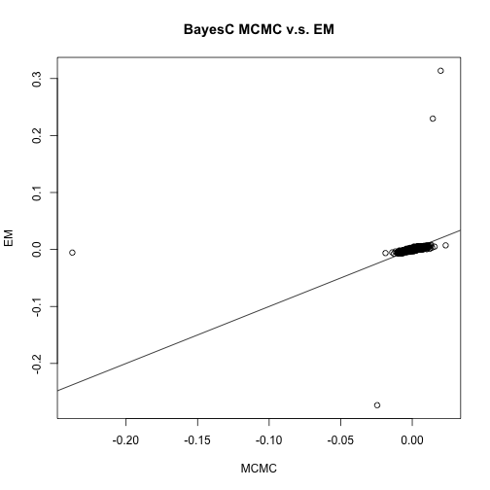

We can also compare the difference bewteen BayesA and BayesC for MCMC:

plot(ba$ghat,bc$ghat,xlab="BayesA",ylab="BayesC",main="BayesA v.s. BayesC in MCMC")  
abline(a=0,b=1)

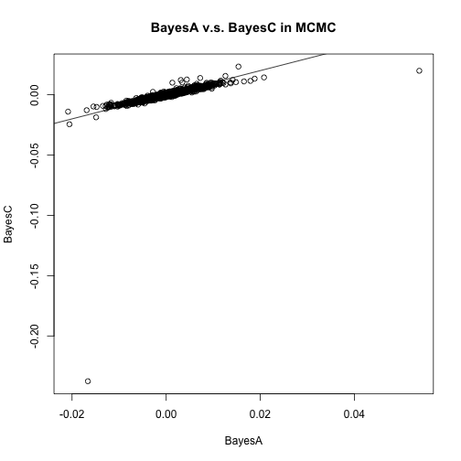

We can also compare the difference bewteen BayesA and BayesC for EM:

plot(ba$ghat,bc$ghat,xlab="BayesA",ylab="BayesC",main="BayesA v.s. BayesC in EM")  
abline(a=0,b=1)

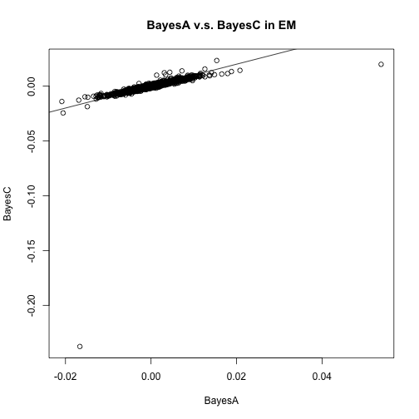

### BayesB

init=set_init(pig,df=5,pi_snp=0.05,h2=0.5,c=NULL,model="BayesB",centered=T,trait="driploss")  
run_para=list(niter=5000,burnIn=2500,skip=10)  
print_mcmc=list(piter=2500,time_est=T,print_to="screen")  
update_para=list(df=F,scale=TRUE,pi=TRUE)  
op<-create.options(model="BayesB",method="MCMC",ante=FALSE,priors=NULL,init=init,  
update_para=update_para,run_para=run_para,save.at="BayesB",  
cv=NULL,print_mcmc=print_mcmc)  
  
bb<-bafit(dataobj=pig,op=op,trait="driploss")

## iter= 2500 vare= 0.402923 scale= 0.00451316   
## timepercycle= 0.001 estimated time left= 2.42 seconds   
## iter= 5000 vare= 0.421983 scale= 0.0029603   
## timepercycle= 0.001 estimated time left= 0 seconds

### GWA

We can use get_pvalues function to obtain p-values from EM algorithms.And the manhattan_plot function creates manhattan plots using those p-values.

prr1<-get_pvalues(rr)  
prr2<-get_pvalues(rr,type="fixed")  
  
manhattan_plot(prr1,pig$map,threshold = 0.05,main="rrBLUP random effects test")

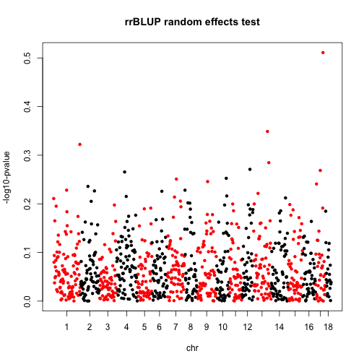

manhattan_plot(prr2,pig$map,threshold = 0.001,main="rrBLUP fixed effects test")

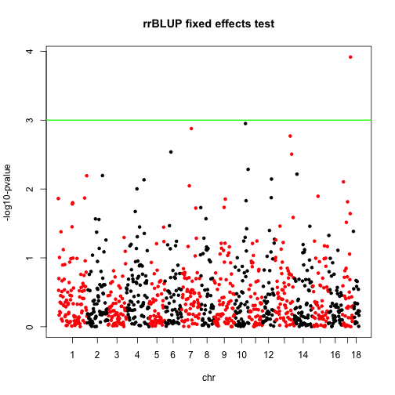

pba<-get_pvalues(ba_em,type="random")  
  
manhattan_plot(pba,pig$map,threshold = 0.05,main="BayesA random effect test")

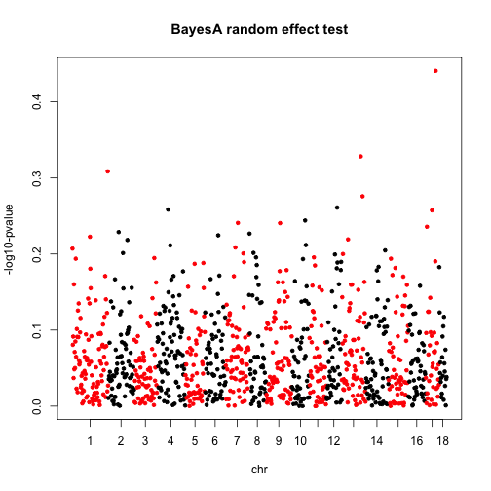

pbc<-get_pvalues(bc_em,type="random")  
  
manhattan_plot(pbc,pig$map,threshold = 0.05,main="SSVS random effect test")

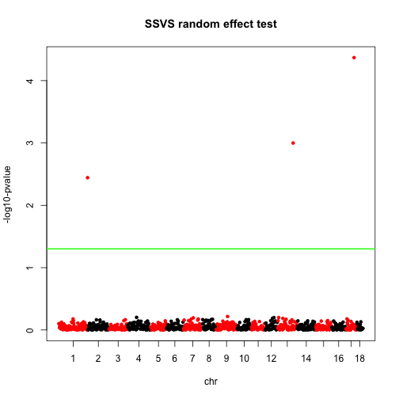

postprob_plot(bb$prob,pig$map,main="BayesB posterior probability")

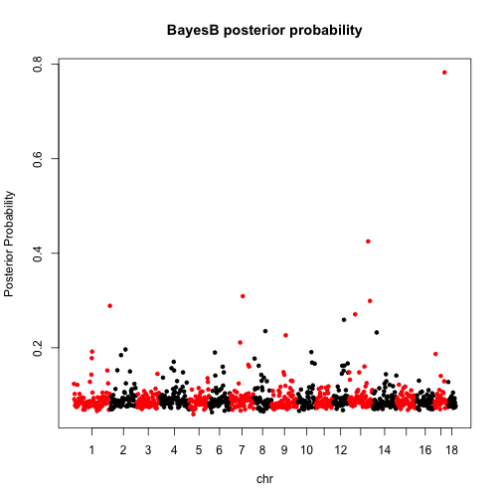

postprob_plot(bc$phisave,pig$map,main="SSVS posterior probability")

