Software Engineering Meeting Minutes for 10th September 2017

|  |  |
| --- | --- |
| Date: | 10th September 2017 |
| Start Time: | 1300 |
| End Time: | 2024 |
| Venue: | SIS 2-1 |
| Attendees: | *CBH, **GMSB, CZR, TMS, DL |
| Agenda: | 1. Design Database for location, demographics, location look-up 2. Project critical path 3. Design use-case diagram 4. Design logical diagram 5. Design class diagrams for login function including bootstrap 6. Design sequence diagram for login function |

* Project Manager  
** Minutes Taker

1. Design Database for location, demographics, location look-up
   1. 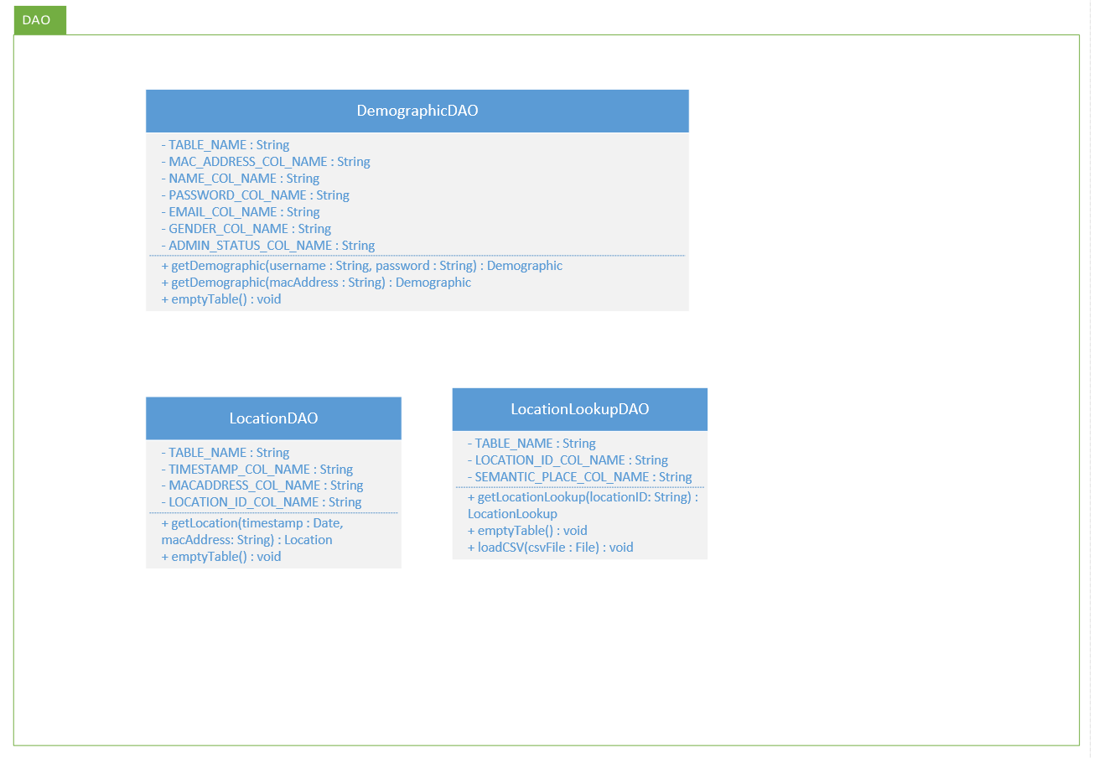
   2. 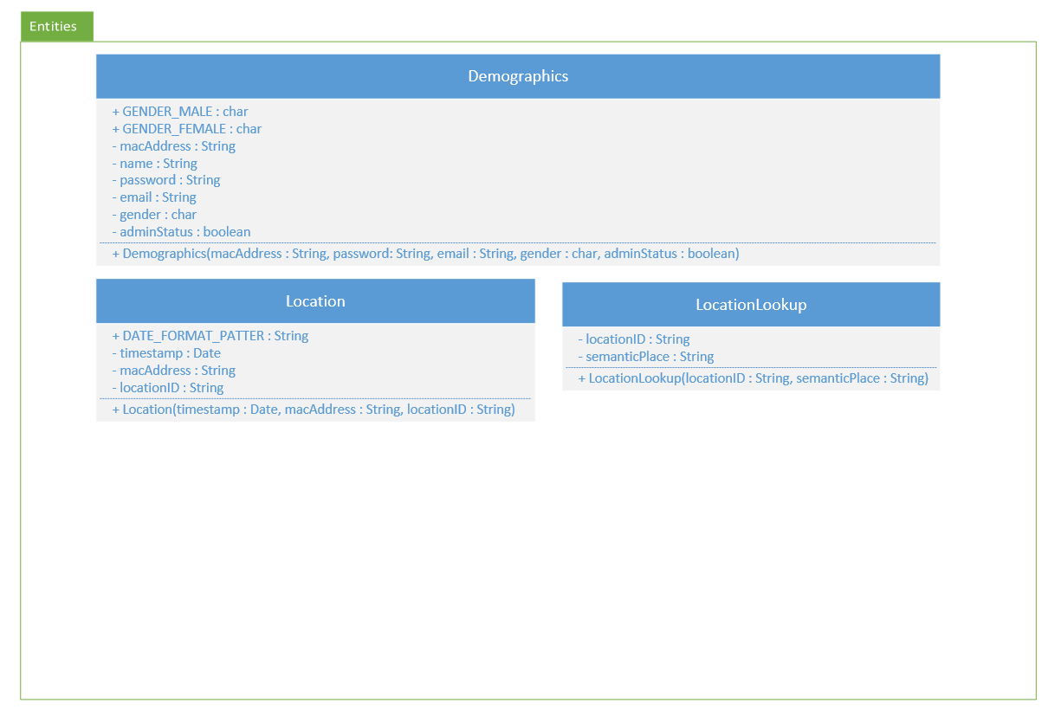
2. Project critical path
   1. (Sunday 10 September) - ZhengRen
3. Design use-case diagram
   1. 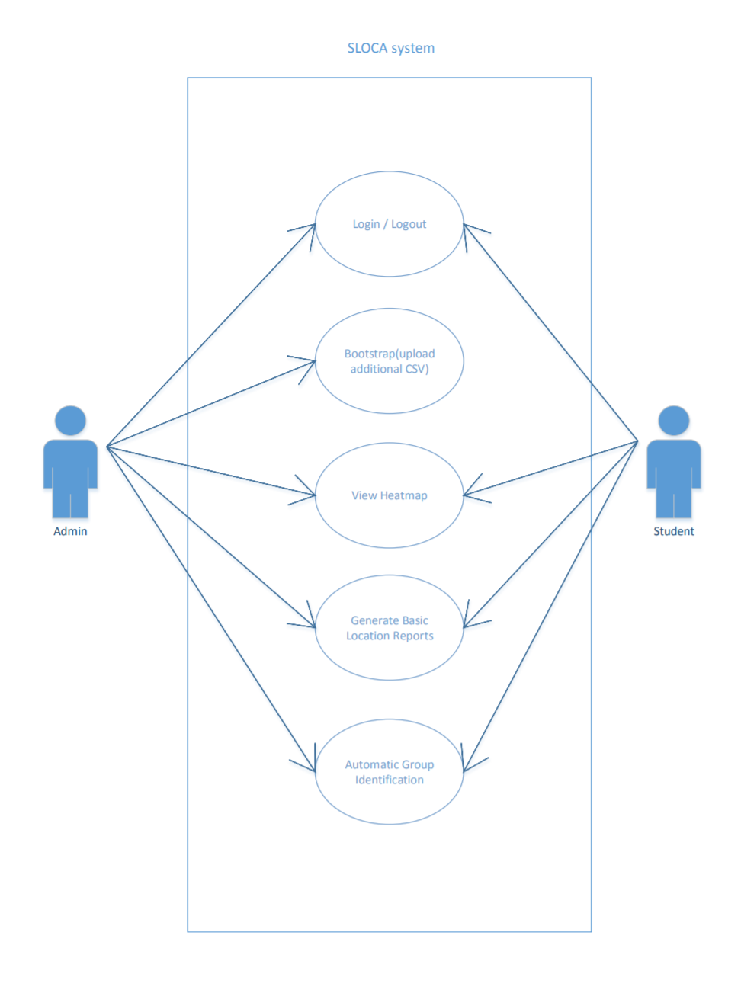
4. Design logical diagram
   1. 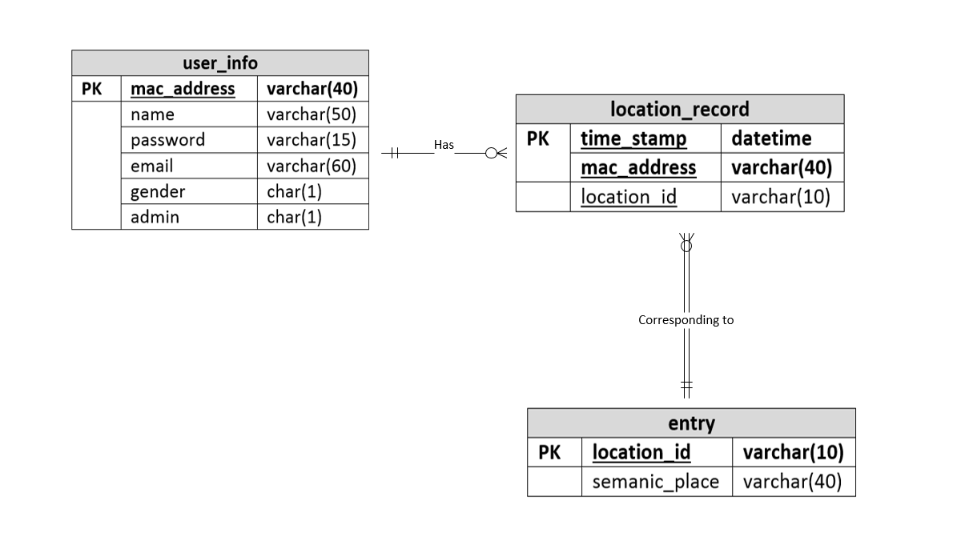
5. Design class diagrams for login function including bootstrap
   1. Login Function
   2. 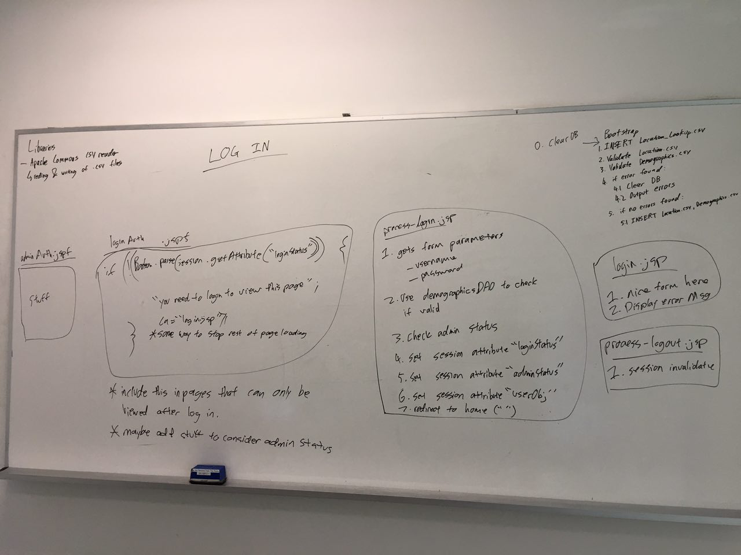
   3. Created a rough design for the DemographicDAO, LocationlookupDAO and LocationDAO
   4. 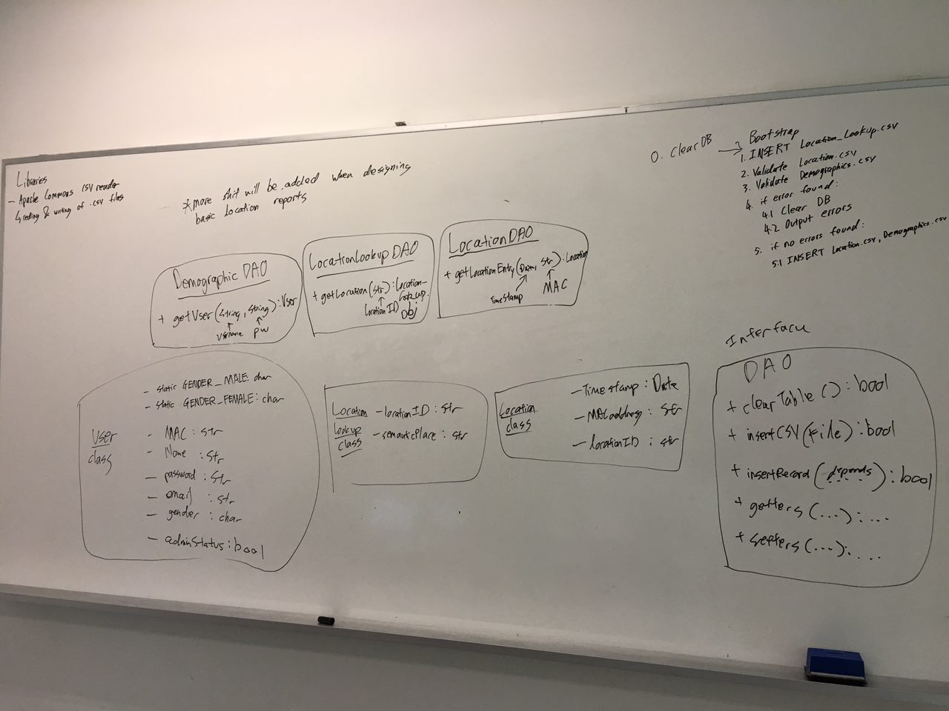
   5. Connection Package
   6. 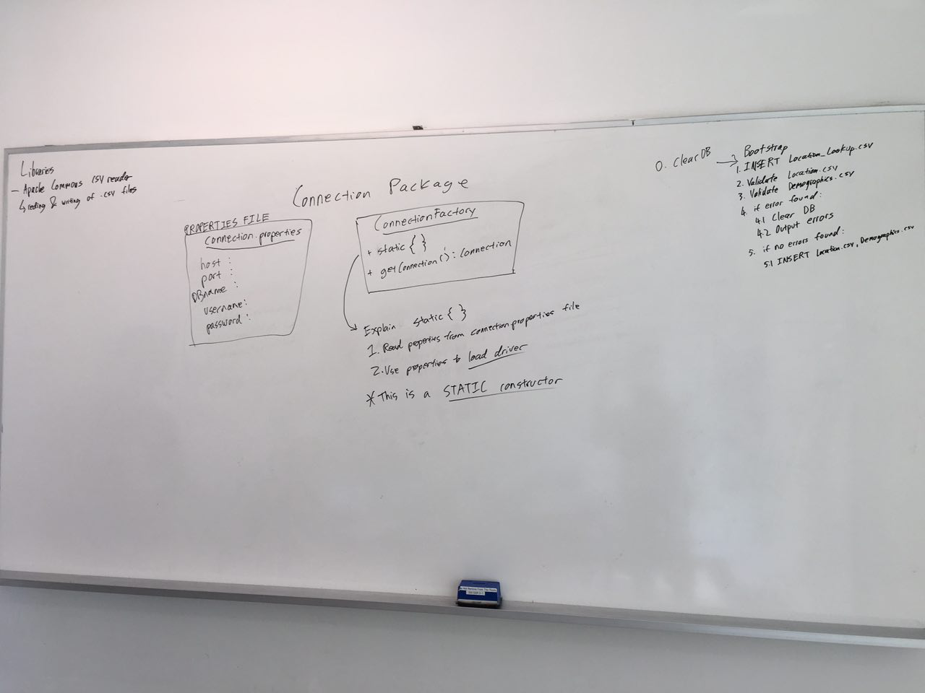
6. Design Validation Classes (1hr)
   1. Drew up a rough design on validation class
   2. 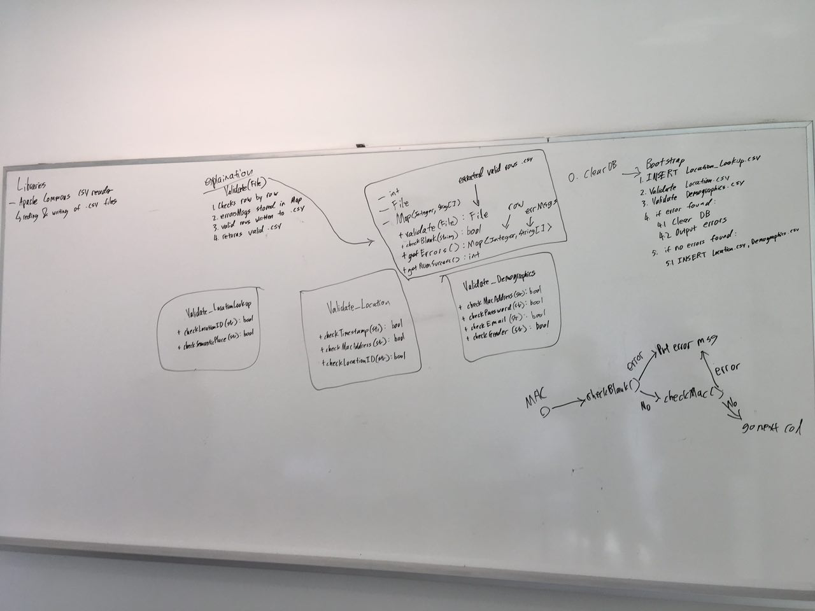
7. Pair programming allocation
   1. David and Brittany will be doing the Bootstrap
   2. Colin and Chris will be Login and connection

|  |
| --- |
| TO DO |
|  |

Meeting adjourned at 2024hrs. These minutes will be circulated and adopted if there are no amendments reported in the next three days.

Prepared by,

Brittany Goh

Vetted and edited by,

David Liu