深 圳 大 学 实 验 报 告

课程名称： Java程序设计

实验项目名称： 接口与例外

学院： 计算机与软件

专业： 网络工程

指导教师： 林少聪

报告人：陈丹萍 学号：2012150131 班级： 计软3班

实验时间： 2013/10/30

实验报告提交时间： 2013/11/11

教务部制
实验目的与要求：

- 本实验的目的是让学生使用子类继承父类。
- 掌握子类方法的继承与重写。
- 掌握接口的定义与实现。
- 掌握自定义异常类的使用。
实验内容：
- 建立Student类的子类CollegeStudent，增加成员变量出生时间Date，性别sex，专业 major，重写displays()方法。测试该类，并建立上转型变量测试。
- 自定义一个异常类NumCodeException，检查CollegeStudent对象的学号是否符合要求（学号由8个数字符号组成），如果出现非法字符则抛出该异常。
- 利用集合类ArrayList<E>生成一个具有若干个（最少5个）学生的集合，当输入的学号为“00000000”时停止；使用2中的异常类检查学号是否符合要求，如果不符合，说明原因并要求重新输入。
- 使CollegeStudent类实现下面的接口，然后调用接口中的方法对CollegeStudent数组（可以把ArrayList先转换为普通数组）按数学成绩从高到低排序。
interface Compare{
boolean compare(Object o);
}
- 使用TreeMap<K,V>类，让CollegeStudent对象分别按照数学成绩和姓名进行排序输出。
实验过程：
（源程序代码，即.java文件）
1.
package chendanping_no2012150131;

public class Student{
String name,studcore;
double score;
Student(){}
public Student(String n,String sc,double s){

name=n;
studcore=sc;
score=s;
}
void display(){
System.out.println("name: "+name);
System.out.println("studcore: "+studcore);
System.out.println("score: "+score);
}
public void setScore(double s){
score=s;
}
public double getScore(){
return score;
}
}

package chendanping_no2012150131;
import java.util.*;
import java.text.*;
public class CollegeStudent extends Student {
Date date;
String sex;
String major;
CollegeStudent(){}
CollegeStudent(String n,String c,double s,Date d,String Sex,String m)
{
super(n,c,s);
date=d;
System.out.println("Birth date: "+date);
sex=Sex;
major=m;
}
void display(){
SimpleDateFormat matter1=new SimpleDateFormat("yyyy/MM/dd");
System.out.println("CollegeStudent's message:");
super.display();
System.out.println("Birth date: "+matter1.format(date));
System.out.println("sex: "+sex);
System.out.println("major: "+major); }
}

package chendanping_no2012150131;

import java.util.Date;

public class Demo {
public static void main(String args[])
{
Student stud=new CollegeStudent("xiao chen","2012150150",90,new Date("1993/12/25"),"female","Internet Engineering");
stud.display();
}
}
2.
package chendanping_no2012150131;
import java.util.*;
import java.text.*;
public class CollegeStudent extends Student {
Date date;
String sex;
String major;
CollegeStudent(){}
CollegeStudent(String n,String c,double s,Date d,String Sex,String m)throws NumCodeException
{
super(n,c,s);
if(c.length()!=8)
{
NumCodeException e1=new NumCodeException(c);
throw(e1);
}

char []array=c.toCharArray();
for(int i=0;i<array.length;i++)
{
if(array[i]<'0' || array[i]>'9')
{
NumCodeException e2=new NumCodeException(c,0);
throw(e2);
}
}
date=d;
sex=Sex;
major=m;
}
void display()
{

SimpleDateFormat matter1=new SimpleDateFormat("yyyy/MM/dd");
System.out.println("CollegeStudent's message:");
super.display();
System.out.println("Birth date: "+matter1.format(date));
System.out.println("sex: "+sex);
System.out.println("major: "+major);
}
}
class NumCodeException extends Exception{
String message;
NumCodeException(String s){
message="错误！学号一定要是八位";
}
NumCodeException(String s,int n){
message="错误！学号中有非数字字符";
}
public String getMessage(){
return message;
}
}
package chendanping_no2012150131;
import java.util.Date;

public class Demo1 {
public static void main(String args[])
{
CollegeStudent collegestudent1,collegestudent2,collegestudent3;
System.out.println("第一个案例测试：");
try{
collegestudent1 = new CollegeStudent("xiao chen","2012103",90.0,new Date("1993/12/25"),"female","Computer");
collegestudent1.display();
}
catch(NumCodeException e){
System.out.println(e.getMessage());
}

System.out.println("第二个案例测试：");
try{
collegestudent2 = new CollegeStudent("xiao chen","2012a103",90.0,new Date("1993/12/25"),"female","Computer");
collegestudent2.display();
}
catch(NumCodeException e){
System.out.println(e.getMessage());
}

System.out.println("第三个案例测试：");
try{
collegestudent3 = new CollegeStudent("xiao chen","20121003",90.0,new Date("1993/12/25"),"female","Computer");
collegestudent3.display();
}
catch(NumCodeException e){
System.out.println(e.getMessage());
}
}

}

3
package chendanping_no2012150131;

public class Student{
String name,studcore;
double score;
Student(){}
public Student(String n,String sc,double s)throws NumCodeException{

name=n;
if(sc.length()!=8)
{
NumCodeException e1=new NumCodeException(sc);
throw(e1);
}
char []array=sc.toCharArray();
for(int i=0;i<array.length;i++)
{
if(array[i]<'0' || array[i]>'9')
{
NumCodeException e2=new NumCodeException(sc,0);
throw(e2);
}
}
studcore=sc;
score=s;
}
void display(){
System.out.println("name: "+name);
System.out.println("studcore: "+studcore);
System.out.println("score: "+score);
}
public void setScore(double s){
score=s;
}
public double getScore(){
return score;
}
}

class NumCodeException extends Exception{
String message;
NumCodeException(String s){
message="错误！学号一定要是八位";
}
NumCodeException(String s,int n){
message="错误！学号中有非数字字符";
}
public String getMessage(){
return message;
}
}
package chendanping_no2012150131;
import java.util.*;

public class Demo1 {
public static void main(String args[])
{
ArrayList<Student> students = new ArrayList<Student>();
Scanner in = new Scanner(System.in);

Student stud;
String n,c;
double s;

while(true)
{
System.out.println("Enter student'name,code and math score");
n=in.next();
c=in.next();
s=in.nextDouble();
if (c.equals("00000000"))
break;
try{
stud=new Student(n,c,s);
students.add(stud);
}
catch(NumCodeException e){
System.out.println(e.getMessage());
System.out.println("请重新输入：");

}

}
Iterator it = students.iterator();
System.out.println("Student's message");
while(it.hasNext())
{
stud=(Student)it.next();
stud.display();
System.out.println();

}

}

}
4.
package chendanping_no2012150131;
import java.util.*;
import java.text.*;
public class CollegeStudent extends Student implements Compare{
Date date;
String sex;
String major;
CollegeStudent(){}
CollegeStudent(String n,String c,double s,Date d,String Sex,String m)
{
super(n,c,s);
date=d;
sex=Sex;
major=m;
}
void display()
{

SimpleDateFormat matter1=new SimpleDateFormat("yyyy/MM/dd");
System.out.println("CollegeStudent's message:");
super.display();
System.out.println("Birth date: "+matter1.format(date));
System.out.println("sex: "+sex);
System.out.println("major: "+major);
}
public boolean compare(Object o)
{
CollegeStudent stud = (CollegeStudent)(o);
if(getScore()>=stud.getScore())
return true;
else
return false;

}
}
interface Compare{
abstract boolean compare(Object o);
}
package chendanping_no2012150131;
import java.util.*;

public class Demo1 {
public static void main(String args[])
{
ArrayList<CollegeStudent> students = new ArrayList<CollegeStudent>();
Scanner in = new Scanner(System.in);
int i = 0,j;
CollegeStudent stud;
String n,c,sex,major,date;
double s;

while(true)
{
System.out.println("Enter CollegeStudent'name,code,math score,birth date,sex and major");
n=in.next();
c=in.next();
s=in.nextDouble();
date=in.next();
sex=in.next();
major=in.next();

if (c.equals("000"))
break;

stud=new CollegeStudent(n,c,s,new Date(date),sex,major);
students.add(stud);
}

Object []stud1 = students.toArray();
System.out.println("Student's math scores from low to high:");
for(i=0; i<stud1.length; i++)
{

for(j=i+1; j<stud1.length; j++)
{
if(((CollegeStudent)stud1[i]).compare((CollegeStudent)stud1[j]))
{
{
CollegeStudent stud2;
stud2=(CollegeStudent)stud1[i];
stud1[i]=stud1[j];
stud1[j]=stud2;
}

}
}
((CollegeStudent)stud1[i]).display();
System.out.println();
}

}
}
5.
package chendanping_no2012150131;
import java.util.*;

public class Demo1 {
public static void main(String args[])
{
CollegeStudent s1=new CollegeStudent("zhang san","2012150001",79,new Date("1993/2/25"),"female","Computer"),
s2=new CollegeStudent("Li si","2012150002",90,new Date("1993/12/5"),"male","Computer"),
s3=new CollegeStudent("Wang wu","2012150003",87,new Date("1993/7/18"),"female","Computer");
TreeMap<Double,CollegeStudent> treemap=new TreeMap<Double,CollegeStudent>();
treemap.put(s1.getScore(), s1);
treemap.put(s2.getScore(), s2);
treemap.put(s3.getScore(), s3);

Collection<CollegeStudent> collection = treemap.values();
Iterator<CollegeStudent> it = collection.iterator();

System.out.println("Sort by the math score:");
System.out.println();
while(it.hasNext())
{
CollegeStudent s = it.next();
s.display();
System.out.println();
}
TreeMap<String,CollegeStudent> treemap1=new TreeMap<String,CollegeStudent>();
treemap1.put(s1.name, s1);
treemap1.put(s2.name, s2);
treemap1.put(s3.name, s3);

Collection<CollegeStudent> collection1 = treemap1.values();
Iterator<CollegeStudent> it1 = collection1.iterator();

System.out.println("Sort by the name:");
System.out.println();
while(it1.hasNext())
{
CollegeStudent s = it1.next();
s.display();
System.out.println();
}
}
}

实验结果及数据处理分析：

（ 运行程序截图）
- 运行结果：
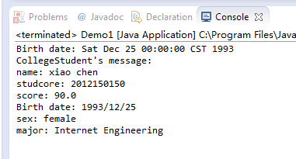
- 运行结果：
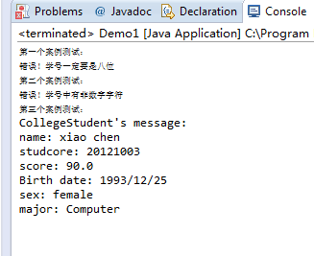
- 运行结果：
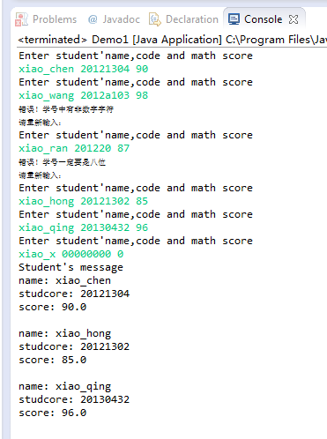
- 运行结果：
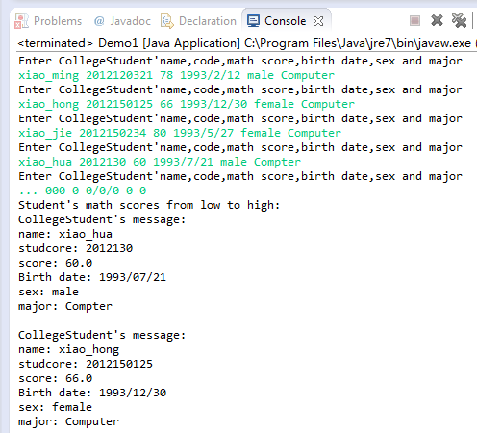
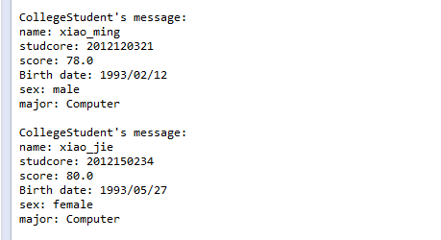
- 运行结果:
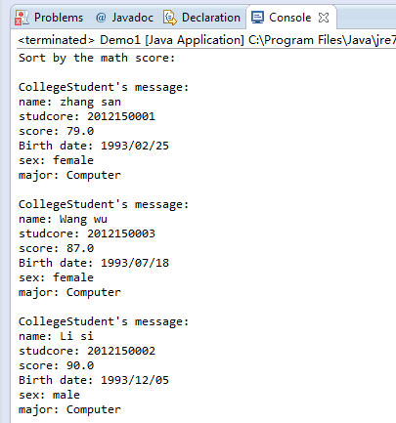
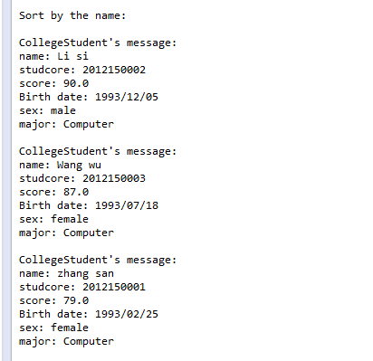

实验结论：
如以上结果所示，程序都都到正确的结果。
实验收获及思考
（实验心得）：对类的继承，接口，自定义异常类以及一些常用类理解更深了。感觉常用类很好用。

指导教师批阅意见：

成绩评定：

指导教师签字：
年 月 日
备注：
注：1、报告内的项目或内容设置，可根据实际情况加以调整和补充。
2、教师批改学生实验报告时间应在学生提交实验报告时间后10日内。

