Supporting Information

Fan Aoran^{a‡}, Hu Yudong^{a‡}, Zhang Yufengª, Ma Weigangª, Zhang Xing^{a,}*

ªKey Laboratory for Thermal Science and Power Engineering of Ministry of Education, Department of Engineering Mechanics, Tsinghua University, Beijing, 100084, China

‡These authors contribute equally to this article

*Corresponding Author: x-zhang@mail.tsinghua.edu.cn

Characteristics of 3.07 nm SWCNT
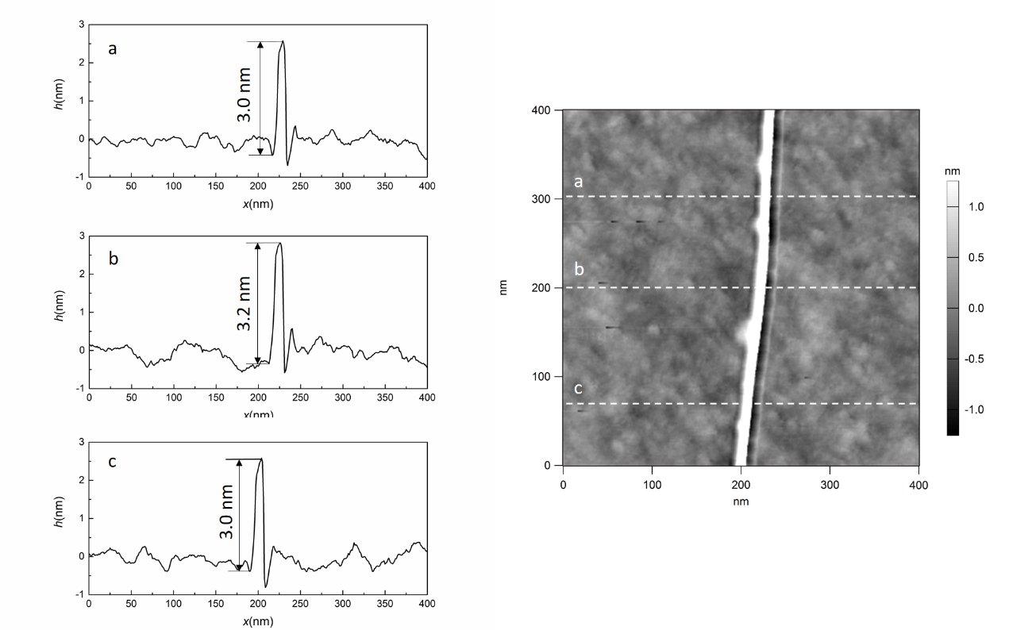
Figure S1. AFM characterization of 3.07 nm SWCNT

In this work, atomic force microscopy (AFM) was used to locate and characterize the diameter of the carbon nanotube. The average diameter of the carbon nanotube measured at three positions is about 3.07 nm, and the measurement uncertainty is within 0.1 nm.

Characteristics of 1.07 nm SWCNT
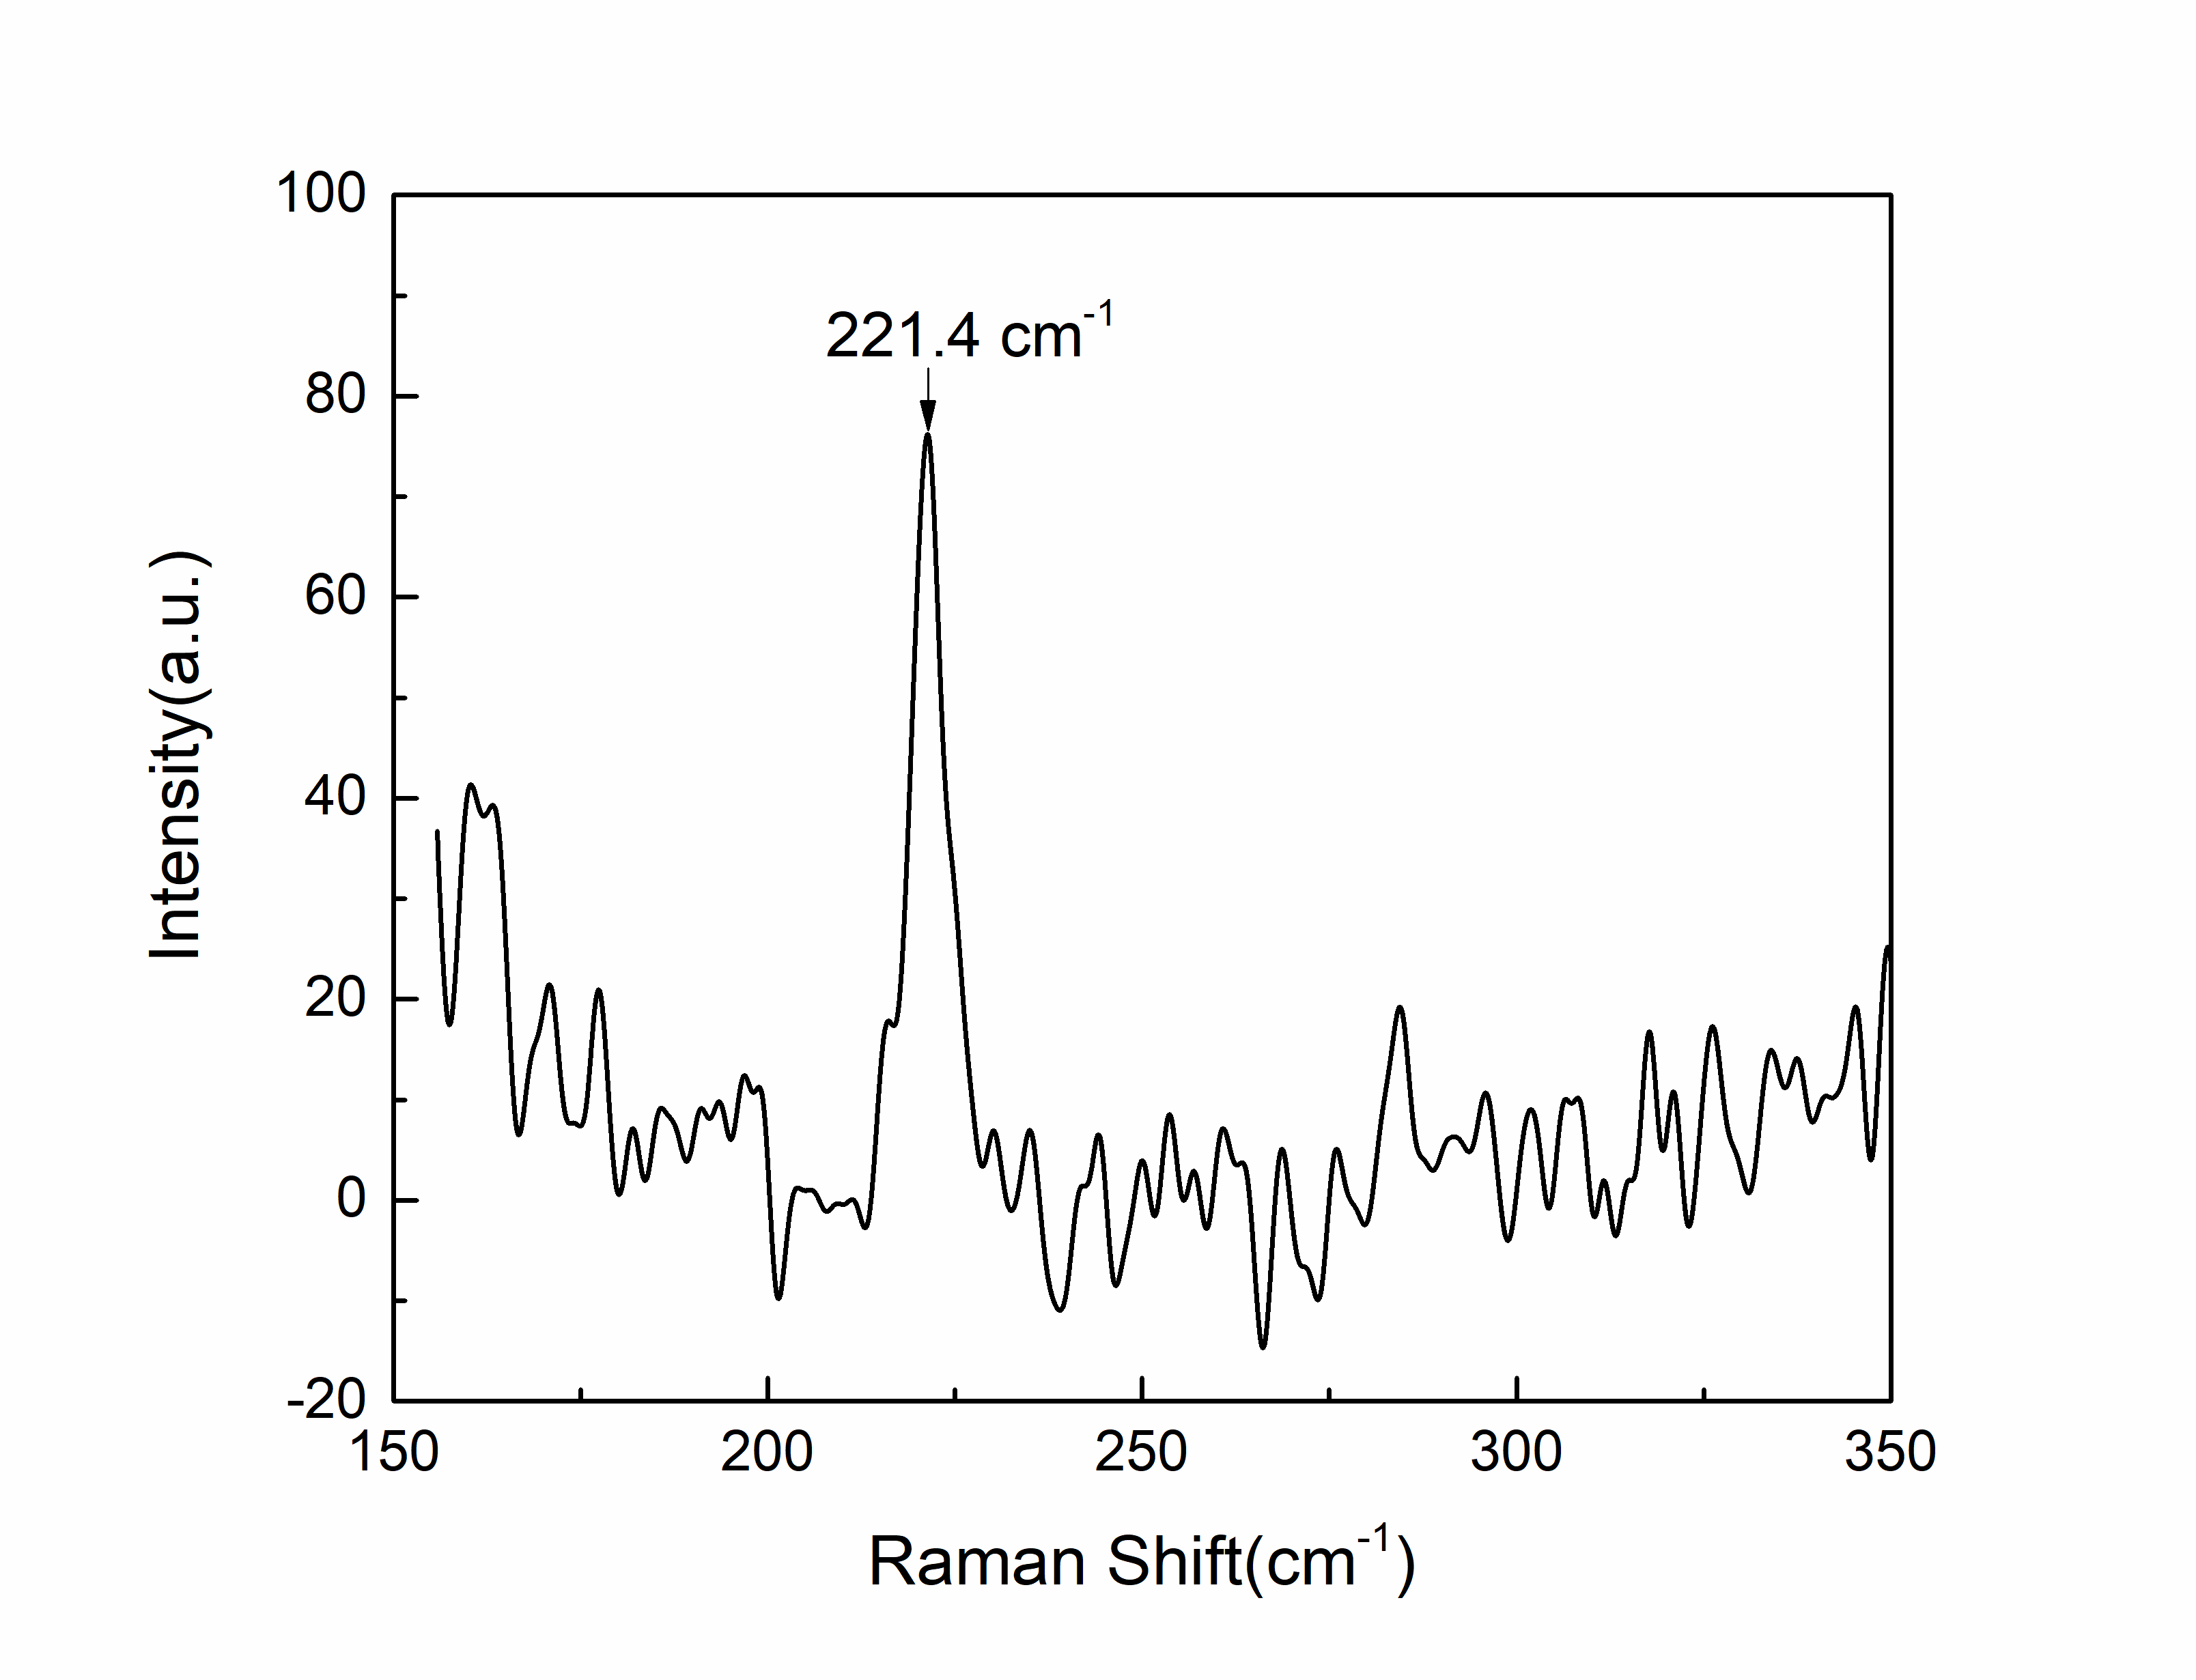
Figure S2. Radial breathing mode Raman peak (RBM) of 1.07 nm SWCNT
The Raman spectrum was used to determine the diameter of the small SWCNT. The diameter D of the SWCNT can be calculated by the equation, D = 223.5/(RBM - 12.5) , which is 1.07 nm.
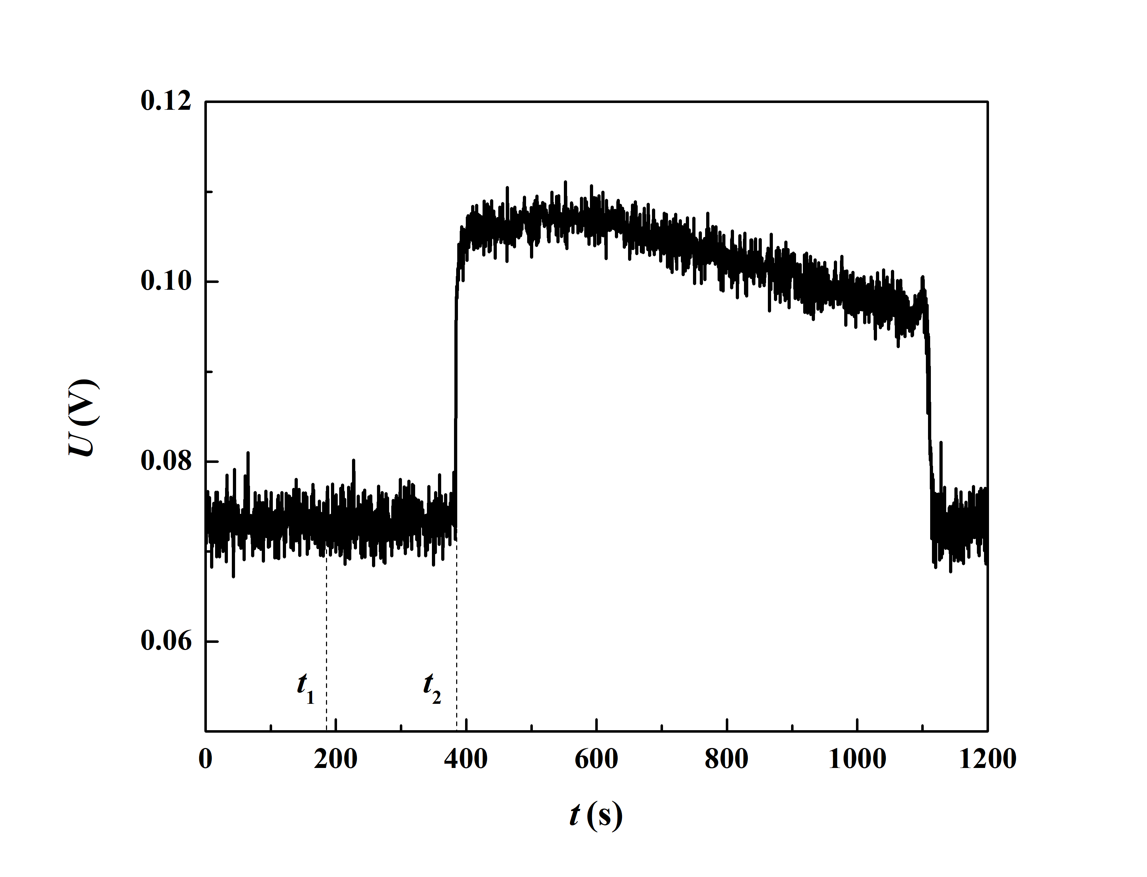
Figure S3. Voltage changes between the two electrodes during measurement of 1.07 nm SWCNT.
The times t1 and t2 in Figure S3 are respectively the time when the water went into the SWCNT and the time when the water arrived at the first probe-electrode contact point. The water velocity in 1.07 nm SWCNT can be also determined by Equation (1). For the small diameter SWCNT, when the water reached the first electrode, the voltage between the two electrodes increased, which means the resistance of the SWCNT increased. The reason for the opposite tendency of the resistance change of SWCNT with a large diameter and a small diameter can be explained by the doping theory. Carbon nanotubes are p-type semiconductors and the resistances are mainly dependent on the numbers of electron holes. For a small diameter SWCNT, the number of water molecules per unit length is less than the number of carbon atoms. Therefore, water doping can only compensate for part of the electron holes, which leads to a reduction in the number of electron holes available for conduction, and ultimately leads to a decrease in conductivity. For a large diameter SWCNT, water molecules per unit length contain more water molecules than carbon atoms. Thus, water molecules can provide enough free electrons to fill the electron holes, and the resistance of carbon nanotubes will decrease due to the action of free electrons.

Measurement results of flow parameters
Table S1. Velocity of water flow through the SWCNTs
 | l₁ (μm) | t₁ (s) | t₂ (s) | v (μm / s)
SWCNT-1 | 624.8 | 102.0 ± 1 | 106.5 | 146.1±32.5
SWCNT-2 | 8667 | 186.0± 3 | 383.5 | 43.9±0.67

Table S2. Enhancement factor, mass flux coefficient and other relative parameters of the SWCNTs
 | D (nm) | r (nm) | ρ/ρ₀ª | v_{av,H-P} (μm / s) | ε | f_{m}
SWCNT-1 | 3.07 | 1.385 | 1.10 | 10.1 | 14.5 | 5.36
SWCNT-2 | 1.07 | 0.37 | 1.21 | 0.144 | 304.9 | 1.32
a. Based on the reference [3,5,11]

