**Good morning,dear professors. Thank you for giving me the opportunity to have this interview.**

**I`m Chenxiaolong, graduating from the Department of Electronic Communication Engineering at Wuhan Textile University in July ,2016. I come from Jingzhou where has a long history. I`m a patient person.In my spare time,I like reading books (such as Learning PHP Design Patterns),programming and playing some computer games.**

**In the past two years,I have been working as a Web development engineer at fs.com. This experience is very meaningful to me. During my work, I used PHP to develop the website of my company, and the experierce make me relize the importance of teamwork,and it has also improved my programming skills and the ability to learn new knowledge. Besides, I learned how to solve problems encountered in my work.**

**The reason that I would like to pursue my further study in computer science field is my passion in this field. Owing to my diligence and persistence, I could contrate on my study and I believe that led by the distinguished professors and scholars here,I could eventually succeed.**

**Thank you so much again for giving me the chance for this interview.**

**自我介绍引申问题：**

**1：介绍一下你的家乡(人物)**

**My hometown has a long history. And there are many historical figures in my hometown. One person worth mentioning in the history of Jingzhou is Guan Yu who was regards as a model of devotion in Chineseculture. He was a man of keeping his words and loyalty tohis friends in his life : after promising to fight with Liu Bei and becoming his sworn brother, Guan Yu didn`t changed his mind until fought to death in Maicheng city.**

1. **介绍家乡食物**

**The most famous food in my hometown is GuoKui which is a pork-filled pancake,and The surface is brushed with chilisauce. It`s is very delicious.**

1. **介绍书**

**The book is about learning PHP design patterns,and I have benefited a lot from this book. I have learnd how to design a good program by reading this book.**

1. **自己的优缺点（高频）**

**优点（merit、advantage、excellence）  
I feel that my biggest merit is the strong willpower and attitude to take everything seriously . Furthermore, I always have a strong thirst for knowledge . so I like reading books , especially those about computer science.**

**缺点（drawback/shortcoming/defect/weakness）**

**Sport is my weekness , maybe I neglect exercise all the time ,but I hope to change the situation in the future. because i know the health is so important to our life and working .**

1. **目标（高频）**

**目标（goal/object）  
My short-term goal is to pass the exam of postgraduate in order to get a further development of computer knowledge.  
My long-term goal is to be a computer professional . I know the future is full of uncertain factors , what I need to do is keeping on learning and improving myself constantly .**

1. **爱好**

**爱好、业余时间（hobby、interest/your spare time）  
In my spare time , I like reading books , programming and playing some computer games , such as LOL which is a good way for me to relax .**

1. **为什么考研（Why participate in postgraduate examinations/pursuing graduate degree）**

**During my work, I have learned much professional knowledge and practical skills .However ,As I konw more and more konwledge, I gradually realize that it`s not enough to support me to go farther and higher in the future.**

**At present,  I just understand many things in a superficial level , So I`m eager to study and broad my horizons . Besides I have more opportunity to communicate with more excellent people here . Therefore, I prefer to go on for further study.**

1. **为什么报考武汉大学（why choose/apply wuhan university）**  
   **As we all know , Wuhan university is not only a beautiful college, but also has a strong academic in the field of computer science. So I think it can provide a better platform and atmosphere to study and enrich myself so as to lay the foundation for my future , in addition , my hometown is near Wuhan city ,so it is more convenient for me to visit family during the holidays .**
2. **为什么选你(why we choose you not others)**  
   **First of all , I have a good attitude to study and take everything seriously . Second, My practical ability is very good , and my work experence could help me complete the task better .Last but not least, I`m full of passion , so I believe your decision of choosing me is right.**
3. **喜欢的课程（course/lesson/subject）原因（why、reason）（高频）**  
   **My favorite course is computer network because I can learn lots of practical skills ,which always help me solve many network problems.**
4. **研究生规划**

**First, I will finish my studies. If possible, I will go on with my study for doctorate degree。In a word, I am looking forward to making a solid foundation for future profession after two years study here。**

1. **研究方向**

**Internet of Things technology**

1. **你有什么问题问我们**
2. **最敬佩的人**

**I admire person most is my mother,she is telented and considerate. She has had such an influence on me that i want to become the best as the bast can be.**

**15、稀罕什么样的老师**

**A good teacher allows students ask questions,and konws which students need extra assistance.**

**16、音乐**

**Music is a worldwide language without any translation, by listening to the music,we can share our emotions with different people around the world.**

1. **Virtues**

**With modest and humble ,we can make progress everyday.**

1. **节日**

**Spring Festival,chinese Lunar new year ,compared with christmas western countries Family get together ,making dumplings,sit around the table,toast to each other,wish everybody good luck.**

上机： 5个题目

软件： VC

语言： C/C++

**唐浩强书（第四版）的前七章（c基础，指针和其之后的章节不用看）的例题和课后题做一遍，后期又刷了一些九度和武大oj**

**刷完[woj starter](http://acm.whu.edu.cn/starter/" \t "http://www.cskaoyan.com/_blank)、[hdu 11页](http://acm.hdu.edu.cn/listproblem.php?vol=11" \t "http://www.cskaoyan.com/_blank)的题就差不多了。**

**<http://acm.whu.edu.cn/olive/>**

**http://acm.hdu.edu.cn/listproblem.php**

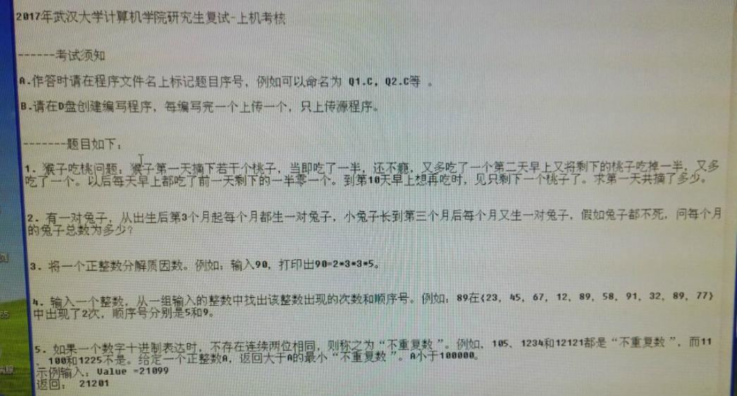

**++++++++++++++++++++++++++++++++++++++++++++++++++++++++++**

**英语问题：**

1. **自我介绍**
2. **研究生规划**
3. **你来自哪里**
4. **为什么要不选家乡的学校**
5. **研究方向（高频问题）**
6. **为什么要跨专业（仅限于跨专业考生）**
7. **为什么选武大，你对研究方向的了解，兴趣爱好，怎么管控自己的业余时间/主要时间（高频问题）**
8. **短期目标/长期目标（高频问题），**
9. **优缺点（高频问题），**
10. **最爱的课程（高频），最爱看的书，**
11. **你对研究方向的了解。**
12. **来自哪里**
13. **什么专业**
14. **为什么高考毕业的报考计算机，把为什么喜欢数据结构与算法的答案套上去答的**
15. **最喜欢的一本书是什么**
16. **未来5年，你觉得计算机哪一个行业的发展前景最好。**
17. **你的Hobby**
18. **你的短期和长期目标。**
19. **你会的编程语言。**
20. **口语经验：就是尽人事，知天命。问题是准备不完的，准备基本问题，剩下的随机应变就好，你也猜不到老师会问啥，心平气和，有话说就行。**
21. **你的业余时间干嘛？**
22. **how do you manage your time ? hobby?**
23. **说一说你的长处；为什么选择报考我们学校？**
24. **你做过什么项目？你有哪些业余爱好？你平常都干些什么？**
25. **介绍下自己的手机**
26. **此刻的感觉**
27. **对你影响最大的人。**
28. **what is your experience about  computer science?**
29. **平时玩不玩网络游戏**
30. **你认为什么样的老师是好老师。**
31. **来自哪里，本科学校**

**中文问题：**

1. **有没有项目经历**
2. **本科期间哪些课程学的比较好**
3. **说一说你对这个课程一些自己的理解**
4. **你怎么看待你想研究的方向，其发展前途**
5. **你想研究的方向与你本科所学有什么相关吗**
6. **你研究生相对于本科会有什么改变**
7. **喜欢什么课程**
8. **数据结构中最令你深刻的问题**
9. **递归会出现哪些问题**
10. **以后的研究方向是什么（我答的机器学习）**
11. **谈谈你对机器学习的理解（我就随便说了下生成模型，判断后续）**
12. **什么是生成模型**
13. **你未来研究生阶段的规划**
14. **问了兴趣方向是什么？**
15. **问有没有为这个方向做些努力和准备？**
16. **女老师问谈谈你对云计算的理解？**
17. **问如果给你一堆机子，比如mac、pc、台式机等等，能不能搭建一个云平台？Openstack问有没有搭过伪分布式服务器？**
18. **跨专业转的过程中遇到的最大的困难有没有是什么？**
19. **问有没有搭过伪分布式服务器？**
20. **一定要自己找话说，是你带领老师在你熟悉的领域遨游。小心自己挖坑，老师会根据你的答案深挖你的。实事求是就好。**
21. **虽然英语口语面试和专业课面试时两个部分，但是这两个部分是一起进行的，面试我的一共四个老师，口语上好好准备，让老师看到你的自信和精彩，专业面试一般不会太低的，如果两个部分都没发挥好，那就很危险。**
22. **中文自我介绍**
23. **大学中学的最难的课程是什么？**
24. **大学中学的最难的课程里面的核心是什么？最新的应用？**
25. **你报考的方向是什么？对什么方向感兴趣？这个方向还有什么问题没有解决？**
26. **嵌入式系统的？核心是什么？**
27. **是否学过图论？怎么求最小生成树？**
28. **车联网技术是主要在控制方面还是嵌入式方面？**
29. **本科最喜欢的课程**
30. **感兴趣的课程以及对此的了解**
31. **为什么报考武大？你做过什么项目？你将来的报考方向？谈谈你对它的理解？**
32. **没录取准备怎么办，未来规划**
33. **喜欢什么专业课？ 数据结构 双链表 感兴趣的方向**
34. **数据挖掘是什么，数据检索与数据挖掘的区别，数据挖掘的应用**
35. **最熟悉的语言是什么？以后想做的研究方向是什么？**
36. **以后从事的研究方向 大数据是什么 其余是这方面的问题**
37. **java与c++的区别**
38. **你为什么要跨考这个专业？如果你没有考上的课，你打算怎么办？**
39. **谈谈做过的项目**
40. **做过的项目负责哪些，关于项目的一些东西（问的都是比较抽象的东西，没有问很细），为什么选择武大，编程使用的语言，以后打算的研究方向，有哪些了解**

**物流优化**

1. **C# 打印， PHP-快递公司-TCP-字节流-自学C#-与打印机交互；**
2. **问题-优化：为了提高仓库效率节省人工，不想用快递公司的软件--自己开发-英文开发文档**
3. **用自己的数据获取字节流--从数据库查找数据 webservice XML快递公司服务接口 发送数据**
4. **获取数据 PHP没法和硬件打交道--C#**
5. **不会C#--自学**
6. **人机交互--C#打包成浏览器插件JS+HTML调用插件**

**沟通系统**

1. **最一开始通过企业QQ 效率低，记录不能保留，信息安全--自己开发沟通系统**
2. **需求复杂，一对多 多对多 问题不同需求不同优先级 权限管理---设计合理数据表结构，编程方式自己简单的框架**
3. **最开始没问题 数据多访问速度慢-- 优化慢查询建立合适的索引（主键索引 联合索引） memcache-redis缓存再存到数据库**

**计算机专业可能会问一下毕设的内容，**

**跨专业的可能会尽力找两者之间的关系问你**