User manual for the application for searching dissertations defended at the University of Novi Sad

Introduction
Dissertations data in CRIS UNS software system are in accordance with the requirements prescribed by the University as well as in accordance with the requirements prescribed by standards in library and scientific research domain (MARC 21, Dublin Core, ETD-MS, CERIF). This compatibility with the worldwide accepted standards will ensure that the data from this system can be exported to and made publicly visible throw the international library systems and networks repositories of scientific research results such as NDLTD (http://www.ndltd.org/), Driver (http://search.driver.research-infrastructures.eu/), DART Europe (http://www.dart-europe.eu/basic-search.php).
The application is located at: http://www.cris.uns.ac.rs/searchDissertations.jsf and can be accessed by web browsers. Using of some of the following web browsers is recommended:
- Internet Explorer 8.x, installation version can be downloaded from this address http://www.microsoft.com/windows/internet-explorer/worldwide-sites.aspx,
- Mozilla Firefox 5.0.x, installation version can be downloaded from this address http://www.mozilla.com/en-US/firefox/firefox.html.
We hope that application does not have too many flaws. We apologize in advance for any mistakes in the application. If you notice a mistake, you have a claim, a complaint or any comment please send us an e-mail by selecting the item  in the right corner of the main menu of our application (cris@uns.ac.rs). Also, if you notice that information about some dissertation should be fixed, please let us know.
Thank you for using our application!
CRIS UNS development team

Header of application
Header (top) of the application for dissertations search is all time accessible and it is shown in Figure 1. In addition to the title (Search of dissertations of University of Novi Sad), there are options to change the user interface language (/), send e-mail () to CRIS system development team, and download this user manual ().
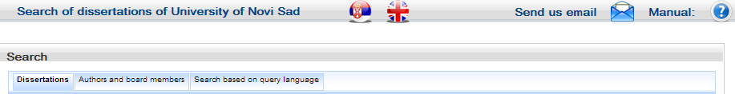
Figure 1. Header of application

User interface language can be changed by selecting one of the graphical symbols (Serbian) or (English).
A question or request a user can submit to the development team using the option located in the right corner of the main application menu.
User manual can be downloaded by selecting the item which is located in the far right corner of the main application menu.
Searching has three distinct modes which can be opened by selecting one of the following options Dissertations, Authors and board members and Search based on query language (Figure 1). These modes are described in the following sections.

Search of dissertations
By selecting the option Dissertations the form for making query for dissertations search is opened. Queries consist of operands that are separated by operators AND, OR or AND NOT shown in the left corner of the table in Figure 2. Each operand is defined by one row in the table. After opening a form for searching dissertations there are three operands that are connected by logical operator AND. Adding and deleting of operands is enabled by selection buttons and which are located in the right corner of the table in Figure 2.
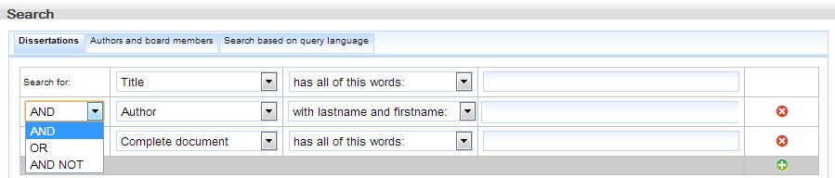
Figure 2. Mode for making queries for searching dissertations
The user can select the field name for searching by choosing an option from the list (Figure 3).
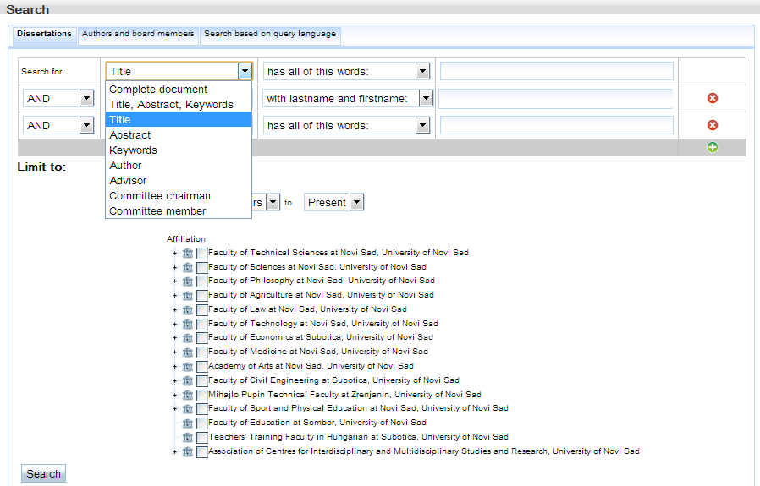
Figure 3. Fields names
The fields Complete document; Title, abstract, keywords; Title; Abstract; Keywords enable four types of words superposition as it is shown in Figure 4, the default value is has all of this words.
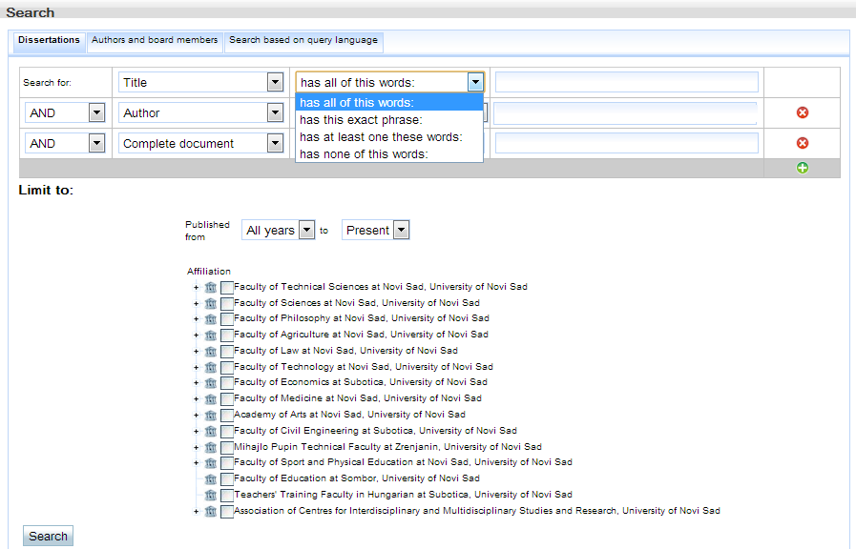
Figure 4. Superposition of words for field Title
By selecting the field Author from the drop-down list of fields names system offers words superposition with lastname and firstname. After a typing of couple of letters in input fields, regardless of whether the characters are in Cyrillic or Latin alphabets, the system offers drop-down list of researchers which names start with entered letters. Figure 5 shows offered help by system after entering the lastname Surla. The same kind of help is available when user chooses one of the following fields Advisor, Committee chairman, Committee member.
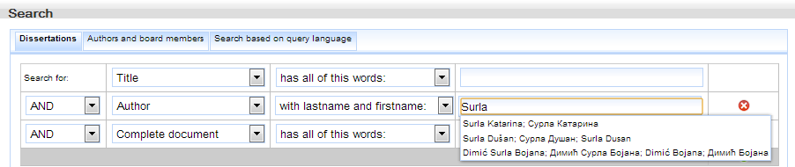
Figure 5. Drop-down list of researchers after entering lastname Surla
Figure 6 shows an example of setting up a more complex query that has two operands. This query searches dissertations which titles contain words information systems and moreover which texts contain words software architecture.
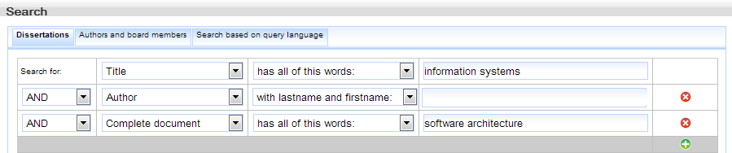
Figure 6. An example of a more complex query
The user can filter results by time period, by the institution where the dissertations are defended and by gained degree. If the user wants to search for dissertation only in specific period of time, the user can require it by entering or selecting the year from the drop-down list. Also, filtering can be done by institutions of the University of Novi Sad where the dissertations are defended. After selecting some institution, a list of all degree that can be gained by defending dissertation on that institution is shown.
Figure 7 shows a filtering of list of dissertations that have affiliation Faculty of Technical Sciences at Novi Sad, University of Novi Sad, which gained degree is Doctor of Technical Sciences, and which are published from 2005 to 2010.
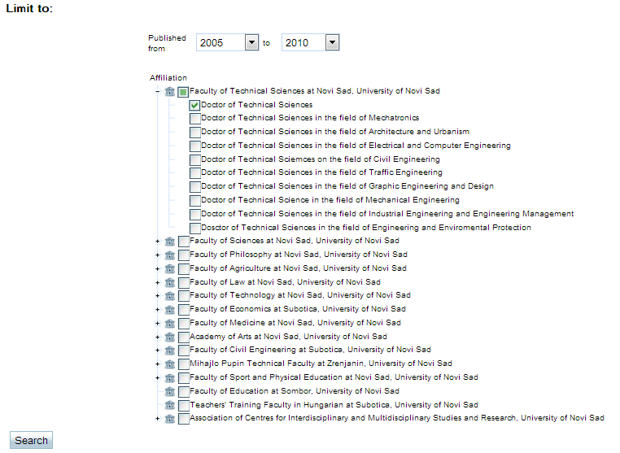
Figure 7. Filtering results
After pressing the button Search the system sends a query to the server and then displays the results list.

Search by authors and board members
By selecting the option Authors and board members the form for making queries for searching authors and board members is opened (Figure 8).
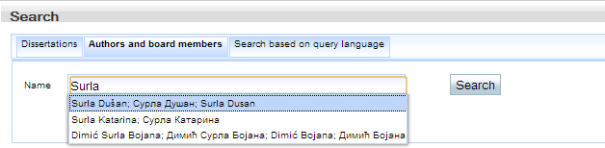
Figure 8. Mode for making queries for searching authors and board members
The user can enter the firstname and lastname by entering it from keyboard, or as previously described (text below Figure 4) choosing a researcher from drop-down list offered by the system. Both ways open a table with a list of authors/board members. If the user entered lastname using keyboard and pressed the Search button the list of authors and board members with that lastname is shown (Figure 9).

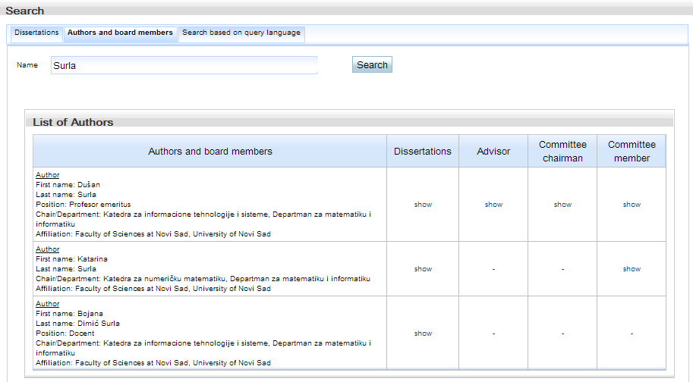
Figure 9. List of authors with lastname Surla
If the user has selected authors from the drop-down list (Figure 8) Surla Dušan, the system displays information about that author (Figure 10). Table in Figure 10 contains basic information and some additional data such as: Dissertations, Advisor, Committee chairman and Committee member. Option show in column Dissertations shows list of dissertations written by Dušan Surla. Other columns options show list of dissertations where Dušan Surla was advisor, committee chairman or committee member, respectively.
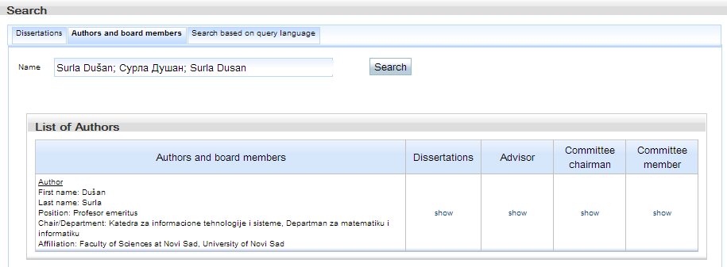
Figure 10. Researcher Surla Dušan

Search based on the Lucene query language
By opening the mode Search based on query language the form for writing Lucene query is opened. Syntax for Lucene query language is available on address http://lucene.apache.org/core/old_versioned_docs/versions/2_9_1/queryparsersyntax.html. List of available fields for searching are located on the right side of the form. Figure 11 shows the query written in Lucene query language that retrieves the same results as query created in Figure 6.
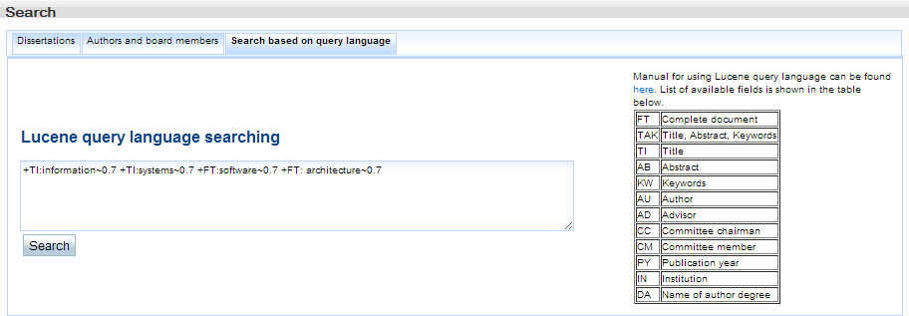
Figure 11. Search based on query language
After pressing the button Search the system sends a query to the server and then displays the results list.

Search results
Search results are available in form that is shown in Figure 12.
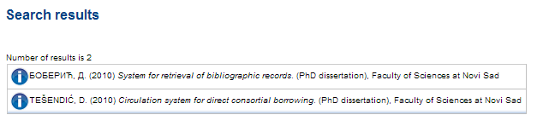
Figure12. Search results
The default view of result contains basic information about the dissertation using Harvard style. By clicking on the button a window with modes Additional data, MARC 21, Dublin Core, ETD MS and Electronic version is opened. Mode Additional data offers additional information about dissertation (Figure 13). The window with the additional information can be closed by clicking on the button for the second time.
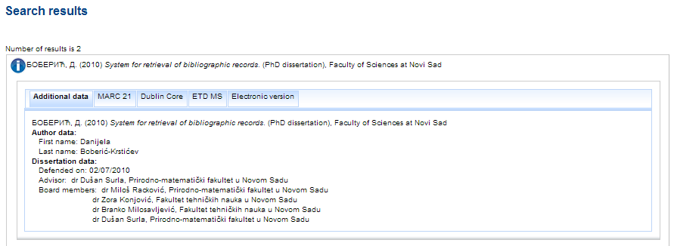
Figure 13. Additional data
The next three modes of the window contain information about the dissertation in some of widely adopted library standards. MARC 21 mode offers display of dissertation in the MARC 21 standard (http://www.loc.gov/marc/bibliographic/), Dublin Core mode offers display of dissertation in the Dublin Core standard ((http://dublincore.org/documents/dces/), ETD MS mode offers display of dissertation in ETD MS standard (http://www.ndltd.org/standards/metadata/etd-ms-v1.00-rev2.html). The last mode Electronic version shown in Figure 13 enables sending a request to the University library (CBUNS@uns.ac.rs) for obtaining electronic version of dissertation.

