[贝塞尔曲线的数学原理](http://blog.csdn.net/likendsl/article/details/7852658)

标签： [algorithm](http://www.csdn.net/tag/algorithm)[distance](http://www.csdn.net/tag/distance)[function](http://www.csdn.net/tag/function)[construction](http://www.csdn.net/tag/construction)[scheme](http://www.csdn.net/tag/scheme)[numbers](http://www.csdn.net/tag/numbers)

2012-08-10 17:43 5811人阅读 [评论](http://blog.csdn.net/likendsl/article/details/7852658#comments)(0) [收藏](javascript:void(0);) [举报](http://blog.csdn.net/likendsl/article/details/7852658#report)

http://static.blog.csdn.net/images/category_icon.jpg 分类：

UIBezierPath（1） http://static.blog.csdn.net/images/arrow_triangle%20_down.jpg iphone开发之功能实现部分（17） http://static.blog.csdn.net/images/arrow_triangle%20_down.jpg

目录[(?)[+]](http://blog.csdn.net/likendsl/article/details/7852658)

**Bézier curve(**贝塞尔曲线**)**是应用于二维图形应用程序的[数学曲线](http://baike.baidu.com/view/627248.htm)。 曲线定义：起始点、终止点（也称锚点）、控制点。通过调整控制点，贝塞尔曲线的形状会发生变化。 1962年，法国数学家**Pierre Bézier**第一个研究了这种[矢量](http://baike.baidu.com/view/77474.htm)绘制曲线的方法，并给出了详细的计算公式，因此按照这样的公式绘制出来的曲线就用他的姓氏来命名，称为贝塞尔曲线。

以下公式中：B(t)为t时间下 点的坐标；

 P0为起点,Pn为终点,Pi为控制点

**一阶贝塞尔曲线(线段)：**

http://hi.csdn.net/attachment/201008/28/0_1282984310y353.gif



意义：由 P0 至 P1 的连续点， 描述的一条线段

**二阶贝塞尔曲线(抛物线)：**

http://hi.csdn.net/attachment/201008/28/0_1282984320awS6.gif



原理：由 P0 至 P1 的连续点 Q0，描述一条线段。   
      由 P1 至 P2 的连续点 Q1，描述一条线段。   
      由 Q0 至 Q1 的连续点 B(t)，描述一条二次贝塞尔曲线。

经验：P1-P0为曲线在P0处的切线。

**三阶贝塞尔曲线：**

http://hi.csdn.net/attachment/201008/28/0_1282984326C3m1.gif



**通用公式：**

http://hi.csdn.net/attachment/201008/28/0_1282984842iZn0.gif

**高阶贝塞尔曲线：**

4阶曲线：



5阶曲线：



<http://www.cs.mtu.edu/~shene/COURSES/cs3621/NOTES/spline/Bezier/de-casteljau.html>

Following the construction of a Bézier curve, the next important task is to find the point **C**(*u*) on the curve for a particular *u*. A simple way is to plug *u* into every basis function, compute the product of each basis function and its corresponding control point, and finally add them together. While this works fine, it is not numerically stable (*i.e.*, could introduce numerical errors during the course of evaluating the Bernstein polynomials).

In what follows, we shall only write down the control point numbers. That is, the control points are **00** for **P**0, **01** for **P**1, ..., **0*i*** for **P***i*, ..., **0*n*** for **P***n*. The **0**s in these numbers indicate the initial or the 0-*th* iteration. Later on, it will be replaced with **1**, **2**, **3** and so on.

The fundamental concept of de Casteljau's algorithm is to choose a point **C** in line segment **AB** such that **C** divides the line segment **AB** in a ratio of *u*:1-*u* (*i.e.*, the ratio of the distance between **A** and **C** and the distance between **A** and **B** is *u*). Let us find a way to determine the point **C**.

http://www.cs.mtu.edu/~shene/COURSES/cs3621/NOTES/spline/Bezier/point-c.jpg

The vector from **A** to **B** is **B - A**. Since *u* is a ratio in the range of 0 and 1, point **C** is located at *u*(**B - A**). Taking the position of **A** into consideration, point **C** is **A** + *u*(**B - A**) = (1 - *u*)**A** + *u***B**. Therefore, given a *u*, (1 - *u*)**A** + *u***B** is the point **C** between **A** and **B** that divides **AB** in a ratio of *u*:1-*u*.

The idea of de Casteljau's algorithm goes as follows. Suppose we want to find **C**(*u*), where *u* is in [0,1]. Starting with the first polyline, **00-01-02-03...-0*n***, use the above formula to find a point **1*i*** on the leg (*i.e.* line segment) from **0*i*** to**0(*i*+1)** that divides the line segment **0*i*** and **0(*i*+1)** in a ratio of *u*:1-*u*. In this way, we will obtain *n* points **10**, **11**, **12**, ...., **1(*n*-1)**. They define a new polyline of *n* - 1 legs.

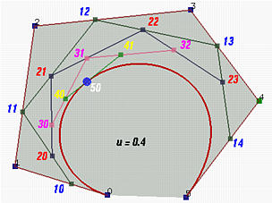

In the figure above, *u* is 0.4. **10** is in the leg of **00** and **01**, **11** is in the leg of **01** and **02**, ..., and **14** is in the leg of**04** and **05**. All of these new points are in blue.

The new points are numbered as **1*i***'s. Apply the procedure to this new polyline and we shall get a second polyline of *n* - 1 points **20**, **21**, ..., **2(*n*-2)** and *n* - 2 legs. Starting with this polyline, we can construct a third one of *n* - 2 points **30**,**31**, ..., **3(*n*-3)** and *n* - 3 legs. Repeating this process *n* times yields a single point ***n*0**. De Casteljau proved that this is the point **C**(*u*) on the curve that corresponds to *u*.

Let us continue with the above figure. Let **20** be the point in the leg of **10** and **11** that divides the line segment **10** and **11**in a ratio of *u*:1-*u*. Similarly, choose **21** on the leg of **11** and **12**, **22** on the leg of **12** and **13**, and **23** on the leg of **13**and **14**. This gives a third polyline defined by **20**, **21**, **22** and **23**. This third polyline has 4 points and 3 legs. Keep doing this and we shall obtain a new polyline of three points **30**, **31** and **32**. From this fourth polyline, we have the fifth one of two points **40** and **41**. Do it once more, and we have **50**, the point **C**(0.4) on the curve.

This is the geometric interpretation of de Casteljau's algorithm, one of the most elegant result in curve design.

http://www.cs.mtu.edu/~shene/COURSES/cs3621/NOTES/GrLine1.gif

**Actual Computation**

Given the above geometric interpretation of de Casteljau's algorithm, we shall present a computation method, which is shown in the following figure.

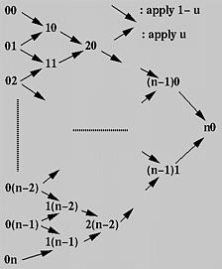

First, all given control points are arranged into a column, which is the left-most one in the figure. For each pair of adjacent control points, draw a south-east bound arrow and a north-east bound arrow, and write down a new point at the intersection of the two adjacent arrows. For example, if the two adjacent points are **ij** and **i(j+1)**, the new point is**(i+1)j**. The south-east (*resp.*, north-east) bound arrow means multiplying 1 - *u* (*resp.*, *u*) to the point at its tail, **ij**(*resp.*, **i(j+1)**), and the new point is the sum.

Thus, from the initial column, column **0**, we compute column **1**; from column **1** we obtain column **2** and so on. Eventually, after*n* applications we shall arrive at a single point ***n*0** and this is the point on the curve. The following algorithm summarizes what we have discussed. It takes an array **P** of *n*+1 points and a *u* in the range of 0 and 1, and returns a point on the Bézier curve **C**(*u*).



**Q**[*i*] := **P**[*i*]; // save input



**Q**[*i*] := (1 - *u*)**Q**[*i*] + *u* **Q**[*i* + 1];

**for** *i* := 0 **to** *n - k* **do**

**Input:** array **P**[0:*n*] of *n*+1 points and real number *u* in [0,1]   
**Output:** point on curve, **C**(*u*)   
**Working:** point array **Q**[0:*n*]   
  
**for** *i* := 0 **to** *n* **do   
for** *k* := 1 **to** *n* **do   
return Q**[0];

http://www.cs.mtu.edu/~shene/COURSES/cs3621/NOTES/GrLine1.gif

**A Recurrence Relation**

The above computation can be expressed recursively. Initially, let **P**0,*j* be **P***j* for *j* = 0, 1, ..., *n*. That is, **P**0,*j* is the *j*-th entry on column 0. The computation of entry *j* on column *i* is the following:

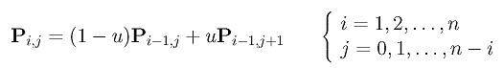

More precisely, entry **P***i*,*j* is the sum of (1-*u*)**P***i*-1,*j* (upper-left corner) and *u***P***i*-1,*j*+1 (lower-left corner). The final result (*i.e.*, the point on the curve) is **P***n*,0. Based on this idea, one may immediately come up with the following recursive procedure:



**return P**0,*j*

**return** (1-*u*)\***deCasteljau**(*i*-1,*j*) + *u*\***deCasteljau**(*i*-1,*j*+1)

**if** *i* = 0 **then   
else**

* + **function** **deCasteljau**(*i*,*j*)   
    **begin   
    end**

This procedure looks simple and short; however, it is extremely inefficient. Here is why. We start with a call to**deCasteljau**(*n*,0) for computing **P***n*,0. The **else** part splits this call into two more calls, **deCasteljau**(*n*-1,0) for computing **P***n*-1,0 and **deCasteljau**(*n*-1,1) for computing **P***n*-1,1.

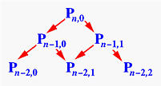

Consider the call to **deCasteljau**(*n*-1,0). It splits into two more calls, **deCasteljau**(*n*-2,0) for computing **P***n*-2,0 and**deCasteljau**(*n*-2,1) for computing **P***n*-2,1. The call to **deCasteljau**(*n*-1,1) splits into two calls, **deCasteljau**(*n*-2,1) for computing **P***n*-2,1 and **deCasteljau**(*n*-2,2) for computing **P***n*-2,2. Thus, **deCasteljau**(*n*-2,1) is called twice. If we keep expanding these function calls, we should discover that almost all function calls for computing **P***i*,*j* are repeated, not once but many times. How bad is this? In fact, the above computation scheme is identical to the following way of computing the*n*-th Fibonacci number:



**return** 1

**return** **Fibonacci** (*n*-1) + **Fibonacci** (*n*-2)

**if** *n* = 0 **or** *n* = 1 **then   
else**

* + **function** **Fibonacci**(*n*)  
    **beginend**

This program takes an exponential number of function calls (an exercise) to compute **Fibonacci**(*n*). Therefore, the above recursive version of de Casteljau's algorithm is ***not*** suitable for direct implementation, although it looks simple and elegant!

http://www.cs.mtu.edu/~shene/COURSES/cs3621/NOTES/GrLine1.gif

**An Interesting Observation**

The triangular computation scheme of de Casteljau's algorithm offers an interesting observation. Take a look at the following computation on a Bézier curve of degree 7 defined by 8 control points **00**, **01**, ..., **07**. Let us consider a set of consecutive points on the same column as the control points of a Bézier curve. Then, given a *u* in [0,1], how do we compute the corresponding point on this Bézier curve? If de Casteljau's algorithm is applied to these control points, the point on the curve is the opposite vertex of the equilateral's base formed by the selected points!

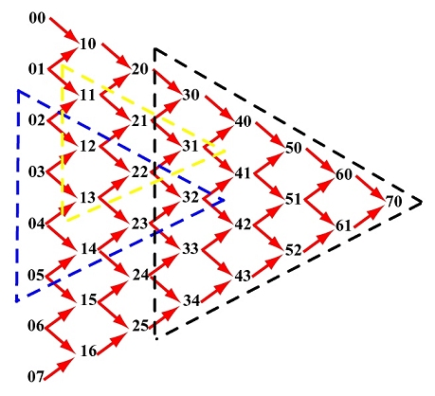

For example, if the selected points are **02**, **03**, **04** and **05**, the point on the curve defined by these four control points that corresponds to *u* is **32**. See the blue triangle. If the selected points are **11**, **12** and **13**, the point on the curve is**31**. See the yellow triangle. If the selected points are **30**, **31**, **32**, **33** and **34**, the point on the curve is **70**.

By the same reason, **70** is the point on the Bézier curve defined by control points **60** and **61**. It is also the point on the curve defined by **50**, **51** and **52**, and on the curve defined by **40**, **41**, **42** and **43**. In general, if we select a point and draw an equilateral as shown above, the base of this equilateral consists of the control points from which the selected point is computed.