Type 1, view target file with absolute path inode information

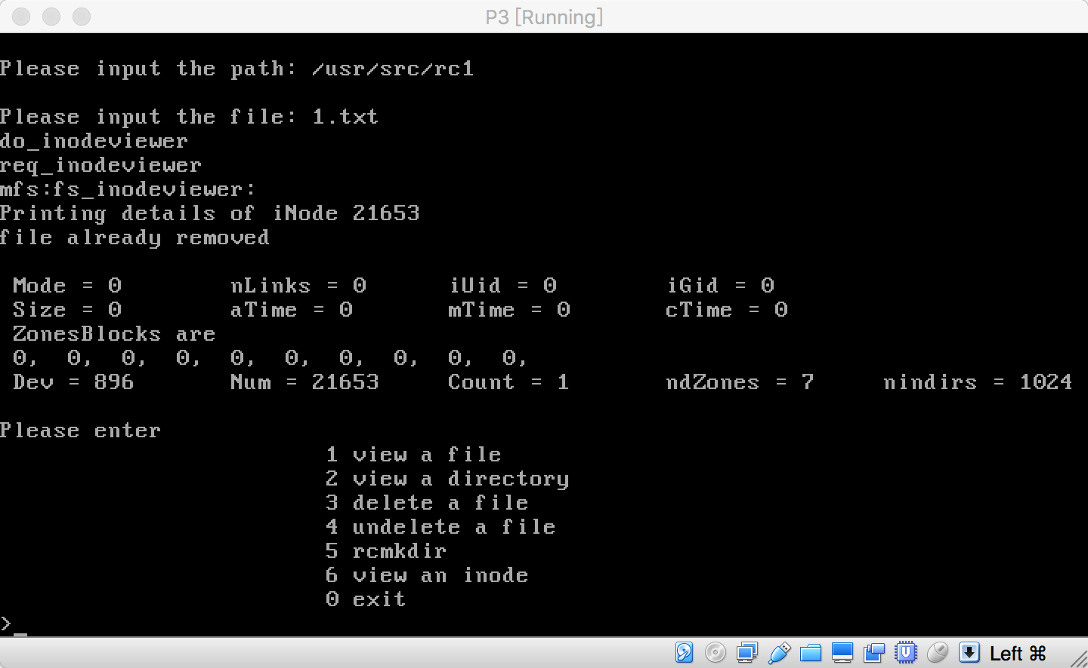

2. view target directory with absolute path and children inodes information

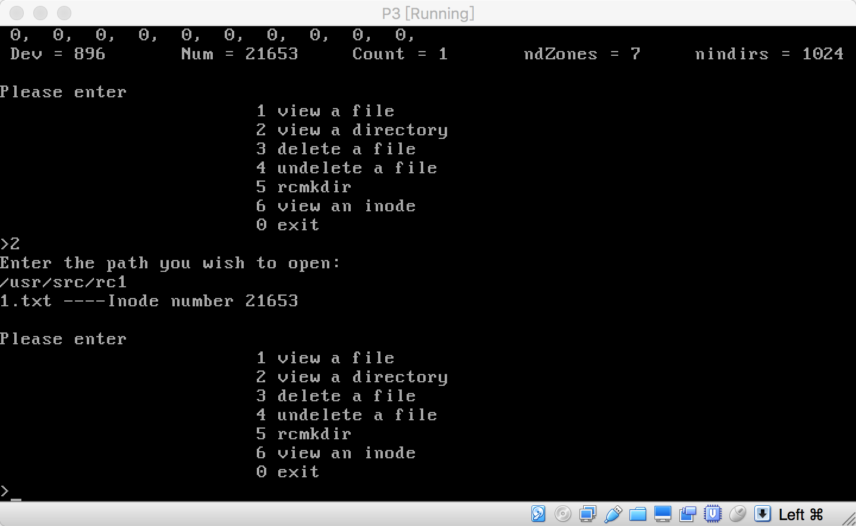

Type 6, we can see specific inode information

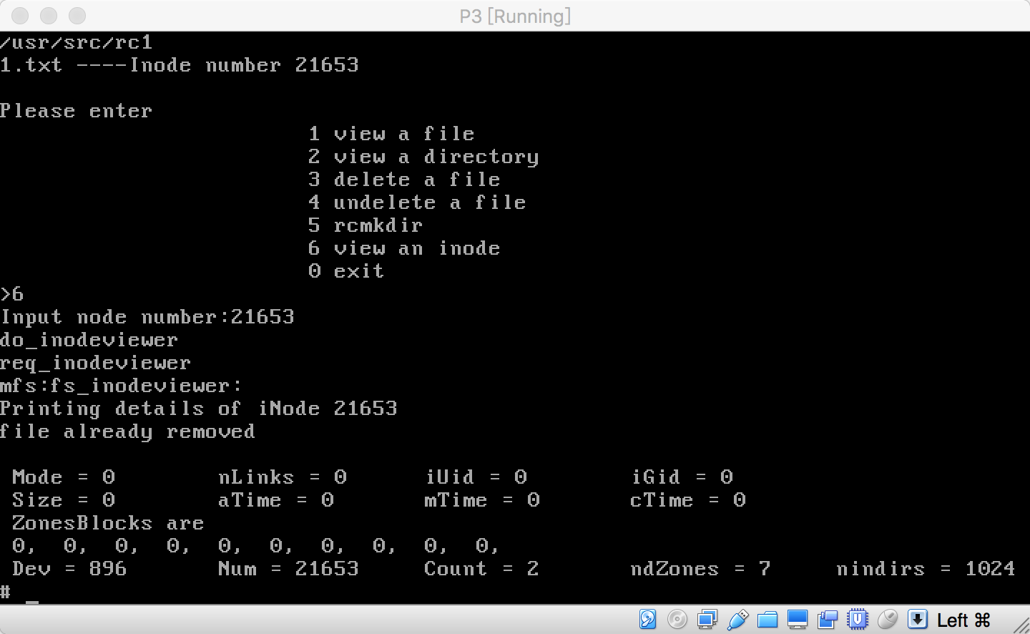

type 3 delete a regular file with absolute path

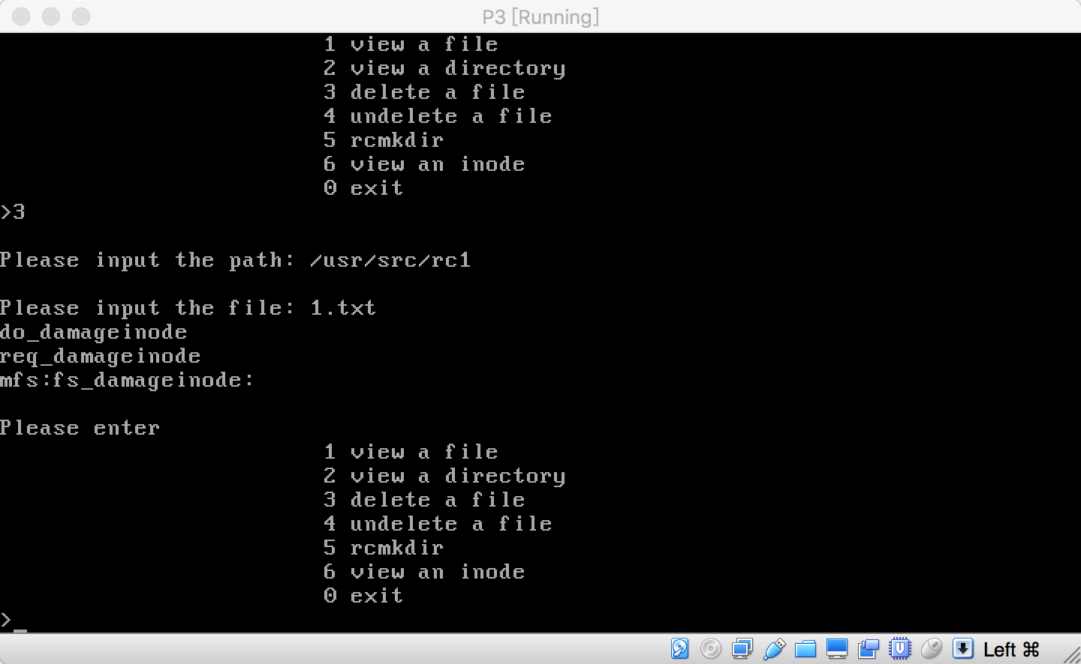

Without rcmkdir, we cann’t undelete this file.

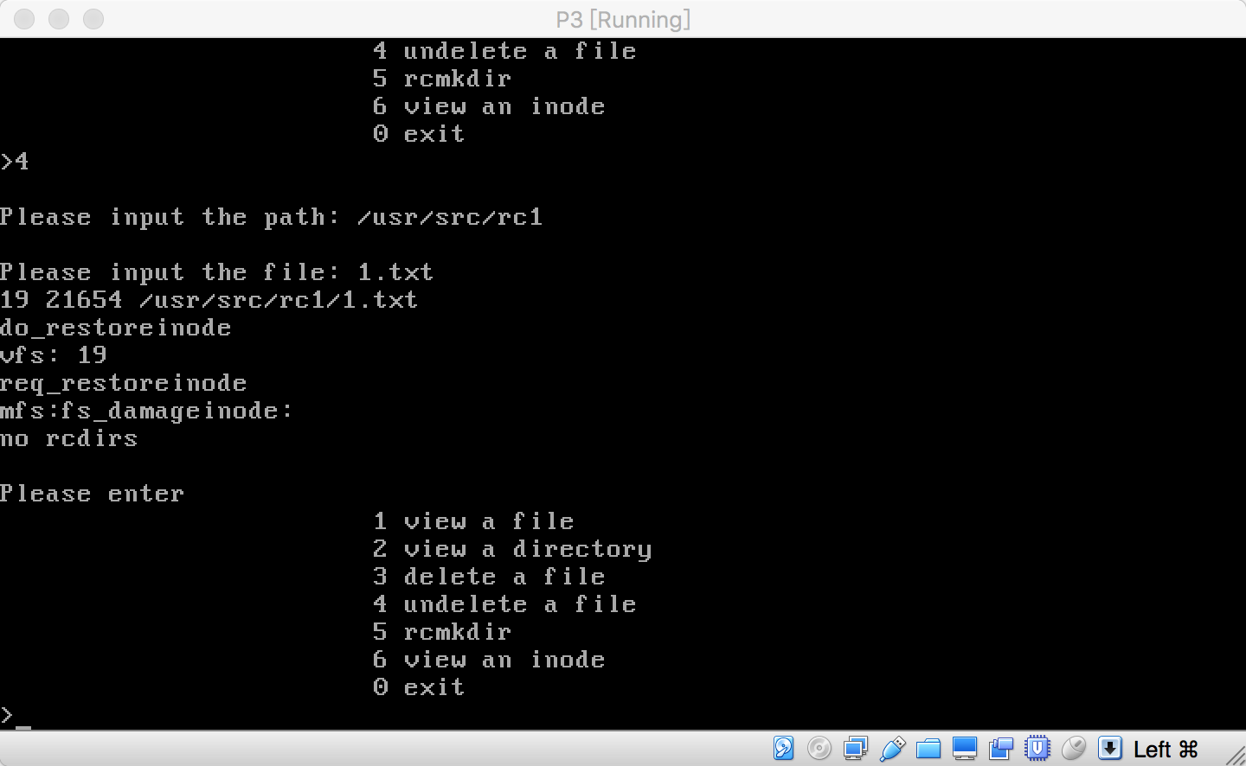

Type 5, we can mkdir, but already has the same file name.

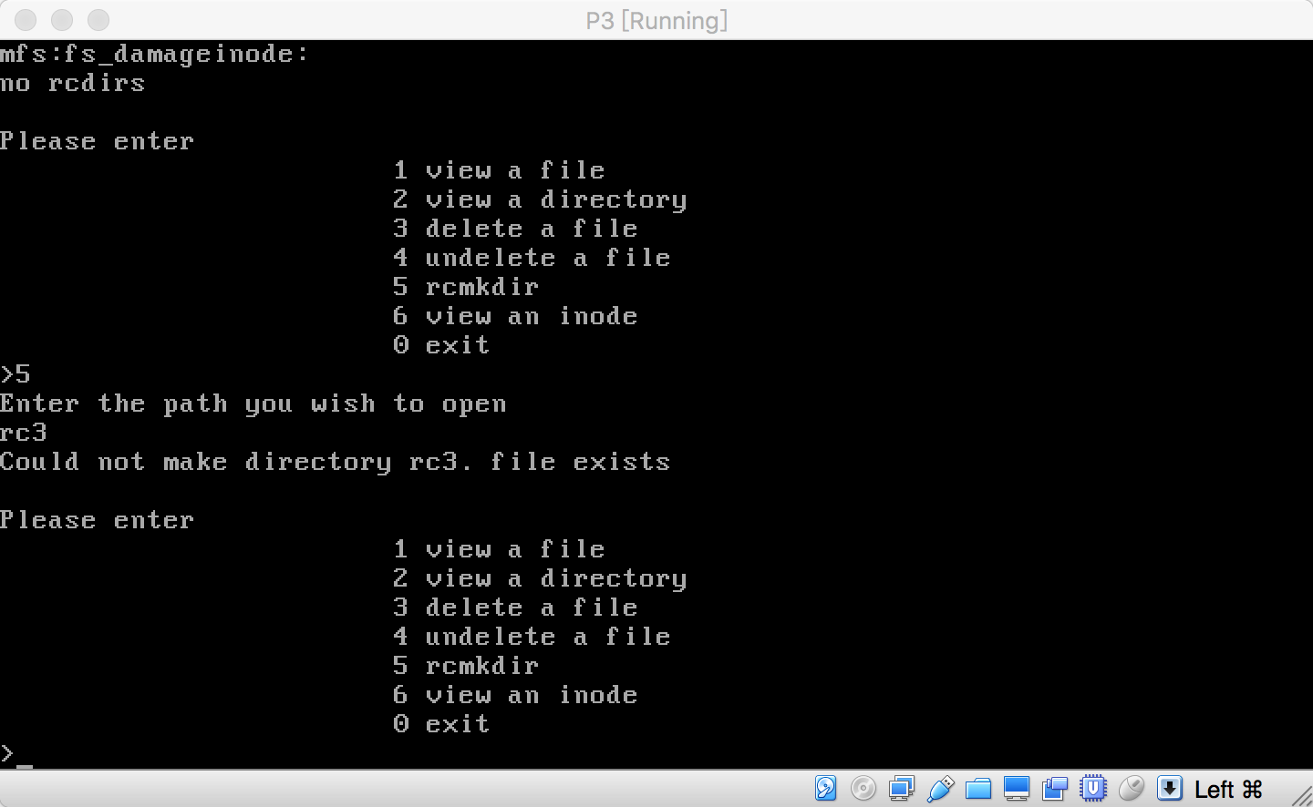

Type 5, we can mkdir with unused name, and store path inode in MFS.

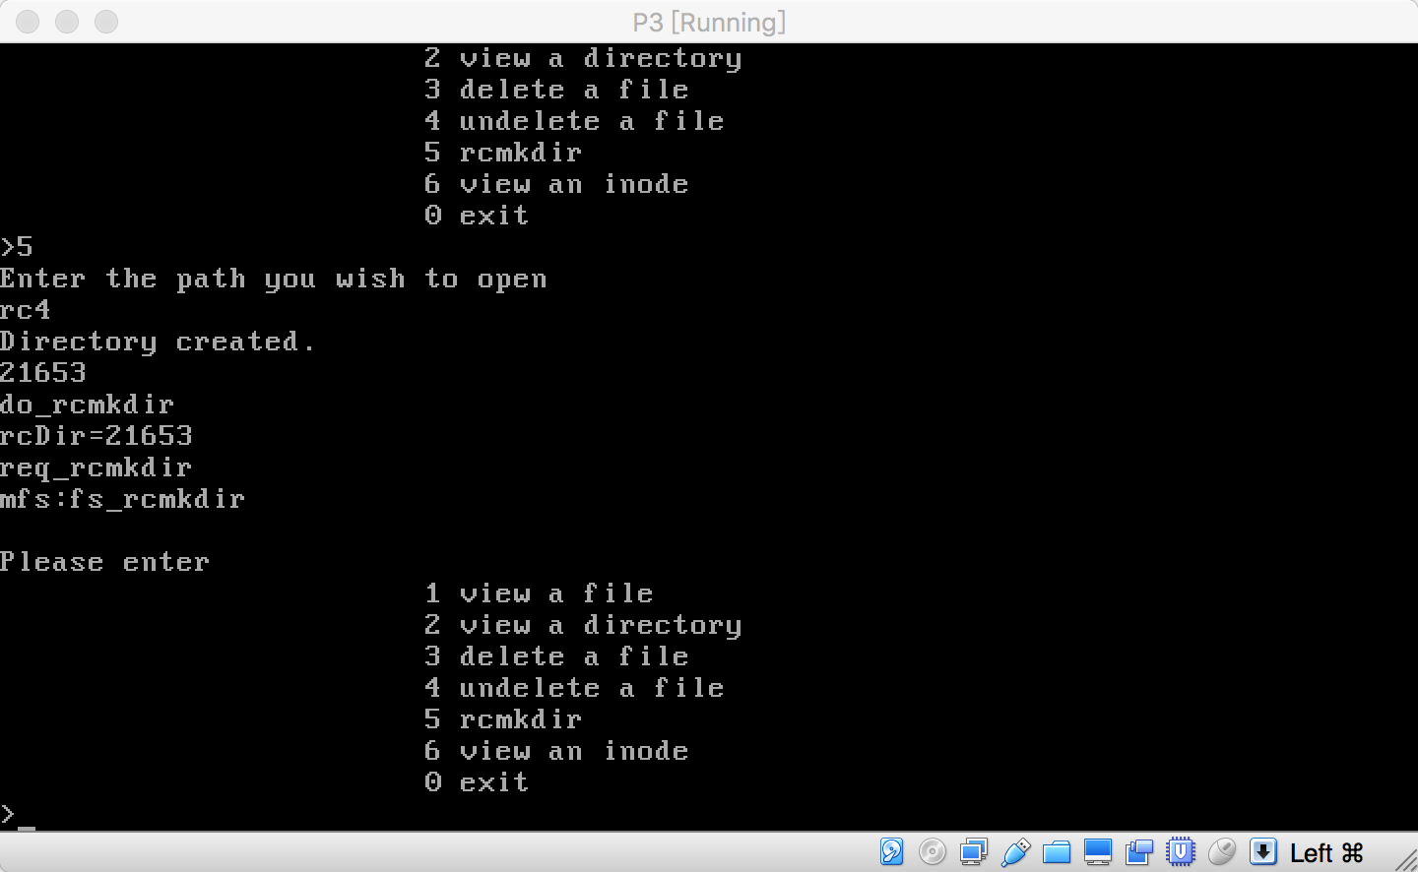

Now, we delete a file in rcmkdir directory and also let MFS server to store pinode, finode and file name

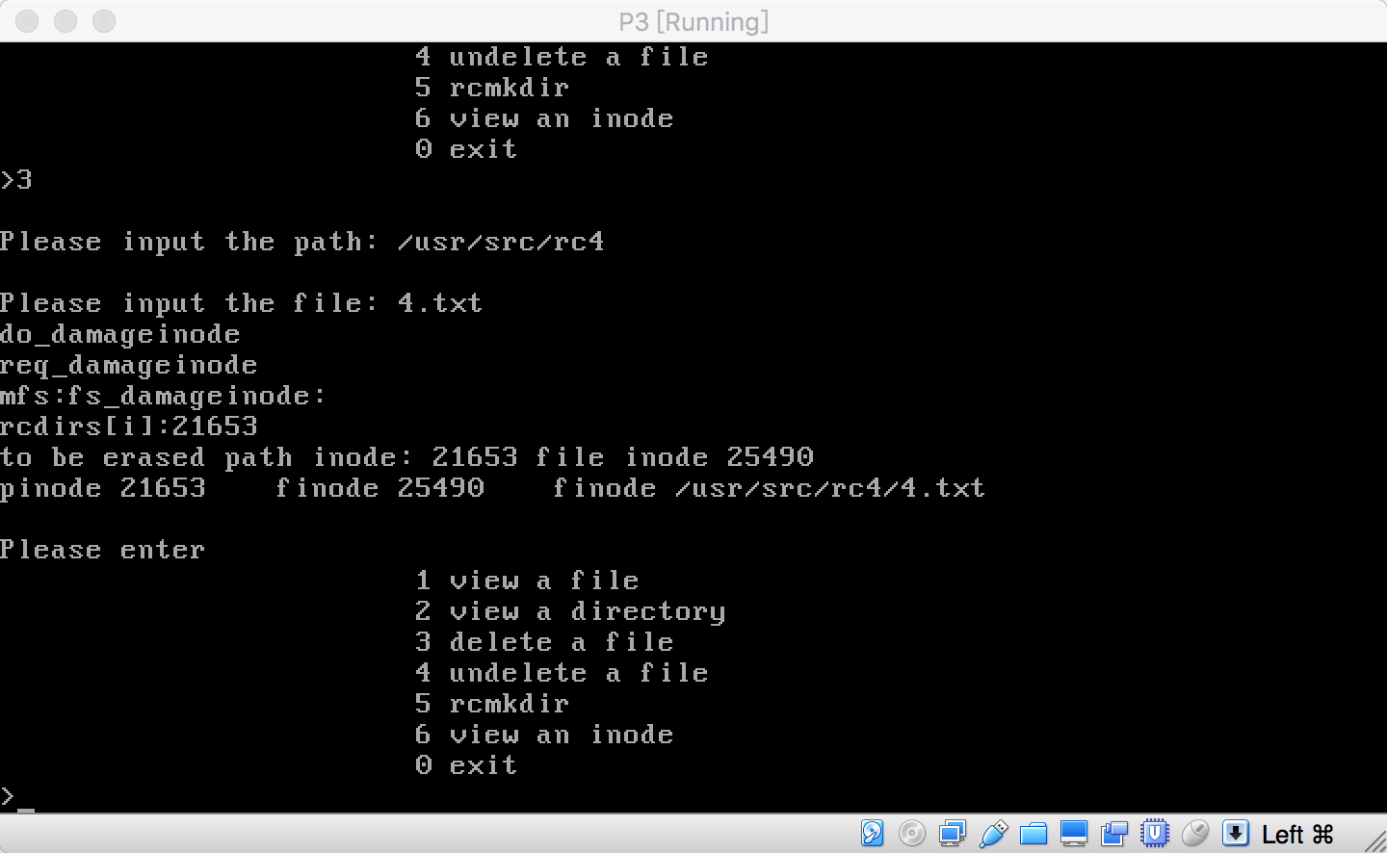

After deleting, we undelete the target file in rcdir folder successfully by calling syscopy.

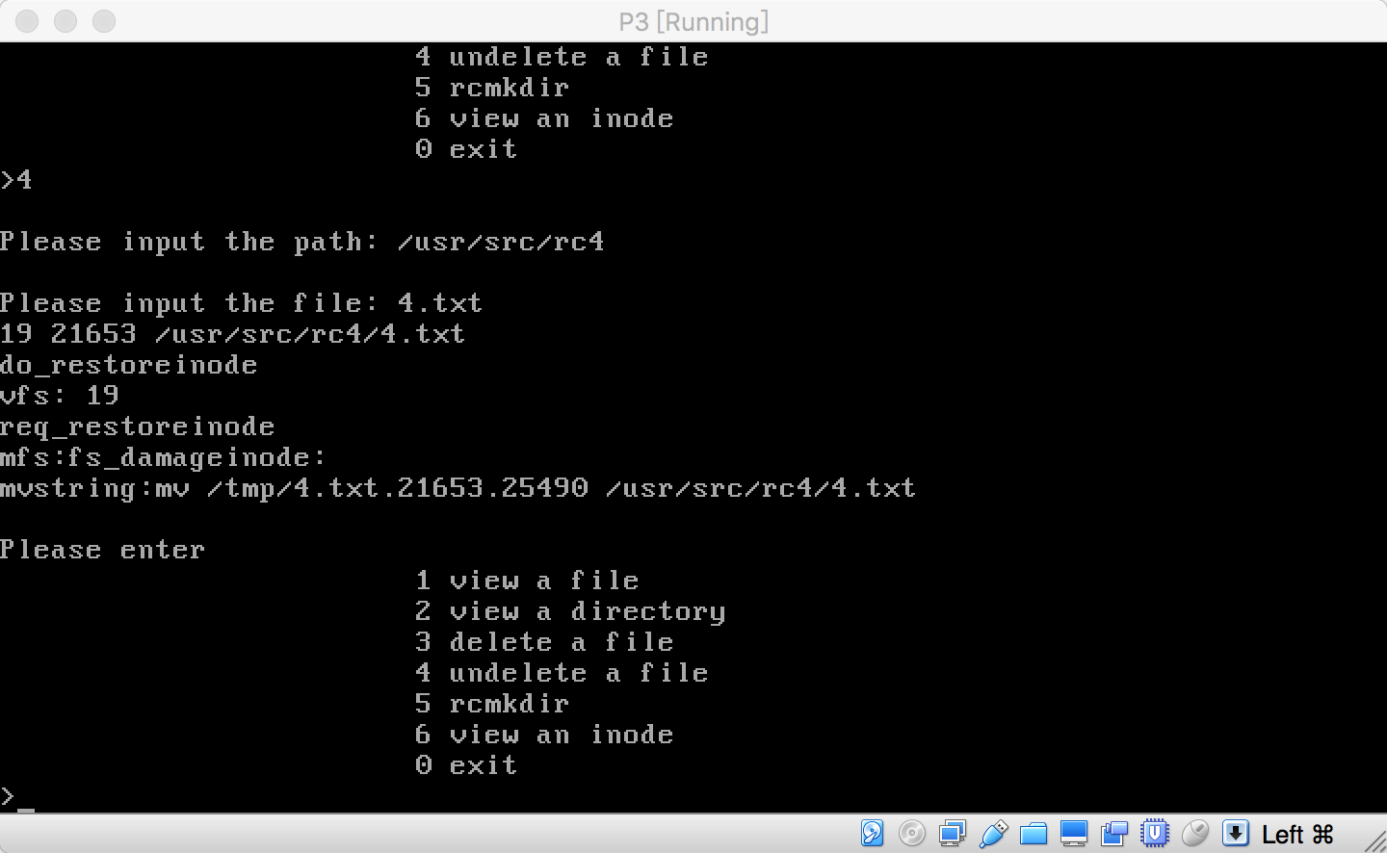

After undelete successfully, we failed to undelete the same file because target inode is being used.

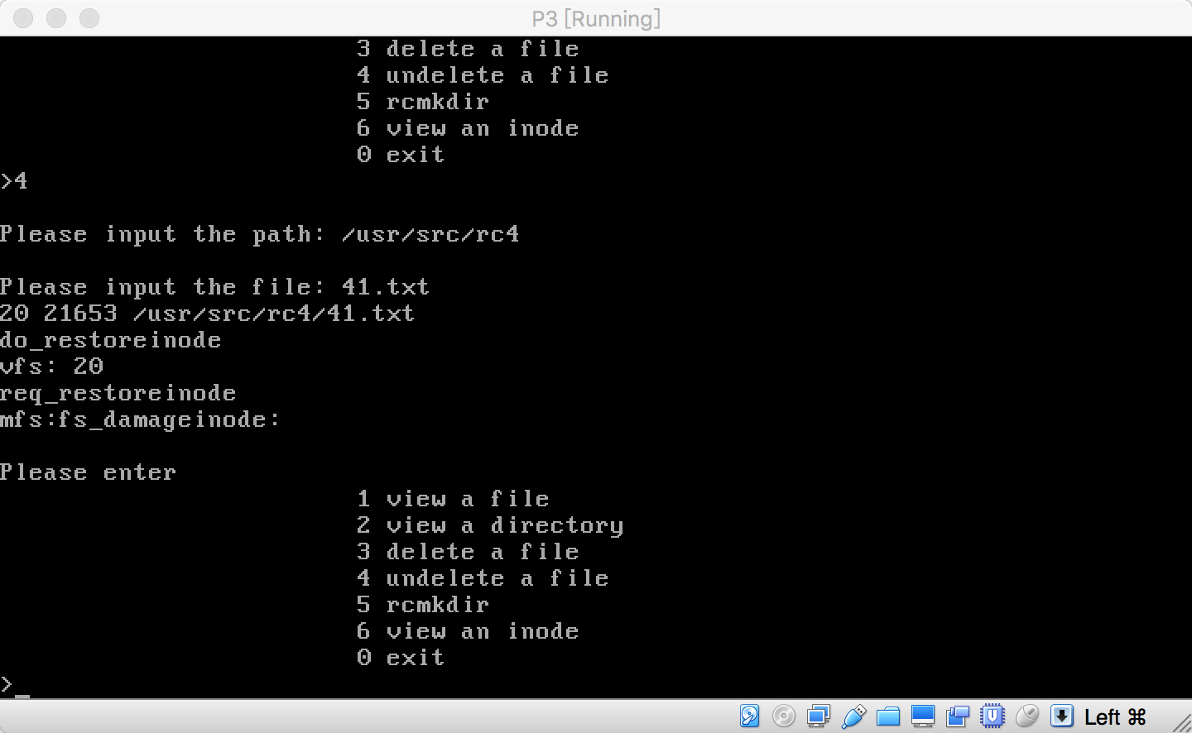

Close testing program, create a new file and we can also delete new file by calling MFS to store a new array information including path inode, file inode and file name.

