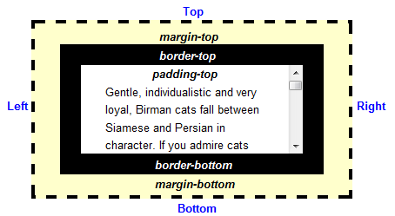

# element.offsetHeight

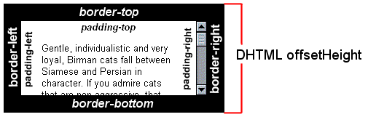

element + padding + **border**

# element.clientHeight

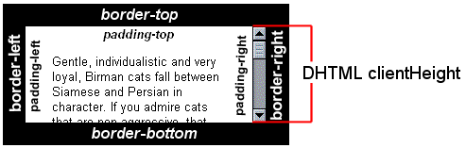

element + padding

# jQuery.outerHeight*([true]*)

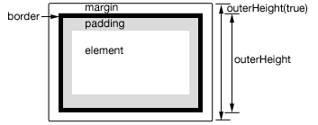

**False**:  
 element + padding + border

**True**:  
element + padding + border + **margin**

# jQuery .innerHeight()

# 

Element+  
padding

# jQuery.height()

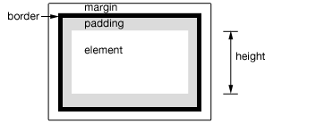

Element

|  |  |
| --- | --- |
| DHTML | jQuery |
| element.offsetHeight | outerHeight() 🞑 |
| element.clientHeight | innerHeight() 🞕 |